Chapter 4 - Answers to review questions in textbook, page 94

1. Write a short paragraph on the benefits that can be derived from the strategic human resource management process.
Answer: (Introduction to chapter 4)
The strategic human resource management process is often an after thought in organisations but there are numerous benefits from this process. These include that it can contribute to the goal accomplishment and survival of the company, it can support and successfully implement given corporate and business strategies of the company, it can create and maintain a competitive advantage for the company, it can improve the responsiveness and innovation potential of the company. The strategic human resource management process can also increase the number of feasible strategic options available to the company, participate in strategic planning and influencing the strategic direction of the company as an equally entitled member of top management and improve cooperation between the human resource management department and line managers.

2. One of the early definitions to be found in the strategic human resource management literature is that of Tsui. Discuss briefly.
Answer: (Sec 4.1)
Tsui describes strategic human resource management as follows:
The concept of strategic human resource management tends to focus on organisation-wide human resource concerns and addresses issues that are related to the firm's business, both short-term and long-term. It is particularly useful for designing specific human resource programmes, policies, systems or management practices at the organisational or business level. It also suggests that the line executive is the most important constituent for the human resource function.
This definition clearly supports the 'proactive' approach to be found within the literature. With this approach HR professionals participate in the strategic planning process and can, as a result of limitations in the company's HR situation, potentially influence the formulation of the company strategy. Other authors also describe this concept such as Dyer and Holder, they describe it as follows: “Strategic human resource management consists of three major tasks. The first task, which arises during the formulation of business strategies, is to assure that the HR issues and implications of various alternatives or proposals are fully considered (their desirability and feasibility). The next task involves establishing HR goals and action plans - that is HR strategies (at all levels) - to support the business strategies. And the final task requires working with line managers as principal clients to ensure that established action plans are indeed implemented.”

From the above definitions it is clear that two major issues or aspects need to be in place within the organisation before the SHRM process can function successfully. The first of these is the presence of a strategic management process; the second, the restructuring of the HRM function itself.

3. At a strategic level, HR professionals fulfil their strategic partner role and are involved in corporate and human resource planning. Identify the four features of this role, according to Casio.
Answer: (Sec 4.1)
For the HR function to operate at the strategic level, it needs to reorganise the existing HR administrative function into three distinct levels, namely strategic, operational and functional.

At the strategic level, HR professionals fulfil their strategic partner role and are involved in corporate and human resource planning. Casio identifies the following four features of this role:
● Senior human resource professionals meet regularly with their counterparts in line management to formulate and to review broad human resource strategies (those designed to promote innovation, quality enhancement, or cost control).
● Senior human resource professionals participate fully in all top-level business strategy sessions. This permits early evaluation of proposals in terms of their feasibility and desirability from a human resources perspective, as well as an early warning of upcoming human resource management issues.
● Human resource professionals at all levels work closely with line managers on an ongoing basis to assure that all components of the business strategy are implemented adequately.
● The human resource management function itself is managed strategically. It has its own departmental strategy that identifies priorities, directs the allocation of resources, and guides the work of various specialists (e.g. compensation, labour relations).
The other two levels are operational and functional, although a discussion on these two levels are not required to answer this question it has been included here for clarity purposes.

At the operational level, the HR team develops action plans to meet present labour needs, and at the functional level it will carry out the many activities which ensure that employees are at the right place at the right time and cost. Take, for example, the performance appraisal function. At the strategic level a decision will be made regarding what will be valued in the long term. At the operational level, appraisal systems that relate current conditions and future potential will be set up. At the functional level, the actual appraisal system will be implemented annually and day-to-day control systems will be put in place.

Once the new HR structure has been finalised, it is important that proper communication links are established with line management. This relationship can be enhanced by having regular meetings with line managers, circulating relevant HR reports to them and establishing a computerised HR system that allows access by all stakeholders.

4. Give four reasons (according to Rothwell & Kazanas) why the relationship between strategic management and strategic human resource management is non-existent.
Answer: (Sec 4.2)
If the functioning of an organisation is to be successful, the relationship that must exist between strategic management and SHRM cannot be ignored. However, in many cases, this relationship between the two processes within a company is non-existent for a number of reasons. Rothwell & Kazanas have named a few:
- top managers do not perceive a need for a relationship;
- HR practitioners are perceived as 'personnel experts' not 'experts in business';
- HR information is sometimes incompatible with other information used in strategy formulation; and
- conflicts may exist between short-term and long-term HR needs.
5. What are the four essential components of HR strategies, according to Dyer & Holder?
Answer:
To implement the SHRM process, one needs HR strategies. Dyer & Holder make the following remarks regarding HR strategies:
While a wide variety of issues are addressed in such strategies, at a minimum they include four components:
● mission statement or a set of prioritised goals for the function and the major subfunctions (e.g. training, compensation);
● a proposed organisation structure;
● a programme portfolio to outline priorities and policies; and
● a budget to address the issue of resource allocation.

6. Explain Tichy's human resource management cube model, which indicates the important relationship between strategic management and strategic human resource management. In your discussion focus on:
1 the basic problems that confront organisations
2 the design of three systems to solve these problems
3 aids required to manage these systems, and
4 the process of integration of all the issues
Answer: (Sec 4.2)
According to Tichy, companies are continually confronted by three basic problems that must be managed: a technical problem, a political problem and a cultural problem. As far as the technical problem is concerned, Tichy is of the opinion that, as a result of the external threats and opportunities and the internal strengths and weaknesses of companies, all companies continually face a production problem. In other words, technical resources must be managed in such a way that the required output is continuously delivered. To solve problems in this area, management is regularly involved in strategy and goal formulation and the design of organisational and management systems.

As far as the political problem is concerned, companies continually have problems with the allocation of power and resources within the organisational structure. Aspects that are important here are the direction in which they are moving, and who will share in the benefits. Decisions in this regard will be reflected in the compensation paid, budget allocations made and the allocation of decision-making power to the different levels within the organisational structure.
Regarding the cultural problem, it is important to remember that companies are held together by their 'culture'. Culture consists of values, beliefs and views shared by the employees within the company. The organisation must thus continually decide which values, views and beliefs its employees must possess and also which sections within the company must possess which values.
To solve these problems, Tichy suggests that companies design three systems - namely the technical system, the political system and the cultural system. The technical system will include all those aspects that are required to solve the production problem. The political system will contain all the practices, activities and elements that will be involved in the allocation problem, and the cultural system will contain all the symbols, values and elements necessary to address the ideology problem within the organisation.
Tichy suggests that, for these systems to be managed properly, certain aids are required. He identifies the following three as necessary:
● the mission and strategy of the company;
● the structure of the organisation, including the administrative
procedures; and
● the HRM systems of the company.
'Mission and strategy' refer to the setting of goals and the development of a strategy. The structure will include the tasks, the manner in which workers are grouped and coordinated to perform the tasks, and the management processes of control and information to enable the organisation to function properly. The HRM system will include all the activities such as recruitment, selection, performance appraisal, training and development and compensation. Thus, for the organisation to be managed efficiently and effectively, these issues must be managed as an integrated whole. This process will be discussed briefly.
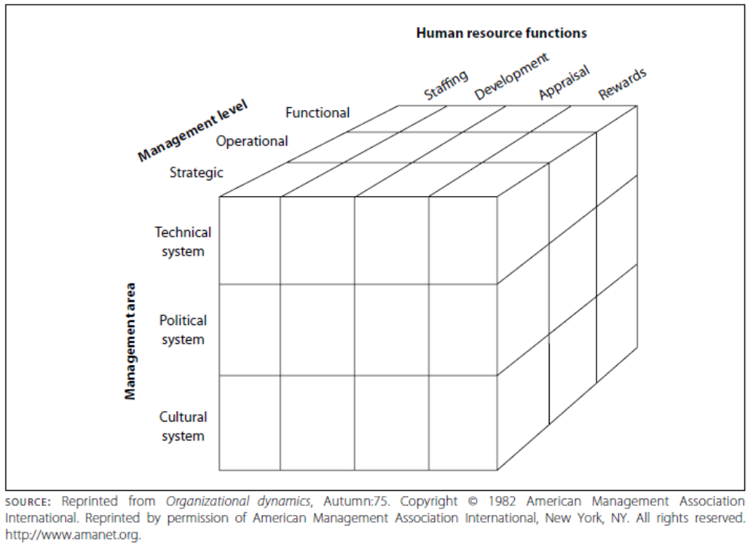

7. Discuss the design of an HR strategy by referring to the issue of strategic imperatives.
Answer: (Sec 4.3)
It is clear that many issues need to be considered in the design of a HR strategy. A key aspect in this regard is to understand the strategic imperatives behind important decisions taken either within the HR department or the company. According to Swamy (refer to your prescribed book sec 4.3), strategic imperatives are "priority issues that must be addressed to meet long-term objectives". These imperatives, when properly understood, are used to guide the behaviour of for example the HR department or company. Thus, major undertakings within the company or HR department demands a properly evaluated strategic imperative. In other words, when a HR department/company starts a new initiative or addresses a critical or urgent concern that will affect its long term future, it is very important that management understands the rationale, sets goals, tests them with independent, objective reliable tools or systems as well as consider alternative options, and plans a roadmap for execution. Swamy continues to indicate that strategic imperatives can be categorised into two broad categories.

Figure: High-level framework for understanding strategic imperatives

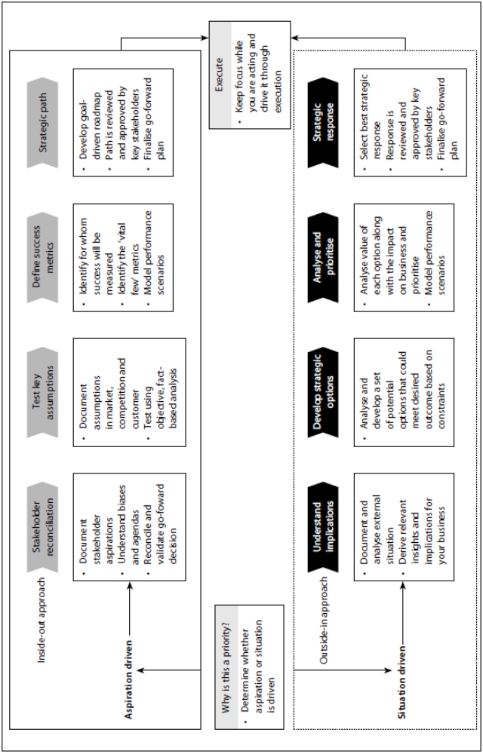

Firstly, an aspiration-driven imperative which consists of two components namely a growth imperative e.g. a merger or acquisition and an efficiency-imperative e.g. informal restructuring. The aspiration imperative comes thus from within. Secondly also found is a situation-driven imperative. This imperative comes from external forces, e.g. a government facilitated imperative such as regulatory change or a market-led imperative such as cost cutting to remain competitive. The question thus is; how can a HR department/company for example better understand its strategic imperatives? To answer this question it is clear that the HR department/company must identify a priority that must be addressed and understand why it is a priority. Depending on whether it is aspiration-driven or situation-driven, there are different considerations to take into account (see Figure below). The steps contained in this figure will be briefly described. Please note that the discussion in this part of the chapter is based on the work done by Ramesh Swamy and published in his article "Strategic Imperatives".

Step 1
In this step the goals management is formulating for a particular setting needs to be examined. In the case of an aspiration driven imperative it may be necessary to interview key stakeholders to determine their aspirations, institutional biases and operational preferences. In the case of a situation-driven imperative, adequate documentation needs to be analysed.

Step 2
For aspiration-driven imperatives testing management's assumptions using objective fact-based analysis is important. In the case of a situation-driven imperative, management must develop an exhaustive set of potential strategic options that could meet the same desired outcome.

Step 3
For a strategic path to be successful on the aspiration-driven side it is necessary to identify for whom and by whom success will be measured. A few measurements must be identified that will satisfy its stakeholders and a number of performance scenarios should be modelled against these measurements: On the situation-driven side performance scenarios must also be identified as they will allow the company to analyse the value of each option it has identified in step 2. From this exercise they can then prioritise correctly.

Step 4
This step represents the "strategy" component of strategic imperatives. In the case of the aspiration-driven imperatives management needs to develop a goal-driven roadmap - an executable strategy for the imperative and ensure the path is reviewed and approved by key stakeholders. In the case of a situation-driven imperative, management needs to decide on the best strategic response and finalise a plan for moving forward.

In conclusion, note that two types of HR strategies can be distinguished - namely organisational strategies and functional strategies. Organisational strategies can be seen as part of the organisational or company strategy and have a major impact throughout the organisation. On the other hand, functional strategies are seen as more narrowly focused and are involved only with the strategic management of HR divisions or departments.

It is inevitable that with the emergence of SHRM as a field of study and practice, 'how to' models have also emerged. In the next section we will give a brief overview of the major types of models which have been developed over a period of two decades.
8. Explain the two dominant approaches of two models of strategic human resource management and Dyer's classification method of these models.
Answer:
According to the prescribed book several SHRM models have been developed over the years which describe how the company strategy and HRM should be linked. However, two dominant approaches to integration can be found. The first approach is the reactive role of HRM, in which strategy dictates HR policies, and the second is a proactive role, in which HRM is involved in the strategy formulation process itself.
In order to understand the SHRM models found in the literature a classification method designed by Dyer will be applied. Dyer suggests in his four-quadrant model that two dichotomies are important to consider. The first is to separate the organisational from the functional level HR concerns, and the second, to differentiate between content and process elements.
Content concerns specific choices such as policies and practices in SHRM, whereas process focuses on the means by which these policies and practices are derived and implemented.

9. Briefly explain Rothwell & Kazanas' model of strategic human resource management.
Answer:
The model of Rothwell and Kazanas creates a framework for the inclusion of human resources as an integral part of the total business strategy. The model is interactive and integrative and at each step permits the exchange of both data and feedback. It is important to note that although the model might create the impression that human resources are a separate element to be integrated into the company strategy, this is not the case. There can be no company strategy without the inclusion of human resources.

The model that any type of company can implement consists of the following steps:

- Step 1

Link the purpose, goals and objectives of the HR department and/or HR plan to the organisation’s purpose, goals and objectives.

This step is necessary if the HRM process is to be goal directed. Without a proper understanding of where the organisation is going, it will not be possible to provide the necessary support.

Role: HR organisational coordinator

Figure: The SHRM model of Rothwell & Kazanas
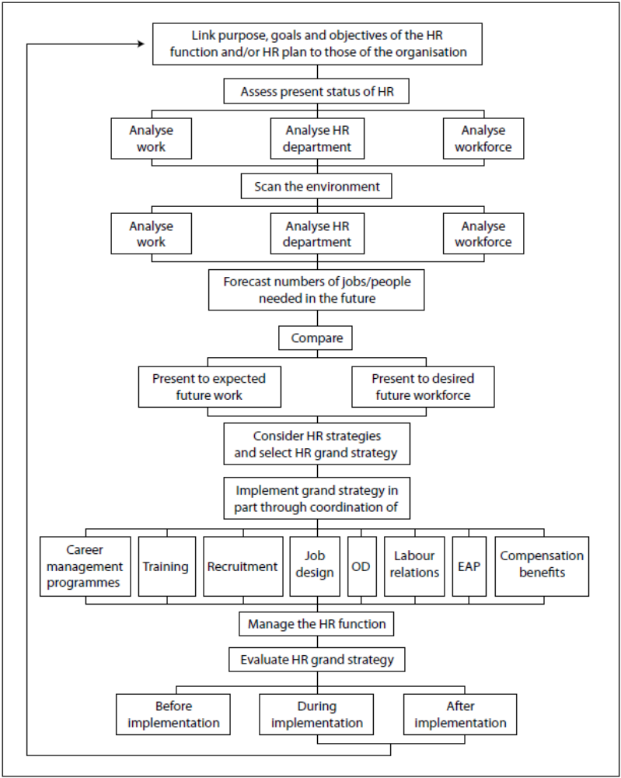

- Step 2

Assess the present status of HR in the organisation by analysing the following:
  - the work done in jobs, positions or job categories.

Role: HR work analyst

  - the people in the jobs, positions or job categories

Role: HR work force analyst

  - the HR department

Role: HR auditor

The HR process directly affects the functioning of the organisation through the work that is done, the people performing the tasks and the HR department structure. It is thus important to identify where the organisation stands on these issues at present.

- Step 3

Scan the environment to assess

  - how jobs, positions or job categories will change over time
  - how people in those jobs, positions or job categories will have to change overtime to keep up with the job changes
  - how the HR department will be affected by changes inside and outside the organisation over time

In order to function successfully within a turbulent environment one must continuously scan the external environment. This must be done to identify potential threats and opportunities that have an impact on the management of the company’s human resources. Changes taking place in the economic, technological, social, political, legal geographical and cultural spheres (as well as the labour market) must be monitored for their impact on the jobs to be performed, the people in those jobs as well as the functioning of the HR department.

Role: HR environmental scanner

- Step 4

Compare
  - the present work being done in jobs with expected work that will probably be done in future
  - the present people doing the work and those who will be needed in the future (the result is a planning gap in the work force)

The identification of the gap that exists between where we are now and where we want to be is absolutely essential for planning purposes. Without this information the development of suitable HRM strategies will not be possible.

Role: HR forecaster

- Step 5

Consider the range of long-term HR strategies that will help to close the planning gaps - HR grand strategy.

The HR executive must be actively involved in the formulation of the company strategy. This involvement will entail the evaluation of the proposed company strategies from a feasibility point of view, (can the manpower be obtained) and a desirability aspect (will there be a strike?). The HR executive must then accept or reject the company strategies. The approved company strategies must be used to identify the quality (skill composition) and quantity (number) of people desired for the future. With this information available, the HR executive must develop various HR strategic alternatives and evaluate them to choose the most appropriate one to be included in a grand HR plan.

Role: HR planning formulator

- Step 6

Implement the HR grand strategy through the coordination of HR practice areas such as:

  - career management programmes
  - training
  - recruitment
  - job design
  - organisational development
  - labour relations
  - employee assistance programmes
  - compensation/benefits

These specialised functions must be integrated into and related to the company strategy. In addition, priority should be given to the various programmes developed so that the HR budget can be allocated in the most effective manner.

Role: HR integrator

- Step 7

Manage the HR function so that it is an effective vehicle for helping to implement the HR grand strategy by changing people and jobs.

Without the availability of a proper HR function, no effective implementation of the HR grand strategy is possible. Various issues such as a good communication system and the use of power and politics can play an important role in the enhancement of effectiveness of such a function.

Role: HR planner

- Step 8

Evaluate the HR grand strategy before, during and after implementation. The results are fed back to step 1.

This final step in the model entails the evaluation and review of the whole strategic human resource management process. Thus the vital question here is “How well is the HR plan working?” Elements that are important here are how well the HR programmes are succeeding in the attainment of the HR goals and how easily the programmes are being executed. The ultimate goal of this step of the model is to establish the impact that SHRM has on the overall effectiveness of organisational performance.

Role: HR evaluator

10. Explain the fit/flexibility model of Wright & Snell.
Answer: (Sec 4.4.6)
There are two types of “fit”. One is a vertical fit, which involves the alignment of HRM practices and the strategic management process; the other is a horizontal fit, which implies congruence or fit among the various HRM practices. The vertical fit involves directing human resources towards the main initiatives of the organisation, whereas the horizontal fit is viewed as being instrumental in efficiently allocating the resources needed by the horizontal fit.
In addition to the so-called 'fit' approach, a number of articles have also been found in which the emphasis has been on the so-called 'flexibility' in SHRM. The authors in this area are of the opinion that organisations are faced with a complex and dynamic environment which requires them to be sufficiently flexible in order to adapt to changing requirements. Thus they see 'fit' as a snapshot of a particular short period of time.
Nadler & Tushman, as quoted by Wright & Snell, define congruence or fit as 'the degree to which the needs, demands, goals, objectives and/or structure of one component are consistent with the needs, demands, goals, objectives and/or structure of another component'. Thus, it can be deduced that organisations should be more effective when they achieve fit than when they do not.
In contrast to this, Sanchez, as quoted by Wright et al., defines flexibility as 'a firm's abilities to respond to various demands from dynamic competitive environments'. Thus flexibility provides an organisation with the ability to modify current practices in response to changes in the environment. By consistently scanning the environment and detecting changes, organisations will have to have a pool of alternatives available to accommodate these changes.
Wright et al. indicate that, as a result of the existence of 'fit versus flexibility' two opposing groups of researchers can be found: those that see the two alternatives as opposites - the so-called 'orthogonal' group - and those that are of the opinion that the two approaches are independent of one another - the so-called 'complementary' group. The complementary group is of the opinion that both concepts are essential for organisational effectiveness, since the strategic management challenge is to cope with change (requiring flexibility) by continually adapting to achieve fit between the firm and its external environment.
We find that the 'orthogonal' group is thus concerned with companies only at one point in time, while the complementary group sees 'fit' over a longer time frame while exploring adaptation processes. The first group sees what firms actually do, while the complementary group sees what firms ought to do.

Wright & Snell see 'fit' as an interface between an external and internal variable, while 'flexibility' is seen as only focusing internally. According to Wright, a company is required to increasingly promote organisational flexibility, in order to achieve a dynamic fit.
A brief discussion of the HR model as it appears in the Figure below follows. In the model, the top half depicts the 'fit' component and the lower half the 'flexibility' part.
Like other SHRM models, this model starts with the mission and goals of the organisation, followed by an examination of internal resources (strengths and weaknesses) and external developments (opportunities and threats). These make up the basic components of the model that lead to the choice of a given strategy. At the same time, input is also received from the HRM function regarding the strengths and weaknesses, opportunities and threats, as seen from the point of view of the company's human resources. As in previous models, the model also uses the company's strategy to dictate the skills and behaviours required from employees to successfully implement the strategy. This subsequently drives the HRM practices. These desired HRM practices are then operationalised into actual HRM practices which influence the actual skills and behaviours of human resources impacting on the company's performance. Finally, the company's performance is fed back into the strategy formulation process that will affect future strategies. This concludes the 'fit' process of the model. It is interesting to note that a number of assumptions are made here, namely that decision-makers are able to identify all the skills and behaviours required for a specific strategy, that decision-makers can specify and control all HRM practices, and lastly that the environment stays stable enough to achieve fit.
However, these assumptions cannot always be accepted in an ever-changing environment. Hence the lower part of the model, where flexibility plays an important role. The authors view this part as important in that achieving fit over time may depend upon the extent to which flexibility exists in the system. The flexibility component expands upon the fit component in a number of ways: that it is accepted that HR practices can focus on more than just fit; that a broader range of skills than those needed to implement the current strategy exists; and that the employees possess a broader repertoire of behaviours than simply those relevant to the strategy. These various skills and behaviours make it possible to implement different strategies that can respond to a variety of different competitive demands. Finally, the model also highlights the role of the participative infrastructure in developing, identifying and exploiting emergent strategies. This model is an interesting development within the SHRM theory and reflects the future trend in the flexible firm.

