Chapter 3 - Case study: Sam Magubane – Sun Sporting Goods
Textbook page 67
Answers to case study questions in textbook, page 67

1. Explain how each of the five generic elements of the definitions of leadership apply to this case.

Answer:
The definition highlights a number of important issues. Firstly, it is clear that leadership is a process and not a position, in the case study Sam Magubane has instituted a number of activities in the organisation to take place over time guided by five philosophies namely (1) employee involvement, (2) total-quality management, (3) continuous improvement, (4) lowest-total-cost manufacturing, and (5) just-in-time manufacturing this can be seen very clearly in the case study; secondly, it involves a relationship between a leader and followers in a given situation Sam Magubane as plant manager has formed a good relationship with the employees at the plant; thirdly, it involves influencing people. Sam has tried to influence the employees by telling them about the vision, mission and values he wants them to share. Fourthly, it influences followers to think not only of their own interest but the interest of the organisation. Sam got the employees to participate, in other words they had something to achieve. In the case study this is very clear employees received the same training as the managers and they are becoming involved in decision-making. Fifthly, it involves influencing followers to bring about change towards a desired future for the organisation. Sam changed the attitude of the staff to one of “we can do it, and we cannot afford not to do it”. In this case study the employees have formed their own teams with logo’s and t-shirts and they are rewarded for their efforts and they receive recognition when it is due. This is done by means of awards presented in front of all the staff members. This has lead to the company being named one of the "Best Plants in South Africa" by a leading financial magazine. Some of the team accomplishments are: market share increased from 2 to 17 percent, inventory turns per year increased from 6.5 to 8.5, inventory was reduced by two-thirds, manufacturing losses caused by scrap and rework were reduced by 67 percent, and productivity increased by 121 percent.

2. Identify leadership roles illustrated in this case. Which role was the most important?

Answer:

Role | Description | Application to case study
- Interpersonal roles
Figurehead role: | Leaders perform the figurehead role when they represent the organisation/department in legal, social, ceremonial and symbolic activities. | Not very clear
Leader role: | The leader role is that of performing the management functions to effectively operate the managers' organisation unit. | This role is very clear in the case study
Liaison role: | Leaders perform the liaison role when they interact with people outside their organisational unit, e.g. networking. | This is not very clear in the case study
- Informational roles
Monitor role: | Leaders perform the monitor role when they gather information. | It is clear that Sam performed this role well
Disseminator role: | Leaders perform the disseminator role when they send information to others in the organisational unit. | Sam established many teams
Spokesperson role: | Leaders perform the spokesperson role when they provide information to people outside the organisational unit. | Sam spoke to everyone
(C) Decision roles
Entrepreneur role: | Leaders perform the entrepreneur role when they innovate and initiate improvements. | Sam changed many aspects such as having meetings with groups of employees to tell them about the vision, mission, and values he wanted them to share. He asked everyone to radically change the facility's way of doing business. He stressed the need to change from the old dictatorial management style to the new employee-involvement style. As a result of those meetings, employees were called associates and empowered to find new solutions to old problems. Managers were trained in employee-involvement management, and through training they developed skills to include employees in decision making, to develop teams, to develop better human relations, to coach employees, to better manage time, and to manage total quality. The old attitude of "we cannot do it, or we cannot afford to do it" was changed to "we can do it, and we cannot afford not to do it".  To solve Sun's problems, Sam instituted a voluntary employee participation program called Team Sun. Teams of associates were developed to participate in problem solving in the areas of productivity, quality, cost, safety, morale, and housekeeping. Teams focused on reducing operating expenses, increasing cash flow, reducing inventory, and improving safety and housekeeping. To ensure team success, at the beginning of the change in process, all associates on teams were given training similar to that given to managers.  To recognise team accomplishments, three Team Sun teams are chosen each quarter for awards that Sam presents at a meeting of the entire plant.
Disturbance-handler role: | Leaders perform the disturbance-handler role when they take corrective action during a crisis or conflict situation. | In the beginning Sam had to make changes
Resource-allocator role: | Leaders perform the resource allocator role when they schedule, request authorisation and perform budgeting activities. | Although not very clear, Sam did make changes
Negotiator role: | Leaders perform the negotiator role when they represent their organisational unit during routine and non-routine transactions that do not include set boundaries such as the pay of an employee. | Sam changed around the “us versus them” mentality

3. Describe how each level of analysis of leadership theory is illustrated in this case. Which level is the primary focus?

Answer:
A number of models can be found at the three levels of leadership, e.g. at the individual, group and organisational level. In the case study the focus has mainly been on group models of leadership theory. Sam has instituted a voluntary employee-participation programme called Team-Sun. Under this scheme, employees formed voluntary teams. Each team represented a specific area of the plant. To recognise team accomplishment, three teams were chosen each quarter for awards that Sam presented personally.

4. Explain how each of the leadership theory classifications applies to this case.

Answer:
Individual models
Not used in this case study
Group models
Yes, this theory was applied. This can be seen with the new team approach that was introduced. Concepts of self-managed work teams as well as cross-functional teams were used.
Organisational models
To some degree the managerial as well as strategic based approach was used in the case study. Sam displayed aspects of both transactional and transformational leadership. He also displayed the ability to anticipate, envision, maintain flexibility, think strategically, and work with others to initiate changes that will create a viable future for the organisation.

5. Describe how this case illustrates the management-to-leadership paradigm.

Answer:
There are differences between management and leadership but the two concepts are complementary.
Sun Sporting Goods experienced problems in many areas such as productivity, quality, cost, safety, morale, and housekeeping. The management and employees displayed an "us against them" mentality. Sam was alert to opportunities and he had the imagination and vision to capitalise on this (Sam developed the following five guiding philosophies, or what he wanted to become shared values: (1) employee involvement, (2) total-quality management, (3) continuous improvement, (4) lowest-total-cost manufacturing, and (5) just-in-time manufacturing), he created a new paradigm, worked on the systems, inspiring the people to change and manufacture the best golf balls available and to also be much more productive, in fact he aimed to make the plant the most productive in the world. In order to achieve this vision he had to earn the respect of the people and he also showed a genuine interest in the people, Sam also had an attitude of serving which enabled him to inspire the people to achieve the new goals. The complementarity of management and leadership is shown beneath.

Figure The complementarity of management and leadership
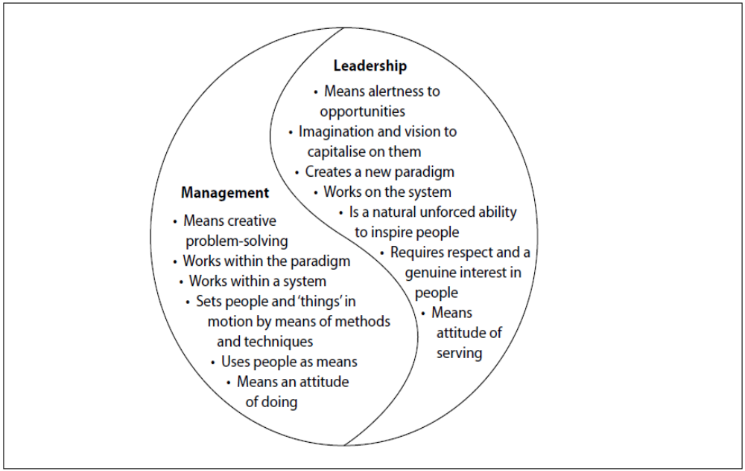
Sam empowered the employees and involved them in the decisions. He also used a team approach and he ensured that employees were properly trained. Employees received the same training management did. He inspired people to change their view of "we cannot do it, or we cannot afford to do it" to "we can do it, and we cannot afford not to do it". Sam also implemented a system where all the employees voluntarily participated in problem-solving and they attempted to reduce costs, increasing cash flow, reducing inventory, and improving safety and housekeeping. Sam also initiated an event where employees would receive recognition for their efforts and performance. Thus, the move from a purely management to leadership approach at Sun Sporting Goods can be clearly seen.

The end !!!

