Chapter 10 – Object-Oriented Design: Principles

Solutions to End-of-Chapter Problems

Review Questions
1. Describe in your own words how an object-oriented program works.

As per Figure 10-1, view objects (windows) receive inputs, and send and receive data via messages to business layer objects. As required, business objects send and receive data to database access objects, which retrieve and update the database. The basic approach is that an object-oriented program is a set of interacting objects that get work done sending messages and requesting services from each other.

2. What is instantiation?

It is the process of creating and new “instance” of an object using the template provided by the class definition.

3. List the models that are used for object-oriented systems design.

The primary UML models are component diagrams deployment diagrams, design class diagrams, Interaction diagrams (sequence diagrams and communication diagrams), state machine diagrams, and package diagrams. Although not a UML model, CRC cards can also be considered a model.

4. What UML diagram is used to model architectural design?

Component diagrams can be used to model architectural design.

5. Explain how domain classes are different from design classes.

Domain classes usually contain the class name and a list of attributes. Design classes extend domain classes by type casting the attributes, identifying keys, identifying initial values. Design classes also include method signatures with return type and passed parameters.

6. What is an enterprise-level system? Why is it an important consideration in design?

An enterprise-level system is one which is used by multiple people or groups and has common resources that must be shared by all users. Designing an enterprise-level system requires considerations about the network and how these common resources will be made available to all users. Hence designing an enterprise-level system requires a broader view of the system and how it will fit into the organization.

7. What are some of the differences between a client-server network system and an Internet system?

There are three primary differences identified in the chapter (Figure 10-3).
- State – or the ability of the system (both clients and server) to remember what was the last activity and know what to do next. Client-server systems have state, particularly remembering the last connection activity, where Internet system is stateless and the server does not remember what each client was doing.
- Screens and reports – a client-server has its screens directly programmed, while an Internet system depends on a browser to display and present the screens. “Active screens” which do things dynamically on Internet system must also use browser accepted programming languages, where client-server can program the screens directly in any desired language.
- Server configuration – client-server systems are connected directly where an Internet system uses the services of an Internet server.

8. What is an API? Why is it important?

API stands for Application Program Interface and it is mechanism that a subsystem or a component provides its services to the world. An API is set of method signatures for public methods that can be used by other systems to access internal services. Since OO systems depend on objects ( and at a higher level, subsystems or components) to work together by invoking methods, the API is a critical part of this interacting set of objects.

9. What notation is used to identify the interface of a component?

The notation is a port and socket. The port is represented by a ball and the socket is represented by a cup into which the ball fits.

10. What is the difference between the notation for problem domain classes and design classes?

Problem domain classes usually only contain two internal compartments, one for the class name, and the other for the attribute list. Design classes add an addition compartment to list the method names.

11. In your own words, list the steps for doing object-oriented detailed design.

The domain model is enhanced to add type information to the attributes and to add navigation visibility. (First cut).
The following steps are done on a use-case by use-case basis, i.e. for each use case independently.
- For simple use cases use CRC cards to design the method interactions.
- For more complex use cases use sequence diagrams to define multi-level interactions.
- Update the design class diagram to add method signatures and additional navigation visibility.
- Add package diagrams as necessary.

12. What do we mean by use-case driven design, and what is use case realization?

Use case driven design means that detailed design is performed on a use-case by use-case basis. Use case realization is the process of identifying and defining all of the internal messages (methods) between the view layer, business logic layer, and data access layer objects for the specified use case.

13. What are a) persistent classes, b) entity classes, c) boundary classes, d) control classes, and e) data access classes?

- Persistent classes are those where the data must be stored between program executions, usually in a database. The genesis of persistent classes are usually the problem domain classes.
- Entity classes are the business classes, which also come from the problem domain classes.
- Boundary classes are the view layer classes
- Control classes are those classes that act as the interface between the view layer and the business layer. These classes are like switchboard classes.
- Data access classes are those in the data layer and contain the logic necessary to read and write to the database.

14. What are class-level methods and class-level attributes?

Class-level methods and attributes are those that are maintained at the class level and do not need an instantiated object. A class level method can either provide a service method that does not depend on an object, or it can provide a service across all instantiated objects.

15. What are attribute and method visibility, and what are the types of visibility shown on a design class diagram?

Attribute and method visibility define whether attributes and methods are public or private, if objects from other classes can access them or if only objects of the same type (class) can access them.
On a design class diagram are attribute and method visibility plus navigation visibility, which indicates which classes (objects) have references to which other classes (objects).

16. What is a method signature?

A method signature is a unique identifier of a method. Depending on the programming language, it usually consists of the method name, the return type, and the list of all the parameters with the type of each.

17. Compare and contrast abstract and concrete classes. Give an example of each.

An abstract class is one which cannot have any objects instantiated. A concrete class does allow for objects to be instantiated. An abstract class might be a “vehicle”, with concrete subclasses of “car” and “truck.” There are no vehicles that are not also a car or truck.

18. Describe navigation visibility. Why is it important in detailed design?

Navigation visibility is the ability of the objects in one class to have a reference to, and thus access the API, of the objects in another class. Obviously, if a class does not have a reference to another class, it cannot access its methods. It is a critical design concept.
19. List some typical conditions that dictate in which direction navigation visibility occurs.

A superior/subordinate relationship with the superior being able to view the subordinate
Mandatory relationship such as a client and order. A client object should know about its orders.
Informational requirements will need visibility to access the class with the information

20. What information is maintained on CRC cards?

CRC cards have one card for each class. On the card are listed the class name, the responsibilities (which are like the methods), other classes that are required to collaborate, and on the back a list of the attributes for that class.

21. What is the objective of a CRC card design session?

A CRC design session is to define a set of collaborating classes (i.e. a set of CRC cards) that work together to carry out a use case. It is a simple way to do use case realization.

22. Compare and contrast the ideas of coupling and cohesion.

Coupling has to do with how closely connect two (or more) classes are connected. Ideally classes are loosely coupled so that programming changes to one do not also require changes to the other class. So coupling is a concept describing the relationship between classes.

Cohesion is an internal concept to describe the “focus” or “unity” within a class. A class with high cohesion is easier to maintain because it does not have a lot of extraneous methods of functions that may be negatively impacted to programming changes.

23. What is protection from variations, and why is it important in detailed design?

Protection from variations is a technique to isolate or segregate those portions of the system that change frequently from those portions that are more stable. By isolating the less stable portions, changes can be made without having to investigate large portions of the system. It isolates the changes to a few classes.

24. What is meant by object responsibility, and why is it important in detailed design?

Object responsibility is a principle to help decide which classes should have which methods. By considering object responsibility during design, the result is a set of classes with high cohesion. Classes are given responsibility for their own data and for their own functions.

Problems and Exercises

1. Given the following system description, develop a component diagram for a desktop-operated internal network system (i.e., Internet access not required).

The new Benefits for Employees, Spouses, and Dependents (BESD) system will be used primarily by the human resources department and will contain confidential information. Consequently, it will be built as a totally in-house system, without any Internet elements. The database for the system is the human resource employee database (HRED), which is shared by several other systems within the company.
There are two types of screens from a systems design viewpoint: simple inquiry screens and complex inquiry/update screens. The simple inquiry screens just access the database, with no business logic required. The complex screens usually do fairly complicated calculations based on sophisticated business rules. These programs often have to access other data tables from other databases in the company.
The database will always remain on a central database server. The application program itself will be installed on each desktop that is allowed access. However, authentication is a centralized process, and it will control which screens and program functions can be accessed by which users.

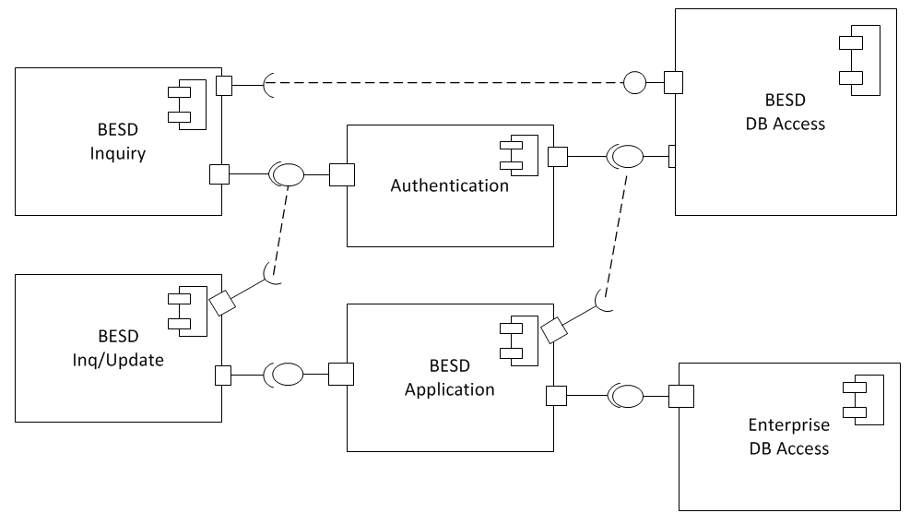

2. Develop a component diagram for the following description of a Facebook application.

The Facebook platform is available for entrepreneurs to develop applications for use among all Facebook users. A new application is being written that allows Facebook users to send gifts and greeting cards to their friends. (These are real gifts and greeting cards, not just electronic images.) The application running within Facebook is on its own server and has its own database of information, which includes a list of gifts and cards that have been sent or received. The actual retail store of gifts and cards to send must be located on a different server because it is part of a regular Internet sales storefront. This storefront maintains the database of inventory items to sell and collects credit card payment information.

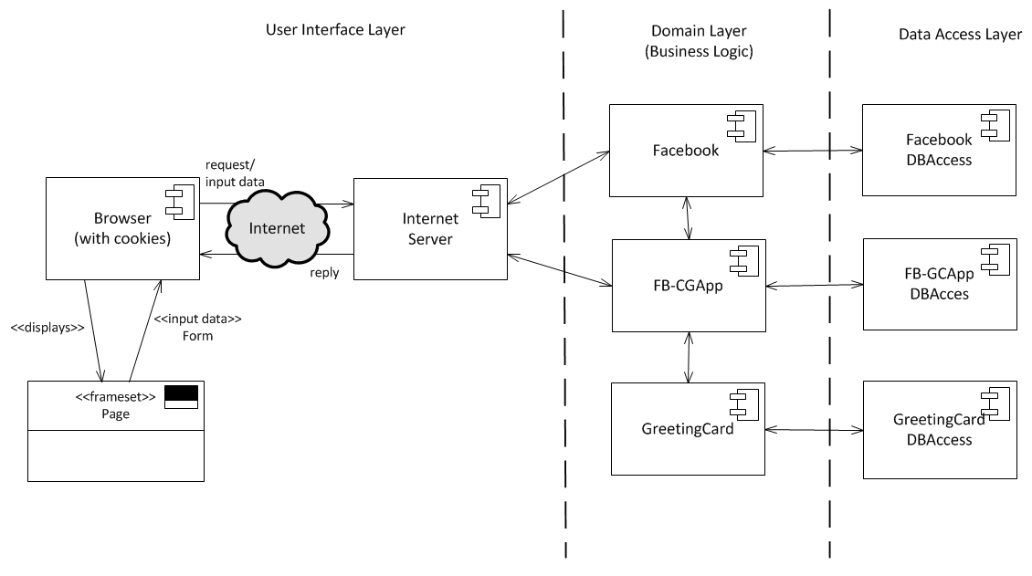

3. In this chapter, we developed a first-cut DCD, a set of CRC cards, and a final DCD for the Create phone sale use case for RMO. Create the same three drawings for the Look up item availability use case.

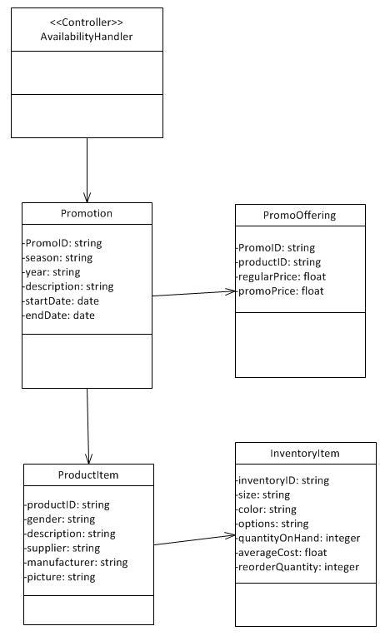

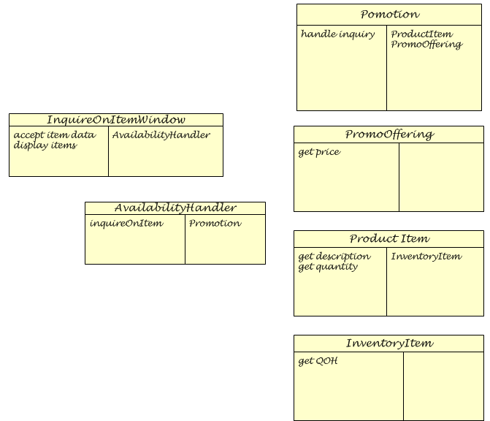

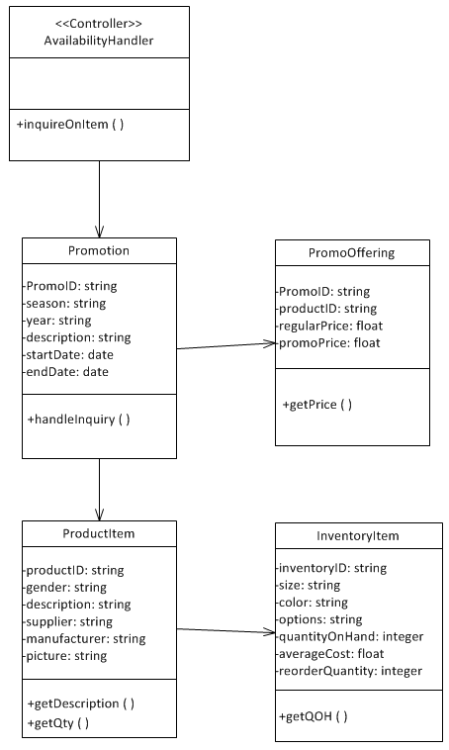
4. Find a company that does object-oriented design by using CRC cards. The information systems unit at your university often uses object-oriented techniques. Sit in on a CRC design brainstorming session. Interview some of the developers about their feelings regarding the effectiveness of doing CRC design. Find out what documentation remains after the sessions and how it is used.

Answers will vary.

5. Find a company that has an enterprise system. (If you are working for a company, see what systems they use.) Analyze the system and then develop a component diagram and a deployment diagram.

Answers will vary.

6. Find a system that was developed by using Java. If possible, find one that has an Internet user interface and a network- based user interface. Is it multi-layered—three layers or two layers? Can you identify the view layer classes, the domain layer classes, and the data access layer classes?

Answers will vary.

7. Find a system that was developed by using Visual Studio .NET (Visual Basic or C#). If possible, find one that has an Internet user interface and a network-based user interface. Is it multi-layered? Where is the business logic? Can you identify the view layer classes, the domain layer classes, and the data access layer classes?

Answers will vary.

8. Pick an OOP language with which you are familiar. Find a programming IDE tool that supports that language. Test its reverse-engineering capabilities to generate UML class diagrams from existing code. Evaluate how well it does and how easy the models are to use. Does it have any capability to input UML diagrams and generate skeletal class definitions? Write a report on how it works and what UML models it can generate.

Answers will vary.

9. Draw a UML design class that shows the following information.
The class name is Boat, and it is a concrete entity class. All three attributes are private strings with initial null values. The attribute boat identifier has the property of “key.” The other attributes are the manufacturer of the boat and the model of the boat. There is also an integer class-level attribute containing the total count of all boat objects that have been instantiated. Boat methods include creating a new instance, updating the manufacturer, updating the model, and getting the boat identifier, manufacturer, and model year. There is a class-level method for getting the count of all boats.

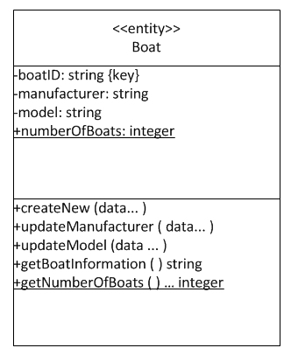

Solutions to End-of-Chapter Cases

Case Study: The State Patrol Ticket-Processing System (Revisited)
In Chapter 3, you identified use cases and considered the domain classes for the State Patrol Ticket Processing System. Review the descriptions in Chapter 3 for the use case Record a traffic ticket. Recall that the domain classes included Driver, Officer, Ticket, and Court.

1. Draw a domain class diagram for the ticket-processing system based on the four classes just listed and include attributes, association, and multiplicity.

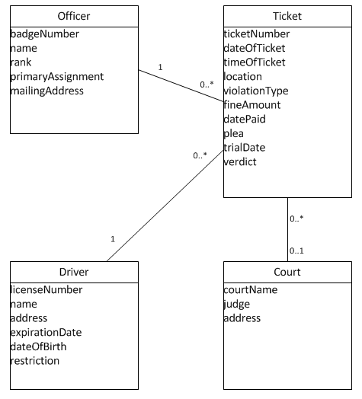

2. List the classes that would be involved in the use cases and decide which class should be responsible for collaborating with the other classes for the use case Record a traffic ticket. Consider some possibilities: 1) a driver object should be responsible for recording his/her ticket; 2) the officer object should be responsible for recording the ticket that he or she writes; and 3) a ticket object should be responsible for recording itself.

To record a traffic ticket, the system will want to verify the officer, verify the driver information, and then record the ticket. The ticket should be responsible for recording itself. The officer and driver are only verification.

3. Create a set of CRC cards showing these classes, responsibilities, and collaborations for the use case.

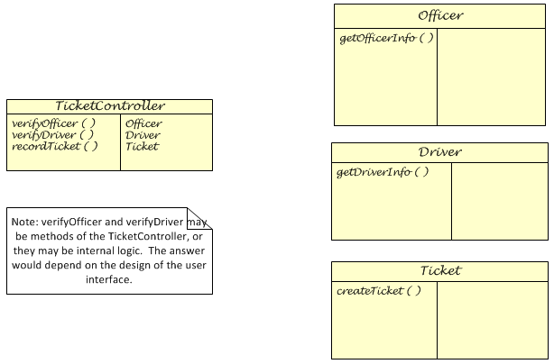

4. Draw a first-cut design class diagram (DCD) based on your CRC cards.

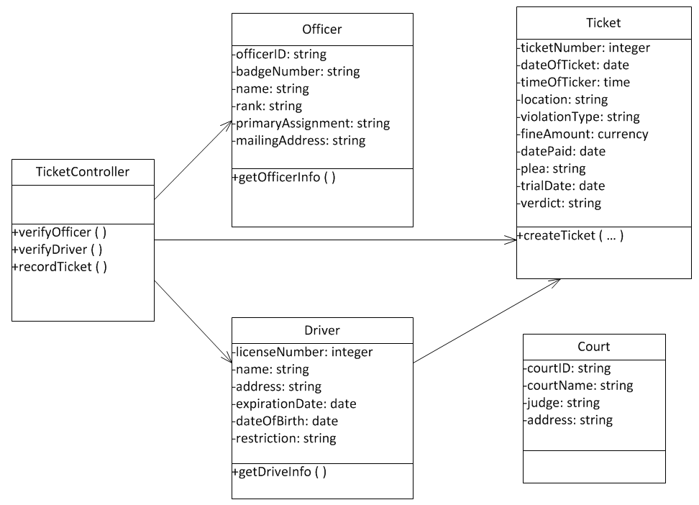

Running Cases: Community Board of Realtors
In Chapter 3 and Chapter 5, you identified and then modeled use cases for the Multiple Listing Service (MLS) application. You also identified and modeled domain classes. Use your solutions from these chapters to do the following:

1. Draw a basic component diagram showing the architectural design for the system, assuming that it is a two-layer Internet architecture.

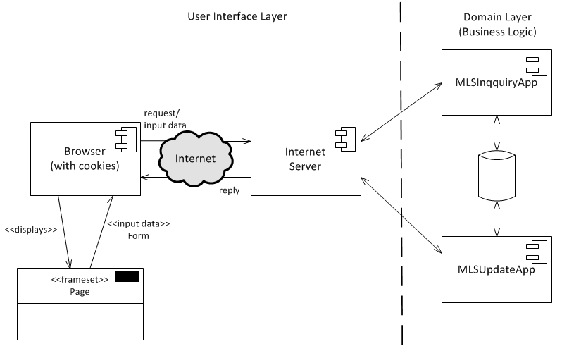

2. Use the CRC cards technique to identify the classes that are involved in the Create new listing use case. Recall that creating a new listing involves an agent, a real estate office, and a listing. Decide which class should have the primary responsibility for collaborating with the other classes and then complete the CRC cards for the use case.

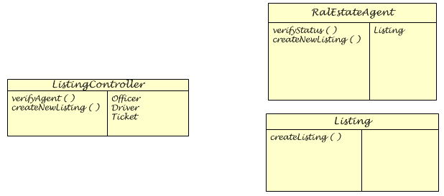

3. Draw a first-cut design class diagram (DCD) based on the CRD cards for this use case.

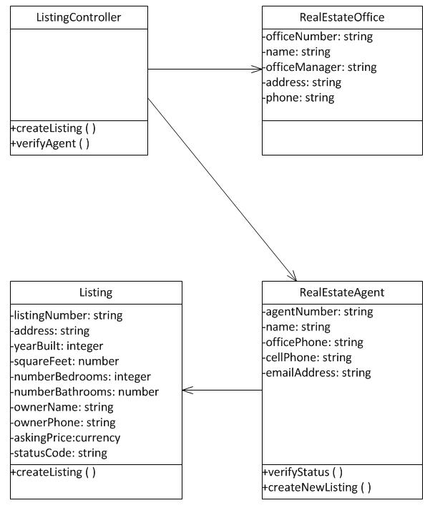

Running Cases: The Spring Breaks 'R' Us Travel Service
In Chapter 3, you identified use cases for the Spring Breaks ‘R’ Us Travel Service. In Chapter 5, you elaborated those use cases. In Chapter 4, you identified the classes associated with these use cases. Using your solutions from these chapters, do the following:

1. Draw a basic component diagram showing the architectural design for the system, assuming it is a two-layer Internet architecture.

Note: Three components (subsystems) are identified for this architectural design. Each basically operates independently. The Reservation component works with student travelers, while the Resort component is for the resorts. They share several tables in the database. The Chat/Message component also shares some of the database, but also has its own chat data.

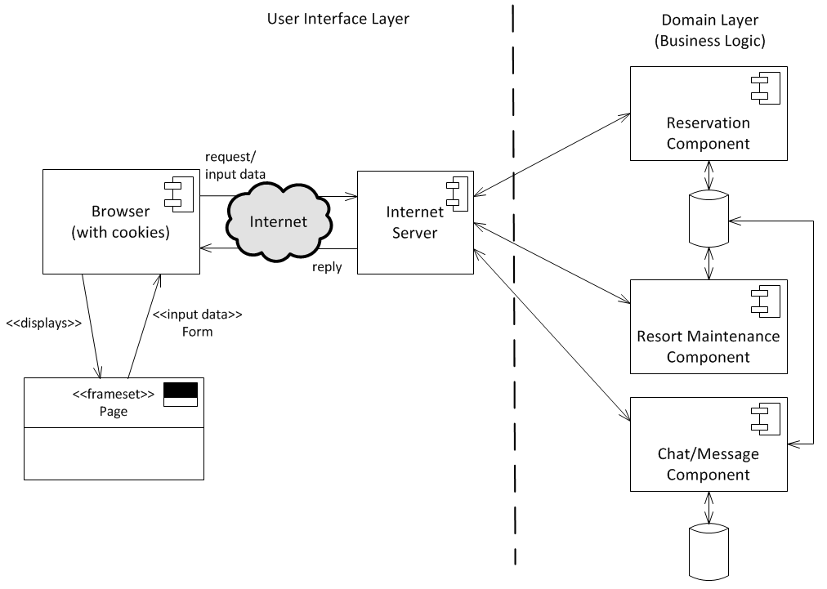

2. Use the CRC cards technique to identify the classes that are involved in the Book a reservation use case. Recall that creating a booking involves at least a student group, a resort, a week, and a room type. Decide which class should have the primary responsibility for collaborating with the other classes and then complete the CRC cards for the use case.

Note: We are using the expanded class diagram developed in Chapter 5. We are also using the SSD developed for in Chapter 5 for Book a Reservation use case. It has five input messages to
- findResorts
- showResortDetails
- checkAvailability
- requestReservation
- payForReservation
As shown in the solution, it has many classes involved in the solution. We used UML notation to show class level methods.
This use case is pushing the limits of CRC cards. It is fairly complex.

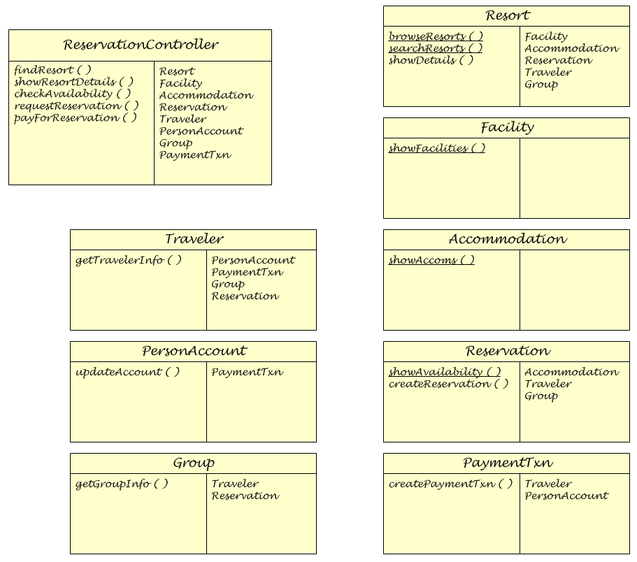

3. Draw a first-cut design class diagram (DCD) based on the CRD cards for this use case.

Note: A first-cut design class diagram is a “best guess” at the navigation visibility required. It often changes as the detail design progresses. Notice in this solution that the Resort and the Traveler take responsibility for many of the actions.

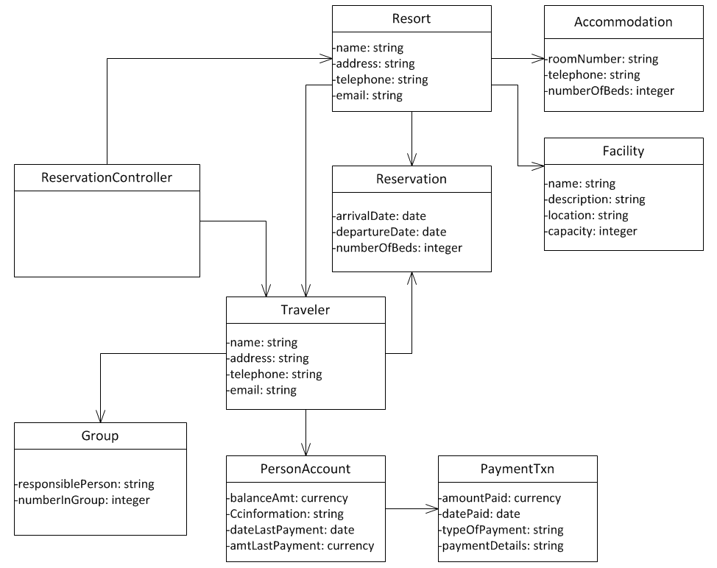

Running Cases: On the Spot Courier Services
In Chapter 6, you considered the issues relevant to the specification of the hardware equipment and networking requirements. The case description in Chapter 6 also reviewed the three primary types of users for the system and many of their respective system-supported activities.

Consistent with the network that you recommended in Chapter 6, develop a component diagram. Show which parts of the system may use general Internet access and which parts may use VPN capabilities.

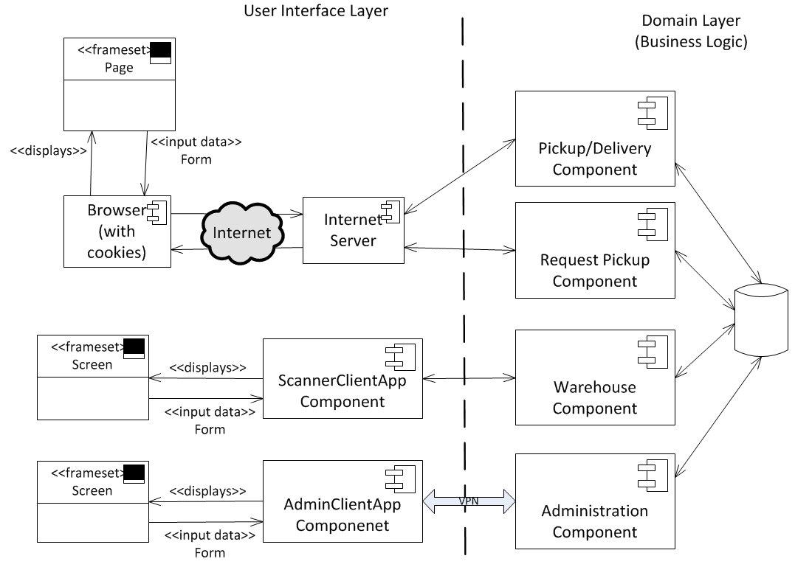
In Chapter 5, you developed activity diagrams and system sequence diagrams for two use cases: Request a package pickup and Pickup a package. In Chapter 4, you developed a domain model class diagram for the system.
For each of the two use cases, develop a first-cut design class diagram and a set of CRC cards. The design class diagram should elaborate the attributes and show navigation visibility. You may also need to add more classes from your solution in Chapter 4. It isn’t uncommon for developers to enhance early models as they begin to understand system requirements better. The CRC cards should include classes for the Controller class and any classes for screens you identified in Chapter 7.

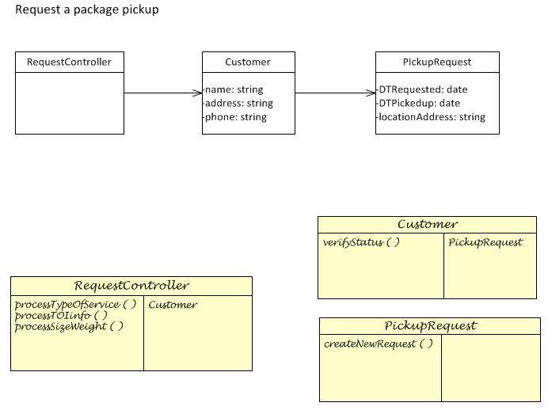
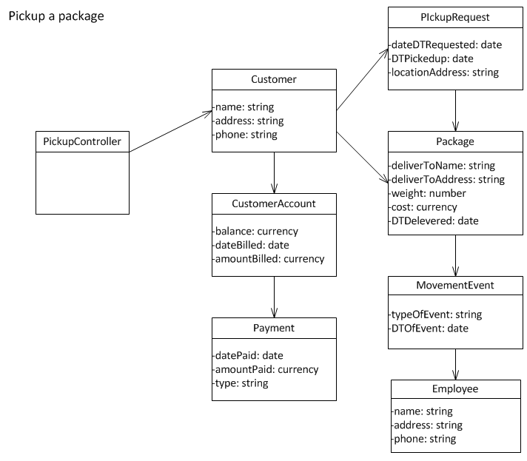
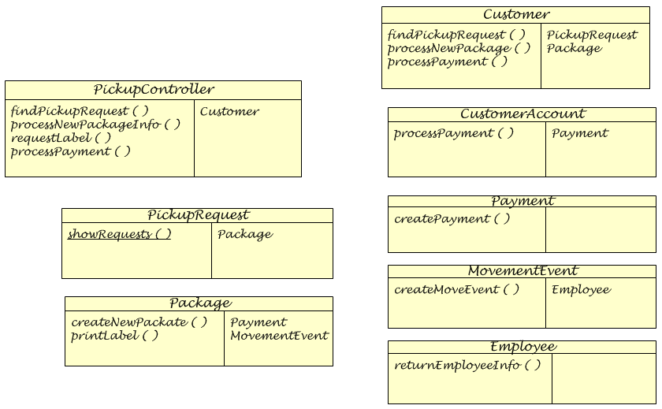

Running Cases: Sandia Medical Devices

Review the original system description in Chapter 2, additional project information in Chapters 3, 4, 6, 8, and 9, and the use case diagram shown in Figure 10-20 to refamiliarize yourself with the proposed system. Complete these tasks:

1. Develop a deployment diagram that shows the equipment specified in Chapter 6 and the list of software components you developed while answering question 1 in Chapter 9.

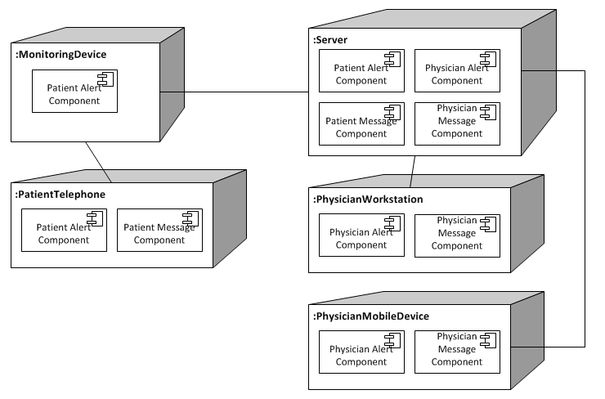

2. For the moment, assume that the database will store two glucose levels for each patient—normal minimum and normal maximum—and that an alert will be generated if three or more consecutive glucose readings are above or below those levels. Expand the domain class diagram in Chapter 4 to include this information and then develop a firstcut design class diagram to support the patient use case View/respond to alert.

