Study Unit 8
Discuss the ethical issues that may arise within the traditional HR activities of employee promotion (4) May 2013, Oct 2013, May 2014, May 2016

The key ethical issues in managing the promotion of employees, is fairness. The difficulty is in determining the criteria that should be serve as the basis for fair promotion procedures. While there is debate over how much weight should be given to the criteria of seniority and job qualifications, it is widely recognized that promotion should normally be on the basis of job-related criteria, especially performance, and that employees should not be discriminated against on the basis of inappropriate criteria such as gender, race and religion. Employees may not have a right to promotion, but they do have a right to fair evaluations and consideration for promotion. They also have a right to be informed of the reasons for lack of promotion in those situations where it might reasonably be expected. Promotion is one more example where HR practitioners are challenged to “merge dual responsibilities in a way that is beneficial to the firm and fair to all concerned.

Discuss the ethical issues that may arise within the traditional HR activities of employee selection (10)
May 2013, Oct 2013, Oct 2014, May 2017

Selection: Effective and fair selection practices for the strategic deployment of highly motivated and competent employees are an important vehicle for enterprises to gain competitive advantage. In making selection decisions, HR practitioners must ensure that all job applicants are treated fairly. Selection practices typically include screening, the employment interview and psychometric testing, all in which can be viewed as strategic tools supporting business strategy.

Screening: begins with a job description and a job specification. A job description provides detail about a job’s duties, responsibilities, working conditions and physical requirements, while job specification describes the qualification, educational experience and physical attributes needed to successful undertake the job. A successful screening process is one that ensures there is a pool of suitable candidates who have all been treated fairly with regard to their right to equal employment opportunity. The screening out of suitable or less suitable candidates must be done on the basis of job-relevant criteria of it be considered fair.

The employment interview: remains the most widely used selection tool and is often the first point of formal contact between a potential employee and an enterprise. Interviews can vary in structure from unstructured to semi-structured to structured. Structured interviews standardize questions and processes across interviews with different candidates. Structured interviews are considered to be fair since each candidate has the same opportunity and interviewer bias is minimized.

A critical component of ethical employment interviewing is the standardization and objectification of the interview. Although they will not guarantee the elimination of discrimination and harmful practices, they are essential steps for HR practitioners who seek to interview ethically.

Psychometric testing: Is another screening and selection tool often used by large enterprises. The most common types measure ability and personality, but may also include drug testing, health screening and more recently genetic testing. The ethical implications of genetic testing are huge, mostly because there is a danger that “the risk of disease will be treated as a disease”.
When conducting psychometric testing, Hr professionals must safeguard the interest of enterprises and candidates by upholding the right of those tested

Considerations of justice and rights play an important role in ensuring that all candidates are treated fairly and are assured equal employment opportunity. In addition to the issue of discrimination, if jobs are to be truly fair, the selection process must also recognize that it provides an opportunity for a potential employee to select the organization.

Identify and discuss the ethical dilemma(s) in this scenario. (6) May 2014, May 2015

This is an example of how to answer the question – replace the quotes from the case study with the relevant case study
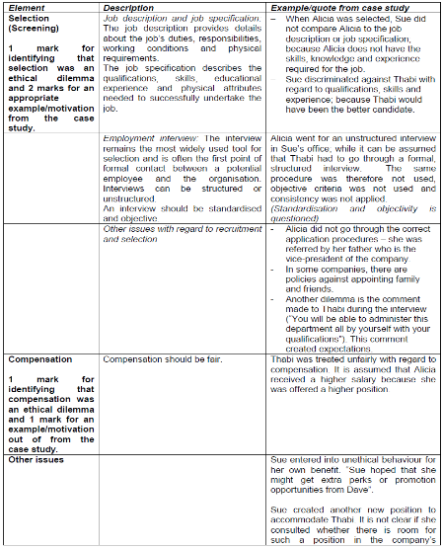
Provide solutions to or recommendations for the dilemmas identified (6) May 2014, May 2015

This is an example of how to answer the question – replace the quotes from the case study with the relevant case study
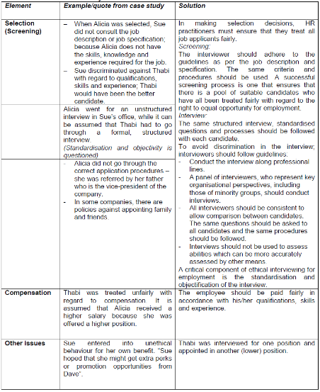
Apply the Utilitarianism, Kantian duty, justice and moral rights perspectives to case study. (8) May 2014
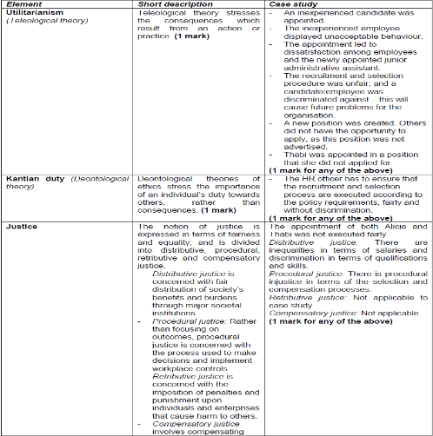
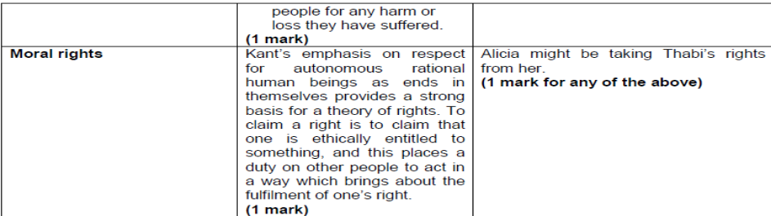
Discuss how ethical theories can help inform good practice of HRM activities (3)
Integration of ethics into strategic HRM decision-making requires HR executives to be fully capable of identifying the social and ethical issues attached to alternative business strategies and to be fully capable of resolving them in HR practices.
Josephson identified three qualities that are essential to ethical decision-making, namely:
- Ethical consciousness,
- Competency, and
- Commitment.
The theories will therefore assist HR practitioners to explore and resolve ethical dilemmas or issues – this is also known as ethical reasoning.

Discuss the issues that should be addressed in formulating a company’s policy on employee privacy (6) May 2015

Employees have a right to privacy and HR should take the following actions to ensure that this privacy is respected in the workplace:

- Ensure that there are procedures in place to protect the employee’s data
- Ensure that due process is followed in video surveillance practices
- Ensure that due process is followed in testing, drug testing and genetic screening practices
- Encourage work-life balance
- Email access notifications (based on concepts of respect, fairness, autonomy)

An individual’s right to privacy should always be respected. Included in the notion of privacy and psychological privacy (relating to your inner life), physical privacy (relating to your space and time) and autonomy to determine when, how and what information is communicated about yourself to others. When conducting psychometric testing, HR professionals must safeguard the interests of enterprises and candidates by upholding the rights of those tested to.

- Informed consent
- Not be harmed or unfairly disadvantaged by the process of assessment (or testing)
- Full information about the purpose and results of the assessment
- Suitable preparation for the process of assessment
- Not be subjected to assessment processes which have systematic bias, high error rates, unwarranted discrimination or which are not relevant to the job
- Confidentiality
- Secure storage of test data and results
- Destruction of results when no longer needed
- Counselling, especially in the case of drug, health and genetic testing

Identify the important concepts involved in a definition of business ethics. How are these concepts relevant in the context of South Africa? (9) Oct 2015

Business ethics (or management ethics) focuses on moral standards as they apply to organisations and the behavior of organisational members. Most decisions in business, particularly those relating to human resources, have an ethical component.
Business ethics thus require an integrated approach to decision-making. An integrated approach recognises that managers must take the moral point of view as well as make economically sound decisions and act within applicable law. The moral point of view requires that we act impartially and in accordance with reason, rather than on the sole basis of self-interest or tradition. If ethics are about relationships between people then business ethics are about relationships between stakeholders and the recognition that their divergent interests must be accommodated. Decisions must also be understood as involving different levels of analysis, including on the individual, the organisational, the professional, the business-system and societal levels. Employment equity is a case in point.
In South Africa, business ethics have two important anchors in both the public and private sector.
- The first anchor is the Constitution’s founding values of human dignity, the achievement of equality and the advancement of human rights and freedom.
- The second anchor is the King reports on corporate governance which have been instrumental in moving ethics onto the agenda of corporate boards in South African-based enterprises.

It is important to note that the King reports recognised that many enterprises need to put in place training programmes to develop ethical competency and to develop organisational processes that embed ethics into organisational cultures and operations.
The HR activities of recruitment, selection, training and development, compensation and performance management are not only a means to gaining competitive advantage, they are important vehicles for promulgating an ethical culture.

