Study Unit 6
Discuss how the psychological contract between employees and employers has been affected by the new era of HRM (5) May 2013, May 2014, Oct 2014

The employment relationship has changed. Employees will look for employability not employment and will want to change jobs often. Psychological contracts and engagement profiles will be substantially different for older workers.
These trends indicate that organisations that are prepared to focus on attracting and developing talent will be in a stronger position to retain key human resources as the so-called ‘‘war for talent’’ intensifies. It is also clear that the way organisations seek to retain these highly skilled resources will have to change. This places human resources at the centre of policy and systems development to achieve outcomes that promote the organisation as an ‘‘employer of choice’’ for potential employees. The structural changes driving the ‘‘war for talent’’ are widespread across many advanced market economies. This creates a ‘new’’ business reality in which management skills and ability to embrace a new mindset are critical.

Define the concept of talent (3) Oct 2013, Oct 2014, May 2015, Oct 2015

Talent is the sum of the person’s abilities – his or her intrinsic gifts, skills, knowledge, experience, intelligence, judgment, attitude, character and drive. It also includes the ability to learn and grow.

How does talent mindset differ from the old view of management (8) Oct 2013, Oct 2016, May 2017 p2

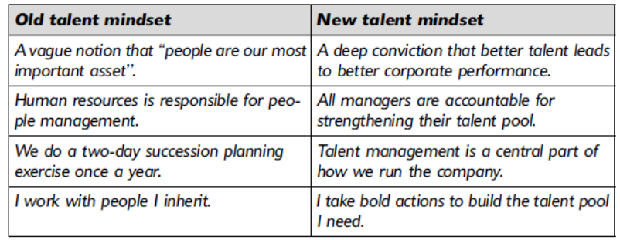

Discus strategies for dealing with the potential “war for talent” from a human capital perspective and resource-based perspective (6) May 2014, Oct 2014, May 2015, Oct 2016

The attraction and retention of employees has become an increasingly significant aspect of contemporary HRM. A review of the literature reveals two theoretical perspectives which provide a framework to analyze the strategic approach linked to the long-term development of the organization’s human resources.
The first is human capital theory which links investment in the organization’s key asset, its employees, to increased productivity and sustained competitive advantage. The strategic aspect is the long-term enhancement of the firm’s resource base by linking employee skills development with retention through training and development, career management and progression. This is also consistent with the second theoretical perspective
The second is Resource-Based View of the firm and the focus is on an organisation retaining and developing these human resources through investments such as human resource development strategies. This will ensure that these assets become valuable, rare, difficult to imitate, enhancing further the organisation’s competitive advantage. Many scholars have adopted theses theoretical approaches in interpreting the essential elements in building a competitive organisational advantage.
The strategic focus on the management and development of HRD can be linked to the deliberate promotion of HRD strategies as a catalyst for the attraction and retention of talented employees. This had led to an increased focus on HRM as a platform for building a competitive advantage. A critical element is the strategic development of diverse strategies for staff enhancement and development as important attraction and retention tools. Organisations taking the strategic course will seek a long-term and diverse approach to managing and investing in their human resource to ensure that appropriate training and development is available to all employees.

The management of learning and knowledge in organisations is a complex task in the creation of a competitive advantage; a theme which is increasingly reflected in the literature. In a dynamic environment, this means that the organisations must commit resources to developing a diverse and adaptive approach to ensure that each area in the organisation has access to appropriate levels of training and development to meet diverse organisational objectives.

Micheals, Handfield-Jones and Axelrod identify four key areas for organisations to act upon if they are going to make talent a source of competitive advantage. Briefly discuss these four areas and provide examples from the case study as to how Apple uses talent management as a source of competitive advantage (15) May 2015

Embrace a talent mindset
- Having better talent at all levels is how you out-perform your competition
- Better talent is a critical source of competitive advantage
- Better talent pulls all the other performance levers
- Talent management is becoming an important role for CEO

Craft a winning Employee Value Proposition
- EVP is everything employee experiences within organisation including intrinsic/extrinsic satisfaction, values, ethics, culture
- How well organisation fulfils employee’s needs, expectations, aspirations
- Intrinsic satisfaction is rated higher than extrinsic satisfaction

Rebuild your recruitment strategy
- Understand the new workforce
- Values and ethics act as important sources of attraction
- Understanding how potential employees view or obtain information about organisation can enhance the match between person and organisation, increasing fit and retention

Weave development into your organisation
- Employees and work that provide opportunities and is challenging
- Organisations must develop talent at all levels and weave it into the culture
- Training and development considered critical issues in retention

Differentiate and affirm your people
- Recognize individual achievement
- Be aware of employee’s diverse lifestyles and needs
- Building diversity is an opportunity to attract wider range of talent

Identify the four talent management challenges in the case study and apply your HR knowledge in discussing solutions for each of the mentioned challenges (18) May 2016

The organization does not have accountability when it comes to talent management in the form off:

They are unable to craft a winning Employee Value Proposition
To address this problem, an organization should craft a winning employee value proposition

Craft a winning Employee Value Proposition
- EVP is everything employee experiences within organisation including intrinsic/extrinsic satisfaction, values, ethics, culture
- How well organisation fulfils employee’s needs, expectations, aspirations
- Intrinsic satisfaction is rated higher than extrinsic satisfaction

They do not have a recruitment strategy.
To address this challenge, the organization needs to rebuild its recruitment strategy

Rebuild your recruitment strategy
- Understand the new workforce
- Values and ethics act as important sources of attraction
- Understanding how potential employees view or obtain information about organisation can enhance the match between person and organisation, increasing fit and retention

The development of employees has not been prioritised.
To address this challenge the organization needs to weave development in.

Weave development into your organisation
- Employees and work that provide opportunities and is challenging
- Organisations must develop talent at all levels and weave it into the culture
- Training and development considered critical issues in retention

People are not differentiated and affirmed
To address this challenge, organization needs to invest heavily in their star performers, develop solid employees to contribute their best to retain them and help poor performers to improve their performance

Differentiate and affirm your people
- Recognize individual achievement
- Be aware of employee’s diverse lifestyles and needs
- Building diversity is an opportunity to attract wider range of talent

Pricewine seems to be losing talent in the form of experienced employees, Advise the management of Pricewine on how to leverage the existing talent (4) May 2016

- Leveraging talent is a priority, developing sound EVP, ensuring that the sourcing strategy is a powerful one
- There are a number of steps regarding development that companies should implement to complete their talent programme
- There is little clarity on who should be developed and how
- Senior people often believe that moving people around is not worth the disruption
- Divisions hoard their best staff
- HR executives are often preoccupied with training and other initiatives
- People learn by being put in situations that require skills they don’t have and this dominates staffing decisions.
- Rebuilding talents banks is costly and time consuming
- Most organisations need to leverage the talent they already have

