Study Unit 5
Explain the major difference between numerical flexibility and functional flexibility (6) May 2013, Oct 2014, May 2015.

Numerical Flexibility:
- Is a quantitative approach to the utilization of the workforce.
- Based on the principle of relating the size of the workforce to the levels of economic activity easily and at short notice.
- As the workload fluctuates, management has the option to adjust or redeploy its human resources accordingly.
- The use of seasonal, casual, part-time and subcontracted workers typically provides this form of flexibility.
- The pressures of unpredictable short term fluctuations in demand, combined with increased competitiveness, make these work patterns efficient and effective to sustain, as organisations are relieved of the cost of a fixed labour force
- While these patterns of work organisation have been traditional aspects of some segments of the labour market (e.g. the service and retail sectors), the use of these work practices to externalize traditional core organisational activities is the major factor in increasing enterprise efficiency through numerical flexibility.

Functional flexibility
- Functional flexibility refers to management's ability to deploy and redeploy particular sections of the workforce on a wide range of tasks, in response to market demand, as and when required.
- To ensure that this can be achieved efficiently, employees are trained in a wide range of skills.
- The volatility of product markets and the blurring of skill boundaries through technological change provide the environment for the development of this form of flexibility.
- Central to the development of functional flexibility is the reversal of the Taylorist practices of fragmentation and de-skilling.
- Working practices which incorporate elements of functional flexibility include team working, empowerment, multi-skilling, re-skilling, and project-working.

Explain the major differences between financial flexibility and procedural flexibility (4) May 2013, Oct 2015, Oct 2016, May 2017

Financial flexibility
- Is the compensation system designed to facilitate the development of flexible patterns of work, in particular numerical and functional flexibility
- It is sought after for two reasons.
- So that pay and other employment cost reflect the state of supply and demand in the external labour market.
- Pay flexible means a shift to new pay and remuneration systems that facilitate numerical or functionality flexibility, such as assessment-based pay systems in place of rate-for-the-job systems.
- Financial flexibility provides the duality of
- Allowing market forces to dictate relative wage rates, providing cost-efficient numerical flexibility to the organization
- Providing the incentive to increase its skills base by relating pay to skill levels (e.g. gainsharing, profit sharing and variable executive pay schemes).

Procedural flexibility
- Is the central principle in the development of flexible patterns or work.
- It is concerned with the establishment of consultative mechanism for introducing changes or negotiating variations in work practices, primarily through changes in both legal and traditional practices covering employment
- In most industrialized countries the “flexible debate”, concerned with changing rigidities in labour and employment patterns has been an important element in industrial policy-making and industrial relations
- At the level of the organisation the process can range from directive through to a particular framework of negotiation
- The substantive aspects of the traditional Taylorist relationship between employer and employee and the employee’s representative (trade unions) are fundamental recast for flexible patterns of work to be fully utilized.
- Central to procedural flexibility is the acceptance of and a role in managing the new relationship for the employees and their representatives
- Such procedures are indicative of commitment to join administrative of labour flexibility in the workplace
- Procedural flexibility facilities the combination of work patterns and practices that increase the utilization of the enterprise’s human resources.

Briefly discuss why it is important to develop and manage flexible patterns of work (7) May 2013

Flexible work patterns are key in generating sustainable competitive advantage. Organisations need to attract, retain and develop key employees for the core activities and develop a stable supply of workers for the periphery. Consequently, flexible has become a key platform of the new organisational environment. A key aspect of the new “core” workers in the emerging “knowledge” economy is that they increasingly own the means of production – knowledge – which attracts large rewards. The changing labour market has also changed the nature of the psychological contract which has significantly transformed the employer-employee relationship.

The management of gold-collar workers assumes greater significance. The term “gold-collar worker” implies that these workers need to be managed carefully and provided with excellent working conditions. It is in this group that is at the core of a firm’s unique strategic advantage. It is not possible to develop a competitive advantage without the consideration of the people that form the core of a firm’s knowledge base. The management of these human resources throws out particular challenges to organisations that base their advantage on these “free thinking” workers and “managed” resources. Organisations need to focus their employment systems, practices and organisational structure to ensure they capture these unique resources.

The key to developing strategies that attract, develop and retain these employees is to understand what motivates them. These workers think differently, behave differently and have needs differently to the traditional employee. These workers are self-focused and less interested in the traditional benefits of employment such as job security and working conditions. The fundamental issue for organisations to is “employability”. There is an expectation therefore that an organisation will play a part in not only securing employment, but in upgrading employees knowledge, skills and ability so that they remain in demand in the wider employment market. While the concept of job-hopping may become a norm, this approach of characteristic of employment paradoxically may be a factor in, at least, reducing turnover. It can even make the organisation and “employer of choice” for these increasingly discerning workers to move back to.

These fundamental changes to the nature of the employment relationship will further accelerate the move away from the traditional employment relationship as exemplified in the traditional psychological contract based on loyalty and stability of employment. Organisations will have to adapt to this new paradigm in a variety of ways. In particular, terms and conditions of employment and the way work is organized will need to be conductive of these workers.

Briefly define the concept of flexibility (5) Oct 2013

The term “flexibility” is difficult to define as it has been applied to a wide range of issues and levels on analysis. At a national level the debate is focused on rigidities in the regulation of the labour markets. At an organisational level flexibility is concerned with the integrative use of employment practices and organisational structures to create a capacity to adopt and manage innovation. Flexibility can be broadly defined as the ability of the organisation to adapt the size, composition, responsiveness and cost of the people inputs require to achieve organisational objectives”. There are a number of forms of flexibility and these forms of flexibility are not mutually exclusive. There are many forms of overlapping flexibility which managers need to distinguish to be able to seize opportunities for increasing organisational flexibility, but they should also be aware of the problems inherent in categorization.
There are numerous types of flexibility, namely functional, numerical, work-time, job-sharing, distancing, financial, procedural, regulatory, location, cognitive and organisation flexibility

Briefly discuss ten organisational and management practices organisations can use to determine whether they are ready for flex work (flexible work arrangements) (10) Oct 2013, May 2016

Policy: Are specific policy and strategic statements approved and communicated by top management that endorse flex work as a component of the employment relationship
Employee commitment: How deeply are employees committed to the success of the organisations mission and to high achievement in their own jobs?
Management commitment: Do the actions of management as well as the communication to employees reinforce management support for flex work?
Workforce planning: How good is the organisation as forecasting projects, deadlines, production quotas, and workloads? How good it is at scheduling workforce needs, and at allocating resources?
Technology: Are information-technology and communication systems in place to support flex work in smooth, efficient, consistent ways?
Training and orientation: How effective are training content and delivery mechanisms for meeting the ongoing needs of flex workers?
Teamwork: To what extent is work done in teams, and is there sufficient coordinating to ensure coverage and to compensate for having team members on different schedules?
Performance management: Are there methods for performance measurement, employee appraisal, and stuff development that are equivalent, if not identical, for flex workers and others?
Decision making: Who holds decisions in the course of everyday work?
Communication and information dissemination: How effective are the means, media, and frequency of communication of everyday business information and re those processes robust enough to keep flex workers in the loop?

What are the key advantages and disadvantages of flexible patterns of work from the employers perspective (6) May 2014, Oct 2014

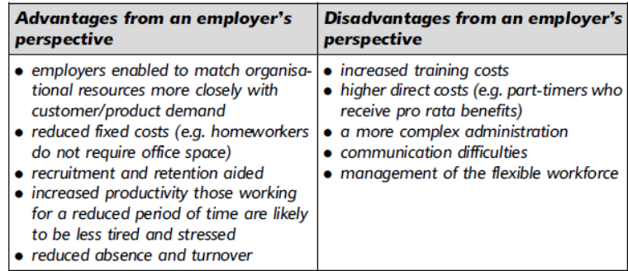

What are the key advantages and disadvantages of flexible patterns of work from the employee’s perspective?
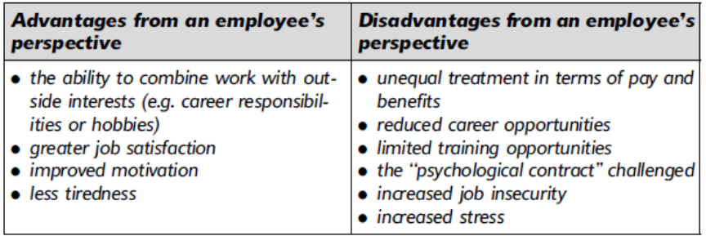

With reference to the cases study what would you say is the reason for Best-Bucks implementation of flex? (3) May 2016
- To match organisational resources more closely with customer/product demand reduced fixed costs (e.g. home workers do not require office space)
- To improve recruitment and retention strategies
- To increased productivity. Those working for a reduced period of time are likely to be less tired and stressed
- To reduced absence and turnover rate.

