MAY/JUNE 2013
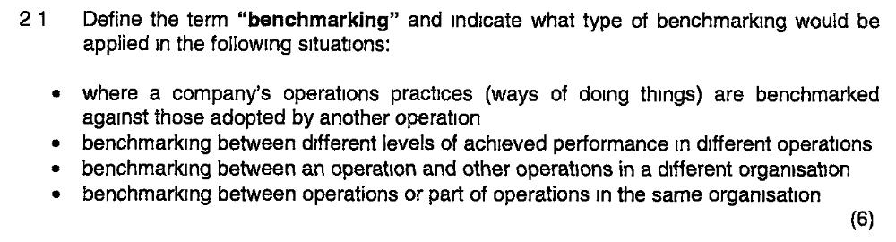
Benchmarking is the process of learning from others and involves comparing one’s own performance or methods against other comparable organisations. It’s a broader issue than setting performance targets and includes investigating other organisations’ operations practise to derive ideas that could contribute to performance improvement. Its rationale is based on the idea that (a) problems in managing processes are almost certainly shared by processes elsewhere and (b) there is probably another operation somewhere that has developed a better way of doing things.
- Practise benchmarking is a comparison between an organisation’s operations practises and those adopted by another organisation.
- Performance benchmarking is a comparison between the levels of achieved performance in different operations.
- External benchmarking is a comparison between an operation and other operations in a different organisation
- Internal benchmarking is a comparison between operations or parts of operations which are within the same organisation.

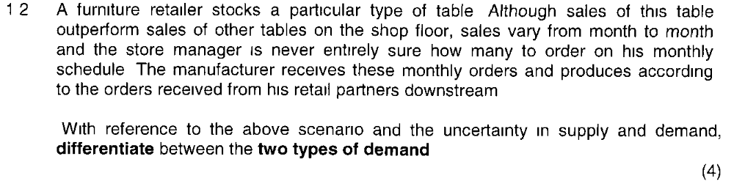
Dependent demand
This is demand that is relatively predictable because it is dependent upon some factor which is known. Demand forecasting is relatively straightforward. Materials requirements planning is one such dependent demand approach.
Example, the manager who is in charge of ensuring that there are sufficient tyres in an automobile factory will not treat the demand for tyres as a random variable derived from some other known factor.
Independent demand
This is demand that is not obvious or directly dependent on the demand for another product or service Supply demand without having a firm forward visibility of customer orders.
Example supermarket – will plan based on experience and understanding of the market.
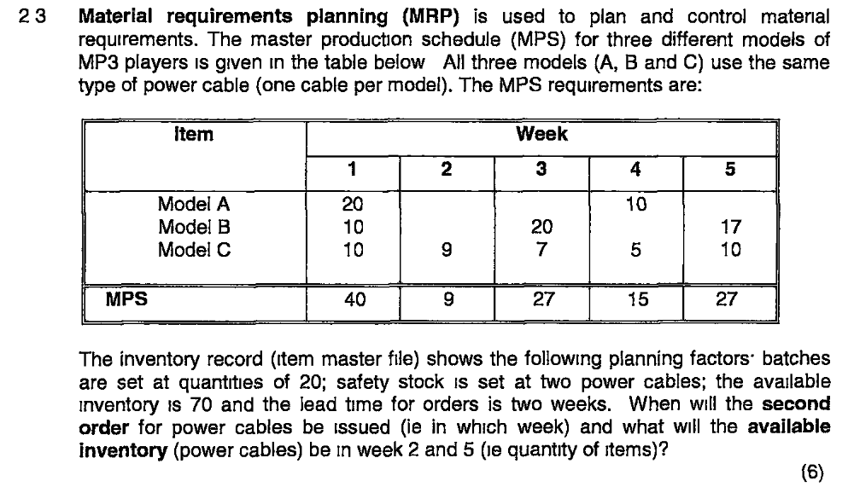
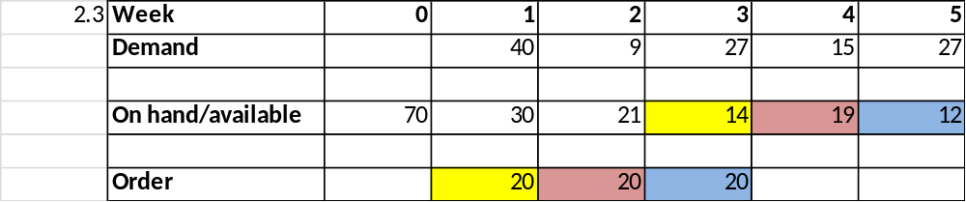

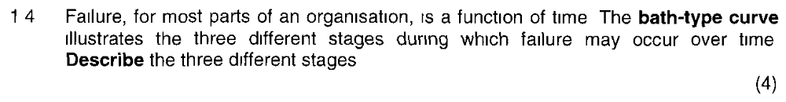
The three distinct stages are:
Failure over time - The curve which describes failure probability of this type is called the bath-tub curve
- The ‘infant-mortality’ or ‘early-life’ stage where early failures occur caused by defective parts or improper use;
- The ‘normal-life’ stage when the failure rate is usually low and reasonably constant, and caused by normal random factors;
- The ‘wear-out’ stage when the failure rate increases as the part approaches the end of its working life and failure is caused by the ageing and deterioration of parts.
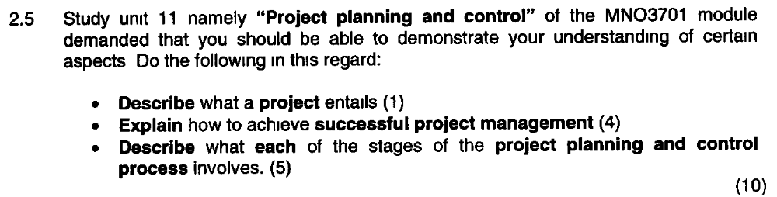

(1) A project is a set of activities with a defined start point and a defined end state which pursues a defined goal and uses a defined set of resources. [page 463]
(2) The following factors are important to ensure successful project management [page 466]
- Clearly defined goals: including the general project philosophy/ mission
- Competent project manager: a skilled project leader who has the necessary interpersonal, technical and administrative skills
- Top management support: and that their commitment has been communicated to all concerned parties
- Control mechanisms: there must be mechanisms in place to monitor actual events and identify deviations from plan
- Sufficient resource allocation: resources needed for project execution available in the correct quantities

(3) The five stages of the project planning and control process are outlined below:
Stage 1: Understanding the project environment:
The project environment comprises all the factors which may affect the project during its life and is the context and circumstances in which the project takes place. Understanding the project environment is key because it affects the way a project needs to be managed and the possible dangers which may cause the project to fail. Environmental factors to consider include geo social environment, econo-political environment, business environment and internal environment
Stage 2: Project definition:
It’s key to define exactly what the project is considering the following three elements: (1) the project’s objectives ie. End goal (2) the project’s scope ie. The exact range of responsibilities taken on by project management (3) the project’s strategy ie. How project management is going to meet its objectives.
Stage 3: Project Planning:
Planning, deciding how the project will be executed, is not a one-off process and may be repeated several times during the project’s life cycle. The planning process has four distinct purposes:
- Determine cost and duration of the project
- Determines the level of resources needed
- Helps to allocate work and monitor progress
- Helps assess the impact of any changes to the project
Stage 4: Technical execution
This stage involves performing the technical aspects of the project
Stage 5: Project Control:
This stage involves ensuring that the project is carried out according to plan. It involves 3 sets of decisions (1) how to monitor the project to check on progress (2) how to assess the performance of the project (3) how to intervene in the project in order to make changes that will bring it back to

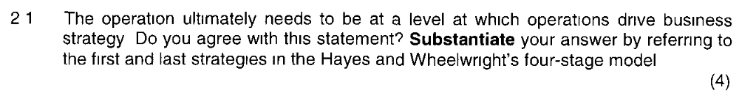

Yes, I agree with this statement as it is in line with stage 4 of the Hayes and Wheelwright’s four-stage model.
Stage 1: Internal neutrality
This is the poorest level of contribution by the operations function. It is holding the company back from competing effectively. It is, inward-looking, reactive with very little positive contribution towards competitive success. Its foal is ‘to be ignored’ (or ‘internally neutral’). The organisation won’t look to operations as the source of any originality, flair or competitive drive. It attempt to improve by ‘avoiding making mistakes’.
Stage 4: Externally supportive
The difference between stage 3 and 4 is subtle but important. A stage 4 company sees the operations function as providing the foundation for its competitive success. Operations look to the long term. It forecasts likely changes in markets and supply and develops the operations-based capabilities required to compete in future market conditions. They are innovative, creative and proactive and driving the company’s strategy by being ‘one step ahead’ of competitors (‘externally supportive’).

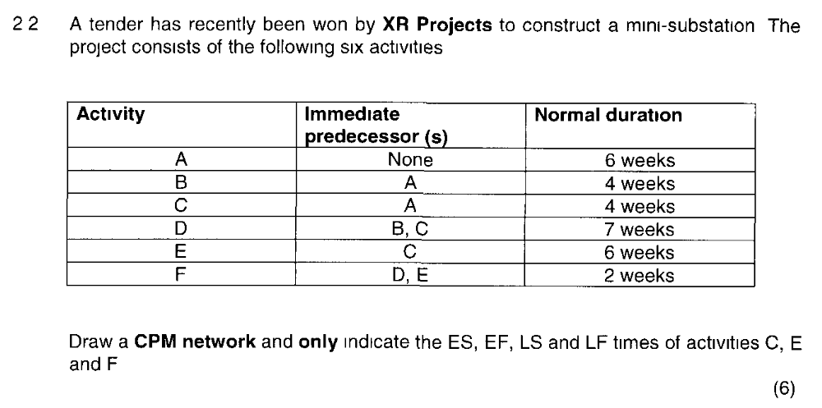
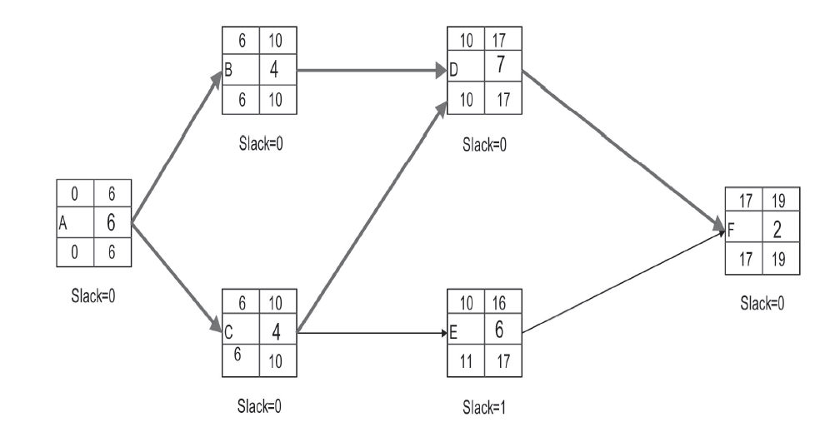

 | C | E | F
EF = earliest start | 3 | 4 | 13
EF = earliest finish | 9 | 10 | 19
LS = latest start | 9 | 7 | 15
LF = latest finish | 15 | 13 | 21

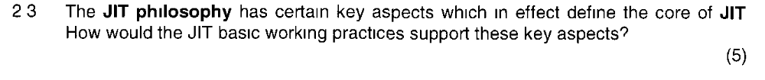
The key aspects of JIT is:
To eliminate waste
Involvement of all in operations
The drive towards continuous improvement
These key aspects will be supported by the adoption of JIT basic work practices through:
Discipline - all people following standard work instructions
Flexibility - allowing staff to have more responsibility based on their capabilities
Development of personnel
Creativity - indispensable element to keep motivation
Total people involvement - staff taking on more responsibilities based on their capabilities for the benefit of the whole company.

Corporate social responsibility filters into operations management as the way in which an operation is managed has a significant impact on its customers, the individuals who work for it, the individuals who work for its suppliers and the local community in which the operation is located. Corporate social responsibility can be seen as the broad application of ethics in decision makings and issues such as customer’s welfare and safety, job design and capacity planning must be done with this in mind. Now a day companies are also required to make corporate social investments and report on these commitments which is referred to as the triple bottom line.

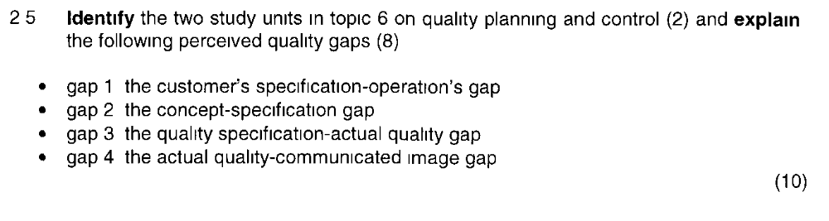
Gap 1: The customer’s specification-operation’s specification gap
Perceived quality is poor due to mismatch between the organisation’s own internal quality specification and the specification which is expected by the customer.
Example: car is designed to need service every 10,000 km but customer expect 15,000 km service intervals.
Gap 2: The concept-specification gap
Perceived quality could be poor because of mismatch between the product/service concept and the way the organisation has specified the quality of the product or service internally.
Example: concept of a car might have been for an inexpensive, energy efficient means of transportation but the inclusion of a catalytic converter may have both added to its cost and made it less energy efficient.
Gap 3: The quality specification-actual quality gap
Perceived quality could be poor because of mismatch between the actual quality of the service/product provided by the operation and its internal quality specification. This may be the result of an inappropriate or unachievable specification or poorly trained or inexperienced personnel or because effective control systems are not in place.
Example: internal quality specification for a car may be that the gap between its doors and body when closed do not exceed 7 mm but due to inadequate equipment the gap in reality is 9 mm.
Gap 4: The actual quality-communicated image gap
Perceived quality could be poor because there is a gap between the organisation’s external communications and the actual quality of the service/product delivered to the customer. This may be the result of either the marketing function setting unachievable expectations in the mind of customers or operations not providing the level of quality expected by the customer.
Example: advertising campaign for an airline show cabin attendant offering to replace a customer’s shirt on which food or drink has been spilt, whereas such a service may not in fact be available should this happen

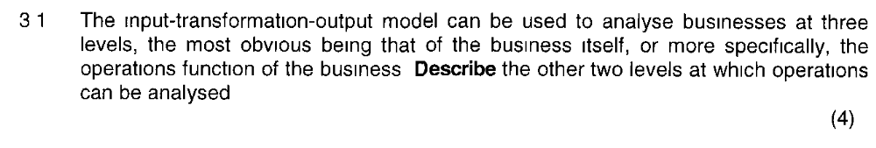
Operations can be analysed at 3 levels namely, the supply network, the operation and the processes (see study guide p 8 activity 1.3 question (1) & feedback 1.3)
- Supply network
An operation can have several suppliers and several customers and also be in competition with other operations producing similar services. This collection of operations is called the supply network. The supply network is the network of supplier and customer operations that have relationships with an operation.
- Internal supplier
Processes or individuals within an operation that supply products or services to other processes or individuals within the operations.
- Internal customer
Processes or individuals within and operation who are the customers for other internal processes or individuals’ outputs; thus the internal activities of an operations.

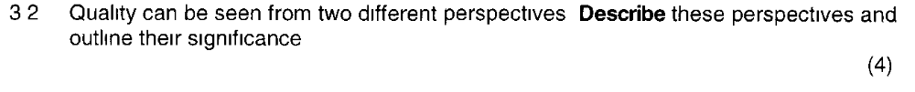
It is important to understand that quality can be seen from a (1) customer perspective, i.e. how a customer perceives the quality of a product or service, organisation’s image, or from an (2) operations perspective, ensuring the manufactured product or delivered service conformance to specification (scrap and rework, size of inventory, capital costs and productivity are affected). Whilst these two perspectives should be the same often in practice they are not. We provide the gap model which tries to show what might cause these differences.
Quality can have a significant effect on both revenues and costs because it impacts on the organisation’s image, scrap and rework, size of inventory, capital costs and productivity

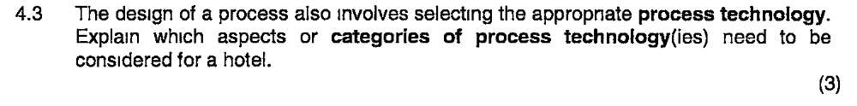
(TB PG 213)

Process types
The position of a process on the volume-variety continuum shapes its overall design and the general approach to managing its activities.

These general approaches are called process types. Different terms are used to identify process types depending on whether they are predominantly manufacturing or service processes.

Process types
The position of a process on the volume-variety continuum shapes its overall design and the general approach to managing its activities.

These general approaches are called process types. Different terms are used to identify process types depending on whether they are predominantly manufacturing or service processes.

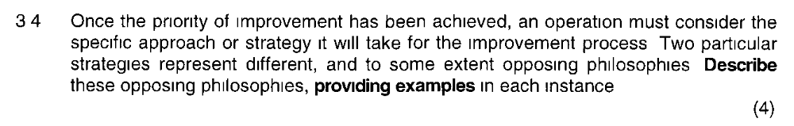
These two strategies are breakthrough improvement and continuous improvement. Breakthrough improvement is an approach to improving operation performance that implies major or dramatic change in the way an operation works, e.g. Business process engineering(BPR). Continuous improvement is an approach to operations improvement that assumes many, relatively small, incremental, improvements in performance, stress the momentum of improvement rather than the rate of improvement, also known as Kaizen.
(TB 554)
Text book p554 -555
- Breakthrough improvement
An approach to improving operations performance that implies major and dramatic change in the way an operation works, for example business process re-engineering (BPR) is often associated with this type of improvement also know as innovation-based improvement, contrasted with continuous improvement.
Example: the total redesign of a computer-based hotel reservation system.
- Continuous improvement
An approach to operations improvement that assumes many, relatively small, incremental, improvements in performance, stress the momentum of improvement rather than the rate of improvement; also known as *kaizen, often contrasted with breakthrough improvement.
Example: simplifying the question sequence when taking a hotel reservation.
*Kaizen – a Japanese term for continuous improvement.

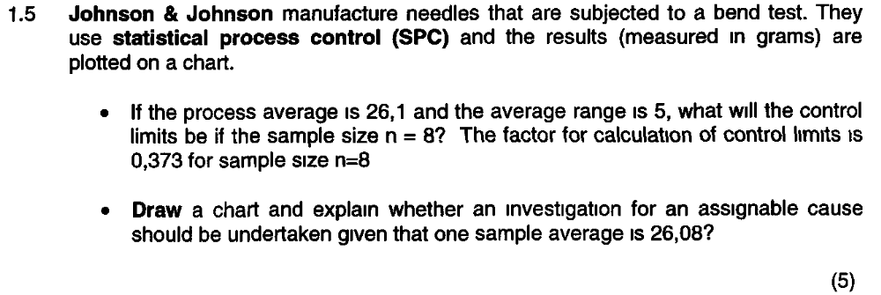
UCL=Control limits are X + A2R = 26.1 + (0.373 X 5) = 27.965
LCL = Control limits are X + A2R = 26.1 - (0.373 x 5) = 24.235
No need for investigation as 26.08 is within the control limits
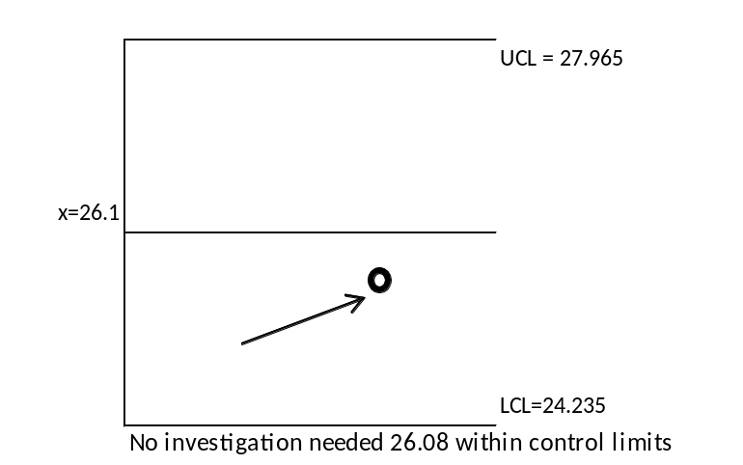

TQM: a holistic approach to the management of quality that emphasises the role of all parts of an organisation and all people within an organisation to influence and improve quality; heavily influenced by various quality ‘gurus’, it reached its peak in popularity in the 1980’s and 1990’s.
Prevention Costs: those costs that are incurred in trying to prevent quality problems and errors occurring; an element within quality related costs.
Appraisal costs: Those costs associated with checking, monitoring and controlling quality problems or errors have occurred; an element within quality related costs.
Internal failure costs: The costs associated with errors or failures that are dealt with inside an operation but yet cause disruption; an element within quality related costs.
External failure costs: Those costs that are associated with an error or failure reaching a customer, an element within quality related costs.
Pg 660, 616 -617
Text book p609 – 611
Concept: TQM is a philosophy of how to approach the organisation of quality improvement. It stresses the ‘total’ of TQM and puts quality (and indeed improvement generally) at the heart of everything that is done by an operation and including all activities within an operation.
Text book p616
- Prevention costs are those costs that are incurred in trying to prevent quality problems and errors occurring; an element within quality related costs and include things like:
  - training and development of personnel to perform their jobs
- Appraisal costs are those costs associated with controlling quality to check to see whether problems or errors have occurred during and after the creation of the product or service and includes things like:
  - conducting customer surveys and quality audits
- Internal failure costs are those costs associated with errors which are dealt with inside the operation and includes things like:
  - the cost of scrapped parts and material
- External failure costs are those costs associated with an error going out of the operation to a customer and includes things like:
  - loss of customer goodwill affecting future business

June 2013
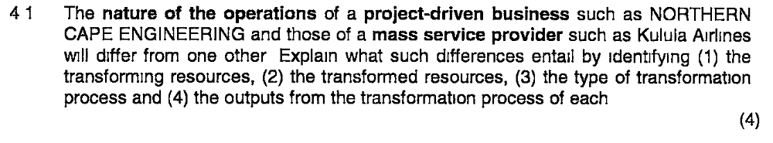
Inputs are: Transformation process Outputs:
(Northern Cape Engineering)Gibbs: Transformed inputs: Raw materials and Information
Transforming inputs: Assembly Plant and engineers Assembly of project Fully assembled project
(Kulula) SAA: Transformed inputs: Customers
Transforming resources: Check in staff and Pilots Flying of plane Transported passengers
(tarynweb) REMEMBER THIS QUESTION IS THE SAME BUT ONLY NAME CHANGE!!
Inputs to the process
One set of inputs to any operations processes are transformed resources – resources that are treated, transformed or converted in the process.

Materials
Transformation of the physical properties. Other operations process materials to change their location. Some retailer operators change the possession of the materials. Some operations store materials i.e. wharehouse.

Information
- Transformation of the informational properties of the inputs – accountants.
- Changing the position of the information – marketing and research companies
- Store the information – libraries
- The location of the information – telecommunication companies

Customers
- Changing the physical properties in a similar way to materials – hair stylist or cosmetic surgeon
- Accommodating customers – hotels
- Transportation and bus companies - transforming the location of customers
- Hospitals – transformation of the customer physiological state
- Entertainment Centres – music, theatre, television and radio transformations – transforming the psychological state of the customer.

The other set of inputs to any operations process are transforming resources.
These are the resources which act upon the transformed resources.

The are two types which form the building blocks of all operations:

- Facilities – buildngs, equipment, transforming resources, plant and process technology of the operation
- Staff –the people who operate, maintain, plan and manage the operation

Outputs from the process
All processes exist to produce products and services.

The most obvious difference is their respective tangibility – the main characteristic that distinguishes products from services.

Services may have a shorter stored life. Products can be stored for a time, some Food Products only a few days. The life of the service is much shorter.

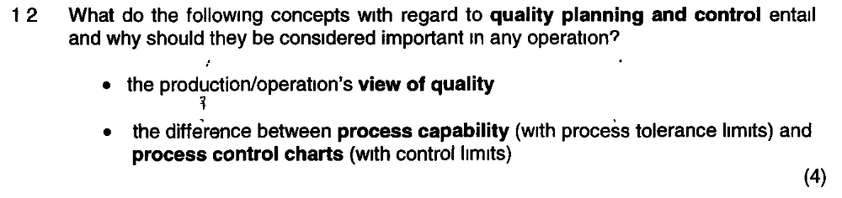
Text book p 504
The production/operation’s view of quality
Quality is consistent conformance to customers’ expectations. Conformance implies there is a need to meet a clear specification which is a key operations task. Consistent implies that conformance to specification is not an ad hoc event but that materials, facilities and processes must be designed and controlled to ensure compliance using a set of measurable product or service characteristics. Quality is important to operation management as it can increase revenue (i.e. more items to sell due to fewer errors) an reduce costs (less scrapped material or ‘re-work’ to fix errors).
Text book p 517
The difference between process capability and process control charts
Control charts record process performance;
They are used with statistical process control (SPC) to record process performance. The concept is build around the checking of many samples over a period of time using control charts to see if the process is performing as it should or whether it is out of control. It is important to operation management as it provides a trend and deviations from the trend will easily be notified allowing corrective steps to be taken.
Process capability measures the acceptability of a variation;
It is an arithmetic measure of the acceptability of the variation of a process. It compares the natural variation of the process with the specification range whish is required. The process capability measure allows operations management to calculate the simplest measure of capability$(C_{p}$) by the ratio of the specification range to the ‘natural’ variation of the process (i.e. $±$ 3 standard deviations). It is important to operations because if the deviation is higher than the acceptable specification range it may result in financial losses as the product may be rejected by the customer or cause safety issues.
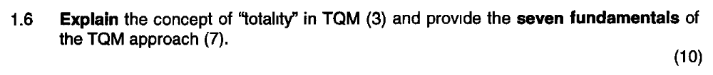
TQM is best thought of as a philosophy of how to approach the organisation of quality improvement. This philosophy, above everything, stresses the ‘total’ of TQM. It is an approach that puts quality at the heart of everything that is done by the operation and including all activities within an operation. This totality can be summarised by the way TQM lays particular stress on the following fundamentals:
- Meeting the needs and expectations of customers;
- Covering all parts of the organisation;
- Including every person in the organisation;
- Examining all costs which are related to quality, especially failure costs;
- Getting things ‘right first time’, i.e. designing-in quality rather than inspecting it in;
- Developing the systems and procedures which support quality and improvement;
- Developing a continuous process of improvement.
(TB 610-611)
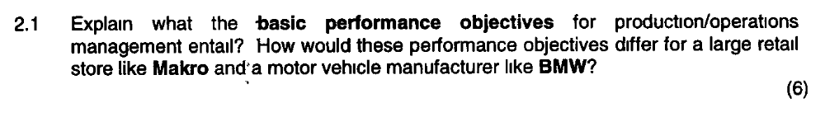
Text book p 38-45
The basic performance objectives are:
- Quality
Quality is defined as the consistent conformance to customer’s expectations. Quality has a major influence on customer satisfaction or dissatisfaction. It reduces cost and increases dependability.
Makro: The store is clean and tity
BMW: All parts are made to specification
- Speed
Speed refers to the elapsed time between when a customer requests a product or service and when they receive it. Speed can increase value for some customers. Speed reduces inventories and reduces risks.
Makro: The immediate availability of goods
BMW: Time to deliver spares to service centres kept to a minimum
- Dependability
Dependability refers to delivering or making available products or services when they were promised to the customer and is valued by most customers. Dependability saves time and money.
Makro: Keeping to reasonable queuing times
BMW: On-time delivery of vehicles to dealers
- Flexibility
Flexibility means being able to change in some way thus, the degree to which an operation’s process can change what it does and how it is doing it. Four types of customer requirements:
- operation’s ability to introduce new or modified products and services
- operation’s ability to produce a wide range or mix of products and services
- operation’s ability to change its level of output or activity
- operation’s ability to change the timing of the delivery of its products or services
Makro: delivery flexibility – the ability to obtain out-of-stock items
BMW: product/service flexibility – the introduction of new models

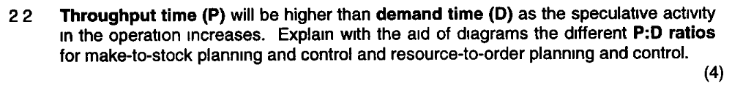
Text book p 279
Customer orders

Obtain resources | Deliver to customer  Produce product/service
Produce to stock |  | DP
PP
Part produce to order
 |  | DP
 | PP
Produce to order | DP
 | PP
Resource to order | D  P

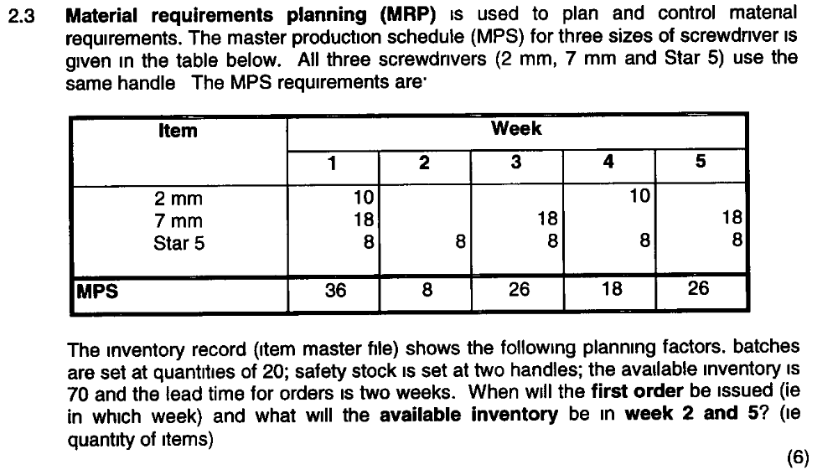

???????

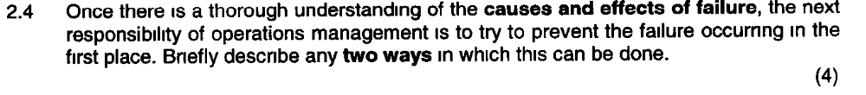
Text book p 589-592
- Fail-safeing
Fail-safeing refers to building in often simple devices that makes it difficult to make the mistakes that could lead to failure; also know by the Japanese term poka-yoke. It is accepted that human mistakes occur but it is important to prevent them becoming defects. Simple devices or systems are incorporated into a process to prevent inadvertent operator mistakes resulting in a defect. Example, a light beams which activates an alarm if a part is positioned incorrectly.
- Maintenance
Maintenance tries to avoid or minimise failure by taking care of physical facilities. There are 3 basic approaches to maintenance but in terms of preventing failure before it occurs preventative maintenance is most applicable;
Preventative maintenance – an approach that performs work on machines or facilities at regular intervals in an attempt to prevent them from breaking down.
Condition-based maintenance – an approach to maintenance management that monitors the condition of process equipment and performs work on equipment only when it is required.

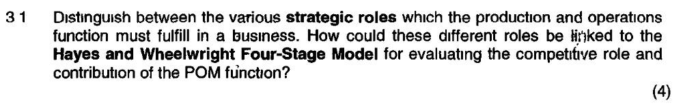
Text book p 34 -37
The strategic roles of the production and operations function are:
- To implement business strategy
The most basic role of operations is to implement strategy. They thus have to put the strategy in to practice.
- To support business strategy
Operations must develop the capabilities which allow the organisation to improve and refine its strategic goals.
- To drive business strategy
This is the most difficult role and requires operations to give the organisation a unique and long term advantage. A company’s success is based on such unique operation capabilities.
Linking to the Hayes and Wheelwright Four-Stage Model
The Hayes and Wheelwright Four-Stage Model categorises the degree to which operations management has a positive influence on overall strategy. The level to which operations contribute in terms of their strategic role links to the Hayes and Wheelwright model as they believe that when operations only contribute in terms of the implementing strategy the company will remain on stage 1 (i.e. internal neutral) where they correct the worst problems and may hold the organisation back or on stage 2 (external neutral) where they will adopt best practice and get to be as good as its competitors. If however operations support the company strategy and link the strategy with operations their capabilities and therefore the strategic impact will increase to stage 3 (i.e. internally supportive) and ultimately stage 4 (i.e. externally supportive) where operations will drive strategy and give the company an operations advantage. According to Hayes and Wheelwright if a company’s production/operations function is seen to be operating at stage 4 this means that the function itself becomes the foundation of the business’ future competitive success. In this case, production/operations-based strategies are developed to enable the business to compete in future markets.

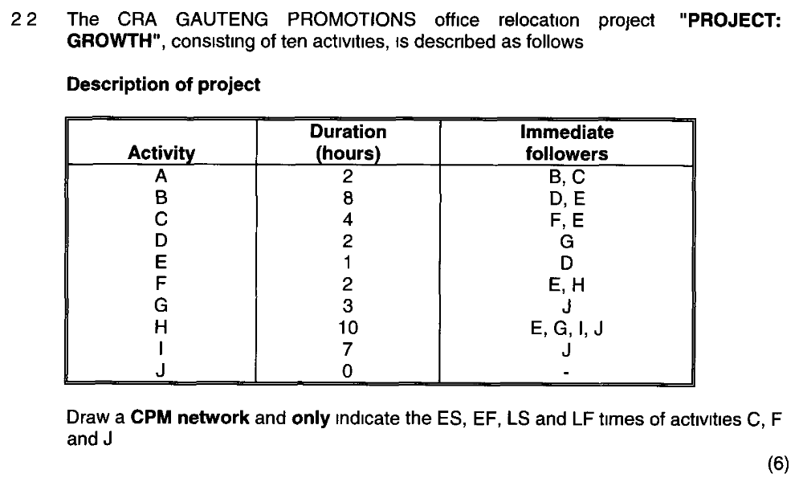
???????????????????????

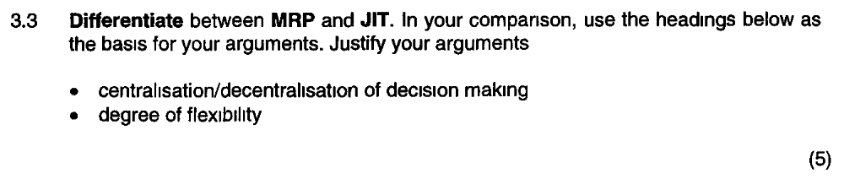
MRP (Materials Requirement Planning): a set of calculations embedded in a system that helps operations make volume and timing calculations for planning and control purposes. (TB 656)
JIT (Just-in-time): a method of planning and control and an operations philosophy that aims to meet demand instantaneously with perfect quality and no waste. (TB 655)
Text book p 410
MRP | JIT
Driven by the master production schedule which identifies future end-item demand | Aims to meet demand instantaneously
Models a fixed lead-time environment; needs complex centralised computer-based organisation; requirements are calculated and coordinated centrally | Simple control system; results is simple, visual and transparent. decision making is largely decentralised
Outputs in the form of time-phased requirements plans; parts made in response to central instructions.
A push system | Pulled by demand
Uses orders derived from the master schedule as the unit of control
Dependent on accuracy of data from bills of material, stock records etc.
Assumes a fixed operations environment, fixed lead times.
Not flexible – difficult to cope with variable lead times | Encourages resource flexibility and minimised lead times
Excellent in planning it is weak at control | Good at control, weak on planning

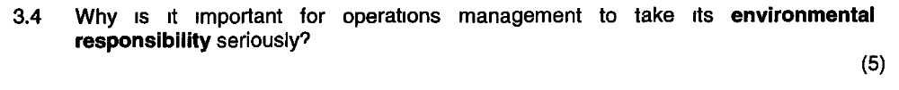
Most dramatic environmental contamination disasters are caused by operational failure. In a broader sense all operations management decision have some kind of environmental impact. Increasingly, companies are making formal reports and statements relating to their environmental practice. Operations managers are often responsible for providing the basic information for these reports. The environmental management system ISO 14000 is being adopted by a wide range of organisations. Operations managers will often have to implement these standards.
(TB 647)
Text book p 638 -643
In order to achieve sustainability means reducing or at least stabilising the environmental burden. Products which cannot be recycled and processes which consume large amounts of energy is not sustainable in the long run. Operational decisions in product and service design influences the proportion of energy and labour that is wasted as well as materials wastage and environmental responsibility is therefore intimately connected with the day-to-day decisions of operations managers. Planning and control activities of operations managers affect material wastage, energy and labour wastage. Reducing waste is not just environmentally sound but also saves cost for the organisation. Some process technologies may also cause pollution and be harmful to the environment impacting the company’s ecological footprints. Green reporting is also required more and more by companies as it makes good business sense and reduces the chances of operational failure resulting in environmental damage together with all its cost implications. It also creates positive public relations for the organisation. Lastly there are regulation and legislation and companies can be fined or penalised if they act irresponsibly in respect to the environment.

MAY 2014
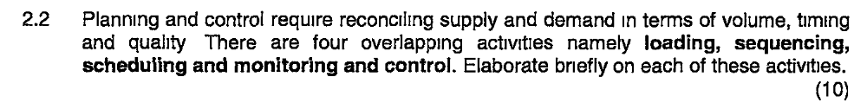
Loading is the amount of work that is allocated to a work centre. It is important to note that even if a machine has e.g. 168 hours of work that can be loaded onto the machine it doesn’t necessarily mean it can be loaded. For some periods the machine cannot be worked, e.g. holidays and weekends and this must be taken into consideration.
Sequencing is the activity within planning and control that decides on the order which work is to be performed. The priorities given to work in an operation are often determined by some predefined set of rules; certain constraints must be taken into consideration, e.g. Physical – lighter dye to be loaded prior to darker dye. Customer priority – an aggrieved client might need to be processed prior to others. DD,LIFO,FIFOLOTSOT
Scheduling is a term used in planning and control to indicate the detailed timetable of what work should be done, when it should be done and where it should be done.
Monitoring and control which involve detecting what is happening in the operation, replanning if necessary and intervening in order to impose new plans. Two important types are ‘pull’ and ‘push’ control. Pull control is a system whereby demand is triggered by requests from a work centres (internal) customer. Push control is a centralised system whereby control (and sometimes planning) decisions are issued to work centres which are then required to perform the task and supply the next workstation. In manufacturing, ‘pull’ schedules generally have far lower inventory levels than ‘push’ schedules.
(TB 296)
  - Planning and control require the reconciliation of supply and demand in terms of
    - (a) loading, which means determining the amount of work allocated to the work centre.
    - (b) Sequencing, which means determining the order in which work will be performed.
    - (c) scheduling, which means deciding on detailed timetables of start and finish dates
  - loading
    - In working out the loading the difference between maximum available time and valuable operating time (eg of a machine) takes into consideration certain unavoidable losses in time (public holidays, weekends, equipment idling, set-up and changeover - planned times of unproductivity, etc) and avoidable losses in time (quality losses, slow running equipment, breakdown, failure - unplanned times of unproductivity, etc) in well-run operations.
    - finite loading is ``an approach which only allocates work to a work centre up to a set limit'', which is the estimate of the capacity of the work centre. Infinite loading is ``an approach to loading work which does not limit accepting work, but tries to cope with it''
  - sequencing
    - when priorities are given to work in an operation, some predefined set of rules may apply, or physical constraints (physical nature of materials being processed) may determine the priority. This predefined set of sequencing rules includes:
      - Customer/client priority sequencing is when important or aggrieved customers/clients are processed prior to others, irrespective of the order of arrival
      - DD sequencing is when work is sequenced according to the due date for delivery, irrespective of the size of each job or importance of the customer/client.
      - LIFO sequencing is when work is selected for practical reasons ,meaning those last in move out first.
      - With FIFO sequencing customers/clients are served as they arrive - this is also known as first-come-first-served.
      - LOT sequencing is when jobs that take the longest are done first
      - SOT is usually when cash constrained operations do the shortest jobs first to invoice, receive payment quicker and improve cash £low
    - the five performance objectives may also be used to judge the effectiveness of the sequencing rules. These performance objectives include dependability (meeting dues dates promised), speed (minimizing the time a job spends in process) and cost minimizing work-in-process inventory and minimizing idle time at work centres).
  - scheduling
    - scheduling activity is considered to be one of the most complex tasks in production/operations management, because it deals with several different types of resources simultaneously (eg machines with different capabilities and capacities) and the number of possible schedules increase rapidly as the number of activities and processes increase.
    - forward scheduling involves starting work as soon as it arrives, while backward scheduling involves starting the jobs at the last possible moment. In theory both MRP (material requirements planning) and JIT (just-in-time) use backward scheduling, which means that the work is only started when it is required.
  - after a plan has been created for the operation through loading, sequencing and scheduling, each part of the operation has to be monitored to ensure that the planned activities do take place. Any deviation from the plans must be rectified through some kind of intervention and may involve replanning.
  - An important distinction is made between intervention signals that push work through the process within the operation (work is pushed out without considering whether the succeeding work centre can use it and idle time occurs - inventory build-up and queues may result) and intervention signals that pull work only when it is required (the customer works as trigger to pull the work from the preceding work station).

SU 6, Chapter 10 on page 280 - 293
Planning and control requires the reconciliation of supply and demand in terms of volumes, timing and quality. There are four overlapping activities namely loading, sequencing, scheduling and monitoring and control. Different organisations may use these in different ways.
1. Loading: [page 280]
Loading can be defined as the amount of work that’s allocated to a work centre. E.g. A machine in a manufacturing business is in theory available for 168 hours a week but this does not necessarily mean that 168 hours of work can be loaded onto the machine -> for some periods it can’t be worked due to holidays/ time can be lost through breakdown/ remain idling for another reason. Thus the valuable operating time available for productive working can significantly below the maximum time available even in the best operations.

Finite loading is an approach to planning and control that only allocated work to a work centre up to a set limit (usually its useful capacity). Work over and above this capacity is not accepted. It’s particularly relevant for operations where:
- It is possible to limit the load e.g run an appointment system for a hairdresser
- It is necessary to limit the load e.g. for safety reasons a finite number of people and luggage allowed on aircraft
- The cost of limiting the load is not prohibitive e.g. cost of maintaining a finite order book at a specialist car manufacturer does not adversely affect demand
Infinite loading is an approach to planning and control that allocated work to work centres irrespective of any capacity or other limits. It’s relevant for operations where:
- It is not possible to limit the load e.g emergency room
- It is not necessary to limit the load e.g fast food outlets can up or down capacity demanding on demand
- The cost of limiting the load is prohibitive e.g. if retail bank turned away customers they would be unhappy with service
2. Sequencing [page 282 – 286]
The activity within planning and control that decides on the order in which work is to be performed. The priority given to work in an operation are often determined by some predefined set of rules – examples below:
- Physical constraints: the physical nature of materials processed determines the priority of work
- Customer Priority: An important or aggrieved customer or item is processed prior to others, regardless of arrival time
- Due Date: Prioritising by when work is due for delivery regardless of size of the job or importance of the customer
- Last in, First Out: method of sequencing usually selected for practical reasons e.g. unloading an elevator is more convenient on a LIFO basis
- FIFO: Serve customers exactly in the sequence in which they arrive
- Longest Operation Time: Operations sequence their longest jobs first
- Shortest operation Time First: Tackle short jobs first
All five performance objectives can be used to judge the effectiveness of sequencing rules:
- Meeting due date promised to customer (dependability)
- Minimising the time the job spends in the process / flow time (speed)
- Minimising work in progress inventory (an element of cost)
- Minimising idle time of work centres (an element of cost)
3. Scheduling [page 286 – 291]
Scheduling indicates the detailed timetable of what work should be done, when it should be done and where it should be done.
Forward scheduling involves starting work as soon as it arrives, thus loading work onto work centres as soon as it’s practical to do so. Advantages include high labour utilisation and flexibility.
Backward scheduling involves starting jobs at the last possible moment to prevent them from being late so they should be finished exactly when they’re due. Advantages includes lower material costs, less exposure to risk in case of a scheduling change by the customer and focus of the operation on customer due dates.
The most common method of scheduling is by use of the Gantt chart. Advantages includes that they provide a simple visual representation of what should be happening and what’s actually happening in the operation.
4. Monitoring and controlling the operation [page 291 – 293]
Each part of the operation must be monitored to ensure that planned activities are indeed happening and any deviation from the plans can be rectified through some kind of intervention in the operation. An important decision is how periodic intervention takes place. The key distinction is between intervention signals which push work through the processes within the operation and those which pull work only when it is required.
Push control indicates that work is being sent forward to workstations as soon as it is finished on the previous workstation. In a push system of control, activities are scheduled by means of a central system and completed in line with central instructions such as MRP system. Each work centre pushed out work without considering whether the succeeding work centre can make use of it. Idle time, inventory and queues often characterise push systems.
In a pull system, a workstation requests work from the previous station only when it is required so they set the pace and specification of what is done. The ‘customer’ workstation is the only trigger for movement. If a request is not passed back from the customer to the supplier, the supplier can’t produce anything or move any materials. Pull systems are far less likely to result in inventory build-up and are therefore favoured by JIT operations.

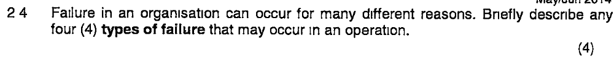
Chapter 19 on page 577 - 578
- Design failures: In design stage an operation might look adequate but when it has to cope with real circumstances then inadequacies might become evident. Some design failures occur because a characteristic of demand was overlooked or miscalculated so the process can’t cope with the demands placed on it.
- Facilities failure: All facilities (machines, equipment, buildings) are liable to facilities to facilities breakdown or failure. It may only be partial or it can be a total and sudden cessation of operation.
- Customer failure: Not all failures are directly caused by the operation or its suppliers. Customer failure can result from the misuse of the products and services which the operation has created. E.g. washing machine can be overloaded by the customer.
- Supplier failure: This is caused by any failure in the delivery or quality of goods and services into an operation. The more an operation relies on suppliers of materials or services, the more it’s liable to failure caused by missing or sub standard inputs.
- People failure: These come in two types (1) errors and (2) violations. Errors are mistakes in judgement where with hindsight a person should have done something different. Violations are acts which are clearly contrary to operating procedures.

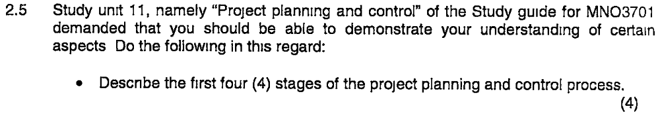
Chapter 16 on page 467 - 476
Stage 1: Understanding the project environment:
The project environment comprises all the factors which may affect the project during its life and is the context and circumstances in which the project takes place. Understanding the project environment is key because it affects the way a project needs to be managed and the possible dangers which may cause the project to fail. Environmental factors to consider include geo social environment, econo-political environment, business environment and internal environment
Stage 2: Project definition:
It’s key to define exactly what the project is considering the following three elements: (1) the project’s objectives ie. End goal (2) the project’s scope ie. The exact range of responsibilities taken on by project management (3) the project’s strategy ie. How project management is going to meet its objectives.
Stage 3: Project Planning:
Planning, deciding how the project will be executed, is not a one-off process and may be repeated several times during the project’s life cycle. The planning process has four distinct purposes:
- Determine cost and duration of the project
- Determines the level of resources needed
- Helps to allocate work and monitor progress
- Helps assess the impact of any changes to the project
Stage 4: Technical execution
This stage involves performing the technical aspects of the project
[Not required by question but added for completeness] Stage 5: Project Control:
This stage involves ensuring that the project is carried out according to plan. It involves 3 sets of decisions (1) how to monitor the project to check on progress (2) how to assess the performance of the project (3) how to intervene in the project in order to make changes that will bring it back to plan.

???????????????????????????
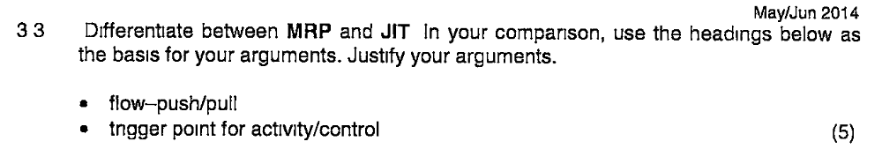
MRP (Materials Requirement Planning): a set of calculations embedded in a system that helps operations make volume and timing calculations for planning and control purposes. (TB 656)
JIT (Just-in-time): a method of planning and control and an operations philosophy that aims to meet demand instantaneously with perfect quality and no waste. (TB 655)
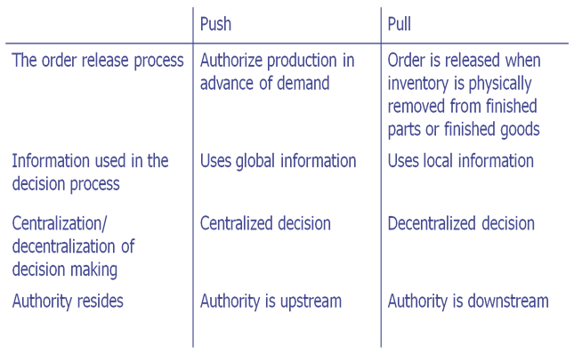

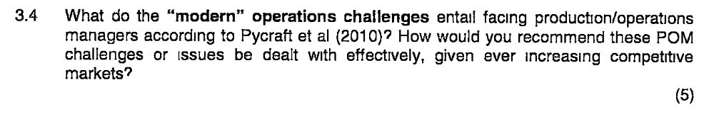
5 operations challenges that were identified:
1. the impact of globalisation of markets.
2. the changing view of social responsibility
3. the environmental responsibility of businesses
4. the indlugence of technology developments on operations management
5. the emergence of the concept of knowledge management.

(TB 504 -506)
It is important to understand that quality can be seen from a (1) customer perspective, i.e. how a customer perceives the quality of a product or service, organisation’s image, or from an (2) operations perspective, ensuring the manufactured product or delivered service conformance to specification (scrap and rework, size of inventory, capital costs and productivity are affected). Whilst these two perspectives should be the same often in practice they are not. We provide the gap model which tries to show what might cause these differences.
Quality can have a significant effect on both revenues and costs because it impacts on the organisation’s image, scrap and rework, size of inventory, capital costs and productivity
Reconciling the operation's and the customer's views of quality
The operation's view of quality is concerned with trying to meet customer expectations.

The customer's view of quality is what he or she perceives the product or service to be. To create a unified view, quality can be defined as the degree of fit between customers' expectations and customer perception of the product or service.

If the product or service experience was better than expected then the customer Is satisfied and quality is perceived to be high.

If the product or service was less than his or her expectations then quality is low and the customer may be dissatisfied. If the product or service matches expectations then the perceived quality of the product or service is seen to be acceptable.

Both customers' expectations and perceptions are influenced by a number of factors, some of which cannot be controlled by the operation and some of which, to a certain extent, can be managed.

This model of customer-perceived quality can help us understand how operations can manage quality and identifies some of the problems in so doing.

These two domains meet in the actual product or service, which is provided by the organisation and experienced by the customer. Within the operation's domain, management is responsible for designing the product or service and providing a specification of the quality to which the product or service has to be created.

Within the customer's domain, his or her expectations are shaped by such factors as previous experiences with the particular product or service, the marketing image provided by the organisation and word-of-mouth information from other users.

These expectations are internalised as a set of quality characteristics
Pg 509 and 510
Step 1 - Define the quality characteristics
Much of the 'quality' of a product or service will have been specified in its design. But not all the design details are useful in controlling quality.
Consequences for quality planning and control of the design are called the quality characteristics of the product or service.
Step 2 - Decide how to measure each characteristic
These characteristics must be defined in such a way as to enable them to be measured and then controlled. This involves taking a very general quality characteristic such as 'appearance' and breaking it down, as far as one can, into its constituent elements.

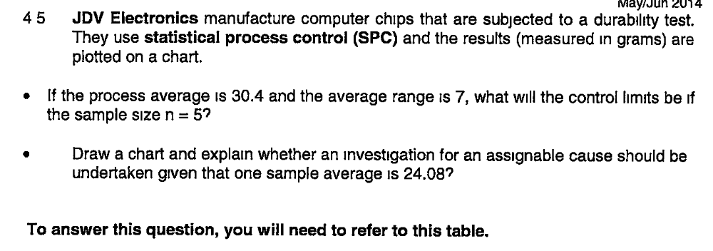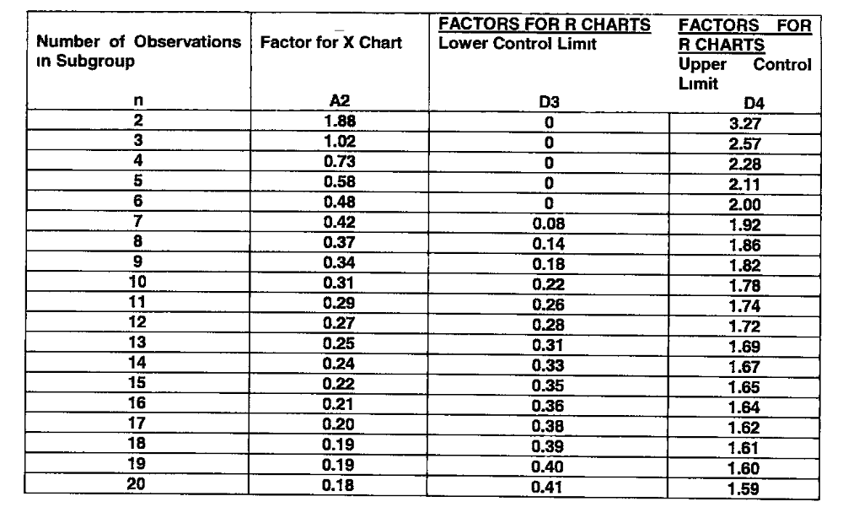
Text book p 518 = Study guide p 110
UCL=Control limits are X + A2R = 30.4 + (0.58 X 7) = 34.460
LCL = Control limits are X + A2R = 30.4 - (0.58 x 7) = 26.340
Yes, sample must be investigated as at 24.08 it is falls outside of the UCL and LCL
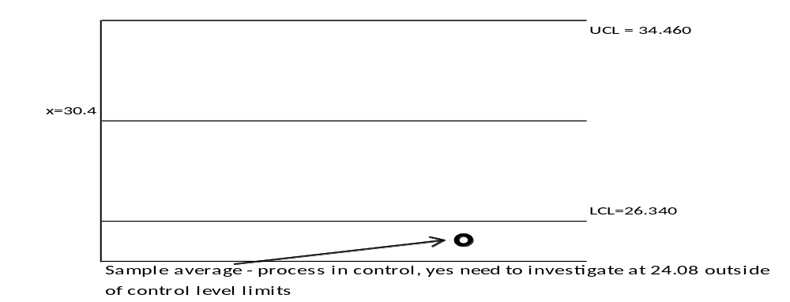
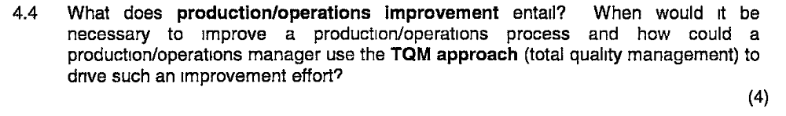
(TB 609)
Operations management is about managing processes
Process: an arrangement of resources that produces some mixture of goods and services.
The mechanisms that transform inputs to outputs are called processes.
Any operation is made up of a collection of processes, interconnecting with each other.
(not sure this answers the question in full?)

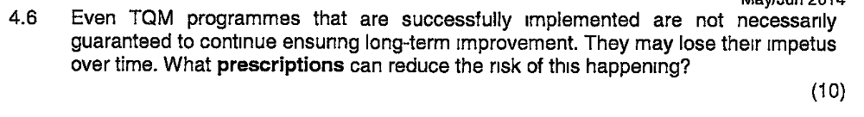
Text book p 623
The following prescriptions have been put forward and are intended to reduce quality disillusionment:
- Do not define ‘quality’ in TQM narrowly; it includes all aspects of performance (what we have called the performance objectives of operations management).
- Make all quality improvement relate to the performance objectives of the operation. TQM is not an end in itself; it is a means of improving performance.
- TQM is not a substitute for the responsibilities of normal managerial leadership. Ineffective managers are not made better simply by adopting TQM.
- TQM is not a ‘bolt-on’ attachment to the company – an activity which is separate from the other activities of the organisation. It should be integrated with and indistinguishable from everyday activities.
- Avoid the hype. TQM has a considerable intuitive attraction for many. It is sometimes tempting to exploit the motivational ‘pull’ of TQM through slogans and buzz words rather than thoroughly thought-out plans.
- Adapt TQM to be the circumstances of the organisation. Different organisations will have different needs depending on their circumstances. This means that different aspects of TQM might become more or less important.

OCTOBER 2014
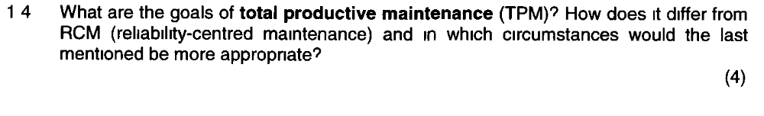
Text book p595 + Study guide p172-173 activity 15.3 question 14 & feedback activity 15.3 (4)
Goals of TPM
TPM aims to establish good maintenance practice in operations through the pursuit of the 5 goals of TPM:
- Improve equipment effectiveness by examining all the losses which occur
- Achieve autonomous maintenance by allowing staff to take responsibility for some maintenance tasks and for the improvement of maintenance performance
- Plan maintenance with a fully worked out approach to all maintenance activities
- Train all staff in relevant maintenance skills so that maintenance and operating staff have the skills to carry out their roles
- Achieve early equipment management by ‘maintenance prevention’ (MP) which involves considering failure causes, maintainability of equipment during design, manufacture, installation and commissioning.
Difference between TPM and RCM
TPM recommends preventative maintenance when it is not necessarily appropriate whilst RCM uses the pattern of failure for each type of failure mode of a part of a system to dictate the approach to its maintenance.
RCM is more appropriate in circumstances where failure or breakdowns occurs in a relatively random manner (thus failure patterns cannot be predicted).

MAY 2015
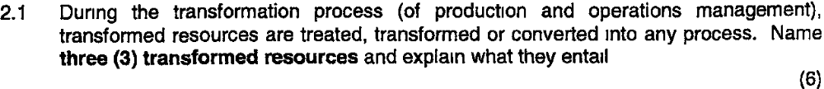
Page 9
Materials – entails processing of raw materials into finished products
Information -
Cutomers -

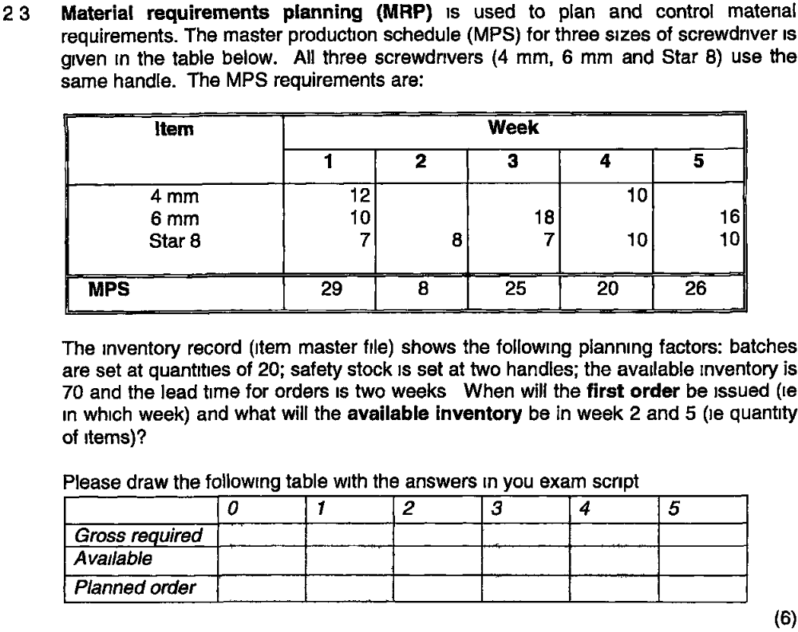

?????????????????
2.4 What is ISO 9000 (2) and what is the role in TQM (2) (4)
ISO 14000 is an international standard that guides environmental management systems and covers initial planning, implementation and objective assessment.
TQM refers to the approach as a holistic, comprehensive management philosophy for a business and it endeavours to excel at:
- developing the systems and procedures which support quality and improvement - thus strives “to design quality in” rather than “inspecting it in” (“to get things right the first time”); it uses quality system standards such as those based on ISO 9000 to support quality and improvement;

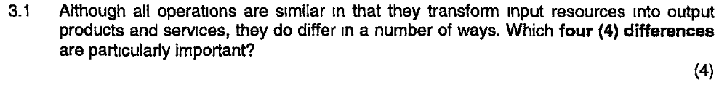

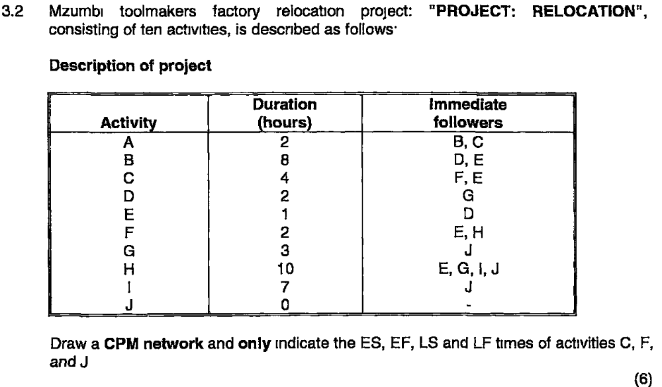

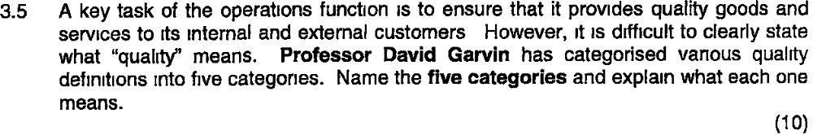

4.1 Process types decribes a particular general approach to managing processes. Name the five manufacturing process types and three service process types. (8)
Page 177
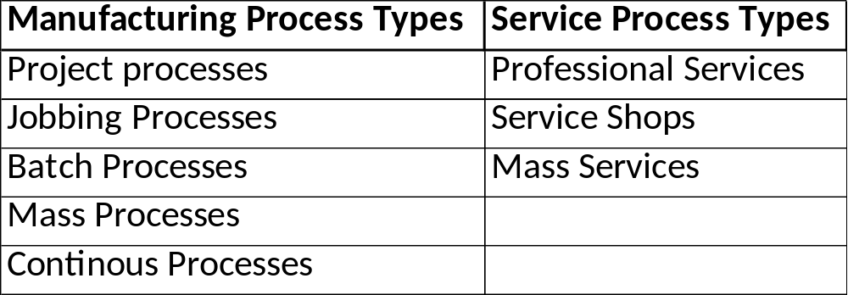

4.2 Describe what enterprise resource planning (ERP) is. (3)
Page 422
Enterprise resource planning (ERP) is the integration of all significant resource planning systems in an organization that, in an operations context, integrates planning and control with the other functions of the business.
4.3 Green reporting or environmental reporting is increasingly gaining momentum. It is estimated that around 35% of the world’s largest corporations publish reports on their environmental policies and performance. Discuss the reasons underlying this phenomenon. (4)
Page 641
This is motivated by a desire to cause less damage to the planet. Green reporting is also required more and more by companies as it makes good business sense and reduces the chances of operational failure resulting in environmental damage together with all its cost implications. It also creates positive public relations for the organisation. Lastly there are regulation and legislation and companies can be fined or penalised if they act irresponsibly in respect to the environment.
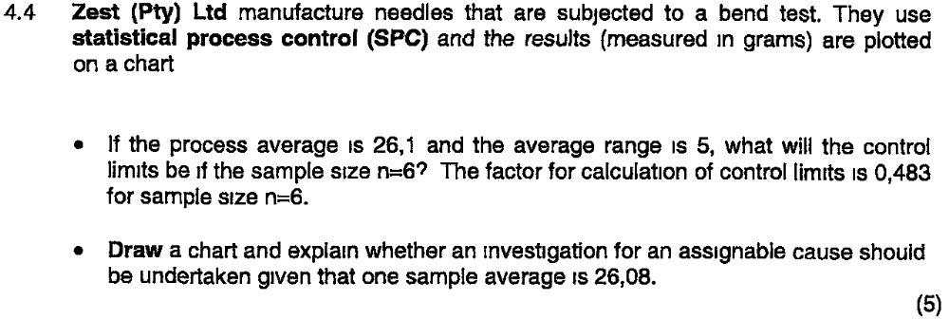

4.5 Total productive maintenance (TOM) is an approach to maintenance management that adopts a similar holistic approach to total management (TQM). Name and discuss the five goals of total productive maintenance (TPM). (10)
Goals of TPM
TPM aims to establish good maintenance practice in operations through the pursuit of the 5 goals of TPM:
- Improve equipment effectiveness by examining all the losses which occur
- Achieve autonomous maintenance by allowing staff to take responsibility for some maintenance tasks and for the improvement of maintenance performance
- Plan maintenance with a fully worked out approach to all maintenance activities
- Train all staff in relevant maintenance skills so that maintenance and operating staff have the skills to carry out their roles
- Achieve early equipment management by ‘maintenance prevention’ (MP) which involves considering failure causes, maintainability of equipment during design, manufacture, installation and commissioning.

