October/November 2017

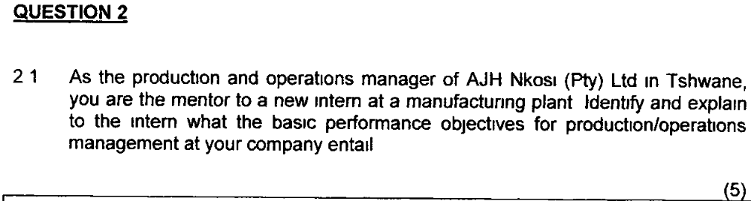
Ans:
Quality – satisfying customers by providing error free goods and services
Speed – do things fast
Dependability – do things on time and keep the delivery promise
Flexibility – change far enough and fast enough to meet customer requirements:

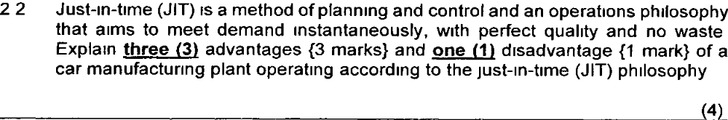
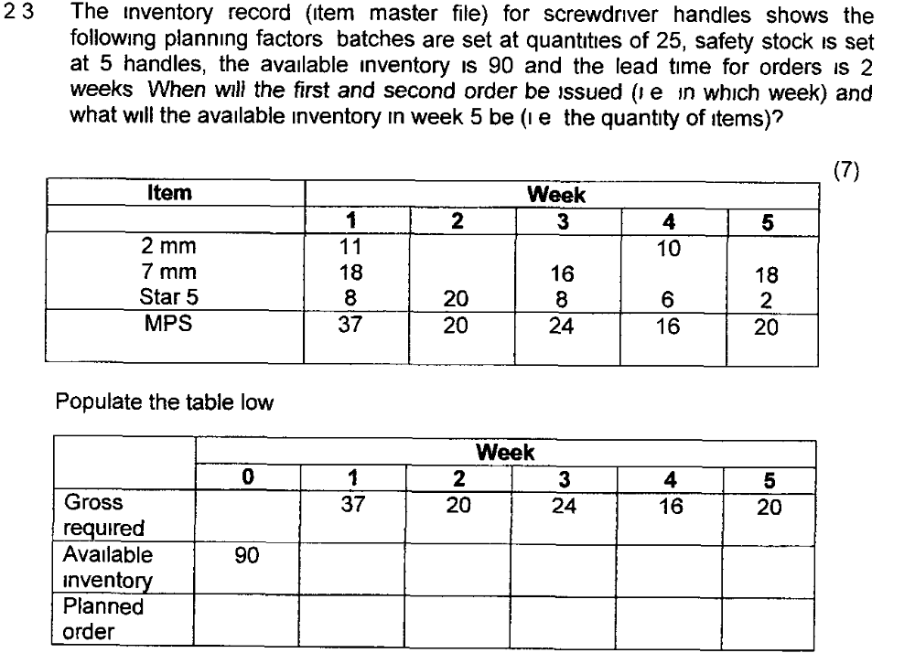
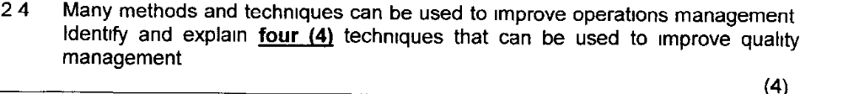
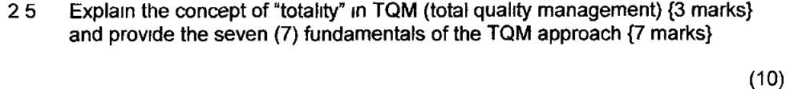
ANS: (June2013
TQM is best thought of as a philosophy of how to approach the organisation of quality improvement. This philosophy, above everything, stresses the ‘total’ of TQM. It is an approach that puts quality at the heart of everything that is done by the operation and including all activities within an operation. This totality can be summarised by the way TQM lays particular stress on the following fundamentals:
- Meeting the needs and expectations of customers;
- Covering all parts of the organisation;
- Including every person in the organisation;
- Examining all costs which are related to quality, especially failure costs;
- Getting things ‘right first time’, i.e. designing-in quality rather than inspecting it in;
- Developing the systems and procedures which support quality and improvement;
- Developing a continuous process of improvement.

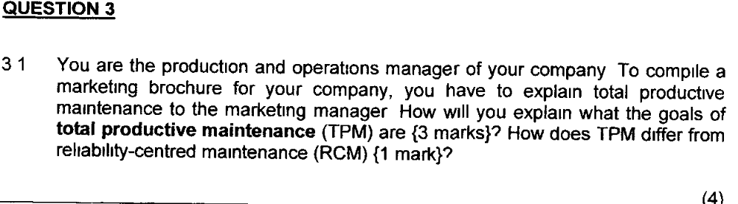
ANS: May/June 2015
Goals of TPM
TPM aims to establish good maintenance practice in operations through the pursuit of the 5 goals of TPM:
Improve equipment effectiveness by examining all the losses which occur
Achieve autonomous maintenance by allowing staff to take responsibility for some maintenance tasks and for the improvement of maintenance performance
Plan maintenance with a fully worked out approach to all maintenance activities
Train all staff in relevant maintenance skills so that maintenance and operating staff have the skills to carry out their roles
Achieve early equipment management by ‘maintenance prevention’ (MP) which involves considering failure causes, maintainability of equipment during design, manufacture, installation and commissioning.
Difference between TPM and RCM
TPM recommends preventative maintenance when it is not necessarily appropriate whilst RCM uses the pattern of failure for each type of failure mode of a part of a system to dictate the approach to its maintenance.
RCM is more appropriate in circumstances where failure or breakdowns occurs in a relatively random manner (thus failure patterns cannot be predicted).
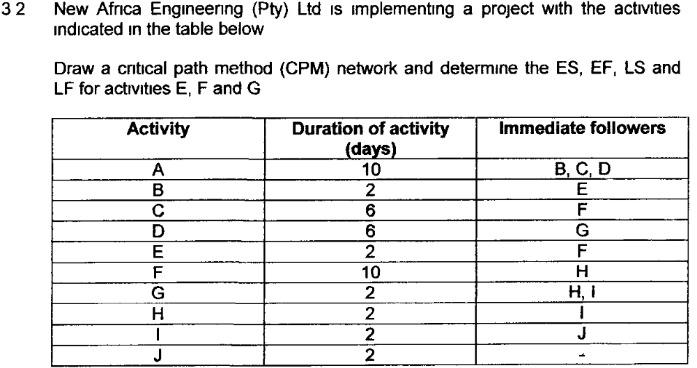(6)
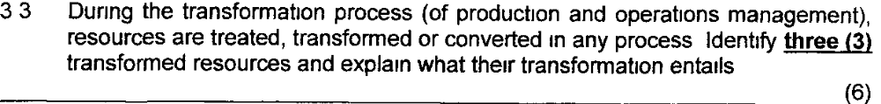
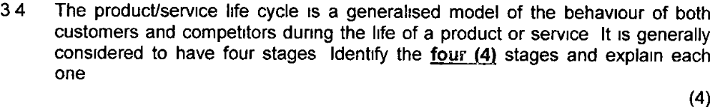
ANS:
The product/Service Life cycle influence on performance objectives One way of generalizing the behaviour of both customers and competitors is to link it to the life cycle of the products or services that the operation is producing. The form of product or Services Life cycles will vary but generally they are shown as the sales volume passing through four stages.
- Introduction
- Growth
- Maturity
- Decline
Introduction stage When a product or service is introduced it is likely to be offering something new in terms of its design or performance. Needs of customers are unlikely to be well understood, so the operations management needs to develop the flexibility to cope with any changes and provide quality.
Growth Stage Is volume growing, competitors may move into the growing market. Keeping up with demand could prove to be the main operations preoccupation. Rapid and dependable response to demand will help to keep demand buoyant while quality levels ensure that the company keeps its share of the market as competition starts to increase. See figure 3.7 on page 69 of the textbook Maturity Stage Demand starts to level off. Early competitors may have left the market and the industry is probably dominated by a few large players. Operations will be expected to get the cost down to maintain profits or allow price cutting. Cost and productivity issues, together with dependable supply are likely to be the operations main concerns.
Decline Stage After time, sales will decline with more competitors dropping onto the market. There might be a residual market but only if the shortage of capacity develops the market will continue to be dominated by price competition. Operations objectives continue to be dominated by cost

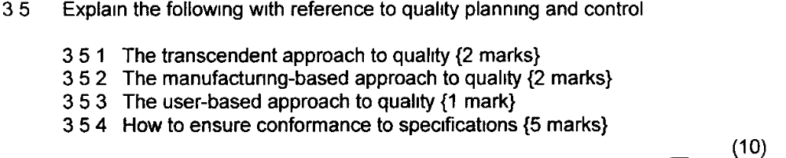
ANS: The transcendent approach - views quality as synonymous with innate excellence. Quality is being defined as the absolute - the best possible, in terms of the product's or service's specification.

The manufacturing-based approach - is concerned with making products or providing services that are free of errors and that conform precisely to their design specification.

The user-based approach - is concerned with making sure that the product or service is fit for its purpose. This definition demonstrates concern not only for its adherence to specification but also for the appropriateness of that specification for the customer.
Conformance to specification Conformance to specification means producing a product or providing a service to its design specification. During the design of any product or service, its overall concept, purpose, package of components and the relationship between the components will have been specified
Step 1 Define the quality characteristics of the product or service.
Step 2 Decide how to measure each quality characteristic.
Step 3 Set quality standards for each quality characteristic.
Step 4 Control quality against those standards.
Step S Find and correct causes of poor quality.
Step 6 Continue to make improvements.

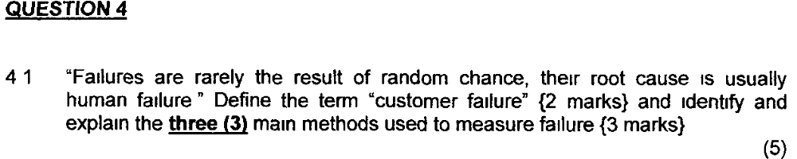
ANS:
Customer failure: Not all failures are directly caused by the operation or its suppliers. Customer failure can result from the misuse of the products and services which the operation has created. E.g. washing machine can be overloaded by the customer
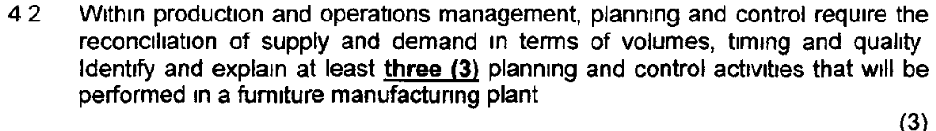
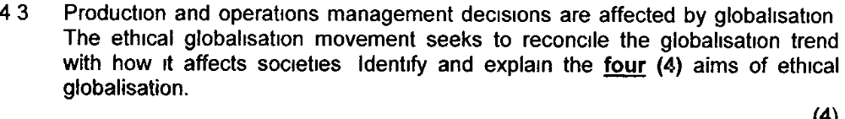
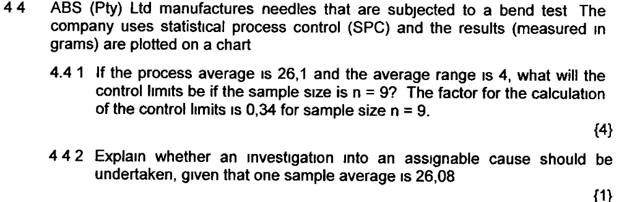
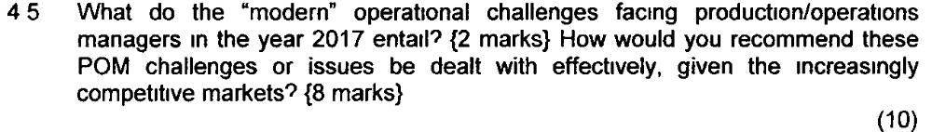

May/June 2017
SELECT AND ANSWER ANY TWO (2) OF THE FOLLOWING THREE ESSAY-TYPE QUESTIONS.
EACH QUESTION COUNTS 30 MARKS.
QUESTION 2
2.1 What is the Deming (or PDCA) cycle in production and operations management? {2} Name the four (4) stages of the Deming (or PDCA) cycle and explain what each stage entails. {4} (6)

2.2 Just-in-time (JIT) is a method of planning and control and an operations philosophy that aims to meet demand instantaneously with perfect quality and no waste. Specify and explain three (3) advantages {3} and one (1) disadvantage {1} of a car manufacturing plant's operating according to a just-in-time (JIT) philosophy. (4)

2.3 Material requirements planning (MRP) is used to plan and control material requirements. The master production schedule (MPS) for three sizes of screwdrivers is given in the table below. All three screwdrivers (2 mm, 7 mm and star 5) use the same handle. The MPS requirements are as follows:
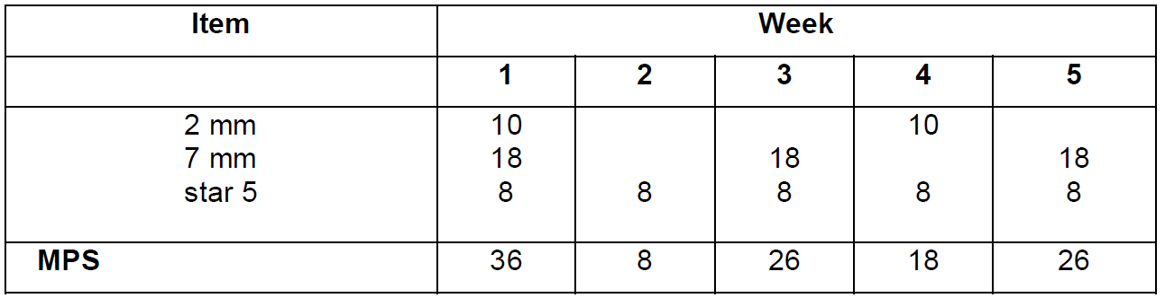

The inventory record (item master file) shows the following planning factors: batches are set at quantities of 30, safety stock is set at two (2) handles, the available inventory is 60 and the lead time for orders is two (2) weeks. When will the second order be issued (i.e. in which week) and what will the available inventory be in weeks 2 and 5 (i.e. quantity of items)?
Answer the question on the following table: (6)

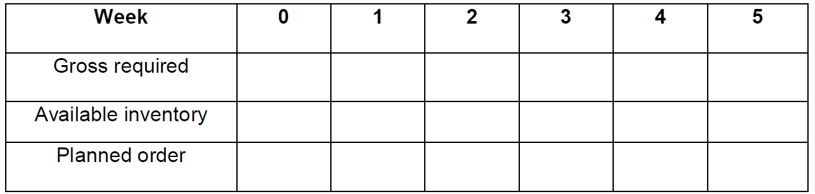

2.4 Name and explain the Hayes and Wheelwright four-stage model for evaluating the competitive role and contribution of the production and operations management (POM) function. (4)

2.5 “Project planning and control” is very important within any organisation.
2.5.1 Describe what a project entails. {1}
2.5.2 Explain how to achieve successful project management. {4}
2.5.3 Describe what each of the stages of the project planning and control process involves. {5} (10)

QUESTION 3
3.1 You are the production and operations manager of your company. To compile a marketing brochure for your company, you have to explain total productive maintenance to the marketing manager. How will you explain what the goals of total productive maintenance (TPM) are? {3} How does TPM differ from reliability-centred maintenance (RCM)? {1} (4)

3.2 Millennium Logistics (Pty) Ltd is a company specialising in the relocation of companies. The following are activities for a specific relocation project:

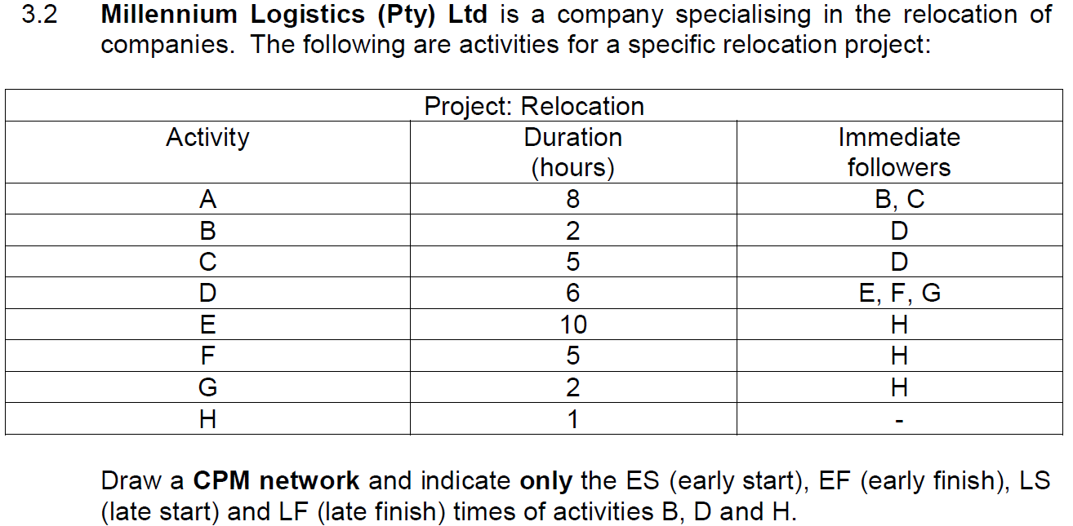
(6)

3.3 As the production and operations manager, you are the mentor to a new intern at a manufacturing plant. Identify and explain to the intern what the basic performance objectives for production/operations management entail? (5)

3.4 “Failures are rarely the result of random chance; their root cause is usually human failure.” Define the term “customer failure” {2} and identify and explain the three (3) main methods used to measure failure {3}. (5)

3.5 Explain the concept of total quality management (TQM) {2} and distinguish between the four (4) main components of the cost of quality {8}. (10)

QUESTION 4
4.1 The product/service life cycle is a generalised model of the behaviour of both customers and competitors during the life of a product or service. It is generally held to have four (4) stages. Identify the four (4) stages and briefly explain each one. (8)

4.2 Within production and operations management, planning and control requires the reconciliation of supply and demand in terms of volumes, timing and quality. Identify and explain at least three (3) planning and control activities that will be found in a furniture manufacturing plant. (3)

4.3 Production and operations management decisions are affected by globalisation. The ethical globalisation movement seeks to reconcile the globalisation trend with how it may affect societies. Identify and explain the four (4) aims of ethical globalisation. (4)

[TURN OVER]
4.4 Johnson & Johnson manufactures needles that are subjected to a bend test. The company uses statistical process control (SPC) and the results (measured in grams) are plotted on a chart.
4.4.1 If the process average is 26,1 and the average range is 5, what will the control limits be if the sample size is n = 8? The factor for calculation of control limits is 0,373 for sample size n = 8. {4}
4.4.2 Draw a chart and explain whether an investigation into an assignable cause should be undertaken, given that one sample average is 26,08. {1} (5)

4.5 What are the “modern” operations challenges facing production/operations managers (POM)? How would you recommend that these POM challenges or issues be dealt with effectively, given the increasingly competitive markets? (10)

October/November 2016

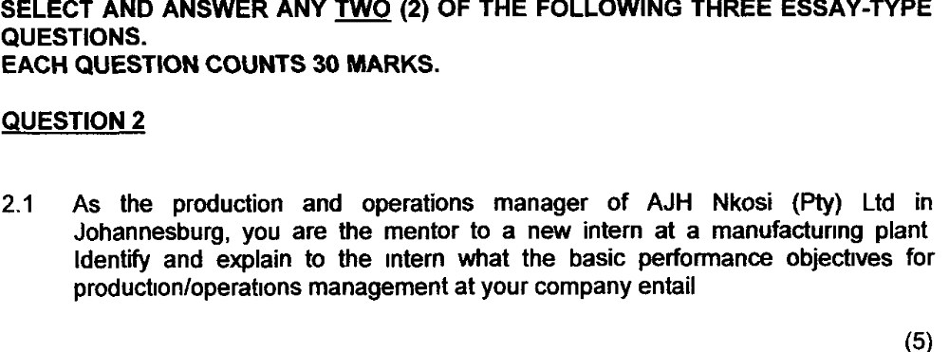
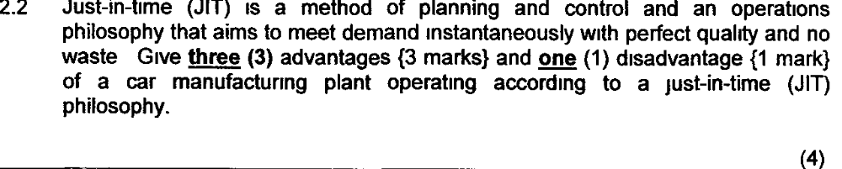

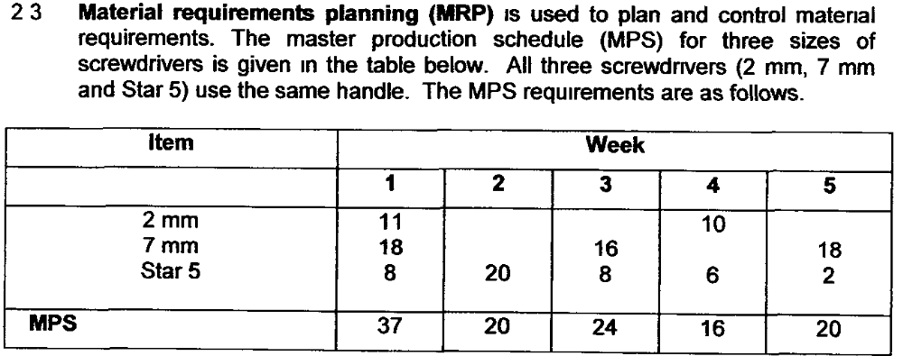

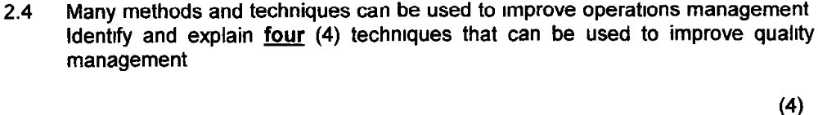
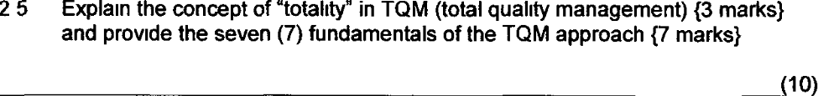
%%%%%%%%%%%%%%%%%%%%%%%%%%%%%%%%%%%%%%%%%%%%

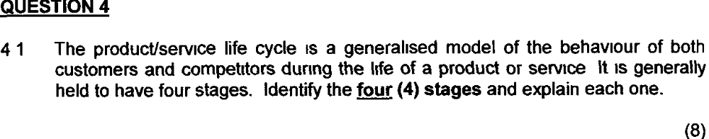
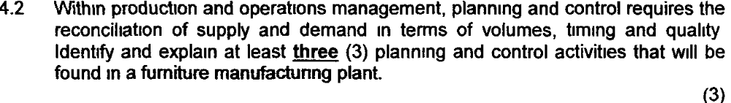

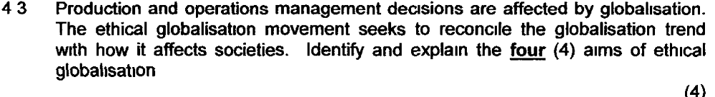
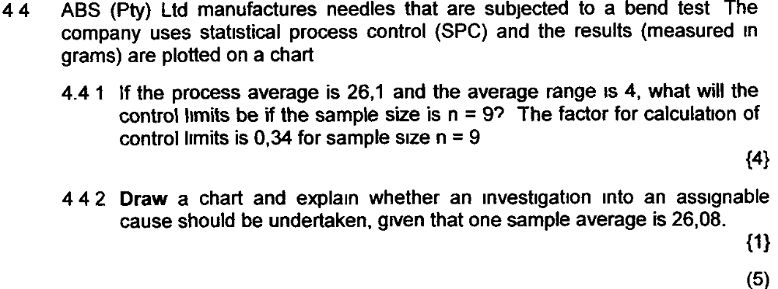
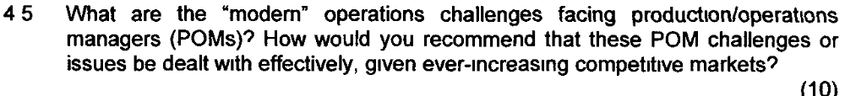

May/June 2016
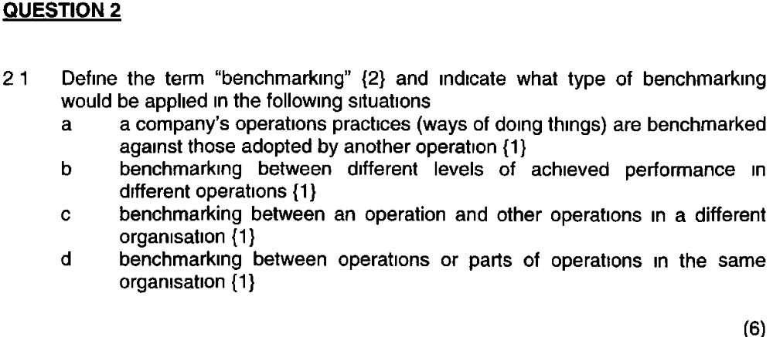

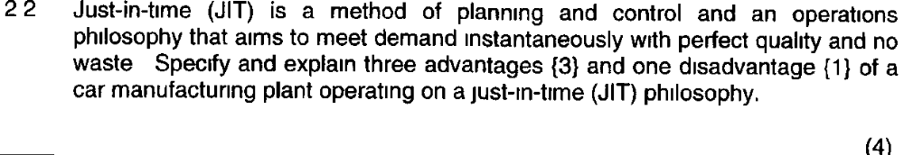

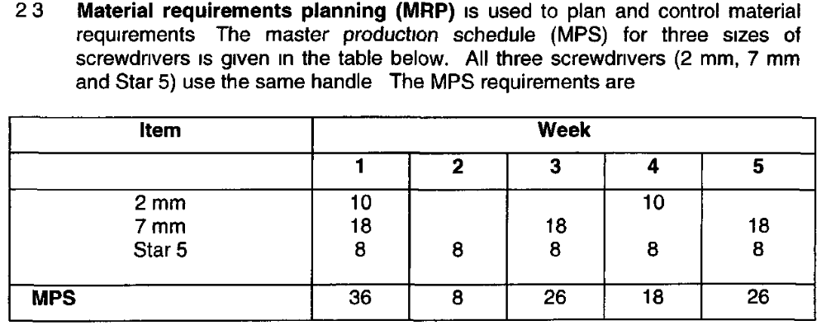
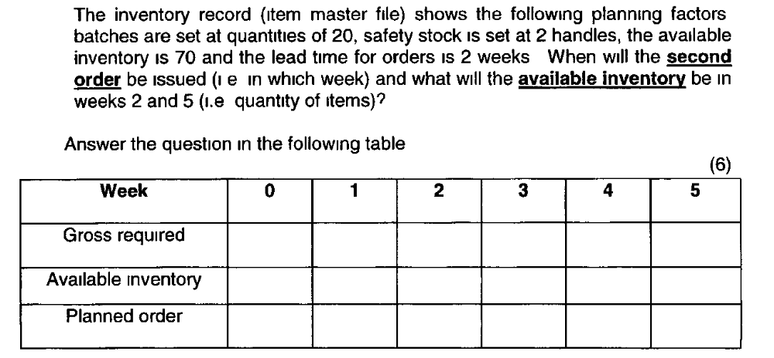

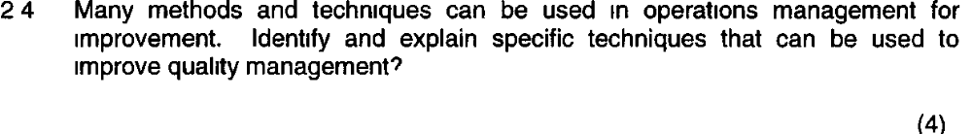

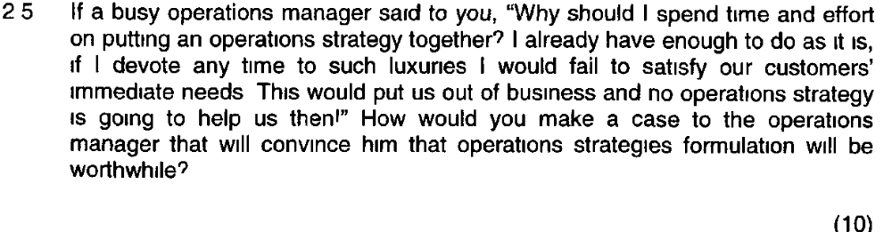
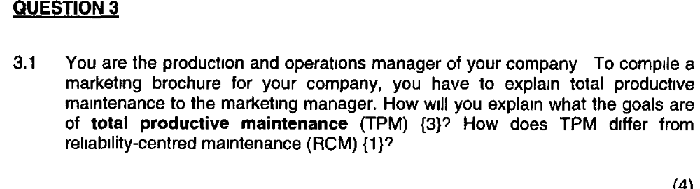

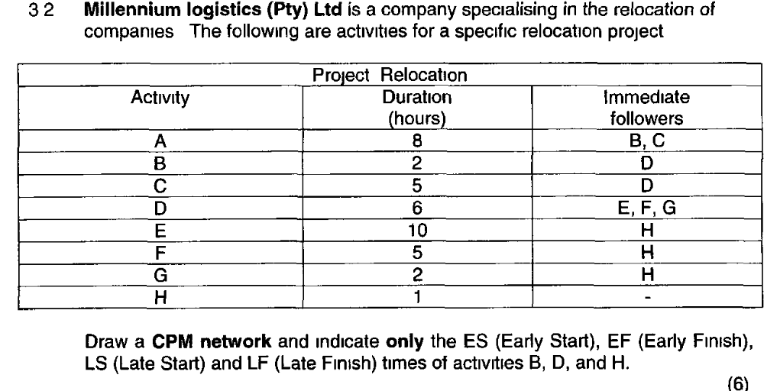

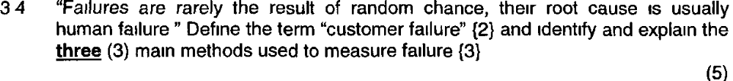

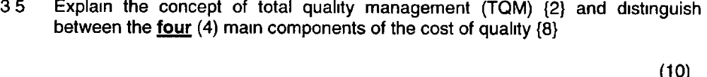
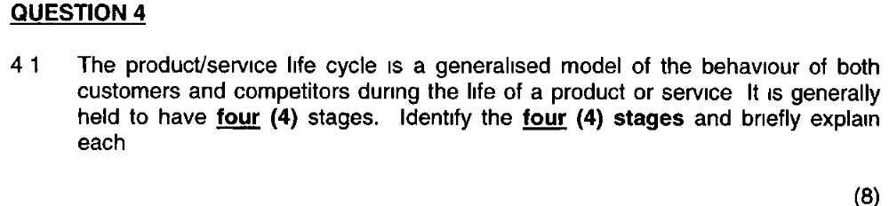
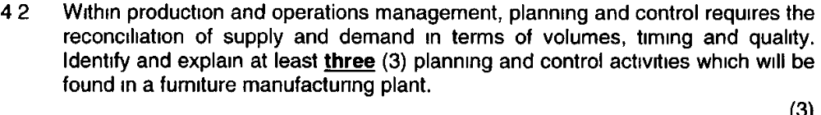

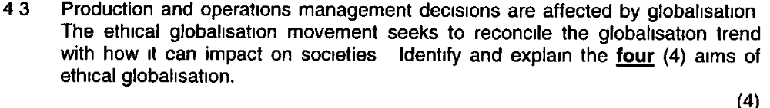

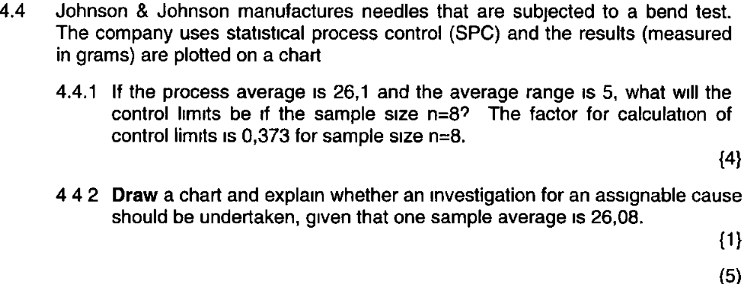

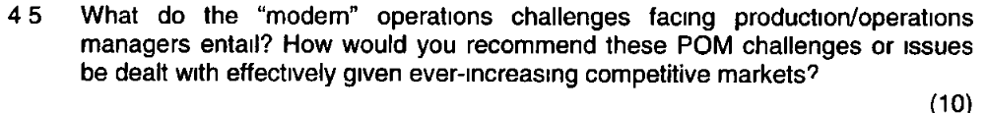
October /November 2015
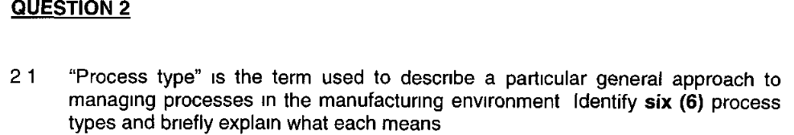
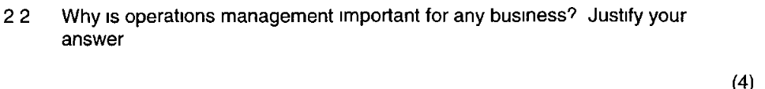
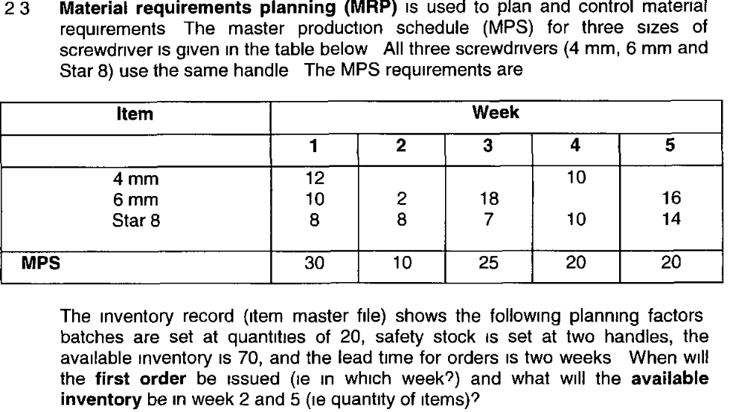
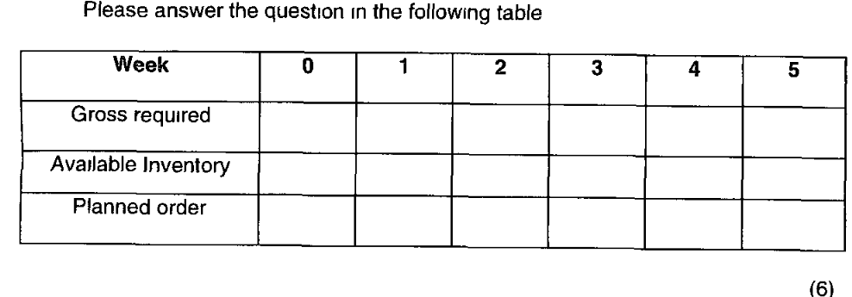
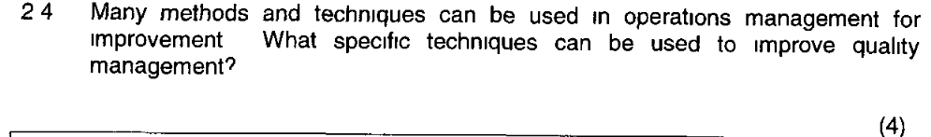
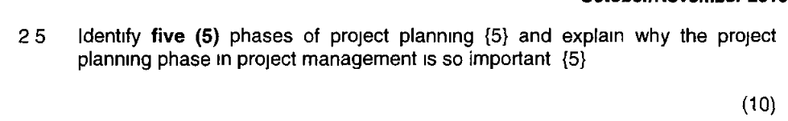

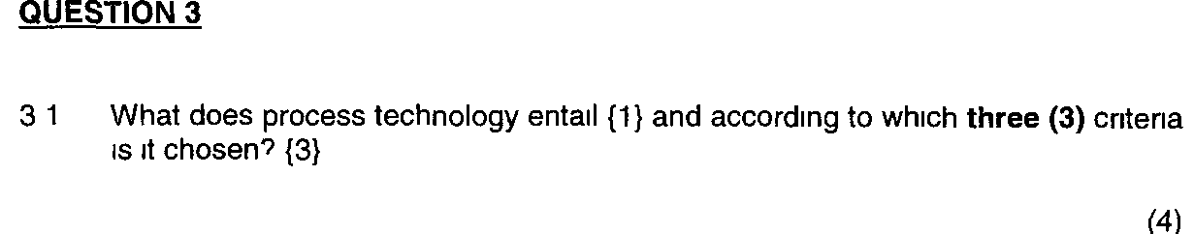
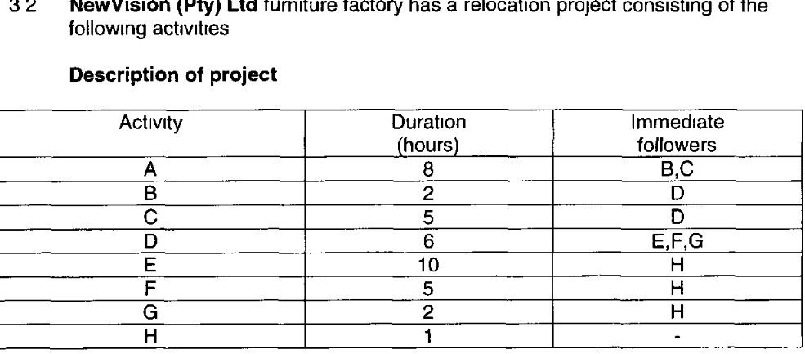
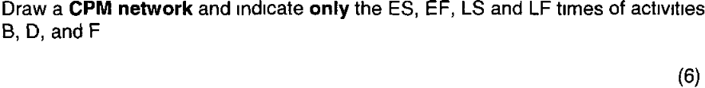
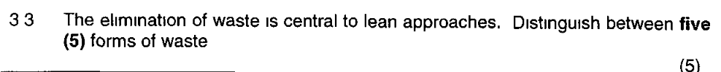
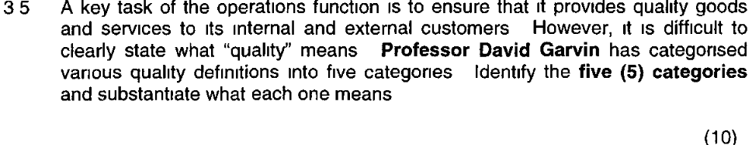
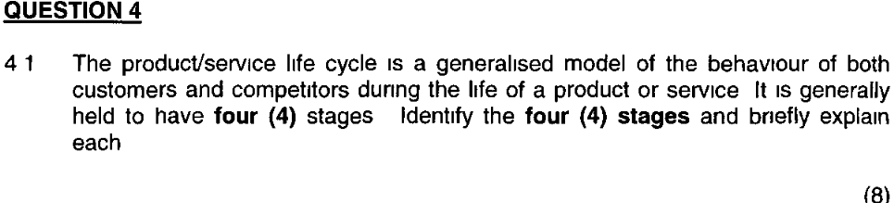
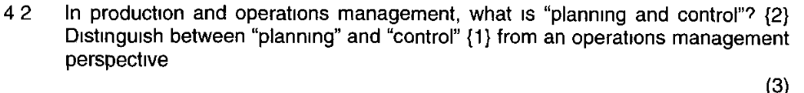
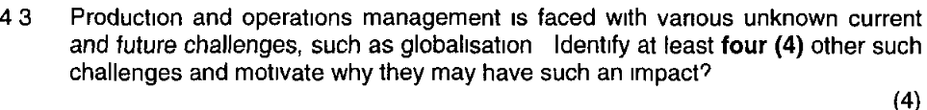
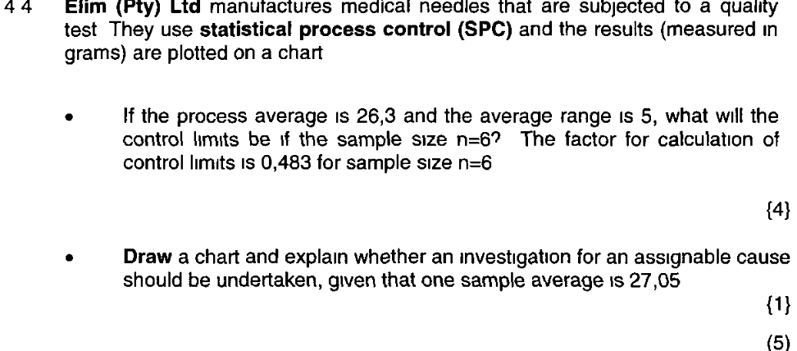
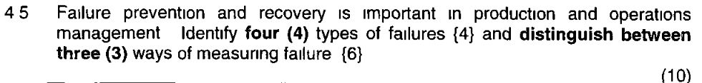

May/June 2015

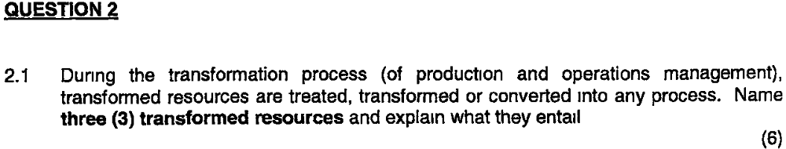

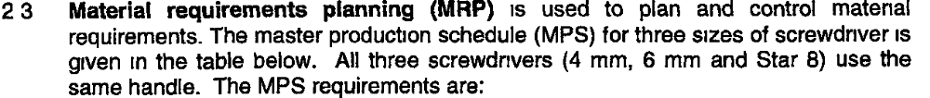
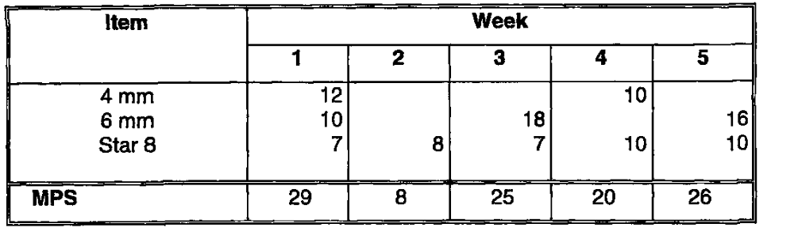
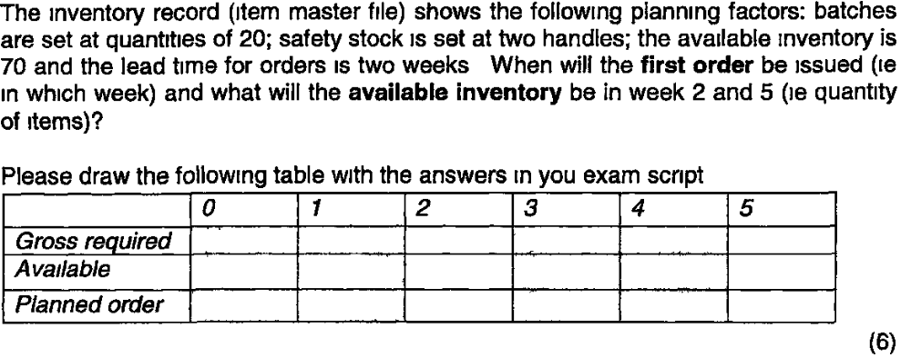

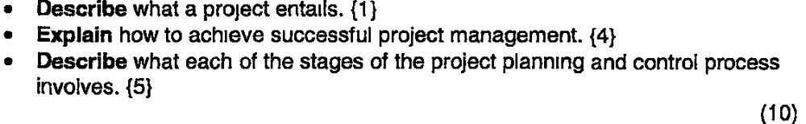

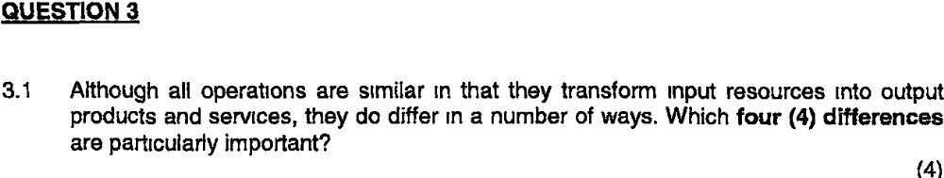

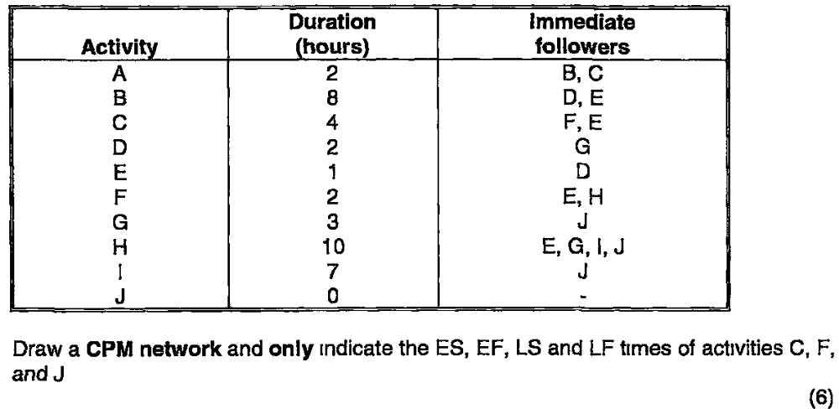

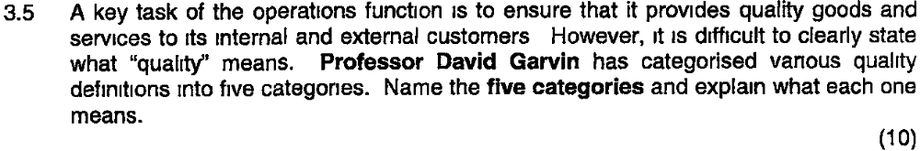
@@@@@@@@@@@@@@@@@@@@@@@@@@@@@@@
Question 4
Complete the Table Below
