- 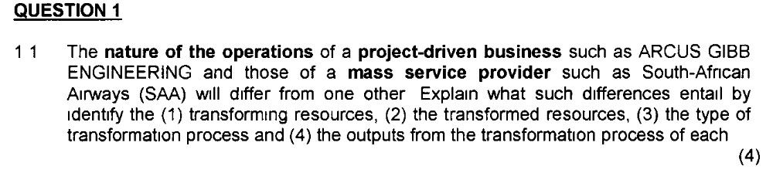
 | Transforming Resources | Transformed Resources | Types of transformation process | Outputs from transformation process
Argus GIBB Engineering | Engineers  Artisans  Machinery & Equipment | Materials, equipment | Assemble of machinery , equipment | Fully assembled machinery and equipment
SAA | Pilot  Airhostess  Ground crew  Air craft  Passengers | Check in passengers  Board Passengers  Fly passengers around the world  Care for passengers | Handing cold drink or food to the customer in the aircraft.  Transport passengers to their destination | Transported passengers

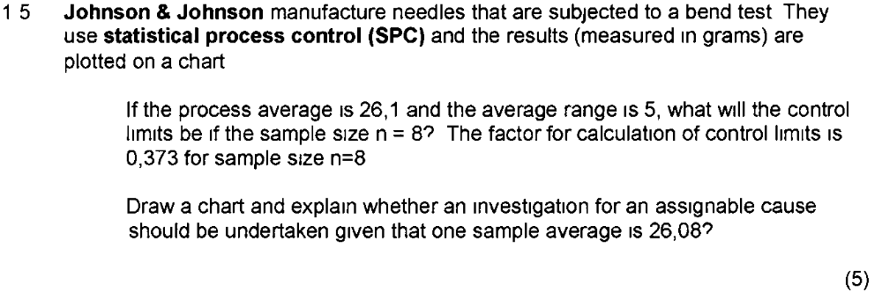
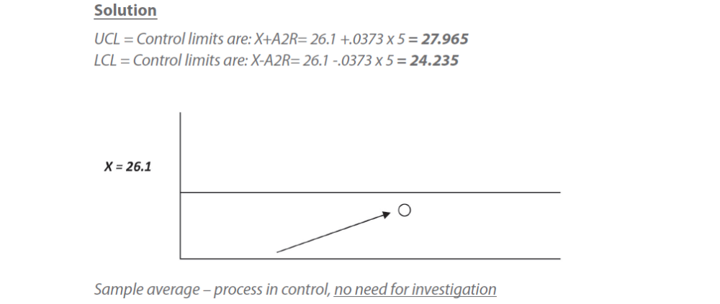
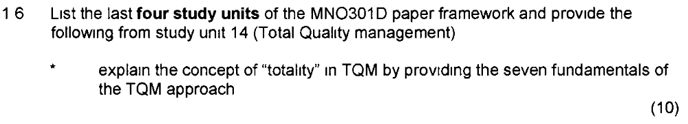
Study unit 13 – Production and operations management improvement
Study unit 14 – TQM
Study unit 15 – Failure prevention and recovery
Study unit 16 – The production and operations management challenge
Its an approach that puts quality at the heart of everything that is done by an operation and including all activities within an operation.
This totality can be summarised by the way TQM lays particular stress on the following 7 fundamentals
- Meeting the needs and expectations of customers
- Covering all parts of the organisation
- Including every person in the organisation
- Examining all costs which are related to quality, especially failure costs
- Getting things right first time i.e designing in quality rather than inspecting it in
- Developing the systems and procedures which support quality and improvement
- Developing a continuous process of improvement
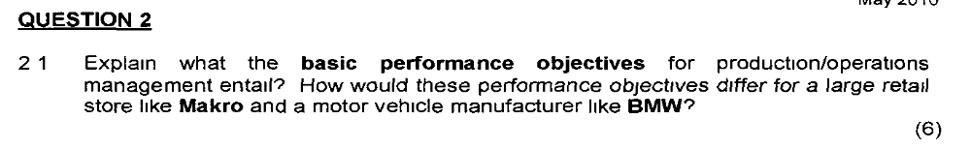
  - At a strategic level the performance objectives relate to the interest of the operations stakeholders – the company’s responsibility to customers, suppliers, shareholders, employees and society
  - By doing things right operations influences the quality of goods and services.
  - By doing things fast operations influence the speed at which goods/services are delivered.
  - By doing things on time operations influence the dependability of delivery.
  - By changing what they do operations influence the flexibility with which the company produces goods/services.
  - By doing things cheaply operations influence the cost of the company’s goods/services.
- BMW is a manufacturer and MAKRO is a retailer

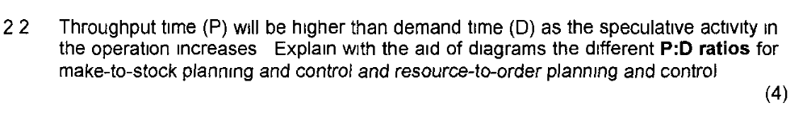
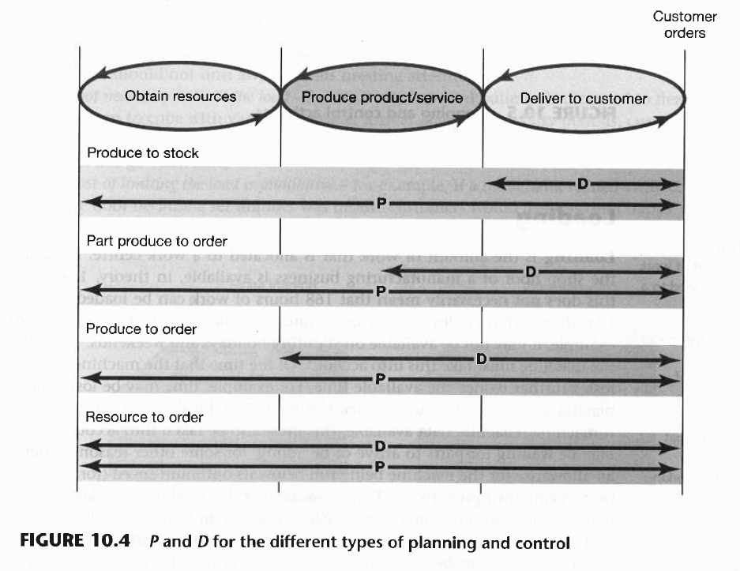
Make-to-stock – will produce goods ahead of orders and keep in stock . D is reduced and P is higher
Resource-to-order – operation will only start the process of producing goods when a customer order is confirmed. Throughput time (P) and Demand (D) are the same

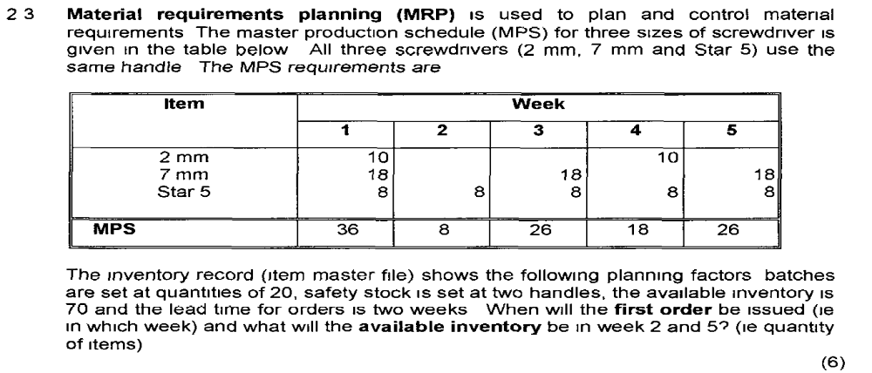
 |  | 1 | 2 | 3 | 4 | 5
Demand |  | 36 | 8 | 26 | 18 | 26
On hand/Available | 70 | 34 | 26 | 20 | 2 | 16
Order |  | 20 |  | 40
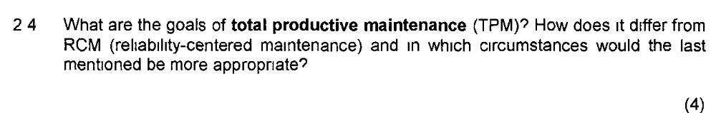
Five goals of TPM
- Improve equipment effectiveness by examining all the losses which occur
- Achieve autonomous maintenance by allowing staff to take responsibility for some of the maintenance tasks and for the improvement of maintenance performance
- Plan Maintenance with a fully worked out approach to all maintenance activities
- Train all staff in relevant maintenance skills so that both maintenance and operating staff have all the skills to carry out their roles
- Achieve early equipment management by maintenance prevention which involves considering failure causes and the maintability of equipment during its design, manufacture, installation and commissioning
RCM uses different types of maintenance for different parts of a process depending on their pattern of failure Refer Pg 595 text book

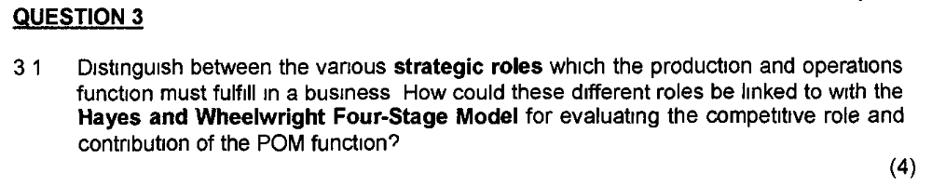
- Implementing business strategy – the most basic role of operations. Operations puts the strategy into practice
- Supporting business strategy – developing the capabilities which allow the organisation to improve and refine its strategic goals
- Driving business strategy – the most difficult role of operations is to drive strategy by giving it a unique and long term advantage.
Both Hayes and Wheelright’s stage 4 of their 4 stage model and the concept of operations driving strategy not only imply that it is possible for operations to take such a leading role but are explicit in seeing it as a good thing
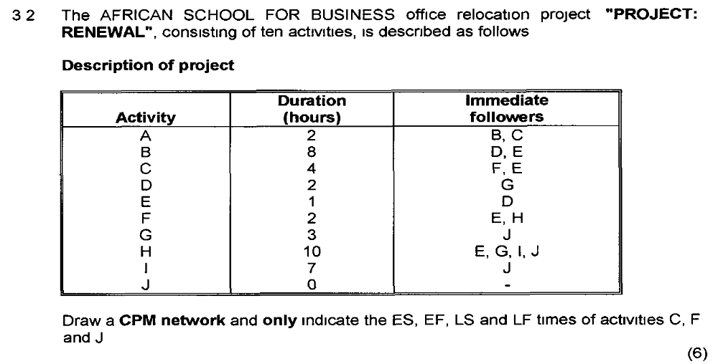
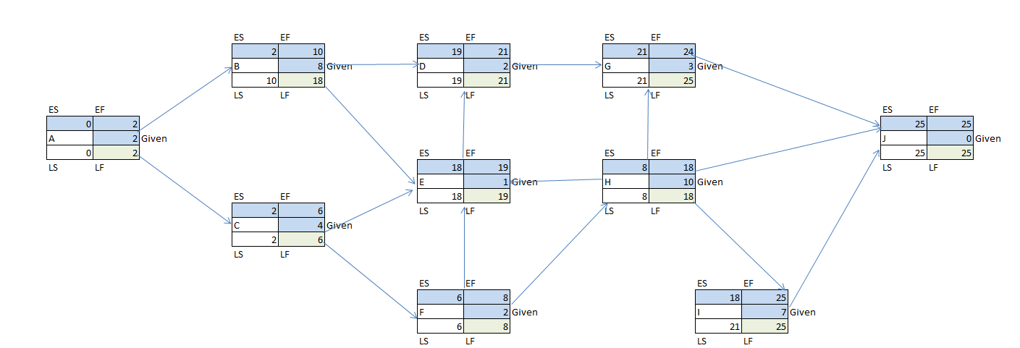

Basic working practices can be considered as the method of operationalizing the lean principle.
They are held to be the basic preparation of the operation and its staff for implementing JIT.
They include the following:
- Discipline – work standards that are critical for the safety of company members and the environment
- Flexibility – It should be possible to expand responsibilities to the extent of people’s capabilities.
- Equality – Unfair and divisive personnel policies should be discarded.
- Autonomy – Delegate increasing responsibility to people involved in direct activities of the business so the management task becomes one of supporting the shop floor.
- Development of personnel – over time the aim is to create more company members who can support the rigours of being competitive.
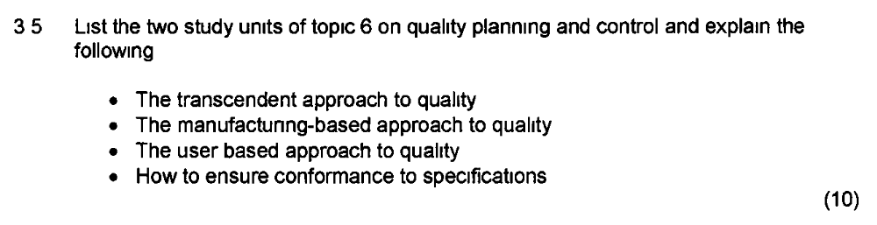
- Study unit 9 (Assuring quality in production and operation management systems)
- Study unit 10 (Statistical process control , six sigma and acceptance sampling)
- The transcendent approach to quality – Views quality as synonymous with innate excellence. Using this approach, quality is defined as the absolute-the best possible, in terms of the products or service specification
- The manufacturing based approach- is concerned with making products or providing services that are free of errors and that conform precisely to their design specification
- User based approach – is concerned with making sure that the product or service is fit for its purpose. This definition demonstrates concern not only for its adherence to specifications but also for appropriateness of that specification for the customer.
- How to ensure conformance to specifications – conformance to specification means producing a product or providing a service to its design specifications. During the design of any product or service, its overall concept, purpose, package of components will have been specified. This is the quality planning and control activity. It can be divided into 6 sequential steps
  - Step 1 Define the quality characteristics of the product or service
  - Step 2 Decide how to measure each quality characteristic
  - Step 3 Set quality standards for each quality characteristic
  - Step 4 Control quality against those standards
  - Step 5 Find and correct causes of poor quality
  - Step 6 Continue to make improvements

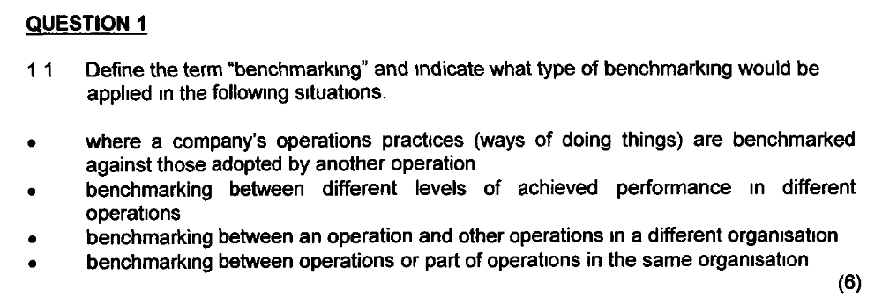
Benchmarking is the process of learning from others and involves comparing one’s own performance or methods against other comparable operations. Benchmarking is essentially about stimulating creativity in improvement practice.
- Practice benchmarking
- Performance benchmarking
- External benchmarking
- Internal benchmarking
Practice benchmarking – comparison between an organisations operations against another organisations operations.
Internal benchmarking – comparison between operations or parts of operations within the same organisation.
External benchmarking – comparison between an operation and other operations which are part of a different organisation.
Non – competitive benchmarking – benchmarking against external organisations which don’t compete directly in the same markets.
Competitive benchmarking – comparison between competitors in the same or similar markets.
Performance benchmarking – comparison between the levels of achieved performance in different operations.

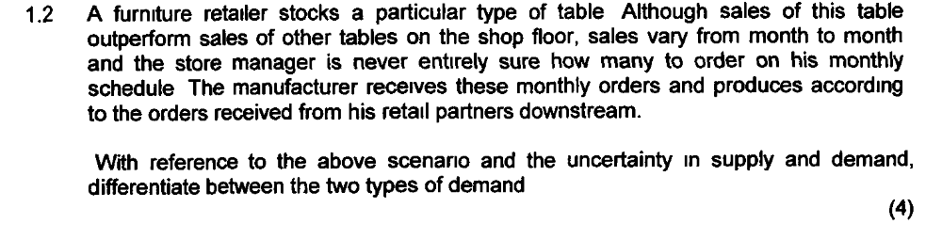
- Dependant demand is relatively predictable because it is dependent upon some factor which is known.
- Independent demand operations will supply demand without having any firm idea of customer’s orders and thus run the risk of being out of stock when demand is greater than the operation can supply.
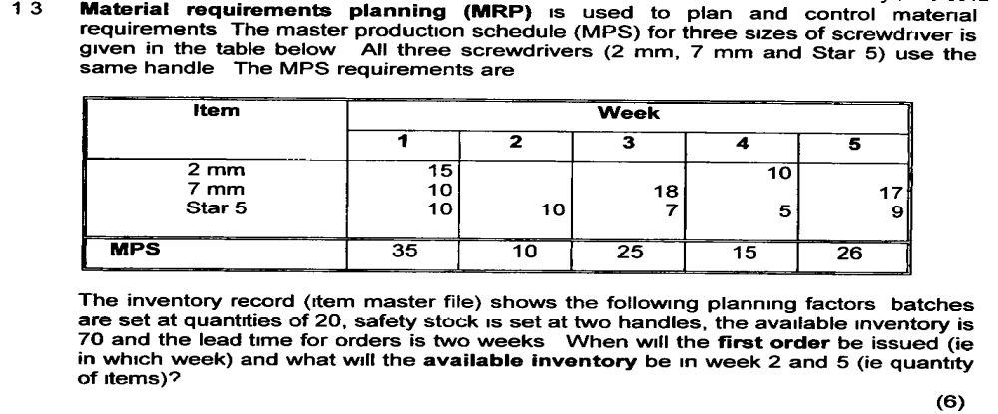

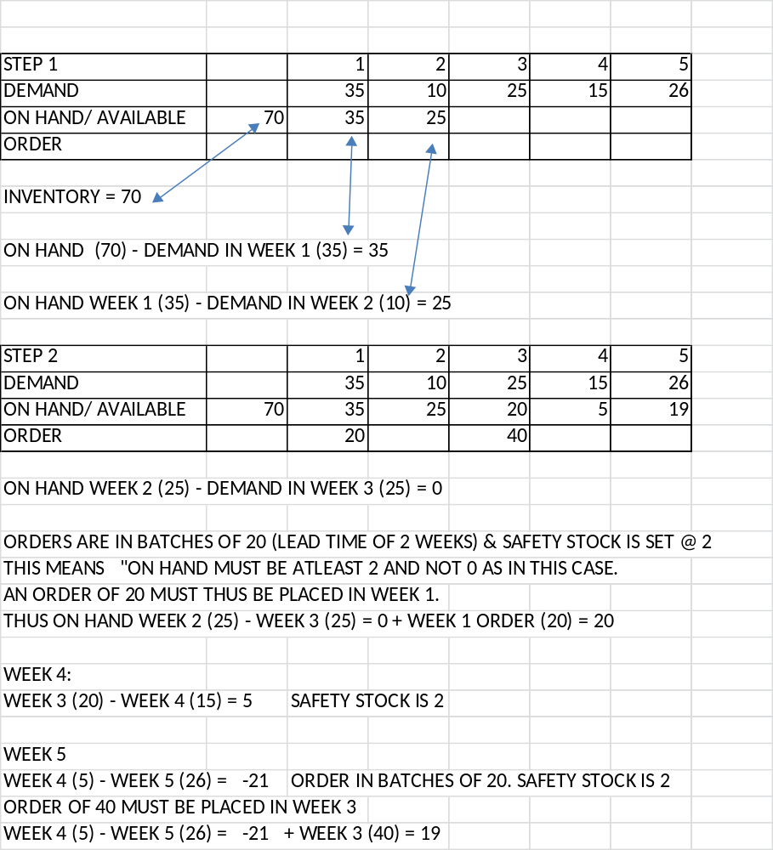

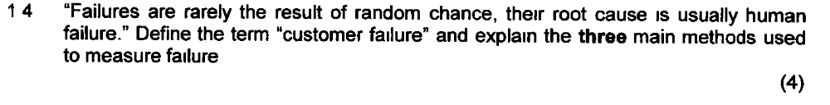
- Customer failure can result from the misuse of the products & services which the operation has created.
- There are 3 ways of measuring failures.
  - Failure rates indicate how often a failure is likely to occur.
  - Reliability measures the chance of a failure occurring.
  - Availability is the amount of available & useful operating time left after taking account of failures.

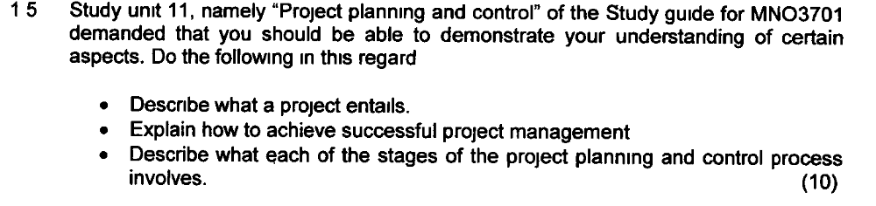 Describe what a project entails
- A project is a set of activities with a defined start point and a defined end state which pursues a defined goal and uses a defined set of resources.
Explain how to achieve successful project management
- The success of project management depends on the project objectives, which usually involve the 3 dimensions of time, cost and performance and being satisfied. It also involves the agreement on the part of all stakeholders both internal and external to the project environment that their expectations have been met or exceeded and they understand the value of the project.

Describe what each stage of project planning and control process involves.
Stage 01 - Understanding the project environment and project stakeholders.
It is important to understand the environment for 2 reasons.
First the environment influences the way a project is carried out, often through stakeholder activity.
Second the nature of the environment in which a project takes place is the main determinant of the uncertainty surrounding it.
Stage 2 – Defining the project
Projects can be defined in terms of their objectives, scope and strategy
Stage 3 - Planning the project
Project planning involves 5 stages:
- Identifying the activities within a project
- Estimating times and resources for the activities
- Identifying the relationship and dependencies between the activities
- Identifying the schedule constraints
- Fixing the schedule
Project planning is particularly important where complexity of the project is high.
Stage 4 – Technical execution of the project
Network planning and Gantt charts are the most common techniques used
Stage 5 – Project control planning
This includes the decisions related to project monitoring, assessing project performance and project change intervention.

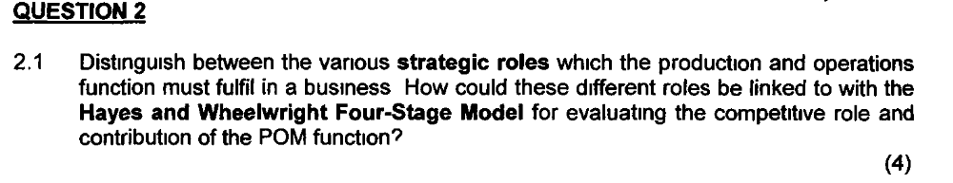
- The 3 roles the production and operations function may play in a business (namely a supporter, an implementer and a driver of the business strategy) are not mutually exclusive.
- For a business to be truly competitive, the function must fulfil all 3 roles. Hayes and Wheelwright Four stage model traces the progression of the production and operations function of a business and its competitiveness.
  - Stage 1 comprises a state of internal neutrality
  - Stage 2 external neutrality
  - Stage 3 internal support
  - Stage 4 External support

- The increased contribution and competitive role of the Production and Operations function are defined from Stage 1 to Stage 4 by the phrases
  - “Stop holding the organisation back”
  - “Be as good as competitors”
  - “Be clearly the best in the industry”
  - And finally the ultimate aspired position to “Re-define the industries expectations”
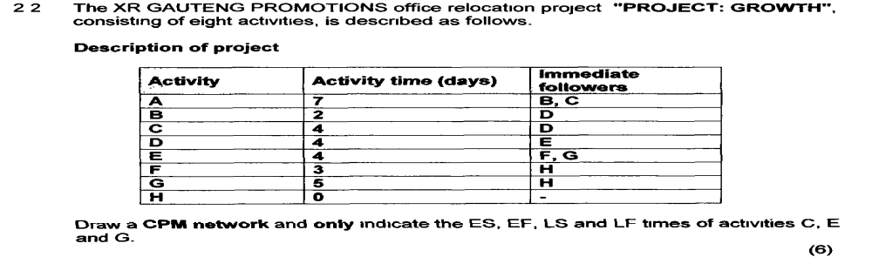

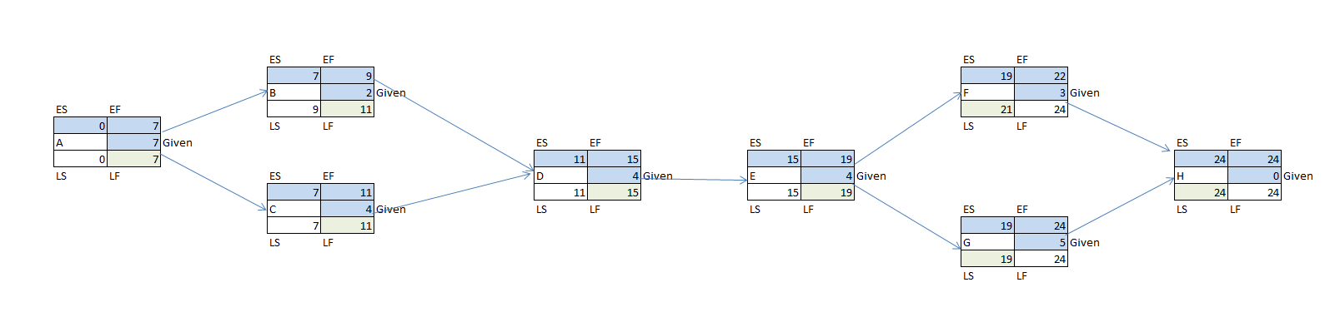
- Corporate social responsibility includes understanding the effects of operations management decisions on organizations, groups and individuals.
- It can be seen as the broad application of ethics to decision- making . All the decision areas of operations management have a social responsibility dimension to them.
- The concept of corporate social responsibility permeates almost every decision taken by operations managers.
- Most dramatic environmental contamination disasters are caused by operational failure. In a broader sense, all operations management decisions have some kind of environmental impact
- The concept of corporate social responsibility permeates almost every decision taken by operations managers. 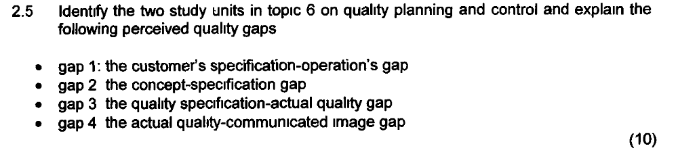
- Study unit 9(Assuring quality in production and operations management systems)
- Study unit 10(Statistical process control,six sigma and cceptance sampling)
GAP 1: The customer’s specification –operations gap
Indicates any difference’s that exists between what the customer requires and what the company aims to produce. This gap is small here because both the market requirements are well understood.
GAP 2: The concept specification gap
This gap arises because of any internal differences between management product concept and the internal specifications.
GAP 3: The quality specification – actual quality gap
Is there any difference between the finished product as received by the customer and its specifications ie. a conformance gap.
This gap is small because the specification is met at all costs.
GAP 4: The actual quality – communicated gap
Shows differences between the customer’s image of the project and the actual product. The problems in this area are the drivers for many of the problems occurring in the company.
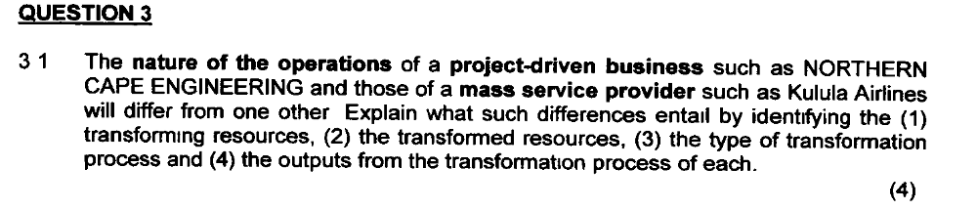

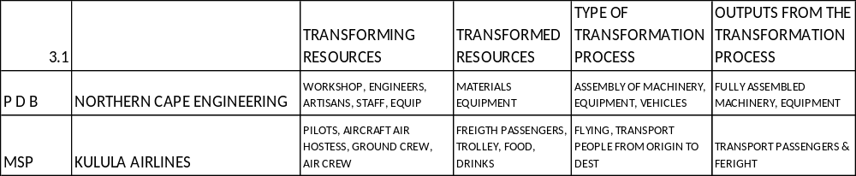

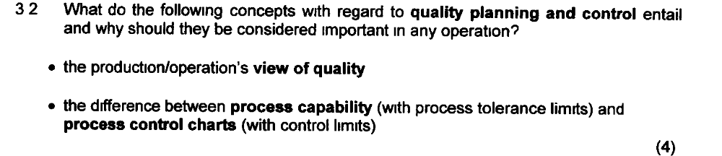
The production / operations view of quality
- Quality is consistent conformance to customer’s expectations.
- Ensuring a product/ service conforms to specification is a key operations task.
- The product service must meet the expectations of customers which may indeed be influenced by price.
The difference between process capability (with process tolerance limits) and process control charts (with control limits)
- Process capability is a measure of the acceptability of the variation of the process. The measure of capability is Cp.
- Generally if the Cp of a process is greater than 1, it is taken to indicate that the process is capable and a Cp less than 1 indicates that the process is not ‘capable’ assuming that the distribution is normal.
- Process control charts are charts that are used within statistical process control to record process performance.
- Looking for trends is an important use of control charts. If the trend suggests the process is getting steadily worse, it will be worth investigating the process.

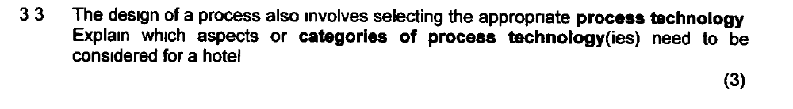
Category of process technology considered for a hotel is customer – processing technology.
The way technology is classified here is through the nature of the interaction between customers, staff and the technology itself.
There are essentially 2 types of customer –processing technologies;
Those that you interact with yourself and those that are operated by an intermediary.
When booking a hotel room, you can either make the reservation yourself by interacting with the reservation computer via the internet, mobile phone, e-mail or have an intermediary do it for you (a secretary, personal assistant, travel agent).
Active interaction with the technology :
- Mobile phone services
- Internet based order
- Email
Interaction with the technology through an intermediary:
- Call centre technology
- Travel shops booking systems

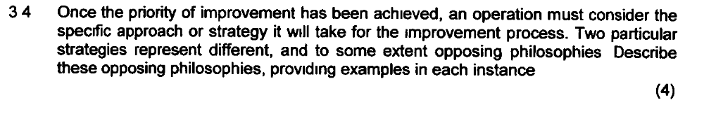
These 2 strategies are breakthrough improvement and continuous improvement
- Breakthrough improvement - assumes that the main vehicle of improvement is major and dramatic change in the way the operation works. Eg the introduction of a new more efficient machine in the factory.
- Continuous improvement adopts an approach to improving performance which assumes more & smaller incremental steps. Eg. rescheduling the assignment completion dates on a university course so as to smooth the student’s workload. Continuous improvement is also known as Kaizen.

- TQM is a holistic, comprehensive approach or philosophy to business improvement. It endeavours to excel at meeting the needs and expectations of its customers.
- It covers and includes all parts of the organisation.
- It involves every person in the business,
- It examines all costs related to quality.
- It strives to get things right the first time

- Prevention costs are those costs incurred when trying to prevent problems, failures and errors from occurring in the first place. Eg Training and development of personnel in the best way to perform their jobs.
- Appraisal costs are those costs associated with controlling quality to check to see whether problems or errors have occurred during and after the creation of the product or service. They include such things as:
- Investigating quality problems and providing quality reports
- Conducting customer surveys and quality audits.
- Internal failure costs are failure costs associated with errors which are dealt with inside the operation. These costs might include such things as:
- The cost of scrapped parts and material
- Reworked parts and material
- The lost production time as a result of coping with errors
- External failure costs are those which are associated with an error going out of the operation to a customer. These costs include such things as:
- Aggrieved customers who may take up time
- Litigation
- Guarantee & warrantee costs

Oct/Nov 2012
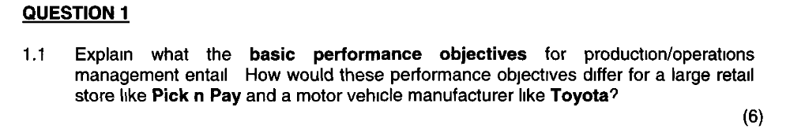
Will be the same as MAKRO and BMW

According to Pycraft et al, there are 5 operations challenges that were identified.
Namely,
- The impact of globalisation of markets
- The changing view of social responsibility
- The environmental responsibility of businesses
- The influence of technology developments on operations management
- The emergence of the concept of knowledge management
May/June 2013
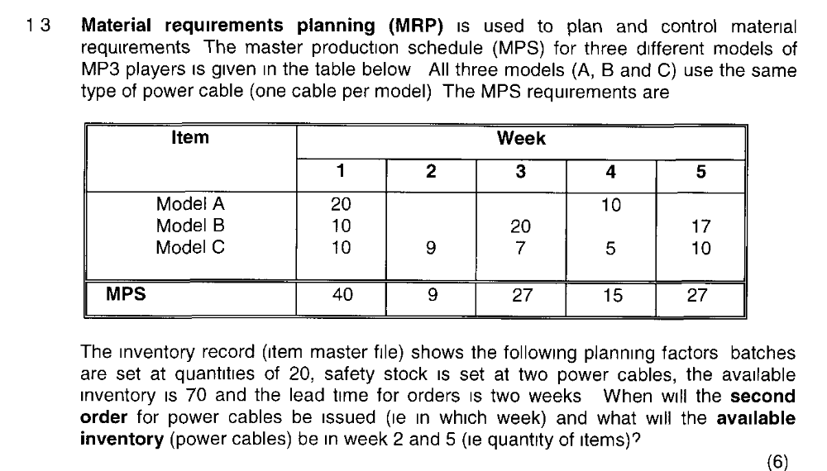
 |  | 1 | 2 | 3 | 4 | 5
Demand |  | 40 | 9 | 27 | 15 | 27
On hand/Available | 70 | 30 | 21 | 14 | 39 | 12
Order |  | 20 |  | 40

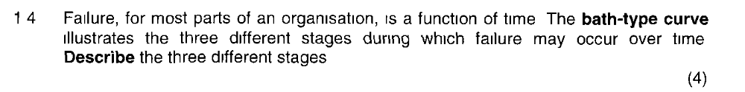
The curve that describes the time-behaviour of failure probability is called the bath-tub curve. The exact shape of the curve varies but essentially has the following characteristics:
- An initial period of high failure probability; the 'infant mortality' region.
- A steady-state region where failure probability is reduced and stable.
- A region where failure probability increases as the component or system approaches senescence.

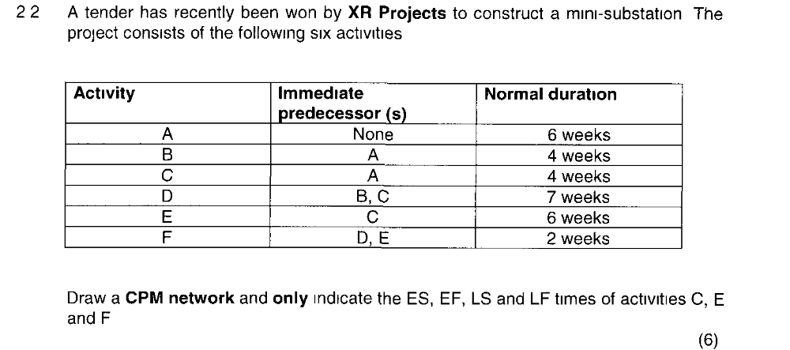
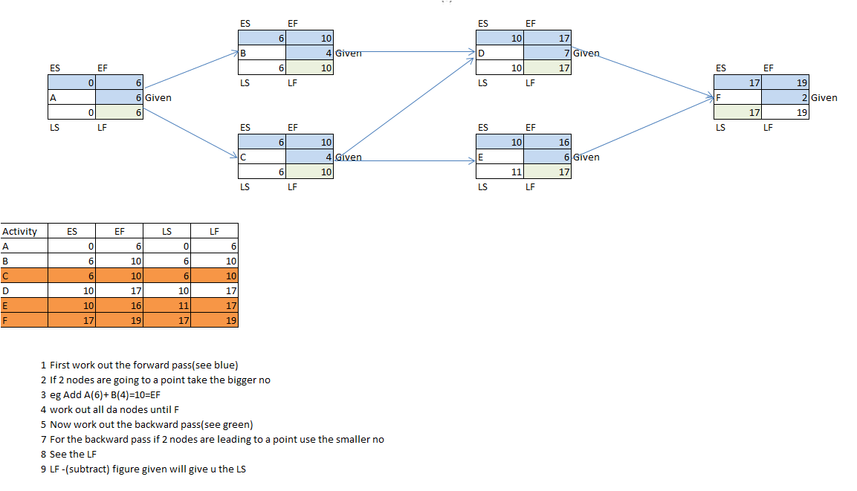
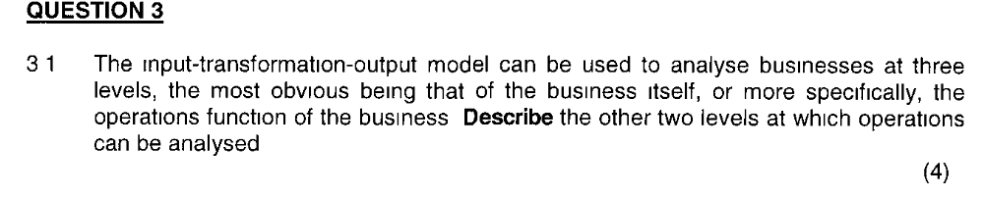
- Supply network the network of supplier and customer operations that have relationships with an operations
- Internal Supplier – Processes or individuals within an operation that supply products or services to other processes or individuals within the operation
- Internal Customer – Processes or individuals within an operation who are the customers for other internal processes or individuals outputs

It is important to understand that quality can be seen from a
- customer perspective, i.e. how a customer perceives the quality of a product or service, organisation’s image, or from an
- operations perspective, ensuring the manufactured product or delivered service conformance to specification (scrap and rework, size of inventory, capital costs and productivity are affected). Whilst these two perspectives should be the same often in practice they are not. We provide the gap model which tries to show what might cause these differences.
- Quality can have a significant effect on both revenues and costs because it impacts on the organisation’s image, scrap and rework, size of inventory, capital costs and productivity

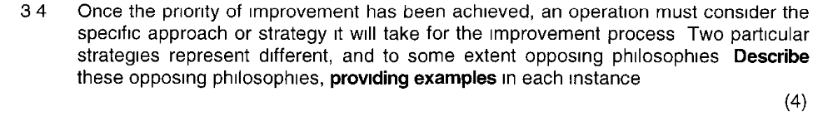

Oct/Nov 2013

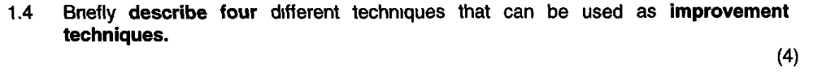
- Scatter diagrams | - Attempt to identify relationships and influences within processes
- Process maps (flow carts) | - Can be used to give a detailed understanding prior to improvement  - Describe processes in terms of how the activities within the process relate to each other.
- Cause effect diagram | - A technique for searching out the root cause of problems, it is systematic questioning technique
- Pareto diagrams | - Attempts to sort out the ‘ important few’ cause from the ‘trivial many’ causes
- Why-why analysis | - Pursues a formal questioning to find the root causes of problems

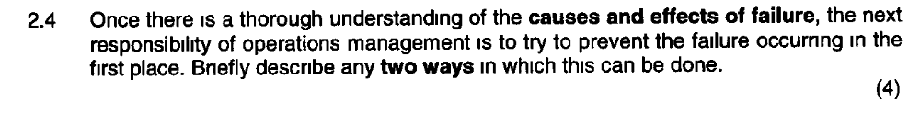
2 Ways to prevent failure occurring
- Improving process reliability
Redundancy
- Building in redundancy to an operation means having back-up systems/components in case of failure
- The extent to which a process , product / service has systems/components that are used only when other systems /
- components fail
- Some organizations have ‘back up’ staff held in reserve in case someone does not turn up for work etc
Fail Safeing
- On the principle that human mistakes are to some extend inevitable.
- What is important is to prevent them becoming defects
- Poka Yokes are simple devices / systems which are incorporated into a process to prevent inadvertent operator mistakes resulting in a defect.

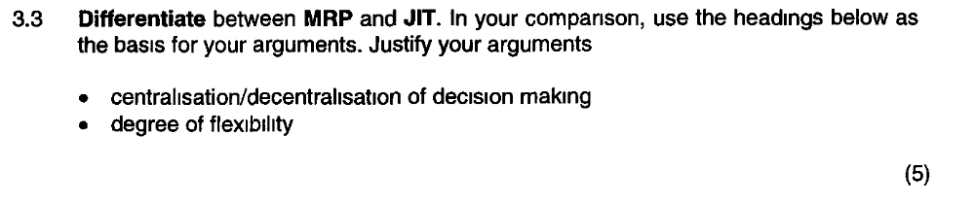
MRP | JIT
- MRP is driven by the master production schedule which identifies future end item demand  - It models a fixed lead time environment, using the power of the computer to calculate how many and when each part should be made. Its output is in the form of time-phased requirements plans that are centrally calculated and co-ordinated.  - Parts are made in response to central instructions  - Day to day disturbances such as inaccurate stock records can make the plans unworkable  - MRP is excellent at planning but it is weak at control  - MRP is also better dealing with complexity as measured by numbers of items being processed.  - It can handle detailed requirements even for strangers | - JIT scheduling aims to meet demand instantly through simple control systems based on Kanban.  - If the total throughput time is less than the demand lead time, then JIT systems should be capable of meeting that demand.  - JIT is good at control but weak on planning.  - JIT pull scheduling is less capable of responding instantly to changes in demand therefore JIT production systems favour designs based on simpler products structures with high parts commonality. Hence JIT is less flexible than MRP.

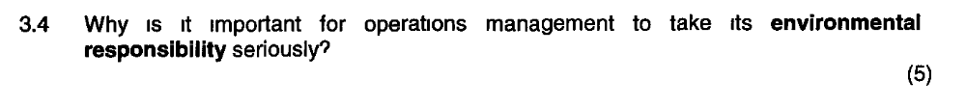
- Most dramatic environmental contamination disasters are caused by operational failure.
- In a broader sense all operations management decisions have some kind of environmental impact.
- Increasingly, companies are making formal reports and statements relating to their environmental practice.
- Operations managers are often responsible for providing the basic information for these reports. The environmental management system ISO 14000 is being adopted by a wide range of organisations.
- Operations managers often have to implement these standards.

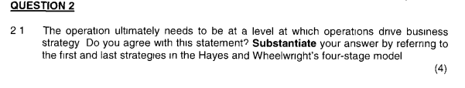
Yes I agree with this statement.
- In the 1st stage of Hayes and Wheelwrights model, the operations function is at the very poorest level of contribution.
- It is holding the company back from competing effectively. The operations function is reactive with very little positive to contribute towards competitive success.
- At this stage the operations function is unable to drive business strategy.

- The 4th stage of Hayes and Wheelwrights model is where the operations function has re-defined industry expectations and has an operations advantage.
- In stage operations are innovative, creative and pro-active and are driving the company’s strategy by being one-step ahead of competitors which according to Hayes and Wheelwright, termed as being ‘externally supportive’.

