CHAPTER 6
mphakip@gmail.com
Marketing, public relations and the media

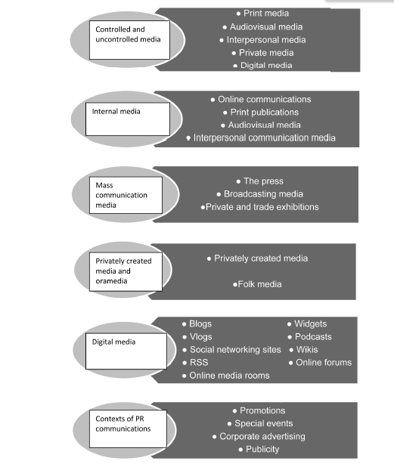
- Controlled media
  - The pr practitioner has a say over content; how and when
  - Paid for media
  - Corporate print material such as pamphlets & annual reports
- Uncontrolled media
  - The practitioner does not have direct influence over media content
  - Photographs with captions and news stories
- Internal communication
- Online communication
  - e-mail, intranet, voicemail and new media
- Print publications
  - bulletins, news letters, news tabloids, magazines etc.
- Audiovisual media
  - flip charts, transparencies, video calls and PowerPoint
- Interpersonal communication media
  - meetings, briefings, speeches and discussion groups
For example – when an employee puts on their workstation in the morning the first they they are greeted with is news and information about the organisation on the intranet here is an example of Unisa’s intranet.
Print publications – this is internal print publications for example an employee magazine
Audiovisual media such as video calls on Skype
Interpersonal communication which is face to face such as the setting we have today.
- Online communications
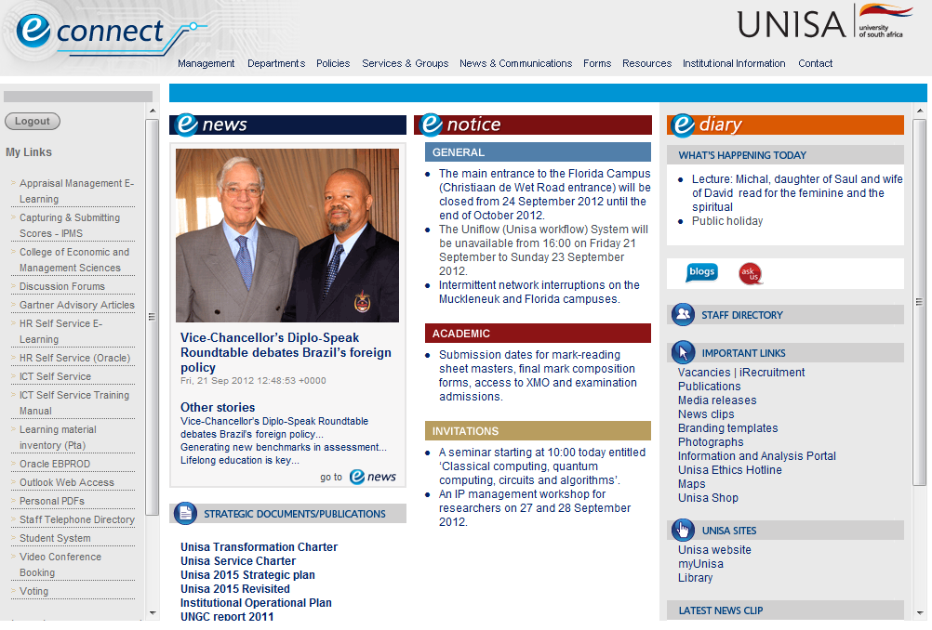
- External communication
- Mass communication
  - The press
  - printed media such as newspapers and magazines
  - Broadcast media
  - television and radio
  - Public and trade exhibitions
  - exhibitions, shows, displays and trade fairs

- Trade exhibitions


  - Privately created media
  - Documentary films
  - Videotapes/DVDs
  - Private and mobile exhibitions
  - Educational literature
  - Seminars and conferences
- New media/digital channels
  - Blogs
  - Vlogs
  - Social networking sites
  - Real simple syndication (RSS)
  - Widgets
  - Podcasts
  - Wikis
  - Online forums
  - Online media rooms

- The meaning of social media networks

- You will realise that social media, as the name itself explains, provide people with opportunities to socialise on a wider scale than ever before, but in a virtual environment.
- People can now communicate with many friends, acquaintances, admirers and people within a chosen interest group all over the world at the same time.
- Socialising, in marketing terms, generally took place in the marketplace.
- The marketplace, even far back into the past, has been the gathering and meeting place of people
- This has become less and less true of the new markets and in the hustle and bustle of modern shopping centres and central business districts

You will notice a few characteristics of social networks:
- Participation is free for their members.
- These networks tend to rely on advertising for their revenue.

The benefits of social media networks for marketing

Because of demographic information collected by the social networks, PR managers are able to target their PR messages to particular audiences.
PR managers can use social media to create inbound marketing. With inbound marketing the focus is on “getting found” by customers. With traditional or outbound marketing, the company focuses on finding customers.
Public relations managers can obtain valuable information and feedback straight from the customer in a spontaneous way.

- Special marketing application possibilities through social media

- Social media in themselves can be interesting, good to retain contacts, fun and even a waste of time if misused.
- The social media, however, provide a platform for use by PR managers, marketers, politicians, action groups, environmentalists and many more to be heard and to get into a conversation with the online audience.
- Various application possibilities for the use of social media as part of the overall marketing strategy are emerging as marketers start to embrace the social media.
- introducing new concepts to the market or a specific section of the market and generating feedback for analysis
- creating brand image through social media groups
- building relationships by keeping regular contact with the chosen consumer groups

- CONTEXTS OF PUBLIC RELATIONS COMMUNICATIONS
The context of public relations communications relates to the situations in which the various public relations media can be used to help achieve public relations objectives.

Examples of these contexts include the following:
- sponsorships
- promotions
- special events
- corporate advertising
- publicity
- media relations

