MNG2602 – EXAM PAPERS & SOLUTIONS
MAY/JUN 2015
Section A: Multiple Choice Questions
- Mr Chris O’Reilly, the CEO of MoneyMax Micofinancing Solutions, is looking for a new manager to operate and lead the first international branch of his business in Australia. While doing research, he comes across a profile for effective global leaders and users this profile as an aid to compile the job requirements for the position.
Which one of the following is not an ability that the new global manager of MoneyMax would need?
1. He/she must be able to work independently.
2. He/she should be able to transfer knowledge effectively.
3. He/she must be able to manage the change process.
4. He/she should have excellent communication skills
- Which one of the following is not a variable that influences a contemporary organisation to change?
1. Technological advances
2. Higher expectations of workers
3. Intellectual capital as a critical resource
4. Flatter organisational structures
Questions 3 to 4
Match the feature of the new organisation in column A with the managerial challenge inherent to that feature in column B
COLUMN A – FEATURE | COLUMN B – MANAGERIAL CHALLENGE
- Networked (3) | 1. Negotiating with win-win situations
- Global (4) | 2. Working productively at several tasks
 | 3. Forming alliances with suppliers
 | 4. Managing culturally diverse individuals
Consider the following list of job requirements of workers and answer question 5.
a) Repetitive skills
b) Risk avoidance
c) Dependence on memory
d) Being creative
e) Collaborating with people
- Which 2 of the above requirements are relevant to the knowledge era?
1. d; c
2. b; a
3. d; e
4. a; r
Questions 6 to 13
Read the following case study and answer questions 6 to 13
- The consumer trend where customers increasingly choose healthier and more organic food products refers to an _________ change, caused by a ________ force.
1. External; social
2. External; technological
3. Internal; stakeholder
4. Internal; technological
- The implementation of the new point-of-sales system at Organix refers to an ________ change, caused by a ________ force.
1. External, technological
2. Internal; power and politics
3. Internal; new technology
4. External; pressure to grow
- The decision that Mrs. Scott should find a new supplier would deliver quinoa more frequently, is an example of _________ change.
1. Revolutionary
2. Punctuated
3. Reactive
4. Planned
- The new manager, Mrs. Scott, used the _________ method to overcome resistance to change.
1. Education
2. Participation
3. Facilitation
4. Negotiation
- When Organix expanded and opened a branch in Pretoria, it followed a _______ growth strategy.
1. Integration
2. Market development
3. Diversification
4. Product development
- Should Organix successfully acquire Fresh Eating, they would be implementing a(n) ________ strategy.
1. Concentric diversification
2. Unrelated diversification
3. Horizontal integration
4. Backward integration
- The new tradition that will be taking place on Fridays, forms part of creating a _________, which is step _______ in Kotter’s successful change process.
1. Culture, eight
2. Vision, five
3. Sense of urgency, five
4. Guiding team, eight
- There are a number of situational factors that could have influenced the choices Mr. Hudson faced when he decided to design and implement a change effort. When the anticipated strength of resistance is _______, the involvement of others will be ________.
1. Strong, lots
2. Weak, lots
3. Great, little
4. Little, lots
- __________ is an integration model of how the organisation conducts its business.
1. The mission statement
2. Strategic leadership
3. An environmental analysis
4. Organisational architecture
- The ______ perspective of the balanced scorecard is measured by ________.
1. Financial, growth
2. Customer, quality
3. Learning, growth
4. Internal, quality
Question 16 to 17
Match each quadrant of the Boston Consulting Group Growth-share Matrix in Column A with an appropriate description in column B.
COLUMN A – QUADRANT OF THE MATRIX | COLUMN B – DESCRIPTION OF QUADRANT
16. Question marks (3) | 1. Strategic business units with a high market share and low market growth rate
17. Cash cows (1) | 2. Strategic business units with a high market share and high market growth rate
 | 3. Strategic business units with a low relative market share and a high relative market growth rate
 | 4. Strategic business unit with low market share and a low market growth rate

- Mustard Seed Communications (MSC) believes in diversity and employing people, regardless of their ethnicity, in positions that match their skills and experience. MSC is hosting a diversity week to show that they promote the diverse nation within which they operate. They will have an informational programme every day on all the different ethnic groups in SA.
What misconception regarding diversity is illustrated in the above scenario? Diversity is not _____?
1. A culture
2. Affirmative action
3. Equal employment
4. An absence of standards
- Which one of the following is a reason for an increased focus on managing workforce diversity?
1. The industrialisation of countries globally
2. An increase in productivity and profitability
3. Globalisation of businesses and the use of information and communication technologies (ICTs)
4. The increasing number of ethnic groups in countries.
- The _____ approach is not an approach used to manage diversity.
1. Golden rule
2. “Right the wrongs”
3. Platinum rule
4. “Value of differences”
- When applying the learning-effectiveness diversity paradigm as a strategy for diversity management, the organisation focuses on ________.
1. Making all employees feel valued and respected
2. Creating equal opportunities and ensuring fair treatment
3. Matching employee demographics to the customers and marketplace
4. Incorporating diversity into the heart of the mission, work and culture
Questions 22 to 23
Consider the following perspectives on project management and answer the questions
a) Control is exercised over all the activities of the project, which leads to higher overall productivity
b) The different beliefs and values of the project team can be transmitted and aligned
c) Transparency in a project can be improved when all the role-players are involved
d) A viewpoint taken on the efficiency of systems, methods and procedures employed by the organisation to deliver quality products and/or services
e) A view taken to determine the effectiveness of the organisation’s products and/or services in the marketplace
f) The project manager needs to allocate resources, tasks and responsibilities to an individual group in order to complete the task within a certain time
g) Projects are undertaken in a competitive environment where work is acquired through tenders
h) Different government departments invariably have to collaborate to ensure the success of these projects
- Which 2 of the above-listed variables form part of the internal perspective of project management?
1. a; h
2. c; e
3. b; g
4. d; f
- Which 3 of the above-listed variables form part of the external perspective of project management?
1. a; d; f
2. e; g; h
3. d; e; f
4. b; e; h
Questions 24 to 26
Consider the table below on the key-role players in project management and their corresponding responsibility, and answer questions 24 to 26.
KEY ROLE PLAYER | CORRESPONDING RESPONSIBILITY
a) ________ | Mediates at strategic level on behalf of the project management / team
Tactical manager | b) ____________
c) ________ | A cohesive group of professionals working together to achieve contracted project deliverables
- Identify the key role-player for option (a)
1. Project sponsor
2. The project team
3. Operational manager
4. Project management office
- Identify the main responsibility of a tactical manager in option (b)
1. Identify the internal and external environments of the organisation, and defines the strategies direction and priorities of the organisation
2. Manages at lower management level, and ensures that system, methods, processes and resources are optimally used
3. Manages at middle management level, and ensures that systems, methods, processes and resources are in place.
4. Responsible for the management and administration of project-specific systems, processes, procedures, methods, tools and techniques
- Identify the key role-player for option (c)
1. Project sponsor
2. The project team
3. Operational manager
4. Project management office
Questions 27 to 33
Read the following case study and answer questions 27 to 33
- The element of culture that is illustrated by the open door policy and informal communication between top management and the employees at Microsoft South Africa is a(n) ___________.
1. Assumption
2. Symbol
3. Artefact
4. Value
- The fact that employees dress professionally during the week, but wear informal outfits on Fridays, is an example of a(n) _________, which is part of the _________ level of culture.
1. Norm; second
2. Assumption; third
3. Symbol; first
4. Ritual; fourth
Questions 29-31
Consider the following list of influence tactics and answer the questions.
a) Rational persuasion
b) Inspirational appeal
c) Pressure
d) Coalition
e) Ingratiating
f) Exchange
- When Mr. Spector speaks to his subordinates in the sales department about their failure to reach their midyear targets, he could influence them by using tactics such as _________ and ___________.
1. b; c
2. a; e
3. b; d
4. c; e
- Mr. Spector consults his colleague, Mr. Ross, about an internal organisational matter. In this situation the most effective influence tactics that Mr. Spector could use, are ________ and ________.
1. c; e
2. b; d
3. d; e
4. b; c
- The best tactic Mr. Spector could use to provide Mr. Nyati with arguments and evidence concerning the changes he wishes to introduce to achieve the sales department’s goals more efficiently, would be _______.
1. e
2. d
3. b
4. a
- Microsoft topped the ratings in this regard in the USA by ensuring that their present actions would not hamper the ability of future generations to satisfy their needs, thereby creating a cycle of sustainability.
The 3 pillars of the triple bottom line of sustainability that Microsoft should focus on are ______, _______ and __________.
1. Profit, communities, ethics
2. Morality, people, planet
3. Environment, economy, ethics
4. Economy, society, environment
- The Microsoft Unlimited Potential (UP) programme is an example of ___________.
1. Business ethics
2. Promissory relations
3. Corporate governance
4. Corporate social responsibility
Questions 34 to 35
Match the type of group in Column A with its corresponding example in Column B to answer the questions
COLUMN A – QUADRANT OF THE MATRIX | COLUMN B – DESCRIPTION OF QUADRANT
34. Interest Group (1) | 1. Colleagues as Microsoft who share a love for mountain biking and ride together every Sunday
35. Task Group (4) | 2. A committee in the Microsoft human resources department that organises social events for all the members of that department
 | 3. The general manager; and the marketing manager report to the regional director
 | 4. Individuals in a standing committee form a group that are tasked with identifying new research areas for Microsoft SA
- According to Edgar H Schein, culture is a pattern of assumptions that is developed by an organisation to deal with problems of external adaptation and internal integration.
External adaption tasks do not include the development of consensus on the _________.
1. Goals of the organisation
2. Group boundaries and criteria for inclusion
3. Criteria that are used to measure the results
4. Resources the organisation uses to accomplish its goals
- The ________ culture, as categorised by __________, is typified in terms of norms, values and beliefs.
1. Person, Jones et al (2006)
2. Role, Charles Handy (1993
3. Process, Deal and Kennedy (2000)
4. Market, Trompenaars and Prud’homme (2004)
- Quinn and McGrath (1985) identify 4 types of culture, namely the ________, _________, ____________ and hierarchy culture.
1. Power, process, logic
2. Role, aggressive, constructive
3. Person, authority, passive
4. Market, adhocracy, clan
- The relationship between power and ________ is based on the idea that a member of a group that has formed because the members work in the same geographical area, will use his/her power to protect the group.
1. Politics
2. Interests
3. Influence
4. Conflict
- A(n) ________ strategy will be appropriate to manage organisational conflict in a situation where a high level of willingness to consider the apprehensions of others and a high degree of assertiveness are present. This strategy involves __________.
1. Avoidance, on or both parties choosing to avoid or suppress the conflict
2. Collaboration, addressing all differences and creating a win-win situation for all parties
3. Compromise, both parties giving something up and the parties reaching a consensus decision
4. Accommodation, one party choosing to focus on the other party’s needs to suppress or resolve the conflict
Consider the following steps in the second and final phase of the negotiation process and answer question 41.
a) Allow the other party to make the first offer
b) Focus on the issues, not the individuals
c) Do not rush into the agreement
d_ Make sense of the other party’s needs
- Place the steps in the negotiation phase listed above in the correct sequential order.
1. b, a, d, c
2. a, c, b, d
3. b, c, a, d
4. a, b, d, c
- Groups represent __________, because group action can achieve what individuals often cannot achieve by themselves.
1. Power
2. Status
3. Authority
4. Achievement
- Which one of the following is not a condition for an effective team?
1. Widespread acceptance and commitment are critical to the successful implementation of a response to a situation
2. The problem and its solution have important organisational sequences
3. The problem is relatively complex, uncertain and holds the potential for conflict
4. There are tight and immediate deadlines
- In the _______ stage of group and team development _________.
1. Forming, individuals attempt to influence the group
2. Storming, members become more assertive and opinionated
3. Norming, there is a sensitive balancing of forces between members
4. Performing, the group can complete complex tasks
- Which one of the following statements regarding an organisation’s value system is incorrect?
1. The value chain and value system allow managers to focus on their internal activities and are linkages with the activities taking place in their industry
2. Michael Porter developed both the value chain and the value system
3. The value chain is an interdependent system of activities connected by various linkages
4. Quality initiatives such as total quality management (TQM) and just-in-time (JIT) principles focus on the value chain rather than the value system
- The secondary activities of the value chain do not include ___________.
1. Human resources
2. Technologies
3. General management
4. Marketing
- A(n) __________-based business model adds value through selection, distribution efficiencies and the leveraging of brand image and reputation.
1. Mark-up
2. Subscription
3. Advertising
4. Commission
- _________ systems can act as an early warning system and allow managers to take preventative steps in good time.
1. Expert
2. Workflow management
3. Decision support
4. Management information
Read the following mini case study and answer the questions.
- takealot.com is an example of a(n) ____________ e-business shopping model.
1. Storefront
2. Online trading
3. Click-and-mortar
4. Online service provision
- When doing an internet search on Google using the words “shop online South Africa”, one finds the takealot.com link in the right-hand margin of the first results page. Google reserves this section and the top margin on the page for _________ search results.
1. Ranked
2. Organic
3. Pay per click
4. Online trading

Section B
Question 1
Read the following case study and answer the question that follows.
Mike, Maggie and the rest of the cockpit crew looked at each other with pained expressions on their faces. After talking quietly for a few minutes, Mike summarised their options: They could follow Denver’s orders and stay aloft, or they could demand a landing for a medical evaluation. What should Mike do?
Approach this ethical dilemma from a utilitarian perspective and apply the rational, ethical decision-making process to assist you in deciding what to do. Use the 8 steps as headings to structure your answer. Conclude whether you would land the plan or stay aloft.
Utilitarianism – a consequentialist approach. However, unlike egoism, the morally appropriate action under utilitarianism is the one that holds the most positive long-term consequences for the majority of people affected by a specific action. Using Utilitarianism, the manager may reason that the benefits arising from the company’s passive compliance with a corrupt regime are greater than the benefits that will result from ceasing operations, since a number of primary stakeholders such as employees, suppliers and consumers are directly dependent on the company for their livelihoods, and will suffer greatly if the company closes office. Therefore, according to utilitarianism, the moral course of action in this specific instance may well be to continue with operations, even though the rights of a number of people may be indirectly harmed by this decision.
Utilitarianism approach refers to morality of where interests of everyone is involved.
When the utilitarian approach is adopted, the effects of a particular action on those directly involved is judged in terms of what provides the greatest good for the greatest number of people.
Utilitarianism is consequential where the morality of an action is judged according to the positive long-term consequences that the action holds.

OCT/NOV 2015
Section A: Multiple Choice Questions
Read the following case study about Woolworths and answer questions 1 to 9.
- When considering the objectives of the Good Business Journey programme, Woolworths is applying the ________ corporate social responsibility.
1. Broad view
2. Virtue approach
3. Statutory approach
4. Shareholder model
- The measures taken to receive the Good Egg Award indicate that Woolworths is concerned about ______.
1. Social sustainability
2. Ethical leadership
3. Corporate governance
4. Environmental sustainability
- The normative ethical theory approach used by Zyda Rylands, when deciding that Woolworths will only sell free-range whole eggs in their stores, is the _________ approach.
1. Altruism
2. Morality
3. Deontology
4. Utilitarianism
- The normative ethical theory approach used by Woolworths when deciding to sell only free-range eggs is not virtue ethics, because the morality of the action is not only based on the _________.
1. Action’s adherence to a set of rules
2. Self-interest of an individual
3. Character of a good person
4. Interest of other individuals
- Mr. Susman is a _________ stakeholder of Woolworths, which forms part of one of the pillars of the triple bottom line, an accounting measure for _________.
1. Primary, governance
2. Primary, sustainability
3. Secondary, ethical business
4. Secondary, ethical leadership
- Mr. Susman’s position in the sustainability committee gives him _________ power.
1. Reward
2. Coercive
3. Referent
4. Legitimate
- Ms. Rylands possesses ______ power that stems from her knowledge of sustainability and the NSPCA’s Animal Welfare Code of Practice.
1. Formal
2. Expert
3. Referent
4. Coercive
- If Mr. Nissan (a member of the sustainability committee) uses a coalition influence tactic, he will _________ in order to convince the chairman to add a specific sustainability target to the committee’s activity list for the upcoming year.
1. Arouse enthusiasm through an emotional request
2. Seek the support of the other committee members
3. Use logical arguments and factual evidence
4. Use humour and friendliness
- If Mr. Nissan decides to speak to a journalist shortly after a committee meeting, disclosing the sustainability performance of Woolworths before the final sustainability report has been compiled, it will be ___________, a(n) _________ and _________ form of political behaviour.
1. Sabotage, legitimate, internal
2. Retaliation, legitimate, external
3. Disloyalty, illegitimate, internal
4. Whistle-blowing, illegitimate, external
Read the following additional information on Woolworths and answer questions 10 to 18
Match each example in Column B to the correct strategic management concept in Column A.
COLUMN A – STRATEGIC MANAGEMENT CONCEPT | COLUMN B – EXAMPLE
10. Vision Statement (4) | 1. “Woolworths is planning to sell more private label fashion in the stores, as well as introducing a loyalty programme and other operational changes”
11. Mission statement (3) | 2. “it’s about letting our customers shop how, where and when they want”
 | 3. “as passionate, committed retailers, they understand and lead their customers through excellence and a deep knowledge of their products and services and the world we live in”
 | 4. “they aim to be a world leader in retail brands that appeal to people who care about quality, innovation and sustainability”
- When purchasing David Jones, Woolworths followed a ____________ and ______________ strategy.
1. Backward integration, related diversification
2. Market development, corporate combination
3. Concentration growth, product development
4. Forward integration, cost leadership
- According to the Boston Consulting Group growth-share matrix, Country Road can be classified as a ___________.
1. Star
2. Dog
3. Cash cow
4. Question mark
- Woolworths is following a(n) _______________ e-business shopping model.
1. Storefront
2. Online trading
3. Click-and-mortar
4. Business-to-consumer
- Woolworths implemented a(n) _____________-based revenue generating business model.
1. Referral
2. Mark-up
3. Advertising
4. Commission
- The advanced e-business technology that was recommended for Woolworths to use when they wanted to prevent the loss of the acquired intellectual capital built up by Nikki Cockcroft can be classified as a(n) ___________.
1. Expert system
2. Neural network
3. Workflow management system
4. Management information system
- Which one of the following statements is incorrect regarding groups at Woolworths?
1. A group that forms at a Woolworths branch will involve 2 or more interdependent individuals, who work together to achieve specific goals
2. Individuals may join a group at their Woolworths branch in order to satisfy their social and affiliation needs
3. If a group of individuals from Woolworths decide to form a book club that meets weekly during lunch, they are classified as an interest group
4. A group formed at a Woolworths branch in Pretoria that has a very clear line of authority can be classified as a command group
- Which one of the following statements demonstrates an example of a self-managed work team at Woolworths?
1. Managers from all the functional areas of Woolworths have a meeting where they use their collective expertise to solve complex problems
2. Employees from the marketing department at the Woolworths H/O in Cape Town meet every Friday to discuss ways of improving their efficiency as well as new marketing opportunities
3. Individuals employed by various Woolworths branches country-wide form a team where members are task-orientated and use technology to complete their designated tasks
4. Multi-skilled individuals who functional autonomously and meet with their leader every day to decide on issues such as improvements in design and the hiring of new team members
- Knowledge management in a systematic approach to manage the __________ assets of the organisation, and an example of these assets includes ______________.
1. Information, policies
2. People, skills
3. Information, culture
4. People, experience
- Structural capital is the _______________.
1. New technologies that allow customers to compare prices
2. Accumulated knowledge and expertise of the organisation
3. Combined skills and knowledge of the employees
4. Value of established relationships with suppliers
- Bureaucracy is widely used in many organisations, except where_________________.
1. The technology is routine
2. Consumer needs are relatively stable
3. Efficient processing methods are in operation
4. Customised products and services are delivered
Consider the following list of variables and answer questions 22 to 24
a) forges close relationships with suppliers
b) builds alliances with other organisations
c) uses a vertical flow of information
d) has an ethnocentric mindset
e) presents fewer chances for promotion
f) has a compliant culture
g) requires multitasking
h) exhibits heterogeneous employees
- The new organisation _______________, __________________, _____________ and _______________.
1. a, b, e, g
2. b, c, d, h
3. a, c, d, f
4. b, e, f, g
- One of the challenges for the new organisation, when becoming flatter and leaner, is that the organisation ____________.
1. e
2. c
3. d
4. g
- The traditional organisation ___________ and __________.
1. a and h
2. b and e
3. c and d
4. f and g
- ____________ is an internal force of change that could involve implementing a plan to regain market share that the organisation has lost to competitors.
1. Balance of power
2. Pressure to grow
3. New technology
4. Demographic trends
Consider the following table and match the type of change in Column B with the correct dimension of change in Column A.
COLUMN A – STRATEGIC MANAGEMENT CONCEPT | COLUMN B – EXAMPLE
26. Scope (1) | 1. Revolutionary change, which involves radical changes such as downsizing and restructuring
27. Process (3) | 2. Punctuated change, which involves a set of uninterrupted adjustments in work processes
 | 3. Reactive change, which involves responding to forces outside the organisation’s control
 | 4. Continuous change, which involves dealing with one problem at a time after long periods of stability
- __________ is a barrier to change that occurs because the forces for and against change are equally strong
1. Volatility
2. Eustress
3. Inertia
4. Incongruity
- _____________ is the third step in Lewins’ change model.
1. Unfreeze
2. Refreeze
3. Change
4. Communicate
- A change in ________ may involve departmentalisation and the alignment of processes.
1. Strategy
2. Structure
3. Resources
4. Technology
- Which one of the following is incorrect regarding the artefacts level of organisation culture?
Artefacts ____________
1. Are found on the first level of organisational culture
2. Include visible aspects of the organisation
3. Are always visible and understandable
4. Include the archives of the organisation
- According to Edgar H Schein, culture is a pattern of assumptions that is developed by an organisation to deal with problem of external adaption and internal integration.
Internal integration tasks do not include the development of consensus on the criteria for ________.
1. Allocating power
2. Measuring results
3. Allocating rewards
4. Developing friendships
- ____________ reinforce the culture of an organisation and relate to the success and failures of an organisation.
1. Symbols
2. Artefacts
3. Stories
4. Rituals
- ___________ culture, as categorized by _______________, is typified by members being encouraged to interact with each other.
1. Constructive, Jones, Dunphy, Fishman, Larne and Canter (2006)
2. Process, Deal and Kennedy (2000)
3. Adhocracy, Quim and McGrath (1985)
4. Person, Trompenaars and Purd;homme (2004)
- Charles Handy (1993) identify 4 types of culture, namely _______________, ______________, ______________ and power culture.
1. Task, role, person
2. Process, logic, role
3. Person, market, clan
4. Defensive, authority, passive
- Cummings and Worley’s (2009) guidelines for cultural change does not include the ________________.
1. Demonstration of commitment by top management
2. Modification of current authority structures
3. Selection of people who fit in the culture
4. Formulation of a new strategic version
- Diversity is _____________ while employment equity is ____________ focused.
1. Proactive, qualitatively
2. Legally drive, problem-
3. Internally focused, externally
4. Productivity focused, reactively
- The quest for a new management philosophy is a management issue in the South African business world which has been activated by the ______________ and _____________ movements.
1. Multinational, transformation
2. New management, multicultural
3. Empowerment, affirmative
4. Transformation, empowerment
- The ____________ argument for diversity states that the reactions of the organisation will be faster and at a lower cost.
1. System flexibility
2. Creativity
3. Resource acquisition
4. Marketing
- Woolworths uses a uniform performance appraisal policy to rate all its employees on all levels of the organisation.
The _____________ approach to managing diversity can be suitable to remedy the above situation.
1. “Value of difference”
2. “Right the wrongs”
3. Compensation
4. Golden rule
- A secondary dimension of diversity is ____________.
1. Geographic location
2. Ethnicity
3. Physical ability
4. Sexual orientation
- The ______ paradigm of diversity will enable organisations to benefit adequately from the management of diversity.
1. Discrimination-fairness
2. Learning-effectiveness
3. Access-legitimacy
4. Flexibility-individual
- The __________ perspective of the balanced scorecard is measured by ______________.
1. Financial, growth
2. Customer, quality
3. Learning, growth
4. Internal, quality
- Strategic management is not _____________.
1. Establishing a clear direction for the organisation
2. A creative and innovative process
3. About effecting strategic change
4. A linear four-step process
- _________ stems from the ability of successful organisations to provide greater worth to customers, which competitors try to emulate. An important contributor to the creation of worth is an organisation’s _____________, a term developed by Michael Porter to describe the interconnectedness and interrelatedness of these internal functions and activities.
1. Price advantage, value system
2. Fairness of exchange, value chain
3. Competitive advantage, value system
4. Sustainable competitive advantage, value chain
- Which one of the following did Michael Porter classify as a secondary support activity?
1. Procurement
2. Operations
3. Logistics
4. Service
Match the examples in Column B with the stages in group and team development in Column A.
COLUMN A – STAGES IN GROUP AND TEAM DEVELOPMENT | COLUMN B – EXAMPLE
47. Storming (3) | 1. Group members are supportive and can tackle even complex tasks without compromising quality
48. Performing (1) | 2. Members of a group work according to rules and procedures that they have set
 | 3. Members of a group do not want to accept restrictions imposed on them as each member feels that his opinion is the best
 | 4.
Match each appropriate characteristic in Column B with the team role, as defined by Belbin, in Column A.
COLUMN A – ROLES | COLUMN B – CHARACTERISTICS
49. The company worker (2) | 1. Introverted, but intellectually dominant
50. The plant (1) | 2. Turns ideas into manageable tasks
 | 3. Glue that keeps the team together
 | 4. Worries about due dates

Section B
Read the following case study and answer questions 51 and 52.
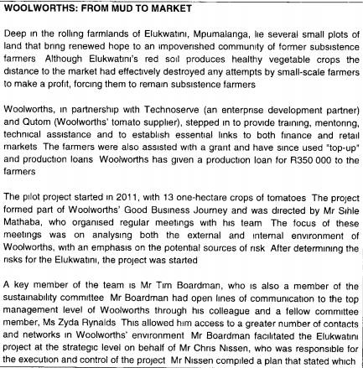
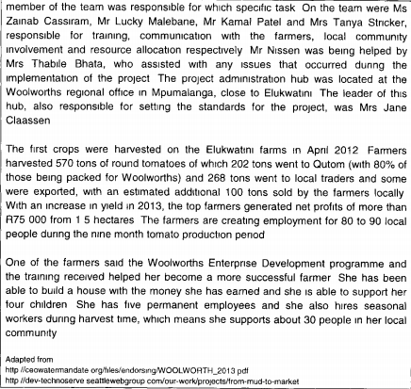
Question 51
Name all the key role players in project management and identify these key role players in the Elukwatini project from the above case study.
- Strategic manager (Programme Director) was Mr. Sihle Mathaba, he organised regular meetings and analysed both the external and internal environment of Woolworths. He also considered all sources of potential risk.
- Project sponsor is Mr. Tim Boardman. He had opened lines of communication to the top management level of Woolworths through his colleagues. He has access to a greater number of contacts and networks in the Woolworths environment.
- Operational manager (Project manager) is Mr. Chris Nissen. He is responsible for the execution and control of the project. He compiled a plan that stated which member of the team was responsible for which task.
- Project team consisted of Ms. Cassiram, Mr. Malebane, Mr. Karnal and Mrs. Sticker, who is responsible for training, communication with local farmers, local community involvement and resource allocation.
- Project management team office was the project administration hum located at the Woolworths regional office in Mpumalanga close to Elukwatini.
- The client is the farmers of Elukwatini, Mpumalanga.

Question 52
Categorise the farmer improvement project under one of the perspectives of project management and use relevant theory as well as examples from the case study to substantiate your answer.
The farmer improvement project can be categorised under the external perspective of project management. External perspective is an outward perspective taken to determine the effectiveness of the organisation’s products & services in the market place. Given the inequalities of between communities in a developing society such as SA, upliftment and development programmes are needed. Woolworths partnered up with Technoserve and Qutom and provided training, mentoring and technical assistance to small scale farmers with the impoverished community of Elukwatini, Mpumalanga. Woolworths further assisted the farmers with a grant and production loan of R350 000. The pilot project started in 2011 and it formed part of the Woolworths Good Business Journey.

MAY/JUN 2016
Section A: Multiple Choice Questions
- Which one of the following is false regarding the roles and expectations of workers in the Knowledge Era?
1. Workers actually own the means of production
2. Jobs require a much higher level of technical skill
3. Workers need to depend on facts and focus on procedures
4. Permanent employees are replaced with temporary employees
- The characteristics of the new organisational model differ substantially from those embodied in the traditional, bureaucracy model. The new organisation’s ___________ is/are participative whereas a traditional organisation’s will be ______________.
1. Culture, unhealthy
2. Discussions, non-engaging
3. Decision-making, top-down
4. Management style, autocratic
- An example of a management challenge for a networked organisation is ____________.
1. Developing the skills as team members and team leaders
2. Actively encouraging initiatives for innovation and change
3. Understanding the diverse cultures of the individuals involved
4. Developing negotiation skills that enable them to negotiate win-win situations
- During step 6 in Kotter’s Eight Step Process for successful change, managers should ______________.
1. Plan and create visible performance improvements
2. Develop strategies to make the vision a reality
3. Empower those who want to embrace change
4. Stress the need for change
Consider the following methods manager can use to deal with resistance to change and answer questions 5 and 6.
a) manipulation and co-optation
b) education and communication
c) negotiation and agreement
d) facilitation and support
e) participation and involvement
f) explicit and implicit coercion
- When the cause of resistance to change is a lack of information or wrong information, ____________ can be an effective way to overcome the resistance.
1. b
2. d
3. e
4. f
- The method to overcome resistance that involves giving and individual or leader a role in the implementation of a change initiative, not to obtain the participation of the individual but to secure his/her endorsement of the initiative is ________________.
1. a
2. c
3. d
4. f
- An example of a taken-for-granted assumption is _____________. This is the tendency of organisations to develop strategies incrementally based on historical and cultural influences, but failing to keep pace with changes in the environment.
1. Strategic drift
2. Strategy deployment
3. Organisational learning
4. Organisational architecture
- National and regional cultures differ in terms of _____________, ____________ and _______________.
1. Synergy, equality, assumptions
2. Assumptions, authority, synergy
3. Attitudes toward work, authority, equality
4. Power distance, restraint, attitudes toward work
- Which one of the following national culture dimension deals with society’s search for virtue?
1. Power distance
2. Uncertainty avoidance
3. Individualism versus collectivism
4. Long-term versus short-term orientation
- Which one of the following is not a guideline, as identified by Cummings and Worley (2009) in attempting to change the culture of an organisation?
1. Formulating a new vision that guides the purpose of the culture change
2. Terminating the services of people who do not fit into the culture
3. Socialising newcomers to fit into the new culture
4. Leaving elements of the culture unchanged
Match the actions of the person with the power in Column B to the influence tactics in Column A.
COLUMN A – INFLUENCE TACTICS | COLUMN B – ACTIONS OF THE PERSON WITH THE POWER
11. Ingratiating (3) | 1. Coaxing the target through logical arguments and factual evidence that a proposal or request is viable
12. Rational persuasion (1) | 2. Promising that the target will receive rewards or benefits if he/she complies
 | 3. using friendliness, humour or flattery before making a request to the target
 | 4. Arousing enthusiasm by making an emotional request to the target
- Governance of ethics concerns the ____________, while the ethics of governance concerns the ___________.
1. Direction of ethical culture, directing of an organisation’s relationships
2. Organisation’s social responsibilities, evaluation of the ethical standards employed
3. Management of stakeholders, development of the organisation’s ethical culture
4. Control of an organisation’s operations, promotion of the organisation’s ethical culture
- The _________ dimension of ethical analysis is defined by the tacit and explicit norms and rules that characterise an organisation’s culture.
1. Normative
2. Organisational
3. Macro-ethical
4. Consequentialism
- According to the ___________ approach to normative ethics, the morality of an action is judged according to the ____________.
1. Deontology, action’s adherence to a set of rules
2. Virtue ethics, interests of everyone involved
3. Consequentialism, outcome of the moral agent’s virtuous nature
4. Deontology, positive long-term consequences that the action holds
- The main advocate of the narrow view of corporate social responsibility is ___________, and he argues that _____________.
1. Milton Friedman, organisations should contribute to the welfare of society
2. Edward Freeman, social responsibility arises from social power
3. Edward Freeman, corporate social responsibility is unethical
4. Milton Friedman, the business of a business is profit making.
- Which one of the following is not one of the four pillars on which corporate governance should be based, as stipulated by the World Bank?
1. Accountability
2. Transparency
3. Responsibility
4. Honesty
- Corporate citizenship, ethical leadership and sustainability are dimensions of ______________.
1. The comply or else model
2. Normative ethical theory
3. The King III Report
4. Business ethics
- The __________ is/are the cornerstone(s) of diversity behaviour.
1. Organisation’s strategic values
2. Right the wrongs approach
3. Melting pot assumption
4. Platinum rule
- Which one of the following categories of management problems relating to diversity in a South African workplace is based on the premise that the environment of organisations in developing countries is different from that of First World countries?
1. The question of affirmative action
2. The question of economic empowerment
3. The quest for a new management philosophy
4. The quest to create a balanced management environment
Consider the table below about the arguments for managing diversity and their corresponding reasoning, and answer questions 21 & 22.
ARGUMENT | REASONING
a) ______________ | Organisations with the best reputations for managing diversity will win the competition for the best personnel
Creativity | b) _____________________
- Identify the argument for option a)
1. Resource acquisition
2. System flexibility
3. Problem-solving
4. Cost
- Identify the reasoning for option b) that relates to the creativity argument.
1. The diversity of perspectives and the modernizing of diversity management will improve the use of imagination
2. Heterogeneity in decision-making groups produces better decisions through a wider range of perspectives
3. The system will become less standardised and therefore more fluid; creating a greater flexibility to react creatively
4. Members with roots in other countries bring new insight and cultural sensitivities to operations
Consider the following list of diversity efforts and answer questions 2 and 24.
a) effective implementation of affirmative action policies
b) inconsistent enforcement of diversity policies
c) believing in a monoculture organisation
d) little is being done in the area of economic empowerment
e) ongoing diversity education and training initiatives
f) believing a culture of enabling employees
g) managerial commitment not tied to organisational rewards
- Broad-based diversity efforts on the organisational diversity continuum include _________ and ____________.
1. a, b
2. b, e
3. e, f
4. f, g
- In the middle of the diversity continuum, diversity efforts are based on __________ and __________.
1. a, c
2. b, d
3. c, e
4. e, g
- Which one of the following is the second step in the implementation of the diverse workforce development strategy?
1. Formulating a vision for a diverse workplace
2. Building a corporate culture that values diversity
3. Changing structures, policies and systems to support diversity
4. Providing diversity awareness and cultural competency training
- Identify the role player in project management that is responsible for ensuring that the projects produce the expected organisational benefits.
1. Operational manager
2. Tactical manager
3. Programme director
4. Project sponsor
Consider the following list of steps in the project management process:
a) develop a stakeholder plan
b) develop the quality manager plan
c) define change control procedures
d) define the scope of the project
e) develop a tactical project plan
f) develop a communication plan
- Rearrange these 6 steps in the correct sequential order.
1. e, f, d, b, c, a
2. b, f, d, c, a, e
3. e, b, c, a, f, d
4. b, a, d, c, e, f
- Which one of the following is not a responsibility of the project management office, but rather that of the project manager?
1. Ensuring that the skills of the project team meet project-specific quality requirements
2. Acquiring and utilising project management systems and tools
3. Handling all the administration for project-related activities such as monitoring, controlling and reporting
4. Developing, documenting and maintaining the organisation’s project management policies processes and procedures
- In a stakeholder matrix, the most appropriate strategy to manage stakeholders with a high interest in, but low influence on, the project is to _____________.
1. Put in minimal effort
2. Keep them satisfied
3. Keep them informed
4. Build a strong relationship with them
- Compiling a resource management plan, is an activity that forms part of step ________ of the project management process, namely _____________.
1. Fourteen, monitoring and controlling project objectives
2. Seven, developing key performance indicators
3. Ten, conducting the risk management plan
4. Nine, developing the project schedule
Consider the following figure and complete it by answering questions 31 to 33
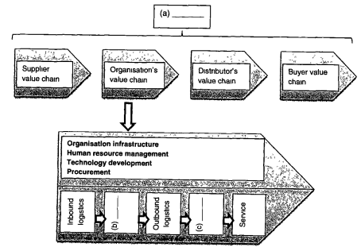
- Complete option (a) in the figure above
1. Value system
2. Primary activities
3. Expert system
4. Secondary activities
- Complete option (b) in the figure above
1. Marketing
2. Accounting
3. Operations
4. Human resources
- ____________ works closely with the _____________ function, represented by option (c)
1. Research and development, marketing
2. Supply management, supplier logistics
3. Marketing, information technology
4. Top management, operations
Read the following case study and answer questions 34-40
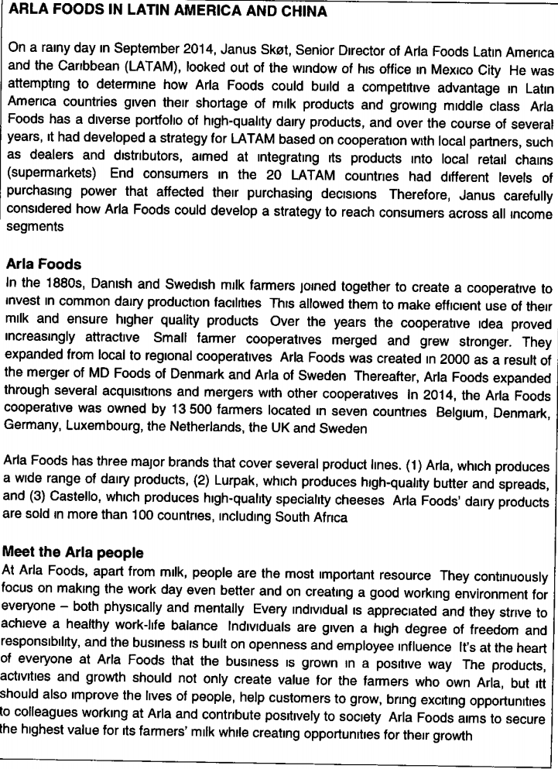
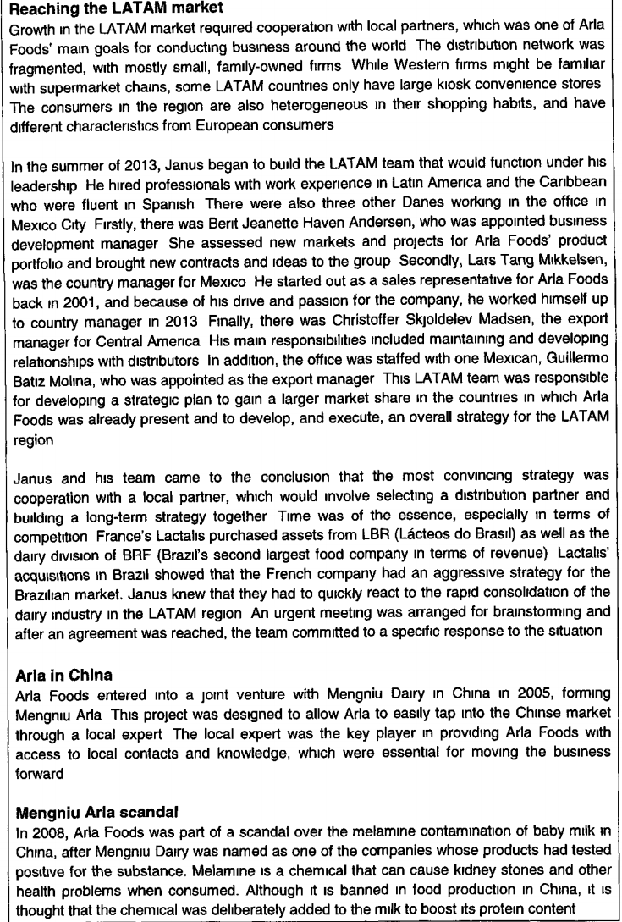
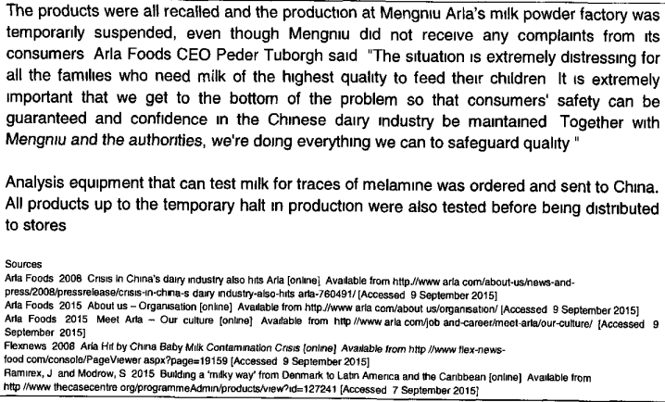
- The process of the changes at Mengniu Arla, resulting from the 2008 Mengniu crisis, can be categorised as ____________.
1. Reactive
2. Top-down
3. Punctuated
4. Revolutionary
- According to Jones, Dunphy, Fishman, Larne and Canter, Arla Foods’s culture can be classified as a __________ culture.
1. Clan
2. Person
3. Defensive
4. Constructive
- Arla Foods’ strategic partnership with Mengniu Dairy represents a(n) ___________ for the company.
1. Threat
2. Strength
3. Weakness
4. Opportunity
- In 2005, Arla Foods employed a __________ corporate growth strategy.
1. Product development
2. Market development
3. Backward integration
4. Forward integration
- According to the Belbin method, the resource-investigator o the LATAM team is ___________.
1. Berit Jeanette Have Andersen
2. Christoffer Skjoldelev Madsen
3. Lars Tang Mikkelsen
4. Janus Skot
- According the Belbin method, Lars Tang Mikkelsen fulfils the ___________ team role.
1. Plant
2. Shaper
3. Company worker
4. Monitor-evaluator
- The LATAM team is a _______ type of team.
1. Virtual
2. Self-managed
3. Problem-solving
4. Cross-functional

Section B
Refer back to the case study on Arla Foods, and complete the following sentences by filling in the missing words.
- Arla Foods’ brands, Lurpak and Castello, represents its (intellectual) structural capital.
- Arla Foods’ decision to increase its competitive advantage in LATAM reflects the internal force of change, change in strategy.
- The demographic trends in the LATM market act as external forces for Arla Foods to change.
- The variable which influence organisations to change that is most evident in the case study is social forces stemming from economic, technological and cultural environments (demographic trends).
- Arla Foods is following a focus generic strategy.
- Freedom and openness at Arla Foods is an example of the artefacts level of organisational culture.
Complete the following sentences by filling in the missing word(s).
- In project management, a programme (tactical manager) manages at the tactical level (middle management), which is in contrast to a project manager whose sole responsibility is planning, execution, control & finalization of the projects.
- A PERT diagram will typically be developed during the 9th phase of project management. (Develop the project schedule).
- He internet business model that is production-based business model-based adds value by capturing customer preference and by improving customer service.
- Management information system is an e-business advanced technology that is used for monitoring, control and reporting on an organisational performance at tactical and strategic level.
Section C
Question 1
Name the conditions that should ideally exist for the Arla Foods LATAM team to be effective. Indicate which of these conditions currently exist by providing evidence from the case study.
Chairperson: presides over the team, coordinates its efforts and is disciplined, balanced and focused. From the case study this is Janus Skot, Senior Director of Arla Foods who set up the team in 2013.
Shaper: highly-strung, outgoing and dominant person with a drive and passion for the task. From the case study this is Lars Tang Mikkelson, who started as a sales representative for Arla Foods back in 2001 and because of his drive and passion for the company he worked himself up to country manager in 2013.
Plant: introverted but intellectually dominant, the source of original ideas and proposals.
Monitor-evaluator: is an analytical rather than a creative intelligent.
Resource-investigator: is the popular member of the teams extroverted. From the case study, this person is Berit Jeanette Haven Anderson, who was appointed business development manager. She assessed new markets and brought new contract and ideas to the group.
Company worker: is the practical organiser who turns ideas into manageable tasks.
Teamworker: holds te team together by being supportive of others, listening, encouraging, harmonizing and understanding. From the case study this could be Christoffer Skjoldelev Madsen.
Finisher: checks the details, worries about schedules and due dates and brings to the team a sense of urgency.
Question 2
2.1 Identify the mission statement of Arla Foodss as stated in the case study.
The mission statement for Arla Foods is “At the heart of everyone at Arla Foods that the business is grown in a positive way. The products, activities and growth should not only create value for the farmers who own Arla, but it should improve the lives of people, help customers to grow, bring exciting opportunities to colleagues working at Arla and contribute positively to society.”
2.2.1 According to the answer in Q2 above, identify which components of the mission statement are present.
- “business is grown in a positive way” – the values, ethics and beliefs of the organisation
- “the products, activities and growth should not only create value for the farmers who own Arla, but it should improve the lives of people, help customers to grow, bring exciting opportunities to colleagues working at Arla” – the organisation’s concerns for all stakeholders
- “contribute positively to society” – the social responsibility of the organisation.
2.2.2 State whether Arla Foods has a good mission statement and justify your answer.
Yes, Arla Foods does have a good mission statement, because it reflects an organisation’s reason for being in its products, market and consideration for its stakeholders.

Question 3
3.1 Name and describe any 2 conflict management strategies.
- Avoidance – one party chooses to focus on the other party’s needs to suppress or resolve the conflict or to seek some form of conflict
- Accommodation – one party chooses to focus on the other party’s needs to suppress or resolve the conflict or seek some form of maintaining the status quo
- Compromise – both parties give up something and the parties reach a consensus decision
- Competition – the focus of one or both parties is on their own interests, resulting in dysfunctional conflict and win-lose results
- Collaboration – differences are met and addressed, resulting in a win-win solution for the parties
3.2 Explain where each of the strategies identified in question 3.1 falls within the model of Thomas
- Avoidance – assertive and uncooperative
- Accommodation – highly cooperative, but unassertive
- Compromise – middle-ground / neutral on assertiveness and cooperation
- Competition – highly assertive, but uncooperative
- Collaboration – highly assertive and highly cooperative

OCT/NOV 2016
Section A: Multiple Choice Questions
Read the following background information on Le Creuset and answer question 1.
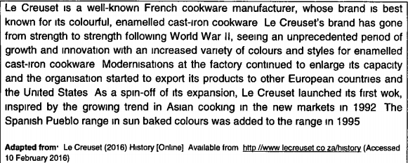
- Evaluate the change Le Creuset underwent and select the variables influencing change in contemporary organisations, which are most likely to be a reason for the described changes.
a) New roles of workers
b) Technological advances
c) Globalisation and the global economy
d) Radical transformation of the world of work
e) The growing importance of intellectual capital
f) Increased power and demands of the customer
1. a, c and f
2. b, d and e
3. b, c and f
4. a, d and e
Match the appropriate feature of a “new” organisation in Column B to the management challenge described in Column A.
COLUMN A – MANAGEMENT CHALLENGES | COLUMN B – FEATURE OF A “NEW” ORGANISATION
2. An over-reliance on teams (2) | 1. Flexibility
3. Multi-tasking (1) | 2. Networked
 | 3. Flatter and leaner
 | 4. Workforce diversity
- Which one of the following options is incorrect regarding the artefacts level of organisational culture? Artefacts _______________.
1. Are found on the first level of organisational culture
2. Include visible aspects of the organisation
3. Include the archives of the organisation
4. Can always be understood
- If employees have to dress professionally during the week, but are allowed to wear informal outfits on Fridays, it is an example of a norm, which is part of the ______________ level of culture.
1. Second
2. Fourth
3. Third
4. First
- According to Edgar H Schein, culture is a pattern of assumptions developed by an organisation to deal with problems of external adaption and internal integration.
External adaption tasks do not include the development of consensus on the ______________.
1. Goals of the organisation
2. Group boundaries and criteria for inclusion
3. Criteria that are used to measure the results
4. Resources the organisation uses to accomplish its goals
- The ___________ culture, as categorised by Charles Handy (1993), is typified in terms of work by logic and rationality.
1. Role
2. Person
3. Market
4. Process
- In which one of the following national culture dimensions does society have a preference for achievement, heroism and assertiveness?
1. Uncertainty avoidance
2. Power distance
3. Collectivism
4. Masculinity
- Which one of the following is not a guideline, as identified by Cummings and Worley (2009), in attempting to change the culture of an organisation?
1. Formulating a new vision that guides the purpose of the culture change
2. Terminating the services of people who do not fit into the culture
3. Socialising newcomers to fit into the new culture
4. Leaving elements of the culture unchanged
- Consider the question, “What is formal power?”
Now suppose the following answer is given: “formal power includes legitimate power which allows an individual, who possesses the power, to make decisions on information flows and resource allocation. It also includes reward power, which rests with an individual who can offer or restrict employee benefits.”
What is wrong with the answer?
1. Reward power is incorrectly described
2. Formal power does not include reward power
3. Formal power does not include legitimate power
4. Legitimate power does not allow an individual to make decisions
Match the description in Column B to the correct phase of the negotiation process in column A
COLUMN A – PHASE OF THE NEGOTIATING PROCESS | COLUMN B – DESCRIPTION
11. The planning phase (3) | 1. Involves 4 steps that include setting objectives, researching the other party, developing options, anticipating issues that the other party might raise, and allowing the other party to make the first offer
12. The negotiation phase (2) | 2. Involves 4 steps that include focusing on the issues, not the individual, allowing the other party to make the first offer, making sense of the other party’s needs, and not rushing into an agreement
 | 3. Involves setting objectives with regard to an opening, a fair and achievable target, and an exit target
 | 4. Involves both parties giving up something in order to reach a consensus
- According to Morgan (1997), power stems from all of the following sources, except ____________.
1. Informal interpersonal alliances
2. Control of technology
3. Formal authority
4. Social networks
- If an individual informs the media about unethical internal organisational activities it is a(n) _________, ____________ form of political behaviour.
1. Internal, legitimate
2. External, legitimate
3. Internal, illegitimate
4. External, illegitimate
- Which one of the following options is an example of a secondary stakeholder?
1. Community
2. Suppliers
3. Investors
4. Creditors
Consider the following figure that illustrates the 2 views of corporate social responsibility (CSR), and answer questions 1 and 17.
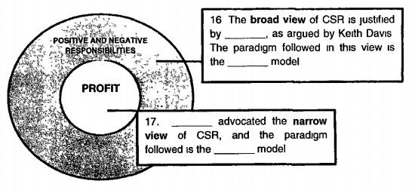
- Complete the figure by choosing the correct option for question 16 (outer circle in the figure provided).
1. Social power, stakeholder
2. A social contract, shareholder
3. A promissory relation, shareholder
4. Stakeholder value creation, stakeholder
- Complete the figure by choosing the correct option for question 17 (inner circle in the figure provided).
1. Melvin Anschen, stakeholder
2. Milton Friedman, shareholder
3. Edward Freeman, shareholder
4. Thomas Donaldson, stakeholder
- If the organisation has been using a uniform performance appraisal policy to rate all employees on all levels of the organisation, the _________ approach to managing diversity can be used to remedy the above situation.
1. “Value of differences”
2. “Right the wrongs”
3. Compensation
4. Golden rule
- ____________ is a primary dimension of diversity.
1. Ethnicity
2. Education
3. Marital status
4. Religious beliefs
- The _______ diversity paradigm increases the organisation’s effectiveness in capturing niche markets.
1. Discrimination-fairness
2. Learning-effectiveness
3. Access-legitimacy
4. Growth-efficiency
Consider the following list of variables and answer questions 21 and 22
a) proactive
b) qualitative
c) legally driven
d) problem focused
e) assumed integration
f) government initiated
g) only externally focused
- Which of the above variables are characteristics of diversity?
1. a, b and e
2. a, c and g
3. b, d and e
4. c, f and g
- Which of the above variables are characteristics of employment equity?
1. a, b and e
2. a, c and f
3. b, d and g
4. c, d and f
Read the following scenario and answer questions 23 to 28
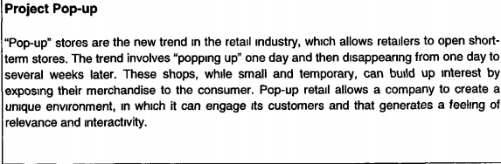
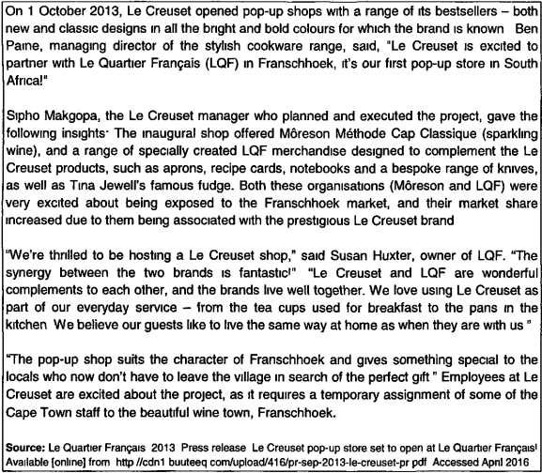
Use the information on the stakeholders in Project Pop-up to conduct a stakeholder analysis. Use your analysis to answer questions 23 to 25.
- Based on a stakeholder analysis, which stakeholder/s should the project team keep satisfied?
1. Le Creuset employees
2. Franschoek locals
3. Ben Paine
4. Moreson
- Based on a stakeholder analysis, with which of the stakeholder/s should the project team build strong relationships?
1. LQF
2. Moreson
3. Franschoek locals
4. Le Creuset employees
- The stakeholder tactical plan for ____________ would require that the project team communicate project progress by using a Facebook page.
1. Le Creuset employees
2. Tina Jewell
3. Ben Paine
4. Moreson
Consider the role players in the project management and answer questions 26 to 28.
- Ben Paine is the ____________ of Project Pop-up.
1. Public face
2. Project sponsor
3. Operational manager
4. Programme manager
- Sipho Makgopa is the ___________ of Project Pop-up
1. Public face
2. Project sponsor
3. Operational manager
4. Programme manager
- Project Pop-up has an ________ perspective and it is pitched at the __________ level.
1. Internal, operational
2. Internal, marketing
3. External, strategic
4. External, tactical
- Read the following paragraph regarding an organisational value chain and correct it by choosing the correct option. “To optimise the value chain, organisations must shift their focus to internal efficiencies of the secondary activities. Efficiency is achieved by minimising operational inputs and optimising operational outputs, with little or no investment or expansion being undertaken.”
1. The word “internal” should be replaced by “external”
2. The word “secondary” should be replaced by “primary”
3. The word “efficiency” should be replaced by “effectiveness”
4. The word “little or no” should be replaced by some”
- Which one of the following characteristics best describes a commission-based e-business revenue-generating model?
1. An amount is charged for intermediary services. It adds value by providing expertise and/or access to a wide network of alternatives
2. This model entails selling marked-up merchandise. It adds value through selection and distribution efficiencies
3. Fees are charged for unlimited use of the service or content. It adds value by leveraging a strong brand name
4. Fees are charged for metered services. It adds value by providing service efficiencies, expertise and practical outsourcing solutions.
Determine whether the following statements are true or false.
- A click-and-mortar e-business shopping platform showcases products by giving customers access to an inventory of stock. It provides for order taking and management of customer data.
1. True
2. False
- The e-business advanced technology, management information systems, may serve the organisation well by acting as an early warning system and enabling management to take preventative steps in good time.
1. True
2. False
- Important consideration for e-business web management are the control, development and management of a website.
1. True
2. False
- Select the correctly constructed sentence regarding groups and teams from the statements below:
1. A task group is a unit of two or more people who interact primarily to share information and to make decisions that will help each group member perform within his/her own area of responsibility.
2. Self-managed work teams have the ability to reduce costs because they can make and implement decisions quickly, and take full responsibility for the outcomes.
3. The reason for the existence of interest groups is that the members have things in common, such as similar hobbies, to share with colleagues.
4. Belbin listed 8 roles that teams need in order to be effective, and stated that the optimum size of a team is 7-10 members
- The group behaviour model depicts 5 variables that ________________.
1. Influence the development and effectiveness of work groups in organisations
2. Group members need to overcome in order to function as a cohesive unit
3. Represent the stages of the development of groups
4. Predict the performance of individuals in groups
- _____________ and ____________ define a group’s structure.
1. Cohesiveness, leadership
2. Leadership, power and politics
3. Authority structures, group decision making
4. Group decision-making, performance management
- _________________ form(s) part of the organisational context that influences the functioning of a group.
1. Group decision making
2. Authority structures
3. Power and politics
4. Leadership
- An example of a group process is _______________.
1. Performance management
2. Group decision-making
3. Personnel selection
4. Leadership
Consider the following conversation between two colleagues and answer question 39.
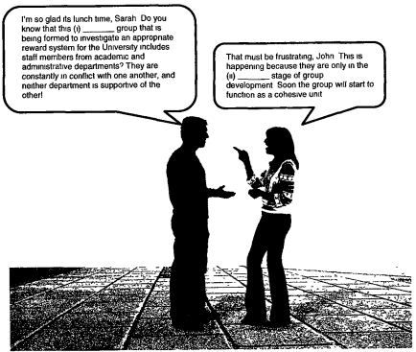
- Complete the conversation by choosing the correct option provided below.
1. (i) interest; (ii) norming
2. (i) interest; (ii) forming
3. (i) task; (ii) storming
4. (i) task; (ii) forming
- There are various options available to organisations wishing to develop individuals into team members. If they have already changed their selection procedures for hiring new employees and have altered their reward systems, what option are they left with?
1. Implementing a turnaround strategy to reduce staff with unwanted personality traits.
2. Providing incentives to recognize employee performance
3. Using the Belbin method to improve the diversity of skills
4. Using teambuilding interventions

Section B
- Strategic management encompasses the process of strategic analysis, formulation, implementation and control.
- The real challenge of any winning strategy is the creation of a competitive advantage, which can be defined as the ability to create value that rivals cannot duplicate.
- Corporate citizenship, ethical leadership and sustainability are dimensions of the King III Report.
- An important contributing factor to the value chain of an organisation is the value that the organisation is creating for its customers.
- Workforce diversity reinforce the culture of an organisation and relate to the successes and failures of an organisation.
- Constructive culture, as categorised by Jones et al. (2006), is typified by members being encouraged to interact with each other.
- According to the deontology approach to normative ethics, the morality of an action is judged according to the actions adherence to a rule or set of rules.
- The King III Report on Governance is an example of the voluntary approach to corporate governance.
- Governance ethics concerns the managing of both the company’s impact on stakeholders and society while the ethics of governance concerns the development of the organisation’s ethical culture.
Section C
Read the following Le Creuset scenario and answer questions 1 to 3.
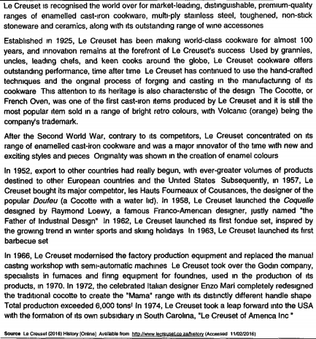
QUESTION 1
Evaluate the summary of the scenario below by identifying which statements about change are omitted in the summary, which are correct and which are incorrect.
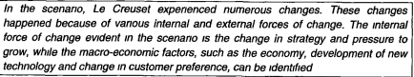
The internal force/s correctly identified in the summary is/are:
Change in strategy
Pressure to grow
The internal force/s incorrectly identified in the summary is/are:
?????
The internal force/s evident in the scenario, but omitted in the summary is/are:
Implementation in new technology
The macro environmental force/s correctly identified in the summary is/are:
Economy
New technology
The macro environmental force/s incorrectly identified in the summary is/are:
Change of customer preference
The macro environmental force/s evident in the scenario, but omitted in the summary is/are:
Social forces
The macro environmental force/s listed in the summary but that is not evident in the scenario is/are:
Events that occur in one country may affect and lead to change in the organisation operating in other countries because of the integration and interdependence of world markets.

QUESTION 2
Interpret how change is dealt with at Le Creuset using the dimensions of change.
First list the 4 dimensions of change, and then select where the changes at Le Creuset fall on each of the dimension’s continuums.
- Planned change – When Le Creuset launched its first fondue set, inspired by the growing trend in winter sports and skiing holidays
- Reactive change
- Revolutionary change
- Incremental change
- Punctuated change
- Continuous change – 1966 – Modernised the factory production equipment; 1970 – Took over the Godin company; 1972 – Enzo Mari redesigned the traditional cocotte to create the “mama” range; 1974 – Took a leap forward into the USA

QUESTION 3
Identify the generic strategy of Le Creuset. Motivate your answer by correctly defining the strategy and then providing evidence from the scenario to support your answer.
Differentiation strategy – “Le Creuset has continued to use the handcrafted techniques and the original process of forging and casting in the manufacturing of its cookware.”
“Le Creuset concentrated on its range of enameled cast-iron cookware and was a major innovator of the time with new and exciting styles and pieces. Originality was shown in the creation of enamel colours.”

MAY/JUN 2017 – PAPER 1
Section A: Multiple Choice Questions
- Which one of the following statements regarding the roles and expectations of workers in the Knowledge Era is false?
1. Jobs require workers to have a much higher level of technical skill
2. Workers need to depend on facts and focus on procedures
3. Permanent workers are replaced with temporary workers
4. Workers actually own the means of production
Match the appropriate feature of “new” organisation in Column B to the management challenge described in Column A.
COLUMN A – MANAGEMENT CHALLENGE | COLUMN B – FEATURE OF A “NEW” ORGANISATION
2. Fewer opportunities for promotion (3) | 1. Flexibility
3. Multitasking (1) | 2. Networked
 | 3. Flatter and leaner
 | 4. Workforce diversity
- During step 5 in Kotter’s eight-step process for successful change, managers should _____________.
1. Plan and create visible performance improvements
2. Develop strategies to make the vision a reality
3. Empower those who want to embrace change
4. Stress the need for change
Consider the following methods managers can use to overcome resistance to change, and answer questions 5 and 6.
a) manipulation and co-optation
b) education and communication
c) negotiation and agreement
d) facilitation and support
e) participation and involvement
f) explicit and implicit coercion
- When resistance to change is caused by fear and anxiety, _______________ can be an effective way to overcome this resistance.
1. b
2. d
3. e
4. f
- The method that involves giving an individual or leader a role in the implementation of a change initiative, not to obtain the participation of the individual, but to secure his/her endorsement of the initiative, is ___________.
1. a
2. c
3. d
4. f
- The “new broom” effect refers to _________ which is an __________ force of change.
1. Social forces, external
2. Power and politics, internal
3. Changes in top management, internal
4. Pressure from stakeholders to grow, external
- Managers initiate and implement ____________ change when preparing for changes in the organisation’s environment.
1. Planned
2. Punctuated
3. Incremental
4. Revolutionary
- Quinn and McGrath (1985) identify 4 types of culture, namely the __________, _____________, ___________ and hierarchy culture.
1. Power, process, logic
2. Market, adhocracy, clan
3. Person, authority, passive
4. Role, aggressive, constructive
- The _________ culture, as categorised by Trompenaars and Prud’homme (2004),is typified by low risk and slow feedback on actions and decisions.
1. Role
2. Person
3. Market
4. Process
- A(n) ___________ strategy will be appropriate to manage organisational conflict in a situation where a high level of willingness to focus on others, and a low degree of assertiveness are present.
1. Avoidance
2. Collaboration
3. Compromise
4. Accommodation
- The _____________ influence tactic is applied when an individual uses friendliness, humour or flattery before making a request to another individual.
1. Ingratiation
2. Exchange
3. Pressure
4. Coalition
- Which one of the following influence tactics involves the agent using the support of others as an argument to convince the recipient to agree?
1. Inspirational appeals
2. Rational persuasion
3. Integration
4. Coalition
- Max Weber identified 3 types of authority, namely charismatic, traditional and _______________.
1. Bureaucratic
2. Legitimate
3. Informal
4. Referent
- Which one of the following options indicates sources (or causes) of intergroup conflict?
1. Communication breakdowns and role incompatibility
2. Environmental stressors and jurisdictional ambiguity
3. Task interdependence and power and status differences
4. Competition for scarce resources and personal differences
Consider the following steps that occur in the second and final phase of the negotiation process and answer question 16.
a) allow the other party to make the first offer
b) focus on the issues, not the individuals
c) do not rush into the agreement
d) make sense of the other party’s needs
- Place the steps in the negotiation phase listed above in the correct sequential order.
1. b, a, d, c
2. a, c, b, d
3. b, c, a, d
4. a, b, d, c
- The strategic analysis phase of the strategic management process has 3 steps. _____________ requires managers to think about ways to carry their organisation into the future.
1. Developing a vision
2. Analysing the environment
3. Formulating a mission statement
4. Identifying key performance areas
- _____________ is an integration model of how the organisation conducts its business.
1. Strategic leadership
2. The mission statement
3. An environmental analysis
4. Organisational architecture
Match the appropriate description in Column B to a quadrant of the Boston Consulting Group growth/share matrix in Column A.
COLUMN A – QUADRANT OF THE MATRIX | COLUMN B – DESCRIPTION OF THE QUADRANT
19. Stars (2) | 1. Strategic business units with a high market share and low market growth rate
20. Cash Cows (1) | 2. Strategic business units with a high market share and a high market growth rate
 | 3. Strategic business units with a low relative market share and a high relative market growth
 | 4. Strategic business units with a low market share and a low market growth rate
- In the _________ stage of group and team development members become more assertive and opinionated.
1. Forming
2. Norming
3. Storming
4. Performing
- The group behaviour model depicts 5 variables that __________.
1. Influence the development and effectiveness of work groups in organisations
2. Group members need to overcome in order to function as a cohesive unit
3. Represent the stages of the development of groups
4. Predict the performance of individuals in groups
- A variable that defines group structure is ________.
1. Performance management
2. Group decision-making
3. Personnel selection
4. Leadership
- Which one of the following is not a condition for an effective team?
1. Widespread acceptance and commitment are critical to the successful implementation of a response to a situation
2. The problem is relatively complex, uncertain and holds the potential for conflict
3. The problem and its solution have important organisational consequences
4. There are tight and immediate deadlines
Read the following Shoprite Holdings Ltd case study and answer questions 25 to 40.
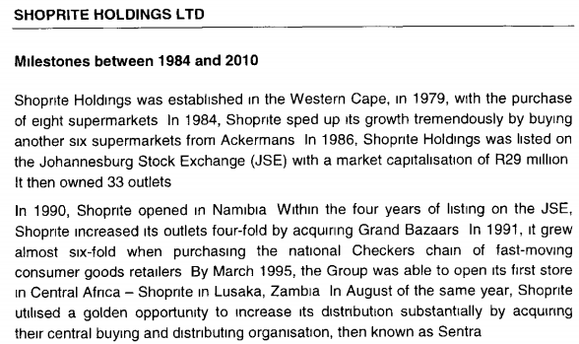
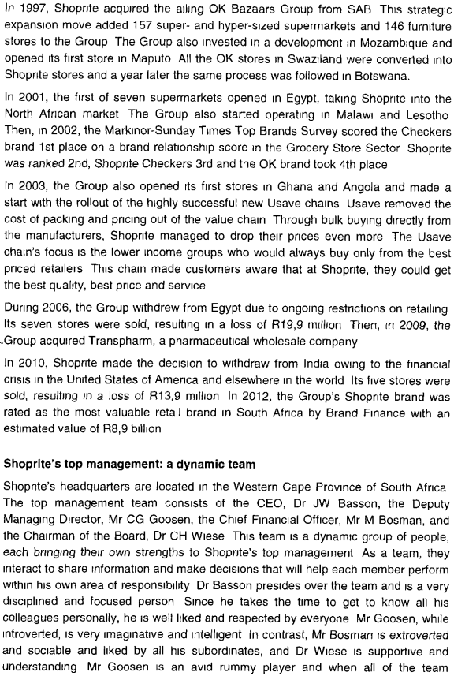
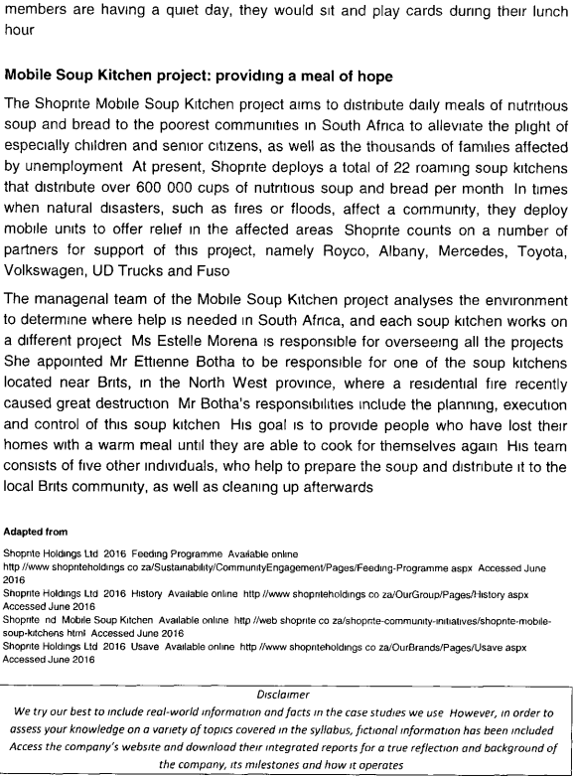
- The variable in Shoprite’s environment that caused them to open the Usave chain in 2003, is most likely the ___________.
1. Increased power and demands of the customer
2. Radical transformation of the world of work
3. Growing importance of intellectual capital
4. New roles and expectations of workers
- When considering the answer to Q25, it can be said that the __________ feature of the “new” organisation was evident when Shoprite opened the Usave chains.
1. Flexibility
2. Networked
3. Flatter and leaner
4. Workforce diversity
- The variable that was most evident in 2001, and that influenced Shoprite to change was ___________.
1. Increased power and demands of the customer
2. The growing importance of intellectual capital
3. The transformation of the world of work
4. Globalisation and the global economy
- The variable that influenced Shoprite to change, as identified in Q27, comes with various management challenges such as __________.
1. Understanding the diverse cultures of the individuals involved
2. The fact that there are fewer opportunities for promotion
3. Developing the skills of managers as team members
4. Developing systems for conflict resolution
- The reason for divesting from India in 2010 is an ________, ______________ force of change.
1. External, economic
2. Internal, power and politics
3. Internal, change in strategy
4. External, international/global
- During which year did Shoprite follow a market development strategy?
1. 2984
2. 1990
3. 1991
4. 2009
- The corporate combination strategy Shoprite followed when enlisting partners to work with their Mobile Soup Kitchen project is a/n ________.
1. Strategic alliance
2. Joint venture
3. Acquisition
4. Merger
- When acquiring the OK Bazaars Group in 1997, and Transpharm in 2009, Shoprite implemented a/n __________ strategy.
1. Unrelated diversification
2. Concentric integration
3. Forward integration
4. Concentration
- Shoprite implemented a __________ corporate decline strategy in 2006.
1. Turnaround
2. Harvesting
3. Divestiture
4. Liquidation
- “The 2002 Markinor-Sunday Times Top Brands Survey scored the Checkers brand 1st place on a brand relationship score in the Grocery Store Sector”
In this extract, the Checkers brand is an example of a/n ___________ when analysing Shoprite’s environment.
1. Threat
2. Strength
3. Weakness
4. Opportunity
- Mr. Botha and his team who run the Brits Mobile Soup Kitchen can be seen as a __________ group.
1. Task
2. Interest
3. Informal
4. Command
Read the section titled “Shoprite’s top management a dynamic team” and answer the following questions.
- Mr. Bosman has _____ power because of his position at Shoprite, which allows him to ____________.
1. Legitimate, make decisions about resource allocation
2. Personal, gain respect because of his personality
3. Reward, offer or restrict employee benefits
4. Formal, instill fear into subordinates
- The power that Dr. Basson possesses because of his charisma can be classified as being ______ power.
1. Expert
2. Referent
3. Coercive
4. Rational-legal
- In their organisational capacity, the top management team is a/n __________ type of group.
1. Informal, friendship
2. Informal, interest
3. Formal, work
4. Formal, task
The following questions are based on Belbin’s classification of team members.
- Dr. Basson fulfils the team member role of the ___________.
1. Plant
2. Chairperson
3. Monitor-evaluator
4. Resource-investigator
- Mr. Goosen fulfils the team member role of the ______________.
1. Plant
2. Team worker
3. Company worker
4. Monitor-evaluator

Section B
Review the “Mobile Soup Kitchen project providing a meal of hope” section of the case study and answer questions 1 and 2.
QUESTION 1
Categorise the Mobile Soup Kitchen project under one of the perspectives of project management and use the relevant theory as well as examples from the case study to substantiate your answer.
External perspectives of management – an outward perspective taken to determine the effectiveness of the organisation’s products and/or services in the market place.
Example – The feeding program aims to distribute meals like nutritional soup and bread to the poorest communities in South Africa to alleviate the plight of, especially children and senior citizens as well as the thousands of families affected by unemployment – distribution of warm, healthy food to those in need.

QUESTION 2
Mr. Neo Mogalobe is the strategic manager of the Mobile Soup Kitchen programme.
Identify 4 additional key role players in project management that are evident in the case study.
Name the key role players and state who this role player is in the context of the Mobile Soup Kitchen project.
- The client – children, senior citizens and families affected by unemployment
- Operational Manager – Ms. Estelle Morena
- Tactical Manager – Mr. Ettienne Botha
- Project Team – Shoprite, Royco, Albany, Mercedes, Toyota and UD Trucks

QUESTION 3
There are 3 different perspectives on how organisations perceive the task of managing diversity.
- Differentiate between the 3 perspectives by discussing the focus and effectivenss measures of each perspective.
Discrimination-Fairness
Focus – creating equal opportunity, assuring fair treatment and compliance with equal opportunity laws
Effectiveness – recruitment numbers, retention rates of women and PDG’s
Access-Legitimacy
Focus – match internal employee demographics to customer and marketplace served
Effectiveness – Niche markets captured, degree of diversity among employees
Learning-Effectiveness
Focus – incorporate diversity into the heart and fabric of the mission work and culture of the organisation
Effectiveness – all employees feel respected, valued and included
- Indicate which one of the perspectives will enable an organisation to benefit adequately from managing diversity.
Learning-Effectiveness

QUESTION 4
Consider the following incorrect explanations of the levels of culture that needs to be corrected.
- Level one – Always understandable but not always visible. The annual report of the organisation is an example.
- Typical behaviours – This second level of culture involves mostly rules for how to behave. These rules are stated in organisational policies.
- Core level – unconscious and unspoken thoughts and values.
Rewrite each level of culture so that all of them are correctly named and explained.
Level 1 – Artefacts – valuable aspects of the organisation (tip of the iceberg) – what someone feels and deserves when entering an organisation – the visible but not always understandable aspects of the organisation (visual aspects)
Level 2 – Values and beliefs (just below the water) – the goals and ideas, norms, standards, moral principles and other premises which an organisation chooses to promote – most employees are able to identify with work norms after some time – “on Friday afternoons we don’t have to work hard”
Level 3 – Taken for granted assumptions – from the core of an organisation’s culture and often have historical roots – the core of the culture ca only be distinguished by observing behaviour carefully, noting differences, contradictions that remain unexplained – taken for granted

QUESTION 5
In order to generate revenue, an organisation can implement on of 7 basic internet business modules.
- Differentiate between the 7 business revenue-generating models.
- Commission-based model – based on commission that are charged for brokerage/intermediary services
- Advertising-based model – advertisers pay for web content
- Mark-up based model – selling marked-up merchandise
- Production-based model – selling manufactured goods and customer services
- Referral-based model – fees are charged by referring customers
- Subscription-based model – charges for unlimited use of service or content
- Fee-for-service-based model – charges fees for metered services
- Classify YouTube’s revenue-generating model based on the following information.
YouTube allows billions of people to discover, watch and share originally-created videos on the www.youtube.com website. Organisations looking to use this forum as a marketing tool can specify their target market. The organisation’s advertisement starts playing automatically when a video is selected and they will be charged once customers (anyone forming part of the target market watching a video on the website) watch seconds or more of the advertisement.
Advertising-based model

MAY/JUN 2017 – PAPER 2
Section A: Multiple Choice Questions
- Which one of the following is not a stimulant for change in organisations?
1. Diversity
2. Globalisation
3. New roles and expectations of the worker
4. Increased power and demands of customers
- _________ capital is represented by copyrights, trademarks and patents.
1. Shareholder
2. Structural
3. Customer
4. Human
- Which one of the following is a weakness of the traditional organisational model?
1. Impartiality
2. Rigid rules
3. Predictability
4. Clear lines of control
- When examining the differences on the dimensions of traditional and “new” organisations, the “traditional” organisation’s workforce can be described as ________ while the “new” organisation’s workforce is _________.
1. Homogenous, diverse
2. Compliant, committed
3. Efficient, innovative
4. Inflexible, flexible
- Which one of the following is a trait of the workers in the industrial era? Workers __________.
1. Avoid risk
2. Focus on collaboration
3. Can deal with the unexpected
4. Are spontaneous and creative
- _________ is/are an example of social force for change, while _____________ is a physical force for change.
1. Health issues, the internet
2. Business ethics, global competition
3. Demographic trends, climate change
4. Trade union activities, gender and race issues
Match the appropriate statement in column B to the reason for resisting change in Column A.
COLUMN A – REASON FOR RESISTING CHANGE | COLUMN B – STATEMENT
7. Lack of trust (4) | 1. Employees fear that they will not be able to learn a new skill
8. Organisational inertia (2) | 2. Employees do nothing as they do not want to change the status quo
 | 3. Employees live in a comfort zone and do not wish to change due to the perceived sacrifices involved
 | 4. Employees may not understand the full consequences of change
- Given the changes taking place in the organisation, the manager Mrs. Mbiko, in an attempt to decrease her employees’ resistance to the proposed changes, decides to give a thorough presentation on the proposed changes to all her staff members, and to offer them 2 days’ additional leave. This is an example of ______________.
1. Facilitation and support
2. Negotiation and rewards
3. Participation and involvement
4. Education and communication
- The process of change that will take place in an organisation when reorganising themselves for improved performance after bankruptcy can be categorised as _____________.
1. Incremental
2. Continuous
3. Top-down
4. Planned
- Which statement regarding the levels of culture is incorrect?
1. Every organisation’s basic assumptions are the same
2. Shared values and beliefs influence the actions and activities in an organisation
3. Every organisation has its own personality, which is known as the corporate culture
4. “Basic assumptions” refer to beliefs about the world and how it works
Read the scenario on Green Lantern and answers questions 12-15
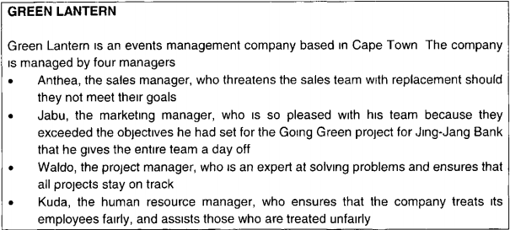
Match the type of power used in Column B with the specific behaviour displayed by the various managers in the scenario in Column A.
COLUMN A – MANAGER | COLUMN B – TYPE OF POWER
12. Anthea (4) | 1. Expert
13. Javu (3) | 2. Legitimate
 | 3. Reward
 | 4. Coercive
- In the scenario, Waldo is displaying _____________ power.
1. Reward
2. Expert
3. Personal
4. Legitimate
- In the scenario, Kuda is displaying _________ power.
1. Expert
2. Referent
3. Coercive
4. Legitimate
- The theorist(s) _____________ emphasises the importance of social networks as a source of power.
1. French Raven
2. Morgan
3. Ancona
4. Pfeffer
- Which one of the following factors is not a source of power as listed by Morgan (1997)?
1. Control of the decision-making process
2. Restriction of benefits
3. Control over knowledge
4. Usage of symbolism
- Which one of the following is not a step in developing a truly diverse workplace?
1. Providing change structures, policies and systems to support diversity
2. Having open communication channels between subordinates and managers about diversity issues
3. Providing diversity awareness and cultural competency training
4. Building a corporate culture that values diversity
- Diversity is not ___________.
1. About values
2. About culture
3. About behaviour
4. A long-term process
- The platinum rule relating to diversity suggests one treats others, ________________.
1. As they want to be treated
2. As you want to be treated
3. With respect
4. Equally
- Which one of the following is the 3rd step in implementing a diversity strategy in an organisation?
1. Changing structures to support diversity
2. Providing diversity awareness training
3. Identifying departments with a lack of diversity
4. Ensuring there is open communication channels about diversity issues
- The __________ argument for managing cultural diversity, suggests that poor job integration will decrease the price of the workforce.
1. Cost
2. Resource acquisition
3. Systems flexibility
4. Problem solving
- Which one of the following statements is not true regarding a mission statement? The mission statement ____________.
1. Can be used as a guide when making decisions on resource allocation
2. Reflects the organisation’s corporate social responsibility activities
3. Describes the organisation’s product, market and technology
4. Addresses the values, beliefs and ethics of the organisation
- Before a project manager assists an organisation on a project, the organisation needs to answer which of the following questions.
a) Is the organisation flexible enough to implement project management?
b) Will the organisation be able to handle the level of complexity of the project?
c) Can the project be completed in the required time?
d) What are the client’s requirements?
1. a b d
2. b c d
3. a b c
4. Only b
- The tactical manager of a project has to _______________.
1. Analyse the internal and external environments of the organisation
2. Compile a project plan which states how, when, where and by whom the various tasks will be done
3. Translate the strategic priorities and goals of the organisation into potential programmes
4. Approve project plans and receive project process reports
- When identifying a need for a project, several methods can be used. ___________ are an example of a formal method, while _________ are an example of an informal method.
1. Questionnaires, scientific surveys
2. Scientific surveys, discussions
3. Observations, opinion polls
4. Debates, observations
- Which one of the following statements is false regarding an organisation’s internal value chain?
1. Competitive advantage is the ability to create value that your competitors cannot
2. Competitive advantage grows out of the ability of an organisation to perform discrete activities
3. Sustainable competitive advantage occurs when organisations have tried unsuccessfully to duplicate an organisation’s competitive advantage
4. Competitive advantage ensures the survival of the organisation over the short term
- An organisation’s ______________ is an interdependent system or network of activities, connected by various linkages.
1. Sustainable advantage
2. Competitive advantage
3. Value system
4. Value chain
- Which statement is incorrect regarding E-business?
1. Electronic business can be defined as a business using the internet for greater efficiency in every aspect of its operations
2. B2B e-commerce stands for ‘Business-to-Buyer’ e-commerce
3. Consumer-to-Consumer e-commerce is made possible when an internet-based business acts as an intermediary between consumers
4. Electronic business contributes to a greater competitive advantage for the organisation
- The ___________-based business model adds value to the organisation by leveraging a strong brand name and providing high quality information to specialised markets.
1. Subscription
2. Commission
3. Fee-for-service
4. Advertising
- Which statement is incorrect regarding teams?
1. In a team, the team members are involved in setting the team’s goals
2. The individual efforts of team members result in a level of performance that is greater than the sum of their individual inputs
3. Team members should all have similar skills in order to work together effectively
4. The best teams are those in which everyone suppresses their individual ego for the good of the team
Match the appropriate statement in column B to the group structure in column A.
COLUMN A – REASON FOR RESISTING CHANGE | COLUMN B – STATEMENT
32. Cohesiveness (3) | 1. Diverse groups with a variety of skills and knowledge tend to be more effective
33. Norms (2) | 2. As a group, we all eat lunch together on a Friday afternoon
 | 3. Group members feel close to one another as they are a small group that stands together as a unit
 | 4. The reason why the Springbok rugby captain gets his own room while the other squad members have to share accommodation
- Betty joined a group at work because it made her feel stronger and less threatened. Jim joined the group could achieve more than what he could achieve on his own. Betty joined the group for ____________, whereas Jim joined for _____________.
1. Self-esteem, status
2. Status, security
3. Power, self-esteem
4. Security, power
Read the following case study and answer questions 35 to 40
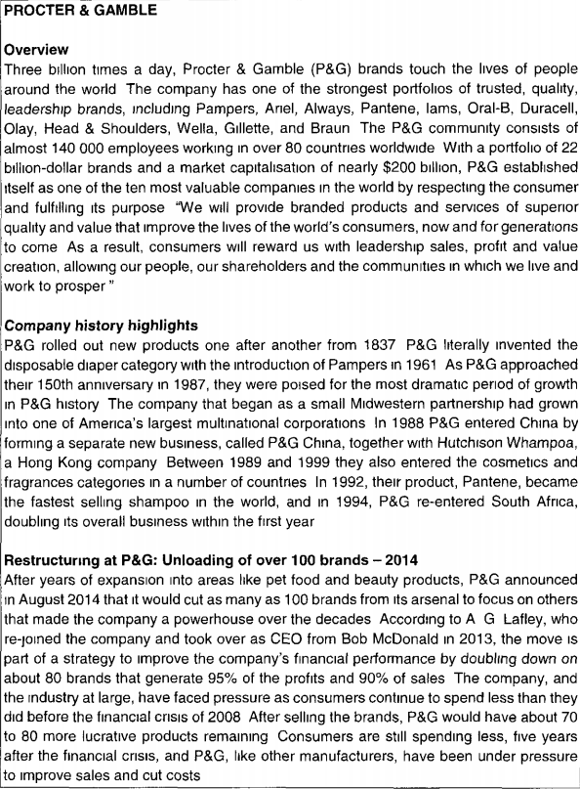
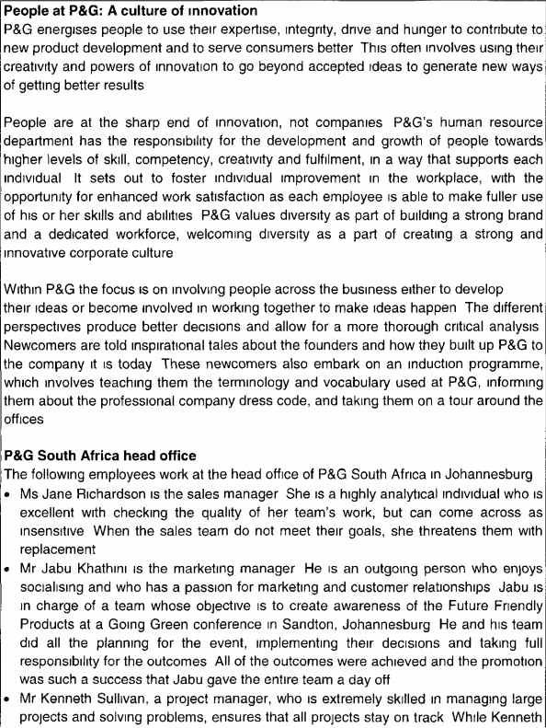
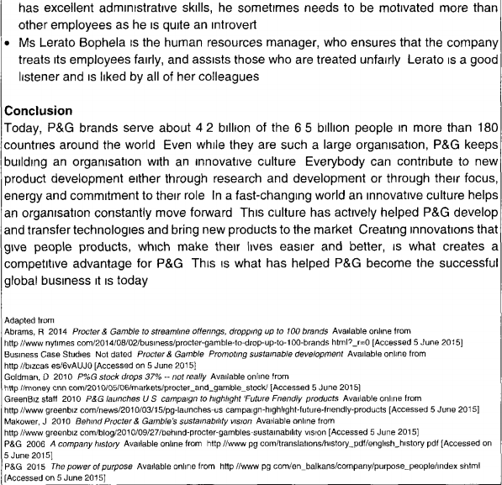
- _____________ is the level of organisational culture that is evident in the case study when considering the _____________.
1. Beliefs, individuals that are seen as the source of innovation
2. Artefacts, formal dress code of the company
3. Stories, inspirational tales told about the founders
4. Assumptions, terminology used in the company
- _________ is/are an element of organisational culture that is evident in the case study when newcomers are told about Wiliamd Procter and James Gamble.
1. Language
2. Symbols
3. Rituals
4. Stories
- P & G’s decision to cut almost 100 brands from their arsenal can be classified as a(n) ____________ strategy.
1. Divestiture
2. Harvesting
3. Integration
4. Focus
- The growth strategy P & G implemented in 1961 is a(n) _____________ strategy.
1. Product development
2. Concentration growth
3. Innovation
4. Integration
- The corporate combination strategy P & G implemented in 1988 cab be classified as a(n) ________________.
1. Merger
2. Acquisition
3. Joint-venture
4. Strategic alliance
- Jabu Khathini’s team can be classified as a ____________ team.
1. Self-managed
2. Cross-functional
3. Formal
4. Work

Section B
QUESTION 1
Discuss all the organisational culture typologies as categorised by Jones, Dunphy, Fishman, Larne and Canter (2006), then identify the category most evident in the case study and justify your answer.
Attempts to group types of culture by how they impact on the behaviour of individuals and groups in an organisation.
- Constructive cultures: members are encouraged to interact with others and approach tasks in ways that will help them meet their higher-order satisfaction needs.
- Passive/defensive cultures: members believe that they must interact with others I ways that will not threaten their own security
- Aggressive/defensive cultures: members are expected to approach tasks in vigorous ways in order to protect their own status & security
Case Study – Constructive culture as P & G energises people to use their expertise, integrity, drive and hunger to contribute to new product development and to serve consumers better.

QUESTION 2
Consider the following conversation between two friends and answer question 2.
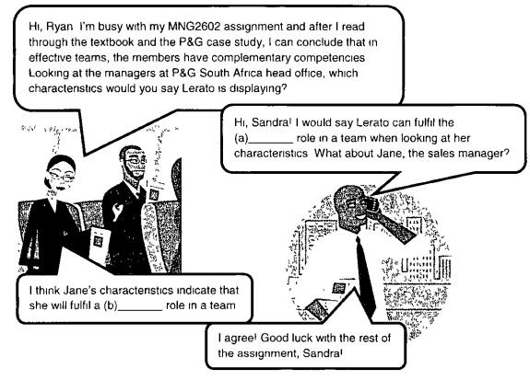
2.1 Complete the above conversation by filling in the blanks
a) Legitimate power
b) coercive power

QUESTION 3
  - Identify the mission statement of P & G.
“We will provide branded products and services of superior quality and value that will improve the lives of the world’s consumers, now and for generations to come. As a result, consumers will reward us with leadership sales, profit and value creation, allowing our people, our shareholders and the communities in which we live and work to prosper.”
  - According to your answer in Q2.1 above, identify which components of the mission statement are present.
- A mission statement defines the organisation for key stakeholders in terms of its product/services, market and technology
- Outcomes how the vision is to be accomplished
- It generates enthusiasm
- Empowers present and future members of the organisation to believe that every individual is the key to success

QUESTION 4
Name and discuss all they key role players in project management
- Strategic manager – A.G. Lafley – by taking over as CEO, it is part of a strategy to improve the company’s financial performance by doubling down on about 80 brands that generate 95% of the products and 90% of sales
- Project Management Office – HR Department – has the responsibility for development and growth of people towards higher level of skill, competency, creativity and fulfilment, in a way that supports each individual
- Tactical manager – Jane Richardson – a highly analytical individual who is excellent with checking the quality of her team’s work. When the sales team do not meet their goals, she threatens them with replacement
- Project team – Mr Jabu Khathini – Jabu is in charge of the team whose objective is to create awareness of the product. He and his team did all the planning for the event, implementing their decisions and taking full responsibility for the outcomes
- Operational manager – Kenneth Sullivan – extremely skilled in managing large projects and solving problems, ensures that all projects stay on track.

QUESTION 5
In order to generate revenue, an organisation can implement on of 7 basic internet business modules.
- Differentiate between the 7 business revenue-generating models.
- Commission-based model – based on commission that are charged for brokerage/intermediary services
- Advertising-based model – advertisers pay for web content
- Mark-up based model – selling marked-up merchandise
- Production-based model – selling manufactured goods and customer services
- Referral-based model – fees are charged by referring customers
- Subscription-based model – charges for unlimited use of service or content
- Fee-for-service-based model – charges fees for metered services
- Classify YouTube’s revenue-generating model based on the following information.
YouTube allows billions of people to discover, watch and share originally-created videos on the www.youtube.com website. Organisations looking to use this forum as a marketing tool can specify their target market. The organisation’s advertisement starts playing automatically when a video is selected and they will be charged once customers (anyone forming part of the target market watching a video on the website) watch seconds or more of the advertisement.
Advertising-based model

In order to generate revenue, an organisation can implement on of 7 basic internet business modules.
- Differentiate between the 7 business revenue-generating models.
- Commission-based model – based on commission that are charged for brokerage/intermediary services
- Advertising-based model – advertisers pay for web content
- Mark-up based model – selling marked-up merchandise
- Production-based model – selling manufactured goods and customer services
- Referral-based model – fees are charged by referring customers
- Subscription-based model – charges for unlimited use of service or content
- Fee-for-service-based model – charges fees for metered services
- Classify YouTube’s revenue-generating model based on the following information.
YouTube allows billions of people to discover, watch and share originally-created videos on the www.youtube.com website. Organisations looking to use this forum as a marketing tool can specify their target market. The organisation’s advertisement starts playing automatically when a video is selected and they will be charged once customers (anyone forming part of the target market watching a video on the website) watch seconds or more of the advertisement.
Advertising-based model

OCT/NOV 2017
Section A: Multiple Choice Questions
Consider the following statement then answer Q1.
As the demand for generic medicines grew form customers in the rest of Africa, Aspen, a pharmaceutical company, could gradually export its products to the rest Africa.
- The external force of change is in _________ scope.
1. Continuous
2. Punctuated
3. Incremental
4. Revolutionary
- Organisations such as Aspen, operating in a highly competitive market, should have the ability to change often and rapidly, effecting ___________ change. This type of change entails a pattern of uninterrupted adjustments in work processes and social practices driven by organisational instability and cumulative reactions to daily events.
1. Revolutionary
2. Punctuated
3. Continuous
4. Planned
Consider the following scenario.
Pharm Manufacturing is a pharmaceutical manufacturing organisation, situated in Riversdale in the Southern Cape. Aspen has successfully entered into the final stages of buying the organisation.
Next, consider the following table and answer questions 3 and 4.
COLUMN A – OPTIONS TO IMPLEMENT CHANGE | COLUMN B – METHODS TO DEAL WITH RESISTANCE TO CHANGE
a. at a slow pace | e. manipulation and co-optation
b. with a clear plan | f. negotiation and agreement
c. by encouraging substantial involvement from others | g. participation and involvement
d. by attempting to overcome it | h. facilitation and support
- Aspen plans to appoint Pharm Manufacturing middle-level managers in positions at its head office in Durban, but it is facing strong resistance from the managers who do not want to relocate to Durban.
Aspen should implement the __________ change and use the _____________ method to deal with the change.
1. a, h
2. c, f
3. d, e
4. b, g
- Aspen has provided all the workers with the necessary information on how an acquisition might affect them, but despite this, the factory workers at Pharm Manufacturing still fear that they may lose their jobs.
Aspen should implement any changes involving the factory workers __________ and use the ________ method to deal with the change.
1. a, h
2. c, f
3. d, e
4. b, g
- Aspen’s change team realises how vital it is to create and communicate a clear picture of the envisaged future state of the organisation to all the members of the organisation.
This is the ___________ step in ____________ change model.
1. Fourth, Malsow’s
2. Second, Lewin’s
3. Third, Kotter’s
4. Fifths, Porter’s
Read the following case study and answer questions 6 to 15.
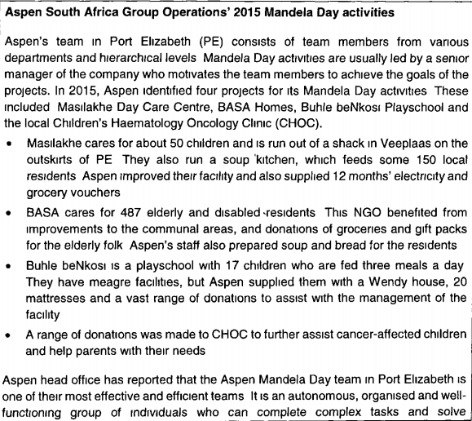
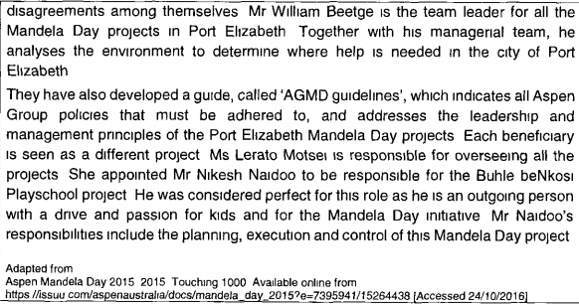
- The Mandela Day project has a/n ____________ perspective.
1. Profit
2. Quality
3. Internal
4. External
- Ms. Lerato Motsei is the _____________ of the Mandela Day activities in Port Elizabeth.
1. Programme manager
2. Operational manager
3. Programme director
4. Project sponsor
- Mr. Nikes Naidoo is the ________________ manager of the Buhle beNkosi Playschool Project.
1. Project
2. Tactical
3. Strategic
4. Programme
- Masilakhe Day Care Centre, BASA Homes, Buhle beNkosi Playschool and CHOC are _________ of Aspen’s Mandela Day project.
1. Low-interest stakeholders
2. Supporting role players
3. Sponsors
4. Clients
- ____________ conducted step ______________ of the project management process when ____________.
1. Mr. Beetge, three, he developed the AGMD guidelines
2. Aspen, four, they appointed Mr. Naidoo
3. Ms. Motsei, six, she appointed Mr. Botha
4. Mr. Naidoo, one, he planned the project
- Aspen’s Mandela Day team can be classified as a/n _________ group.
1. Informal interest
2. Formal interest
3. Command
4. Task
- At what stage in group development is Aspen’s Mandela Day team?
1. Norming
2. Storming
3. Adjourning
4. Performing
- Consider the way in which Aspen’s Mandela Day projects are led. What variable that influence group and team behaviour was most likely impacted by this fact?
1. Group member resources
2. Group processes
3. Group structure
4. Group task
- When considering the Belbin method for complementary team competencies, it is evident that Mr. Naidoo fulfils the __________ team role.
1. Shaper
2. Chairperson
3. Team worker
4. Resource-investigator
- The Aspen Mandela Day team can be classified as a _________ team.
1. Problem-solving
2. Cross-functional
3. Self-managed
4. Command
- ____________ is the tendency of organisations to develop strategies incrementally based on historical and cultural differences, but failing to keep pace with changes in the environment.
1. Strategic drift
2. Strategy deployment
3. Organisational learning
4. Organisational architecture
- Which one of the following national culture dimensions involves the degree to which members of a society feel uncomfortable with ambiguity?
1. Power distance
2. Uncertainty avoidance
3. Individualism vs collectivism
4. Long-term vs short-term orientation
- ______________ is the element of culture that represents an idea, process or physical entity with the purpose of communicating meaning.
1. Symbols
2. Artefacts
3. Stories
4. Rituals
- ____________ culture, as categorised by Deal & Kennedy (2000), is typified by low risk and slow feedback on actions and decisions.
1. Person
2. Process
3. Adhocracy
4. Constructive
- Jones et al (2006) identified 3 types of culture, namely ______________, ________________ and passive/defensive.
1. Constructive, aggressive/defensive
2. Adhocracy, work hard/play hard
3. Defensive/aggressive, authority
4. Assertive/aggressive, logic
- __________ is a primary dimension of diversity.
1. Geographic location
2. Work background
3. Physical ability
4. Marital status
- The ___________ is/are the cornerstone(s) of diversity behaviour.
1. Organisation’s strategic values
2. Right the wrongs approach
3. Melting pot assumption
4. Platinum rule
- Which of the following is the second step when implementing a strategy to develop a diverse workforce?
1. Formulating a vision for a diverse workplace
2. Building a corporate culture that values diversity
3. Changing structures, policies and systems to support diversity
4. Providing diversity awareness and cultural competency training
Consider the table below about the arguments for managing diversity and their corresponding reasoning, and answer questions 24 and 25.
ARGUMENT | REASONING
a) ________________ | Heterogeneity in decision-making groups potentially produces better decisions through a wider range of perspectives and more thorough critical analysis of issues
Marketing | b) _________________________
- Identify the argument for option (a).
1. Resource acquisition
2. System flexibility
3. Problem solving
4. Cost
- Identify the reasoning for option (b) that relates to the marketing argument.
1. The diversity of perspectives and the modernizing of diversity management will improve the use of imagination
2. Organisations with the best reputations for managing diversity will win the competition for the best personnel
3. The system will become less standardised and therefore more fluid, creating greater flexibility to react creatively
4. Members with roots in other countries bring new insight and cultural sensitivities to operations
- The ________ diversity paradigm is focused on incorporating diversity into the mission, work and culture of the organisation.
1. Growth-efficiency
2. Access-legitimacy
3. Learning-effectiveness
4. Discrimination-fairness
- In which situation can project management not be used?
1. To effect improvement and change
2. For a unique once-off task
3. In situations with an undefined start and finish
4. When more resources are needed than are available
- Compiling a resource management plan is an activity that forms part of step _____________ of the project management process, namely ______________.
1. Fourteen, monitoring and controlling project activities
2. Seven, developing key performance indicators
3. Ten, conducting the risk management plan
4. Nine, developing the project schedule
- Which one of the following is not an advantage of project management?
1. Control is exercised over all activities of the project, which leads to higher overall productivity
2. The different beliefs and values of the project team can be communicated and aligned
3. Effective project management can improve the quality of the product/service
4. Transparency in a project can be improved when all the role players are involved
Consider the following figure and complete it by answering questions 30 to 32.
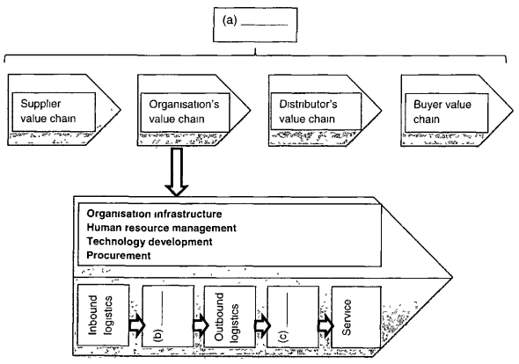
- Which of the following best completes option (a) in the figure above?
1. Secondary activities
2. Primary activities
3. Value system
4. Value chain
- Which of the following best completes option (b) in the figure above?
1. Marketing
2. Accounting
3. Operations
4. Human resources
- Option (c) in the figure refers to _____________ that works closely with the __________ function.
1. Research and development, marketing
2. Supply management, supplier logistics
3. Marketing, information technology
4. Top management, operations
Consider the following table and answer question 33.
COLUMN A – Type of shopping model | COLUMN B – METHODS TO DEAL WITH RESISTANCE TO CHANGE
a. Portal | e. The trading of intellectual capital on a per project basis
b. Storefront | f. Provides access to information stored either in a horizontal or vertical nature
c. Click-and-mortar | g. An offline offering is successfully integrated with an online offering
d. Online service provision | h. Provides for online shopping, payment, shipping and management of customer data
- Match the e-business type of shopping model in Column A with the relevant description in column B.
1. a-h, b-g, c-e, d-f
2. a-f, b-h, c-g, d-e
3. a-e, b-f, c-h, d-g
4. a-g, b-e, c-f, d-h
- The _____________-based internet business model often uses entertainment to enhance sales, and adds value through selection, distribution efficiencies and the leveraging of brand image and reputation.
1. Subscription
2. Advertising
3. Mark-up
4. Referral
Determine if the following statements are true or false.
- A storefront e-business shopping platform showcases by giving customers access to an inventory of stock. It provides for order taking and management of customer data
1. True
2. False
- The e-business advanced technology, management information system has evolved from expert systems, and it able to function in a designated non-linear environment, is able to learn and make correlations.
1. True
2. False
- Important considerations for e-business marketing are the control, development and management of a website.
1. True
2. False
Match the appropriate characteristic of the team in column B to the type of team in column A.
COLUMN A – TYPE OF TEAM | COLUMN B – CHARACTERISTICS
38. Cross-functional (3) | 1. Focuses on the improvement of quality, efficiency and the work environment
39. Problem-solving (1) | 2. Functions autonomously
 | 3. Members are usually from the same organisation, but can include members from another organisation
 | 4. Communicates and accomplishes tasks by mostly using telecommunications and information technology
- Which one of the following is not an example of a reason why an employee, Ms. Jane Riley, would join the group?
1. Belonging to the top management group of an organisation would provide Jane with recognition and status.
2. Jane can reduce the insecurity of standing alone since being part of a group will ensure she feels less threatened
3. Jane wants to work towards a common purpose – a specific project that will contribute to achieving the organisation’s goals
4. In order to satisfy social needs, as groups are social systems with opportunities for interpersonal relations.

Section B
Read the following Aspen case study and answer questions 1 and 2.
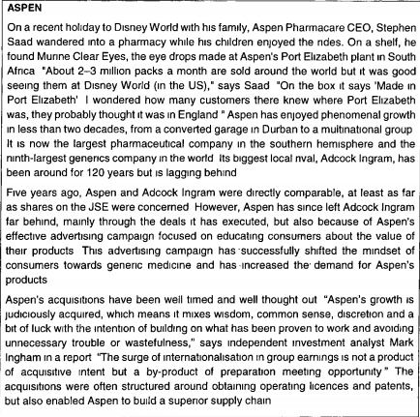
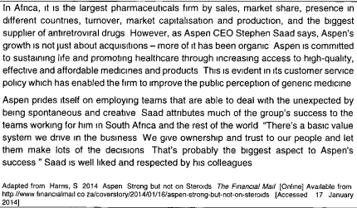
QUESTION 1
Organisations worldwide have to deal with a number of variables in their environment that emerged during the last decade or so, forcing them to become flatter, and more flexible, networked, global and diverse.
Identify 3 variables applicable to Aspen that forced them to change and cite examples form the above study case to substantiate your answer.
(Name each variable, describe it and provide a quote or shortened quote from the case study to substantiate your answer. No marks will be given for listing the variables without applying them to the case study).
- Globalisation – In Africa, it is the largest pharmaceuticals firm by sales, market share, presence in different countries, turnover, market capitalisation and production and the biggest supplier of anti-retro viral drugs.
- Increase power and demands of the customer – This advertising campaign has successfully shifted the mindset of consumers towards generic medicine and has increased the demand for Aspen’s product.
- New roles and expectations of workers – Aspen prides itself on employing teams that are able to deal with the unexpected by being spontaneous and creative. We give ownership and trust people and let them make lots of decisions

QUESTION 2
Discuss all the types of formal and informal power. Stephen Saad may possess as CEO, and identify which types of power are evident in the case study.
(Name the 5 types of power, describe each and state which 2 are evident in the case study.
Formal power
- Legitimate power – people gain legitimate power because of their formal positions in organisations, which allow them to make decisions pertaining to resource allocation, information flows, performance evaluations, task alignment and conflict resolution
- Reward power – rests with an individual, such as a manger in an organisation who has the ability to give rewards or reinforce desirable behaviour, ie salary increases, promotion, feedback and praise
- Coercive power – an individual who can offer/restrict benefits or inflict punishment or control the behaviour of another person has coercive power. Fear is the basis of coercive power because the person with power has the ability to inflict punishment or take action with adverse consequences for the other person.
Personal power
- Referent power – refers to the power of an individual because of his personal characteristics/charisma. People will follow and obey such and individual because they like and respect him and they accept that the person has power.
- Expert power – refers to an individual’s power that stems from the possession of scarce and valued expertise. Expertise is a source of power if it is the perception in the organisation that the individual possesses knowledge and understanding pertaining to a specific defined area.
Case study
- Referent power
- Legitimate power

QUESTION 3
Compare the 4 phases of the strategic management process by completing the table below.
Name the phases (in the top row of the table), state what question each stage answers (in the second row) and indicate one activity each stage involves (in the third row).
Phase | Strategic analysis | Strategy implementation | Strategic control
Question | What is the current position of the organisation? | How can the organisation get where it wants to be? | How will the organisation know when it has arrived?
Activity | Develop a vision and mission statement and analysis of the management environment | Formulating functional strategies & institutionalising them | Analysis of results, comparison with the objectives and goals of the organisation and corrective action

QUESTION 4
Shortly discuss any 2 misconceptions regarding diversity.
- Diversity is not culture – this approach reinforces an “us against them” mentality. It focuses on the ways we are different, without including the ways in which we are alike.
- Diversity is neither equal employment opportunities nor affirmative action – both EEO and AA are laws that are imposed on people and create an adversarial environment. Also, there is the belief that these 2 concepts mean that less qualified people should be given jobs, instead of more qualified “traditional” employees. The insinuation is that we have to help the designated classes of people because they are not really qualified enough to succeed on their own merits.
- Diversity is not an absence of standards – because we are removing our preconceived ideas about who is qualified for a job, we must create better definitions of actual job requirements. For true equality to happen, there needs to be less emphasis on race, gender and other differences, and increased focus on a person’s capabilities, and system adjustments that support diversity
- Diversity is not a vendetta against white males – to some, diversity symbolizes a more enlightened society, a reflection of our future as global citizens. To others, it breeds resentment. These 2 extreme views are at the heart of diversity and are the reasons why efforts to promote diversity so often fail. Although well intentioned, a focus on only culture, race and gender, which ignores ability and competence and which blames the white male for past injustices only intensifies the division between groups, instead of bringing them together to create a more productive workplace.

MNG2601 – SEMESTER 1 – ASSIGNMENT 1

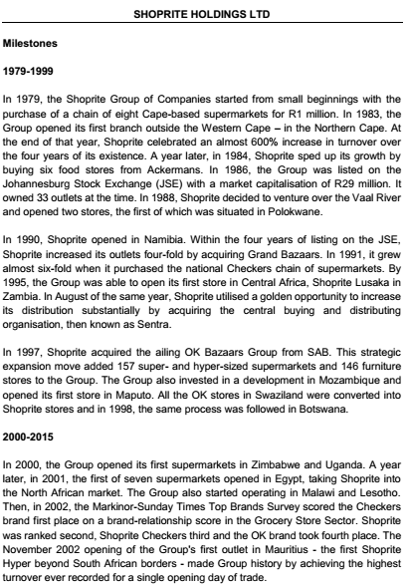
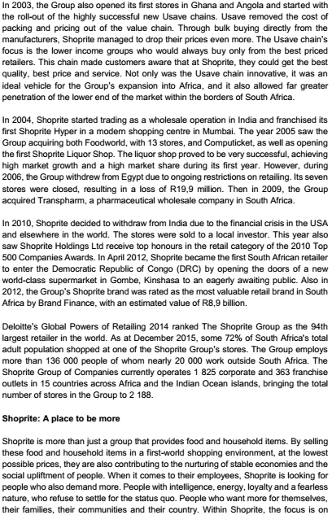
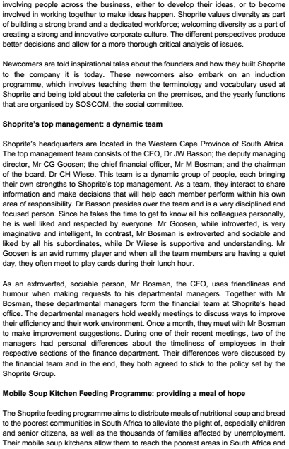
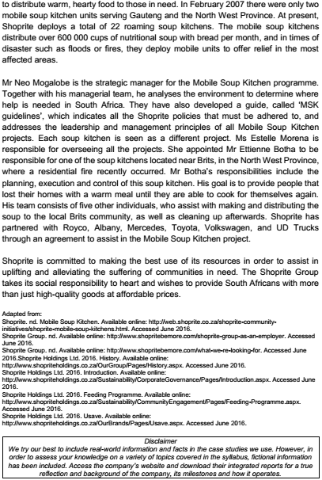
Read the Shoprite case study and answer questions 1 to 6.
QUESTION 1
Identify the variables that forced Shoprite to change in 2001 and 200 respectively and explain your answer.
2001 – Globalisation and the global economy
Description:
Globalisation refers to the worldwide integration of markets cultures, the removal of legal and political trade and the “death of distance”.
Globalisation is the economic and social interaction process whereby different countries work together to create a global economy.
Justification:
Shoprite expanded to the North African market (Egypt) – this indicates operating in another country, a new market.
2003- Increased power and demands of the customer
Description:
There has been an increase in the customers’ awareness of possible products and services. They are now able to choose products according to the criteria they set in terms of cost, quality, time, service, innovation and customisation.
Justification:
Lower-income groups would buy only from the best-priced retailers. Shoprite dropped their prices even more so that the lower-income consumers would also buy from them at the Usave chains.
QUESTION 2
When considering the answer for question 1, certain features of the ‘new’ organisation are evident (both in 001 and 2003). Identify the features that are evident in 2001 and 2003 respectively, and discuss the management challenges inherent in each feature.
2001 – Global
Shoprite, as a “new” organisation, is operating in an increasingly global economy.
Management challenges
- Managers of organisations competing in the global environment require global leadership skills
- Managers of organisations must understand and appreciate the diverse cultures of the individuals involved
- Managers or organisations must be able to think and operate globally
2003 – Flexibility
Flexibility is a key feature because Shoprite had to respond to changes in customer needs
Management challenges
- Managers need to be able to work on more than one project simultaneously as they might be members of various teams at any given time
- Multitasking skills must be developed
- Flexible organisations must have flexible labour practices
- Employees (current and prospective) need to have certain characteristics
- Leadership, people skills, a positive attitude and maturity are critical for managers’ personal progress
QUESTION 3
Consider the reason why Shoprite divested from India. Classify and explain the force of the change.
“… due to the financial crisis worldwide”
The force of change is external as it stems from the macro-environment of the organisation, more specifically the global/international sub-environment. This environment includes events that occur in one country that lead to change in other countries because of the integration and interdependence of world markets. The financial crisis worldwide had a direct impact on most countries’ economies, and therefore on many large organisations.
QUESTION 4
Discuss the organisational culture typologies as categorised by Jones, Dunphy, Fishman, Larne and Canter (2006), then identify the category most evident in the case study and justify your answer.
Constructive culture
Members are encouraged to interact with others and approach tasks in ways that will help them meet their higher-order needs.
Passive/defensive culture
Members believe that they must interact with others in ways that will not threaten their own security.
Aggressive/defensive culture
Members are expected to approach tasks in vigorous ways in order to protect their own status and security.
Shoprite has a constructive culture. The focus is on involving people across the business, either to develop their ideas or to become involved in working together to make ideas happen.
QUESTION 5
Consider the conflict that occurred between 2 managers at one of the monthly meeting and do the following:
5.1 Identify and discuss the cause of conflict.
The cause of the conflict is interpersonal.
Interpersonal conflict refers to the relationship or communication between individuals.
Interpersonal conflict can occur due to the following:
- Personal differences between individuals stem from different demographical factors
- Communication breakdown – Poor communication and misinformation result in individuals or groups having the wrong perceptions of other individuals or groups in the organisation
- Role incompatibility – Manager have different functions and roles that are interdependent. This interdependency may lead to conflict
- Competing for the same positions – Individuals may compete for the same scarce positions in the organisation
5.2 Discuss all the possible conflict management strategies then identify the one that was used to resolve the conflict.
The 5 conflict management strategies resulting from the 2 management style dimensions are the following:
- Avoidance – on or both parties choose to avoid or suppress the conflict
- Accommodation – one party chooses to focus on the other party’s needs to suppress or resolve the conflict or to seek some form of maintaining the status quo
- Compromise – both parties give up something and the parties reach a consensus decision
- Competition – the focus of one or both parties is on their own interests, resulting in dysfunctional conflict and a win-lose result
- Collaboration – differences are met and addressed, resulting in a win-win solution for the parties.
Collaboration was used to resolve the conflict
QUESTION 6
Identify any 3 strategies for managing diversity. Discuss these 3 strategies in terms of the diversity paradigm that Shoprite subscribes to.
Shoprite subscribes to the learning-effectiveness paradigm.
“… the focus is on involving people across the business…”
“Shoprite values diversity as part of creating a strong and innovative corporate culture.”
The focus strategy in this paradigm involves diversity being incorporated into the heart and fabric of the mission, work, and culture of the organisation. Their focus should be on diversity.
The HR practice strategy involves HR practices being redesigned and transformed to enhance the performance of all employees.
The effectiveness strategy involves all employees feeling respected, valued and included. There is a considerable degree of diversity among employees.
The weakness/strengths strategy involves the organisation capitalising on the diversity of all employees, and making all employees feel respected, valued and included.

MNG2601 – SEMESTER 1 – ASSIGNMENT 2
Read the Shoprite case study and answer questions 1 to 16.
- During which year did Shoprite follow a market development strategy?
1. 1984
2. 1990
3. 1991
4. 2009
- The corporate combination strategy Shoprite followed when enlisting partners to work with in their Mobile Soup Kitchen project is a/n _____________.
1. Strategic alliance
2. Joint venture
3. Acquisition
4. Merger
- When acquiring the Checkers chain in 1991, Shoprite implemented a _________ growth strategy.
1. Forward integration
2. Horizontal integration
3. Product development
4. Conglomerate diversification
- Which growth strategy did Shoprite implement in August of 1995?
1. Market development
2. Backward integration
3. Concentration growth
4. Related diversification
- Shoprite implemented a ____________ corporate decline strategy in 2010.
1. Turnaround
2. Divestiture
3. Harvesting
4. Liquidation
- “The 2002 Markinor-Sunday Times Top Brands Survey scored the Checkers brand first place on a brand relationship score in the Grocery Store Sector”
In this extract, The Checkers brand is an example of a/an ___________ when analysing Shoprite’s environment.
1. Threat
2. Strength
3. Weakness
4. Opportunity
- According to the Boston Consulting Group growth-share matrix, Shoprite Holdings can classify their new Liquor Shops in 2005 as a _______________.
1. Dog
2. Star
3. Cash cow
4. Question mark
- The Mobile Soup Kitchen project has a/an ______________ perspective.
1. Profit
2. Quality
3. Internal
4. External
- Ms. Estelle Morena is the ______________ of the Mobile Soup Kitchen project.
1. Programme manager
2. Operational manager
3. Programme director
4. Project sponsor
- _______________ conducted step _____________ of the project management process when _____________.
1. Mr Mogalobe, 12, he developed the MSK guidelines
2. Shoprite, 4, they appointed Mr. Mogalobe
3. Ms. Morena, 2 , she appointed Mr. Botha
4. Mr. Botha, 1, he planned the project
- When conducting a stakeholder analysis and plotting a stakeholder matrix, which stakeholder should the project team keep satisfied?
1. Mr. Neo Mogalobe
2. Ms. Estelle Morena
3. Shoprite employees
4. The local Brits community
- The MSK guidelines documented can be classified as the _____________ project plan of the Mobile Soup Kitchen programme.
1. Tactical
2. Operational
3. Communication
4. Quality management
- Dr. Basson fulfils the ____________ team role.
1. Plant
2. Chairperson
3. Monitor-evaluator
4. Resource-Investigator
- Mr. Bosman fulfils the _______________ team role.
1. Shaper
2. Chairperson
3. Team worker
4. Resource investigator
- When the top management team plays cards together on a quiet day, they can be seen as a/an ___________, ___________ type of group.
1. Informal, friendship
2. Informal, interest
3. Formal, work
4. Formal, task
- The financial team at Shoprite’s head office is a ________________ type of team.
1. Virtual
2. Self-managed
3. Problem-solving
4. Cross-functional
- According to ______________, the main reason why change efforts associated with re-engineering fail is ____________.
1. Kotter, time and costs overruns
2. Porter, costs that are out of control
3. Senge, a failure to communicate clearly
4. Lewin, that change cannot be effected in allocated time frames
- As an ear of change, ____________ is concerned with the activators or other resources.
1. Changes in structure and design
2. Technological change
3. Strategic change
4. Changing people
- _____________ is a barrier to change that occurs because the forces for and against change are equally strong.
1. Inertia
2. Volatility
3. Eustress
4. Incongruity
- Consider the question, “What is organisational culture?”
Now suppose the following answer is given: “According to Morgan (1997), organisational culture is ‘the pattern of basic assumptions that a group has invented, discovered or developed in learning to cope with its problems of external adaptation and internal integration…’. External adaption tasks involve developing consensus on a number of things, including the mission and goals. The internal integration tasks involve developing consensus on a number of things, including common language and criteria for status and power. Organisational culture has 3 levels, namely artefacts, values and assumptions.”
Which one of the following option identifies a mistake in the answer given above?
1. The external adaption tasks are incorrectly listed
2. The internal integration tasks are incorrectly listed
3. This definition was not by Morgan (1997)
4. Culture does not have 3 levels
- Mr. Bosman has legitimate power because of his position at Shoprite, which allows him to ________________.
1. Make decisions about resource allocation
2. Gain respect because of his personality
3. Offer or restrict employee benefits
4. Instill fear into subordinates
- The _________ strategy is a ____________ strategy employed by organisations to minimise the price of their inputs while targeting a segmented market.
1. Differentiation, grand
2. Cost leadership, grand
3. Focus differentiation, generic
4. Focus cost leadership, generic
- A _________ strategy involves the sale of a business or a component thereof and is implemented with the intention to focus on the more efficient divisions or business units of the organisation.
1. Turnaround
2. Divestiture
3. Harvesting
4. Liquidation
- The project sponsor is the person who ___________ of the project.
1. Controls the finances
2. Translates the strategic goals
3. Is in control of the maintenance
4. Removes obstacles encountered during the lifetime
- Read the following paragraph regarding an organisational value chain and correct it by choosing the correct option:
To optimise the value chain after vertical integration has been exhausted, organisations must shift their focus to internal efficiencies of the secondary activities. Efficiency is achieved by minimising operational inputs and optimising operational outputs, with little or no investment or expansion being undertaken.
1. The words “little or no” should be replaced by “some”
2. The word “internal” should be replaced by “external”
3. The word “secondary” should be replaced by “primary”
4. The word “efficiency” should be replaced by “effectiveness”
- ______________ stems from the ability of successful organisations to provide greater worth to customers, something which competitors try to emulate. An important contributor to the creation of worth is an organisation’s________, a term developed by Michael Porter to describe the interconnectedness and interrelatedness of these internal functions and activities.
1. Price advantage, value system
2. Fairness of exchange, value chain
3. Competitive advantage, value system
4. Sustainable competitive advantage, value chain
- Visit PnP’s website (shop.pnp.co.za). PnP uses a/an _________ revenue model and a/an _________ selling model.
1. B2C, storefront
2. Markup, click-and-mortar
3. Fee-for-service, online trading
4. Advertising-based, online product vision
- Which one of the following characteristics best describes a commission-based revenue-generating model?
1. An amount is charged for intermediary services. It adds value by providing expertise and/or access to a wide network of alternatives
2. This model entails selling marked-up merchandise. It adds value through selection and distribution efficiencies
3. Fees are charged for unlimited use of the service or content. It adds value by leveraging a strong brand name
4. Fees are charged for metered services. It adds value by providing service efficiencies, expertise and practical outsourcing solutions
Consider the following list of variables that influence behaviour in a group:
a) group processes
b) communication
c) authority structure
d) organisational culture
e) member skills
f) leadership
g) group task
h) member status
i) member power
j) group decision-making
k) group structure
l) group member resources
m) organisational context
n) task interdependence
Classify (organise) he variables that influence the functioning of a group under the correct factors of the group behaviour model.
Firstly, identify the factors of the model from the list above, then classify the corresponding variables under each factor. For example: a factor of the group behaviour model is (g) group task, and a variable this factor includes is (n) task interdependence.
- ___________ include(s) _____________.
1. l, c and d
2. k, f and h
3. j, c, e and f
4. d, e, h and i
- ___________ include(s) ______________.
1. m, c and d
2. a, c and f
3. e, l
4. j, h

