FAMILY BUSINESS

MNE 3704

TOPIC 1

STUDY UNIT 1: The Family Business

Chapter 1: The Family Business (Pg 2 – TB)

INTRODUCTION

Family businesses are major contributors to economic growth in free economies all over the world. Statistics indicate that Family businesses constitute (80 to 98)% of all businesses in the world’s free economies and employ more than 75% of the working population around the world. Poza (4th Ed) expresses concern about the high failure rate of family businesses and the transition of the business to the third generation. Nevertheless, family businesses that are agile and niche focused and that deliver high-quality customer service continue to thrive.

Family businesses make a significant contribution to South Africa’s economy. Some 84% of businesses in South Africa have been identified as family businesses, including some well-known family businesses with a proven track record.

WHAT CONSTITUTES A FAMILY BUSINESS?

Family businesses are all enterprises in which an entrepreneur or next-generation chief executive officer (CEO) and one or more family members significantly influence the firm through their participation, ownership control and strategic preferences, and the culture and values they impart to the enterprise.

From research, Poza (4th Ed) indicates how difficult it is to find a universally acceptable definition of the term “family business”. Four factors emerge as a working definition of a family business, which is a synthesis of the following:

- ownership control (15% or higher) by two or more members of a family or a partnership of families

- strategic influence by family members on the management of the firm

- concern for family relationships

- continuity across generations

Poza (4th Ed) describes four characteristics that define the distinctiveness of family businesses:

- the presence of the family

- the overlap between family, management and ownership, with its zero-sum propensities in the absence of firm growth

- the unique sources of competitive advantages derived from the interaction of family, management and ownership, especially when family unity is high

- the owner’s dream of keeping the business in the family (the objective of business continuity from generation to generation)

SUCCESSION AND CONTINUITY

A factor that contributes to the uniqueness of family business is the extent to which succession planning assumes a strategic role in the enterprise. A lack of succession planning is the most prevalent reason for the failure of family businesses. In South Africa, family-owned businesses are visible in the townships of the previously disadvantaged communities. Most spaza shops and other ventures are owned by a family member, and the grandparents, spouses and children participate in the daily running and management of these ventures. They contribute to the combined family income and form a critical part of the second economy of South Africa.

A family business is not a normal business because of the involvement of family issues which are, by nature, more emotional. In addition to the problematic nature of family businesses, their contribution to socioeconomic growth has never really received sufficient attention in South Africa. Questions and remarks such as “Who wants to do business with family?” or “Stay away from family in business.” or “It is difficult enough to accept him/her as a family member and now you expect me to go into business with him?” have aggravated the situation. These phrases are all too familiar in the South African environment and may be a reason why family businesses have not received adequate attention until now.

The family business sector is still characterised to a certain extent by a traditional mindset – from father to son, with the mother there to look after the children. With more women entering business, this trend seems to be changing.

BUILDING FAMILY BUSINESSES THAT LAST

For family businesses to continue across generations, a balance has to be found between protecting the core of the business success and adapting to a changing and competitive environment.

According to Maas (2009:228), the biggest concern regarding family businesses in South Africa is the level of family business management skills. The majority of family businesses are simply not trained to manage their businesses successfully — either business-wise and/or family-wise. This also influences their ability to manage risk in a fast-changing environment where one needs to stay entrepreneurial in order to survive and grow.

Family businesses in South Africa are a growing sector, but there are certain deficiencies that impede their growth and expansion, such as a lack of management skills. Decisions are still taken on an ad hoc basis without regard for balancing the relationships between all subsystems.

THEORETICAL PERSPECTIVES ON FAMILY BUSINESSES

There are 5 theoretical perspectives on family business as follows:

- The systems theory perspective:

The systems theory perspective of the family business, reveals the family business as a complex and dynamic social system comprising three overlapping, interacting and interdependent subsystems, namely;

- the family,
- ownership, and
- management.

This makes significant adaptive capacity and competitive advantage possible through joint optimisation. The boundaries between these subsystems present unique challenges. Where priority is given to a particular subsystem, it could lead to significant sub-optimisation of the family-ownership-management system, resulting in lower levels of performance than the family business is capable of achieving.

Poza (4th Ed) distinguishes the primary focuses in family businesses with the following priorities:

- Family-first businesses:
  - employment based on birthright
  - Stereotype – nepotism
  - Non-family managers with high career aspirations are often reluctant to join family businesses
  - Business exists primarily for the benefit of the family
  - The transfer of benefits to family members are often excessive
  - Lack of transparency and financial systems are usually obtuse by design and secrecy is paramount
  - Continuity must be regarded as important by both the current and future family generation in order for the family to continue as a family business.

- Management-first businesses:
- Likely to discourage family members or require work experience as a prerequisite for employment.
- Performance of employed family members is reviewed in the same manner as that of non-family managers
- Next generation family members often viewed in terms of their ability to manage and grow the firm
- No automatic commit to family-business continuity as the business is seen as a productive asset

- Ownership-first businesses:
- Focus on shareholders, EBITDA, earnings growth rates
- Investment time horizon and perceived risk are significant issues
- Financial results are evaluated more frequently
- Danger of losing Patient capital – a significant source of competitive advantage of many family businesses – may disappear at the hands of greedy shareholders. Family members may be caught in a web of high expectations for short-term returns via dividends and may become prone to second guessing family members in management. Family members who understand the limited capabilities of the business to deliver on the promise of high returns, are most likely managing in the long-term interests of shareholders. Other family members may be in favour of high returns and short time frames. This struggle may result in the loss of vision by family members and the continuity of the business may be abandoned in favour of recapturing the value created by the founders by selling the business.

Owing to the different goals and operating principles of each of the three systems in a family business, blurred boundaries may occur between the family, ownership and management subsystems. It is, however, possible to balance the goals and needs of each subsystem for the greater good of the larger system — the family business. Poza (4th Ed) offers several suggestions for joint optimisation. The systems theory perspective is of particular importance.

- The agency theory perspective:

Agency theory has traditionally suggested that the overlap between ownership and management (the agents) found in family firms is an asset.

Agency theory’s more recent argument is that because of the altruism of owner-managers, family organisations have one of the more costly forms of organisational governance. A number of sources of increased agency costs are cited such as:

- The owner-manager’s inability to resolve conflicts,
- Executive entrenchment,
- A lack of performance monitoring and goal incongruity between the CEO and the rest of the family and
- A preference for less business risk.
- A lack of monitoring the firm’s performance

According to the Agency theory, the inclusion of outside directors on the board of a family business is an important mechanism and could limit managers’ self-serving behaviour where the managers and the owners have conflicting goals. It should be kept in mind that family-business owners are well aware of the unique competitive challenges they have to face.

- The strategic perspective: competitive challenges faced by the family

The following are some of the challenges that family business owners or next-generation members have to face:

- Shrinking product life cycles require companies to innovate and adapt more.

- Intense cost competition, rapid changes in distribution and the value chain require tremendous agility.

- The increasing individualism of younger generations manifests in them not relating to the family legacy.

- The media have created the biased image that large corporations are the winners, which may cause the next generation to seek employment elsewhere.

- Increased life expectancy results in the entrenchment of the current-generation CEO.

- The growing complexity of tax may predispose owners towards tax minimisation.

- From the agency costs literature, it is not yet clear whether the interaction between business and family represents a net positive for the family firm.

- The resource-based perspective: Competitive Advantage

The resource-based view of family business focuses on the resources that are unique to these family businesses. These resources, often referred to as organisational competencies embedded in internal processes, human resources or other intangible assets, can provide the firm with competitive advantages in certain circumstances.

5 unique resources that the family business can call on to create competitive advantages:

- The overlapping responsibilities of owners and managers, along with small company size, enable rapid speed to market.

- The concentrated ownership structure leads to higher overall corporate productivity.

- The strategic focus on customers and market niches results in higher returns on investment.

- The desire to protect the family name and reputation often translates into high product/service quality and higher returns on investment.

- The nature of the family-ownership-management interaction, family unity and ownership commitment supports patient capital, lower administrative costs, skill/ knowledge transfer and agility in rapidly changing markets.

The ability of a particular family business to capitalize on its unique advantages depends on the quality of interaction between family business and family. Measuring the perceptions of different stakeholders, monitoring executive performance, and implementing a particular set of prescribed managerial and governance practices can all contribute to controlling the hypothesized costs and turning the unique features of family firms into resources that actually produce competitive advantage.

- The stewardship perspective:

The stewardship perspective claims that the founding-family members view the firm as an extension of themselves and therefore view the continuing health of the enterprise as been connected to their own personal well-being. This view argues that responsible ownership by any given generation is characterised by its commitment to something larger than the individual (e.g. the family clan) and by its dedication to passing on a healthy firm to the next generation. This fact translates into the continuing health of the business correlating with the well-being of the owner.

It emerges that stewardship in the family business refers to commitment to the business, individual responsibility and the advisory, objective and committed stance of independent board members. Appreciation of the legacy, advocacy for the ongoing concern and advisors on a board that complements the family’s competency set are often present in family firms with this perspective.

As stewards of the firm, family owners often place individuals on the board who have industry knowledge and who can provide objective advice and advocate for a going concern. The independence of the board is a reflection of the family’s commitment to avail itself of complementary skills that the family lacks, such as legal, financial, succession-planning, accounting and international-marketing skills and knowledge. The directors are chosen to promote continued corporate health based on their ability to provide advice that adds value. As such, the board has a positive impact on the financial performance of the firm through its advice more than through its monitoring or supervisory function – the overriding function boards perform for publicly traded nonfamily firms.

ETHICS, SOCIAL RESPONSIBILITY AND THE FAMILY BUSINESS

Family businesses are perceived as being less socially responsible because of their incentive to protect family wealth. In addition, they are often perceived as less ethical because of their incentive to reduce tax liabilities. However, family businesses have a built-in desire to uphold the family company’s image and protect the family’s name and reputation.

According to Kruger and De Klerk (2008:331), good ethics is good business. Behaving ethically can be profitable, and the development of an ethical corporate culture through training and education is of utmost importance. The scope of business ethics includes the responsibility of business towards the different state authorities and the environment (both the immediate community and the country as a whole).

The primary aim of social responsibility should not only be to improve the quality of life of all employees in a business, but also to make a contribution to the development and upliftment of the community through projects, donations, quality of work-life programmes and adult literacy. Participation in social responsibility is one of the best methods of promoting a business’s public image and gaining the goodwill and support of the public at large.

FAMILY BUSINESS RESEARCH

There is an observable trend in South Africa that more husband-and-wife teams are joining hands in business. Maas (2009:218) does not classify these businesses as proper family businesses. According to him, only if they involve more family members and/or their children and wish to continue the business into the next generation, do they become family businesses. He regards husband-and-wife teams without the intention of creating a family business as “co-preneurs”.

ADVANTAGES OF FAMILY BUSINESS

Advantages | Disadvantages
Long-term orientation | Less access to capital markets may curtail growth
Greater independence of action  - Less or no pressure from stock market  - Less or no takeover risk | Confusing organization  - Messy structure  - No clear division of tasks
Family culture as a source of pride  - Stability  - Strong identification, commitment and motivation  - Continuity in leadership | Nepotism  - Tolerance of inept members as manager  - Inequitable reward systems  - Greater difficulties in attracting professional managers
Greater resilience in hard times, willing to plough back profits | Internecine Strife  - Family dispute overflow into business
Less bureaucratic and impersonal  - Greater flexibility  - Quicker decision making | Paternalistic/autocratic rule  - Resistance to change  - Secrecy  - Attraction of dependent personalities
Financial benefits  - Possibility of greater success | Financial strain  - Family members milking the business  - Disequilibrium between contribution and compensation
 | Spoiled-kid syndrome
 | Succession dramas
Family business can succeed and grow in spite of complex challenges for the following reasons:

- Family-owned companies are not encumbered by demanding stockholders who insist on dictating operating strategy.

- Family members are willing to sacrifice short-term profits for long-term gain.

- Research shows that family members are more productive than other employees.

- Family-owned companies are more flexible in responding to challenges and opportunities.

- Owners of family businesses can convey an image of stability, providing continuity for both customers and employees.

(Longenecker, Moore, Petty & Palich 2006:89; Kuratko & Hodgetts 2004:651) identified three advantages that flow from family values and influences:

- Preserving the humanity of the workplace: Family businesses tend to demonstrate higher levels of concern and care for employees compared with typical corporations.

- Focusing on the long term: A family business can choose to take a longer-term view, whereas the corporate manager is judged on the business’s year-to-year results.

- Emphasising quality: Family businesses are known for providing customers with quality and value.

PRIMARY SOURCES OF COMPETITIVE ADVANTAGES

The seven primary sources of value on which family companies can build competitive advantage are:

- financial resources, such as cash and securities;
- physical assets, such as plants and equipment;
- the product (sometimes protected by patents) and its price and performance;
- brand equity, which is the market’s perception of a distinction in quality or reputation, a perception created over time;
- organizational capabilities, which are the competencies residing in employees and unique organizational architectures;
- customer–supplier integration (once called “distribution and logistics”), which includes new ways of getting the product or service to the customer in any form, at any time, and in any place; and
- a positive family–business relationship, the source of patient family capital. Combining these seven sources of value in various ways, as if different pieces in a custom-assembled puzzle, will give rise to a unique business model, one that is rooted in the core competencies of the business and can create value for both the owners and the customers.

STUDY UNIT 2: FAMILY DYNAMICS (Chapter 2 – TB Pg 30)

Great Families in Business (Pg 16 – SG)

INTRODUCTION

ZERO – SUM DYNAMICS AND FAMILY CULTURE

It is within the rights of ownership to focus on individual gain and to retain the right to immediate liquidity. However, multi-generational family – controlled businesses are largely illiquid.

Zero-sum dynamics happen when the family business stops growing or is in decline. A zero-sum dynamic in a relationship occurs when the one party’s perceived gain is the other party’s perceived loss. This results in a so-called “us-versus-them” dynamic triggered by perceived differences such as

- Male versus female
- Active in the business versus inactive in the business
- Richer versus poorer
- Better educated versus less educated
- Older versus younger
- Blood relative versus in-law

THE FAMILY SYSTEMS PERSPECTIVE

Poza (4th Ed) explains the family systems theory using concepts such as higher-order system, emotional interdependence, sharing responsibility and family of origin.

Bowen’s theory of family systems states that:

- A family is a system
- Family systems transfer rules, patterns, messages or expectations about the behavior of its members
- Individuals and families can still learn behaviors and establish different patterns to those transferred from the family of origin
- Tension and distress tend to make individuals go back to patterns and behaviors learned from the family of origin.

Differentiation of self is therefore a foundational principle of family systems theory. It suggest that emotions are very old and powerful in the context of our family history. As a result of the difficulty implicit in self-determination, individuals often behave as if they are pouring out their emotional selves onto others, which in family systems theory gives rise to Bowden’s concept of triangulation.

Triangulation is the predictable emotional pattern among three people, with the “third”, the outsider, being triangulated as a result of the emotional outpouring in the relationship between the other two family members. In large, extended families, many triangles exist, and according to this theory, whenever people are in conflict, a triangle person is not far from being brought into the discussion for support or reassurance. Ultimately it is the task of the two people in conflict to resolve the situation, and not through the triangle third who is the most at risk by getting in the middle.

Family systems theory fundamentally aims to increase our understanding of family patters and behaviors and of how these might help or hinder relationships between family members and between the family and its business.

THE ROLE OF GENOGRAMS AND FAMILY MESSAGES IN UNDERSTANDING THE FAMILY SYSTEM

Family names and events

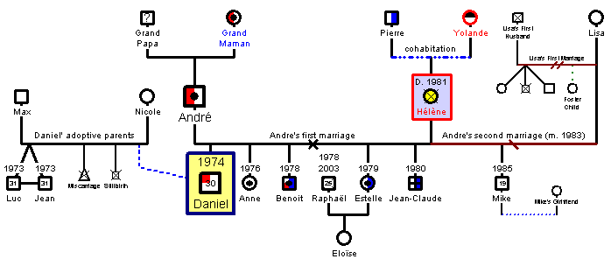
FAMILY EMOTIONAL INTELLIGENCE

An emotional intelligence test measures the individual’s self-awareness, social awareness, self-management and relationship management. (Poza 4th Ed) explains why an understanding of the level of emotional intelligence of different family members contributes to understanding the emotional intelligence of the family as a unit, and how this information can be used in family business consulting.

Balshaw and Goldberg (2005:47) argue that the core elements of emotional intelligence in highly effective leaders are the following:

- Self-awareness: the awareness of your own feelings and the ability to recognise and manage these feelings

- Emotional resilience: the ability to perform well and consistently in a range of situations and under pressure

- Motivation: the drive and energy you have to achieve results, balance short- and long-term goals and pursue your goals in the face of challenge and rejection

- Interpersonal sensitivity: the ability to be aware of the needs and feelings of others and to use this awareness effectively in interacting with them and arriving at decisions impacting on them

- Influence: the ability to use insight and interaction to arrive at and implement decisions when faced with ambiguous or incomplete information

- Conscientiousness and integrity: the ability to display commitment to a course of action in the face of challenges in order to act consistently and in line with understood ethical requirements

HOW FAMILIES ADD VALUE: THE FAMILY BUSINESS INTERACTION FACTOR

A family business with a high degree of family harmony tends to be more effective in planning for business continuity. Another construct that emerged is the tolerance of differences, which results in greater understanding of each other and is more likely to lead to decisions that are mutually beneficial for all parties.

Poza (4th Ed) discusses the results based on the scores on the Family Unity Index, which is the sum of family harmony, tolerance of differences and participation and succession scales.
Family unity correlates with the following effective management practices:

- Planning activity
- Performance feedback
- Succession planning disclosure
- Advisory boards
- Family meetings

The findings indicate that business effectiveness and continuity are fostered when the family’s health and harmony are ensured via:

- Guidelines on the employment of family members
- Clear standards for succession and ownership transfer processes
- Promotion of cooperation and positive relationships between family members

The unique interaction between the family and the business is a resource that provides an opportunity for gaining a competitive advantage.

THE BENEFITS OF FAMILY MEETINGS

Frequent family meetings prevent zero-sum dynamics. Poza (4th Ed) cites two reasons for the importance of family council meetings:

- Family unity and continuity:

Maintaining family unity is often difficult because family members may be separated geographically. Family unity is a strong predictor of the successful use of a set of best managerial and family practices by family companies and a defining element in the relationship between the owning family and the business.

Stakeholders in the family business vary with regard to their involvement in the business. This involvement may assume one of the following forms:

- Owner only
- Owner-manager
- Family member with no share ownership
- Member of the current or next generation
- A key nonfamily member

Increasing a sense of unity, trust and commitment to goals requires well-structured processes that involve family members in developing policies and setting direction. Family unity is a strong predictor of the successful use of managerial and family practices and a defining element in the relationship between the owning family and the business.

- Planning and policy making:

To avoid uninformed opinions and passionate second-guessing, family meetings should address three critical issues:

- Educating uninformed members
- Communicating the necessary information to the uninformed members through open and safe processes, such as conversations, deliberations and presentations by experts
- Developing effective planning and policy-making bodies

Types of policy that are useful for families in business are discussed in detail in Poza (4th Ed):

- A family employment policy: A family employment policy should cover the following:
- Outline the levels of education and experience required for employment in the business
- The policy should be based on merit and company need, and not membership in the family business
- Family employment policies, including promotion practices, need to be written down and communicated to create greater clarity, transparency and a sense of fair play
- The policy should emphasise the principle of equal opportunity

- A subcontractor policy:
A policy that offers guidelines for “at arm’s-length” transactions in an open competitive marketplace. The bidding processes should create a level playing field for relatives and non-family alike.

- A board service policy:
A board policy should include criteria for the selection of family members to serve on the board as at-large representatives of the owning family. The systems should provide a link between family strategies without giving undue influence to family members.

- A family council service policy:
A family council service policy should state the criteria for selecting family members to serve as group coordinators of the family council and other committees that may be formed. Possible goals of the committee may be that of a family newsletter, family history project and philanthropic activities.

- A dividend policy:
Although the amount of dividends to paid is a business decision, a dividend policy should address the family needs and balance them against reinvestment in the business for growth, and then inform management of the general sentiments of the family.

- A liquidity policy:
This includes principles supporting the desired relationship between the controlling family and the company in the future and recognising that individuals or particular family member branches may have cash-flow needs. This policy usually differentiates between small transactions and the sale of large quantities of stock within the family. It also backs the company and references legal documents in effect (such as buy-sell agreements)

- A family constitution:
Used primarily in older and larger multigenerational family businesses; the family constitution is a collection of the established policies and a statement of family history, family commitment and the desired relationship between the company and the owning family.

- A prenuptial policy:
States the family’s desire to keep the ownership of the business within the family and the steps required of every family member when they marry.

- An owner’s plan:
The owner’s plan conveys to the board of directors the vision, values, mission, goals and the needs of the shareholders.

Poza (4th Ed) offers five guidelines to assist families in developing family business policies (Family business interaction policy).

- Involve as many family members as are relevant to the particular policy being developed. Relevance of a policy is defined by expertise on the subject(s) to be discussed, by the need of family members to feel included, and by the potential effect of the policy on those family members.

- Look at the bigger picture by formulating a mission statement or objective that defines what is best for the extended family and the business.

- Focus on the future and let go of the past. Self-Management is critical in moving away from repetitive retelling of past experiences.

- Use experienced facilitators, who can play a significant roles in helping a family business focus on the future, and benchmark the draft policies against those of other successful family-owned businesses.

- Agree on the process to be followed to develop, review, edit, redraft, approve and ultimately enact policies with confidence that people will support them.

TRUSTS, LEGAL AGREEMENTS AND PERSONAL RESPONSIBILITY

Shareholders who share the founder’s and successors’ dreams and vision will choose to be stewards of the legacy. The rest will be driven by their personal interests and agendas. Even restrictive trusts cannot prevent the actions of the latter group of shareholders. A family council can be instrumental in rediscovering the legacy.

Evidence now exists that generation-skipping restrictive trusts crafted to maintain business continuity and family unity, fail miserably in preventing next-generation members from doing with the company as they see fit. As a family business passes from generation to generation it is important to rediscover the intangible, value-based legacy of the founder and earlier generations.

Rediscovering the legacy of a family business takes time and discussions are important. In fourth generation family businesses, family members consider themselves fortunate to have senior family members on board who have nurtured the family business for more than 80 years. Rediscovering the legacy requires family history projects and candid discussions regarding the strategies and growth opportunities sought by the different generations and family members acting as chief trust officers.

CONFLICT MANAGEMENT

Conflict is inevitable in families, especially when the families live, work and control assets together. A family council can play a critical role in reducing the potential for conflict.

Some problems to be addressed are:

- Frustration over alienation or lack of inclusion
- Anger over unfairness in employment practices and promotions
- Dissatisfaction with dividend policies and lack of liquidity.

The root of most types of conflict is found in mistaken “perceptions”, which a family council could correct through its educative task.

The following steps that should be followed in managing conflict can be summarised as follows:

- Avoidance: This is a technique in which the conflicting parties withdraw from the conflict. However, this technique is rarely effective.

- Face-to-Face problem solving: Involves a face-to-face meeting of the conflicting parties in an effort to identify the problem and resolve it through open discussion.

- Formulate a shared goal: that cannot be attained without the cooperation of each of the conflicting parties.

- Expand resources: Where possible, expand resources to create a win-win solution to conflict.

- Manage differences: Play down differences between the conflicting parties and emphasise their common interests.

- Use authoritative command: Management may use authoritative command to resolve conflict and communicate its desires to the conflicting parties.

- Change to formal organisational structures: to resolve conflict. This will result in a change in the communication patterns of the conflicting parties. Examples are job redesign and the creation of coordinating positions.

- Negotiation: A general strategy for dealing with conflict is negotiation. Negotiation is “a process of interaction (communication) between parties, directed at reaching some form of agreement that will hold and that is based upon common interests, with the purpose of resolving conflict, despite widely dividing differences. This is achieved through the establishment of common ground and the creation of alternatives”.

STUDY UNIT 3: THE OWNERSHIP CHALLENGE (Chapter 3 – TB Pg 58)

OWNERSHIP OF AN ENTERPRISE BUILT TO LAST (Pg 24 – SG)

INTRODUCTION

It is not only the family that has a substantial influence on what is fundamentally different about a family business, but also the share ownership and the corporate control exercised by the shareholders. Poza (4th Ed) cites research findings showing that family-controlled firms enjoy higher financial performance compared with management-controlled firms. Poza (4th Ed) emphasises the importance of understanding and leading the ownership of the family firm when there is no longer only a single founding entrepreneur.

The family business is fundamentally different from non-family businesses. The family business has been stereotyped more often than it has been well understood by management experts and the business media.

The term ownership refers to company share ownership and the corporate control exercised by shareholders. Studies have shown that family-controlled firms can enjoy better financial performance than management-controlled firms. An essential part of the CEO’s job is to understand and successfully lead the owners of the family firm – its shareholders.

As second generation family members become owners, some may work in the business, whilst others may not. Maintaining unity and a realistic assessment of business and career opportunities among family members and shareholders in this situation becomes very difficult.

If a family business is to preserve one of its intangible yet well-documented competitive advantages – its propensity to manage with a long-term horizon – investments in the ownership subsystem is essential. This means investing in:

- The design and execution of an appropriate ownership and control structure
- The education, access to information and engagement of shareholders
- The creation of institutions that govern the interaction between owners and the firm

Shareholders Priorities

Shareholders usually want risk-adjusted economic return captured in shareholder value and dividends or distributions.

EBITDA (Earnings Before Interest, Taxes, Depreciation, and Amortization) as well as net earnings, earnings growth rates as well as debt/equity and debt/asset rate are important elements of the financial scorecard of a family enterprise. However, family members may also be interested in noneconomic outcomes such as identity, reputation and the ability to carry out philanthropic initiatives.

Whilst all businesses strive for financial success, a family business may see success a for more than just financial gain.

Managers on the other hand tend to be more concerned with market share, competitors, growth and their own compensation and career opportunities. Often their scorecards reflect this bias by focusing more on revenues, sales growth, and margins. But it is profit and cash flows that drive both shareholder value creation and the possibility of other shareholder returns, like dividends.

Two mission with some alignment

Management:
Competitiveness, Growth, Career Opportunity, Profit?
Ownership:
Return on Invested Capital, Family unity, Shareholder value, continuity?

Responsibilities of shareholders to the company

Shareholders have the following responsibilities:

- Define and then demand reasonable returns on shareholder equity or invested assets.
- To provide the values and principles of doing business and ensure they remain instilled in the company, and
- To define the owning family’s strategy and communicate owning-family priorities

EFFECTIVE GOVERNANCE OF THE SHAREHOLDER-FIRM RELATIONSHIP

If owner-family-business interaction is positive, it is a source of competitive advantage. However, it may also be a major challenge for the family business, namely the effective governance of the shareholder-firm relationship. Two issues need to be considered:

- The role of the board:

Consistent with agency theory, independent directors should balance family board members to minimise the potential agency costs of the family business ownership. Apart from the traditional role of the board in strategic planning, the board has to govern the relationship between the family and its business to ensure a positive-sum dynamic. This may require a lot of communication and education.

- The role of shareholder meetings, family meetings and meetings of the family council:

The role of these is to communicate, educate and share financial and strategic information in order to keep the shareholders involved and comply with the legal requirement to recognise the rights of minority shareholders.

By keeping the overlap between ownership and management healthy, competitive advantages can be exploited and the traditional agency costs faced by nonfamily firms (the costs of separating management from ownership and having managers as agents of the owners) are mitigated.

INFORMATION, COMMUNICATION AND EDUCATION OF SHAREHOLDERS

Owners need to be financially literate and understand financial statements, the capital structure of the firm and debt levels in relation to owners’ equity. To enhance the shareholders’ understanding, they should attend shareholder meetings and communicate with top management and board members.

Trust is the result of information, reliability and predictability, accessibility, shared goals, emotional bonds, a sense of fairness and transparency. These generate confidence in understanding the people and the situation the company is in. The following factors also create and promote trust:

- Success and meeting performance goals tend to enhance trust; the absence of these often gives rise to mistrust.
- Frequent updates about financial matters and the state of the business promote trust.
- Goal alignment and family unity (being in it together as partners) make trust easier
OWNERSHIP STRUCTURE: DESIGN AND EXECUTE IT

In structuring ownership it is critical to ensure that entrepreneurial speed, agility and competitiveness are maintained and that the next-generation owner-manager’s ability to lead is not eroded. To accomplish this, different classes of stock can be issued, such as voting and nonvoting stock for family members and phantom stock for nonfamily management. Buy-sell agreements offer liquidity windows for dissident shareholders to exit the family business.

Unlike ownership, the authority to lead is earned rather than inherited. However, transferring ownership without an eye toward corporate control makes it more difficult for successors to acquire the authority to lead.

SUMMARY

In order to achieve competitive advantages for the family business, the theoretical framework for this is based on the importance of

- jointly optimising the ownership, management and family subsystems
- Controlling agency costs
- Ultimately exploiting the unique resources available to family businesses

TOPIC 2 LEADERSHIP IMPERATIVES FOR THE FAMILY AND BUSINESS: SUCCESSION AND CONTINUITY

STUDY UNIT 4: SUCCESSION: Continuing entrepreneurship and the next generation (Pg 38 – SG)

Chapter 1: The Family Business (Chapter 6 Pg 39 – TB)

INTRODUCTION

IS THE NEXT GENERATION GOOD ENOUGH TO RUN THE BUSINESS?

Evidence of the readiness of the next-generation members to lead can be found in their attitudes (work ethic and commitment), values and education. The systematic review of succession experiences has led to the following conclusions:

- When a successor is held accountable for profit or loss, the results determine his or her capability and readiness to be a successor.

- Next-generation members can earn respect through solid performance and interpersonal skills.

- Education, especially in the form of an MBA, helps successors to gain both the skills and confidence to advance from middle to top management, even though they lack specific family-business training.

- Coaches and mentors, both inside and outside the family, contribute to the development of successors.

- An independent assessment of the strengths and weaknesses of a potential successor, followed by feedback and appropriate coaching, contributes to the preparation of a successor.

- Through a final review of successor performance and company-strategy fit, the board of directors or independent outsiders can advise on the timing of succession.

Characteristics of successful Next – Generation leaders share these characteristics

- They know business and love the nature of the business

- They experience and outside experience they know themselves well

- They want to lead and serve

- They are guided responsibility by the previous generation, advisors and board members

- They have good relationships and the ability to accommodate others

- They can rely on non-family senior management to complement their own skills

- They have controlling ownership or have the ability to lead through allies, as if they do

- They have earned the respect of nonfamily employees, suppliers, customers and other family members

- Their skills and abilities fit the strategic need of the business

- They respect the past and focus their energy on the future of the business and the family

REWARDS AND CHALLENGES FOR LATTER-GENERATION FAMILY MEMBERS

Rewards: Business has often been part of the developmental environment for junior-generation family members. This is an outcome of the often blurred boundaries between family and business in family firms. Juniors often engage in occupations closely related to those of their parents, as these lie within their comfort zones. Unknown to them or the senior generation, children absorb a lot of business related information during their formative years.

Challenges: It is never easy for the junior-generation leaders. Careers are long and obligations deep-rooted in many family firms. Primogeniture (where the eldest son is expected to take over the business) or coparcenary (the equal division of the CEO’s job is spread amongst siblings) may prevail. Both of these pose difficult challenges for the entering generation, the family and the business. Even if next-generation members are capable and interested in pursuing careers in their family firms, norms like these may set incapable or uninterested juniors on a road to a long, unsatisfactory career.

Junior-generation family members experience the following rewards:

- Employment: They do not have to go out and search for a job.

- Financial security: They probably earn a decent or above-average salary.

- Job security: They are not likely to be fired.

- Company and product knowledge: Business knowledge has been transferred to them without formal efforts since the birth or the inception of the company, whichever applies.

- Favourable time-compression diseconomies: The family business has already developed processes and strategies and has stable customers and a favourable reputation.

- Social and economic benefits: These benefits stem from being part of an established family business.

Junior-generation family members may have to face the following challenges:

- Primogeniture: The eldest son is expected to take over the business, which leaves the other members of the family out on a limb.

- Coparcenary: The CEO’s job is divided equally among all the siblings.

- Incongruent hierarchies: There is a mismatch between the family members’ positions in the business and their perceived seniority levels in the family.

- Shadow of the entrepreneurial founder: The junior family member has to deal with the founder’s high need for autonomy, independence and achievement.

- The rules are pre-established: The junior family members have to find ways to make their mark and gain legitimacy.

- Professionalism of the junior family members: This is under scrutiny. The junior family members have to prove that they have the required talents, abilities, interests and commitment.

- Resistance to change/commitment to the status quo: The junior family members may appreciate the need for change but the natural human tendency is to resist change.

- Endowment effect: There is a tendency to value current possessions more than future acquisitions, which increases with the length of ownership and the amount of sunk costs incurred over time.

To ensure a rewarding career for the latter-generation family members, a fit should be achieved between the interests and abilities of the next generation and the opportunities in the family business.

NEXT-GENERATION ATTRIBUTES, INTERESTS AND ABILITIES: INGREDIENTS FOR RESPONSIBLE LEADERSHIP

Family firm leaders rank desirable attributes as follows:

- Integrity,
- Commitment to the business,
- Ability to gain respect from employees and
- Decision-making and interpersonal skills.

Other more technical skills seem to be moderately important, while demographic factors and related family norms are considered to be of minimal importance.

With regard to the next generations’ the four primary motivations (or basis of commitment) for successors to join the family enterprise, Poza (4th Ed) distinguishes the following four approaches:

- Affective commitment: The next-generation family member wishes to pursue a career in the family business, and has a strong belief in and acceptance of the organization’s goals, combined with a desire to contribute to these goals and confidence in his ability to do so.

- Normative commitment: The next-generation family member may have made the conscious decision to work elsewhere until it became known that the family business requires there help. This next-generation family member now feels obliged to join the family business.

- Calculative commitment: The next-generation family member feels that he or she has to pursue a career in the family business based on his or her perceptions of substantial opportunity costs and threatened loss of investments or value if he or she does not.

- Desperate/dependent commitment: The next-generation family member needs to pursue a career in the family business based on his or her perceived dependence on the firm and a lack of confidence to pursue a career outside the family business.

Subsequent behaviours will have implications for firm performance, and consideration should be given to furthering the abilities and confidence levels of the next-generation employees and their careers.

Crafting the next-generation career plan

To prepare junior-generation family members to perform effectively in a family business, two dimensions need to be addressed:

- Smart money management: — a sense of financial responsibility.

To ensure that the next generation is ready to handle their ownership duties with regard to money effectively, training can start from the time they are old enough to get pocket money or open a bank account.

A good way to develop a sense of financial responsibility among very young next-generation members is to provide them with their own expense account, based on a quarterly or biannual budget, and no possibility of additional deposits in the case of overspending.

A strong work ethic is the most influential counterbalance to any experiences with the advantages of wealth. In addition to a strong work ethic, young next-generation members need an understanding that the family’s estate requires stewardship in order to be preserved and grown for subsequent generations.

- Managerial worthiness: — experience, education, planning, compensation and performance reviews

Next-generation leaders need to overcome the general perception by family, nonfamily employees and outsiders that their position in the business is a product of their birth in the owning family rather than being based on their abilities. Business experience both in and outside the family firm comes in handy to develop different types of skills, grow as well-rounded individuals and build confidence and self-efficacy.
The overall objective of this dimension is to ensure that the next generation leaders are well prepared to handle the managerial responsibilities of their business. Effective planning starts with understanding the needs of the business and the type of preparation that would enable the development of competence and confidence, while simultaneously ensuring that the junior generation gains legitimacy in the eyes of internal and external stakeholders.

- Family Relations:
Sibling relations are largely the result of the way parents handle their relations with multiple children. The objective is to develop sibling relations that are close but not enmeshed, separate and differentiated but not isolated, and to provide intellectual and emotional stimulation without destructive rivalry.

Another important index of the success of a family firm on familial dimensions is the calibre of talent attracted and retained through marriage. A measure of parents’ success is how well they have prepared the next generation’s competitive advantage compared with their cohorts, and the value added to opportunities made available to the next generation

SIBLING AND COUSIN TEAMS

Even though a family leader may love all his or her children equally, only one family member can be chosen to manage the family business. A board of directors could assist with this decision. In cases where a team of siblings or cousins assumes power through an “office of the president” or an “executive committee” only represent a minority of all CEO successions.

NEXT-GENERATION PERSONALITIES

Where siblings have differing and complementary personalities, it may be to the advantage of the family business if they fulfil different roles. However, such differences may also lead to arguments. Past experience can be used to predict the future.

INTERDEPENDENCE OF TEAM MEMBERS

At the root of most disagreements between and across generations is the interdependence of team members, which can be minimised through the design of the organisational structure. The various family members are often allocated hugely different roles. Family members can function as a top management team, each bringing their own skill set to the team, but all report to one chief executive officer.

5 guidelines for managing interdependence among members of a team that comprise siblings and/or cousins:

- Establish common goals

- Reflect the different roles in a published organisational chart

- Develop procedures that reduce wear and tear on the relationship, for instance, procedures for role negotiations between parties, a process for team building and a code of conduct or list of ground rules

- Establish forums for discussing relationships and sharing feelings on an ongoing basis so that bad feelings are not allowed to fester and multiply unchecked.

- Transfer ownership with full recognition that the next-generation CEO needs to have not only the job and the title, but also the ability to lead, whether alone or with true allies, as if he held 51% of the voting stock

A VISION FOR THE COMPANY: TAKING IT TO THE NEXT LEVEL

Compared with their predecessors, younger members of a family business are often more inclined to accept new technologies and more likely to assume the risks that go along with promoting growth of the business. The younger members have a change agent role to play. It makes good business sense for a family business to welcome the next generation’s ideas in order to grow and to continue to create value for their customers.

The business reason for welcoming the next generation’s ideas is that their complementary skills and perspectives are precisely what a family business often needs in its struggle to update itself in order to grow and continue to create value for its customers.

DISAGREEMENTS: HAVING THE DIFFICULT CONVERSATIONS

In discussing the vision of the family business, tension usually arises between fully appreciating and respecting what has made the business successful in the past and adapting to change before the business is overtaken by the competition. In conflict-averse families, differences are not dealt with and next-generation members remain dependent on parents. In the case of controlling parents, the next-generation members are often powerless.

RESPECTING THE PAST AND FOCUSING ON THE FUTURE

Tensions across generations often arise around issues of growth and innovation, because innovations are seen as straying too far from the company’s established strengths and core competencies.

SOME FINAL RULES OF THE ROAD FOR THE NEXT-GENERATION LEADERS

According to research findings, the most harmonious relationship exists between a father in his fifties and sons between the ages of 23 and 33. As the father advances into his sixties and the next-generation members into their thirties and forties, communication tends to deteriorate.

STUDY UNIT 5: SUCCESSION AND THE TRANSFER OF POWER: (Pg 46 – SG)

Chapter 7: Succession and the transfer of Power (Chapter 7 Pg 164 – TB)

INTRODUCTION

Chief executive officers (CEOs) of family businesses do not only have a mandate to build institutions of governance, but also to manage the transfer of power. They have to ensure the success of their businesses and institutionalise them for successive generations. The CEO is not only an architect of governance, but also one of succession and continuity.

Whereas the CEO has a major influence on succession planning, recent studies have identified CEO spouses as being central to leadership succession and continuity processes in family-controlled companies.

THE CEO AS AN ARCHITECT OF GOVERNANCE

To avoid blurred systems boundaries, the CEO has to make use of governing institutions to govern the relationships between the family, ownership and management. The perceptions of the CEO owner-manager, nonfamily managers and the rest of the family regarding several dimensions of the family business are researched in a longitudinal
study.

To increase the CEOs’ understanding of their company and family, they have to recognise the existence and magnitude of the differences in perceptions between the CEO owner-manager, and the rest of the family and nonfamily managers in the business. Using research on best practices, CEOs can build institutions of governance that will help them to construct a sound infrastructure. These may include

- A board of directors/advisory board
- A family council
- A family assembly
- An annual shareholders’ meeting
- A management team, including nonfamily managers

Once these institutions of family business governance have been put in place, the CEO can plan how power will be transferred to the next generation.

THE TRANSFER OF POWER

The transfer of power can only be successful if it is uniquely designed for the particular family business and simultaneously incorporates a threefold transfer of family leadership, ownership control and company management within a reasonable period of time. Only then can transition be effective across generations of owner-managers.

THE CEO AS AN ARCHITECT OF SUCCESSION AND CONTINUITY

CEOs of family businesses tend to be modest, substantive entrepreneurs or professionals with a mission — hard working and caring more about doing the right thing for the company and building companies that last. To plan for succession and continuity, the CEO has to enlist the right people and then implement strategies that ensure both sustainability and continuity.
.
CEO EXIT STYLES AND THE TRANSFER OF POWER

Based on research and experience, six exit styles of CEOs have emerged:

- The Monarch:
- Rules for a life-time
- Makes no retirement provision, no expectation of early departure
- Monarchs do not operate on the assumption that they will die, and no succession takes place whilst the Monarch is alive
- Monarchs hire and fire a series of aspiring managers, the better they are, the sooner they go

- The General:
- Retire in a display of self-discipline
- General’s leave office reluctantly and plot their return
- General’s wait patiently, hoping that the younger officer or elected leader will demonstrate inadequacy. When this happens, they return triumphantly to rescue the team

- The Ambassador:
- Exit the business by delegating most of the operating responsibilities to next-generation members
- Makes room for top-notch non-family managers and next-generation members
- CEO’s prone to become an Ambassador are those who enjoy people, like to travel and discover a calling in philanthropy

- The Governor:
- Set a departure date and announce it publicly, thus committing themselves to the goal of transferring power

- The Inventor:
- Takes on a satisfying key position in another enterprise
- Also called the marketer, private investor, or the tinkerer
- Creative type people always ready to pursue their next dream

- The Transition Czar:
- Seeks outside advice and consults with various functions

Leadership Imperatives for the Current Generation as It Transfers Power:

- The CEO and CEO spouse: As co-architects of family-business continuity, communicate their vision and commitment to continuity.
- Help build institutions that will help the next generation govern the business–family relationship.
- Exercise a trust-catalyst function in family communications and planning activity leading to a family strategy and a succession plan.
- Make a priority of the development of the next generation—from sons and daughters to CEOs and key management.
- Help the next generation owner-managers build bridges with important stakeholders: other family shareholders, key nonfamily management, employees, suppliers, customers, local government, etc., and then depart.

PROMOTING TRUST AMONG FAMILY MEMBERS IN THE PROCESS OF TRANSFERRING POWER

Some research studies have identified the CEO spouse as being central to succession and continuity processes in family-controlled companies. In addition, CEO spouses tend to have a longer life expectancy and may be called on to provide interim leadership for the family business.

THE UNIQUE ROLES OF THE CEO SPOUSE

CEO spouses play a key, if not invisible, role in most family-controlled corporations. Some spouses begin as business partners during start-up and through the early stages of development before moving over to a different role. There are economic benefits of having two highly committed owner-managers working side-by-side as it can include a more flexible and lower-cost management structure.

However, benefits seldom come without complications.
The CEO spouse’s unique roles include:

- Steward of the family
- Facilitator of communication
- Touchstone of emotional intelligence in family relations

A research study found that spouses assume different leadership roles, depending on

- Their relationship with the CEO
- Their knowledge of and interest in the business
- Their commitment and vision, which includes continuity of family participation in the business
- Their perception of need, dependent mostly on the quality of the relationship between the CEO and the next-generation members
- The spouse’s ability to perform the leadership role required
- The availability of others to perform communication-promoting and trust-enabling functions

As needs change, spouses often assume multiple leadership roles.

ROLE TYPES OF THE CEO SPOUSE AND THE TRANSFER OF POWER

Six leadership or role types have emerged from research, and these are discussed in detail in the prescribed book

- The business partner:

Some spouses are critical to the business, whether through their financial investment in it or because of their professional, technical, or administrative skills. Some of these spouses begin as business partners during the start-up and early stages of company development and then move on to a different role. Others remain active business partners. Among those who move to a different role later in life, their presence and determination in those early days is the subject of family anecdotes and family pride.

One business partner started a new division in a business run by the fourthgeneration CEO. She told us, “My husband had wanted me to join the company for a long time. The custom decorative hardware business I started within the company has grown to where many women are working at home and earning an extra $1,000 a month for their families. We need to have opportunities like this in our economy.”

The business partner’s advice is often sought, both on and off the job. He or she shows up regularly for work and is responsible for a variety of projects. Business partners may be the lineal descendants of the owning family and have effectively employed the CEO spouse to run their inherited business. Or they may be large shareholders (e.g., 50-percent owners) and therefore act as a full partner of the CEO. The economic advantages of having two highly committed owner-managers working side by side can include a more flexible and lower-cost management structure.

Such benefits seldom come without complications, however. One business partner acknowledged the unique challenges of working side by side when she said, “You want to be sure what role you want to play. Do you want to play marriage or business partnership, or both? For me, it is difficult to do both.”

Accounting, finance, and human resource managers were common functional roles for CEO spouses. Sometimes the spouse is the accountant or CFO, depending on his or her skills and the size and complexity of the business. Sometimes the spouse is the family’s financial officer and overseer of the family’s wealth: “Financial planning, I am very much in the middle of that. Because that, in a sense, is the other side of the business that has nothing to do with what the company manufactures. It has more to do with managing family affairs, and I am very much involved in that.”

Although the advantage of having a trusted family member in these functional roles is evident, the spouse’s adoption of these roles may enable a culture of secrecy to persist in the family business. Having problems or difficulties relating to company finances, relations with customers, or employee relations handled privately by one of the business’s most trusted members—the CEO’s spouse—enables secrets to remain “in the family.” Another drawback is that the spouse may take credit for things done by other employees and thus have a negative impact on the culture of the organization.

- The chief trust officer:

Some CEO spouses see their major contribution to the family-owned business as providing the glue that keeps everyone united through the predictable challenges faced by families who work together. These spouses, known as chief trust officers, act as healers, mediators, facilitators, and communication conduits for their families. They are the fence-menders in business and family relationships. Individuals performing this role are sometimes referred to as trust catalysts.

The following statements from CEO spouses illustrate this role:

- “You’ve heard the term pillow talk? I listen to my husband, I listen to my daughter, I listen to my son, and I put it all together.”

- “I am the peacekeeper, the troubleshooter, and fence-mender.”

- “I bring intuition, insight, discernment. I am the spiritual captain, the nurturer of love, respect, and honor. I also bring an ability to see things in context.”

- “What I bring to this process is creativity and a kind of glue. I bring a staying quality that rides through rough or smooth times, consistent and dogged. I also bring an ability to keep an eye on a distant spot, rather than focusing on pieces. It’s about focusing. If you can do that even in the squabble of the short term, then you can keep your balance.”

These spouses often remind family members of the need for balance between work and family. They may also take responsibility for family initiatives, like creating a family council, writing the family’s history, hosting weekly or monthly family gatherings, being the contact person for facilitators of semiannual family retreats, and planning family vacations and multigenerational celebrations. Sometimes polar opposites of their business-first CEO spouses, chief trust officers try to balance family and business by advocating a family-first agenda. Chief trust officers often have a unique appreciation of the interpersonal and developmental challenges in family-business continuity. Their capacity to understand and articulate various stakeholders’ points of view frequently enables them to broaden the dialogue from an exclusive focus on facts to a wider view, encompassing both facts and feelings, so that better decisions can be made. These spouses are often effective at putting succession planning and transition to retirement on the CEO’s agenda.

- The senior advisor/keeper of family values:

Although akin to the chief trust officer, the senior advisor is more than a relationship problem-solver; he or she helps the children grow up with a sense of the business, its history, and its customers. Also known as the keeper of family values, the senior advisor instills a sense of what the business stands for and what it means to the family. While nurturing a love for the business among family members, senior advisors often have no visible role in the business. Their independence and lack of visible influence over business issues enhance the respect they command in matters of great importance to the family and the business.

These spouses are deans of the intangible crossovers between family and business. Katharine Graham, former CEO and chairperson of the Washington Post, attributed to these crossovers much of the commitment to quality shown by family-owned newspapers. She said, “I don’t think it’s an accident that the newspapers best known for quality in this country—the New York Times, the Wall Street Journal, the Los Angeles Times, the Boston Globe, the Washington Post, and outstanding papers in Dallas, Sacramento, California, St. Petersburg, Florida, and elsewhere—are, or were until recently, family controlled. It seems that certain attributes essential to quality are more easily provided by families than by public companies.
”
In addition to a commitment to quality, senior advisors may bring an antidote to the CEO’s propensity to create a culture of secrecy, with its corresponding sense of loneliness. One senior advisor believes that the role she plays is that of an anti-isolation agent in continuity efforts in the family business: “When you live in a relatively small town and you know people who have a family business, they don’t talk about [it]. So you are very isolated. You might think you are the only person having a certain kind of problem. No one is ever going to tell you that you are not unique.”

Senior advisors often promote family values that advocate family-business continuity. One spouse told us, “In the end, it isn’t dad’s business. The business belongs to the children. And if the business continues, it will belong to the grandchildren. So what I can do for the business is love them all.” This same spouse added, “A family business is an extension of your family. It is an extension of your love, your trust and respect. You can’t separate them.”

Some CEO spouses recognize that they are role models for the next generation, the builders of new legacies—legacies the preceding generation may not have considered important. One senior advisor–type spouse in a third-to fourth-generation business stated it this way: “In a very male-oriented culture in the business, it’s good if there are roles there for women to follow because of me. There are now more than male role models. Three out of our four grandchildren are girls; this new legacy is important.”

Senior advisors are keenly aware that for the family legacy to remain vibrant and alive, it has to change and adapt itself to the present and the future. After all, “The business that my husband runs isn’t the business that his father ran, and the same will be true for the next generation.” These spouses often have active lives as community leaders, volunteers, grandparents, and bearers of the legacy for multigenerational family-owned businesses.

As free agents, they are available to fulfill other roles (e.g., chief trust officer or even business partner) should the business and/or the family urgently need their contributions. Despite the wide-ranging influence they have, senior advisors often are not interested in controlling the business or in gaining recognition or appreciation for the role they play. They know, as do others close to the action, that in the areas of love for the business and the family, commitment to legacy, and intangible crossovers (e.g., love in the family evidencing itself in the quality of products), these spouses are masters.

- The free agent:

The free agent is often very aware of both family and business matters, having perhaps served the family-owned business in some capacity earlier in life. But this spouse chooses to develop an identity separate from the CEO and the family business: “My role is being me, not the wife and not the mother. I believe it is very important for a spouse to maintain a separate sense of self. I feel so sad when I see a woman who feels so lost when her husband dies because he was her whole life. A woman can’t be the most helpful and supportive she can be if she does not have some understanding of who she is separately.”

Free agents often believe that there is no need for them to be any more involved with the business or the family than they are because other people are satisfactorily performing the role of chief trust officer or trust-facilitator: Paul never had a peer discussion with his dad about the real estate development business he had started. That is why when we went on vacation, about twice a year, at 4:00 p.m. every day, Paul would have a session with the kids. When they were young, it was with cookies and milk, then pop, then beer and wine. Paul would talk to them about the business, about different memories, where the grandparents came from and similar topics. It was a fun family meeting. It was an important foundation of respect. No one else’s father talked to them about the business. Another thing that Paul did was to sit down with the kids at the beginning of the school year and discuss what they [thought] their expenses [would] be. Then Paul would write them a check, and they had to manage it. Paul wondered sometimes if the kids ever got extra money from me. Never did we give them extra. They had to manage the money and they did. You have to trust them. Parents tend to hold money as control. I think Paul thought of it because his father never did it with him.

Free agents are usually available for consultation and advice during particularly trying or challenging times in the life of the family and the business. But, in general, these spouses thrive on their marginality vis-à-vis the business. One spouse confided, “She [my daughter] is now the CEO, her brother reports to her on some things but also runs his own division, [and] it is entirely up to the two of them to make it work. Other than being supportive of her, I have nothing to do with the management of the business.” Another free agent recognized that for succession and continuity to go smoothly, both she and the CEO had to leave their roles: “Our job is to teach them to walk and then walk away. We both must walk away.”

Free agents are the polar opposites of jealous spouses, with their constant reactiveness to the business. One free agent told the researchers, “Claire, who I met in one of the sessions, is jealous of her husband. It’s her family’s business, but the husband is running it. So she, and others like her, is constantly involved in intermediating. If they had a life of their own, …”

- The jealous spouse:

Many entrepreneurs and family business owners, particularly those who are first or second generation, have a mistress-like relationship with their business. The family has to compete with the business for the CEO’s recognition, affection, financial resources, and time. In this context, many spouses experience jealousy; competition with the business for time and affection is a prominent theme in their lives. Jealous spouses feel that the CEO loves the business so much that it has become her or his first priority. Jealousy of a spouse’s commitment to her or his work is not limited to spouses of family business owners. Spouses of attorneys, doctors, executives in public companies, and others in extremely demanding professions can all suffer the same fate. Yet in family-owned businesses, the overlap of family and business makes the jealous spouse a particularly hearty type.

Reflecting on her role over the years in the family business, one spouse said, “I am the political pawn. . . . I was an only child and often events connected to me, such as school events, graduation, and my wedding, were used as opportunities to cement relationships with important family shareholders.” Today, she is the spouse of a third-generation CEO, and the pattern continues. On the other hand, jealous spouses may provide the motivation for greater delegation and professionalization of the business so that its success and survival depend less on the superhuman efforts of the CEO.

- The “interim CEO” spouse:

While not one of the role types discovered in the preceding study (none of the spouses in the sample had been called on to perform as interim CEO), female CEO spouses (because of their longer life expectancy) are often called on to provide either interim or full leadership of the corporation and the family–business relationship before a full transfer of power to the next generation takes place. The high incidence of succession processes that are complicated by the death or incapacitation of the founding entrepreneur, before the full transfer of power has taken place calls for the active engagement of CEO spouses (of either gender) in the multiyear succession process.

Installing spouses as interim CEOs can, under some circumstances, constitute a very adaptive response to the goal of keeping the family business under the founding family’s control across generations while not subjecting the firm to unmotivated, untested, or incompetent leadership.

Reasons why a CEO spouse may be a fitting new CEO or bridging CEO:

- Potential successors are too young or are not quite ready to become the CEO, and a motivated surviving owner represents both a role model and a provider of substantive mentoring in their developmental process.
- No successors are yet qualified to carry out the chosen strategy—for example, a business plan to significantly expand the company to serve a global rather than a regional marketplace.
- Key nonfamily employees are deemed not capable of the key leadership role or of performing to the standards of an owner-manager
- The owning family recognizes that the business needs leadership that will focus on the future, not the past, and therefore leaving things on autopilot is not an option.

I have argued in the preceding chapters that the family–business interaction factor represents a tremendous source of value in the creation of inimitable competitive advantages. If that is the case, a compelling argument could easily be made for the advantage of a person who embodies that family–business overlap—that is, a family member in the CEO role. The decision about whether a CEO spouse is a good succession alternative then is contingent on the particular needs and opportunities that the business faces, the skills that are present or absent in younger family members, and the capabilities of available or recruitable key nonfamily managers. For these reasons, it makes sense to cast a wide net in the selection of the best successor CEO, whether a family member or not.

THE IMPLICATIONS OF CEO EXIT STYLES AND CEO SPOUSE ROLES FOR SUCCESSION AND THE TRANSFER OF POWER

The implications of CEO exit styles for succession and continuity differ. Difficulties are experienced with monarchs and generals when it comes to succession. While monarchs and generals do not contribute to succession planning, ambassadors, governors, investors and transition czars allow for a planned generational transition.

Although the CEO spouse fulfils a particular role as a trust builder, this role is generally not fixed. It may shift from one role to another, depending on the changing internal and external needs of the family business over time and the person’s life-cycle changes. The CEO spouse is a co-architect of family unity, family communication and business processes.

FACTORS INFLUENCING THE ROLE ADOPTED BY CEO SPOUSES

Spouses assume different leadership functions, depending on their relationship with the CEO, their knowledge of and interest in the business, and their commitment to a vision that includes continuity of family participation in the business. Three other factors influence the role adopted by a spouse in a family controlled business:

- the perception of need, described by spouses as dependent mostly on the quality of the relationship between the CEO and next-generation member(s);

- the spouse’s ability to perform the needed leadership role; and
- the availability of others to perform communication-promoting and trust-enabling functions.

The study found some traditional spousal types but also found many CEO spouses comfortably assuming multiple leadership roles as needs changed.

TOPIC 3: BEST PRACTICES FOR THE MANAGEMENT AND GOVERNANCE OF THE FAMILY BUSINESS

STUDY UNIT 6: CREATING THE STRATEGY (Pg 59 – SG)

Chapter 10: STRATEGIC PLANNING (Pg 300 – TB)

INTRODUCTION

STRATEGIC PLANNING 101 AND THE FAMILY BUSINESS

Poza (4th Ed) describes different approaches to strategic planning — Porter’s five forces model, SWOT analysis and the implementation planning method, as well as more recent developments in strategic planning. He points out that, in a family business, strategic planning has to be creative and requires communication at three levels (between family members, between family and management and between management and the board), ample financial and market information, building on different perspectives and predictable disagreements across generations to reconcile the wisdom of the past with the focus for the future.

Porters model of competitive forces

- Threat of new entrants (Mobility of Competitors)
When Vodacom was given the licence, it enjoyed a monopoly for only eight months before MTN came into the market. The two licence holders operated for about eight years before the next threat came into the market (Cell C).
New entrants, in most cases, will try to enter the market with better deals or products than the competitor(s). The threat of new entrants depends on the barriers of entry. Key entry barrier are:
- Economies of scale: For example, organisations with favourable access to raw materials

- Cost advantage: For example a brewery that own a hops farm(s) like SABMiller

- High switching cost: For example switching cellular network providers

- Limited access to distribution channels: For example, new pharmaceutical products

- Government policy: For example, the new credit lay influences all consumers and more personal information is needed and credit is managed

- Product differentiation: It is difficult to compare against products with unique features

- Strong brand identity: For example, BMW, Woolworths and LG

- Likelihood of retaliation:

- Threat of substitute products
The economic climate prevailing since 2008 has increased the profitability of substitute products, as the demand for many products has decline and people are looking for more affordable options across the product spectrum. Cellular phone licence holders (Vodacom, MTN, Cell C) could be faced with threats of substitutes, that is, products that might serve the same functions as cellular phones. The threat of substitute products depends on:
- Buyers' willingness to substitute: For example Pick ‘n Pay ‘No Name Brand’ washing powder instead of SKIP

- Relative price and performance of substitutes: For example, generic versus branded medicines

- Advantages offered by substitutes: For example, the GPS over roadmaps

- Costs of switching to substitutes: For example, from manual to electronic filing

- Image of substitutes: The image or identity of substitute products

- Bargaining power of suppliers

Suppliers are the businesses that supply materials and other products to the industry. The cost of items bought from suppliers can and will have a profound effect on a company’s profitability. Industry is influenced by how powerful the suppliers are. Consider Cell C, for example. Who are Cell C's suppliers and how powerful are they? The RF group, for example, are the only official importers of Nokia, so they are very powerful.

The bargaining power of suppliers will be high when:
- There are many buyers and few suppliers
- There are differentiated, high valued products
- Suppliers consider integrating forward into the industry
- Buyers do not threaten to integrate backwards into the supply chain
- The industry is not a key customer group to the suppliers

- Bargaining power of buyers

Without buyers, there can be no market because buyers decide if there is a demand (market) for the products or not. The bargaining power of buyers refers to the ability of the industry's customers to force the industry to reduce prices or to increase features. In South Africa, this means that Vodacom, MTN and Cell C will negotiate with the manufacturers of cellular phones so that the customers can acquire them at reduced prices.

The bargaining power of buyers is greater when:
- There are few dominant buyers and many sellers in the industry
- Products are standardised
- Buyers threaten to integrate backwards into the industry
- Suppliers do not threaten to integrate forward into the buyer’s industry
- The industry is not a key suppliers for buyers

- Rivalry between direct competitors (Pg 68 – TB)

Rivalry between competitors can take various forms, which could be classified as friendly, smooth and light or serious, strong and even cut-throat. Rivalry between direct competitors such as Vodacom, MTN and Cell C will depend on:
- The structure of competition:
- The structure of costs (industry costs): High fixed costs leads competitors to try to fill unused capacity by cutting prices

- The degree of differentiation (Product differentiation): Rivalry is greater in industries where products are all alike than in industries where competitors can differentiate their products.

- Switching costs: Rivalry is reduced if consumers have to pay a substantial cost to switch to another supplier

- Strategic objectives:

- Exit barriers:

THE ZERO-SUM FAMILY DYNAMIC AND STRATEGIC PLANNING

Strategic planning promotes communication and can counteract secrecy and “me-ism” which are commonly found in family businesses. When no growth occurs in a family business, a zero-sum dynamic exists. Poza (4th Ed) explains this vicious cycle of the absence of growth in detail and illustrates it with the example of the McIlhenny Company.

CREATING VALUE WITH UNIQUE BUSINESS MODELS

Family businesses can combine any of seven sources of value in various ways to design unique business models in order to enhance their competitive advantage. These sources are:

- Financial resources
- Physical assets
- The product: its price and performance
- Brand equity
- Organisational capabilities
- Customer-supplier integration
- The nature of the family-business relationship
THE LIFE CYCLE OF THE FIRM AND THE FAMILY, AND THE NEED FOR PARALLEL STRATEGIC PLANNING

Strategic planning in a family firm relies on a parallel process. In other words, it requires both the shareholders (family owners) and the management (often a team of owner/managers and nonfamily managers) to think about, plan and execute strategy in tandem.

It is to the benefit of the family business, and not just to the family, to acknowledge the wishes of the owners in its strategic planning activity and to expect in return enough shareholder commitment for family capital to behave patiently, allowing for tax-efficient transfers of this capital and a long-term perspective on the strategy of the business

- Stages of business development

Beyond the start-up phase and the subsequent growth phase lies organisational maturity. During the mature stage, the business represents a complex set of stakeholders: the banks that have financed the growth, the family members who have worked in the business since high school or college, key nonfamily managers who have contributed substantially to the business’s success, other family members with financial and/or emotional interests in the business, other investors, lower-level employees and the government.

Each of these stakeholders has a different perspective on the business and, for different reasons, feels entitled to certain benefits or returns.

Leaders of family-controlled enterprises, overwhelmed by the complexity of the stakeholder base, may lose the vision that was so much a part of the young organisation. This absence of vision often sets the stage for decline. Because of the life cycle of the business, what the business needs in order to remain competitive (reinvestment) may very well not be what the shareholders (ownership life cycle) had in mind when several of them committed to a significant investment outside the firm in a family real estate partnership (regeneration).

The stages of business development:

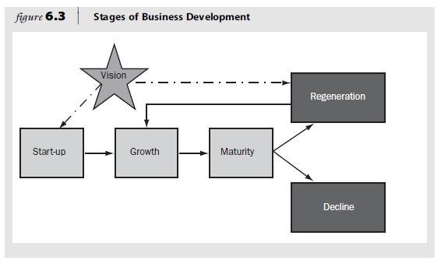

- Life cycle stages influencing family business strategy

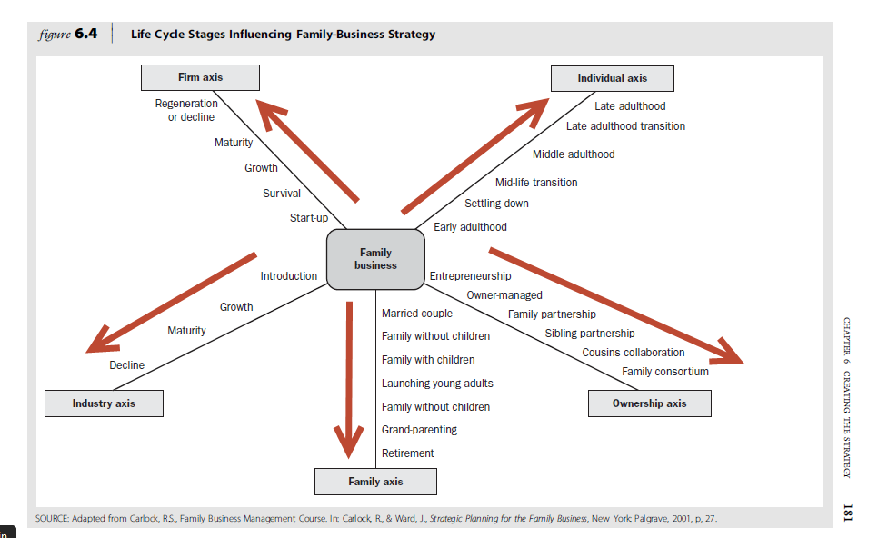

The parallel strategic planning activity includes the following:

- Candid conversations between family business shareholders take place in the safe environment of a family council. Shareholders develop a family vision that encompasses the desired relations, going forward, between the family and its business.

- Shareholders discuss and develop policies that respond to matters such as:

- The requirements that family members need to meet before they are hired into the business

- Their desire to have the family business continued as a family business that is professionally managed

- Their expectations on returns on family capital

- Their willingness to reinvest in the business for continued growth

- More formal strategic planning processes occur in the management ranks, and they analyse

- The competition

- The strengths and weaknesses of the business in relation to those of its competitors

- Changes and trends in the industry and the business supply chain

All of these result in a summary strategy statement that flags unique challenges and opportunities. The culmination of this work is the identification of a set of strategic actions that requires human, organisational and financial resources.

- The dual-path trajectory of the parallel strategic planning process then interacts. In a strategic planning session of the board of directors where family shareholder interests and purely business interests are represented, strategic choices are made, and the business model of the family business is updated.

- In this parallel strategic planning process, the CEO, family business leaders and board members are the advocates the customers’ changing interests, tastes and priorities. By advocating those interests fervently, they make it possible for shareholders to trust the promise of long-term shareholder value creation.

THE CUSTOMER-ORIENTED COMPANY

Owing to the constantly changing needs of customers, the owners of family-controlled companies need to re-evaluate their core competencies to assess whether these are still contributing to a competitive advantage.

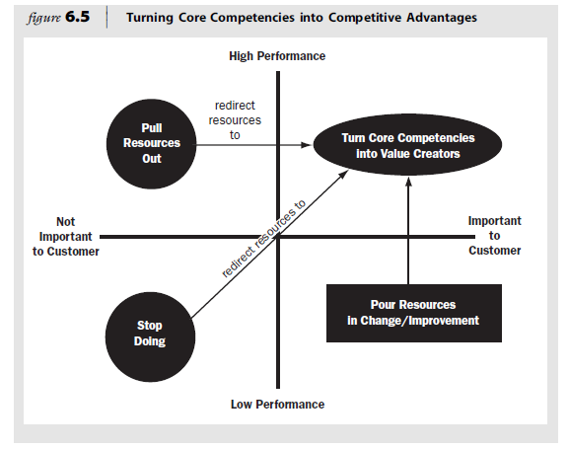

STRATEGIC PLANNING AND DISCIPLINED EXECUTION

Business sustainability is under threat, it has been cited that the average life expectancy of companies (both family and non family) in the United States is pegged at a mere 10 years. And the profitable life of the average product shortened by 70 percent in the past decade alone.

The important question to ask, is what are family enterprises doing about the new challenge, given their particular propensity to want to continue from generation to generation, and what can they do to leverage their unique resource, patient family capital, to obtain comparative advantages in our hypercompetitive era? Some are doing it – sometimes called inter-preneurship or inter-generational entrepreneurial ventures – driven by new products, product line extensions, new markets for existing products, going global via the internet, etc..etc...

5 steps to Inter-Preneurship

- Develop the owner's dream and vision on strategy making

- Assign a suitably skilled next-generation family member the responsibility for being the company’s strategic-planning back-up.

- Write the business plan

- Once the business plan is approved and the new venture is funded, make the next-generation member the General manager or President of the new venture. Ideally the next-generation member should already have served as the general manager or president of the existing business unit or division in which there was a profit-and-loss (P&L) responsibility.

- Start a family bank or family venture capital company. Some are funded by the family enterprise, whilst others are funded out of family capital outside the main business. This may be one of the activities of a family holding company, the family counsel, or the family office.

Why is a mature family-owned business — one often facing the prospect of succession — so vulnerable to decline and failure?

From a strategic perspective, family-owned enterprises are most susceptible to accelerated decline and failure precisely because of their reliance on the individual entrepreneur or next-generation CEO. The hero, who founded and led the young business to accelerated growth, displays a natural disdain for organisational architecture, and for establishing systems, professional managerial practices and governance mechanisms.

While this is not always the case, next-generation heroes often exhibit some of this same disdain for managerial discipline as they engage in the strategic regeneration and growth of the business. Professional managerial practices are, after all, considered to be a relative of bureaucracy — and bureaucracy is the dreaded disease CEOs of privately-owned companies fled from in the world of publicly owned global behemoths in the first place.

When a family group is added to the equation, that is, when multiple members of a family become active in management and/or engaged as shareholders in thinking about the future of the enterprise, disagreement, and conflict, and as a result, paralysis, often sets in. The different perspectives on conflict and the varying tolerances for differences held by active and inactive shareholders, as found in the Discovery Research for Family Business Project, makes strategic planning a task to avoid. The survival statistics for family-controlled enterprises are alarmingly poor. Entrepreneurial organisations have a dismal record of preserving the spirit of innovation that started them and propelled them through maturity. What lies beyond the exciting and exhausting start-up or regeneration and growth phases of each generation is organisational maturity.

Maturity may be wise and may feel like a well-deserved stage in which there is wealth, influence and a feeling of finally having “arrived”. But under the veneer of plenty lies the greater risk of accelerated and protracted decline and the ultimate scaling down or death of the enterprise.

At this stage, the business has become a complex set of stakeholders or audiences — the banks that have financed the growth, family members who have worked summers in the enterprise since high school, key nonfamily managers who have substantially contributed to the success the business has enjoyed, other branches of the family with a financial and/ or emotional interest in the enterprise, other investors, employees and the government. And each of these stakeholders hold a different perspective on the enterprise and feels entitled, for different reasons, to what he or she would want from it. Like running an election campaign by poll results, leaders of family-controlled businesses, overwhelmed by the complexity of their audience, often lose sight of that visceral sense of vision that was so much a part of the young organisation. The absence of this vision often sets that stage for decline.

THE UNIQUE VISION OF FAMILY- CONTROLLED COMPANIES

To regenerate and grow a family business in the interest of continuity, a unique vision and business model are needed.

The following are core competencies that family-controlled companies have turned into value creators for their customers and therefore competitive advantages for their organisations:

- Rapid speed to market
- Flexibility and nimbleness in response to customers and competitors
- Strategic focus on proprietary products and specialty niches that afford more protected profits
- A concentrated ownership structure that provides more patient capital and commitment to the long term, enabling the company to build brand equity, promote customer loyalty and sponsor continued reinvestment in family unity and unique organisational capabilities
- Lower total costs derived from reduced agency costs — for example, in administration, supervision and financial controls
- High quality of product and/or service that builds brand equity, reputation and higher profitability
- Capacity for customisation

TOPIC 3: BEST PRACTICES FOR THE MANAGEMENT AND GOVERNANCE OF THE FAMILY BUSINESS

STUDY UNIT 7: PLANNING THE ESTATE (Pg 69 – SG)

Chapter 11: ESTATE PLANNING (Pg 324 – TB)

INTRODUCTION

Estate planning is necessary to minimise estate tax and to allow for the continuity of the family business.

ESTATE TAXES

This section on estate taxes applies to US tax laws and is not relevant to South Africa. In South Africa, various Acts and statutory regulations govern deceased estates. The following Acts are currently applicable (Butterworths website):

- Administration of Estates Act 66 of 1965
- Wills Act 7 of 1953
- Intestate Succession Act 81 of 1987
- Maintenance of Surviving Spouses Act 27 of 1990
- Matrimonial Property Act 88 of 1984
- Trust property Control Act 57 of 1988
- Estate Duty Act 45 of 1955
- Immovable Property (Removal or modification of restrictions) Act 94 of 1965
- Deeds Registries Act 47 of 1937
- Minerals Act 50 of 1991
- legislation governing the ownership and occupation of land
- legislation governing tax payments (eg capital gains tax)

You are strongly advised to consult a professional advisor when drawing up an estate plan. The term “estate” is the collective name for everything a person owns. Estate planning involves all the activities leading to the accumulation and management of assets or possessions and involves three processes:

- Building up an estate
- Preserving (protecting) the estate
- Transferring the estate

The following financial objectives are important in the transfer of an estate:

- The minimisation of transfer costs — particularly estate duty, capital gains tax (CGT), administration costs and the costs involved in the transfer of fixed property to heirs, institutions or trusts
- The protection (retention) of assets
- The provision of sufficient (liquid) funds to make transfer possible

Family business owners can adopt any one of three approaches to estate planning (Swart 2002:90–91):

- No estate planning: The owner does not draw up a will to indicate how the estate (large or small) should be transferred. In such a case, the person’s estate will be distributed in terms of the Intestate Succession Act 81 of 1987.

- Elementary estate planning: If the family business owner has a relatively small estate, the owner’s wishes in respect of the transfer of the estate appear in his or her will. This simplifies matters after the death of the owner.

- Comprehensive estate planning: When the estate is fairly large, the plan requires knowledge of specialised fields such as law, investment, income tax and insurance. It is recommended that professional advice be sought from attorneys, accountants and insurance advisors.

Estate planning is a continuous process during which the changing circumstances of the estate owner and his or her heirs should be taken into consideration (Swart 2002:91). The estate planning process typically comprises the following five steps:

- Step 1: Set objectives — identify heirs; decide what each heir should inherit; and decide who should control the assets.

- Step 2: Take stock — identify estate property; and establish the value of the estate

- Step 3: Establish the estate’s liabilities — assess estate duty liabilities; assess other estate costs; and analyse liquidity of assets.

- Step 4: Choose estate planning techniques — identify a team of professional planners; establish available techniques; and select the most suitable techniques.

- Step 5: Implement the estate plan — draw up the necessary documents; and inform heirs of the plan.

THE ESTATE PLAN

The main focus of some family business owners when they do estate planning is to minimise tax. Although this is a relevant issue it should not be done at the cost of generational transitions. Poza (4th Ed) highlights the fact that, apart from some transfer-of-wealth issues, a further 13 key aspects of generational transfers should be considered in estate planning. In addition, estate plans should consider the need for restructuring corporate forms and assets in order to maximise wealth retention for heirs and for charitable giving.

Where the value of shareholder equity appreciates over time, the transfer of accumulated value to heirs should take place earlier rather than later.

Many owners consider their estate planning completed when they have selected some transfer-of-wealth approach with their accountant or tax attorney. They fail to address other important aspects of generational transfers, including the following:

- Financial and retirement needs of the CEO and the CEO spouse
- Strategic needs of the business versus financial needs of the estate
- Ownership successor development
- Relationships among family members
- Day-to-day management of the business
- Corporate governance and voting control in the next generation
- Next-generation expectations for the business
- Needs and dreams of individual heirs
- Stewardship capacity of next-generation members as either owners or managers
- Willingness of family members not active in the management of the firm to be loyal shareholders and represent patient family capital
- Economic value of the business to family members who do not participate as employees of the enterprise
- Liquidity needs of inactive or minority shareholders
- Retention of nonfamily top managers and their continued commitment to the enterprise

Estate plans must also consider the possible need for restructuring of corporate forms and assets in order to maximize wealth retention for heirs and for charitable giving, if the owner is philanthropically inclined. Some corporate forms and estate planning techniques will be reviewed later in this chapter. Because of the appreciation in the value of shareholder equity over time, estate taxes make a compelling argument for an earlier rather than a later transfer of accumulated value to heirs.

Over 10 years, a rather modest 6 percent annual growth rate (including inflation) in the value of a family business produces an asset with almost double (1.8 times) its former taxable value. Similarly, a business growing at a healthy, but not extraordinary, 12 percent rate will triple in value in a decade. The dilemma is that, during those 10 years over which the value of the estate is growing, the current generation is probably well served by retaining voting control. That way, the current generation can provide oversight (“nose in, fingers out”) while learning more about the next generation—how they perform when tested by competition, recession, periods of fast growth, union negotiations, and in some cases even challenges to their leadership by other family members.

A successful entrepreneur in the product-identification industry efficiently transferred his Pacific Northwest firm to one son precisely as it was about to grow significantly in revenues, profits, and value. He pursued this transfer of ownership with tremendous expediency, convinced that his son had tested positively for his ability to lead the company. He was concerned that gift and estate taxes would make the accomplishment of his dream much harder in a couple of years. So he commissioned a third-party business valuation, gifted almost all of his stock (freezing the value of his estate before equity growth wreaked havoc on it), and paid the appropriate gift taxes, all at the age of 54. He kept the company building and other properties as income producing assets (leased at market rates to what was now his son’s company) and then proceeded to start work in a nearby office suite turned laboratory.

He had a new product he wanted to develop and a new business he wanted to grow—he set out to be an entrepreneur all over again. Seldom are transfers of equity ownership, income sources, and control as straightforward as this one was. An estate plan that encompasses a family business has to address the appropriate allocation of income sources to the founder, his or her spouse, and non-active family shareholders, as well as the inheritance or beneficial equity interest of the heirs. It also has to address financial control of the corporation via buy–sell agreements, the transfer of voting and nonvoting stock, and the allocation of stock to the appropriately qualified heirs (and, in some cases, employees).

Buy–sell agreements are contractual arrangements between shareholders and the company. They are typically used by family-business owners to facilitate an orderly exchange of stock in the corporation for cash. To prevent the stock from ending up in unfriendly hands—or even the hands of friendly in-laws—such agreements typically include a provision that the stock will be first tendered to the company or to family members through a right of first refusal. The most obvious benefit of a buy–sell agreement is that it allows some family members to remain patient shareholders while providing liquidity to family members with other interests or goals. In this way, families can prune the corporate family tree across generations. A buy–sell agreement is often the primary vehicle through which family shareholders can realize value from their highly illiquid and unmarketable wealth—company stock. The ability to sell, whether exercised or not, often makes the difference between feeling fortunate to be able to participate in a family enterprise and feeling enslaved and controlled by it.

While most buy–sell agreements are written so that only death or discord triggers their use, some are created to provide liquidity windows for younger family members. A 30-year-old facing the prospect of purchasing her or his first home, for instance, could convert shares to cash at a predetermined value.

As discussed in previous chapters, family-business leaders wear many hats—those of parent, spouse, CEO, chairman of the board, principal shareholder, and philanthropist, to name just a few. Succession and continuity planning is the most intellectually and emotionally challenging facet of balancing these multiple hats.

A family business’s estate plan should address the appropriate allocation of income sources to the following recipients:

- The founder
- His or her spouse
- Nonactive family shareholders
- The heirs (their inheritance or beneficial equity interest)

It should also address

- The financial control of the corporation through buy-sell agreements
- The transfer of voting and nonvoting stock
- The allocation of stock to appropriately qualified heirs (and employees)

To accomplish all this satisfactorily, the family business leader has to approach estate planning from a number of different points of view, as indicated below:

- Parent — father or mother
- Spouse
- CEO
- Chairperson of the board
- Principal shareholder
- Philanthropist

The following are additional issues that should receive attention in the planning of an estate:

- Preserving speed and agility (Poza 4th Ed)
- Giving successors the capacity to lead (Poza 4th Ed)
- Corporate structures and classes of stock — buy-sell agreements and valuation of the business (Poza 4th Ed)
- Trusts — grantor-retained annuity trust and intentional grantor trust (Poza 4th Ed)
- Equity and nonfamily employees — employee stock ownership plans (Poza 2010:195–196)

PITFALLS TO AVOID IN ESTATE AND OWNERSHIP TRANSFER PLANNING

Pitfalls to avoid in estate and ownership transfer:

- Procrastinating in planning the estate and ignoring the inevitability of the owner’s eventual death:

- Single-mindedly pursuing tax minimization to the detriment of the continuity of the business:

- Failing to use estate planning as an opportunity to transfer fundamental values and teach the next generation:

- Failure to make business continuity the cornerstone of the company’s culture, and planning:

- Confusing fairness with love and a desire to treat all heirs equally:

- Failing to consult and communicate with heirs in order to understand what individual family members most value, desire and want:

- Insufficiently preparing successors and/ or failing to acknowledge the specific strengths and weaknesses of next generation members:

- Failing to submit the estate and ownership transfer plan to a professional advisor or board of directors for review:

THE ROLE OF THE BOARD OF DIRECTORS

A board of directors includes independent outsiders has some leverage with owners with regard to topics that tend to evoke denial, fear or procrastination on the part of the owners.

The following roles can be summarised:

- The board of directors can make the owner accountable for progress in the leadership development of the next generation.

- The board of directors can repeatedly address the subject of estate planning and ownership transfer and discuss these with the owner's professional advisors to ensure follow-through.

- The board of directors can invite the spouse(s) and co-owner(s) of the business to attend board meetings held with tax and estate planning consultants.

- Board members facilitate discussions with the potential successors and other members of the family and ask probing questions to develop a sense of the goals, principles and philosophies that should guide the development of the estate plan.

What is meant by estate planning:

Estate planning involves all the activities leading to the accumulation and management of assets or possessions and involves building up, preserving (protecting) and transferring the estate. It is a continuous process during which the changing circumstances of the estate owner and his or her heirs should be taken into consideration.

TOPIC 3: BEST PRACTICES FOR THE MANAGEMENT AND GOVERNANCE OF THE FAMILY BUSINESS

STUDY UNIT 8: FINANCIAL CONSIDERATIONS AND VALUATION OF THE FAMILY BUSINESS (Pg 75 – SG)

Chapter 13: FINANCIAL AND WEALTH MANGEMENT IN THE FAMILY BUSINESS (Pg 359 – TB)

INTRODUCTION

Family businesses add significant value to the local economies in which they operate, and according to a research study, businesses with founding family control reported

- Higher profit margins
- Faster growth rates
- Higher sales/cash flow per employee
- More stable earnings
- More capital reinvested in the business

In order to determine whether the family business does in fact report the above financial growth measures, the family business owners need to familiarise themselves with the different financial measures and should be able to evaluate the financial worth of the business.

OVERCOMING THE ACCOUNTING LANGUAGE BARRIER

Businesspeople communicate using accounting terms and family business owners therefore need to master accounting language. This language entails concepts such as earnings before interest and tax, depreciation, discount rates, return on assets, return on equity, profits and cash flow. If one understands the language, one can then use this information to determine what adds value to the business.

According to Bloom and Boessenkool (2008:187), it is almost impossible for any business to function effectively without an independent financial division. Each functional area in a business has financial implications that affect the integration of all decision making, from purchasing through production to marketing and after-sales service. The integration of financial management within a business includes the following:

- Link with strategy: It is necessary to ensure that finance is available to implement the strategy of the business.

- Link with accounting: Financial statements are a major source of information for financial management.

- Link with line management: A budget should be compiled in conjunction with line management to ensure that the budget forms part of financial control during the next year.

- Link with the economic environment: It is necessary to determine the effect of the economic environment on the business.

- Link with law: This generally entails conducting business with other parties within the ambit of the law — in other words, the transactions of the business have financial and tax consequences.

- Link with investment decisions: This involves the financing of different investment decisions. This applies not only to noncurrent (fixed) assets but also to investment decisions relating to current assets (ie debtors and stock), as well as to the investment of surplus funds.

- Link with financing decisions: It is necessary to determine the cost of capital and the most efficient and effective sources of finance, which will ensure an acceptable financial risk for the business.

Every family business owner needs a basic understanding of financial transactions and the financial effects of decisions that are taken on a daily basis.

Give reasons why you think financial literacy is so important for family business owners.

Family shareholders expecting to fulfil their responsibility of aligning management interests with shareholder priorities and holding management accountable require a thorough understanding of financial statements.

They need to be able to make sense of what the numbers say about the business and its competitiveness. Financial literacy is therefore essential knowledge for every shareholder, not only those who are active in the management of the business. Without it, the desirable alignment of management and shareholders is at risk. Without it, family-business shareholders can easily become just as indifferent or impatient, fickle and greedy as hedge fund managers and investors on the Johannesburg Stock Exchange, Wall Street, and so on. Hedge fund managers, aided by analysts and the media, often pressurise well-managed publicly traded companies into short-term thinking.

Family shareholders inactive in the business, with little understanding of management and the time cycles involved in new strategies or new investments, can hamper the effective operation of a family-controlled business. They can cause significant erosion of the founding entrepreneurial culture, which valued the role of hard work and patient capital and tacitly understood the benefits of owner-manager alignment.

If the family unit suffers as a result of this pressure by some family members for high returns and/or short timeframes, a loss of will and vision may result. Hence in the short to medium term, a family business may lose one of its precious sources of competitive advantage in relation to larger management-controlled businesses. In the longer term, family-business continuity may be abandoned in favour of immediately recapturing, via the sale of the business, the value created by previous generations.

FINANCIAL MEASURES THAT MATTER

Every family business member needs to know and understand the financial statements of the business, namely the balance sheet and the income statement.

The balance sheet

A balance sheet includes the following:

- Assets of the business: These include all the goods and property owned by the company, and any uncollected amounts due (referred to as “accounts receivable”) to the company from others.

- The liability section: This includes all debts and amounts owed (referred to as “payables”) to outside parties.

- The equity section: This represents the shareholders’ ownership interest in the company — that is, what the company’s assets would be worth after all the claims upon those assets have been paid. Equity includes the initial investment in stock made by the owners and the additional investment in the company made by the owners — that is, retained earnings.

- Short-term assets: Short-term assets are cash and anything that can be converted to cash within one year.

- Fixed assets: These include net property, plant and equipment.

- Capital equipment: This involves assets not intended for sale that are used to manufacture, display, store and transport the company’s products and house its employees.

- Depreciation: This occurs when companies write off the expense of the fixed asset over its estimated useful life.

- Accumulated depreciation: This is the total depreciation over the life of all the assets of the business except land.

- Current liability: This will need to be paid within one year, depending on the credit terms.

- Retained earnings: These are the accumulated profits the company earned and has reinvested — that is, “retains” in the company.

- Total equity: This is the owner’s net ownership position in the company.
- Net working capital (NWC): This the difference between total current assets and total current liabilities.

- Capital expenditures (CAPEX): This is the additional investment in long-term fixed assets, year over year.

The income statement

The income statement matches the revenues earned from selling goods or services against all the costs and outlays incurred to operate the company. The difference is the net income (or net loss) for the year. The income statement shows the record of a company’s operating results for the year and serves as a guide in anticipating how the company may do in the future as highlighted below;

- The expenses involved in selling, general and administrative (SG&A) are grouped separately from the cost of goods sold to allow an analysis of other expenses relating to selling the product. When we subtract SG&A expenses from gross profit, we obtain earnings before interest, taxes, depreciation and amortisation (EBITDA).

- EBIDTA is a widely used measure of operating performance and is a sound indicator of the company's ability to pay its debt, and it allows a view of operating performance that is not influenced by the capital structure of the business (the financing decision) or the effect of different measures of depreciation.

- Earnings before interest and taxes (EBIT) is referred to as operating income, the income available after subtracting all operating expenses from sales.

- Depreciation is considered an operating expense on the income statement because it is the write-off for the economic life of the assets held in that particular year.

- EBT refers to earnings before taxes.

FINANCIAL STATEMENT ANALYSIS

To understand the raw data in context, it is necessary to analyse the data in the income statement and balance sheet). The analysis involves calculating financial ratios. The following ratios highlight the business’s strengths and help identify areas that need improvement:

- Days sales outstanding is accounts receivable, divided by average sales per day. It reflects the average number of days it takes after making the sale to receive the cash from the sale.

- Fixed asset turnover is sales divided by net fixed assets. The turnover tells us how well fixed assets are being used to generate sales.

- Total asset turnover is sales divided by total assets. It tells us how effectively all the assets of the company are being used to generate sales.

- Inventory turnover is sales divided by inventory. A business should evaluate whether it can meet the same level of sales with less inventory on hand. Inventory that is not in stock costs money in lost sales.

- Debt ratio is calculated as total debt (long-term debt plus current liabilities) divided by total assets. Gross margin is calculated as gross profit divided by sales.

- Profit margin is calculated as net income divided by sales.

THE DUPONT APPROACH TO RETURN ON EQUITY (ROE)

The DuPont method for calculating ROE identifies the following three areas on which the DuPont method focuses:

- Expense control through the profit margin
- Asset utilisation through the total asset turnover
- Debt utilisation through the equity multiplier

The DuPont method is an excellent way to quickly assess the financial strengths of the business. This method also allows the business owner to see what is driving return and identify areas for improvement in financial performance.

It is critical to remember that debt financing adds risk to the family business and ROE does not explicitly consider risk.

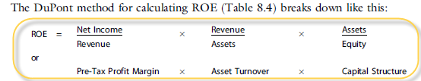

FAMILY BUSINESS ACCOUNTING: IS IT REALLY DIFFERENT?

The case “ABC Family Business Inc” is used as a fairly typical family business. In this example, the family provides all the financing for growth.

WHAT IS YOUR BUSINESS WORTH?

Businesspeople operate in a world of financial accountability and value every day. Every business owner, regardless of whether he or she ever intends selling the business, wants to know “How much is my business worth?” If the family business is a private company and needs a valuation for a specific purpose such as a sale or transfer of stock, the owners should hire a professional appraiser whose credentials have been checked. Nevertheless, family business owners should understand the valuation process.

BUSINESS VALUATION

Business valuation is the art of estimating the economic value of an owner’s interest in a business. Ultimately, the value is an opinion guided by sound judgement.

Underlying factors impacting on value

The following six factors ensure that valuation is being done to suit the needs of a family business:

- Fair market value: Base the valuation on a free-market decision, that is, between a willing buyer and a willing seller who are both well informed about the market for the property.

- Going-concern perspective: Evaluate the company as an ongoing operating business.

- Highest and best use: Focus the evaluation on the use of the assets of the business to generate the highest economic value for the business.

- Future prospects: Determine the future prospects of the business with regard to product life cycle, management team retention and skills and the competitive environment.

- Substitution: Assess the likelihood of substitute or alternative products.

- Objectivity: Use sound valuation principles and supportable data to differentiate between realistic future economic prospects and overzealous anticipation or irrational exuberance.

Other factors impacting on the valuation

Analysts review the following four additional key factors in determining an appropriate valuation for a business:

- Growth is influenced by the overall economic and financial market outlook and the specific industry environment.
- Profitability is measured in terms of the net income and cash flow of the business.
- The management of the business is assessed on the strength of the management team.
- Risk is assessed by evaluating the size and position of the business in the industry and the sustainability of earnings, as well as of the product.
Moore et al (2008:113) identify the following non-quantitative factors to evaluate a business:

- Competition: A prospective buyer should look into the extent, intensity and location of competing businesses.

- Market: The ability of the market to support all competing business units, including the one to be purchased, should be determined.

- Future community development: Examples of future developments in the community that could have an indirect impact on a business include a change in zoning ordinances already enacted but not yet in effect, a change from a two-way to a one-way traffic flow, and the widening of a road or construction of an overpass.

- Legal commitments: These may include contingent liabilities, unsettled lawsuits, delinquent tax payments, missed payrolls, overdue rent or instalment payments and mortgages of record against any of the real property acquired.

- Union contracts: One should determine what type of labour agreement, if any, is in force, as well as the quality of the business’s employee relations. Conversations with key employees can be helpful in determining their job satisfaction.

- Buildings: The quality of the buildings housing the business should be checked, with attention to possible fire hazards and determining whether there are any restrictions on access to the buildings.

- Product prices: One should compare the prices of the seller’s products with those listed in manufacturers’ or wholesalers’ catalogues and also the prices of competing products in the locality.

Adjustments for family accounting

Non-operating adjustments segregate items not required for the ongoing operation of a business, such as the high level of cash that many family businesses hold. Typical discretionary adjustments faced by family businesses are salary distortions and perks (such as club memberships for family members). The valuation analyst should determine if, and what type of distortions exists and could follow three steps to determine whether distortions exist.

Evaluate a family business and investigate possible factors that might drive the valuation
of such a business.

Consider the following factors for discussion:

- Growth:
- economic outlook
- industry outlook
- market condition
- corporate strategy

- Profitability:
- Margins
- fixed cost leverage
- volatility

- Management:

- depth/strength of management team
- strategic vision

- Business-/company-specific risk:

- relative size
- industry position
- quality of earnings
- breadth/concentration of customer base
- diversity of product offering
- leverage

- Normalising financial statements, given entrepreneur or family ownership:

- comparability adjustments
- non-operating adjustments
- non-recurring adjustments
- discretionary adjustments

- Technology:

VALUATION METHODS

The enterprise value is considered to be the economic value of a company and is the value of the equity capital plus the outstanding debt of the company, offset by the amount of cash the company holds. Professional appraisers typically use three common valuation approaches to determine a value for a going-concern privately held business.

- The discounted cash-flow approach converts the company’s estimated future cash flow into a value for the business by applying a discount rate. The discount rate reflects the risk that the projected cash flows are not actually realised in the future. This approach requires estimates of the future cash flows of the business, the timing of these future cash flows and an appropriate return that “covers” the risk of being wrong about the estimates.

Estimates, that is:

- estimating future cash flows
- timing future cash flows
- estimating appropriate return — in particular, there are three factors that affect the appropriate return from a family business perspective, namely; shareholders’ perception, liquidity concerns and the shareholder effect
- discounted cash-flow value

- The guideline public company method is a market approach to valuation and compares the values of select publicly traded companies to those of their privately held counterparts. The analyst applies valuation multiples derived from the guideline companies to the financial data of the subject company to obtain a value. The challenge is to find companies that are comparable, based on size, business mix, capital structure and profit growth potential.

- The guideline transaction method is also referred to as the “merger and acquisition method”, and evaluates past sales of companies or divisions to determine appropriate valuation multiples for the comparison company. Ideally, guideline transactions are in the same industry as the company being analysed. If that is not possible, companies with similar investment characteristics in terms of products, growth, cyclicality or asset size are considered

According to Moore et al (2008:690), when valuing businesses, it is necessary to distinguish between business value and owner value.

Business (or enterprise) value is the value of the entire business, regardless of how it is financed. It reflects the value of the underlying assets of the business. Equity value (or owner’s value), however, is the total value of the firm less the amount of debt owed by the firm, that is:

Firm value — outstanding debt = equity value

As a business grows and becomes more profitable, the owner needs to know if it is also increasing in value. In some situations, a profitable business may lose value over time. Hence being aware of its value is vital in the management of a business. Knowing your business’s value provides critical insight into how the business is performing, what options it has and how it can improve in the long term.

Estimate of enterprise value

Increased market volatility and uncertainty surrounding future cash flows produce a wide valuation range. The analyst must assess the following situations to build a case for what value within the range is appropriate:

- economic situations
- market situations
- industry situations
- company-specific situations

Discounts for lack of control and minority positions

The value of a privately held company is subject to discounts for lack of control and lack of marketability. Controlling owners have decision-making authority that minority holders do not have. For example, controlling owners can increase compensation, reduce the dividend payout, alter the use of the company’s assets and make decisions about capital structure.

The following different levels of value, in order of value:

- acquisition value
- controlling value
- minority marketable value (as if publicly traded)
- minority nonmarketable value

So what are the levels of value? The controlling interest is the value an investor is willing to pay to acquire more than 50 percent of a company’s stock. The typical premium paid to the controlling owner is 25 to 50 percent. There is an acquisition value that is even higher than the controlling value. That higher acquisition value is reserved for the types of acquisitions that enhance the strategic positioning of the company or add synergies that cannot be replicated by any other buyer. The next level of value below controlling value is referred to as “marketable minority.” This level of value represents the perceived value of equity interests that are freely traded without any restrictions. This is the value that is attached to publicly traded stocks. Presumably, most investors in publicly traded stocks are minority owners; they own only a small number of shares versus the total number of shares outstanding for a public company.

Marketability is defined as the ability to convert the business interest into cash quickly, with minimum transaction and administrative costs, and with a high degree of certainty as to the amount of net proceeds. All else being equal, an interest in a privately held company is worth less than an interest in a publicly traded company because no established market exists. This situation requires the stock to be discounted for lack of marketability.

NONFINANCIAL RETURNS AND COSTS NOT CAPTURED BY BUSINESS VALUATION

There are nonfinancial private benefits for family-business shareholders. These may include investments in brands or ventures that convey a high reputation for the family; a long-range internationalisation project undertaken to enhance future opportunities for the next generation; and investments that diversify the family’s wealth as contained in the family company that reduce risk but do not readily create value. Nonfinancial returns are also referred to as “emotional returns”. They are often just as real as financial returns to business-owning families. They are simply not captured in the traditional business valuation or appraisal process (Poza 4th Ed).

A total-value formula has been developed by family-business scholars (Astrachan & Jaskiewicz) who suggest taking the nonfinancial returns into consideration in the following manner:

Total value = financial value + emotional value

Or

$$TV=DCF+DFPB+(ER-EC)$$

Where:
TV = total value of the business to the owner, including its financial value (FV = the value of the discounted cash flows [DCF]) and the value of the discounted financial private benefits (DFPB), benefits not usually available to employees or holders of shares in publicly traded companies, plus the net value of all the emotional returns (ER) realised and emotional costs (EC) incurred by the business-owning family (Poza 4th Ed).

What is Fair market value?

This concept is the price at which the property would change hands between a willing buyer and a willing seller when the buyer is not under any compulsion to buy and the seller is not under any compulsion to sell, both parties having reasonable knowledge of the relevant facts. Court decisions frequently state in addition that the hypothetical buyer and seller are assumed to be able and willing to trade and to be well informed about the property and the market for such property.

The importance of valuing a family business

There could be various reasons for valuing a private business, one whose fair market value is not established by a stock market transaction.

The reasons would include the following:

- Major business transactions:
- Buying or selling a business
- Mergers and other acquisitions
- Creditworthiness

- Ownership transition planning:
- Estate planning/gifting
- Management buyouts
- Buy/sell agreements
- Employee stock ownership plans (ESOPs)
- Shareholder disputes
- Marital dissolutions

Ratios:

- Day’s sales outstanding AR/average sales per day. Indicate the average number of days after the sales was made getting the money.

- Fixed asset turnover Sales / Net Fix Assets. How well fixed assets are used to generate sales.

- Total asset turnover Sales / Total Assets. How effective all assets are used

- Inventory turnover Sales/Inventory. What is the inventory flow?

- Debt ratio total liability / total assets

- Gross margin Gross profit/sales

- Profit margin net income / sales

TOPIC 3: BEST PRACTICES FOR THE MANAGEMENT AND GOVERNANCE OF THE FAMILY BUSINESS

STUDY UNIT 9: KEY NONFAMILY MANAGEMENT: THE VISIBLE COMMITMENT TO MANAGING THE FAMILY BUSINESS PROFESSIONALLY (Pg 88 – SG)

Chapter 14: KEY NONFAMILY MANAGEMENT: THE VISIBLE COMMITMENT TO MANAGING THE FAMILY BUSINESS PROFESSIONALLY (Pg 395 – TB)

INTRODUCTION

For continued success and growth family businesses depend on the quality and effectiveness of nonfamily managers. A Financial Times survey (Poza 4th Ed) found that the following factors contribute to a family business’s continuation across generations:

- A quality product and/ or service
- A strong sense of family history
- The ability to exclude incompetent family members
- Willingness to employ nonfamily executives whose unique set of skills add value

Activity

In the family business where you are employed, do you have nonfamily managers and, if so, what are their perceptions of the innovativeness of the family business, its management practices, strategic planning and succession planning? How do their perceptions compare with those of the owner(s) of the family business and other family members? What concerns do they have?

Feedback

You probably found a difference in perception between nonfamily managers and family managers. The Discovery Action Research Project found that even though nonfamily managers tended to view their firms positively, at least four differences in perceptions between owners and nonfamily managers of family businesses existed with regard to

- The efficacy of management and governance practices
- The capacity of the firms for innovation and change
- Anxiety on the part of nonfamily managers concerning the qualifications of potential successors
- Nonfamily managers’ ambiguity about their own position in the company

PERSPECTIVES OF NONFAMILY MANAGERS

Research has identified three concerns of nonfamily managers:

- Balancing the competing demands of the family and the business is a challenge. The nonfamily manager has to skilfully manage relationships with family members of different generations and other employees, while keeping abreast of the latest professional management practices and improving task competence.

- Management and governance practices are inadequate. Nonfamily managers of family businesses are dissatisfied with the level of innovativeness, product development, management practices and systems. They are not as aware as family members of the values and planning assumptions.

- There are concerns about succession. Nonfamily managers believe that the next CEO will be a member of the owning family.

If top leadership positions are reserved for family members, what would encourage a top-flight executive who is not a family member to stay?

CAREER OPPORTUNITIES FOR NONFAMILY MANAGERS

Nonfamily members need to know what future career opportunities are available to them. This is possible in a merit-based and professionally run family business that promotes business growth. Where career opportunities do not exist, the costs associated with turnover, low morale and an inability to recruit top-notch managers and set benchmarks for family managers increase.

COMPENSATION AND BENEFITS

The results of research studies show that nonfamily managers tend to expect a higher compensation than they are receiving; are paid less in family businesses than their counterparts in public corporations, have less flexible vacation policies than the owners and have flexible job descriptions.

Balshaw (2003:133) argues that a rational way of conceptualising and viewing payments to family members from a family business perspective, is that there should be a clear separation between payments to family members in their role as employees (salaries, benefits and performance bonuses), owners (dividends and share price appreciation) and family (gifts and bequests).

Family members should be rewarded in accordance with sound business practices and principles. Those family members employed in the business should be made aware of the difference between seeking to satisfy a lifestyle to which they have become accustomed based on the family wealth, as opposed to performance related remuneration as an employee in the family business.

A rational compensation plan for family members should include the following steps:

- Decide on a compensation philosophy, such as pay based on the market value of the particular job.

- Benchmark levels of remuneration and determine and adopt market-related salaries for family and nonfamily members.

- Adjust pay to reflect the qualitative characteristics of the job, such as position, technical skills, leadership, team playing, people skills and strategic outlook.

- Decide on an annual incentive plan.

- Establish criteria for assessing performance.

(6) Clearly communicate the plan and update regularly.

PERFORMANCE FEEDBACK

Nonfamily members are more satisfied with the performance feedback they receive than owner-managers. Satisfaction with performance feedback differed according to the age of the owner-manager; those over 51 years were more satisfied. Nonfamily managers giving feedback to younger family members had to bear in mind that they may be working for such family members in future years.

EXTENDING THE FAMILY CULTURE TO NONFAMILY MANAGERS

To avoid nonfamily members feeling that they are taken for granted or treated like outsiders, Poza (4th Ed) suggests a number of actions the CEO can take to remedy such a situation.

MOTIVATING AND RETAINING NONFAMILY MANAGERS

(Poza 4th Ed) provides six reasons why a family enterprise should consider a nonfamily CEO.

The decision whether or not to appoint a nonfamily CEO is contingent on three factors:

- The particular needs and opportunities the business faces,

- The family’s preferences, and

- The skills or lack thereof in family-member candidates.

A NONFAMILY MANAGER AS A BRIDGING PRESIDENT OR CEO

Six reasons (Poza 2010:240) why a family enterprise should consider a nonfamily CEO.

- Where the outgoing family CEO is not capable of leading a succession process and/ or choosing among the children

- Where no successors are qualified to carry out the chosen strategy, for example; a business plan to significantly expand the company to serve a global rather than a regional marketplace

- Where potential successors are too young or not yet ready for the job

- Where the owning family recognizes that the business needs leadership that will focus on the future, not the past

- When the business needs dramatic change. Internal candidates, especially members of the owning family, are too wedded to a particular product, location, or way of doing business that is now under competitive attack and incapable of producing profits

- When the family sees the need for change but desires to keep the business under family control; they requiring a transformational nonfamily CEO to an outright sale of the company

For an outside nonfamily CEO to be successful, he should:

- Build credibility with multiple stakeholder groups

- Effect change by balancing a sense of urgency with the speed required to incorporate traditional values and established core competencies

- Communicate extensively

- Obtain consensus on the board and among shareholders regarding new business plans

- Provide all shareholders with detailed and timely financial and operating information

- Groom his or her own successor, ideally a next-generation family owner-manager

Ways to Create a Beneficial Environment for Nonfamily Managers

- Build family/nonfamily management teams that provide complementary skills at the top and set benchmarks for running the family business professionally. Doing so also sends a clear signal to nonfamily managers that career opportunities are available.

- Discuss career advancement opportunities for nonfamily managers—and how the succession process may affect these opportunities—with candor. This is essential and is greatly appreciated by key nonfamily managers. The change and discontinuity that the prospect of succession represents are great stressors and de-motivators of ambitious nonfamily employees.

- Involve nonfamily managers in business planning and succession planning. Soliciting their participation in discussions of the strategic direction of the business gives them a much greater sense of inclusion and more focused motivation.

- Offer compensation and benefit plans that are benchmarked to others in the industry, the profession, and the community. Adopting fair pay plans will diminish the risk of losing key contributors. Equity ownership—or, more likely a phantom stock plan that parallels value creation in the common stock and rewards performance over the longer term—is a great motivator.

- Use performance measures—scorecards—to build motivation. Top management derives much motivation from the feedback the job itself provides. Revenues, profit margins, market share, and other financial information all provide significant motivation.

- Hold meetings periodically between key nonfamily managers and shareholders to promote mutual understanding and respect for the different roles and contributions of each.

- Educate the entire family, whether active or inactive in the company, about business and management in order to create common ground between family and nonfamily managers. For example, a quasi-MBA curriculum for the family could be part of family-business meetings.

- Survey nonfamily employees periodically to assess the work climate and determine whether the relationship between management and ownership is healthy or requires attention. Effective nonfamily managers must have high levels of maturity and self-confidence, as well as the ability to self-manage; they must not only perform the task they were hired to do but also nurture their relationships with multiple generations of owners and owner-managers.

- Emphasize nonfamily employees’ contributions to the family business. American Greetings, for example, watches its internal communications and press releases to ensure that the balance between family and nonfamily is right. Making nonfamily employees part of a successful family in business builds a culture in which people truly are a competitive resource.

- Treat family members like employees when they are at work. Call them by their professional names, require that they follow employee policies and rules, and expect just as much from them as you would from any competent nonfamily manager.

- Use advisory boards or boards of directors with independent outsiders. Such boards help nonfamily managers to feel confident that the family company is being run professionally and objectively, with merit—not blood—as the major determinant of success.

- Develop a family constitution that spells out policy on family employment and family-business relations. This will increase the perception of fairness and mutuality and also reduce the chances of inappropriate family interference in management.

- Hire high-caliber key nonfamily managers to be bridging presidents or full-term CEOs of the corporation and business mentors of the family shareholders. A nonfamily CEO can serve as a bridge across a generation of owners, as the family-controlled Ford, Marriott, Scripps, and L.L. Bean companies all demonstrate.

TOPIC 3: BEST PRACTICES FOR THE MANAGEMENT AND GOVERNANCE OF THE FAMILY BUSINESS

STUDY UNIT 10: FAMILY BUSINESS GOVERNANCE: ADVISORY BOARDS AND BOARDS OF DIRECTORS (Pg 95 – SG)

Chapter 9: FAMILY-BUSINESS GOVERNANCE: BOARDS OF DIRECTORS, FAMILY COUNCILS AND FAMILY OFFICES (Pg 255 – TB)

INTRODUCTION

Poza (4th Ed) defines governance as “the ability to optimally discipline and control the nature of the relationship between family members, shareholders and managers in such a way that the enterprise prospers and the family promotes and protects its unity — as much for the family’s sake as for the company’s sake”.

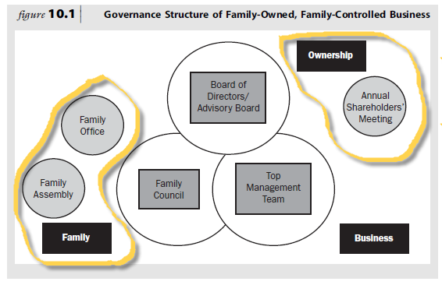

THE BOARD OF DIRECTORS

A board of directors should perform their duties towards the shareholders of the family-owned business with objectivity, focusing on the larger issues of strategy, financial analysis and succession and continuity planning.

Activity

Fraudulent and unethical practices and behaviour on the part of directors of companies have led to demands for corporate governance and have resulted in the King Report on Corporate Governance. What is corporate governance and what does the King III Report on Corporate Governance (2009) for South Africa propose? Does it apply to family businesses?

Feedback

In its narrowest sense, corporate governance refers to the formal system of accountability of the board of directors to shareholders. In its broadest sense, the concept refers to the informal and formal relationships between the corporate sector and its stakeholders and the impact of the corporate sector on society in general (Ehlers & Lazenby 2007:49).

The definition used by the King III Report on Corporate Governance (2009:8) reads as follows: “Corporate governance mainly involves the establishment of structures and processes, with appropriate checks and balances that enable directors to discharge their legal responsibilities, and oversee compliance with legislation.”

The King III Report on Corporate Governance (2009:7) isolates the following characteristics of good corporate governance: fairness, accountability, responsibility and transparency. The Code of Practices and Conduct of the King III Report on Corporate Governance (2009:5) covers elements such as the following:

- Boards and directors
- Accounting and auditing
- Risk management
- Internal audit
- Integrated sustainability reporting
- Compliance and stakeholder relationships
- Business rescue
- Fundamental and affected transactions
- IT governance
- Alternative dispute resolution
- Editing

There are examples in South Africa of companies listed on the JSE that have not followed the practices recommended, but have explained the practice adopted and have prospered. In these examples, the board ensured that acting in the best interests of the company was the overriding factor, subject always to proper consideration of the legitimate interests and expectations of all the company’s stakeholders. South African listed companies are regarded by foreign institutional investors as being among the best governed in the world’s emerging economies and we must strive to maintain that high ranking (King III Report on Corporate Governance 2009:7).

The primary responsibilities of a board of directors include the following:

- Review the financial status of the firm

- Deliberate on the strategy of the company

- Look out for the interests of shareholders

- Promote and protect the unity and long-term commitment of the owning family

- Mitigate potential conflicts between shareholders, including majority and minority shareholders

- Ensure the ethical management of the business and the application of adequate internal controls

- Be a respectful critic of management by asking insightful questions

- Review the performance of and hold the CEO and top management accountable for performance and good shareholder returns.

- Provide advice to the CEO on acquisitions, divestitures, performance of key executives, executive compensation, human resource issues, growth opportunities, risk management, financing growth, liquidity, etc..etc...

- Bring a fresh outsider perspective

- Assist in the recruitment, selection and election of new board members

- Assist in objective planning and managing of the multi-year succession and continuity process

The family-business advisory board

Poza (4th Ed) suggests that a family-owned business should have two boards, a board of directors comprising family members and independent outsiders, and an advisory board with independent outsiders. The board of directors monitors the company management, while the advisory board advises and counsels.

The use of advisory boards is not common in South Africa. Where such boards do exist, the family members are generally the board members, formal meetings are not always held and board members are not necessarily remunerated for their service. Board members are approached mainly for their advice, and they also play a role in averting conflict.

The above corresponds with other observations that family businesses in South Africa are still extremely secretive. There are various reasons for this, one of which is certainly linked to society and culture. People fear failure, and bankruptcy is punished severely in a social sense — the person concerned is identified as a loser and tends to lose friends.

The fact that bankruptcy is actually a learning experience is not appreciated. The idea of bringing in somebody from outside is therefore unthinkable. The lack of knowledge of and experience in managing a family business can be regarded as a further significant factor. The idea of bringing in outsiders to stimulate growth and development in a family business is steadily gaining ground as an important strategy, but South Africa has a long way to go before this will be a natural process (Maas 2009:226).

Boards versus independent advisors/consultants

Although independent advisors can contribute substantially to managerial expertise and strategic planning, two major differences exist between advisors and independent board members (Poza 2010:253):

- The issue of independence. Independent thinking and respectful disagreement are more likely to be found among independent board members.
- The issues of commitment and continuity over the long term. Board members are committed to a longer-term relationship with the organisation.

Members of the family-business board

When constituting a board of directors for a family business, the following should be taken into consideration:

- The mission of the board: to work with and advise the CEO
- The size of the board: five to nine members
- The composition of board membership: the CEO and independent outsiders, preferably no other family members, managers or successors until their succession is imminent
- Presentations to the board: other family members, managers and invited guests could present relevant information to the board

Recruitment and selection

The recruitment and selection of members to the board of directors requires specific considerations:

- Should it be decided to have family members other than the CEO serving on the board to ensure fairness, selection should take place according to an acceptable board member selection policy in order to identify the most qualified candidates. This could be the responsibility of the family council.
- The best candidates for the board of a family-controlled business are successful peers, key functional heads and business unit managers who can work on a team with a diverse group of individuals and show commitment to the organisation and its mission.
- Referrals of candidates may come from a variety of sources and through networking.
- Board duty requires knowledge, leadership competencies and experience.
- Criteria for selection must be in line with the company’s mission and the family business’s unique needs.
- The terms of board members should be staggered — three to five years.
- Potential board members should have complementary skills to ensure a variety of skills, experiences and capabilities.

The compensation and motivation of board members:

- It is standard practice to offer a per diem fee for attending meetings and an annual retainer that is market related. The CEO expects board members to add value to the business and they should be rewarded accordingly.
- The continued motivation of the board members will depend on their being allowed to make a difference.

Major roles of the board of directors
A board of directors has three major roles to fulfil

- Setting company strategy. In order for outside board members to contribute to the strategy-formulation process and ensure the retention of a competitive edge in meeting customer needs, they need:
- to be privy to the CEO’s dreams, that is, the envisioned direction of the business
- access to data such as the financial records
- access to people, that is, to become acquainted with the vision of the next generation and the shareholders

- Adaptation over generations (between the old and the new). The board’s task is to reconcile two ingredients that are critical to the sound adaptation of a family business:
- the wisdom to know what has worked in the past and what has made the company successful
- the passion to make a difference, seize today’s opportunities and thrive in the decades ahead

- Succession and continuity planning. The board can relieve the CEO parent of the daunting task of choosing one of his or her children as a successor. A board is in the unique position to consult with independent outsiders after they have assimilated the necessary facts. Such a succession decision is perceived as fairer and as such is more likely to be accepted.

The benefits of boards with independent outsiders include the following:

- They provide unbiased objective views
- They bring a fresher and broader perspective to issues of concern to the firm
- They bring with them a network of contacts
- They make top managers accountable for their actions

THE FAMILY COUNCIL

A family council is a governance body that focuses on family matters. According to Moore et al (2008:138), a family council is an “organised group of family members who gather periodically to discuss family-related business issues”. It is recommended that all interested family members and spouses of all generations be allowed to participate in the family council, which should be a formal organisation that holds regular meetings and has an acceptable mission statement and family creed.

Family councils frequently develop family-participation policies and deal with issues of liquidity, diversification of the estate and estate planning. The business/ ownership education of family members who are not active in the management of the business is also an important agenda item for a family council.

The family council is responsible for ensuring that the noneconomic goals and values of the family are articulated (sometimes via a family constitution or charter).

BOUNDARIES BETWEEN A BOARD OF DIRECTORS AND A FAMILY COUNCIL

In practice, family-owned businesses tend to have boards that are made up completely or mostly of family members. Family members have come to expect that they are titled to be board members, often resulting in dysfunctional boards.

Family councils can contribute to family-controlled companies by:

- helping families draw the line between family membership and board duty

- establishing a system of governance that both differentiates and integrates family and business agendas

The relationship between boards and family councils is depicted below:
These two bodies should jointly optimise the family-business system.

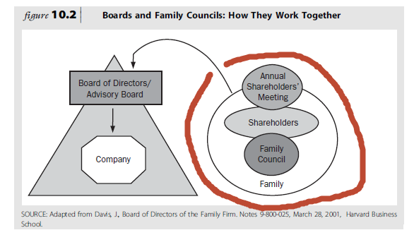

THE FAMILY ASSEMBLY

Family assemblies are arranged by large multigenerational families where all family members cannot serve on the family council. These assemblies are held to inform family members of developments in the family business.

THE ANNUAL SHAREHOLDERS’ MEETING

In corporate law, it is a legal requirement that shareholders have at least one meeting per annum to be informed about the performance of the business, the returns on shareholders’ equity and the dividends to be distributed. During this annual meeting, the shareholders elect the board of directors and attend to other matters on the agenda.

THE FAMILY OFFICE

Family offices assist shareholders with the duties and responsibilities arising from their ownership relationship with the company.

THE TOP MANAGEMENT TEAM

A top management team should consist of both family and nonfamily members with skills that complement each other in order to ensure professional management and business continuity.

TOPIC 3: BEST PRACTICES FOR THE MANAGEMENT AND GOVERNANCE OF THE FAMILY BUSINESS

STUDY UNIT 11: Family communication: family meetings, family councils and family offices (Pg 104 – SG)

Chapter 9: FAMILY-BUSINESS GOVERNANCE: BOARDS OF DIRECTORS, FAMILY COUNCILS AND FAMILY OFFICES (Pg 255 – TB)

INTRODUCTION

The commitment of family members to the continuity of a family-controlled corporation
is adversely affected by secrecy, lack of information and an absence of education.

FAMILY MEETINGS

In family meetings, various concerns can be addressed in order to get the ownership family- management balance right, such as:

- Updating family members not active in the business about the business

- Opportunity for good communication

- Educate family about the three systems

- Engage family members in responsible ownership

- Update family members on the estate plan

- Allow for policy

- Good time for problem solving and conflict resolution

- Forum for introspective and celebration

- Safe harbor for planning the family’s future involvement in the business

THE USE OF FACILITATORS AND ADVISORS

Family-business and organisation-development consultants along with psychologists and family therapists can provide facilitation skills that make family meetings much more effective and constructive.
Group development and team building consultants can also provide this facilitation and relevant group process skills.

It is beneficial to the process if the facilitators and advisors have a thorough acquaintance with family businesses.

Much like the value-added contribution from independent outsiders serving on the board of the family-owned or family-controlled company, an outside facilitator has a tremendous advantage when it comes to objectivity and the perception by family members that they are a neutral third party with no side to take.

Family-meeting facilitators can remove barriers, promote momentum and provide the discipline for continued action required for multiyear processes such as succession, ownership transfer and continuity.

OUTSIDE ADVISORS: THE FAMILY-BUSINESS CONSULTANT (TB – PG 413)

A family business should consider the professional services offered by family business consultants for the following reasons:

- Outside advisors often compliment the skill sets brought into the family firm

- They provide professional services and perform tasks which management may not be qualified to do, or prefer not to do.

- A family business consultant provides subject-matter expertise with an objective detachment from the family business

- Family business consultants offer advise and assistance to address management and ownership issues, including the transfer of management responsibilities and ownership (stock and control) to the next generation in a tax-efficient manner.

- Family business consultants can assist with succession and succession planning

- Family business consultants are often used to help the owning family to address family issues, even emotional ones.

- Family business consultants can be used to perform strategic reviews, planning processes, review of compensation plans, etc..etc…

THE FAMILY COUNCIL

To reduce the family’s propensity to become a zero-sum entity, the family business could institute a family council. Family councils frequently develop family-participation policies and deal with issues of liquidity, diversification of the estate and estate planning.

The Family Council

- Family council help to reduce family’s propensity to become a zero-sum entity
- Governance body
- More formal
- Promote communication
- Safe harbor for conflict
- Support education

OWNERSHIP AND FAMILY POLICY MAKING

Family meetings focus first on education and communication and then on effective planning and policy making. The following types of policies are useful to families in business:

- an employment policy
- a subcontractor policy
- a board service policy
- a family strategy, including a dividend policy and a liquidity policy
- a family constitution

THE FAMILY CONSTITUTION

The primary challenge for the family council is to draw up a family protocol or constitution. This protocol should reflect what the family stands for and should be supported by all family members. Family businesses that are exposed to knowledge of family business management have a family creed. Those without this background (i.e. the majority of small and medium family businesses) usually do not have one. Conflict in the latter businesses may be above normal because the ground rules for issues such as shares, compensation, the employment of in-laws, management philosophy and remuneration have not been spelled out.
The Family Constitution;

- Governs the relationship between shareholders, family members and managers

- Also called family charter

- Make explicit principles and guidelines that shareholders will follow

- No legal bearing

- Contains:

- Vision

- Family values

- Desired behavior of family to firm

- Employment policy

- Next-generation family member development

- Ownership policy

- Family band/venture policy

- Dividends and family benefit policy

- Liquidity policy

- Board of directors

- Family meeting

- Shareholder meeting

THE FAMILY OFFICE

The family office primarily provides and organises a series of services for family shareholders.

A family business constitution may benefit nonfamily managers in so far as they may expect fairer and more equitable treatment affecting compensation, career advancement and opportunities for influencing the direction of the company. They may also derive the benefits of replacing ambiguity and the stereotypical concern for nepotism, with policies that explicitly commit shareholders to professional management of the firm across generations of owner-managers.

For family members interested in participating in the company as managers, board members or contractors, it spells out employment policies and a set of principles to guide any form of participation. The board of directors, the family council, the annual shareholders’ meeting, the next-generation committee, the top management team and the family assembly are the listed governing bodies. Key nonfamily managers, through their membership in the top management team, also represent an institutional influence that helps in governing the family-business interaction. The constitution also spells out the primary functions and rules governing the relationship between governing bodies.

Larger multigenerational business families often have a family office, whose duties are primarily to provide and organise a series of services for family shareholders. These services include providing legal and financial assistance with estate and tax issues; managing the investment portfolios of the family; providing information of relevance to shareholders, sometimes by producing a newsletter; and fairly and equitably distributing family or shareholder benefits, such as education funds from family trusts or foundations and even time at the family beach house.

Ernest Doud has identified four stages in the evolution of family business and wealth:

- In stage one, virtually all of the family’s invested capital is committed to a highly entrepreneurial business. In this stage, there is no need for a family office; family benefits are small to nonexistent and the entrepreneur-owner and the business are often one and the same.

- In stage two, the family is often professionalizing the business, and non-business assets are being added to the family’s investment portfolio. At this stage, typically, the management of non-business assets still falls on the individual owner.

- During stage three, the family, having professionalized the management of the business, often begins to professionalize the management of its non-business investments, which now constitute a substantial portion of the family’s wealth. Depending on the size and nature of non-business assets, some family office functions, either from service providers or a multifamily office, may begin to make sense at this stage. The family office could assist the family with its wealth and govern the relationship between the family, the business, and its non-business investments. By stage three, some business and non-business assets have already been transferred to the next generation. Family meetings are being held to assist in educating heirs on wealth management and their responsibilities as shareholders or trustees; the family office assists in the development of the agenda and meeting logistics. Also at this stage, the family may have established a foundation to carry out its philanthropic goals. Because both liquidity and access to capital for growth purposes may be central concerns, the business family sometimes executes an initial public offering (IPO) and takes the company public at this stage.

- In stage four, the family may no longer own the operating business that was the original source of its wealth. As a financial family, it has likely professionalized the management of its investments. For these families, asset management, wealth preservation, and wise wealth utilization become the new family business. In stage four, the family office indeed is the family business.

Like family councils, family offices enhance a family’s ability to govern the relationship between the family and the company, enabling more professional management of the firm and fairer and more timely handling of shareholder and family issues and requests. A family office may function as a full-time organized arm of the family council, helping the council execute the policies and guidelines it has developed. Families with smaller businesses (companies doing less than $100 million in annual revenues and usually in stage one or two) seldom see the need for a family office, though family members may avail themselves of similar services through advisors to the business. These advisors are often willing to also provide personal professional services. Some larger families in business (often in stages three and four, as discussed above) have in the past decade or so also begun to make it possible for families owning smaller businesses to outsource family office functions to their family office operations for a fee.

A number of large family offices now operate as multifamily offices. The services they provide the large-business-owning family can be retained by the smaller-business owning family for a fee; usually a 1.5 to 2 percent of assets under management.

TOPIC 3: BEST PRACTICES FOR THE MANAGEMENT AND GOVERNANCE OF THE FAMILY BUSINESS

STUDY UNIT 12:

CHANGE, ADAPTATION AND INNOVATION: THE FUTURE OF FAMILY BUSINESS (Pg 111 – SG)

Chapter 8: CHANGE, ADAPTATION AND INNOVATION: THE FUTURE OF FAMILY BUSINESS (Pg 221 – TB)

INTRODUCTION

“The quest for continuity requires that the enterprise adapt, through vision and strategy,
to the changing competitive dynamics that will predominate in the next generation”

Activity

In a family business, different generations have different leadership tasks when it comes to continuity. Which generation do you belong to in your family business? The first, second, third or even later? What are your leadership tasks to ensure continuity?

Feedback

Continuity requires evolution across different generations, each with a specific leadership task:

- First generation: Builds the business from nothing and ensures its survival.

- Second generation: Builds on the foundation and expands the business through rejuvenation and change.

- Third and fourth generations: Adapt the business to changes in the competitive environment, at the same time being stewards of the culture and values of the enterprise and the owning family’s legacy.

CONTINUITY AND CULTURE

Research findings indicate that businesses that score high on performance over a long period of time have a strong culture that fits the strategy of the business. This is confirmed by the information on the examples of “The Marriot Corporation and SC Johnson” (Poza 4th Ed).

Culture is a collection of beliefs, values and ground rules that shapes and significantly influences how individuals, groups and the company as a whole behave or operate when confronted with choices, decisions, opportunities and threats. Company cultures are often composed of unique values that define the nature of the company’s commitment to its major stakeholders: customers, shareholders, employees, suppliers and the communities in which the business operates.

CHANGING THE CULTURE

In the face of change, a strong culture is not enough. The culture also needs to be adaptive and flexible. Owners who hold themselves and management accountable for continuity will be instrumental in building companies that last. The style of leadership that is required for continuity includes the following features:

- The leader challenges the status quo.

- He or she has an external perspective.

- He or she has the capacity to forge a new direction.

- He or she is able to generate a sense of urgency.

Although cultural change takes time, the leader must act with speed and establish a sense of urgency rooted in preserving the loyalty of the customers.

NEW LEADERS OF THE EVOLUTION

- The new leaders of the evolution must demonstrate self-awareness and self-management.

- Their words and actions must be consistent.

- They must realise that although ownership may have been transferred to them, authority has to be earned slowly and by demonstrating competence, caring and consistency and maintaining contact and communication.

New leader of the evolution

- Must demonstrate self-awareness and self-management

- Word and actions consistent

- Ownership transferred, authority earned slowly

- Must demonstrate competence, caring and consistency

- Must maintain contact and communication

Difference between founder and successor:

- Successor does not inherit the authority to lead

- Transfer of power not implicit

Traps for new leaders:

- Authority is earned not inherited

- Staying in contact, even during conflict

- Don’t be distracted by key managers. Don’t lose focus.

- You can’t always answer to all problems

- Attempting to much to fast or too little too slowly

- Being over cautious.

THE RAW MATERIALS OF A NEW CULTURE

What tools can a new leader use to design a new culture? These tools include financial and information systems, organisational structure, compensation and a family constitution. The culture of the organisation changes when the successor leads both the business and the family in the following way:

- The leader changes the information that the employees and the active and inactive family members are receiving.
- He or she alters the way in which the employees are paid and what they are paid for.
- He or she arranges job responsibilities and reporting relationships.
- He or she adapts the mechanisms for coordination and accountability.

According to the change formula, change is a function of the following variables:

- dissatisfaction with the status quo

- a vision of the desired future

- practical first steps for achieving the goal of change
Only if all three of these elements are present can change gain momentum.

THREE STATES OF EVOLUTION

The change process involves three states which are illustrated:

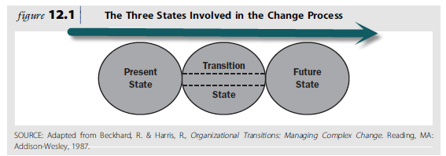

- The future state: The direction in which the leader wishes the organisation to go should be precisely defined in financial, operational and behavioural terms, should be as concrete as possible and should be involved in setting the goals to be followed by the key nonfamily members; these plans should be presented to the board with its independent outsiders. Issues to be considered when creating a future scenario appear in table 12.3

- The present state: The need for change may arise externally or internally or may originate in the family. In order to assess the current situation in the family and the business, the leader can use outside consultants, the Family Business Diagnostic Survey, employee surveys, customer satisfaction surveys, family surveys, information sessions with top managers, open meetings with different sections of the organisation and information sessions with family members to assess the state of the relationships between family members. To assess readiness for change, the leader should, firstly, look for enthusiasm and support for the proposed changes and, secondly, for the power or capability to support or block the proposed changes (Poza 2010:301).

- The transition state: This state involves forming action plans and temporary structures and systems to control the change process. The leader needs to decide where to start the process of change. Poza (2010:302) proposes seven options for a leader.

CONTINUITY AND FAMILY-MANAGEMENT-OWNERSHIP STRUCTURES

In order to move the family-management-ownership relationship from the current state to a future state, each subsystem should be considered, and Poza (2010:303) asks a number of questions. Family meetings should be held at an early stage to start the process of change.

Balshaw and Goldberg (2005:150) argue that families in business the world over have historically guarded their 100 per cent equity holding. Owners of family firms are reluctant to sell equity to outsiders, preferring to remain independent and transfer the business to the next generation of family members. Strong emotions are usually attached to selling a business. Whilst the business may currently be providing a comfortable living for its owner-managers when they decide to sell up, the capital derived from the disposal can provide little in the way of funds to live on.

Some owners will say the business is the best investment they can make in terms of economic returns. Some owners will feel that if they do not sell the business, it will fail; in other words, selling is seen as a relief and a way of bringing the owning family back together; for others it may mean that they will inevitably grow apart.
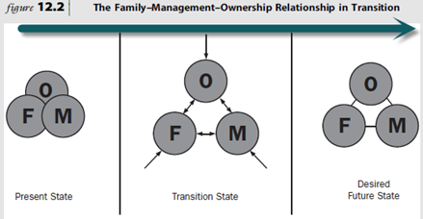

SUCCESSION PLANNING

Research has found that many family businesses cease to exist after 10 years. This is mainly due to a lack of succession planning, which involves the transition of managerial decision making from one generation to the next. Management succession sounds uncomplicated — all the owner has to do is to choose an heir who will inherit the operation and train him or her. In reality, however, a number of problems exist, as listed in table 12.1.

Barriers to succession planning in family organisations

Barriers to succession planning can be erected by either the family business owner or family members — the spouse or the siblings or other family members involved in the business.

Table 12.1: Barriers to succession planning in family organisations

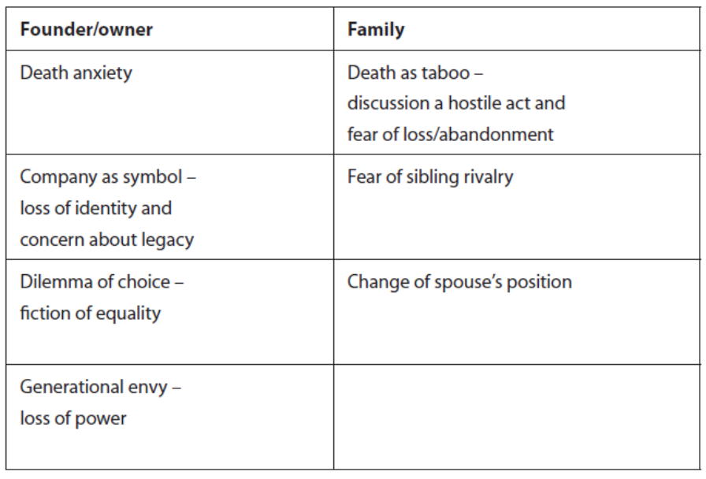

The family business owner’s personality, talents, values and beliefs build the family business to its current status and removing this person may lead to a decline in the business. The owner could therefore be concerned about a loss of identity and about the legacy of the company.

Talk of succession may remind the owner of the fact that death is imminent and result in death anxiety, while the family members may consider any such discussion as a hostile act, which may lead to feelings of fear of losing the father or mother, or feelings of possible abandonment.
The family business owner may be confronted with a dilemma about who to choose as his or her successor, while at the same time trying to treat all the children equally. Many parents believe that they have to treat their children equally and that assets should be equally distributed. Another issue is competency.
Not all the children are equally competent to take over the management of the family business. However, with training and experience, the competency levels can be sufficiently raised. Some children are held back by the reluctance of parent owners to delegate realistically to them. The siblings, however, may start fighting amongst themselves about who would be the most competent to succeed the owner and about the level of responsibility to be allocated to each.

Siblings may have perceptions of not being treated fairly or equally. The family business owner may find it difficult to hand over the reins because he or she will no longer have the power to make the decisions in the business. When the owner transfers power, it is likely that the spouse will lose his or her status and may find this unacceptable and thus resist any talk of succession.

Key factors in succession planning

Even if the family business owner has only one sibling, succession may still not take place smoothly, and where several siblings are involved it could be a highly charged emotional issue that requires both structural and cultural changes. Family succession does not only include the transfer of the actual business itself, but also the transfer of ethics, values, traditions and visions. In terms of the systems theory model of the family business (study unit 1), succession planning has to take into consideration the three interdependent subsystems, namely the family, the ownership and the management.

In their examination of the various considerations that affect the succession issue, Kuratko and Hodgetts (2007:687) approach succession under the following headings:

- Pressures and interests inside and outside the family business

With regard to succession planning, pressure can be exerted from both inside and outside the family business, as indicated in table 12.2.

Table 12.2: Pressures and interests in a family business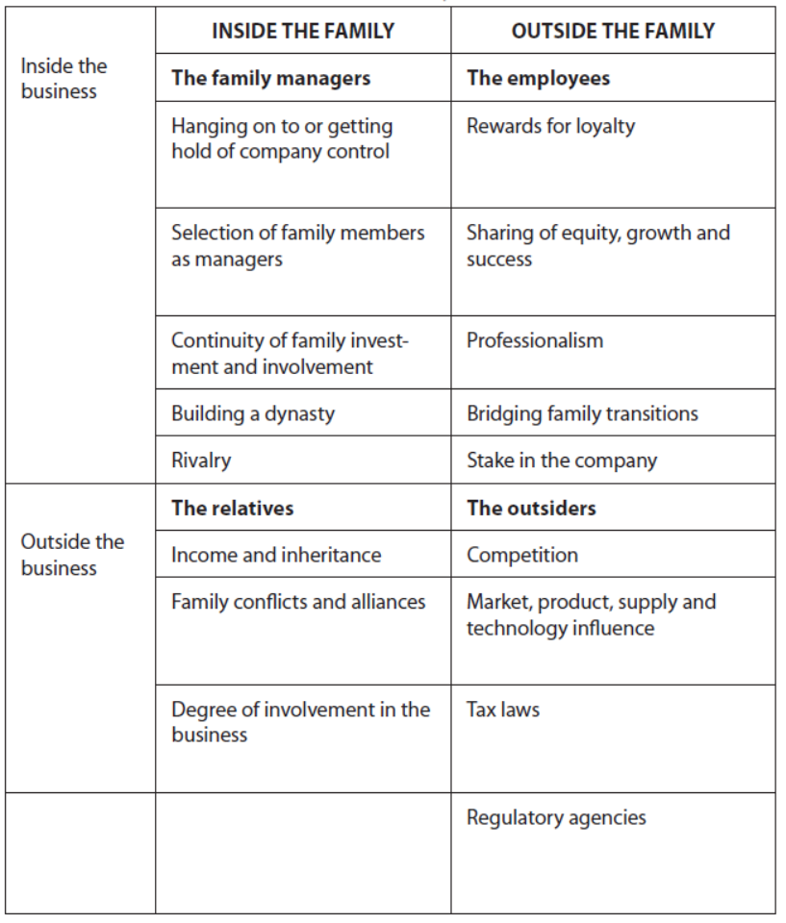

Inside the family business, two groups influence succession, namely the family members themselves and the nonfamily employees:

- Family members: When members of the family are employees, a number of succession-type problems may arise:

- Family members may want to hold on to the business and ensure its continuity to enable them to manage it. To accomplish this, family members may insist on gaining or increasing control over the operations.

- The choice of the right heir as manager of the family business exerts tremendous pressure on the owner-manager.

- Ensuring continuity of the family investment and the family’s involvement is another source of pressure.

- If the family is concerned about building a dynasty that will succeed for several generations, additional pressure is placed on the owner-manager to structure the succession process accordingly.

- Rivalry about who should succeed may arise among the various branches of the family, since each of the owner’s children may be of the opinion that he or she (or one of his or her children) should be in charge of the operation. Because only one family member is usually given management control, this may result in serious sibling rivalry and ultimately lead to the sale of the business or bankruptcy.

- Nonfamily members: Nonfamily employees, especially loyal employees, may feel that their position in the family business is threatened by succession and may bring pressure to bear on the owner-manager in an attempt to protect their jobs. They may request buying a stake in the company or expect to be given a percentage of the business in the owner’s will. When the professional value of nonfamily members is critical to the survival and continued success of the family business, the owner-manager has to consider some form of accommodation to secure the continuity of the family business.

Outside the family business, family members who are not employed by the family business at the time that succession planning is embarked upon, as well as various outsiders, may exert pressure on the owner-manager.

- Family members: Family members who are not involved in the business may become concerned about the income they will continue to receive from the business (dividends) and their ultimate inheritance when talk of succession planning arises. They will put pressure on the owner-manager to achieve these goals. They may demand increased involvement in the business and in some instances even demand management control. When their demands are not met, this may lead to family conflict or even alliances in the family.

- Nonfamily elements or outsiders: While the owner-manager is contending with family and nonfamily pressures, the business environment offers its own set of pressures, such as the following:

- Competitors continually change their strategy and offer new products and services, compelling the owner-manager to adjust to new market considerations.

- The owner-manager has to respond to changes in customer demands and technology advances which result in new product and service development.

- The owner-manager has to contend with changes in tax laws and other regulations, as well as new trends in management practices.

Barriers to succession planning in family organizations

Founder/Owner | Family
Death anxiety | Death as taboo, discussion a hostile act, fear of loss/abandonment
Company as symbol, loss of identity, concern about legacy | Fear of sibling rivalry
Dilemma of choice, fiction of equality | Change of spouse position
Generational envy, loss of power

- Forcing events

Incidents that result in the replacement of the owner-manager are termed “forcing events”. Kuratko and Hodgetts list the following (2007:688):

- the death of the owner-manager, which would mean that the heirs have to immediately find a successor to manage the operation

- illness or some other form of non-terminal physical incapacitation

- mental or psychological breakdown, resulting in the owner-manager having to withdraw from the business

- an abrupt departure, such as a sudden decision to retire without advance warning to the family members

- legal problems, such as incarceration for violation of the law

- a severe decline in the business, followed by a decision of the owner-manager to hand over control

- financial difficulties resulting in the lenders insisting on the removal of the owner/ manager before lending the required funds to the business

When there is no contingency plan in place to deal with unforeseen events, this could create major problems for the business and the successor and could have a negative impact on the effectiveness of the successor.

- Sources of succession

Kuratko and Hodgetts (2007:689) distinguish between the following two types of successor:

- entrepreneurial successors who tend to have high levels of ingenuity, creativity and drive, and provide for new product development and future ventures

- managerial successors who are interested in efficiency, internal control and effective use of resources, and provide stability and day-to-day direction to keep the organisation operating

When selecting a successor, the owner-manager has to keep these definitions in mind to find the correct match for the current state of the business and its future requirements.

The owner-manager could consider the following as successors:

- Family insider: When the owner-manager considers a son or daughter or nephew or niece working for the family business as a successor, he or she should have the intent to gradually delegate operational responsibilities to the chosen successor.

The founder should switch roles from leader to coach and from doer to advisor, while the heir should respect the founder’s attachment to the venture but still initiate the necessary change. An experienced management team can assist in training a successor. A critical issue is that the successor has credibility with the organisation’s employees and nonfamily managers.

- Family outsider: The owner-manager may choose a family member who has gained substantial experience and competencies outside the business while working for other companies.

- Nonfamily insider: None of the family members may be interested in managing the family business or the owner-manager may be of the opinion that none of the family members are suitably qualified or experienced to take over control or that handing over the control to one family member may result in severe family conflict and eventually breaking up the family. In such instances, the family business owner may choose a nonfamily insider as a successor.

- Nonfamily outsider: The founders may sometimes choose a nonfamily outsider as an interim successor until such time as an heir has matured to take over. It may also be necessary for the founder to appoint an outside specialist to take the company through financial difficulties. Where there are no eligible family members, the founder may decide to hand over to an outsider.

Entry strategies

A founder can choose either an early entry strategy or a delayed entry strategy for the family member successor. The advantages and disadvantages of these strategies are set out in table 12.3.

Table 12.3: Comparison of entry strategies for succession in family business

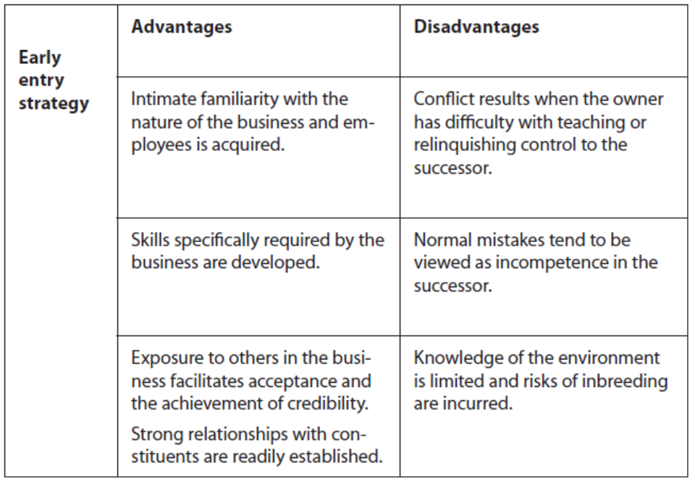

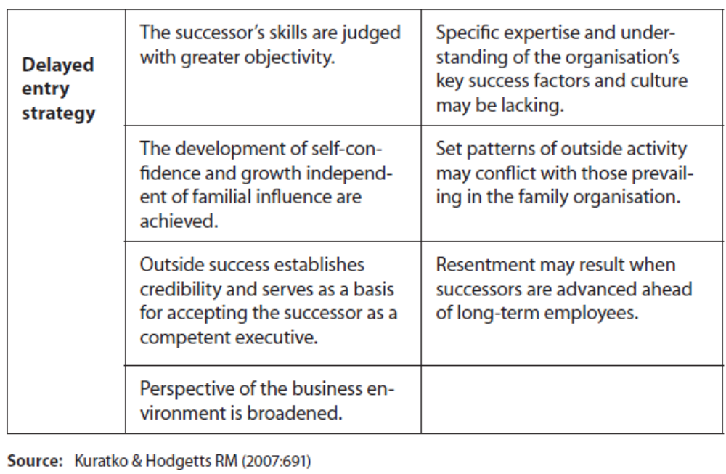

Stages in the process of succession

The process of succession can extend over years and even decades and comprises seven stages (Longenecker et al 2006:99–100), as depicted in figure 12.1:

Stage 1: Pre-business stage: As part of growing up, the child gets to know the business. The young child joins a parent when he or she goes to the office, store or warehouse and plays with the business equipment.

Stage 2: Introductory stage: Although the child is still too young to work for the business, he or she is deliberately introduced to aspects of the business and the people associated with it.

Stage 3: Introductory functional stage: The child now works as a part-time employee after school or during vacations and becomes acquainted with some of the key employees in the business. This stage includes the child’s formal education and experience gained in other organisations.

Stage 4: Functional stage: The potential successor enters full-time employment, usually after completion of formal education. He or she may gain experience by working in a number of different positions, say, as an accountant, salesperson or inventory clerk.

Stage 5: Advanced functional stage: The potential successor is promoted to management
positions, directing the work of others, but does not yet manage the entire
organisation.

Stage 6: Early succession stage: The potential successor is given supervisory positions. He or she may exercise control by giving overall direction to the business as a de jure head, although the parent is still the final decision maker.

Stage 7: Mature succession stage: The leadership transition process is complete and the successor is the leader in fact as well as in name.

Figure 12.1: A model of succession in the family business
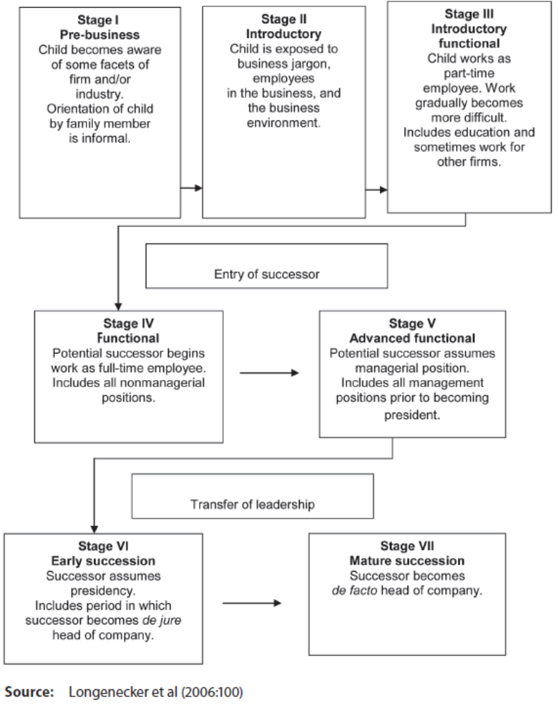

Developing a succession strategy

To ensure that succession proceeds smoothly, the family business owner should address the following steps (Kuratko & Hodgetts 2007:692):

Step 1: Understanding the contextual aspects:
The owner-manager should consider five key aspects of effective succession:

- Time: The earlier the owner-manager starts planning for a successor, the greater the likelihood of his or her selecting the right successor. When events force the owner to transfer power, he or she may not have adequate time to find the best replacement.

- Type of venture: Whether the owner/entrepreneur can be easily replaced depends on the nature of the venture and the market. If the key factors of success of the venture lie in the fact that the owner has a high level of specialised skills and knowledge or extensive personal business contact, it would be difficult to find a suitable successor. Where minimum knowledge or expertise is required of a successor, such a person should be easily found.

- Capabilities of managers: The skills, desires and abilities required of the successor will be dictated by the maturity of the industry, whether it is more technical or more market oriented, or a combination of both.
- Entrepreneur/owner’s vision: Where the vision and expectations of the entrepreneur/ owner are still relevant it would be hoped that the successor would share this. However, where the vision of the owner is outdated, the successor has to come with a new vision to carry the business forward for future generations.

- Environmental factors: Changes in the environment may dictate that type of successor who should replace the owner, since a new breed of manager may be needed at the top to cope with business environmental changes.

Step 2: Identifying successor qualities
The specific qualities required of the successor would depend on the nature of the business and the situation in which it finds itself. The following are some of the common characteristics expected of successors (Kuratko & Hodgetts 2007:693):

- adequate knowledge of the business or the possibility of acquiring such knowledge within a reasonable time
- fundamental honesty and capability
- good health
- energy, alertness and perception
- enthusiasm about the organisation
- a personality compatible with the business
- a high degree of perseverance
- stability and maturity
- a reasonable amount of aggression
- thoroughness and a proper respect for detail
- the ability to solve problems
- resourcefulness
- the ability to plan and organise
- a talent for developing people
- the personality of a starter and a finisher
- an appropriate agreement with the owner’s philosophy about the business

Step 3: Develop a written succession strategy (plan)
Develop a management continuity strategy and policy. A written policy can be established in one of the following strategies (Kuratko & Hodgetts 2007:693):

- The owner controls the management continuity strategy.

- The owner consults with selected family members.

- The owner works with professional advisors.

- The owner works with family involvement.

If the owner is still healthy and the business is in a viable condition, the following additional actions are considered:

- The owner formulates buy/sell agreements at the very outset of the company or soon thereafter, and whenever a major change occurs.

- The owner considers employee stock ownership plans (ESOPs).

- The owner sells or liquidates the business when losing enthusiasm for it but is still able to continue physically.

- The owner sells or liquidates after discovering a terminal illness but still has time for the orderly transfer of management or ownership.

ORGANISATION DEVELOPMENT APPROACHES TO CHANGE

Six organisation development approaches to change:

- individual consultation by the family-business advisor with the CEO and the successor candidate or candidates

- joint consultation with the CEO and successor or successors

- group consultation with the family or shareholder group

- intergroup consultation with the family and nonfamily management

- development of interpersonal skills in the next generation

- designing and facilitating whole-family forums and appreciative inquiry processes

COMMITMENT PLANNING

To obtain commitment to change, the leader needs to identify all the key individuals in both the organisation and the family, assess their current position on change, where they should be and how they may be moved into the position desired in order for the change to be successful.

INSTITUTIONALISING THE CHANGE

In order for the changes implemented to become the current state, the evolutionary process has to be institutionalised and governed with the aid of frequent family meetings or an ongoing family council and a board with some independent outsiders.

Broad-based black economic empowerment (BBBEE) is arguably the greatest strategic issue, challenge, threat and potential opportunity facing businesses of all sizes, structures and shapes in South Africa today. It is a government initiative to promote economic transformation to promote meaningful participation in the economy by black people.

BBBEE is already having a huge impact on the way business is done in South Africa — for large corporate, family businesses, small and medium-sized businesses and professional practitioners. Quite simply, BBBEE affects almost every participant in the South African economy (Balshaw & Goldberg 2005:16–17).

THE FUTURE: CAN FAMILY BUSINESSES COMPETE AND THRIVE?

The question arises: Can the family business compete and thrive?

Balshaw and Goldberg (2005:157) argue that the complexity, paradox, change and instability created by BBBEE will challenge and change existing family business structures and systems. Change begets change — in the chaos, family businesses must find the patterns, strategies, techniques and structures that will empower and work for them. Before a family business can position itself with respect to its customers and competitors, the family and business’s current life-cycle stage must be clarified — recognising that a family system is an emotion-based system and the business system task based. There is generally an antipathy towards change processes within the business and the family.

The following questions can be asked:

- What are the social and business imperatives of providing goods and services in South Africa?

- Who are our potential customers?

- Who will be our customers in ten years’ time?

- Do we want to transform into a truly representative South African-based business?

AGILITY IN THE FACE OF CHANGE

When the next generation senses an urgency to drive rapid change, they need to appreciate the competitive strengths that have led to the family business’s success, at the same time attending to the need for change posed by the new competitive conditions. A family business has the following advantages which are not easily replicated:

- speed and flexibility
- long-term strategies — reinvent themselves on a new growth path
- strategic focus on protected niches
- customer orientation — improve competitive fitness through value creation for customers
- patient capital in the presence of practices that safeguard trust and family unity

COMPETITION AND VALUE CREATION

Family-owned organisations can create competitive advantages by adopting a unique combination of the sources of value, discussed in chapter 6 in Poza (2010). Positive interactions between the family members who own the business and the business itself promote actions that result in a family business that lasts.

According to Balshaw and Goldberg (2005:146), whatever the size of family businesses, research has shown that they share important qualities which bring special benefits to society and the economy in which they operate, including the following:

- They have a stable capital structure (usually backed by family finance), providing a sustainable long-term structure, strategy and performance.

- They are able to take a long-term view of both staffing and investment, and are less concerned with short-term shareholder value.

- They tend to be more labour intensive and less capital intensive. There is less “hire-and-fire”, but a high capacity for employment creation.

- Innovation can be achieved at relatively lower costs, drawing on internal sources of capital and reinvestment of profits.

- Since there is usually a strong local commitment, these businesses make a substantial contribution to the economic, social and environmental quality of the communities in which they are established.

- They have a strong enterprise ethic, uniting a long-term strategy for the business with an awareness of environmental and social responsibility.

- They foster entrepreneurial instinct at the family level, often acting as incubators for new companies.

- Many are active as mentors to a new generation, helping young people learn more about business and stimulating the entrepreneurial culture.

TAPPING THE NEXT GENERATION

Younger family members tend to be more inclined to accept new technologies than older relatives. The complementary skills and perspectives of the next generation may be exactly what a family business needs to update itself and to continue creating value for its customers. Read the case studies of the Sidney Printing Works, Cablevision Systems and Samuel Curtis Johnson III (Poza 2010:309–311).

THRIVING THROUGH COMPETITION

Competition is all about procuring and deploying new products and new product/service combinations in new supply chain channels. Taking an example (Poza 4th Ed) in which the following two companies, which were totally different, restructured to gain a competitive advantage:

- Milliken, Levi Strauss, and Dillard’s — reduced overall inventories
- Cemex — reduced the time needed to deliver cement in traffic-congested Mexico City
ORGANIC COMPETENCIES AND THE BUSINESS FUTURE

Although publicly traded companies tend to enjoy a comparative advantage with regard to physical and financial assets, family-owned companies can differentiate themselves because of the following potential organic competencies of a family company:

- unique or idiosyncratic organisational capabilities: people, skills and systems
- customer-supplier integration: relationships and systems
- product/service price and performance
- brand equity: reputation
- concentrated ownership structure
- family unity and business opportunity

These intangible assets and organic competencies are difficult to replicate. Nevertheless, the changing environment may render even these organic competencies useless as far as customers are concerned.

INTER – PRENEURSHIP: INTER-GENERATIONAL GROWTH IN ENTREPRENEURIAL FAMILIES

To keep the competencies of the family-owned business relevant to customers, intergenerational growth through entrepreneurial activities by the next generation may be employed to produce new products, product line extensions, new markets for existing products, exports, joint ventures or strategic alliances with other members of the value chain.

GLOBAL OPPORTUNITIES

Because trade has become globalised, family-owned businesses may be compelled to expand overseas in the future. Poza (4th Ed) makes two suggestions about entering the global marketplace.

Southern Africa is emerging as a region of potential importance to foreign investors because local governments have made significant changes during the past five years. Reducing the role of the government in the economy (mainly through the privatisation of state organisations) and relaxing foreign exchange controls are examples of these positive changes. Unfortunately, the outside world has not yet acknowledged many of these changes.

Today’s world-class governments and businesses have found ways to create and sustain their global competitive advantage by applying technology, internal capabilities and talents from various stakeholders, suppliers, customers, competitors and strategic alliances. Southern Africa needs to be at the forefront of these issues, and the region’s governments should provide opportunities for organisations to be able to compete successfully in the global area (Ehlers 2008:352).

POSITIVE-SUM DYNAMICS THROUGH FAMILY AND ENTERPRISE LEADERSHIP

Next-generation members in the family business may help to expand the company. When a company grows it does not seem to be so vulnerable to zero-sum dynamics.

TOPIC 3: BEST PRACTICES FOR THE MANAGEMENT AND GOVERNANCE OF THE FAMILY BUSINESS

STUDY UNIT 13:

Continuing the spirit of enterprise: lessons from centennial family companies (Pg 133 – SG)

Chapter 5: DIAGNOSING THE FAMILY BUSINESS AND CREATING CONDITIONS FOR THE CONTINUED SPIRIT OF ENTERPRISE (Pg 112 – TB)

INTRODUCTION

FAMILY CULTURE, ORGANISATIONAL CULTURE AND CULTURAL BLUR IN FAMILY FIRMS

Family organisations, like any other organisation, develop special patterns of behaviours and beliefs that characterise the organisation and are known collectively as organisational culture. In a family business, the founder’s core values and beliefs may become part of both the business culture and the family code, because family members and others in the organisation learn these values simply by being part of the organisation.

Cultural blur endows a family business with invisible crossovers that can be converted into unique competitive advantages for the family business. These include the following:

- Love in the family can result in a strong commitment to quality and customer service.
- Strong ownership commitment may lead to patient capital.
- Social capital may result in the transfer of knowledge.
- A family value of independence may be translated into risk management.
- A strong work ethic in the founder or successor may be manifested in a strong commitment to high productivity in the company.
- Creativity in the founder or predecessor may be evident in continuing entrepreneurship and innovation.
- Caring attitudes may translate into quality products and, ultimately, the success of the company.

THE EROSION OF THE ENTREPRENEURIAL CULTURE

All family businesses are started by entrepreneurs, and during the formative years, these businesses are characterised by nimbleness — speed and agility. Over time, however, this changes because of increased regulations resulting in a bureaucracy and perhaps family turf wars that end in paralysing conflicts. Poza (2010:334–335) explains this by means of an example.

FAMILY UNITY AND A POSITIVE FAMILY-BUSINESS INTERACTION AS A RESOURCE IN THE CREATION OF INIMITABLE COMPETITIVE ADVANTAGES

The resource-based view of organisations holds that the family business has specific albeit complex and intangible resources (organisational competencies) that create competitive advantages such as the following:

- internal processes — lean processes that result in speed of execution
- human resources — knowledge and skills that result in higher quality services and support
- intangible assets — brand and reputation
- an overlapping owner-manager relationship — powerful monitoring mechanisms with several advantages such as reduced overall costs and faster decision making
- the creation of value for the customer through an organisational culture rooted in close interpersonal relationships with customers and suppliers — high quality and high customer service strategies
- the transfer of knowledge and networks of relationships

Families with a high level of family unity are more likely to have:

- a board of independent outsiders
- regular family meetings
- key nonfamily executives as top management
- estate plans that take continuity into consideration

A CUSTOMER-CENTRIC PARADIGM, CONTINUOUS EVOLUTION AND FAMILY-BUSINESS CONTINUITY

A customer-centric paradigm leads to continuous evolution and not to revolution. By continually adapting the core set of company competencies to meet the needs of the customers, a new shared vision emerges, and this energised vision drives the strategic regeneration process.

THE ROLE OF THE BOARD, FAMILY COUNCIL, SHAREHOLDERS AND NONFAMILY MANAGEMENT IN ENSURING CONTINUITY

The following findings emerged as being critical in ensuring continuity:

- The role of the board is prominent in the governance of the relationship between a family and its business when the family-business interaction is preserved as a positive-sum dynamic.

- The board composition has to change in order for the company to adapt and grow.

- Apart from restructuring the board, the CEO also has to re-engineer relationships with shareholders (including the previous CEO) and employees.

- Financial information should be transparent to all shareholders and if necessary frequent informal conversations with shareholders should be held.

- The CEO and top management team should create a sense of urgency in the midst of success in order to be receptive to change.

- Regular family council meetings are paramount during the early stages of the family business, and family retreats can be added to thrash out succession and regeneration processes. Transfer of power and ownership can begin at a family retreat.

- Next-generation family members and key nonfamily executives are given more responsible leadership positions, allowing key nonfamily employees to compete for top-level positions.

- Creating a holding company and a flat operating company allows more opportunity for family and nonfamily to achieve career advancement.

NEXT-GENERATION LEADERSHIP: PARTNERSHIPS AND A FOCUS ON THE FUTURE

What are the differences in focus of the next-generation leadership and the incumbent-generation leadership?

According to Balshaw (2003:23), one of the primary reasons for failure of family businesses is that the unique and complex interaction of problems faced by them is not holistically anticipated, planned for or addressed. The issues rising in a family business cannot be viewed in isolation — one needs to take into account all the factors impacting on the family and the business. Families in business need to distil understand and address the complex interrelated family and business relationships and issues that are often lost in the clutter of family emotions and the day-to-day operational tasks. Solutions clearly need to be identified and implemented in a phased and structured manner.

INCUMBENT-GENERATION LEADERSHIP: GOVERNANCE AND RESOLUTION OF THE PAST

Incumbent CEOs clean house for the next generation before transferring power. Incumbent- generation CEO leadership initiatives are presented in table 13.3 (Poza 2010:341).

LONGEVITY OF A FAMILY BUSINESS

- The first part of the longevity story is all about competitiveness and adaptation. In fact, it may not be much of an overstatement to suggest that the only disagreement worth having in a family business is a disagreement about strategy. When the disagreements are about pay, perks, and the presidency, the path of least resistance often leads to win–lose situations and zero-sum dynamics. And families cannot support zero-sum dynamics because the losers will eventually get their chance to harm the winners, even if it means the destruction of the company and the family.

- Keeping the business growing through a customer-centric paradigm and providing career opportunities for family and nonfamily employees is at the heart of that positive-sum dynamic and the capacity to have that virtuous cycle working for the owning family.

- Commitment by shareholders to govern their relationships for a higher purpose on behalf of continued ownership and control is necessary. Communication, information, and engagement that promote family unity are as important to the success of these centennial companies as managing strategically to remain competitive. The primary asset in creating competitive advantage is embedded in the family through the invisible crossovers from the family’s culture: the intangible assets, the patient capital, the thrift principle, a strong work ethic, the commitment to excellent quality, the commitment to the long term, and the commitment to financial independence.

- Centennial family companies have also learned to govern the family–business interaction and mitigate shareholder disunity (two great vulnerabilities of family businesses postulated by agency theory) through more formal structures and processes such as:

- Hiring and retaining professional nonfamily employees in top management
- Influential, independent boards
- Business planning and strategic planning processes
- Extensive communication using family councils and frequent family meetings
- A lean equity structure that promotes continued control by family members while ensuring that the company remains nimble.

Finally, centennial family companies have learned to change in order to continue to realize, across generations, the value of their traditional or new, but nevertheless idiosyncratic, competitive advantages. These advantages are often rooted in the unique family and family-business culture. Next-generation family-business leaders recognize that their cultural foundation is not easy to change, notwithstanding what may be the urgent need to do so in response to significant changes in their competitive environment. In partnership, the incumbent and next generations assume the responsibility for leading the change effort. In the best of cases, the incumbent generation focuses its efforts on pruning from the family business unnecessary legacy effects (e.g., highly compensated family members who are no longer adding value to the business and old agreements and policies that no longer make sense) so that the next generation can focus on the present and the future.

