ENTREPRENEURSHIP & SMALL BUSINESS MANAGEMENT
MNE 2601

TOPIC 1

STUDY UNIT 1
Chapter 1: The Nature and Development of Entrepreneurship (Pg 3 – TB)

Introduction: The Economic impetus of Entrepreneurship

Economic development can be directly attributed to the level of entrepreneurial activity in a country. A combination of all types of businesses from Small, Medium, and Micro enterprises (SMME’s), to large National and International organisations (Private and Public owned) collectively determines the overall state of the economy.

GDP or the – real Gross Domestic Product – is the value of all production within a country’s geographical boundaries, and it is used to measure the growth activity within our economy – that is, whether the economy is growing or declining. The Economic growth rate is determined by the year-on-year change in the value of real GDP.

Employment is also closely linked to the state of the economy. During periods of poor economic growth, less job opportunities are available. The importance of entrepreneurs is crucial for the improvement of the South African economy and is also regarded as the best opportunity that exists.

Most entrepreneurial activity takes place in small, medium and micro enterprises (SMME’s). SMME’s form 97.5% of all businesses in RSA, they generate 35% of GDP, employ 55% of all formal private sector employees and contribute 43% of the total value of salaries and wages paid in RSA.

The Development of Entrepreneurship Theory (entreprenology)

The progress in entrepreneurship and our understanding of entrepreneurs can be divided into five periods according to Fillion (1991).

Period | Topics | Authors and Researchers
- What entrepreneurs do 1700 – (1950) | From an Economic perspective | Cantillon, Say, Schumpter
- Who entrepreneurs are 1960 – (1980) | From a Behavioural perspective | Weber, McClelland, Rotter, De Vries
- What entrepreneurs do 1980 – | From a Management science perspective (finance, marketing, operations, human resources) | Drucker, Mintzberg
- What support is needed by entrepreneurs 1985 – | From a Social perspective, including economists, geographers and sociologists. | Gartner, Welsh, Bygrave, Reynold
- What entrepreneurial activities are, and what competencies are required to perform them 1990 – | From an Entrepreneurial perspective | Timmons, Vesper, Brockhaus

Defining Entrepreneurship, Small business and Entrepreneurial ventures

Entrepreneur and Entrepreneurship (Pg 9 – TB)

Entrepreneurship: is the emergence and growth of new business. The motivation for entrepreneurship is to make a profit. Entrepreneurship involves the process that causes changes in the economic system through innovations of individuals who respond to opportunities in the market.

In the process entrepreneurs create value for themselves and society.

Defining an entrepreneur remains a problem as researchers and academics never seem to reach agreement. Some definitions of an entrepreneur are given below:

Carland, Hoy, Boulton & Carland: An entrepreneur is an individual who establishes and manages a business for the main purposes of profit and growth. The entrepreneur is characterised principally by innovative behaviour and employ strategic management practices in the business.

Watson: The distinguishing factors of entrepreneurs are mostly innovation, and then opportunity recognition and growth in a business

An entrepreneur can be defined as follows: “an entrepreneur is a person who sees an opportunity in the market, gathers resources and creates and grows a business venture to meet these needs. The entrepreneur bears the risk of the venture and is rewarded with profit if it succeeds.

The key concepts of an entrepreneur that follow the definitions above are:

- Identifying an opportunity: A real business opportunity must exist
- Innovation and creativity: Some new and different is required
- Getting resources: Capital labour and operating equipment must be found
- Creating and growing a venture: Refers to the starting of a new business venture or the conversion of an existing business
- Taking risks: Personal and financial risks are involved for the person who embarks on the entrepreneurial process.
- Being rewarded: Reward is an essential element of the free market system. It can be in the form of profit or an increase in the value of the business.
- Managing the business: The entrepreneurial process requires planning, organisation, leadership and control of all the functions in the business venture.

Small business

It is important to distinguish between entrepreneurial ventures and small businesses. Both are crucial to the performance of the economy but serve different economic functions.

Watson: Small business owners are individuals who establish and manage their businesses for the principal purpose of furthering personal goals and ensuring security. The activities of artisans/craftsmen, administration/manager and security/family are indicated as characteristics of small business ownership.

Carland: Therefore, a small business is any business that is independently owned and operated, but is not dominant in its field and does not engage in any new marketing practices.
The National Small Business Amendment Act 26 of 2003 offers an official definition of small business in South Africa. The Act covers all sectors of the economy, as well as all types of enterprises, and consists of two parts – qualitative and quantitative criteria:

Qualitative criteria

...which relate to the ownership structure of the business, specifies that it must:
- Be a separate and distinct business entity
- Not be part of a group of companies
- Include any subsidiaries and branches when measuring the size
- Be managed by its owners
- Be a natural person, sole proprietorship, partnership or a legal person, such as a close corporation or company.

Quantitative criteria

...quantitative criteria are presented in the Schedule to the Act and classify businesses into micro, very small, small and medium, using the following guidelines in respect of different sectors of the economy:

- Total full-time paid employees
- Total annual turnover
- Total gross asset value (excluding fixed property)

Small business owners are not necessarily interested in growth as an objective, they regard themselves as successful when their businesses are profitable.

Entrepreneurial Ventures (Pg 10 – TB)

Entrepreneurial ventures are businesses in which the principal objectives are profitability and growth. Three characteristics distinguish the entrepreneurial venture from small business (Wickham);

Innovation: Entrepreneurial ventures thrive on innovation, be it technological innovation, a new product or a new way of producing, offering a service, marketing or distributing or even the way in which an organisation is structured or managed. Small business is usually only involved in delivering an established product or service.

Potential for growth: Due to its innovative approach, an entrepreneurial venture has a great deal more potential for growth than a small business. It is in a position to create its own market. The small business operates in an established industry and is unique only in terms of its locality.

Strategic Objectives: The entrepreneurial venture will usually set itself strategic objectives in relation to:
- Market targets
- Market development
- Market share
- Market position

The small business rarely cares about these aspects. Its objectives seldom go beyond survival, sales and profit targets. Entrepreneurial ventures are the ones that create employment. Both ventures require entrepreneurial action for start-up, but the small business will tend to stabilise at an early stage and only grow with inflation.

Entrepreneurial Development (Pg 10 – TB)

A model for Entrepreneurial development

Factors that influence the entry of entrepreneurs are:

- Entrepreneurial orientation:
  - Family and roles models
  - Education
  - Culture
  - Work experience
  - Personal orientation (creativity and innovation, autonomy, risk taking, proactiveness, competitive)

- A supportive environment:
  - Financing
  - Training and development

The fundamental infrastructure requirements such as roads, electricity, water and communications are vital factors in entrepreneurial development.

- Infrastructure:
  - A cooperative environment

The domains of Entrepreneurship, Management and Leadership

Not all entrepreneurs are good managers or leaders, but certain management and leadership skills are critical for entrepreneurial success.

Entrepreneurs are innovative and have the ability to identify business opportunities and grow them into businesses by applying the necessary resources. Once established, the business needs to be managed and the role of the entrepreneur then changes to that of a manager, which includes functions such as planning, organising, leadership and control.

The various business functions also have to be managed; these functions include marketing, purchasing, production, human resources, administration, public relations and finance.

Success factors of Entrepreneurs

Entrepreneurial Factors | Managerial Factors
Creativity and Innovation | Planning – systematic approach
Risk orientated – calculated risks | Knowledge of competitors
Leadership | Mainly market orientated
Good human relations | Client service
Positive attitude | High – Quality work
Perseverance | Financial insight and management
Commitment | Business knowledge and skills
 | The use of experts

The Entrepreneurial process (Pg 22 – TB)

The entrepreneurial process is a process through which a new venture is created. This process results from the efforts of the entrepreneur who brings the required resources together to form an organisation with which to pursue a business opportunity.

The entrepreneurial process has four distinct phases:

- Identifying and evaluating the opportunity:

An opportunity is a gap in the market which is not currently served. A good opportunity is attractive, durable and timely and vests in a product or service that creates or adds value to the market which it serves.

Identifying and evaluating an opportunity is a difficult task as an entrepreneur must deliberately formulate ideas which can be converted into a business opportunity. A number of techniques can be used to generate ideas from:

- The entrepreneur’s skills, expertise or aptitude
- Common needs
- Existing unsolved problems
- Everyday activities
- Others

In order to convert ideas into opportunities, each short-listed idea requires a feasibility and viability study.

A feasibility study: is a general examination of the potential of an idea to be converted into a new business venture, with its primary focus on the ability of the entrepreneur to pursue the idea and match his skills with what is required.

A viability study: is an in-depth investigation into the potential of the idea to be converted into a new business venture.

- Developing the business plan:

A good and detailed business plan must be developed in order to exploit the opportunity identified. The business plan is important in developing the opportunity as well as determining the resources required, how they will be obtained and how to manage the resulting business venture successfully.

By compiling a business plan, the entrepreneur is ‘forced’ into thinking about the various aspects of the enterprise resulting in an information gathering and self examination process. A diligently prepared business plan therefore helps reduce the risk of the venture.

- Determining the resources required:

Resources consist of the following:

- Financial resources – Capital for investing in the venture which can take the form of cash, credit or loans
- Human resources – People (employees)
- Physical resources – Assets such as equipment, machinery, buildings and vehicles etc...

When determining the resources required, the process would start with evaluating one’s own resources and how much investment or loans will be needed to start operating. Resources cannot be determined without a cash flow projection, which is done simultaneously with the development of the business plan.

- Starting and Managing the enterprise:

Once the minimum start-up capital has been acquired, the entrepreneur must put it to use by implementing the business plan. Initially the business may be relatively small employing (if any) only one or two employees. Once the business starts to grow it becomes important to determine the variables required for success.

STUDY UNIT 2
Chapter 2: The Entrepreneur (Pg 29 – TB)

Introduction: The Entrepreneur

Entrepreneurs play a fundamental role in providing goods and services to customers, and also contribute to solving the problem of unemployment. It is for these reasons that the South African economy requires more entrepreneurs.

Due to the unemployment crisis in South Africa, more people are choosing entrepreneurship as their career path. Whilst others are being forced to create their own employment due to the poor job market.

The entrepreneur as a catalyst for economic activity

Entrepreneurship is a key driver within an economy, which is highly valued and a key contributor to economic and social growth. Entrepreneurs in South Africa are seen as the primary creators and drivers of new businesses. Entrepreneurs play a vital role in the survival and growth of any emerging economy, and thus provide a critical solution to slow economic growth, low employment rates and unsatisfactory levels of poverty.

Entrepreneurs at various levels of entrepreneurial sophistication

Entrepreneurs can be found at different levels of entrepreneurial sophistication, based on the nature of their entrepreneurial activities. The 5 levels are discussed below:

- Basic survivalists: No economic independence, little involvement with other entrepreneurs within their social network (individualism)
Entrepreneurial activities: Isolated from markets, unaware of their own potential, illiterate, few income-generating activities. An example would be that of a person standing on a street corner, holding a sign board advertising that he will wash cars in exchange for R10.

- Pre – entrepreneurs: Follow the group’s initiative (collectivism)
Entrepreneurial activities: Welfare-orientated approach, not expected to be self-sustaining and requiring training in entrepreneurial competency. An example would be that of a person selling items on the side of the road with ten other pre-entrepreneurs selling exactly the same products at exactly the same prices.

- Subsistence entrepreneurs: Self employed, independent income generation, temporary market stall or stand.
Entrepreneurial activities: Inexperienced in business management and still needs general support and training in technical and management skills. An example would be street vendors.

- Micro entrepreneurs: Zero to nine employees, operating from a fixed workshop with an operating license from a local authority.
Entrepreneurial activities: Difficulty in getting loans from banks. Focus on credit rather than training and technical assistance. An example would be an entrepreneur who runs a home-based business such as a hairdressing salon.

- Small – scale entrepreneurs: Ten to 49 employees.
Entrepreneurial activities: Qualifies for a loan from a bank. Well – educated and has adequate collateral to apply for a loan. An example would be a small accounting or law firm.

The background and characteristics of entrepreneurs

Entrepreneurs need to internalise and adopt entrepreneurial attitudes and characteristics. Entrepreneurial characteristics can contribute to the background of the entrepreneur as in the case where the entrepreneur is brought up in an entrepreneurial family environment.

Other qualities are hardworking, honesty, ambition and persistence in overcoming numerous failures, and always striving for excellence and constant self – improvement.

The background of entrepreneurs

- Childhood family environment: It is often found that entrepreneurs have at least one parent who was (or still is) an entrepreneur. Entrepreneurship is best learnt through experience to through contact with family members who are entrepreneurs.

- Education: Education is seen as one of the most significant barriers to entrepreneurial activity. Higher levels of education are associated with significantly higher levels of entrepreneurial activity.

- Personal values: Research indicates that certain values nourish entrepreneurship. These include individuality, leadership qualities, ambition, opportunity focus, honesty and ethical behaviour. The nature of the entrepreneur in terms of opportunism, institution and individuality diverge significantly from the bureaucratic organisation and the planning, rationality and predictability of its managers.

- Age: According to a study in 2001, the highest number of entrepreneurs is found in the 35 to 54 year age group. Most of these entrepreneurs would have worked for some organisation before embarking on their own venture. In 2006, it was found that this age group was tending toward 25 to 34 years of age, an indication that nowadays people start businesses from a very young age.

- Work experience: Entrepreneurs who are most likely to succeed are those who have gone on to do training after school and have work experience. They have therefore seen entrepreneurial opportunities from an employment base.

The characteristics of entrepreneurs

- Passion: For people who wish to start a business, it is preferable that they pursue business activities for which they have a passion. If entrepreneurs pursue a business activity that they find interesting and fascinating, there is a much higher likelihood of success.

- Locus of control: Entrepreneurs are typically keen to be in control and have good delegation skills. They have a high degree of autonomy and do not want to be told what to do.

- Need for independence: Related to the desire for control is the need for independence. Many entrepreneurs leave their employer to start their own venture, this stems from their desire to be independent and to make their own decisions.

- Need for achievement: The need for achievement is closely linked to the entrepreneurial motivation to excel. McCelland states that entrepreneurs have a great need for achievement when compared with other individuals. Niemann & Bennett agree that entrepreneurs are self starters who are internally driven to compete and pursue challenging goals.
- Risk taking and uncertainty: Risk taking involves more than just the risk of losing financial resources should the venture fail it can also include social and personal risks. Liquidation can result in financial ruin, and entrepreneurs will have to face the social stigma associated with failure and well as the personal distress of letting down investors, employees, clients and their families.

- Creativity and innovation: Creativity and innovation are sources of creating a competitive advantage. Whether it is to create new products and services or to invent new ways to cut costs and improve existing products, creativity and innovation are seen as the key ingredient to establish a niche market and to determine an organisations competitive edge.

- Determination and persistence: In an ever changing economic, social, political and technical environment it is necessary to maintain focus, determination and persistence.

Role models and support systems

Entrepreneurs need role models and support systems to develop and implement their ideas. They also require support for the development and growth of their business, that is, a network system .

Types of network systems:

- Social networks: These include communication and the exchange of information, an example of this would be where two entrepreneurs exchange business cards at a social gathering (pub, golf course, etc...)

- Personal networks: This includes people which whom the entrepreneur has day-to-day direct contact, such as customers.

- Extended networks: These networks are focused on a network of organisations rather than an individual.

- Other networks: These include:
  - The internet
  - Suppliers
  - Investors
  - Bankers
  - Lawyers, etc

Many benefits can be derived from Networks as it opens various support avenues for entrepreneurs.

Push and Pull factors

Many South Africans are forced to become entrepreneurs due to retrenchment, job frustration and job losses.
Botha distinguishes between push and pull factors and states that entrepreneurs who take advantage of business opportunities and therefore start a business due to a gap that was spotted in the market are normally pulled towards entrepreneurship. These entrepreneur types are known as opportunity entrepreneurs.

People who start businesses as a result of not having any other employment options are usually pushed towards entrepreneurship. These entrepreneur types are known as necessity entrepreneurs.

Push factors are those factors that encourage entrepreneurship when there are no other choices or alternatives, these include

- Unemployment
- Job insecurity as in the case of a person working on a contract basis.
- Disagreement with management, career limitations and setbacks in a conventional job.
- Not fitting in with the organisation, or the inability to pursue personal innovation in a conventional job.
- The limitations of financial rewards from conventional jobs.
- Having no other alternatives.

Pull factors are those factors that encourage people to leave their conventional jobs in the pursuit of becoming an entrepreneur, these include

- Independence: the freedom to work for one-self
- Achievement: a sense of acknowledgement gained from managing one’s own venture
- Recognition: a desire to gain the social standing achievement by entrepreneurs
- Personal development: the freedom to pursue personal innovation
- Personal wealth: the financial rewards of entrepreneurship

Challenges facing Entrepreneurs and SMME’s in South Africa (Pg 35 – TB)

In South Africa there are a disappointingly high number of small and micro enterprises that fail during the first few years of operation. The largest percentage of small businesses fails during the first two years of their existence due to cash flow problems that arise because they could not manage growth.

The challenges facing new entrepreneurs include;

- Access to start-up and expansion finance: Raising money in capital markets, including for bank loans, is a minefield for start-ups, and often entrepreneurs launch their business using their own money. Statistics show that more than 80% of start-ups are financed by the founders personal savings, entrepreneurs then rely on debt or retained earnings to finance growth.

Over the past few years the Government through the Department of Trade and Industry and Khula Enterprise Finance, has designed and implemented incentives, subsidies and schemes that have improved SMME’s access to finance. However, a significant number of SMMEs’ are still not able to access affordable start-up and expansion finance.

The reasons for this lack of access to finance include:

- Risk aversion of the banking sector towards SMME’s. SMME’s are regarded as been high risk borrowers and this view is exacerbated by the high percentage of SMME business failures.

- There has been a decline in alternative financial institutions. A large number of Micro Finance Institutions (MFIs) have gone under, limiting access to finance for SMMEs.

- Inadequate funding proposals and business plans. Poorly prepared and presented business plans deter financial institutions from granting finance. Where entrepreneurs have presented adequate business plans and collateral and are still denied finance from a financial institution, the entrepreneur has the right to know why their loan applications were rejected.
The above challenges can be overcome by:

- Business success: The business success and profitability of SMMEs need to be improved. A sound business understanding, experience and exposure to the business environment are critical when accessing finance. Enhanced and improved business performance of small and micro businesses will make them more attractive to financiers.
- Financial products: Financial institutions and MFIs should provide SMMEs with appropriate financial products and information on where and how to obtain finance should be made available.
- Training: People who wish to become entrepreneurs need to be trained and coached in conducting research on and presenting funding proposals, feasibility studies and business plans. This would require accessing business development services.
- Financial guidance: Financial institutions should provide guidance and direction to SMMEs that have been denied finance, and also give them viable reasons why their loan request(s) were rejected.

- Access to markets: SMMEs do not give enough priority to marketing in their overall business approach. Most them do not probe and segment their markets, analyse customer demand, know their competition or interpret trends. Many entrepreneurs especially from the previously disadvantaged sector tend to ‘follow the group’ hoping that success can be achieved by following what others are doing.

The above constraints may be addressed by the following:

- Marketing training: SMMEs need to be provided with effective marketing training. It is imperative to constantly upgrade marketing appeal and competencies by putting more effort and budget allocations towards marketing training.
- Commitment to marketing: SMME entrepreneurs need to appreciate that to be successful, they must demonstrate an early awareness of and commitment to marketing. Most SMMEs place all their attention and focus on the production and finance functions without any clearly defined marketing activities/functions.
- Commitment to the market: SMMEs need to place the needs of the market at the forefront of their business concerns. This will lead to the necessary attitude and behaviour for developing superior value for customers and ensuring superior business performance. It is crucial for entrepreneurs to remain close to their customers and to remain ‘tuned in’ to their wants and needs. Developing new products without a market can result in both product and business failure.
- Market-orientated products: SMMEs should focus their efforts on supplying only those products and services which are demanded by the market. Market research is therefore an important step to make before even starting a business venture. The products and services which can be offered and supplied by the entrepreneur must first be measured against the market demand for those products and services before the venture gets started.
- Networking: Business Development Service agencies (BDS agencies) should assist SMMEs to gain access to markets by facilitating vertical and horizontal (networking) business linkages.

- Access to appropriate technology: The lack of technology is another constraint facing SMMEs. The use of appropriate technology is one of the most important factors behind a successful SMME’s competitive advantage. Successful SMMEs constantly upgrade operational and production equipment and techniques.

The use of up-to-date and new technology leads to:

- Better and more competitive products and services
- Improved efficiency
- Reduce operational and production costs
- Improved quality of products and services

- Access to human resources: It is the entrepreneur who has to gather and mobilise the other production resources (land, labour and capital) to create a new business venture or to change the direction of an existing firm.

Human resources are widely acknowledged as being the ‘most precious asset’ of a business. Issues involved in human resource management include addressing the skills, attitudes and expectations of employees and those of the entrepreneurs themselves.

Entrepreneurs need to address the attitudes and expectations of their employees. They can do this by:

- Building team spirit by doing team building exercises away from the work environment.
- Nurturing life-long learning in themselves and their employees
- Ensuring that their employees regard meeting customer needs as their responsibility
- Initiating an intrapreneurial climate within the organisation, allowing employees more freedom of choice
- Being role models for their employees
- Practicing a code of ethics to ensure an ethical foundation in the business

Women and emerging Entrepreneurs (Pg 35 – TB)

Although entrepreneurship and business in general have been male dominated, the trend is changing and the economic role of women is been recognised.

Types of women business owners can be distinguished as follows:

- Traditional: Traditional women business owners are highly committed to entrepreneurial ideas, as well as to conventional gender roles. They are motivated to start a business due to economic pressure at home, which contributes to the push factor in the economy. Their primary focus is to keep overheads, wages and costs low.

- Innovative: Innovative women business owners are highly committed to entrepreneurial ideas but not to traditional gender roles. They start their business because of limited career prospects in large organisations, they are ambitious and their business has high priority.

- Domestic: Domestic women business owners are not committed to entrepreneurial ideas but have a high attachment to traditional gender roles. They usually give up work to have children. Their motives are self-fulfilment, expression of creative skills and a search for personal autonomy. Most of their businesses are run from home and are often geared with low-volume production of high quality goods and services.

- Radical: Radical women business owners have little commitment to entrepreneurial ideas or to traditional gender roles. They are usually young without children, well educated but have limited work experience. This type cannot be seen as entrepreneurial venture seekers.

New labels for Entrepreneurs (Pg 40 – TB)

- Emerging entrepreneurs: refers to previously disadvantaged groups

- Survivalist and micro entrepreneurs: Petty traders in the informal sector (such as shoeshine boys)

- Opportunity and necessity entrepreneurs: Motivational drivers been seen as choice (Pull factors – opportunity seekers) or necessity driven (Push factors)

- Youth entrepreneurs: Some schools provide students with entrepreneurship as a subject choice,

- Technology entrepreneurs: Entrepreneurs who take advantage of new scientific developments, especially in the areas of information technology, biotechnology and engineering science and offering their benefits to the world.

- Social entrepreneurs: Individuals with innovative solutions to society’s most pressing social problems. As opposed to a business entrepreneur who seeks value in the creation of new markets and profit margins, the social entrepreneur aims for value in the form of transformational change that will benefit disadvantaged communities and generally society at large.

- Tourism entrepreneurs: This is the largest industry in the world and also the biggest employer. Many opportunities are available for entrepreneurs in the tourism industry, especially in South Africa.

Entrepreneurs versus Inventor (Pg 44 – TB)

An inventor creates something new but lacks the skills to sell it. An entrepreneur will take over from the inventor and start a business venture in order to market the new invention.

Male entrepreneurs vs Female entrepreneurs (Pg 39 – TB)

The comparison between Male and Female entrepreneurs include:

- Women forge relatively strong ties, whilst men forge relatively weak ties
- Women form relatively egalitarian coalitions, whilst men forge relatively hierarchical coalitions
- Men have set the foundation of the business environment
- Men are predominately involved in manufacturing and construction, whilst women are more involved in coffee shops and guest houses (more services related)
- Men are more short term orientated, whilst women forge strong relationships with service providers such as bankers
- Male support groups include friends, professional acquaintances, and colleagues, whilst female support groups include network groups or associations

TOPIC 2

STUDY UNIT 3
Chapter 3: Creativity and Business opportunity (Pg 55 – TB)

Introduction

Entrepreneurship is a day to day challenge, and the moment you do not experience the unique challenge anymore, look for a salaried job! Once a new venture has started up and become established, it is very likely that the products and, or services of the new venture will compete with other corporate giants. Various foreseen and unforeseen obstacles will hamper immediate growth and expansion.

Creativity: “Creativity can be defined as the process of generating ideas that result in the improved efficiency or effectiveness of a system.”

One of the primary driving forces that assist entrepreneurs to compete and survive in the market today is creative behaviour. Creative behaviour and creative thinking lead to innovative actions and even processes. When one considers the most successful entrepreneurs in the world, many of them have only changed the existing or conventional into the new. These actions are the result of intense creativity, and innovation a skill that differentiates entrepreneurs.

The theory of creativity

Creativity is a result of brain-driven actions which can transform various complex problems into attractive opportunities. Many definitions of creativity have been formulated, the general definition includes the following:

- Information about the product: The result of creativity is a value adding product or idea which has evolved from the thinking process
- Information about the thinking process: which is usually unconventional and challenges current thinking
- Performance motivation: this supports the thinking process
- The initial problem is usually vague and unstructured but integrated in the thinking process
- Thinking that results in ideas that are unique, practical and understandable.

The creativity model

The 4P model of creativity serves as a basis for entrepreneurial creativity.

Product
Process
Person

Press (environment)

The creativity model is an interactive model, which implies that creativity can be improved by giving special attention to each variable individually and in an interdependent context.

- The Person: The most important variable in the creativity model is the person, which in this case is the entrepreneur. Creativity is a fundamental entrepreneurial skill, but it is also a learnable or acquired skill.

To develop creativity in a person requires:

- Expertise: which includes all the knowledge, experience and talent a person can use to apply in a certain situation. Expertise could be acquired through the persons’ work experience, educational background, training interventions, and general daily social interactions with others, including family.

- Motivation: The motivation component of creative people determines what they will do and whether they will do it. Creative people are not necessarily driven by their position or the level of work they do, as new ideas and their development are fuelled by a certain level of motivation.

- Creative thinking skills: Creative thinking skills play an enormous role in the way a person will deal with a problem or idea. Creative thinking involves thought processes such as associating unrelated components and combining them into a new or unique way.

General myths about creativity include:

- Creativity is an innate skill and cannot be acquired by means of training
- You need to be a rebel to be seen as creative
- Artists are the only creative beings
- You need to be ‘crazy’ before creativity can kick in
- Intelligence and creativity. Up to an IQ level of 120 intelligence and creativity go hand in hand, after creativity decreases
- Group vs individual, although not an exact science it is found that whilst some people have a tendency to be more creative in a group environment, some people are just as creative when working alone.
- All new products were accidental discoveries

Blocks to creativity:

- Environmental barriers: In this context environmental barriers include the social, economic and physical environments. The Social environment creates certain barriers:

  - There is a lack of understanding and support for new ideas in the community, among friends and family
  - Risk taking is prohibited
  - In families with an autocratic decision making structure, it is often found that children are restricted from thinking for themselves
  - Cultural barriers.

The Economic environment may create barriers:

- The economy in general is not conducive to the development of new ideas and products
- There are no growth prospects in the economy
- No financial support is available for the development of new products
- Risk taking is seen as a negative element of the economy
- No rewards for new and feasible ideas

The Physical environment could be a restrictive factor to creativity as follows:

- Distractions, for example sounds, the climate and lack of energy
- Conventional venues in the education and training environment (grey and dull colours, even rows of seat placing)
- Routine – you have to eat, work, exercise and sleep as part of a specific timetable and routine

Cultural barriers the following barriers are considered to be generic cultural barriers or mindsets:

- You must go to school, then to university or college, and after that you will find a job
- The unknown is unsafe
- You must be practical and think economically before you generate ideas
- It is not permitted to ask questions or to question an issue
- Stereotyping – assumptions are make without any background or knowledge of a matter
- The policy of the company is to adhere to rules and procedures, and to stay in line with the organisational structure.

Perceptual barriers, these barriers refer to blocks or barriers in the way we see or perceive the world. The following perceptions are potential barriers to creativity:

- Using a narrow mindset when analysing problems.
- Making assumptions about a problem or idea without considering all the information and without seeing the bigger picture. Or, being unable to structure the problem and evaluate the smaller elements.
- Assuming that something will work, without doing proper research or feasibility studies (relying only on ‘gut feel’)
- Varied perceptions on the characteristics and even the utility of a new product by the owner and the potential customer.

- The Process: Creativity forms part of a continuous process and creative thinking is the fundamental basis of or facilitator in, the development of new initiatives, products or services. In the entrepreneurial context the creativity process should, in the end, always be linked to a feasible opportunity in the market environment.
An opportunity is initially problem based, and it is the creative thinking process that seeks to solve these problems.

The process of creative problem-solving consists of consecutive steps as follows:

- Idea Generation: The idea generation process is predominately a process of discovery. The process involves generating a multitude of ideas seeking to address a current problem or market opportunity (gap) emphasis is placed on quantity and not necessary quality. The opportunity identification process already commences during this phase.

- Developing the most suitable or feasible idea: this is a process of invention, where the most suitable or feasible ideas are developed.

- Transforming the most suitable idea into an innovation: Where creativity is the thought process that leads to the generation of ideas to identify opportunities, innovation is the practical implementation of the idea concept to ensure that the set aims are met on a commercial and profitable basis, in line with a specific market opportunity.

There are numerous creativity techniques that will assist in creative thinking, generating ideas and evaluating opportunities in the market place.
These techniques are an integral part of the creative thinking process, and include:

- Random input:

Random inputs are based on the development of words, pictures or images, for example:

- Write 20 words on small pieces of paper, throw them in a hat and choose one with your eyes closed. Take the word and think of all related elements
- Open a magazine or newspaper and take every secod or third word and analyse the meaning or related elements.
- Take the first 20 photos in your family album and use colours, images and situations to develop new ideas from them.

- Problem reversal:

Almost all ideas, arguments or attributes have an opposite. This is an exercise to see things backwards, inside out and upside down, thus enabling you to analyse the whole concept. The following procedure can be followed:

- View your problem in the reverse form. Change the negative form into the positive, or the other way around.
- Define what something “is not”, or the opposite thereof.
- Analyse what everybody else is not doing, or the opposite thereof.
- Use the “what if” question.
- Change the direction of your perspective.
- Evaluate all results.
- Turn defeat into victory, and the other way around.

- The 5 - W’s & H technique:

Also known as the questioning technique it embraces the questions “Who”, “What”, “When”, “Where”, “Why” and “How”. Apply all these questions to each of your ideas. Similarly, take the advantages and disadvantages of your ideas and do the same.

- Association technique:

Take a problem and make use of unrelated elements such as, and for example, nature to develop a solution to a particular problem.

- Discontinuity principle:

The more we get caught up in a routine or fixed environment, the less stimulating it is for our creative thinking. This method implies that we intervene in our daily routine by means of unusual interruptions, such as:

- Changing the route to work, home or to a friend
- Listening to a different radio station
- Reading material outside your frame of reference
- Talk to strangers
- Using a different approach during your lunch break, such as lying on your back outside on the grass

Other creativity techniques include brainstorming, surveys, focus groups and customer questionnaires

Idea vs Opportunity

An idea is a thought, impression or notion for a new product or service. Not all ideas are opportunities.

An opportunity is a favourable set of circumstances that creates a need for a new product, service or business
Hisrich and Peters define an opportunity as the process whereby the entrepreneur assesses whether a certain product, service or process will yield the necessary earnings based on the resource inputs that are required to manufacture and market it.

There are two building blocks in the assessment of an opportunity:

- The size of the Market: Will the number of customers reward the input and energy required to create and deliver the product?

- The time frame (window of opportunity) of the opportunity: Is the demand for the product or service based on a short fashionable phenomenon or is it based on a sustainable business and how long will it take before a competitor grabs the opportunity?

- The Product: The new innovation or product is the direct result of the process. A multitude of ideas have been generated which are in line with the problem to be solved. The ideas from the creative thinking process are then evaluated and the most suitable one is subjected to the product development process.

There are many examples that illustrate the creative thinking process which develops into product form. The new innovation (product) results in changes such as:

- Fundamental changes: Where for example the development of a vaccine is found to cure HIV/AIDS, or an efficient method that will replace conventional motor car fuel.
- Incremental changes: Here changes take place incrementally over time such as regular updates of Microsoft Windows software and applications.

Wickham identifies critical areas where innovations might be made:

- New products: The most evident examples of innovation are found in tangible products. Today customers are flooded with new products on a daily basis.
- New services: The services industry in South Africa is growing at an immense rate.

- New production techniques: Innovation is present in the way products are created or manufactured, whether by applying new technological methods and machines or by completely replacing the old.

- New operating practices: The economy is based on speed and innovation, and the way in which services are rendered, creates an array of opportunities for entrepreneurs. Mobile networks have become an effective customer service tool, for example businesses have the ability to communicate specials directly to its target market via SMSs.

- New ways of delivering the product or service to the customer: Technology has changed the way in which various products are distributed to customers. The internet plays a pivotal role in this process. Modern customers prefer the comfort of ordering their basic and specialised goods via the internet.

- New ways of informing the customer about the product: Again the internet has transformed the way in which customers are informed about services and products. The emphasis been on comfort and the ability to access information about anything any time anywhere.

- New ways of managing relationships within the organisation: Technological innovation has fundamentally changed the way employees communicate within the work environment.

Legal protection of the product: Any product can be copied, and therefore a legal form of protection is needed to prevent product duplication / replication. In South Africa the following options are available to protect a new product or intellectual property:

- Patents:

Patents are granted for inventions that have not been previously known and that differ effectively from what was previously done along the same lines.

The following options are available to entrepreneurs who wish to protect their product:

- Patents: A patent can cover any invention in the form of an apparatus, an article, a device, method or process.

- Know-how: Secret technology which usually relates to processes, can be licensed in return for payment.

- Trademarks: Trademarks can be registered for name, logo, design and service protection.

- Unlawful competition: This option can be used to protect an entrepreneur from other companies marketing products and services in such a manner that it creates confusion with the entrepreneurs business.

- Copyright: This option can be used for the protection of intellectual content such as literary works.

- Plants: Used for the protection of new varieties of plants.

- Licenses: Licenses protect all forms of intellectual property.

The following are not patentable:

- Mathematical methods

- Aesthetic creations (e.g. fashion designs, motor vehicle designs)

- Architectural designs

- Schemes (such as investment or insurance schemes)

- Business methods (e.g. credit or stock control)

- Rules for playing games, although the equipment used to play the games may be patented.

- Computer programs

- Scientific methods

Stages of the creative process (Pg 62 – TB)

Stages | Requirements
Awareness | - Recognition of a problem or situation  - Curiosity
Preparation | - Openness to experience  - Analysis of how the task might be approached  - Tolerance of ambiguity  - Willingness to refine concepts  - Divergent thought process  - Intuitive ability
Incubation | - Imagination  - Absorption  - Seeking ideas, possible answers and solutions
Illumination (insight) | - Ability to switch from intuitive to analytical thought patterns  - Eurika!  - Ah-Ha!
Verification | - Critical attitude  - Analytical ability  - Testing

TOPIC 2

STUDY UNIT 4
Chapter 4: The window of opportunity (Pg 85 – TB)

Introduction

A window of opportunity is divided into five phases: seeing, locating, measuring, opening and closing the window.

The opportunity

According to Niemann & Bennet; an opportunity is a gap left in the market by those who currently serve it.

Timmons states that an opportunity has the qualities of being attractive, durable and timely.

A good idea is not necessarily a viable and feasible opportunity. For an idea to be a lucrative one, besides being attractive, durable and timely, the resultant product or service must create and/or add value for the purchaser or end-user.

Entrepreneurs are seen as the drivers of the economy as a result of their creation, establishment and growth of new businesses. For these new businesses to be created, entrepreneurs need to identify new business opportunities, new products and services and new ways to meet customer needs.

An idea becomes an opportunity when the idea is attractive, durable and timely, the idea must also be well anchored in the product or service, which creates or adds value to its end-user.

Sources and drivers of ideas and opportunities (Pg 87 – TB)

Goods opportunities do not merely fall from the sky. Finding good ideas and converting them into opportunities is a conscious, creative and deliberate process.
According to Niemann and Nieuwerhuizen ideas can be generated from skills, expertise and aptitude, from common needs, existing problems, everyday problems and other sources.

Opportunity evaluation (Pg 87 – TB)

In order to determine whether or not a business idea will translate into a lucrative opportunity which posses the qualities of being timely, attractive, and durable, the entrepreneur needs to follow a strategy of evaluating or screening the opportunity.

The process of evaluating and screening opportunities seeks to uncover any issues and aspects which may have otherwise gone unnoticed. The evaluation and screening process helps the entrepreneur to clearly see whether the opportunity under review has a high or a low potential, and ultimately whether or not the opportunity is worth pursuing.

The criteria used to screen opportunities can be summarised as follows:

- Industry and market issues: (Pg 89 – TB)

Higher-potential ventures usually comprise of a niche market that caters for needs that certain customers deem to be important, and is therefore sustainable. The attractiveness is determined by the following factors:

- Market Structure:

- The number and size distribution of sellers in the market:

The fewer the sellers in the market, the more difficult the entry for new firms

- The number and size distribution of buyers in the market:

The fewer the buyers in the market, the more difficult the entry for new firms (the market could even be monopolistic)

- Product differentiation:

The higher the product differentiation, the more difficult the entry

- Entry and exit conditions:

Monopolistic markets are difficult to enter

- Demand sensitivity to price changes:

The more price sensitive the market is the more variable the demand and the more difficult to enter. Economies of scale also prevent small firms from entering a market unless they can compete at lower prices and hence lower profit margins.

- Market Size:

A large and growing market is a lucrative market and well suit for an entrepreneur with a high-potential venture. A small stagnated market is not favourable for new entrants.

- Market Capacity:

An attractive market is a market in which the current demand outweighs the current supply.

- Market Share:

A firm that is unable to capture a substantial portion of the overall market share has low-growth potential, and thus not a favourable venture

- Cost Structure:

In general, a firm that can provide low-cost goods and services whilst providing value for money, is attractive.

- Economics:

Businesses that possess high and durable gross margins have high and durable profits (after tax). A venture that achieves a positive cash flow, quickly, i.e. within three years, is attractive. Where the time taken to reach a point of break even exceeds three years, the potential for the venture to be attractive is substantially reduced. Ventures which require low start-up funds and little or no initial capital equipment are attractive.

- Harvest issues:

An entrepreneur should always bear in mind that there is always a possibility that the venture will be sold. This is referred to as an exit strategy, and attractive ventures in attractive markets have the harvest objective in mind. An unattractive venture in an unattractive market makes an exit strategy very difficult.

- Management team issues:

It is both beneficial and important that a venture consists of an entrepreneurial team with proven experience within the chosen industry. Moreover, a team that possesses a complimentary and compatible skills base contributes to the attractiveness of the venture.

- Fatal flaw issues:

The presence of one or more fatal flaws renders the opportunity of a venture unattractive. Fatal flaws can be caused by:

- Markets that are too small
- Markets with overwhelming competitors
- Markets where the cost of entry is too high
- Markets where entrants are unable to produce a sustainable competitive advantage
- Others include; the lack of an entrepreneurial team, no industry or technical experience, lack of honesty and integrity.

- Personal criteria:

Successful entrepreneurs have a good fit between what they wish to derive from the venture and what the venture requires from them in order to do so. A successful entrepreneur takes calculated risks and has relatively high stress tolerance levels. An attractive opportunity is both desirable and good for the entrepreneur to pursue.

- Strategic differentiation:

Strategic differentiation refers to how a venture positions itself to take advantage of the given market conditions to its benefit, whilst maintaining its own identity, thus differentiating itself from the competitors in terms of the value added to customers.
A high-potential venture:

- Tends to have an entrepreneurial team of the highest calibre, with excellent service management and perceived by customers as a good service provider. The venture management team is usually very flexible and can make decisions on its feet, as well as de-commit equally fast, should circumstances make it necessary to do so.

- Is always searching for new opportunities and the pricing strategy enables it to be the industry leader, or be positioned near that prime position.

- Is conducive to high growth as it has distribution channels that are accessible, as well as networks that are firmly in place.

- Has an integral strategy for forgiveness, which allows for mistakes to be made with the resulting learning outcome to be shared with the management team and staff members.

- Times its product or service entry into the market with a product or service that is technologically ground breaking or exclusive.

The pursuit of Opportunities (Pg 90 – TB)

Whilst established businesses hold a stronger position compared to smaller entrepreneurs in terms of market entry and share, small entrepreneurs can (and do) take on the larger players successfully. They manage to identify opportunities in the market and turn them into viable business ventures regardless of the presence of the more established organisations.

The reasons for this are numerous but can be attributed to:

- Organisational inertia: this occurs when an organisation refuses to adapt in a responsive manner to changes that occur in the market place.

- Organisational complacence: Established organisations tend to remain in a comfort zone and thus rely on current and past successes with the view to continue building on current strengths. This means that established organisations rarely pursue new ideas.

- Bureaucracy: As businesses grow and become more successful, the levels in the hierarchy also expand due to increased financial, operational and human resource requirements. Over time communication becomes cumbersome and slow resulting in organisations becoming bureaucratic.

Why organisations leave gaps in the market (Pg 90 – TB)

The most common reasons for bigger or more established businesses to leave gaps in the market are as follows:

- Failure to see new opportunities
- Underestimation of new opportunities
- Technological inertia
- Cultural inertia
- Politics and internal fighting
- Government support of new small entrants

The Window of Opportunity

The window of opportunity refers to the time period available for creating a new venture. As a market grows, more and more opportunities are revealed, and so the window of opportunity opens.

As the market matures, the window of opportunity begins to close and the available opportunities in the market become fewer and fewer until they eventually peter out.

Metaphorically the market and its competitive environment can be viewed as being a ‘wall’, impenetrable and closed off with little to no opportunities available. But where gaps have been left in these markets, the gaps are seen as ‘windows’ and represent the opportunities in which current markets are not been serviced to its fullest potential. It is these windows through which entrepreneurs can view and enter the market, enabling them to offer a better product or service to the end-user.

Once a window of opportunity has been identified, the window must remain open for long enough to enable an entrepreneur to take advantage of the opportunity. The size of the market and the window of opportunity (period of time) are therefore important determinants of the risk and reward.

Seeing, Locating, Measuring, Opening and Closing the window of opportunity

Mark Twain said “I was seldom able to see an opportunity until it ceased to exist” Similarly opportunities do not always present themselves easily, nor do they last forever!

- Seeing the window: identify gaps in the markets and possible opportunities
- Locating the window: fully understand how products or service offerings in the market compare with those of competitors. The entrepreneur needs to identify a possible aspect of competitive advantage should he decide to enter the market.
- Measuring the window: Research and survey the market to ensure that the opportunity is feasible and viable
- Opening the window: entry into market and starting of the business
- Closing the window: the entrepreneur should try and create and maintain a sustainable competitive advantage

Key concepts

- Feasibility study: The ability of the entrepreneur to match his skills, experience, education and expertise to the requirements of the venture. The feasibility study also includes a study of marketing costs, production costs, potential profit margins, the size of the potential market and the industry.

- Viability study: Conducted to determine how the market will respond to innovation as well as how the competition will respond to a new entrant.

TOPIC 2

STUDY UNIT 5
Chapter 5: The business plan (Pg 103 – TB)

Introduction

A business plan is a detailed document that helps an entrepreneur to analyse the market and develop business strategies. By drafting a business plan, entrepreneurs are given an opportunity to think ahead and plan for the future.

Defining a Business Plan

A business plan is a written document that carefully explains the business, its management team, its products or services and its goals. It spells out where the business is heading and explains in detail how it is going to reach that destination. The business plans helps the business to align all of its activities in an organised manner in order to achieve its objectives and in so doing reach its destination.

A business plan therefore involves:

- A process of planning: what goals entrepreneur wants to achieve
- Strategies and actions plans for achieving the goals: how the entrepreneur will achieve them

Reasons for drafting a Business Plan

There are three main reasons for drafting a business plan:

- To Obtain funding:

A business plan can be used to obtain financial resources by approaching investors, or applying for a loan at a financial institution.

Given the limited resources available to most entrepreneurs in the start-up phase, few can afford to waste. Without a business plan, the entrepreneur could easily waste these resources without even realising it before it is too late.

- To serve an internal purpose:

A business plan can be used internally in the business to provide managers and staff with the following:

- Focus: Coordination of efforts towards a clearly defined objective
- Objective (Road map): Everyone will have a clear understanding of where they are headed and what they are working for.
- Measurement tool: A means of evaluating performance against expectations
- Marketing tool: A means to obtain funds and to communicate the business activities

- To reduce business risk:

By developing a business plan, the entrepreneur is forced to consider each aspect of the business and manage it accordingly. Quite often the formulation of the business plan, reveals aspects that encourage the entrepreneur to consider alternatives and new directions, even a ‘plan B’ in the event that certain assumptions are not realised.

Standard format and layout of a Business Plan

The following is an outline of a standard business plan:

- A Cover Sheet:

- Full name of the business
- Ownership status
- Full physical street address
- Postal or official address for communication
- Contact details: telephone, fax, e-mail and web-site information
- Contact name and title
- Date of the Business plan

- A Table of contents:

- Categorise the contents; List main headings and include sub-headings
- List all charts, tables and figures and list any appendixes or supporting documentation

- An Executive Summary:

The summary briefly outlines the contents of the business plan. Generally is contains key points from each section of the plan in order to create an overview of the project. The summary must allow the reader to quickly obtain an overview of the business plan and to evaluate whether the contents would be of interest.

- A Product and/or services Plan:

This section should briefly describe the product or service, the customer base, the current status of the industry and where the new business fits in.

The following points must be included:

- Description of the products and or service to be sold: Describe the primary end-use, as well as any significant secondary applications. Emphasise any unique features and how the products or services on offer will account for marketing penetration.
- Proprietary position: Describe any patents, trade secrets or other features.
- Potential: Describe any features of the product or service that will give it an advantage over the competition. Discuss opportunities for expansion of the product line and how to take advantage of them. Discuss any product disadvantage or technological changes or marketing fads, if applicable.

- A Marketing Plan:

This section should clearly describe the business’s marketing goals, how they are to be achieved and who will have the responsibility for achieving them. Attention must be paid in detail with reference to the 4 P’s of Marketing: Product, Price, Place and Promotion.

In this section you also need to comment on Customers, Industry and Competition:

- Customers: Discuss who the customers are, and describe the basis of the purchase decisions, for example; price, quality, service, personal contacts or political pressure.

- Industry: Describe the size of the current total market for the product or service offered. The market size should be derived from available market data sources. Discuss potential distributors and dealers.

- Competition: Make a realistic assessment of the strengths and weaknesses of competitive products and services, and name the businesses that supply them. Compare the competing products and services on the basis of price, performance, service, warranties and other prominent features.

Do not make any assumptions in this section, ensure that only facts are used and that the information supplied is true and correct. It is important to mention any competitive advantage(s) over competitors.

- An Operational Plan:

This section focuses on facilities, manufacturing capabilities and equipment. If the business is in manufacturing, it will help to include floor plans as well as future space plans should expansionary projects be foreseen.

The following aspects must be mentioned:

- Capacity: Amongst other things, Capacity includes, how many products can be produced by the business over a certain time period.

- Scheduling of Production: Scheduling refers to the timing and steps that will be taken to bring the business up to full speed. Any relevant graphs and charts may be included that help to indicate the interrelationships between events, milestones and processes. A month-by-month progress plan based on the forecast for the first year will also be very helpful.

- Quality Management: This concerns what the business will do to ensure quality and control of inventory.

- A Management Plan:

The quality of the management team often determines the potential success of the business. List all directors, consultants, advisers, and any other key professionals who will be involved in the business. Mention whether any of the Management team members have worked together in the past. Detailed CV’s of the key Management should also be included in the appendix.

The Management plan therefore details the organisational structure of the business. Also present current and proposed salary structures for those who are on board and for those still to come on board.

- A Financial Plan:

The financial side of the business plan has to prove beyond all reasonable doubt that the business has the potential to be operated profitably. The financial section must clearly indicate the following:

- A schedule of start-up or establishment costs:

- Product development costs (incl. R&D)
- Legal costs (company registration, trademark, patients, advice, etc)
- Product testing costs (proto-type testing)
- Market research costs
- Cost of purchasing business premises (if not rented)
- Cost of machinery and equipment
- Cost of installing machinery and equipment
- Office equipment and modifications
- Provision for operating costs – at least 6 months for factories and 3 months for retailers – for expenses such as salaries and wages, rental expenses, water and electricity, interest on loans, advertising, insurance, medical aid fund contributions, pension fund contributions, owner compensation, replacement costs and sundries
- Provision for unforeseen expenses
- Current assets such as stock

- A break-even analysis:

After the operating costs have been estimated for a specific period, the next step is to calculate the break-even point. The break-even point refers to the level of turnover where the gross profit is equal to the estimated operating costs.

The break-even point indicates the minimum turnover required in order to cover all costs. It is therefore important that in order for a profit to be realised, the turnover required must be higher than that required to breakeven.

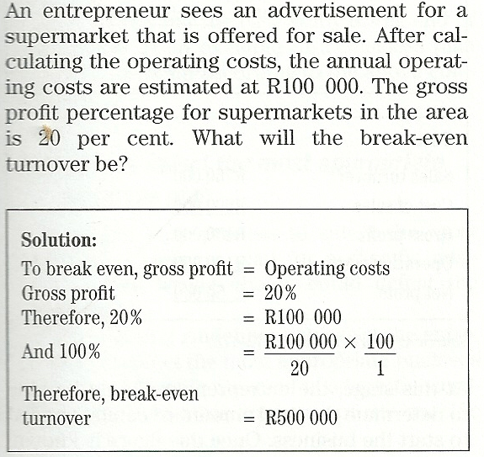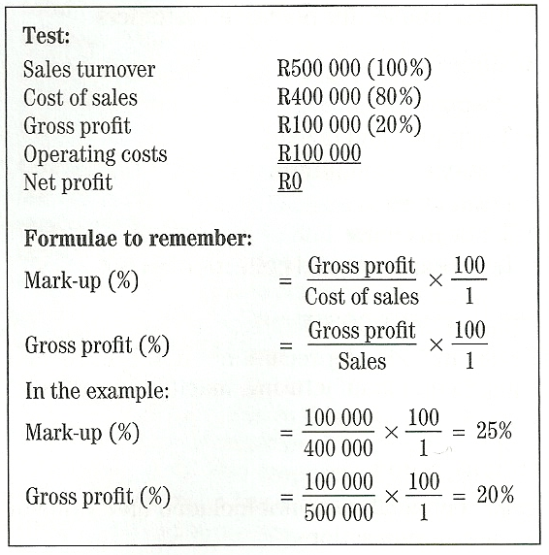

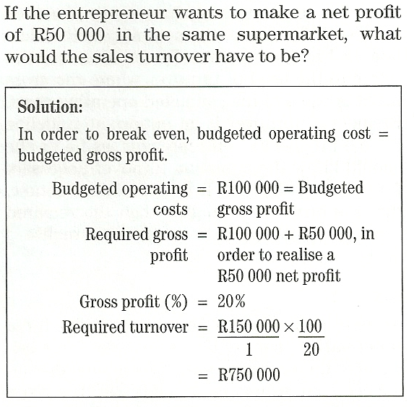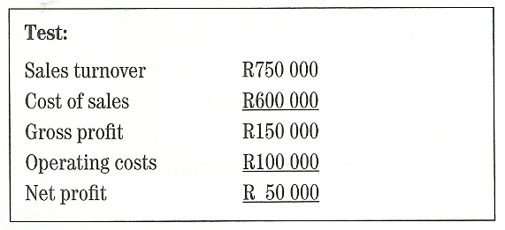

- A pro forma cash flow statement:

This should be done on a monthly basis for at least 2 years. It will imply that the turnover budget and the purchasing and operating cost budgets will also need to be projected on a monthly basis for 2 years.

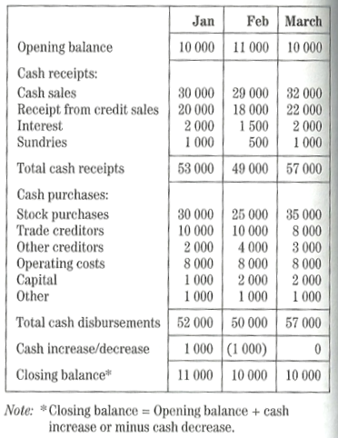

- A projected income statement:

Based on the results of the marketing research, a provisional projected income statement should be compiled as per the example below:

Projected Income Statement Calculation method

- Potential unit Sales
- Average price per unit
- Potential sales (turnover) (1) x (2) = turnover
- Unit costs (manufacturing)
- Cost of sales (1) x (4)
- Gross profit (3) - (5)
- Operating costs
- Net profit before tax (6) - (7)

- A projected balance sheet:

The projected balance sheet will include the following components:

ASSETS
Current assets
Cash
Inventory
Debtors – Account receivables
Provision from income tax

Fixed assets
Land, Property and buildings
Machinery and Equipment
Vehicles
Trademark
Goodwill
TOTAL ASSETS

LIABILITIES AND EQUITY
Current Liabilities
Creditors – Account payables
Income tax

Long-term liabilities
Bank loan
Vehicle finance

Equity
Mr. X
Dr. Y
Miss. Z
Retained earnings
TOTAL LIABILITIES AND EQUITY

- Details of possible risks and problems:

The development of a business entails risks and problems, and the business plan invariably contains implicit assumptions about these. Amongst others, the risks that require to be included in detail are:

- Potential price cutting by competitors
- Any unfavourable industry-wide trends
- Design or manufacturing costs in excess of estimates
- Sales projections not achieved
- Product development schedule not met
- Difficulties or long lead times encountered in the purchase of raw materials
- Difficulties in obtaining needed bank credit
- Larger than expected innovation and developmental costs

- An Appendix:

Include all essential pieces of evidence such as CV’s, product brochures, customer listings, testimonials and news articles.

How to select the most appropriate Business Plan

It is vital that the entrepreneur selects the most appropriate business plan for his business.
The following guidelines can assist the entrepreneur to select the most appropriate business plan in order to satisfy business requirements:

- Understand how the new or existing business is going to operate
- Understand the exact purpose of the specific business plan
- Study and understand different types of business plans

Types of Business Plans and their functions

Different situations may require different types of business plans as listed below:

- Planning a new business:
In this case the business plan layout as above would be used

- Transforming or expanding an existing business:
In this case the business plan layout will require specific emphasis on the following;

- Why transformation is taking place
- Why expansion is taking place
- What the profit and growth implications of the transformation or expansion could be
- What the cost of the transformation or expansion could be
- How the transformation or expansion will be financed; by means of loan capital and owners equity (capital)
- What the return on investment in the transformation or expansion would be, compared with previous business actions or alternative options
- Whether the business has the capacity (capital, labour, entrepreneurial acumen and management) to successfully implement the transformation or expansion.

- Creating a strategic document for an existing or new business:
In this case the business plan layout will require specific emphasis on the following;

- A vision and mission statement
- Clearly stated objectives for achieving the mission
- Competitive analysis
- Statement of competitive advantage
- Strategy for reaching objectives
- Action plan for implementing the strategy
- Controls to monitor performance
- Plan to implement corrective action, if necessary

- Obtaining a loan:
In this case the business plan layout should not differ from the business plan specifically designed for the strategic document above. However, with the conservative nature of financial institutions when evaluating loan application, specific points are required as follows;

- Evidence of the customers’ acceptance of the venture’s product or service (proof of scientific market research and ‘realistic’ findings and forecasts is needed)
- An appreciation of the policy of banks with regard to risk and collateral
- Evidence of focus and concentration on only a limited number of products and or services
- Realistic financial projections
- Realistic growth projections
- Avoidance of infatuation with the product or service, rather than familiarity with real marketplace needs
- Identification and consideration of potential risks
- Avoidance of exaggeration of own and management’s credentials and abilities

Requirements of financial institutions:

When applying for a loan, financial institutions will expect a business plan to include the following:

- Does the proposed business venture have a good chance to develop into a successful business?
- Will the product or service sell?
- How committed are the targeted customers?
- Was thorough market research conducted among a representative sample of the target market to whether there is a need for the product or service at a profitable price
- Does the business have a competent management team that works well together?
- Will the business make a large enough profit to be able to meet interest and capital repayments on the proposed loan on time?
- What security is available if things go wrong?
- Has provision been made in the cash flow forecast for loan repayments?
- What percentage of the start-up capital has the owner provided?
- How realistic are the forecasts presented in the business plan?
- Does the business plan address the perspective of creditors?

- Attracting shareholders or partners:

- Growth potential
- Profit potential
- Solid Management
- A comprehensive strategy for achieving its profit and growth projections
- Realistic projections based on solid market assessment research.

- Selling the business:

- Reasons for selling
- Position of the business relative to competitors
- Could any laws or regulations change the future of the business?
- What is the position with regard to the continuation of the lease if the property is rented?
- Can the business license be taken over or must a new one be obtained (for example a liquor license)
- How competent are the staff and should they be retained?
- What is the credit rating of the business?
- Is the business profitable?
- Has the business been growing over the past few years or months?
- What are the growth prospects of the business?
- What is the condition of the equipment and machinery?
- What is the current customer perception of the business?
- What are the reasons for asking the specific selling price and how can the price be justified?

- Providing direction for management and staff:

- Preparing the business for a merger:

Under the conditions of a merger it is suggested that the reasons for seeking a partner to merge with should not be included in the business plan. The reasons should be predetermined and logically listed prior to negotiating a merger and therefore form part of the negotiations and not part of the business plan.

The business plan should include the following:

- A clear explanation of what exactly the business is all about and what its major activities entail
- An independent evaluation of the business done by a professional valuator
- Audited financial statements of past performance
- A situational analysis (SWOT analysis)
- A competitive analysis
- An explanation of the competitive advantage(s)
- An explanation of the future plans for the business

- Preparing the business for a takeover:

- Helping to position the business in the market:

Problems in drawing up a Business Plan

The following problems are encountered when drafting a business plan:

- Lack of proven market demand
- Lack of objectivity
- Ignoring competition
- Inappropriate market research
- Inability to produce according to quantity and quality required
- Underestimating financial requirements
- Insufficient proof that loan repayments will be made timeously

TOPIC 2

STUDY UNIT 6
Chapter 6: RESOURCE REQUIREMENTS AND LEGAL AND RELATED ASPECTS (Pg 125 – TB)

RESOURCE REQUIREMENTS FOR A NEW BUSINESS

There are 4 types of resources that entrepreneurs will combine to build a business, these are; Financial, Human, Physical and Information.

Financial Resources

Financial resources may take the form of (1) cash or cash equivalents which can be quickly and easily converted into cash, or (2) can be used to buy other resources. Finance can be obtained from various sources such as:

- Equity financing: Money invested by the entrepreneur is known as Equity financing. The Entrepreneur may:

- Use own personal finances and put it into the business, or
- Take in a partner, or
- Sell shares to investors, these shareholders become owners (which does not require paying back the investment)

- Debt financing: Money loaned to the business by outsiders, such as individuals, banks or other lending institutions is known as Debt financing.

- The contract is a legally binding agreement stipulating that the borrower will pay interest on such loans
- The loan needs to be paid back within a reasonable period of time as stipulated in the loan contract
- Loan providers (lenders) do not become owners as in the case with Equity financing

- Other sources of finance:

- Government support programmes: such as Kula Enterprise Finance Ltd, and the National Empowerment Corporation
- Venture capital funds: such as Community Projects Funds
- Companies: such as Business Partners, the Industrial Development Corporation of RSA (known as the IDC)
- Mortgages: for financing business property
- Long-term investments in operating assets: such as machinery
- Leasing: such as machinery, equipment and vehicle leasing.

Human Resources

Human resources refer to all the people who through their efforts, skills, knowledge and insight contribute to the success of the business. Human resources consist of four groups:

- Top management
- Middle management and Professional staff
- Supervisory management
- Non – Managerial workers
A prospective entrepreneur is mainly concerned with the challenges of:

- Accurately forecasting human resource needs, and
- Recruiting candidates and selecting the best person for the job.

Once the business is running, the entrepreneur will need to focus his attention to the training and development of employees and encouraging high performance efforts.

The following steps can be taken by the entrepreneur to accurately forecast, recruit, select and appoint employees:

- List all the tasks that must be performed in the business
- Group tasks logically to form a job description to give you an indication of the number of people you need to employ
- Determine what qualifications and skills the person must have to perform the tasks (job specification)
- Recruit people who are willing to do the tasks in the job description and who meet the job specifications by:

- Advertising the positions
- Using recruitment agencies
- Approach training organizations such as schools, technical colleges or tertiary institutions

- Interview candidates
- Appoint the best person for the job and conclude a contract with the person

Physical Resources

Physical resources include:

- Fixed assets such as buildings and equipment
- Raw materials that will be used to create the products
- General supplies used in the operation of the business

Planning is important in acquiring these resources, especially physical resources. A large amount of capital is required to acquire fixed assets, such as building facilities, production equipment and vehicles. Before buying a building, the entrepreneur must decide where he wants to locate the business. Factors to consider when deciding on a suitable location;

- Access to the market
- Availability of raw materials
- Availability of labour and skills
- Infrastructure such as transport and water supply
- Climate

Information Resources

The technology or ‘Information Age’ necessitates a fourth resource namely information. The Information is just as important as the other three and is needed so that the entrepreneur can make informed management decisions.

The entrepreneur needs two categories of information:

- Information about the external business environment

  - International concerns
  - Economic
  - Social
  - Legal concerns
  - Competitors
  - Consumers / Customers

- Information about the internal business environment

- Marketing information
- Human resources information
- Quality control
- Manufacturing
- Financial information

Sources of Information

- Internet
- Government departments such as SARS, SABS, Stats SA, and the Deptartment of Trade and Industry
- Chambers of commerce
- Trade associations
- Financial institutions
- Science councils
- Educational institutions
- Independent organizations
- Professional societies
- Venture capital fund organisations

LEGAL REQUIOREMENTS FOR ESTABLISHING A BUSINESS

FORMS OF OWNERSHIP

To understand the different forms of ownership, the following concepts must be understood:

- Legal personality: indicates whether or not the owner and the business are separate legal entities. If the business has legal personality, the owner and the business are two separate entities

- Liability: indicates whether the owners of a business will be held personally liable for the business’ debts. When liability is unlimited, owners’ personal assets may be sold to cover the business’ debts. With limited liability the owners are not held liable for the debts of the business

- Continuity: refers to the lifespan of the business

Forms of Ownership – A business can be identified as one of 4 main types:
CRITERIA | SOLE PROPRIETORSHIP | PARTNERSHIP | CLOSE CORPORATION | PRIVATE COMPANY
MEMBERS | 1 | 2 BUT NOT MORE THAN 20 | 1 BUT NOT MORE THAN 10 | MUST HAVE AT LEAST 1 DIRECTOR. MEMBERS (SHAREHOLDERS) 1 TO 50.
(1) LEGAL PERSONALITY  (2) LIABILITY | (1) NO  (2) UNLIMITED LIABILITY – THE SOLE PROPRIETOR IS LIABLE FOR ALL RISKS, AND DEBTS OF THE ENTERPRISE IN HIS PERSONAL CAPACITY | (1) NO.  (2) JOINTLY AND SEVERLY LIABILITY – THE PARTNERS ARE JOINTLY AND SEVERALLY LIABLE FOR ALL RISKS, AND DEBTS OF THE ENTERPRISE IN THEIR PERSONAL CAPACITIES. | (1) YES.  (2) LIMITED LIABILITY – A CLOSE CORPORATION IS A LEGAL PERSON, SEPARATE FROM ITS MEMBERS. THE MEMBERS ARE NOT PERSONALLY LIABLE FOR THE DEBTS OF THE ENTERPRISE, UNLESS MEMBERS ARE FOUND GUILTY OF RECKLESS MANAGEMENT, FRAUD, GROSS NEGLIGENCE OR ABUSE OF JUSRITIC PERSONS. | (1) YES.  (2) LIMITED LIABILITY – A COMPANY IS A LEGAL PERSON, SEPARATE FROM ITS SHAREHOLDERS AND DIRECTORS. SHAREHOLDERS ARE NOT PERSONALLY LIABLE FOR THE DEBTS OF THE ENTERPRISE, UNLESS CONTROLLING SHAREHOLDERS OR DIRECTORS HAVE CONDUCTED BUSINESS RECKLESSLY, OR MADE ABUSE OF JUSRITIC PERSONS.
LEGAL NAME | NONE | NONE | MUST END IN CC TO INDICATE A CLOSE CORPORATION. | MUST END IN (PTY) LTD. PROPRIETORY LIMITED
LIFESPAN / CONTINUITY | LIMITED TO THE LIFE OF THE OWNER | LIMITED TO THE LIFE OF THE PARTNERSHIP. THE DEATH OR WITHDRAWAL OF A PARTNER AUTOMATICALLY DISSOLVES THE PARTNERSHIP, UNLESS OVERCOME BY AGREEMENT. | UNLIMITED TO THE LIFE OF THE MEMBERS. | UNLIMITED LIFESPAN.
EASE OF FORMATION | SIMPLE TO CREATE A SOLE PROPRIETORSHIP | EASY TO FORM A PARTNERSHIP | RELATIVE EASE OF FORMATION. | HIGH DEGREE OF LEGAL REGULATION MAKING FORMATION COMPLICATED
CAPITAL ACQUISITION CAPACITY | LIMITED ACCESS TO CAPITAL. LOANS BASED ON PERSONAL CREDITWORTHINESS. | ABILITY TO ACCESS CAPITAL. MORE PEOPLE CONTRIBUTE SECURITY TO LOANS BASED ON PERSONAL CREDITWORTHINESS. | BETTER ABILITY TO ACCESS CAPITAL. MEMBERS CONTRIBUTE TOWARDS THE ENTERPRISE, LOAN CAPITAL EASIER TO OBTAIN. | GOOD ABILITY TO ACCESS CAPITAL LOAN CAPITAL EASIER TO COME BY DUE TO LEGAL REGULATION OF COMPANIES AND DISCLOSURE. THE PUBLIC CAN NOT SUBSCRIBE TO SHARES, BUT CAN BE INVITED TO BUY SHARES IN THE COMPANY BY MEANS OF A PROSPECTUS.
OWNERSHIP AND CONTROL | THE OWNER TAKES COMPLETE CONTROL OF THE ENTERPRISE AS HE IS THE SOLE OWNER. | PARTNERS HAVE JOINT CONTROL AND AUTHORITY OVER THE ENTERPRISE. CONTROL AND AUTHORITY CAN BE ADJUSTED. | MEMBERS HAVE JOINT CONTROL AND AUTHORITY OVER THE ENTERPRISE. ASSOSSIATION AGREEMENT CAN DEFINE ASPECTS OF MANAGEMENT AND AUTHORITY. | THE ARTICLES OF ASSOSSIATION AGREEMENT CAN DEFINE ASPECTS OF MANAGEMENT AND AUTHORITY.
FUNCTION | UNLIMITED. AT THE SOLE DISCRETION OF THE OWNER | UNLIMITED. AT THE SOLE DISCRETION OF THE PARTNERS | UNLIMITED. AT THE SOLE DISCRETION OF THE MEMBERS. | LIMITED. A COMPANY HAS TO FULFILL ITS PURPOSE AS PER ITS MEMORANDUM OF ASSOSSIATION.
CRITERIA | SOLE PROPRIETORSHIP | PARTNERSHIP | CLOSE CORPORATION | PRIVATE COMPANY
COST OF FORMATION | IN LEGAL TERMS, COSTS ARE VERY LOW. IN TERMS OF CAPITAL FORMATION IT WOULD DEPEND ON THE NATURE OF THE ENTERPRISE. | IN LEGAL TERMS, COSTS ARE FAIRLY LOW. IN TERMS OF CAPITAL FORMATION IT WOULD DEPEND ON THE AMOUNT OF PARTNERS AND NATURE OF THE ENTERPRISE. | IN LEGAL TERMS, COSTS ARE MODERATELY LOW. IN TERMS OF CAPITAL FORMATION IT WOULD DEPEND ON THE AMOUNT OF PARTNERS AND NATURE OF THE ENTERPRISE. | FAIRLY EXPENSIVE DUE TO LEGAL REQUIREMENTS, AND SIZE OF THE ENTERPRISE WHEN CONSIDERING START UP CAPITAL
TAXATION | THE PROFITS / LOSSES OF THE ENTERPRISE ARE COMBINED WITH THE OWNERS OVERALL TAXABLE INCOME. | THE PROFITS / LOSSES OF THE ENTERPRISE ARE COMBINED AND DISTRIBUTED IN ACCORDANCE TO EACH PARTNERS CONTRIBUTION. EACH PARTNER IS THEN TAXED INDIVIDUALLY. | AS A LEGAL PERSON THE ENTERPRISE IS A TAX PAYER, AND SO TAXED SEPRATELY FROM ITS MEMBERS. THE ENTERPRISE IS TAXED AT THE FIXED RATE. TOTAL INCOME TAX PAYABLE DEPENDS ON THE AMOUNT OF FUNDS RETAINED IN THE COMPANY, AND THE AMOUNT PAID OUT TO MEMBERS FRO PROFITS GENERATED. | AS A LEGAL PERSON THE ENTERPRISE IS A TAX PAYER, AND SO TAXED SEPRATELY FROM ITS MEMBERS. THE ENTERPRISE IS TAXED AT THE FIXED RATE.
TRANSFER OF OWNERSHIP | UNLIMITED. THE SOLE PROPRIETOR CAN AT ANY MOMENT, SELL, CLOSE DOWN OR TRANSFER THE BUSINESS AND ITS ASSETS TO SOMEONE ELSE. | LIMITED. MORE COMPLEX, BUT A PARTNER CAN BE BOUGHT OUT BY SELLING HIS INTEREST TO THE REMAINING PARTNERS ONLY. | LIMITED. TRANSFERS OR ACQUISITIONS OF MEMBERS INTERESTS MUST BE IN ACCORDANCE WITH THE ASSOSSICATION AGREEMENT. A MEMBER CAN TRANSFER HIS INTEREST IN THE ENTERPRISE TO THE REMAINING MEMBERS BY SELLING HIS INTEREST TO THE ENTERPRISE (THE ENTERPRISE CAN BUY THIS INTEREST IF IT MEETS THE CRITERIA OF THE SOLVENCY AND LIQUIDITY), OR TO A NEW MEMBER WHO WILL THEN BECOME A MEMBER. | LIMITED. THE METHOD OF TRANSFERRING SHARES IN THE PRIVATE COMPANY IS LAID DOWN IN THE ARTICLES OF ASSOSSIATION. TRANSFER IS THEREFORE SUBJECT TO APPROVAL BY THE BOARD OF DIRECTORS.
LEGAL RESTRICTIONS | NO SPECIAL LEGAL RESTRICTIONS | MINIMAL LEGAL FORMALITIES AND REGULATION | FAIR AMOUNT OF LEGAL FORMALITIES AND REGULATION | SUBJECT TO VARIOUS LEGAL RESTRICTRICTIONS AND REGULATIONS, BUT THESE ARE LESS THAN IN A PUBLIC COMPANY. REGULATIONS INCLUDE THE TRANSPARENCY OF FINANCIAL REPORTS, AUDITING, ANNUAL RETURNS, MINUTES, REGISTER OF SHAREHOLDERS ETC…
SKILLS DIVERSITY | LIMITED AS ONLY ONE PERSON WILL CONTRIBUTE TO THE SKILLS BROUGHT TO THE ENTERPRISE, UNLESS SKILLS ARE DEVELOPED, OR ACQUIRED AT A COST | IN A PARTNERSHIP, EACH PARTNER WILL CONTRIBUTE SKILLS, KNOWLEDGE AND EXPERIENCE IN THE ENTERPRISE | IN A CLOSE CORPORATION, EACH MEMBER WILL CONTRIBUTE SKILLS, KNOWLEDGE AND EXPERIENCE IN THE ENTERPRISE | UNLIMITED

CIPRO (The Companies and Intellectual Property Registration Office)

CIPRO is a sub-directorate of the Department of Trade and Industry, and is responsible for matters relating to the registration of new businesses (close corporations and companies)

Close Corporations

For the incorporation of a close corporation, the following documents have to be lodged with the Registrar of Close Corporations at CIPRO:

- CK7 – Reservation for the business’s name for a period of 2 months, which can be extended by another month by completing a CK9 document
- CK1 – (in duplicate) – founding statement. All members must sign the founding statement. The business can be started once a Registered Founding Statement has been received.
- Letter by an Accounting officer – Consent of the person named as the accounting officer of the Close Corporation to act as such. The accounting Officer must be registered with certain authorities as required by CIPRO.

Private Companies

All South African companies are governed by the Companies Act, which is administered by the Department of Trade and Industry (DTI).

The incorporation of a company entails the following main steps:

- Reserving a company name
- Filing the memorandum and articles
- Filing the written consent of auditors to act for the company

A company name must be reserved with, and approved by, the Registrar of Companies at CIPRO. The memorandum and articles must also be filed with the Registrar of Companies at CIPRO.

The memorandum must indicate amongst other things;

- The name of the company
- The company’s main object, although there may be any number of objects
- The amount of authorised share capital – there is no minimum capital requirement

Registering a Company is a much more complex process compare to a Close Corporation. The following documents are must be completed and lodged when registering a private company

- CK5 – (in duplicate) – Application for reservation of the name, which can be extended by completing a CM7 document
- Power of attorney – Authorisation to act on behalf of promoters
- CM22 – (in duplicate) – Notification of situation of registered and postal address
- CM29 – Return containing particulars of directors
- CM1 – Certificate of incorporation
- CM46 – Application for a certificate to commence business
- CM47 – (by each director) – Statement by directors regarding adequacy of share capital
- CM31 – (in duplicate) – Consent to act as auditor
- CM44B, 44C, - Articles of Association

INTELLECTUAL PROPERTY RIGHTS

Intellectual property refers to all creations or products of the human mind that can be used for commercial gain.
Intellectual property can be legally protected by the Companies and Intellectual Property Registration Office (CIPRO) who registers intellectual property. Intellectual property can be protected by means of copyright, the registering of a patent, a trademark or a design.

CRITERIA | COPYRIGHT | DESIGNS | PATENTS | TRADEMARKS
Works that qualify | Literary works, films, musicals, art, sound recordings, broadcasts, etc | Aesthetic (eg shape) and functional (eg configuration) features of design | Inventions (eg a product, process or device applicable to trade, industry or agricultural improvements) | Any work, phrase, symbol, sound, smell, colour, etc.
Can it be transferred? | Yes, but it has to be in writing | Protection in RSA only. An application has to be filed if one requires protection outside RSA | Protection in RSA only. The patent protects the inventor who can assign someone else to be protected | Yes, the owner may allow a licensee to use the mark
Registration | Automatic, but registration with CIPRO has added benefits | Essential if it is a new design. Necessary to register with Registrar of Designs | Apply and pay the registration fees in revenue stamps | Trademarks can be used without registration, but registered trademarks have added benefits
Duration of protection | Lifetime of the author/creator and for another 50 years after death of the author/creator | 15 years – aesthetic  10 years – functional | Provisional patent is valid for one year and must be followed with a completed patent that covers the inventor for 20 years | 10 years
Notice to public | Necessary to put one’s name, date and copyright statement on original copy and warning notice © | Registered designs should be indicated as “registered design” with the registration number | Inventions should be marked with “Patent applied for” or “Patent” with the relevant patent number | If a trademark is registered, it is indicated as “Registered trademark” and the ®

OTHER LEGAL REQUIREMENTS

TAXATION

Most taxes in South Africa are levied by the central government and administered by the South African Revenue Services (SARS). The Constitution gives some taxing powers to the Provinces such as ‘Assessment Rates’ and ‘Taxes’ in respect of immovable property.

The South African government imposes two main types of taxes, namely Direct and Indirect taxes:

- Direct taxes

- Individual income tax – annual tax on the income of individuals (also of sole proprietorships) and partnerships.
- Company tax – annual tax on income of companies and close corporations
- Secondary tax on companies – tax imposed on dividends declared by companies and distributions made by close corporation, payable and borne by the companies and close corporations
- Tax on dividends from foreign registered or incorporated companies – including retirement funds and insurers

- Indirect taxes

- Value-added tax – an invoice-based value-added tax levied on supplies of goods and services
- Excise and customs duties – duties on the local production of certain commodities, such as cars, jewellery, beer and wine without regard to their sale. Certain goods and services are exempt from exercise duties such as clothing, basic foods, medicine, certain utilities and professional services
- Stamp duties - charges levied on a number of documents in RSA. The tax is imposed on the document itself, not the transaction

RECEIVER OF REVENUE

The South African Revenue Services (SARS), ensures that tax laws are complied with and collects from each taxpayer the correct amount of tax due.

Owners of sole proprietorships and partnerships do not have separate legal personalities and must therefore include the income from the business in their own gross income. They are responsible for the payment of taxes in their individual capacity.

Private companies and close corporations must register as tax payers in their own right. Unlike natural persons, a company or close corporation pays tax at a flat rate of 29% on its taxable income for the year of assessment. Private companies and close corporations have to appoint an auditor to audit its financial statements (company) or accounting officer (cc). Currently net income after income tax can be declared as a dividend but then a further 10% is taxed on the dividend amounting to a maximum effective tax rate of 36.89%. Secondary tax on companies will be phased out and replaced with dividend tax.

Special rates of taxes were introduced for small business corporations in 2000. A small business corporation is defined in the Income Tax Act as follows:

- A CC or private company which is not an employment company (a labour broker not holding an exemption certificate, or a personal service company)
- Employment companies with at least 4 full-time employees for core operations
- The entire shareholding or membership is held by natural persons
- The annual turnover does not exceed R14mil
- Of which none of the shareholders or members, at any time during the year of assessment, holds shares in any other company (other than listed companies)
- Of which not more than 20% of the gross income consists collectively of investment income and the rendering of personal services by the members of shareholders (personal service been defined as any service in the determined fields)

PAYE AND SITE

It is the responsibility of the employer to register with the local Receiver of Revenue as soon as people are employed. To register as an employer an EMP101 form must be completed. Pay as you earn and Standard Income Tax on Employees are deducted from employees’ remuneration by employers and paid over to Receiver of Revenue on a monthly basis and within 7 days after the month end. Late payments will be subject to a penalty of 10% and interest will be charged at the prescribed rate. The employer needs to complete an IRP 1 form to register with Receiver of Revenue.

During the tax year of assessment, the SITE tax is the portion of tax which is withheld for the final tax determination up until a maximum of R60,000. Only SITE is payable up to the first R60,000 of the total employee remuneration, and such an employee will not pay PAYE. If the net remuneration exceeds R60,000 for the tax year, the employee’s tax will comprise of both SITE and PAYE.

When completing their annual income tax returns, employees will require proof that tax was in fact deducted from their salaries and wages.

Employees must be given an IRP5 certificate as proof that tax was deducted from their salaries and wages according to the specified codes as well as SITE and PAYE that were withheld during the tax period.

PROVISIONAL TAX

Any person who falls within the definition of a provisional tax payer is required to register as a provisional tax payer within 30 days of the date on which the person becomes a provisional tax payer.

A provisional tax payer is defined as:

- Any person who derives income that is not remuneration
- Any director of a private company, if such director or such company is a resident
- Any member of a close corporation who is a resident
- Any close corporation or private company
- Any person notified by the Commissioner that he is a provisional tax payer.

Provisional tax payers are required to make two compulsory tax payments during the year and a third voluntary payment referred to as the topping payment. The first provisional tax payment is payable within the first six months of the year, and the second is payable by no later than the end of the year.

VALUE-ADDED TAX (VAT)

VAT is tax applied at each point where value is added to goods or services from primary production to final consumption. When a vendor is supplied with goods or services by another vendor, VAT will be levied by the supplier of those goods and services. This VAT is referred to as the INPUT TAX of the vendor who receives the goods or services. When that vendor in turn supplies goods or services to other persons or vendors, VAT must once again be included in the price charged for those goods or services. This is referred to as the OUTPUT tax of the vendor who supplied the goods or services.

If a business’s generates, or has reason to believe it will turnover (value of taxable supplies/sales) in excess of R300,000 with a 12 month period, then the business must be registered as a vendor. Failure to register will result in liability for VAT even if you have not charged your customers VAT. Interest and penalties will also be imposed and you may be prosecuted.

Application for registration must be completed on the VAT101 form ‘Application for Registration’ which is obtainable from your local Receiver of Revenue.
REGISTRATION WITH THE DEPARTMENT OF LABOUR

An employer who employs people (labour) must register as an employer with the Department of Labour and contribute towards the Unemployment Insurance and Compensation Funds.

UNEMPLOYMENT INSURANCE FUND

The purpose of the Unemployment Insurance Fund is to establish an insurance fund against which employees (or their dependants) on becoming unemployed, can draw unemployment benefits. The UIF provides benefits to unemployed people and to dependents of deceased contributors at rate of 45% of their previous earnings, taken that certain criteria must be met. UIF is deducted at rate of 2% to 1% of the salary contributed by employee and 1% by employer. Employees who qualify to claim UIF benefits must apply and register for a blue UIF card.

COMPENSATION FUND

The compensation fund for Occupational Injuries and Diseases Act provide for compensation for disablement caused by occupational injuries or diseases sustained or contracted by employees in the course of their employment, or for death resulting from such injuries or diseases, and to provide for matters connected therewith.

The Act provides for a system of no-fault compensation for employees. Employees may not institute a simultaneous claim for damages against the employer or any other person for the damage suffered. All employers who employ one or more employees are required to register and to make annual payments to the Compensation Fund. In the event of a claim, the claim must be reported and claimed for within 14 days after accident.

TRADING LICENCES

Local authorities such as local municipalities, issue trading licenses to business who carries out the following activities:

- Sale or supply of meals or perishable food-stuffs
- Provision of certain types of health facilities or entertainment
- Hawking in meals or perishable foodstuffs

To obtain a trading license an entrepreneur must complete and submit a L1 form together with a once-off fee to the local municipality’s licensing department.

REGIONAL SERVICES LEVIES

Regional Services levies was replaced by alternative tax instruments of funding arrangements to ensure the continued independence and financial viability of municipalities. A business person who has started a business within a region must register with the council of that region within 30 days.
Two types of levies payable to the regional business council:

- Service levy: % of net remuneration of all employees
- Establishment levy: % of turnover of the business

LEGAL ASPECTS IN THE NORMAL COURSE OF BUSINESS

CONCLUDING CONTRACTS

A small business owner may have to conclude several contracts throughout the starting and running of a business, for example to acquire business premises, to arrange for finance from a bank or to repay loans for assets bought.

In the process of concluding an agreement or an arrangement a small business person must do the following:

- Check the small print which contains the many stipulations and terms of an agreement
- Make sure that the other contracting party is indeed the contracting party and not a front company or a representative of the real company
- Make sure the arrangement contains all the pages and that it is completed in full before signing it. This will ensure that changes are not made after it has been signed
- Always request a copy of the signed agreement and keep it in a safe place
- Get legal advice if the arrangement is difficult or contains many Latin or incomprehensible terms

LICENSING

Licensing is a contractual agreement in which on partner makes intangible assets such as technology, skills and knowledge available to another partner in exchange for some remuneration such as royalties. The licensor usually has little or no control over the licensee beyond the agreement.

A patent license agreement specifies how the licensee would have access to the patent, For example a franchising agreement (licensing of trademark) and copyright (right to use name, books, photographs etc)

LABOUR LEGISLATION (Pg 144 – TB)

Employment in SA is regulated by the following acts:

- Labour Relations Act (LRA): deals with procedures for termination of employment and grants employees remedies against unfair dismissal.

The Act recognises collective bargaining as the most acceptable means of resolving disputes of mutual interest.

The Act recognises that strikes and lockouts are an intrinsic part of the process of collective bargaining.

- Basic Conditions of Employment Act (BCEA): Implements and enforces basic conditions of employment related to periods of annual leave and sick leave, additional pay for overtime, daily and weekly maximum working hours as well as termination of employment, child labour and forced labour.

- Skills Development and Skills Development Levies Act: The Skills Development Act is aimed at improving the working skills of South African workers to the benefit of the economy as a whole. The Skills Development Levies Act lays down regulations stating how the skills development strategy will be funded.

- Occupational Health and Safety Act: administered by the Chief Directorate of Occupational Health and Safety of the Department of Labour. The main purpose of the Act is the protection of the health and safety of workers as well as persons other than workers, from hazards arising from activities at a workplace.

- Employment Equity Act: eliminate unfair discrimination by providing for equal opportunities and fair treatment in employment and provides for affirmative action for historically disadvantaged people by private business in appointments and promotions.

- Black Economic Empowerment: or BEE, is defined as a strategy aimed at substantially increasing black participation at all levels in the economy. The strategy attempts to redress the imbalances of the past by transferring more ownership, management and control of South Africa’s financial and economic resources to the majority of its citizens.

Business types promoted by the BEE strategy are:

- A Black Company (50.1% black owned)
- A Black empowered company (25.1% black representation with management control)
- A black woman-owned enterprise (25.1% black women management representation)
- A community or broad-based enterprise (An enterprise with an empowerment shareholder who represents a base of members)

PRODUCT LIABILITY

Product liability is the liability of any party along the manufacturing chain of any product for damage caused by the product. This includes the manufacturer of components (at the top of the chain), an assembling manufacturer, the wholesaler and the retail store owner (at the bottom of the chain).

Products containing inherent defects that cause harm to the consumer of the product are subject to product liability suits, based either on;

- a breach of warranty (express or tacit) that the product will be suitable for its purpose, or
- on the warranty (tacit) of a seller against latent or hidden defects in the product.

STANDARDS

SABS is government agency appointed to carry out regulatory functions of the Department of Trade and Industry. SABS sets compulsory specifications which are legal measures and requirements for ensuring that products locally manufactured or imported meet the minimum requirements for health and safety.
FAIR TRADE, COMPETITION AND CONSUMER PROTECTION (Pg 148 – TB)

The competition Commission is an independent organization that functions in terms of the Competition act and investigates anti-competitive conduct, assessing the impact of mergers and acquisitions on competition, monitoring competition levels and market transparency

ENVIRONMENTAL LEGISLATION

Environmental legislation is receiving increasing attention in South Africa, with severe penalties under discussion in a proposed Environmental Bill for those found guilty of damaging the environment. The main environmental issues include the Atmospheric Pollution Prevention Act, the National Health Act and the Water Act.

PROMOTION OF ACCESS TO INFORMATION ACT (Act 2 of 2000)

The Promotion of Access to Information Act gives effect to Section 32 of the Constitution which gives effect to the constitutional right of access to any information held by the State and any information that is held by another person which may be required to exercise or protection of any rights. The Act expressly provides exception to information that must not be released. The purpose is to foster a culture of transparency and accountability in public and private sectors.

USURY ACT (Act 73 of 1968)

The Usury Act; aims to protect the interests of persons entering into leasing, credit and money-lending transactions from exploitation with regard to repayment schedules and finance charges. The most notable regulations of the Act are the maximum finance charges and amount recoverable as well as disclosure of information with regard to the transaction to the borrower or debtor.

TOPIC 2

STUDY UNIT 7
Chapter 7: GETTING STARTED (Pg 155 – TB)

COUNTDOWN TO START-UP AND GRADUAL START-UP

The process of starting up is based on the fundamentals of management: Planning, Organising, Leading and Control

- Planning: Most of the planning was done when the business plan was drafted. The business plan must now be converted into a number of action plans with time frames and resources required to execute these plans eg. Budget and business strategies

- Organizing: involves the gathering of resources, meeting of legal requirements, development of policies and procedures (in terms of employment, ethics and quality assurance), organizing the labour force

- Leading: required as soon as staff has been appointed. Motivate, coordinate and control staff. Delegate as soon as the business starts to grow. Structure the different functions in the company.

- Control: Involves record keeping, risk management, quality, ethics and internal control systems

LOCATING THE BUSINESS

Location is not a once off decision. An entrepreneur must occasionally consider relocating the business to reduce costs, get closer to the customers or gain other advantages. As a business grows it sometimes become necessary to expand in another location.

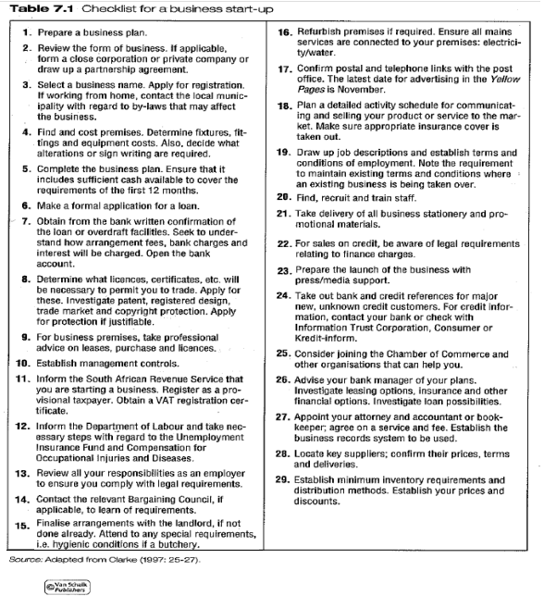

Key attributes of a good business location...

Factors to consider in choosing a physical location:

- Access to the target market (e.g. Convenience store close to residential area)
- Availability of raw materials (transport cost will determine whether the business should be close to the source of raw material)
- Support and technical infrastructure
- Transport infrastructure
- Availability of labour and skills
- Climatic conditions (certain products can only be produced in a specific climate)
- Political and social stability

Home-based businesses

- Appropriate to a business where space requirements are modest
- Physical work and Home space should be divided so as not to interfere with each other
- Keep to office hours
- Must be accessible to clients
- Make sure of the zoning ordinances with the local authorities, as this may prevent the business to operate from a residence.
- Space restriction in phases of rapid growth may have a negative impact on the business

Residential area-based businesses

- Businesses situated along the main roads through cities and suburbs, and residential homes converted into office space and parking
- Used by service industries, professional services and medical practitioners

Shopping centres

Businesses dealing in fast-moving consumer goods (FMCG) generally need to find shopping or suburban retail centres in which to open a shop.

- Factors to be considered when selecting a shopping centre:
- Feet count – number of consumers visiting the centre on a weekly and monthly basis
- Parking – consumers want cheap, easy and accessible parking
- Maintenance – regular cleaning and maintenance of a centre is important to keep up the image
- Conditions of lease agreement – most critical factor. Keep in mind trading hours, sale of business, shop fittings, escalation in rent etc.
- Security – access to the centre, as well as the presence of security guards
- Attitude of centre management – property management firms make it a happy experience or not.
- Location within the centre – not all areas are prime shops. Best is close to national chain stores

RISK MANAGEMENT

Risk is the chance that a situation may end with loss or misfortune. Risk involves uncertainty of an outcome.

Controllable risk such as fires may not be preventable, but the financial loss can be minimized by purchasing insurance.
Uncontrollable risks have a huge financial impact on the business but cannot be covered by insurance e.g. new competition, recession and changes in consumer tastes.

Types of risk

- Business risk – arises from the macro, market and micro environment, such as price changes, technological changes, change in consumer preferences and new competition

- Financial risk – result from financial structure of the business e.g. Profitability, liquidity and debt levels. Management must evaluate these on regular intervals and take corrective action if necessary

- Personal risk – include personal financial losses should the business fail

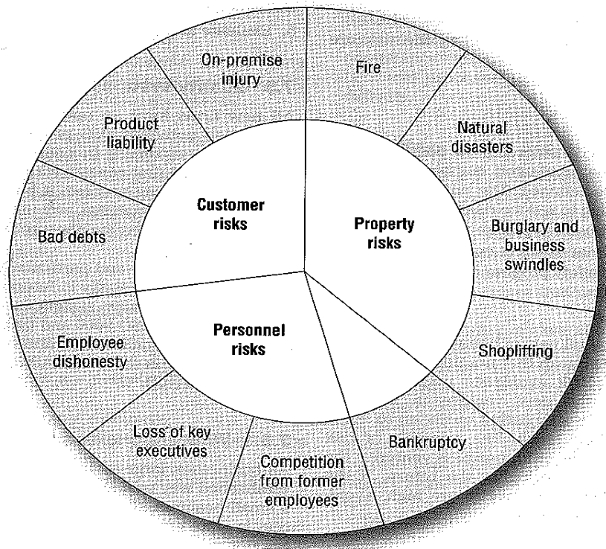

Management of risk

- Retention - bear or accept risk if the following situations are prevalent:
- No practical means of avoidance
- Risk is unknown
- Consequences are not serious
- Consequences of avoiding the risk are unacceptable
- Risk is actively desired

- Reduction - reduce the impact of the risk by:
- Revised the business plan regularly
- Implement management control systems
- Implement safety programmes

- Avoidance – avoid starting the business if chances of loss are high

- Transfer - transfer the risk to another party through underwriting and insurance

QUALITY SYSTEMS AND MANAGEMENT

What are quality management systems?

Quality system standards indentify those features that can help a business to consistently meet its customers’ requirements. Quality involves the features of a product or service that will meet the expectations of the customer and satisfy their needs whilst achieving various regulatory and statutory requirements such as safety, e.g. Décor, cleanliness, facilities and friendliness influence the perception of a hotel’s quality.

Why should a business have a quality management system?

- Improvement of performance and productivity
- Focus on business objectives and customer expectations
- Maintenance of quality so as to meet the customers’ needs
- Management confidence that quality is being maintained
- Evidence to customers of the organisation’s capabilities
- Opening of new market opportunities
- Needed for certification and registration
- Ability to compete on the same basis as larger organizations eg. To tender or submit price quotations

Principals involved in putting a quality system in place

- Ensure that the quality system provides value in terms of money spent and effort put into developing and implementing the system. The system should improve marketability and internal efficiency of the business

- To ensure standardisation of service a system must include specific tasks and monitoring systems
- Apply philosophy of total quality management to system as well as people who have to support the process

- Ensure that tasks are well planned and that responsibilities are assigned to ensure compliance with quality standards.

ETHICS (Pg 163 – TB)

Ethics is a set of principles or a behavioural code that explains what is good and right, bad and wrong. A business has a code of conduct which is a statement of ethical practices to which the business adheres.

What unethical behaviour do small businesses face?

- Unethical behaviour includes:
- Skimming or concealing income to avoid taxes
- Deception of consumers through advertisements or claims
- Inaccurate reporting of financial information

The entrepreneur must display ethical behaviour to develop an organisational culture that supports ethical performance

RECORD KEEPING AND INTERNAL CONTROL

Entrepreneurs need accurate, meaningful and timely information in order to manage their business and to make good, informed decisions

- An accounting system should accomplish the following objectives:
- Maintain source documents and provide an audit trail
- Provide and accurate, thorough picture of operating results
- Permit a quick overview of present and past operating results
- Facilitate prompt filing of reports and tax returns to all government agencies
- Offer financial statements for use by management and other stakeholders

Record-keeping and accounting can be outsourced. Internal control systems need to be put in place to safeguard a firm’s assets and to enhance the accuracy and reliability of the financial statements. The absence of internal control systems increases the chances of fraud and theft

TOPIC 2

STUDY UNIT 8
Chapter 8: FINANCING AN ENTREPRENEURIAL VENTURE (Pg 171 – TB)

FINANCING AN ENTREPRENEURIAL VENTURE

DETERMINING THE FINANCIAL REQUIREMENTS OF THE BUSINESS VENTURE

A successful business cannot be established or managed without setting realistic goals and planning towards these. A business plan is generally used for this purpose. Amongst other things, the financial requirements of the business must be set out in this plan. A business plan helps to reduce uncertainty, but it cannot accurately forecast the future.

A business plan is not just a financial plan, but also a comprehensive analysis of your business, your market, your products and what finance will be required.

The financial plan forms an important part of the business plan, and is referred to as ‘budgeting’. New firms need money to hire staff, buy or rent office space and equipment, as well as training, research, marketing and the launch of the new product. Budgeting is simply a financial forecast of these future events.

Funding for a new business should cover the asset requirements as well as the personal living expenses of the entrepreneur. The entrepreneur will have to submit pro-forma financial statements based on estimations, to indicate how much and what type of financing is needed. Incorrect estimations and information will result in unjust, high or low performance targets and potentially harm the company. As a result of this incorrect financing and investment decisions the firm could be bankrupted.

The basic steps involved in predicting financial needs include:

- Project the firm’s sales, revenue and expenses over the planning period
- Estimate the levels of investment in current and fixed assets that are necessary to support the projected sales
- Determine the firm’s financing needs throughout the planning period
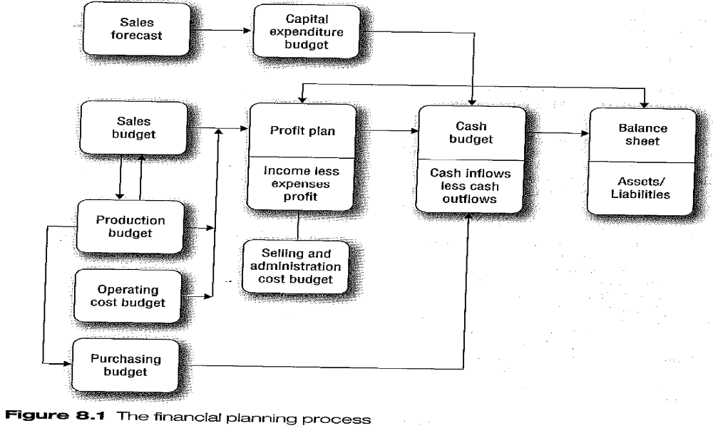

SOURCES OF SHORT-TERM FINANCE

This is finance that is repayable within 12 months:

- Trade credit: businesses purchase stock on credit from other firms and only pay for it at a later stage. This is called trade credit. Difficult for the small business to obtain.
- Bank credit: normally when a company has a cheque account they can apply for an overdraft facility. They have to have funds as a deposit to open the cheque account
- Bills of exchange: these are mostly used in practice to pay or replace trade credit. This comes in the forms of bills payable and promissory negates which will be signed by the buyer who then undertakes to pay the debt plus interest at some agreed future date. The seller can then sell the bill to a financial institution such as a bank.
- Acceptance credits: Banker’s acceptance simply means financing by means of bills of exchange. The bank issue a ‘letter of credit’ whereby a first-class borrower is permitted to draw bills to a specified limit. The bill will then be accepted by the bank, whereby the bank takes responsibility for payment on maturity. The client will then repay the bank by the due date.
- Factoring: Book debts are assigned to a third person, called a factor. This means somebody else is handling the firms debtors. Various options is viable: the debtor can pay directly to the creditor or to the factor, may include all or some of debts, may include bad debts. Cash is therefore received immediately and the seller is not obliged to include a discount for the prompt payment.
- Customer advance payments: progress payments upon the completion of defined stages of a project. Used in construction and engineering industry
- Shipper’s finance: specific financial institution that provides finances necessary to cover the movement of goods from supplier to purchaser e.g. Import of goods. Cost of finance is high.

SOURCES OF MEDIUM-TERM FINANCE

Medium-term finance is considered as finance which is repayable between 1 to 3 years.

Instalment sale transaction (hire purchase)
- Popular to finance a fixed asset such as machinery, equipment, furniture and motor vehicles.
- Credit sale in which it is agreed that the purchases price of the item will be paid in instalments
- The buyer takes possession of the item, but the ownership of the item sold will only pass to the buyer when the last instalment has been paid
- An initial deposit is normally payable by the buyer of the item.
- The deposit is prescribed by the Minister of Finance in terms of the Credit Agreement Act

Leasing finance
- Also regulated by the Credit Agreement Act which offers the buyer and the credit supplier similar protection
- The business leases rather than purchases the fixed assets such as office equipment.
- The owner of the asset (the lessor) grants the use of the property to another person (the lessee) under certain conditions for a certain period of time.
- The lessee has to make a payment for the use of the asset and will never own the asset.

Medium-term loans
- Commercial banks offer medium term loan facilities for clients
- These loans are repayable over 24-36 months
- Granted to finance working capital, to bridge finance gaps until long-term finance can be obtained, or for the acquisition of fixed assets

SOURCES OF LONG-TERM FINANCE

Long-term funding means that capital is provided for anything up to the entire lifespan of your business
Takes the form of shares, loans and /or capital

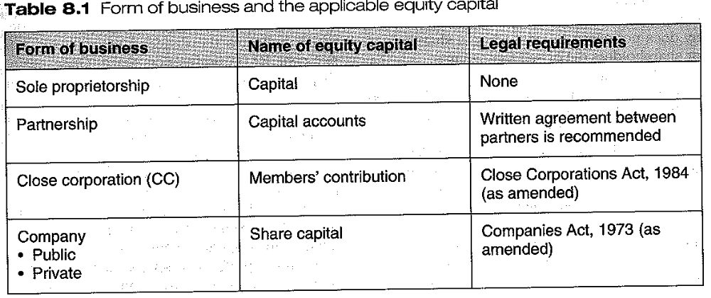

Equity capital
Equity Capital is the initial capital invested to start-up the business. Equity capital is capital invested in the business with no obligation to repay the principal amount or to pay interest on it to another party.

Debentures
- Money is borrowed from outside sources by issuing debentures
- Debentures are normally printed documents that are fully negotiable and transferable
- Principle sum of the loan is normally repayable at some future date, while the interest must be paid at stipulated times.
- Mostly used by public companies

Retained earnings (internal financing)
- Part of the profit of a firm is retained as “reserves” instead of being distributed as dividends
- Comprise about 50% of company finance in South Africa
- Management has almost complete control over this source of finances

Long-term loans/mortgage bonds
- Given if the company owns immovable property that is not already covered by a mortgage bond
- Repayment of mortgage bonds are normally between 20 to 30 years

INSTITUTIONS THAT SUPPORT SMALL AND NEW BUSINESS VENTURES

- Commercial banks
- Business partners
- Khula enterprise Finance
- Industrial Development Corporation
- Ithala Finance Corporation
- Local business support centres (list can be obtained from SEDA)

INFORMAL SOURCES OF FINANCE

- Family
- Fools
- Friends

Many business owners are encouraged to start an enterprise by their parents, friends of relatives who offer to supply loans to get it started. Often later on no more resources is available and business goes bankrupt.

VENTURE CAPITAL AND THE PRIVATE EQUITY MARKET

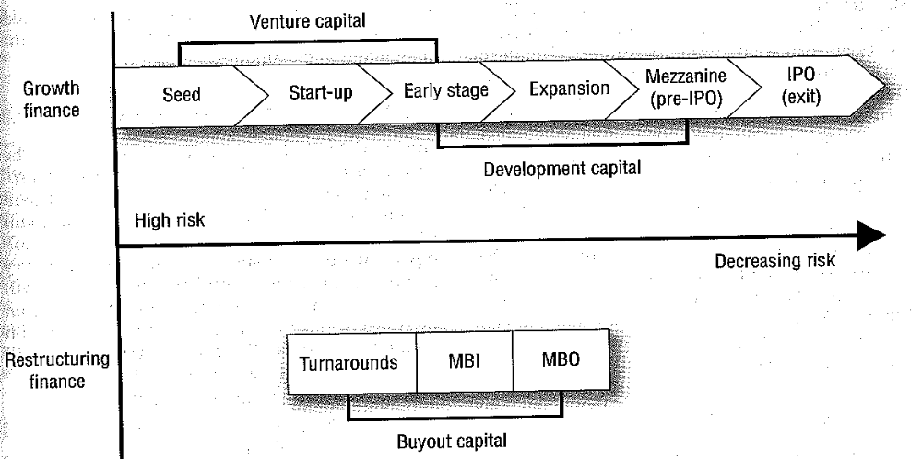

Venture capitalists are investors or investment groups that commit money to new business ventures during the earliest stages of development, mostly in the growth phase, and very seldom in the start-up phase

Venture capital firms consider certain factors before providing funds.

Attractive business opportunity
- Feasible business concept
- Profitablility
- Large operating margins
- Large sustainable growing market

Competitive business venture
- Experience and balanced management team
- Unique and competitive product or service

Feasible exit options
- 3-6 years’ harvest potential
- Global growth potential

Strategic fit with fund or portfolio
- Stage of the firm in the venture life cycle
- Size and terms of the investment
- Industry sector
- Skills and experience required for the industry sector

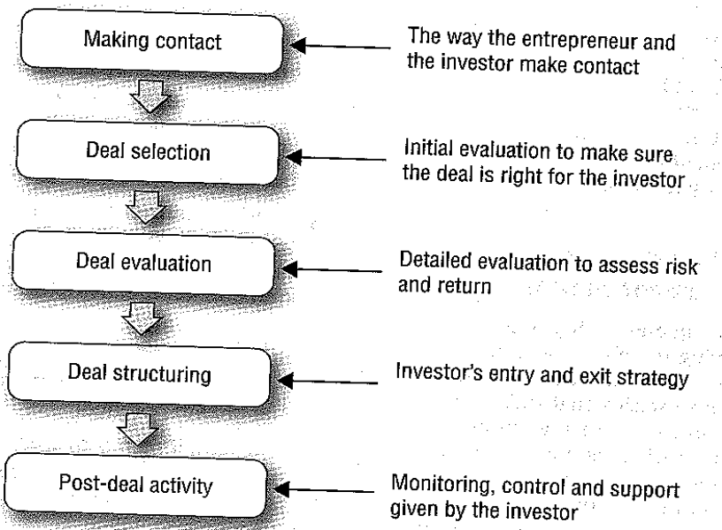

ATTRACTING INVESTORS AND THE PRIVATE PLACEMENT OF SHARES

Stage 1: Making contact
Also called deal origination, this is when the entrepreneur and investor become aware of each other.

Stage 2: Deal screening
Investors do an initial evaluation to make sure the deal is right for the investor – fits their profile of activities and their investment profile. Important criteria include the amount of investment being sought, the type of technology on which the venture is based, the industry sector of the venture, and the stage of growth the venture is in.

Stage 3: Deal evaluation
Detailed evaluation of the proposal to assess the risk and return

Stage 4: Deal structuring
Refers to how the initial investment will be made and how the investor will see that investment will bear fruit. The investor’s entry and exit strategy.

Stage 5: Post-investment activity
Investors usually prefer to retain a degree of involvement. This involvement entails the monitoring, control and support given by the investor.

THE COST OF RAISING FINANCE

Raising finance can be a timely and costly process. For this reason many entrepreneurs prefer to grow slowly by using internal cash flow to fund growth. Some entrepreneurs have a fear of debt and of giving up control of the firm to investors.

The costs of funding are more than the interest rate on the funds obtained.
The costs of raising finance include:

- Upfront costs: Entrepreneur has to prepare a proposal, assisted by and external consultant e.g. Financial consultant, auditor/ca, investment banker. Also includes costs in terms of time lost

- Marketing costs: Secondly, the investment opportunity has to be marketed and the entrepreneur has to advertise, print brochures etc.

- Back-end cost: Lastly, the entrepreneur may incur banking costs and legal fees, brokerage fees and listing fees

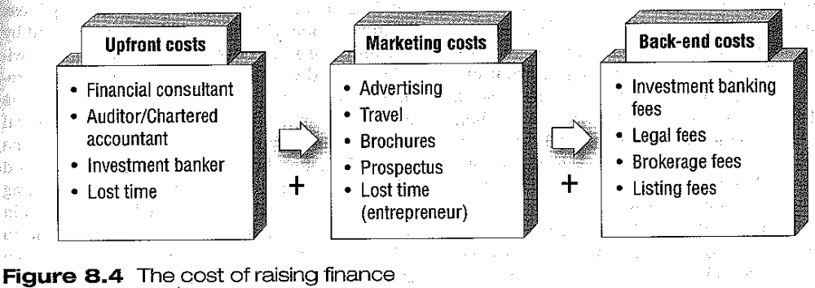

INITIAL PUBLIC OFFERING

‘Going Public’ or the initial public offering (IPO) is quite often the ultimate way of raising growth capital. Offering shares to the public is a means of raising large amounts of interest-free capital for the business.

- To go public, the company must meet the Johannesburg Securities Exchange’s requirements for listing
- Consider it an option once the need for growth capital has exceeded their debt capacity
- A listed company also has more prestige in the market place
- Can also reward existing employers through share options
- Disadvantage: everything the company does, become publics information
- Time consuming and expensive process. Can take between four and 12 months or even longer.
- Cost of going public will normally exceed R10 million

QUESTIONS FROM STUDY GUIDE

What are the legal requirements for a hire purchase or credit sale agreement?

The legal requirements are as follows:
- All agreements must be in writing and be signed by all parties.
- All agreements must state the amount of the initial payment (deposit).
- All agreements must include a description of the goods that are being purchased
- All agreements must include the names and addresses of the credit grantor and credit receiver.

Different forms of businesses do have different abilities to attract finance. Discuss this concept by referring to the
- sole proprietor
- partnership
- close corporation
- companies

See textbook insert below
Summarise from insert in book.
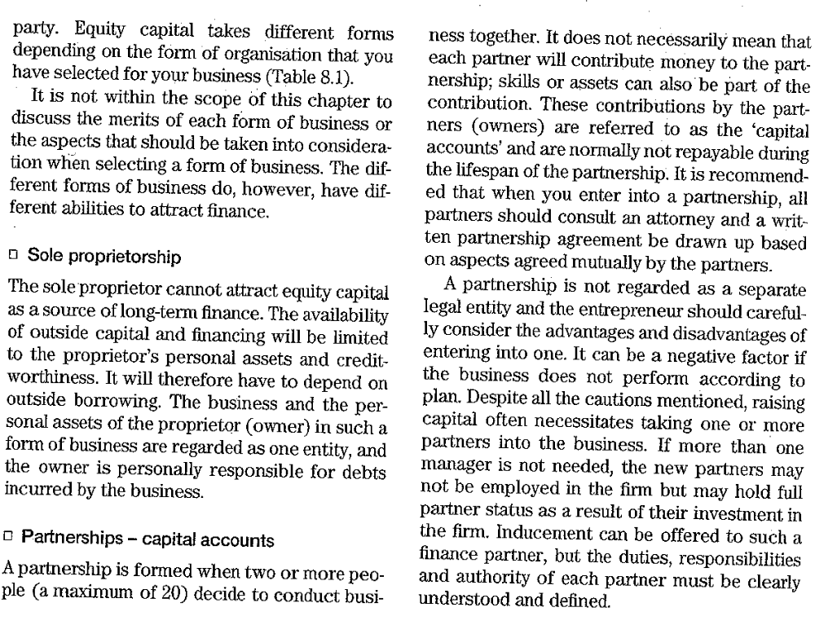
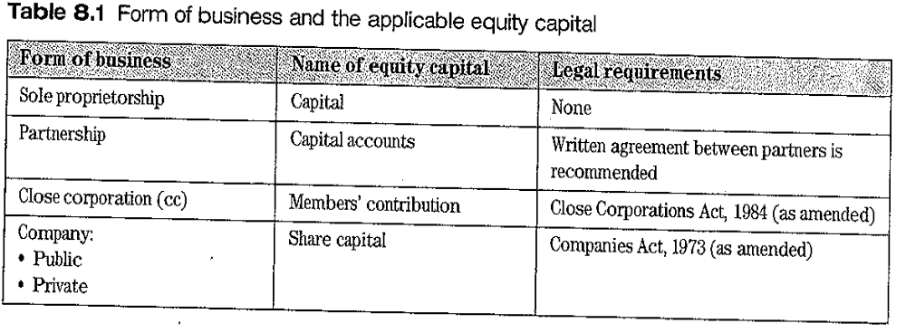
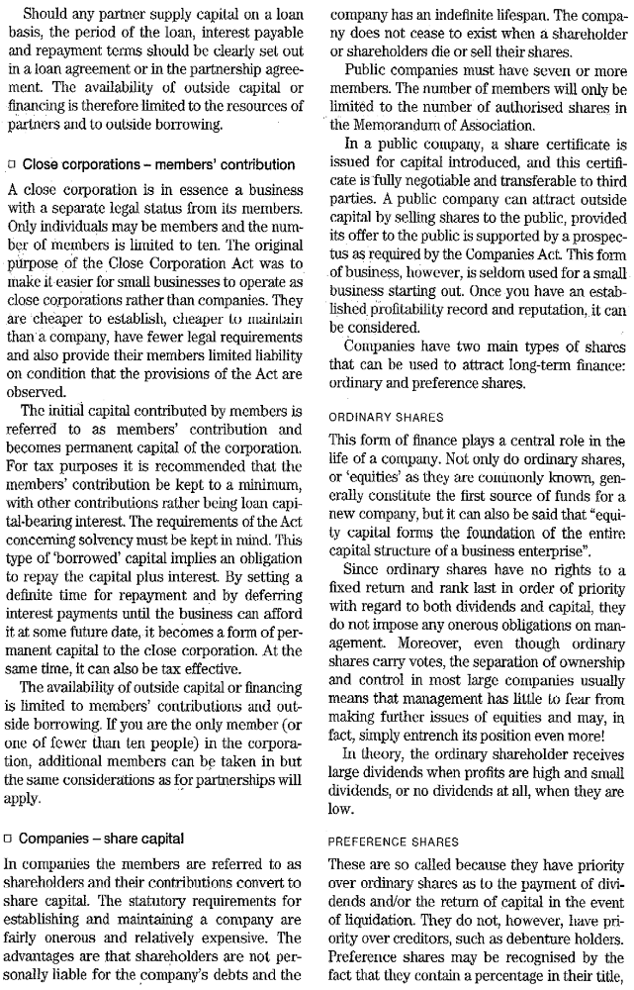

TOPIC 2

STUDY UNIT 9
Chapter 9: NETWORKING AND SUPPORT (Pg 191 – TB)

NETWORKING AND SUPPORT
INTRODUCTION

DEFINING AND ENABLING SMALL BUSINESS ENVIRONMENT

Definition: An enabling environment is a supportive environment for emerging entrepreneurs. The government assists in terms of legislation and policies which aim to create a favourable climate for entrepreneurs by providing:

- Access to finance by ordinary financial institutions e.g. Banks
- Venture capital access
- Training and development programmes to encourage entrepreneurship
- Infrastructure development to advance economic activity
- Deregulation and legal regulation of economic activities

A cooperative environment is also created with:
- Tertiary institutions
- Institutions giving business support, finance and training
- Involvement through SMME development units
- Non-governmental organizations
- International aid agencies

Entrepreneurs have an important contribution to the development of developing countries, but their cultivation is met by numerous obstacles.

NETWORKING AND NETWORKS FOR ENTREPRENUERS

Networking is the process of meeting people, building relationships that can benefit all those involved, sharing information and ideas and getting one’s business on the map.

Networking is the art of making and using contacts. The goal of networking is to create a pool of people and information that can directly increase the quality of your product or service.

Networks are a useful tool in terms of know-how and know-who as critical tools to contribute to business success
Networks are patterned, beneficial relationships between individuals, groups or organizations that are used to secure critical economic and non-economic resources needed to start and manage a business

Types of networks:

- Social networks: communication between different parties where exchange of information takes place. Can also refer to exchange of goods and services and normative exchanges based on social expectations
- Personal networks: individuals with whom the entrepreneur has a direct relationship, a link with others in a similar field. These areas where links are to be built are called a role set. Might include partners, customers, suppliers, bankers, distributors, professional associations and family members. Someone you know and may have face-to-face communication with be it strong or weak
- Extended networks: focus on network of firms and organizations e.g. SACOB South African Chambers of Business
- Other networks: internet, attorneys, bankers and outside consultants

Networking principles:
- Reciprocity: give and take
- Networking relationship: Should be built on friendship, good humour and sharing interests and activities
- Network sustainability: Must be constantly maintained, since they are very hard to repair once damaged

How to develop an effective network:
- Identify people and organizations among existing connections who are close to potential shareholders
- Seek criticism, advice and suggestions
- Ask them for advice about contacts
- Ask them what preparations are necessary
- Tell existing contacts later how they have helped

Functions of networks in the growth of a business venture
- Ensures that goals for growth and vision are realistic
- Increase the entrepreneur’s level of aspiration
- Helps to identify opportunities
- Provide emotional support
- Provide practical assistance
- Provide a sounding board for ideas

Other networks:
- Internal networks such as formal and informal structures
- Internet
- Resources e.g. Board of directors, attorneys, bankers, accountants, consultants etc
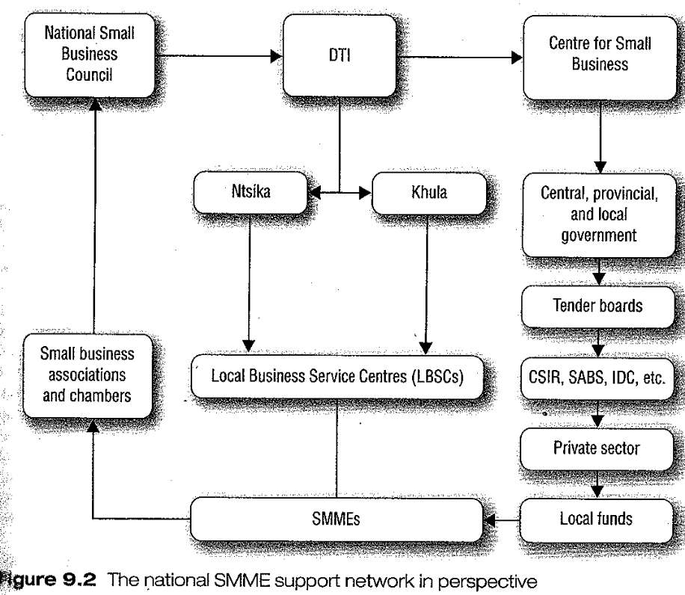

BUSINESS SUPPORT REQUIRED BY EMERGING ENTREPRENEURS TO DEAL WITH CHALLENGES

Business Counselling:
Definition: Business counselling is a process whereby business problems are diagnosed and resolved in such a way that the clients learn not only how to overcome their current difficulties or exploit their opportunities, but also how to tackle similar situations in future.

The aim of business counselling is to boost individual and firm performance, and this is an ongoing process for development. One-on-one meetings should take place between the new venture owner and the experienced entrepreneur.

Business counselling objectives should include:
- Identify problems and their source
- Evaluate actual performance against expected performance
- Develop action plans to bring performance up to minimum expectations
- Provide expert help in start-up and growth phases and to help fill the deficiency gap and avoid crisis management

Business Mentoring

Definition: Business mentoring is an ongoing long-term business counselling relationship between an experienced business advisor (or an corporate executive) and a client through the various stages of a business venture’s growth.

The aim of business mentoring: is to develop both the managerial and entrepreneurial skills of an individual so that an emerging entrepreneur can grow into a long-term sustainable entrepreneur.

Objectives of business mentoring:
- To cover a diverse range of topics as a business develops over time towards an agreed set of objectives
- To provide guidance and skills transfer to emerging entrepreneurs in a supportive environment.

Institutions and organisations involved in business mentoring:

- Khula (Thuso Mentorship Scheme)
- Business partners, and
- The main commercial Banking institutions in RSA, namely: ABSA bank, First National Bank (FNB), Standard Bank, and Nedbank. Each of these banks, have developed its own approach towards business mentoring.

Business Incubation
Definition: Business incubation is a new and innovative system of support designed to nurture start-up and early-stage enterprises in a managed workspace.

Aim of business incubation: A business incubator is a facility and set of activities through which entrepreneurs can receive essential information and support, and valued-added shared services and equipment.

Objective of business incubation:
- Provides an entrepreneurial and learning environment
- To provide visibility in the marketplace, as well as
- To provide ready access to mentors and investors

Why do we need business incubation?
- Fast-tracks the growth of early stage businesses
- Improves the survival rate of start-up companies by helping them to become financially viable, usually within two to three years
- Creates a synergistic environment where entrepreneurs can share learning, create working partnerships and do business together
- Opens doors to markets and resources

THE ROLE OF THE GOVERNMENT IN DEVELOPING AND ENABLING SMALL BUSINESS ENVIRONMENT

The National Small Business Enabling Act of 1996 paved the way for the Department of Trade and Industry (the DTI) to address SMME development in South Africa. The Act was developed after the publication of the White Paper on the national strategy for the development and promotion of small business. The Act intends to create a positive enabling environment for emerging and expanding SMMEs, especially black and previously disadvantaged entrepreneurs.

Key objectives of the White Paper on the national strategy for development and promotion of small business in South Africa, on which this act is based, is as follows:

- Create an enabling environment for small enterprises which includes government support, legislation, access to finance, access to markets and access to training and technology
- Facilitate greater equalisation of income, wealth and earning opportunities
- Strengthen the cohesion between small enterprises
- Assist small businesses to comply with the challenges of an internationally-competitive economy to address the legacy of apartheid-based disempowerment of black businesses
- Support the advancement of women in all business sectors
- Create long-term jobs
- Stimulate sector-focused economic growth
- Level the playing field between bigger and small business, and between rural and urban business

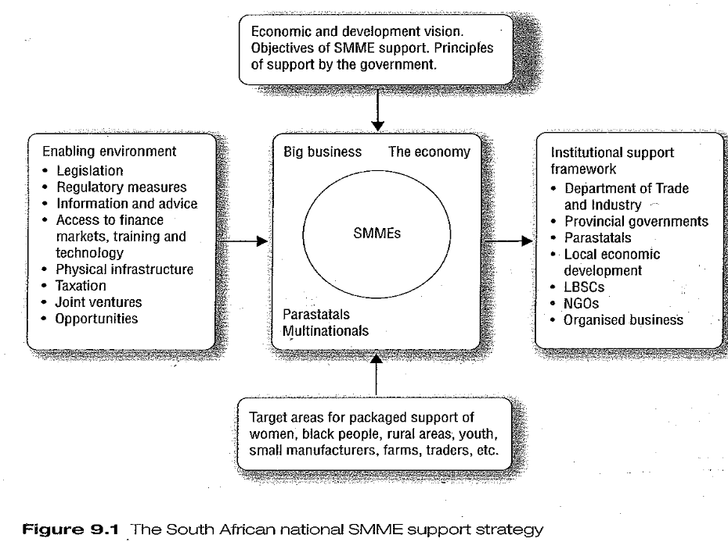

ROLE OF THE DEPARTMENT OF TRADE AND INDUSTRY

The Department of Trade and Industry (the DTI) has been set up to facilitate the most critical function of economic growth which includes wealth and job creation

The DTI had to establish an implementation strategy for the delivery of programmes that would contribute to economic growth. This has resulted in the establishment of the institutional framework for supporting SMME’s and their development e.g. SEDA (Small Enterprise Development Agency) which replaced Ntsika and Khula Enterprise Finance Limited

Assistance offered by the DTI to small and medium business owners:
- Access to technology through their Access to Technology programme offered by SEDA
- Business referrals, advice and information networks (BRAIN) to improve competitiveness and growth of small businesses through the supply of value-added business information
- Business regulatory compliance advice to assist businesses in gaining a better understanding of the laws that apply to their businesses
- EIC (Entreprise Information Centre) , previously the LBSC, Local business support centre programme which is key in promoting, small, medium and micro-enterprises
- Khula offers mentorship for small business owners to ensure the transfer of skills on a one-on-one basis. Entrepreneurs are assisted with advice, counselling and the development of business plans, as well as advice on how to successfully manage a business
- Target assistance through SEDA is available for disables people, youth and women entrepreneurs.
- Trade and investment development programme from SEDA focuses on small businesses in SA to develop their ability to compete in the international marketplace

The role of SEDA

Provides non-financial support to SMMEs, such as:
- Business support information and company registrations
- Business analysis and advisory services
- Exporter development programme
- Mentorship
- Supplier development
- Skills development

The role of Khula
Developed by the DTI and operated as an independent, limited liability company, Khula is a wholesale agency which provides financial support for small businesses through intermediaries. Its financial products include:
- Loans,
- A national credit indemnity guarantee scheme,
- Grants,
- Institutional capacity building, equity funds, and
- Membership schemes

The Enterprise Information Centre (EIC), previously the LBSC (local business services centre)
The EIC programme was developed under the directive of SEDA to increase the reach of seda initiatives by partnering and outsourcing to other public and private organisations that offer small business support services.

  - It is both a vehicle for partnerships in development and a mechanism for encompassing and directing SMME development activities within a national development framework. This is achieved through practical programme partnerships between all three spheres of government, local communities and the private sector

At the national sphere the EIC programme contributes to a number of national development priorities, these include:

- Job creation
- Wealth creation
- Transformation and empowerment

At the local sphere the EIC programme has been established to perform a number of important functions within local communities, these include:
- Increasing the access of local people to SMME support services
- Increasing opportunities for participation in local development efforts by local communities
- Providing a focal point for the expansion of development of local economic, employment and enterprise opportunities
- Increasing the flow of resources into the local community

South African Micro-Finance Apex Fund (samaf)
In 2006 the DTI launched samaf to provide affordable and sustainable access to financial services for the poor. The goal of the Apex Fund is to:

- Develop sustainable micro finance institutions that can reach the poor
- Facilitate training for micro entrepreneurs and financial cooperative clients
- Provide back-office services through a centralised information platform
- Provide mentoring, monitoring and regulating to partner organisations

ROLE OF THE INDUSTRIAL DEVELOPMENT CORPORATION
The Industrial Development Corporation (IDC) is a self-financing, state-owned national development finance institution. The core business of the IDC is to provide finance to entrepreneurs for the development of competitive industries.

Even though the IDC is state owned, it functions as an ordinary business, following normal company policy and procedures in its operations.

The Vision of the IDC: to become the driving force behind commercially-sustainable industrial development and innovation to the benefit of South Africa and the rest of the African continent

Primary objectives of the IDC:

- To contribute to the generation of balanced and sustainable economic growth in South Africa
- To contribute to the economic empowerment of RSA

Core strategies of the IDC:

- Maintaining financial independence
- Providing risk capital to the widest range of industrial projects
- Identifying and supporting opportunities not yet addressed by the market
- Empowering emerging entrepreneurs
- Promoting medium-sized manufacturing
- Establishing local and global involvement and partnerships in projects that are rooted in or benefit SA, The Southern African Development Community or the rest of Africa
- Investing in human capital in ways that systematically and increasingly reflect the diversity of the African continent

The IDC has 3 divisions

- The Services Sectors Division: This division explores ways of increasing its development impact on economic growth and job creation. The division fulfils the IDC’s mandate of SMME and BEE development, as well as its obligations in line with government’s IMS, which identifies new sectors of strategic importance that need support. The division includes; empowerment; media and motion pictures; techno-industries and wholesale bridging finance.

- The Industrial Sectors Division: This division intensifies financing activities in the traditional business areas and concentrates on developing medium-sized enterprises, focusing on labour intensive sectors, such as agro-industries; chemicals and allied industries; entrepreneurial mining and beneficiation; metal, transport and machinery products; textiles, clothing, leather and footwear; and wood, paper and other industries.

- The Projects Division: This division affects the regional economy by using its expertise in evaluating project ideas, participating in and co-funding project pre-feasibility and/or feasibility studies, as well as providing project finance for viable new and/or expanded projects such as agri-projects, mining and beneficiations; oil, gas and chemicals; and public-private partnerships.

ROLE OF BUSINESS PARTNERS

Business Partners is the country’s leading specialised investment company for small and medium enterprises and is an unlisted public company with assets of more than R1.74 Billion. Business Partners currently has a network of offices located in all major cities and towns in South Africa.

Core focus:

- Invests in formal small and medium enterprises in all sectors of the economy, with the exception of on-lending activities, farming operations and non-profit organisations
- Provides a range of value-added services for entrepreneurs, including property broking, property management, consulting and mentorship

Kind of business’s financed by Business Partners:

- Start-ups
- Expansions
- Outright purchases (Take-over’s)
- Management buyouts
- Management buy-ins
- Leveraged buyouts
- Franchises
- Tenders and Contracts

Business Partners offer the following:

- Flexible approach to doing business
- Prepared to make investments when other institutions are not
- Peace of mind, because viability is evaluated by and independent party
- Investment decisions based on sound business and investment principles
- Information, advice and guidance on business-related issues
- Regular aftercare – business advisors and mentors visit the business to offer advice and guidance for a fee
- Broad industry knowledge, expertise and networks
- Fair and equitable rates, terms and conditions, even in times when business is under pressure
- Access to further finance
- Personal service – each client is allocated to a portfolio manager

Commercial banks can play a key role in the development of small businesses

ROLE OF COMMERCIAL BANKS

e.g. Standard Bank, ABSA, First National Bank and Nedcor Bank, offer financial support to small businesses

- Standard bank:
- Package on planning and financing and SME
- Booklet entitled: a business of your own
- SME business plan and loan application
- SME call line
- Business deposits via ATM
- Owner Loan protection Plan

- First National bank:
- SME Investments programme – provide early stage venture capital
- Offer small business support by offering financing mainly to franchisees
- Export Finance Scheme – underwrite finance made available to approved exporters
- Business plan guidelines

- NedEnterprise:
- Specialized small business finance unit with in Nedcor
- Offers one-stop, full service relationship banking
- Finance loans between R50 000 and R1,5 million
- Consider various types of collateral as security for loans e.g. Business assets, investments, mortgage bonds and insurance policies
- Does not finance all types of business e.g. Agriculture, transportation and construction industry

- ABSA:
- Business banking Toolbox – offers complete business guide
- Offer tailor-made products to businesses and making sure that is innovative in its approach

TOPIC 3

STUDY UNIT 10
Chapter 10: ALTERNATIVE ROUTES TO ENTREPRENEURSHIP (Pg 217 – TB)

ALTERNATIVE ROUTE TO ENTREPRENEURSHIP

INTRODUCTION

The importance of family businesses is recognised throughout the world and enjoys growing support in developing and developed economies. It can be assumed that family businesses can also make an important contribution to the development and growth of South Africa’s socio-economic environment.

A family business is not a normal business because of the involvement of family issues which are, by nature, more emotional. The contribution of Family businesses to socio-economic growth has never really received sufficient attention in South Africa.

DEFINING FAMILY BUSINESSES

Definition: A family business is one that is influenced by family ties in order to achieve the vision of the family over, potentially, several generations.

From the definition the following aspects pertain to a family business:

- The family (or part thereof) is actively involved in that particular business
- Family members contribute their input to the strategic direction of the business
- There is more than one family member involved in the business
- The intention is to continue the family business over time

SYSTEMS IN FAMILY BUSINESSES

A family is based on emotion, nurturing and security, while a business is focused on productivity, profit, goal achievements and growth. It is therefore important to distinguish the family system from a business system

The family system cares for its family members, it is an emotional system and due to the fact that the focus is based on the family and the interests of the family, this may result in not all ideas been exploited. This could lead to the business becoming stagnant.

The business system is task orientated and focuses on turning ideas into opportunities, productivity is crucial for survival.

In order to be successful, the business needs to maintain a balance between the two systems. Imbalances could lead to conflict, which could have a negative effect on productivity and staff morale.

PROBLEMS IN FAMILY BUSINESS

- The average life span of a family business is around 24 years – this is also the average time the founder stays in the business.
- The family system is more dominant and so the family business becomes less entrepreneurial
- On average only 30% of family businesses remain successful in the second generation,
- Only 10% of family businesses are successful in the third generation

SUCCESSION

Succession is the process through which the leadership of the business is transferred from the existing leader to a subsequent family member or non-family member (a professional manager). The following obstacles to succession could result in few family businesses being transferred to a second and a third generation:

- The founder is autocratic and resistant to transfer leadership
- The existing leader acts as though he will never die
- There is a sense of a “child been a child” making the advice from children to be ignored
- The existing leader misinterprets environmental trends and does not implement changes in time
- The leader is reluctant to make a choice on a possible successor
- The leader selects a successor who can be his ‘slave’

The management style of the leader can also influence succession, the different styles are as follows:

- Monarchs: They do not leave office until been forced out by death or revolt
- Generals: Forced out of office, but plot their return and come back out of retirement to ‘save’ the business
- Ambassadors: They leave office gracefully and serve as post-retirement mentors
- Governors: They rule for a limited term and then switch to other vocational outlets.

If the leader has decided to pursue succession, the following options are open to him:

- Appoint a family member
- Appoint a caretaker manager if the family member is still too young to take over
- Appoint a professional manager if no family member wants to take over the management of the business
- Liquidate the business
- Sell the business, in whole or in part
- Do nothing and adopt a ‘wait and see’ approach

ADVISORY BOARD

The focus of the family advisory board is mainly on the business/management related aspects. The board should ensure that:

- The business is strategically aligned to major environmental trends,
- The business stays entrepreneurial by constant exploiting opportunities,
- That conflicts within the business are managed timeously
- That decisions are taken based on facts and not emotions, and that
- Decisions are in-line with the family value system

FAMILY COUNCILS

Definition: A family council is an organised group of family members who meet periodically to discuss family-related business issues.

The family council overseas family matters and the members draw up a family creed which covers important matters such as the management philosophy and objectives, the jobs and remuneration for family members, leadership and succession, shareholdings, the board of directors, the employees and changes in the family constitution.

TOPIC 3

STUDY UNIT 11
Chapter 11: BUYING A FRANCHISE (Pg 233 – TB)

BUYING A FRANCHISE

INTRODUCTION

The franchise concept gives an entrepreneur the opportunity to start a business that has been proven in the marketplace. Franchising involves the sharing of knowledge between the franchisor and the franchisee. The franchisor gives the franchisee the right to operate the business using the business name and systems, and the franchisee pays a royalty for this right. As a result the franchisee becomes part of the franchise network which has numerous advantages for the entrepreneur.

Explain the concept of franchising.

DEFINITION AND CHARACTERISTICS OF THE FRANCHISE CONCEPT

- Franchising involves a legal agreement whereby the franchisee conducts business according to the terms specified by the franchisor
- The franchisee is the person who buys the license to used the intellectual property
- The franchisor is the person who has developed a business system with an unique trademark, copyright and payments which he will make available to a franchisee in exchange for payment

Important concepts

- The franchisee: entrepreneur who buys a franchise from a franchisor, and may operate the business.

- The franchisor: firms that owns the business concepts e.g. Steers Holdings

- The franchise contract/agreement: contract which specifies all the terms on which the relationship between the franchisor and the franchisee is based. e.g. Franchisee may supply premises, provide everything needed for start-up, help with marketing of business, provide secret ingredient, business/production know-how etc.

- Royalties: also called management services fees. Monthly fee that the franchisee has to pay the franchisor for the right to operate the franchise. Can be a fixed amount or a percentage of the turnover.

- Advertising fee: can be a fixed amount of percentage of turnover. Used to finance the advertising campaigns of the franchise company

- Franchise fee: lump sum payment that the franchisee pays to the franchisor when they sign the franchise contract. The franchisor uses this money to finance the opening of the new franchisee's business

STRUCTURE OF THE FRANCHISING INDUSTRY IN SOUTH AFRICA

- Franchisor can sell a franchise directly to individual franchisees or market it through master licensees or area developers
- Most franchisors also own one or more outlets that are not franchised. These outlets are referred to as company-owned stores or corporate stores.

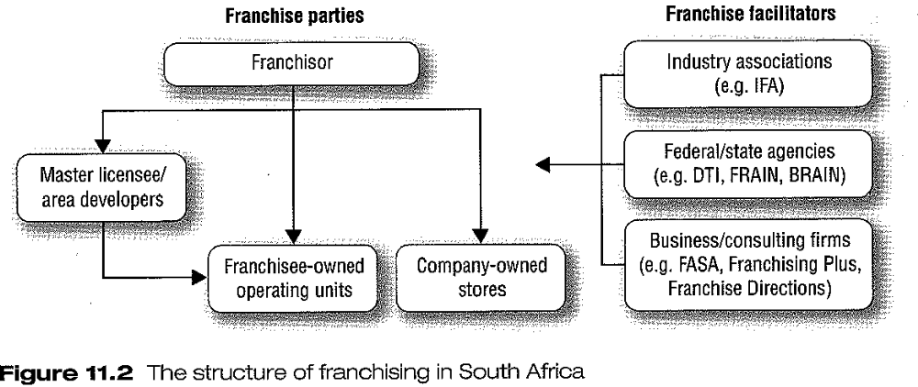

TYPES OF FRANCHISING

- Dealership: commonly found in car industry. Manufacturers use franchises to distribute their product lines. Act as retail store from manufacturer. May be required to meet quotas.
- Business format franchising: offers a name, image and method of doing business, such as McDonald’s, KFC, Nando’s, Spec-Savers and Supa Quick
- Service franchises: offer services e.g. Personnel agencies, estate agents and personal services. Franchises have established names and reputations and methods of doing business e.g. Pam Golding, PostNet

ADVANTAGES AND LIMITATIONS OF FRANCHISING

What are the advantages of buying a franchise?

- Advantages for the franchisee:
- Buying a proven system and well-known concept
- Provides the franchisee with assistance at start up
- Provides ongoing support and assistance to the franchisee
- Advertising and purchasing may be done by franchisor
- May be easier for the franchisee to obtain finance to start the business

- Disadvantages of buying the franchise:
- Increased set-up costs
- Franchisee has to abide by rigid operating procedures
- Franchisor could make mistakes

- Advantages of franchising for the franchisor:
- Franchisor can rapidly expand their business with the capital and human resources provided by the franchisee
- The franchisee is an owner operator and is dedicated to the success of the business

- Disadvantages of franchising for the franchisor:
- Could be costly to set up and operate a head office structure
- Could be reduced income per unit as income is limited to a percentage of franchisee’s sales
- The franchisor has to secure the cooperation of franchisees before making changes and this may restrict the franchisor’s freedom to act. Place them under a moral obligation to ensure ongoing successful operation.

EVALUATING FRANCHISE OPPORTUNITIES

Evaluation of a franchise is almost the same as buying an existing business.
- Evaluate the franchise as a business opportunity.
- Review the disclosure document which contains information about the franchisor and the franchise system
- Speak to current and previous franchisees to determine their views of the franchise system and the franchisor.

The franchisee should keep the following in mind, before investing:
- What is the company’s financial position?
- Can trade or bank references be obtained?
- What is the background of the directors?
- How long had the company been in existence, before it started franchising?
- Is there evidence to show that franchise format has been sufficiently piloted in a number of locations?
- How many franchises are currently open? How many are company-owned?
- What is the company’s rate of expansion?
- Have any franchised units failed or ceased trading in the past 12 months? Reasons?
- Is the franchisor member of FASA currently, or previously?
- Ongoing demand for the product or service? Competition?
- Is geographical location suitable?
- What are the initial and ongoing fees?
- Will there be sufficient profit left once you have paid all your expenses?
- How does the franchisor calculate the financial projections?
- How long will it take you to obtain a full return on your investment?
- Can you talk freely to existing franchisees?
- On what criteria are franchisees selected?
- Can the franchisor demonstrate his capacity to provide the necessary initial and ongoing support services?
- Can you have a copy of the franchise agreement?
- Is the franchisor happy for you to take independent advice on the agreement before signing?
- What are your obligations as a franchisor?
- What is the length of the agreement?
- Are you allowed to resell the franchise?
- What is the procedure for terminating the agreement?
- What are the franchisor’s long-term plans for the future of the business?
COMPLYING WITH ETHICAL AND LEGAL REQUIREMENTS

Determine whether franchisor keeps by the ethical requirements of the franchise industry, so that you won’t be in danger of losing your investment as a result of unethical practices.

The franchisor must comply with the requirements of:
- Consumer code for franchising
- FASA code of ethics
- FASA’s disclosure document requirements
- Advertising practice
- Competition board

What is the purpose of the franchise agreement and what aspects does it cover?

THE FRANCHISE CONTRACT

The franchise agreement explains the terms and conditions under which the franchise is bought. It also outlines the roles and responsibilities of the parties involved. The key elements are;

- the duties of the franchisor e.g. Providing start up assistance such as finding a site, assistance with the design, buying of stock, training, marketing, development of the business, and ongoing support of business once it is established

- the duties of the franchisee e.g. Conducting the business according to the operation manual, conducting the business from premises approved by the franchisor, adhering to specified operating hours and obtaining approval of marketing material from the franchisor

- the protection of the franchisor’s intellectual property and understanding that the franchisee will at no stage own the intellectual property

- restraints of trade on the franchisee and the franchisor e.g. Territorial restraint, price restraints, restraint of the right to advertise, competition restraint and the franchisor may even be obliged to provide products/services to franchisees only

- payment obligations regarding the franchise fee, other levies and royalties

- termination of agreement contract needs to specify what the duration of the contract is, what will happen to the franchise in the event of the death, insolvency or incapacity of the franchisee

THE POTENTIAL OF FRANCHISES WITHIN THE EMERGING ENTREPRENEURIAL SECTOR

Some of the major advantages for developing franchises within the emerging entrepreneurial sector are summarised as follows:

- Emerging entrepreneurs, especially in rural areas, enjoy great consumer loyalty
- Standards of the franchise are seldom questioned
- Selection of management and operational staff is a more efficient process, because of the absence of cultural and communication gaps
- Aspirations and expectations of emerging entrepreneurs are less, thus reducing pressure on the profitability of the business during the early days

TOPIC 3

STUDY UNIT 12
Chapter 12: THE BUSINESS BUY-OUT (Pg 253 – TB)

THE BUSINESS BUY-OUT

INTRODUCTION

It is not always necessary, or essential, for would-be entrepreneurs to start their new business from scratch or to join a family business to be regarded as a true entrepreneur or to become the owner of a business. The alternative option is to buy an existing business or a franchise this is known as a ‘Buy-Out’

EVALUATING THE OPTION OF BUYING AN EXISTING BUSINESS

WHY WOULD AN ENTREPRENEUR BUY AN EXISTING BUSINESS?
- Reduce some of the uncertainties that must be faced when starting a business from scratch
- Buy ongoing operations and established relationships with customers and suppliers
- Obtain an established business at a price below what it may cost to start a new business

ADVANTAGES OF BUYING AN EXISTING BUSINESS
- Business is a going concern
- There is an existing location
- Employees are experienced and reliable
- Established suppliers
- Inventory is in place
- equipment is installed
- May have been possibly to buy the business at a bargain price

DISADVANTAGES OF BUYING AN EXISTING BUSINESS
- Business was not profitable and the owner did not disclose this financial information
- Sales volumes may be inadequate
- Business could have a poor reputation
- Employees inherited with the business, may not be suitable
- Location of the business may not be favourable
- Equipment, facilities and inventory may be obsolete
- Business may be overpriced

FINDING A BUSINESS TO BUY

It is important to analyse one’s own skills, abilities and interests (self-audit) to identify the type of business one will be happy in and thus make a success of

Before buying an existing business the entrepreneur must answer the following questions:
- What business activities do you enjoy the most and why?
- What kind of business do you want to buy/avoid?
- How much time, energy and money are you willing to put into the business?
- How many risks are you willing to take?
- What size business do you want to buy?
- What business skills and experience do you have or are you lacking?
- What do you expect to get out of the business?
- Which industries interest you the most or least? Why?

How do we find a business that is on the market?
- Advertisement in newspapers
- Word of mouth

Name some sources of information on businesses that are for sale but that are not advertised.

- How do we find businesses that are not on the market?
- Property agents
- Financial institutions
- Accountants and auditors
- Suppliers
- Friends and relatives
- Knocking on the door of businesses on is interested in
- trade organizations e.g. South African Business Chamber

Evaluating available businesses

When evaluating businesses that are available for sale, the following questions must be considered;

- Why is the business for sale?
- Is the business profitable?
- What skills and competencies do I need to manage the business?
- What is the history of the business in terms of its previous owners, its reputation and its public image?
- What is the physical condition of the business, its facilities and all its other assets?
- What are the degree and scale of competition?
- What is the existing and potential market size?
- What important legal aspects must be considered?
- What is the situation regarding employees when a new owner takes over?
- What are the legal obligations in relation to matters like ongoing contracts and liabilities?

What information should one study before purchasing a business?

This is summarized by studying the following information before deciding to purchase the business:
- Income statements
- Balance sheets
- Cash flow statements
- Records of any accounts payable
- Records of accounts receivable
- All contacts with suppliers
- Labour contracts with employees
- Bank account info regarding deposits and withdrawals
- Income tax returns
- VAT statements
- All records of maintenance of fixed assets
- Short term and employee insurance policies
- Proof of all payments of LBS (employee salaries) to SARS

Methods for determining the value of the business

Your brother wants to buy an existing business and he is of the opinion that doing a business valuation is a complete waste of time. You need to convince your brother of the benefits of such a valuation. What would you tell him?

When the process is completed, you will be at the higher end of the continuum of making rock-solid decisions! The benefits of such a valuation are:
- A business loan is more easily secured with a quality business valuation.
- Understanding the true value of the business spares one financial loss and perhaps also a deflated ego.
- Costs to be incurred later to rectify a situation may be prohibited.

Contrast the asset-based method with the market-based method in determining the value of a business.

- Asset-based method/balance sheet method
- The value of the business is determined by subtracting total liabilities from total assets

- Market-based method
- This valuation technique relies on the financial markets to estimate the value of the business
- Actual market price of similar businesses is used as a yardstick, while making provision for differences like location, size, quality of service and image
- Can also calculate the value of the business using the price-tot earnings ratio by taking market price divided by after-tax earnings

- Earnings-based method

Explain why the excess earnings approach may be the best method to use in determining the value of a business.

- Excess earnings method
- This method uses a combination of the value of the business’ existing assets and an estimation of the future earnings
- Calculate the value of the business by adding the value of tangible net worth to goodwill
- calculate the opportunity cost by:
  - return on investment % x adjustable tangible net worth of business
- person will also forego salary, so add that to above calculation to determine opportunity cost

- Capitalized earnings approach
- Determine the net earnings for the coming year by using the income statements of previous years
- Value of the business is calculated as:
- Net earnings (after deducting the owner’s salary
Value = rate of return

- the higher the risk, the lower the value of the business

- Discounted future earnings approach
- Value of a business is based on the present value of its future earnings

The second step is to discount these future earnings at the appropriate present value rate.
The future net earnings are R119 040 (after one year), then the present value of this amount at a discounted rate of 20% will be R99 200.

This rate of 20% is again the rate that a buyer could have earned on a similar risk investment.

The third step involves the estimation of the income stream beyond 5 yrs and then discounting this income stream again, using the present value factor.

The last step involves the adding up of all these discouonted values. This total wil then be the value of the business.

Identify qualitative factors should be considered when evaluating an existing business.

- Non-quantitative factors in evaluating a business (qualitative factors)
- Competition
- Future community developments
- Legal commitments
- Employee contracts

Briefly discuss the steps in the negotiation process.

THE NEGOTIATION PROCESS

- The final price of the business is determined through negotiations between the buyer and the seller
- The complete negotiation process includes the following steps:
- The identification and approach of the business for sale
- After the buyer and seller are satisfied with their preliminary research, they are ready to begin serious negotiations.
- Before the buyer makes a legal offer to buy the business, he or she will sign a letter of intent.
- The buyer does his “homework” to make sure that the business is good value for money.
- After the buyer does his “homework”, the parties draw up the purchase agreement.
- After drafting of the purchase agreement, the buyer and seller close the deal by signing the necessary documents
- The real challenge now begins for the buyer, who has to make the transition to being a successful business owner.

The following elements are important:
- Price versus value
- Value of a business in the market place is what somebody is willing to pay for it, and is ultimately determined by the buyer
- Value does not always reflect the full potential of the business
- Seller uses one of the computational methods discussed above to determine a price for the business, and if the buyer agrees, the price is set
- Price is only one of the factors that make up the total sale package – also includes rate of payment and other non-financial arrangements
- Price can also be below the actual value of the business, but it business is in non-desirable location, the calculated price may be higher than the actual value

- Sources of power in negotiation
- Various sources of power:
- Complete and reliable information about the elements of the external environment i.e. market, competition, social, economic, political and technological environments
- Timing. The party with the most time available to strike the deal (thus not desperate) has the advantage in terms of timing as a negotiation power
- Pressure from other people. If the business have more than one owner, there might be pressure to make a quick sale, which proves to be and advantage for the buyer.

TRAPS TO AVOID WHEN BUYING AN EXISTING BUSINESS

- Legal circumference
- Buyer must ensure that he fully understands the terms of the contract of purchase. Get an attorney to pay attention to the details of the transaction

- Attraction to status and size
- Not all big and prestigious businesses are good investments

- Unknown territory
- There must be a fit between the business and the entrepreneur’s skill, experience and interests. The buyer must know the detail of the specific industry and the specific type of business.

- Opportunity cost
- Look at all the opportunity costs involved. The new owner may have to go without a salary for a couple of months until the business settles, work long hours etc.

- Underestimation of other costs
- Don’t forget about costs like payments to auditors, insurance and legal fees

- Greed
- Make sure your actions are based on fundamentals and not on greed

- Being too anxious and impatient
- Make sure that as a prospective new owner, you know everything about the business.

