- Page 21-23
- At this stage it is a vexed question whether the provisions of the code constitute trade usages or not.
- Although the code provides that none of its provisions will be justiciable in a court of law and that it will not give rise to a trade custom or a tacit contract or otherwise between a customer and a bank, and it has been argued that courts could and indeed should have regard to the code’s provision in formulating legal principle.
- Thus in the future the code and the banking adjudicator’s recommendations might be treated as a source of South African banking law.
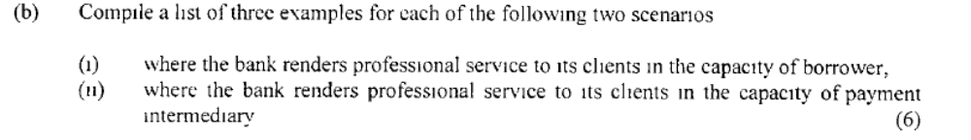

- page 29-30
- bank as borrower: fixed deposits, savings accounts, deposits on credit card accounts, current accounts.
- bank as intermediary: cheques, documentary letter of credit, credit cards, stop orders, debit orders, bills of exchange and travellers cheque.
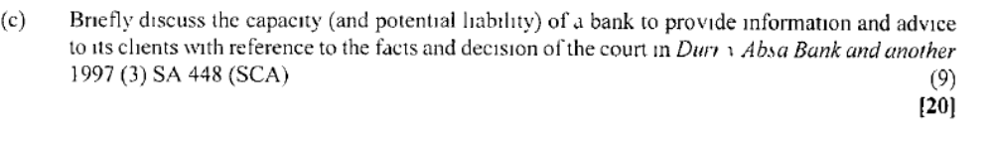
- Page 34
  - In Durr v ABSA Bank the appellant (client of the bank) lost a substantial amount of money because of poor investments advice given to her and some of her family members by one of the bank’s investments advisors.
  - The court held that the test to establish whether the advisor had acted negligently in giving the investment advice was whether he failed to act with ‘the necessary skill and knowledge of a regional manager of the broken division of a bank professing investment skill and offering expert investment advice’.
  - Court held that i.t.o. the test the advisor had acted negligently and the bank was liable for his conduct because it had accepted vicarious liability.

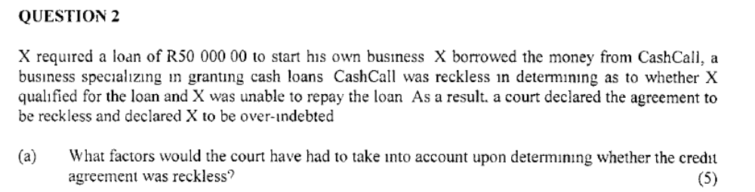
- Page 141
- A credit agreement is reckless if at any time the agreement was made:
- The credit provider failed to conduct an assessment as required, irrespective of what the outcome might have been.
- Page 142
- The court may order a debt restructuring order

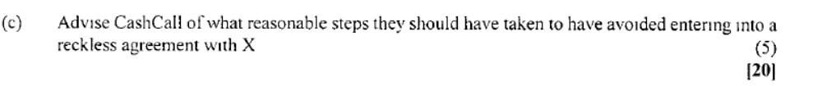
- Page 141
- To determine whether X understood and appreciated the risks and costs of the proposed credit as well as the rights and obligations under the agreement
- X’s debt repayment history under credit agreements from the credit bureau or NCR
- X’s financial means, prospects and obligations
- Whether it was reasonable to conclude that any commercial purpose for which the credit is applied will be successful
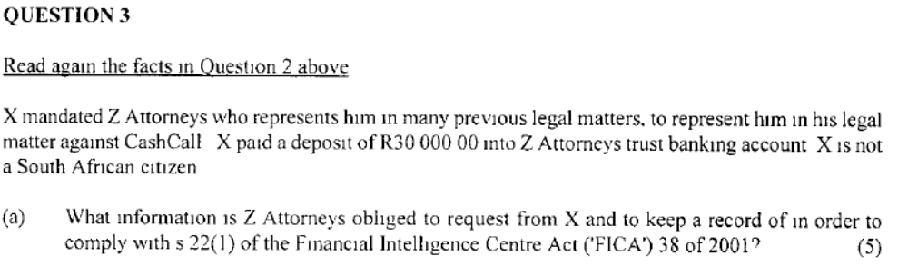
- page 176-178
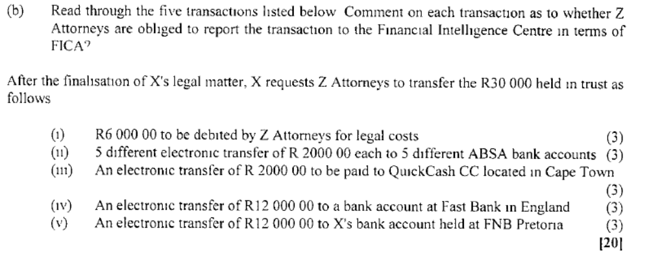
- this is not a suspicious transaction, the payment of legal fees is an ordinary business transaction, there is no need to report.
- The amount is below the threshold; the transaction appears suspicious due to multiple payments and must be reported.
- The transaction is not suspicious, it is below the threshold, and there is no reason to report it.
- A transfer to an overseas bank account must report it.
- The amount is above the threshold and must be reported.
- Page 181-182.
- The threshold amount has been prescribed by regulation, at present the amount is set at R5000
QUESTION FOUR
N/A LETTERS OF CREDIT

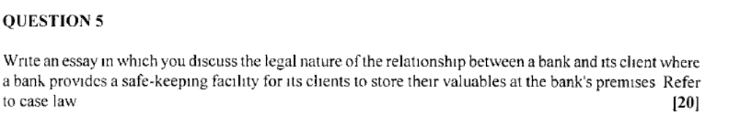

Page 44-49
- In Mensky v ABSA the client and bank had concluded a written agreement i.t.o. which the plaintiff had rented a safety deposit locker at one of the bank’s branches.
- The client deposited jewelry and foreign currency in the locker.
- Some time after the deposit, the safety locker was misplaced by the defendant when it was relocated to different premises.

- It was common cause i.t.o. the agreement that the bank had undertaken to exercise reasonable care for the security of the locker area, but that it was a specific term of the contract that the client was responsible for the contents to be insured.
- The client contended that the exception clause was not applicable, because the loss had occurred while the defendant was relocating to another premises.

- The court reasoned that the provision of the locker did not warrant an undertaking by the bank that could have resulted in substantial liabilities.
- Thus the client had no claim against the bank.

- The court further decided that the bank did not breach its obligations.
- The bank had notified the client that it was relocating to new premises and had informed the client that unless she took some available action, the agreement to continue to store the client’s possessions would cease.

- The court decided that the bank had acted reasonably in the present circumstances, and that the client’s claim had to be dismissed with costs.

- In First National Bank v Rosenblum the content of the safe deposit box were stolen due to the negligence of the bank’s staff.
- The agreement between the 2 provided that while the bank ‘will exercise every reasonable care, it is not liable for any loss or damage caused to any article lodged with it for safe custody… and whether the loss or damage is due to the bank’s negligence or not’.
- It was common cause that one of the bank’s staff had stolen the safe deposit box.

- The court decided that the bank, as a non-human entity, was incapable of being negligent itself.
- The court further held that the indemnity also covered acts of gross negligence.

