Chapter 18
Equity Valuation Models
Miroslav Mateev, Ph.D.
Full-time Professor in Business (Finance)

Multiple Choice Questions
1. ________ is equal to the total market value of the firm's common stock divided by (the replacement cost of the firm's assets less liabilities).
A. Book value per share
B. Liquidation value per share
C. Market value per share
D. Tobin's Q
E. None of the above.
Book value per share is assets minus liabilities divided by number of shares. Liquidation value per share is the amount a shareholder would receive in the event of bankruptcy. Market value per share is the market price of the stock.

Difficulty: Easy
2. High P/E ratios tend to indicate that a company will _______, ceteris paribus.
A. grow quickly
B. grow at the same speed as the average company
C. grow slowly
D. not grow
E. none of the above
Investors pay for growth; hence the high P/E ratio for growth firms; however, the investor should be sure that he or she is paying for expected, not historic, growth.

Difficulty: Easy
3. _________ is equal to (common shareholders' equity/common shares outstanding).
A. Book value per share
B. Liquidation value per share
C. Market value per share
D. Tobin's Q
E. none of the above
Book value per share is assets minus liabilities divided by number of shares. Liquidation value per share is the amount a shareholder would receive in the event of bankruptcy. Market value per share is the market price of the stock.

Difficulty: Easy
4. ________ are analysts who use information concerning current and prospective profitability of a firms to assess the firm's fair market value.
A. Credit analysts
B. Fundamental analysts
C. Systems analysts
D. Technical analysts
E. Specialists
Fundamentalists use all public information in an attempt to value stock (while hoping to identify undervalued securities).

Difficulty: Easy
5. The _______ is defined as the present value of all cash proceeds to the investor in the stock.
A. dividend payout ratio
B. intrinsic value
C. market capitalization rate
D. plowback ratio
E. none of the above
The cash flows from the stock discounted at the appropriate rate, based on the perceived riskiness of the stock, the market risk premium and the risk free rate, determine the intrinsic value of the stock.

Difficulty: Easy
6. _______ is the amount of money per common share that could be realized by breaking up the firm, selling the assets, repaying the debt, and distributing the remainder to shareholders.
A. Book value per share
B. Liquidation value per share
C. Market value per share
D. Tobin's Q
E. None of the above
Book value per share is assets minus liabilities divided by number of shares. Liquidation value per share is the amount a shareholder would receive in the event of bankruptcy. Market value per share is the market price of the stock.

Difficulty: Easy
7. Since 1955, Treasury bond yields and earnings yields on stocks were _______.
A. identical
B. negatively correlated
C. positively correlated
D. uncorrelated
The earnings yield on stocks equals the expected real rate of return on the stock market, which should be equal to the yield to maturity on Treasury bonds plus a risk premium, which may change slowly over time. The yields are plotted in Figure 18.8.

Difficulty: Easy
8. Historically, P/E ratios have tended to be _________.
A. higher when inflation has been high
B. lower when inflation has been high
C. uncorrelated with inflation rates but correlated with other macroeconomic variables
D. uncorrelated with any macroeconomic variables including inflation rates
E. none of the above
P/E ratios have tended to be lower when inflation has been high, reflecting the market's assessment that earnings in these periods are of "lower quality", i.e., artificially distorted by inflation, and warranting lower P/E ratios.

Difficulty: Easy
9. The ______ is a common term for the market consensus value of the required return on a stock.
A. dividend payout ratio
B. intrinsic value
C. market capitalization rate
D. plowback rate
E. none of the above
The market capitalization rate, which consists of the risk-free rate, the systematic risk of the stock and the market risk premium, is the rate at which a stock's cash flows are discounted in order to determine intrinsic value.

Difficulty: Easy
10. The _________ is the fraction of earnings reinvested in the firm.
A. dividend payout ratio
B. retention rate
C. plowback ratio
D. A and C
E. B and C
Retention rate, or plowback ratio, represents the earnings reinvested in the firm. The retention rate, or (1 - plowback) = dividend payout.

Difficulty: Easy
11. The Gordon model
A. is a generalization of the perpetuity formula to cover the case of a growing perpetuity.
B. is valid only when g is less than k.
C. is valid only when k is less than g.
D. A and B.
E. A and C.
The Gordon model assumes constant growth indefinitely. Mathematically, g must be less than k; otherwise, the intrinsic value is undefined.

Difficulty: Easy
12. You wish to earn a return of 13% on each of two stocks, X and Y. Stock X is expected to pay a dividend of $3 in the upcoming year while Stock Y is expected to pay a dividend of $4 in the upcoming year. The expected growth rate of dividends for both stocks is 7%. The intrinsic value of stock X ______.
A. cannot be calculated without knowing the market rate of return
B. will be greater than the intrinsic value of stock Y
C. will be the same as the intrinsic value of stock Y
D. will be less than the intrinsic value of stock Y
E. none of the above is a correct answer.
PV0 = D1/(k-g); given k and g are equal, the stock with the larger dividend will have the higher value.

Difficulty: Easy
13. You wish to earn a return of 11% on each of two stocks, C and D. Stock C is expected to pay a dividend of $3 in the upcoming year while Stock D is expected to pay a dividend of $4 in the upcoming year. The expected growth rate of dividends for both stocks is 7%. The intrinsic value of stock C ______.
A. will be greater than the intrinsic value of stock D
B. will be the same as the intrinsic value of stock D
C. will be less than the intrinsic value of stock D
D. cannot be calculated without knowing the market rate of return
E. none of the above is a correct answer.
PV0 = D1/(k-g); given k and g are equal, the stock with the larger dividend will have the higher value.

Difficulty: Easy
14. You wish to earn a return of 12% on each of two stocks, A and B. Each of the stocks is expected to pay a dividend of $2 in the upcoming year. The expected growth rate of dividends is 9% for stock A and 10% for stock B. The intrinsic value of stock A _____.
A. will be greater than the intrinsic value of stock B
B. will be the same as the intrinsic value of stock B
C. will be less than the intrinsic value of stock B
D. cannot be calculated without knowing the rate of return on the market portfolio.
E. none of the above is a correct statement.
PV0 = D1/(k-g); given that dividends are equal, the stock with the higher growth rate will have the higher value.

Difficulty: Easy
15. You wish to earn a return of 10% on each of two stocks, C and D. Each of the stocks is expected to pay a dividend of $2 in the upcoming year. The expected growth rate of dividends is 9% for stock C and 10% for stock D. The intrinsic value of stock C _____.
A. will be greater than the intrinsic value of stock D
B. will be the same as the intrinsic value of stock D
C. will be less than the intrinsic value of stock D
D. cannot be calculated without knowing the rate of return on the market portfolio.
E. none of the above is a correct statement.
PV0 = D1/(k-g); given that dividends are equal, the stock with the higher growth rate will have the higher value.

Difficulty: Easy
16. Each of two stocks, A and B, are expected to pay a dividend of $5 in the upcoming year. The expected growth rate of dividends is 10% for both stocks. You require a rate of return of 11% on stock A and a return of 20% on stock B. The intrinsic value of stock A _____.
A. will be greater than the intrinsic value of stock B
B. will be the same as the intrinsic value of stock B
C. will be less than the intrinsic value of stock B
D. cannot be calculated without knowing the market rate of return.
E. none of the above is true.
PV0 = D1/(k-g); given that dividends are equal, the stock with the larger required return will have the lower value.

Difficulty: Easy
17. Each of two stocks, C and D, are expected to pay a dividend of $3 in the upcoming year. The expected growth rate of dividends is 9% for both stocks. You require a rate of return of 10% on stock C and a return of 13% on stock D. The intrinsic value of stock C _____.
A. will be greater than the intrinsic value of stock D
B. will be the same as the intrinsic value of stock D
C. will be less than the intrinsic value of stock D
D. cannot be calculated without knowing the market rate of return.
E. none of the above is true.
PV0 = D1/(k-g); given that dividends are equal, the stock with the larger required return will have the lower value.

Difficulty: Easy
18. If the expected ROE on reinvested earnings is equal to k, the multistage DDM reduces to
A. V₀ = (Expected Dividend Per Share in Year 1)/k
B. V₀ = (Expected EPS in Year 1)/k
C. V₀ = (Treasury Bond Yield in Year 1)/k
D. V₀ = (Market return in Year 1)/k
E. none of the above
If ROE = k, no growth is occurring; b = 0; EPS = DPS

Difficulty: Moderate
19. Low Tech Company has an expected ROE of 10%. The dividend growth rate will be ________ if the firm follows a policy of paying 40% of earnings in the form of dividends.
A. 6.0%
B. 4.8%
C. 7.2%
D. 3.0%
E. none of the above
10% X 0.60 = 6.0%.

Difficulty: Easy
20. Music Doctors Company has an expected ROE of 14%. The dividend growth rate will be ________ if the firm follows a policy of paying 60% of earnings in the form of dividends.
A. 4.8%
B. 5.6%
C. 7.2%
D. 6.0%
E. none of the above
14% X 0.40 = 5.6%.

Difficulty: Easy
21. Medtronic Company has an expected ROE of 16%. The dividend growth rate will be ________ if the firm follows a policy of paying 70% of earnings in the form of dividends.
A. 3.0%
B. 6.0%
C. 7.2%
D. 4.8%
E. none of the above
16% X 0.30 = 4.8%.

Difficulty: Easy
22. High Speed Company has an expected ROE of 15%. The dividend growth rate will be ________ if the firm follows a policy of paying 50% of earnings in the form of dividends.
A. 3.0%
B. 4.8%
C. 7.5%
D. 6.0%
E. none of the above
15% X 0.50 = 7.5%.

Difficulty: Easy
23. Light Construction Machinery Company has an expected ROE of 11%. The dividend growth rate will be _______ if the firm follows a policy of paying 25% of earnings in the form of dividends.
A. 3.0%
B. 4.8%
C. 8.25%
D. 9.0%
E. none of the above
11% X 0.75 = 8.25%.

Difficulty: Easy
24. Xlink Company has an expected ROE of 15%. The dividend growth rate will be _______ if the firm follows a policy of plowing back 75% of earnings.
A. 3.75%
B. 11.25%
C. 8.25%
D. 15.0%
E. none of the above
15% X 0.75 = 11.25%.

Difficulty: Easy
25. Think Tank Company has an expected ROE of 26%. The dividend growth rate will be _______ if the firm follows a policy of plowing back 90% of earnings.
A. 2.6%
B. 10%
C. 23.4%
D. 90%
E. none of the above
26% X 0.90 = 23.4%.

Difficulty: Easy
26. Bubba Gumm Company has an expected ROE of 9%. The dividend growth rate will be _______ if the firm follows a policy of plowing back 10% of earnings.
A. 90%
B. 10%
C. 9%
D. 0.9%
E. none of the above
9% X 0.10 = 0.9%.

Difficulty: Easy
27. A preferred stock will pay a dividend of $2.75 in the upcoming year, and every year thereafter, i.e., dividends are not expected to grow. You require a return of 10% on this stock. Use the constant growth DDM to calculate the intrinsic value of this preferred stock.
A. $0.275
B. $27.50
C. $31.82
D. $56.25
E. none of the above
2.75 / .10 = 27.50

Difficulty: Moderate
28. A preferred stock will pay a dividend of $3.00in the upcoming year, and every year thereafter, i.e., dividends are not expected to grow. You require a return of 9% on this stock. Use the constant growth DDM to calculate the intrinsic value of this preferred stock.
A. $33.33
B. $0..27
C. $31.82
D. $56.25
E. none of the above
3.00 / .09 = 33.33

Difficulty: Moderate
29. A preferred stock will pay a dividend of $1.25 in the upcoming year, and every year thereafter, i.e., dividends are not expected to grow. You require a return of 12% on this stock. Use the constant growth DDM to calculate the intrinsic value of this preferred stock.
A. $11.56
B. $9.65
C. $11.82
D. $10.42
E. none of the above
1.25 / .12 = 10.42

Difficulty: Moderate
30. A preferred stock will pay a dividend of $3.50 in the upcoming year, and every year thereafter, i.e., dividends are not expected to grow. You require a return of 11% on this stock. Use the constant growth DDM to calculate the intrinsic value of this preferred stock.
A. $0.39
B. $0.56
C. $31.82
D. $56.25
E. none of the above
3.50 / .11 = 31.82

Difficulty: Moderate
31. A preferred stock will pay a dividend of $7.50 in the upcoming year, and every year thereafter, i.e., dividends are not expected to grow. You require a return of 10% on this stock. Use the constant growth DDM to calculate the intrinsic value of this preferred stock.
A. $0.75
B. $7.50
C. $64.12
D. $56.25
E. none of the above
7.50 / .10 = 75.00

Difficulty: Moderate
32. A preferred stock will pay a dividend of $6.00 in the upcoming year, and every year thereafter, i.e., dividends are not expected to grow. You require a return of 10% on this stock. Use the constant growth DDM to calculate the intrinsic value of this preferred stock.
A. $0.60
B. $6.00
C. $600
D. $5.40
E. none of the above
6.00 / .10 = 60.00

Difficulty: Moderate
33. You are considering acquiring a common stock that you would like to hold for one year. You expect to receive both $1.25 in dividends and $32 from the sale of the stock at the end of the year. The maximum price you would pay for the stock today is _____ if you wanted to earn a 10% return.
A. $30.23
B. $24.11
C. $26.52
D. $27.50
E. none of the above
.10 = (32 - P + 1.25) / P; .10P = 32 - P + 1.25; 1.10P = 33.25; P = 30.23.

Difficulty: Moderate
34. You are considering acquiring a common stock that you would like to hold for one year. You expect to receive both $0.75 in dividends and $16 from the sale of the stock at the end of the year. The maximum price you would pay for the stock today is _____ if you wanted to earn a 12% return.
A. $23.91
B. $14.96
C. $26.52
D. $27.50
E. none of the above
.12 = (16 - P + 0.75) / P; .12P = 16 - P + 0.75; 1.12P = 16.75; P = 14.96.

Difficulty: Moderate
35. You are considering acquiring a common stock that you would like to hold for one year. You expect to receive both $2.50 in dividends and $28 from the sale of the stock at the end of the year. The maximum price you would pay for the stock today is _____ if you wanted to earn a 15% return.
A. $23.91
B. $24.11
C. $26.52
D. $27.50
E. none of the above
.15 = (28 - P + 2.50) / P; .15P = 28 - P + 2.50; 1.15P = 30.50; P = 26.52.

Difficulty: Moderate
36. You are considering acquiring a common stock that you would like to hold for one year. You expect to receive both $3.50 in dividends and $42 from the sale of the stock at the end of the year. The maximum price you would pay for the stock today is _____ if you wanted to earn a 10% return.
A. $23.91
B. $24.11
C. $26.52
D. $27.50
E. none of the above
.10 = (42 - P + 3.50) / P; .10P = 42 - P + 3.50; 1.1P = 45.50; P = 41.36.

Difficulty: Moderate
Paper Express Company has a balance sheet which lists $85 million in assets, $40 million in liabilities and $45 million in common shareholders' equity. It has 1,400,000 common shares outstanding. The replacement cost of the assets is $115 million. The market share price is $90.

37. What is Paper Express's book value per share?
A. $1.68
B. $2.60
C. $32.14
D. $60.71
E. none of the above
$45M/1.4M = $32.14.

Difficulty: Moderate
38. What is Paper Express's market value per share?
A. $1.68
B. $2.60
C. $32.14
D. $60.71
E. none of the above
The price of $90.

Difficulty: Easy
39. What is Paper Express's replacement cost per share?
A. $1.68
B. $2.60
C. $53.57
D. $60.71
E. none of the above
$115M - 40M/1.4M = $53.57.

Difficulty: Moderate
40. What is Paper Express's Tobin's q?
A. 1.68
B. 2.60
C. 53.57
D. 60.71
E. none of the above
$90/ 53.57 = 1.68

Difficulty: Moderate
41. One of the problems with attempting to forecast stock market values is that
A. there are no variables that seem to predict market return.
B. the earnings multiplier approach can only be used at the firm level.
C. the level of uncertainty surrounding the forecast will always be quite high.
D. dividend payout ratios are highly variable.
E. none of the above.
Although some variables such as market dividend yield appear to be strongly related to market return, the market has great variability and so the level of uncertainty in any forecast will be high.

Difficulty: Easy
42. The most popular approach to forecasting the overall stock market is to use
A. the dividend multiplier.
B. the aggregate return on assets.
C. the historical ratio of book value to market value.
D. the aggregate earnings multiplier.
E. Tobin's Q.
The earnings multiplier approach is the most popular approach to forecasting the overall stock market.

Difficulty: Easy
Sure Tool Company is expected to pay a dividend of $2 in the upcoming year. The risk-free rate of return is 4% and the expected return on the market portfolio is 14%. Analysts expect the price of Sure Tool Company shares to be $22 a year from now. The beta of Sure Tool Company's stock is 1.25.

43. The market's required rate of return on Sure's stock is _____.
A. 14.0%
B. 17.5%
C. 16.5%
D. 15.25%
E. none of the above
4% + 1.25(14% - 4%) = 16.5%.

Difficulty: Moderate
44. What is the intrinsic value of Sure's stock today?
A. $20.60
B. $20.00
C. $12.12
D. $22.00
E. none of the above
k = .04 + 1.25 (.14 - .04); k = .165; .165 = (22 - P + 2) / P; .165P = 24 - P; 1.165P = 24 ; P = 20.60.

Difficulty: Difficult
45. If Sure's intrinsic value is $21.00 today, what must be its growth rate?
A. 0.0%
B. 10%
C. 4%
D. 6%
E. 7%
k = .04 + 1.25 (.14 - .04); k = .165; .165 = 2/21 + g; g = .07

Difficulty: Difficult
Torque Corporation is expected to pay a dividend of $1.00 in the upcoming year. Dividends are expected to grow at the rate of 6% per year. The risk-free rate of return is 5% and the expected return on the market portfolio is 13%. The stock of Torque Corporation has a beta of 1.2.

46. What is the return you should require on Torque's stock?
A. 12.0%
B. 14.6%
C. 15.6%
D. 20%
E. none of the above
5% + 1.2(13% - 5%) = 14.6%.

Difficulty: Moderate
47. What is the intrinsic value of Torque's stock?
A. $14.29
B. $14.60
C. $12.33
D. $11.62
E. none of the above
k = 5% + 1.2(13% - 5%) = 14.6%; P = 1 / (.146 - .06) = $11.62.

Difficulty: Difficult
48. Midwest Airline is expected to pay a dividend of $7 in the coming year. Dividends are expected to grow at the rate of 15% per year. The risk-free rate of return is 6% and the expected return on the market portfolio is 14%. The stock of Midwest Airline has a beta of 3.00. The return you should require on the stock is ________.
A. 10%
B. 18%
C. 30%
D. 42%
E. none of the above
6% + 3(14% - 6%) = 30%.

Difficulty: Moderate
49. Fools Gold Mining Company is expected to pay a dividend of $8 in the upcoming year. Dividends are expected to decline at the rate of 2% per year. The risk-free rate of return is 6% and the expected return on the market portfolio is 14%. The stock of Fools Gold Mining Company has a beta of -0.25. The return you should require on the stock is ________.
A. 2%
B. 4%
C. 6%
D. 8%
E. none of the above
6% + [-0.25(14% - 6%)] = 4%.

Difficulty: Moderate
50. High Tech Chip Company is expected to have EPS in the coming year of $2.50. The expected ROE is 12.5%. An appropriate required return on the stock is 11%. If the firm has a plowback ratio of 70%, the growth rate of dividends should be
A. 5.00%
B. 6.25%
C. 6.60%
D. 7.50%
E. 8.75%
12.5% X 0.7 = 8.75%.

Difficulty: Easy
51. A company paid a dividend last year of $1.75. The expected ROE for next year is 14.5%. An appropriate required return on the stock is 10%. If the firm has a plowback ratio of 75%, the dividend in the coming year should be
A. $1.80
B. $2.12
C. $1.77
D. $1.94
E. none of the above
g = .155 X .75 = 10.875%; $1.75(1.10875) = $1.94

Difficulty: Moderate
52. High Tech Chip Company paid a dividend last year of $2.50. The expected ROE for next year is 12.5%. An appropriate required return on the stock is 11%. If the firm has a plowback ratio of 60%, the dividend in the coming year should be
A. $1.00
B. $2.50
C. $2.69
D. $2.81
E. none of the above
g = .125 X .6 = 7.5%; $2.50(1.075) = $2.69

Difficulty: Moderate
53. Suppose that the average P/E multiple in the oil industry is 20. Dominion Oil is expected to have an EPS of $3.00 in the coming year. The intrinsic value of Dominion Oil stock should be _____.
A. $28.12
B. $35.55
C. $60.00
D. $72.00
E. none of the above
20 X $3.00 = $60.00.

Difficulty: Easy
54. Suppose that the average P/E multiple in the oil industry is 22. Exxon Oil is expected to have an EPS of $1.50 in the coming year. The intrinsic value of Exxon Oil stock should be _____.
A. $33.00
B. $35.55
C. $63.00
D. $72.00
E. none of the above
22 X $1.50 = $33.00.

Difficulty: Easy
55. Suppose that the average P/E multiple in the oil industry is 16. Mobil Oil is expected to have an EPS of $4.50 in the coming year. The intrinsic value of Mobil Oil stock should be _____.
A. $28.12
B. $35.55
C. $63.00
D. $72.00
E. none of the above
16 X $4.50 = $72.00.

Difficulty: Easy
56. Suppose that the average P/E multiple in the gas industry is 17. KMP is expected to have an EPS of $5.50 in the coming year. The intrinsic value of KMP stock should be _____.
A. $28.12
B. $93.50
C. $63.00
D. $72.00
E. none of the above
17 X $5.50 = $93.50.

Difficulty: Easy
57. An analyst has determined that the intrinsic value of HPQ stock is $20 per share using the capitalized earnings model. If the typical P/E ratio in the computer industry is 25, then it would be reasonable to assume the expected EPS of HPQ in the coming year is ______.
A. $3.63
B. $4.44
C. $0.80
D. $22.50
E. none of the above
$20(1/25) = $0.80.

Difficulty: Easy
58. An analyst has determined that the intrinsic value of Dell stock is $34 per share using the capitalized earnings model. If the typical P/E ratio in the computer industry is 27, then it would be reasonable to assume the expected EPS of Dell in the coming year is ______.
A. $3.63
B. $4.44
C. $14.40
D. $1.26
E. none of the above
$34(1/27) = $1.26.

Difficulty: Easy
59. An analyst has determined that the intrinsic value of IBM stock is $80 per share using the capitalized earnings model. If the typical P/E ratio in the computer industry is 22, then it would be reasonable to assume the expected EPS of IBM in the coming year is ______.
A. $3.64
B. $4.44
C. $14.40
D. $22.50
E. none of the above
$80(1/22) = $3.64.

Difficulty: Easy
60. Old Quartz Gold Mining Company is expected to pay a dividend of $8 in the coming year. Dividends are expected to decline at the rate of 2% per year. The risk-free rate of return is 6% and the expected return on the market portfolio is 14%. The stock of Old Quartz Gold Mining Company has a beta of -0.25. The intrinsic value of the stock is ______.
A. $80.00
B. 133.33
C. $200.00
D. $400.00
E. none of the above
k = 6% + [-0.25(14% - 6%)] = 4%; P = 8 / [.04 - (-.02)] = $133.33.

Difficulty: Difficult
61. Low Fly Airline is expected to pay a dividend of $7 in the coming year. Dividends are expected to grow at the rate of 15% per year. The risk-free rate of return is 6% and the expected return on the market portfolio is 14%. The stock of low Fly Airline has a beta of 3.00. The intrinsic value of the stock is ______.
A. $46.67
B. $50.00
C. $56.00
D. $62.50
E. none of the above
6% + 3(14% - 6%) = 30%; P = 7 / (.30 - .15) = $46.67.

Difficulty: Moderate
62. Sunshine Corporation is expected to pay a dividend of $1.50 in the upcoming year. Dividends are expected to grow at the rate of 6% per year. The risk-free rate of return is 6% and the expected return on the market portfolio is 14%. The stock of Sunshine Corporation has a beta of 0.75. The intrinsic value of the stock is _______.
A. $10.71
B. $15.00
C. $17.75
D. $25.00
E. none of the above
6% + 0.75(14% - 6%) = 12%; P = 1.50 / (.12 - .06) = $25.

Difficulty: Moderate
63. Low Tech Chip Company is expected to have EPS in the coming year of $2.50. The expected ROE is 14%. An appropriate required return on the stock is 11%. If the firm has a dividend payout ratio of 40%, the intrinsic value of the stock should be
A. $22.73
B. $27.50
C. $28.57
D. $38.46
E. none of the above
g = 14% X 0.6 = 8.4%; Expected DPS = $2.50(0.4) = $1.00; P = 1 / (.11 - .084) = $38.46.

Difficulty: Difficult
Risk Metrics Company is expected to pay a dividend of $3.50 in the coming year. Dividends are expected to grow at a rate of 10% per year. The risk-free rate of return is 5% and the expected return on the market portfolio is 13%. The stock is trading in the market today at a price of $90.00.

64. What is the market capitalization rate for Risk Metrics?
A. 13.6%
B. 13.9%
C. 15.6%
D. 16.9%
E. none of the above
k = 3.50 / 90 + .10; k = 13.9%

Difficulty: Moderate
65. What is the approximate beta of Risk Metrics's stock?
A. 0.8
B. 1.0
C. 1.1
D. 1.4
E. none of the above
k = 13.9% from 18.64; 13.9 = 5% + b(13% - 5%) = 1.11.

Difficulty: Difficult
66. The market capitalization rate on the stock of Flexsteel Company is 12%. The expected ROE is 13% and the expected EPS are $3.60. If the firm's plowback ratio is 50%, the P/E ratio will be _________.
A. 7.69
B. 8.33
C. 9.09
D. 11.11
E. none of the above
g = 13% X 0.5 = 6.5%; .5/(.12 - .065) = 9.09

Difficulty: Difficult
67. The market capitalization rate on the stock of Flexsteel Company is 12%. The expected ROE is 13% and the expected EPS are $3.60. If the firm's plowback ratio is 75%, the P/E ratio will be ________.
A. 7.69
B. 8.33
C. 9.09
D. 11.11
E. none of the above
g = 13% X 0.75 = 9.75%; .25/(.12 - .0975) = 11.11

Difficulty: Difficult
68. The market capitalization rate on the stock of Fast Growing Company is 20%. The expected ROE is 22% and the expected EPS are $6.10. If the firm's plowback ratio is 90%, the P/E ratio will be ________.
A. 7.69
B. 8.33
C. 9.09
D. 11.11
E. 50
g = 22% X 0.90 = 19.8%; .1/(.20 - .198) = 50

Difficulty: Difficult
69. J.C. Penney Company is expected to pay a dividend in year 1 of $1.65, a dividend in year 2 of $1.97, and a dividend in year 3 of $2.54. After year 3, dividends are expected to grow at the rate of 8% per year. An appropriate required return for the stock is 11%. The stock should be worth _______ today.
A. $33.00
B. $40.67
C. $77.53
D. $66.00
E. none of the above
Calculations are shown in the table below.
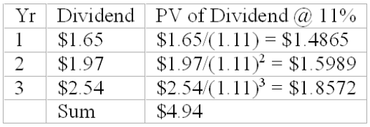
P₃ = $2.54(1.08) / (.11 - .08) = $91.44; PV of P₃ = $91.44/(1.08)³ = $72.5880; P_{O} = $4.94 + $72.59 = $77.53.

Difficulty: Difficult
70. Exercise Bicycle Company is expected to pay a dividend in year 1 of $1.20, a dividend in year 2 of $1.50, and a dividend in year 3 of $2.00. After year 3, dividends are expected to grow at the rate of 10% per year. An appropriate required return for the stock is 14%. The stock should be worth _______ today.
A. $33.00
B. $39.86
C. $55.00
D. $66.00
E. $40.68
Calculations are shown in the table below.
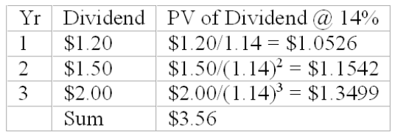
P₃ = 2 (1.10) / (.14 - .10) = $55.00; PV of P₃ = $55/(1.14)³ = $37.12; P_{O} = $3.56 + $37.12 = $40.68.

Difficulty: Difficult
71. Antiquated Products Corporation produces goods that are very mature in their product life cycles. Antiquated Products Corporation is expected to pay a dividend in year 1 of $1.00, a dividend of $0.90 in year 2, and a dividend of $0.85 in year 3. After year 3, dividends are expected to decline at a rate of 2% per year. An appropriate required rate of return for the stock is 8%. The stock should be worth ______.
A. $8.49
B. $10.57
C. $20.00
D. $22.22
E. none of the above
Calculations are shown below.
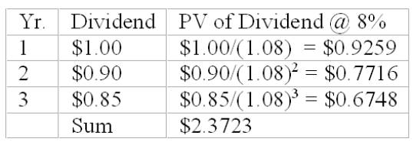
P₃ = 0.85(.98) / [.08 - (-.02)] = $8.33; PV of P3 = $8.33/(1.08)³ = $6.1226; PO = $6.1226 + $2.3723 = $8.49.

Difficulty: Difficult
72. Mature Products Corporation produces goods that are very mature in their product life cycles. Mature Products Corporation is expected to pay a dividend in year 1 of $2.00, a dividend of $1.50 in year 2, and a dividend of $1.00 in year 3. After year 3, dividends are expected to decline at a rate of 1% per year. An appropriate required rate of return for the stock is 10%. The stock should be worth ______.
A. $9.00
B. $10.57
C. $20.00
D. $22.22
E. none of the above
Calculations are shown below.
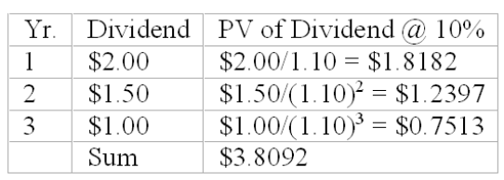
P₃ = 1.00(.99) / [.10 - (-.01)] = $9.00; PV of P3 = $9/(1.10)³ = $6.7618; PO = $6.7618 + $3.8092 = $10.57.

Difficulty: Difficult
73. Consider the free cash flow approach to stock valuation. Utica Manufacturing Company is expected to have before-tax cash flow from operations of $500,000 in the coming year. The firm's corporate tax rate is 30%. It is expected that $200,000 of operating cash flow will be invested in new fixed assets. Depreciation for the year will be $100,000. After the coming year, cash flows are expected to grow at 6% per year. The appropriate market capitalization rate for unleveraged cash flow is 15% per year. The firm has no outstanding debt. The projected free cash flow of Utica Manufacturing Company for the coming year is _______.
A. $150,000
B. $180,000
C. $300,000
D. $380,000
E. none of the above
Calculations are shown below.
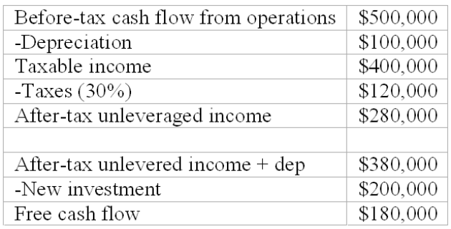

Difficulty: Difficult
74. Consider the free cash flow approach to stock valuation. Utica Manufacturing Company is expected to have before-tax cash flow from operations of $500,000 in the coming year. The firm's corporate tax rate is 30%. It is expected that $200,000 of operating cash flow will be invested in new fixed assets. Depreciation for the year will be $100,000. After the coming year, cash flows are expected to grow at 6% per year. The appropriate market capitalization rate for unleveraged cash flow is 15% per year. The firm has no outstanding debt. The total value of the equity of Utica Manufacturing Company should be
A. $1,000,000
B. $2,000,000
C. $3,000,000
D. $4,000,000
E. none of the above
Projected free cash flow = $180,000 (see test bank problem 18.73); V₀ = 180,000 / (.15 - .06) = $2,000,000.

Difficulty: Difficult
75. A firm's earnings per share increased from $10 to $12, dividends increased from $4.00 to $4.80, and the share price increased from $80 to $90. Given this information, it follows that ________.
A. the stock experienced a drop in the P/E ratio
B. the firm had a decrease in dividend payout ratio
C. the firm increased the number of shares outstanding
D. the required rate of return decreased
E. none of the above
$80/$10 = 8; $90/$12 = 7.5.

Difficulty: Moderate
76. In the dividend discount model, _______ which of the following are not incorporated into the discount rate?
A. real risk-free rate
B. risk premium for stocks
C. return on assets
D. expected inflation rate
E. none of the above
A, B, and D are incorporated into the discount rate used in the dividend discount model.

Difficulty: Moderate
77. A company whose stock is selling at a P/E ratio greater than the P/E ratio of a market index most likely has _________.
A. an anticipated earnings growth rate which is less than that of the average firm
B. a dividend yield which is less than that of the average firm
C. less predictable earnings growth than that of the average firm
D. greater cyclicality of earnings growth than that of the average firm
E. none of the above.
Firms with lower than average dividend yields are usually growth firms, which have a higher P/E ratio than average.

Difficulty: Moderate
78. Which of the following would tend to reduce a firm's P/E ratio?
A. The firm significantly decreases financial leverage
B. The firm increases return on equity for the long term
C. The level of inflation is expected to increase to double-digit levels
D. The rate of return on Treasury bills decreases
E. None of the above
In times of high inflation, earnings are inflated; thus, P/E ratios decline.

Difficulty: Moderate
79. Other things being equal, a low ________ would be most consistent with a relatively high growth rate of firm earnings and dividends.
A. dividend payout ratio
B. degree of financial leverage
C. variability of earnings
D. inflation rate
E. none of the above
Firms with high growth rates are retaining most of the earnings for growth; thus, the dividend payout ratio will be low.

Difficulty: Moderate
80. A firm has a return on equity of 14% and a dividend payout ratio of 60%. The firm's anticipated growth rate is _________.
A. 5.6%
B. 10%
C. 14%
D. 20%
E. none of the above
14% X 0.40 = 5.6%.

Difficulty: Easy
81. A firm has a return on equity of 20% and a dividend payout ratio of 30%. The firm's anticipated growth rate is _________.
A. 6%
B. 10%
C. 14%
D. 20%
E. none of the above
20% X 0.70 = 14%.

Difficulty: Easy
82. Sales Company paid a $1.00 dividend per share last year and is expected to continue to pay out 40% of earnings as dividends for the foreseeable future. If the firm is expected to generate a 10% return on equity in the future, and if you require a 12% return on the stock, the value of the stock is ________.
A. $17.67
B. $13.00
C. $16.67
D. $18.67
E. none of the above
g = 10% X 0.6 = 6%; P = 1 (1.06) / (.12 - .06) = $17.67.

Difficulty: Moderate
83. Assume that at the end of the next year, Bolton Company will pay a $2.00 dividend per share, an increase from the current dividend of $1.50 per share. After that, the dividend is expected to increase at a constant rate of 5%. If you require a 12% return on the stock, the value of the stock is ________.
A. $28.57
B. $28.79
C. $30.00
D. $31.78
E. none of the above
P₁ = 2 (1.05) / (.12 - .05) = $30.00; PV of P₁ = $30/1.12 = $26.78; PV of D₁ = 2/1.12 = 1.79; P_{O} = $26.78 + $1.79 = $28.57.

Difficulty: Difficult
84. The growth in dividends of Music Doctors, Inc. is expected to be 8%/year for the next two years, followed by a growth rate of 4%/year for three years; after this five year period, the growth in dividends is expected to be 3%/year, indefinitely. The required rate of return on Music Doctors, Inc. is 11%. Last year's dividends per share were $2.75. What should the stock sell for today?
A. $8.99
B. $25.21
C. $43.76
D. $110.00
E. none of the above
Calculations are shown below.
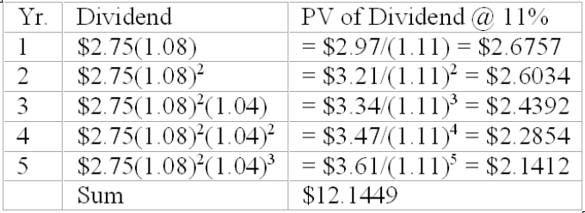
P₅ = 3.7164 / (.11 - .03) = $46.4544; PV of P₅ = $46.4544/(1.08)⁵ = $31.6161; P_{O} = $12.1449 + $31.63 = $43.76

Difficulty: Difficult
85. The growth in dividends of ABC, Inc. is expected to be 15%/year for the next three years, followed by a growth rate of 8%/year for two years; after this five year period, the growth in dividends is expected to be 3%/year, indefinitely. The required rate of return on ABC, Inc. is 13%. Last year's dividends per share were $1.85. What should the stock sell for today?
A. $8.99
B. $25.21
C. $40.00
D. $27.74
E. none of the above
Calculations are shown below.
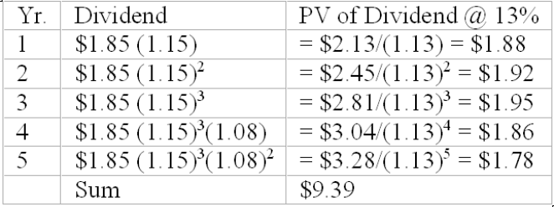

Difficulty: Difficult
86. The growth in dividends of XYZ, Inc. is expected to be 10%/year for the next two years, followed by a growth rate of 5%/year for three years; after this five year period, the growth in dividends is expected to be 2%/year, indefinitely. The required rate of return on XYZ, Inc. is 12%. Last year's dividends per share were $2.00. What should the stock sell for today?
A. $8.99
B. $25.21
C. $40.00
D. $110.00
E. none of the above
Calculations are shown below.
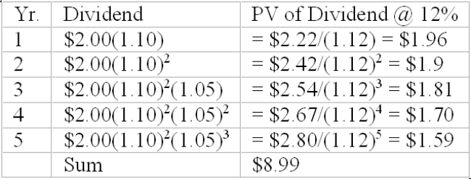
P₅ = 2.80 (1.02) / (.12 - .02) = $28.56; PV of P₅ = $28.56/(1.12)⁵ = $16.21; P_{O} = $16.20 + $8.99 = $25.21.

Difficulty: Difficult
87. If a firm's required rate of return equals the firm's return on equity, there is no advantage to increasing the firm's growth. Suppose a no-growth firm had a required rate of return and a ROE of 12% and a stock price of $40. However, if the firm is able to increase the ROE to 15% with a plowback ratio of 50%, what is the present value of growth opportunities now? (Last year's dividends were $2.00/share).
A. $9.78
B. $7.78
C. $10.78
D. $12.78
E. none of the above
g = 0.50 x 15% = 7.5%; P0 = 2 (1.075) / (.12 - .075) = $47.78; $47.78 - $40.00 = $7.78.

Difficulty: Difficult
88. If a firm has a required rate of return equal to the ROE
A. the firm can increase market price and P/E by retaining more earnings.
B. the firm can increase market price and P/E by increasing the growth rate.
C. the amount of earnings retained by the firm does not affect market price or the P/E.
D. A and B.
E. none of the above.
If required return and ROE are equal, investors are indifferent as to whether the firm retains more earnings or increases dividends. Thus, retention rates and growth rates do not affect market price and P/E.

Difficulty: Easy
89. According to James Tobin, the long run value of Tobin's Q should tend toward
A. 0.
B. 1.
C. 2.
D. infinity.
E. none of the above.
According to Tobin, in the long run the ratio of market price to replacement cost should tend toward 1.

Difficulty: Easy
90. The goal of fundamental analysts is to find securities
A. whose intrinsic value exceeds market price.
B. with a positive present value of growth opportunities.
C. with high market capitalization rates.
D. all of the above.
E. none of the above.
The goal of analysts is to find an undervalued security.

Difficulty: Easy
91. The dividend discount model
A. ignores capital gains.
B. incorporates the after-tax value of capital gains.
C. includes capital gains implicitly.
D. restricts capital gains to a minimum.
E. none of the above.
The DDM includes capital gains implicitly, as the selling price at any point is based on the forecast of future dividends.

Difficulty: Moderate
92. Many stock analysts assume that a mispriced stock will
A. immediately return to its intrinsic value.
B. return to its intrinsic value within a few days.
C. never return to its intrinsic value.
D. gradually approach its intrinsic value over several years.
E. none of the above.
Many analysts assume that mispricings may take several years to gradually correct.

Difficulty: Moderate
93. Investors want high plowback ratios
A. for all firms.
B. whenever ROE > k.
C. whenever k > ROE.
D. only when they are in low tax brackets.
E. whenever bank interest rates are high.
Investors prefer that firms reinvest earnings when ROE exceeds k.

Difficulty: Easy
94. Because the DDM requires multiple estimates, investors should
A. carefully examine inputs to the model.
B. perform sensitivity analysis on price estimates.
C. not use this model without expert assistance.
D. feel confident that DDM estimates are correct.
E. both A and B.
Small errors in input estimates can result in large pricing errors using the DDM. Therefore, investors should carefully examine input estimates and perform sensitivity analysis on the results.

Difficulty: Easy
95. According to Peter Lynch, a rough rule of thumb for security analysis is that
A. the growth rate should be equal to the plowback rate.
B. the growth rate should be equal to the dividend payout rate.
C. the growth rate should be low for emerging industries.
D. the growth rate should be equal to the P/E ratio.
E. none of the above.
A rough guideline is that P/E ratios should equal growth rates in dividends or earnings.

Difficulty: Moderate
96. For most firms, P/E ratios and risk
A. will be directly related.
B. will have an inverse relationship.
C. will be unrelated.
D. will both increase as inflation increases.
E. none of the above.
In the context of the constant growth model, the higher the risk of the firm the lower its P/E ratio.

Difficulty: Moderate
97. Dividend discount models and P/E ratios are used by __________ to try to find mispriced securities.
A. technical analysts
B. statistical analysts
C. fundamental analysts
D. dividend analysts
E. psychoanalysts
Fundamental analysts look at the basic features of the firm to estimate firm value.

Difficulty: Easy
98. Which of the following is the best measure of the floor for a stock price?
A. book value
B. liquidation value
C. replacement cost
D. market value
E. Tobin's Q
If the firm's market value drops below the liquidation value the firm will be a possible takeover target. It would be worth more liquidated than as a going concern.

Difficulty: Easy
99. Who popularized the dividend discount model, which is sometimes referred to by his name?
A. Burton Malkiel
B. Frederick Macaulay
C. Harry Markowitz
D. Marshall Blume
E. Myron Gordon
The dividend discount model is also called the Gordon model.

Difficulty: Easy
100. If a firm follows a low-investment-rate plan (applies a low plowback ratio), its dividends will be _______ now and _______ in the future than a firm that follows a high-reinvestment-rate plan.
A. higher, higher
B. lower, lower
C. lower, higher
D. higher, lower
E. It is not possible to tell.
By retaining less of its income for plowback, the firm is able to pay more dividends initially. But this will lead to a lower growth rate for dividends and a lower level of dividends in the future relative to a firm with a high-reinvestment-rate plan. Figure 18.1 illustrates this graphically.

Difficulty: Moderate
101. The present value of growth opportunities (PVGO) is equal to
I) the difference between a stock's price and its no-growth value per share.
II) the stock's price
III) zero if its return on equity equals the discount rate.
IV) the net present value of favorable investment opportunities.
A. I and IV
B. II and IV
C. I, III, and IV
D. II, III, and IV
E. III and IV
All are correct except II - the stock's price equals the no-growth value per share plus the PVGO.

Difficulty: Moderate
102. Which of the following combinations will produce the highest growth rate? Assume that the firm's projects offer a higher expected return than the market capitalization rate.
A. a high plowback ratio and a high P/E ratio
B. a high plowback ratio and a low P/E ratio
C. a low plowback ratio and a low P/E ratio
D. a low plowback ratio and a high P/E ratio
E. Neither the plowback ratio nor the P/E ratio is related to a firm's growth.
The firm will grow more rapidly if it retains earnings to invest in positive NPV projects. As for the P/E ratio's relationship to growth, the growth rate will increase as long as the projects' expected returns are higher than the market capitalization rates. If the expected returns are lower than the market capitalization rates, the growth rate will fall.

Difficulty: Moderate
103. Low P/E ratios tend to indicate that a company will _______, ceteris paribus.
A. grow quickly
B. grow at the same speed as the average company
C. grow slowly
D. P/E ratios are unrelated to growth
E. none of the above
Investors pay for growth; hence a relatively high P/E ratio for growth firms.

Difficulty: Easy
104. Earnings managements is
A. when management makes changes in the operations of the firm to ensure that earning do not increase or decrease too rapidly.
B. when management makes changes in the operations of the firm to ensure that earning do not increase too rapidly.
C. when management makes changes in the operations of the firm to ensure that earning do not decrease too rapidly.
D. the practice of using flexible accounting rules to improve the apparent profitability of the firm.
E. none of the above.
Earnings managements is the practice of using flexible accounting rules to improve the apparent profitability of the firm.

Difficulty: Easy
105. A version of earnings management that became common in the 1990s was
A. when management makes changes in the operations of the firm to ensure that earning do not increase or decrease too rapidly.
B. reporting "pro forma" earnings".
C. when management makes changes in the operations of the firm to ensure that earning do not increase too rapidly.
D. when management makes changes in the operations of the firm to ensure that earning do not decrease too rapidly.
E. none of the above.
A version of earnings management that became common in the 1990s was reporting "pro forma" earnings.

Difficulty: Easy
106. GAAP allows
A. no leeway to manage earnings.
B. minimal leeway to manage earnings.
C. considerable leeway to manage earnings.
D. earnings management if it is beneficial in increasing stock price.
E. none of the above.
GAAP allows considerable leeway to manage earnings.

Difficulty: Easy
107. The most appropriate discount rate to use when applying a FCFE valuation model is the ___________.
A. required rate of return on equity
B. WACC
C. risk-free rate
D. A or C depending on the debt level of the firm
E. none of the above
The most appropriate discount rate to use when applying a FCFE valuation model is the required rate of return on equity.

Difficulty: Easy
108. WACC is the most appropriate discount rate to use when applying a ______ valuation model.
A. FCFF
B. FCFE
C. DDM
D. A or C depending on the debt level of the firm
E. P/E
The most appropriate discount rate to use when applying a FCFF valuation model is the WACC.

Difficulty: Easy
109. The most appropriate discount rate to use when applying a FCFF valuation model is the ___________.
A. required rate of return on equity
B. WACC
C. risk-free rate
D. A or C depending on the debt level of the firm
E. none of the above
The most appropriate discount rate to use when applying a FCFF valuation model is the WACC.

Difficulty: Easy
110. The required rate of return on equity is the most appropriate discount rate to use when applying a ______ valuation model.
A. FCFF
B. FCFE
C. DDM
D. B or C
E. P/E
The most appropriate discount rate to use when applying a FCFE valuation model is the required rate of return on equity.

Difficulty: Easy
111. FCF and DDM valuations should be ____________ if the assumptions used are consistent.
A. very different for all firms
B. similar for all firms
C. similar only for unlevered firms
D. similar only for levered firms
E. none of the above
FCF and DDM valuations should be similar for all firms if the assumptions used are consistent.

Difficulty: Easy
112. Siri had a FCFE of $1.6M last year and has 3.2M shares outstanding. Siri's required return on equity is 12% and WACC is 9.8%. If FCFE is expected to grow at 9% forever, the intrinsic value of Siri's shares are ____________.
A. $68.13
B. $18.67
C. $26.35
D. $14.76
E. none of the above
$1.6M/3.2M = $0.50 FCFE per share; .50 * 1.09 = .545; .545/(.12 - .09) = 18.67

Difficulty: Moderate
113. Zero had a FCFE of $4.5M last year and has 2.25M shares outstanding. Zero's required return on equity is 10% and WACC is 8.2%. If FCFE is expected to grow at 8% forever, the intrinsic value of Zero's shares are ____________.
A. $108.00
B. $1080.00
C. $26.35
D. $14.76
E. none of the above
$4.5M/2.25M = $2.00 FCFE per share; 2.00 * 1.08 = 2.16; 2.16/(.10 - .08) = 108

Difficulty: Moderate
114. See Candy had a FCFE of $6.1M last year and has 2.32M shares outstanding. See's required return on equity is 10.6% and WACC is 9.3%. If FCFE is expected to grow at 6.5% forever, the intrinsic value of See's shares are ____________.
A. $108.00
B. $68.29
C. $26.35
D. $14.76
E. none of the above
$6.1M/2.32M = $2.6293 FCFE per share; 2.6293 * 1.065 = 2.800; 2.80/(.106 - .065) = 68.29

Difficulty: Moderate
115. SI International had a FCFE of $122.1M last year and has 12.43M shares outstanding. SI's required return on equity is 11.3% and WACC is 9.8%. If FCFE is expected to grow at 7.0% forever, the intrinsic value of SI's shares are ____________.
A. $108.00
B. $68.29
C. $244.42
D. $14.76
E. none of the above
$122.1M/12.43M = $9.823 FCFE per share; 9.823 * 1.07 = 10.51; 10.51/(.113 - .07) = 244.42

Difficulty: Moderate
116. Highpoint had a FCFE of $246M last year and has 123M shares outstanding. Highpoint's required return on equity is 10% and WACC is 9%. If FCFE is expected to grow at 8.0% forever, the intrinsic value of Highpoint's shares are ____________.
A. $21.60
B. $108
C. $244.42
D. $216.00
E. none of the above
$246M/123M = $2.00 FCFE per share; 2.00 * 1.08 = 2.16; 2.16/(.10 - .08) = 108

Difficulty: Moderate
117. SGA Consulting had a FCFE of $3.2M last year and has 3.2M shares outstanding. SGA's required return on equity is 13% and WACC is 11.5%. If FCFE is expected to grow at 8.5% forever, the intrinsic value of SGA's shares are ____________.
A. $21.60
B. $26.56
C. $244.42
D. $24.11
E. none of the above
$3.2M/3.2M = $1.00 FCFE per share; 1.00 * 1.085 = 1.085; 1.085/(.13 - .085) = 24.11

Difficulty: Moderate
118. Seaman had a FCFE of $4.6B last year and has 113.2M shares outstanding. Seaman's required return on equity is 11.6% and WACC is 10.4%. If FCFE is expected to grow at 5% forever, the intrinsic value of Seaman's shares are ____________.
A. $3,555.65
B. $355.65
C. $35.55
D. $3.55
E. none of the above
$4.6B/113.2M = $40.636 FCFE per share; 40.636 * 1.05 = 42.6678; 42.6678/(.116 - .104) = 3,555.65

Difficulty: Moderate
119. Consider the free cash flow approach to stock valuation. F&G Manufacturing Company is expected to have before-tax cash flow from operations of $750,000 in the coming year. The firm's corporate tax rate is 40%. It is expected that $250,000 of operating cash flow will be invested in new fixed assets. Depreciation for the year will be $125,000. After the coming year, cash flows are expected to grow at 7% per year. The appropriate market capitalization rate for unleveraged cash flow is 13% per year. The firm has no outstanding debt. The projected free cash flow of F&G Manufacturing Company for the coming year is _______.
A. $250,000
B. $180,000
C. $300,000
D. $380,000
E. none of the above
Calculations are shown below.
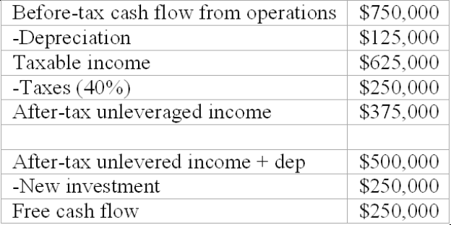

Difficulty: Difficult
120. Consider the free cash flow approach to stock valuation. F&G Manufacturing Company is expected to have before-tax cash flow from operations of $750,000 in the coming year. The firm's corporate tax rate is 40%. It is expected that $250,000 of operating cash flow will be invested in new fixed assets. Depreciation for the year will be $125,000. After the coming year, cash flows are expected to grow at 7% per year. The appropriate market capitalization rate for unleveraged cash flow is 13% per year. The firm has no outstanding debt. The total value of the equity of F&G Manufacturing Company should be
A. $1,615,156.50
B. $2,479,168.95
C. $3,333,333.33
D. $4,166,666.67
E. none of the above
Projected free cash flow = $250,000 (see test bank problem 18.119); V₀ = 250,000 / (.13 - .07) = $4,166,666.67.

Difficulty: Difficult
121. Boaters World is expected to have per share FCFE in year 1 of $1.65, per share FCFE in year 2 of $1.97, and per share FCFE in year 3 of $2.54. After year 3, per share FCFE is expected to grow at the rate of 8% per year. An appropriate required return for the stock is 11%. The stock should be worth _______ today.
A. $77.53
B. $40.67
C. $82.16
D. $66.00
E. none of the above
Calculations are shown in the table below.
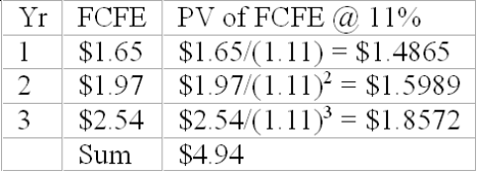
P₃ = $2.54 (1.08) / (.11 - .08) = $91.44; PV of P₃ = $91.44/(1.08)³ = $72.5880; P_{O} = $4.94 + $72.59 = $77.53.

Difficulty: Difficult
122. Smart Draw Company is expected to have per share FCFE in year 1 of $1.20, per share FCFE in year 2 of $1.50, and per share FCFE in year 3 of $2.00. After year 3, per share FCFE is expected to grow at the rate of 10% per year. An appropriate required return for the stock is 14%. The stock should be worth _______ today.
A. $33.00
B. $40.68
C. $55.00
D. $66.00
E. $12.16
Calculations are shown in the table below.
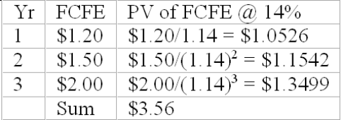
P₃ = 2 (1.10) / (.14 - .10) = $55.00; PV of P₃ = $55/(1.14)³ = $37.12; P_{O} = $3.56 + $37.12 = $40.68.

Difficulty: Difficult
123. Old Style Corporation produces goods that are very mature in their product life cycles. Old Style Corporation is expected to have per share FCFE in year 1 of $1.00, per share FCFE of $0.90 in year 2, and per share FCFE of $0.85 in year 3. After year 3, per share FCFE is expected to decline at a rate of 2% per year. An appropriate required rate of return for the stock is 8%. The stock should be worth ______.
A. $127.63
B. $10.57
C. $20.00
D. $22.22
E. 8.49
Calculations are shown below.
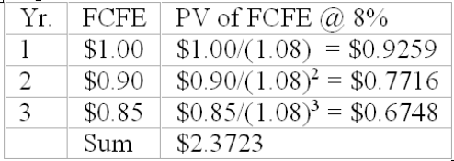
P₃ = 0.85(.98) / [.08 - (-.02)] = $8.33; PV of P3 = $8.33/(1.08)³ = $6.1226; PO = $6.1226 + $2.3723 = $8.49.

Difficulty: Difficult
124. Goodie Corporation produces goods that are very mature in their product life cycles. Goodie Corporation is expected to have per share FCFE in year 1 of $2.00, per share FCFE of $1.50 in year 2, and per share FCFE of $1.00 in year 3. After year 3, per share FCFE is expected to decline at a rate of 1% per year. An appropriate required rate of return for the stock is 10%. The stock should be worth ______.
A. $9.00
B. $101.57
C. $10.57
D. $22.22
E. 47.23
Calculations are shown below.
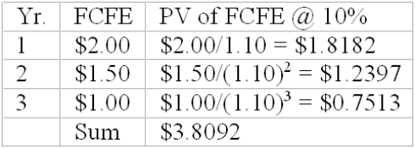
P₃ = 1.00(.99) / [.10 - (-.01)] = $9.00; PV of P3 = $9/(1.10)³ = $6.7618; PO = $6.7618 + $3.8092 = $10.57.

Difficulty: Difficult
125. The growth in per share FCFE of SYNK, Inc. is expected to be 8%/year for the next two years, followed by a growth rate of 4%/year for three years; after this five year period, the growth in per share FCFE is expected to be 3%/year, indefinitely. The required rate of return on SYNC, Inc. is 11%. Last year's per share FCFE was $2.75. What should the stock sell for today?
A. $28.99
B. $35.21
C. $54.67
D. $56.37
E. $43.76
Calculations are shown below.
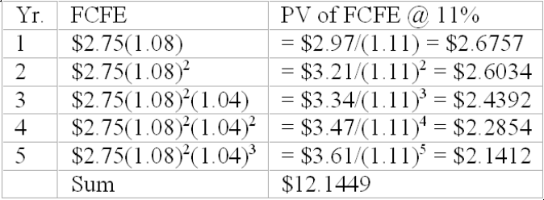
P₅ = 3.7164 / (.11 - .03) = $46.4544; PV of P₅ = $46.4544/(1.08)⁵ = $31.6161; P_{O} = $12.1449 + $31.63 = $43.76

Difficulty: Difficult
126. The growth in per share FCFE of FOX, Inc. is expected to be 15%/year for the next three years, followed by a growth rate of 8%/year for two years; after this five year period, the growth in per share FCFE is expected to be 3%/year, indefinitely. The required rate of return on FOX, Inc. is 13%. Last year's per share FCFE was $1.85. What should the stock sell for today?
A. $28.99
B. $24.47
C. $26.84
D. $27.74
E. $19.18
Calculations are shown below.
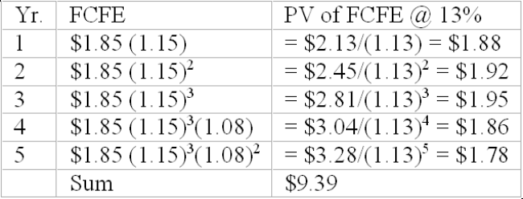
P₅ = 3.28(1.03) / (.13 - .03) = $33.80; PV of P₅ = $33.80/(1.13)⁵ = $18.35; P_{O} = $18.35 + $9.39 = $27.74.

Difficulty: Difficult
127. The growth in per share FCFE of CBS, Inc. is expected to be 10%/year for the next two years, followed by a growth rate of 5%/year for three years; after this five year period, the growth in per share FCFE is expected to be 2%/year, indefinitely. The required rate of return on CBS, Inc. is 12%. Last year's per share FCFE was $2.00. What should the stock sell for today?
A. $8.99
B. $22.51
C. $40.00
D. $25.21
E. $27.12
Calculations are shown below.
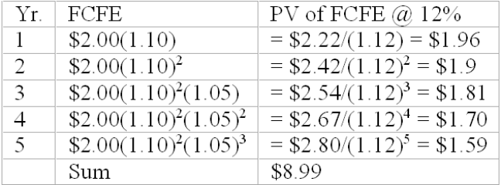
P₅ = 2.80(1.02) / (.12 - .02) = $28.56; PV of P₅ = $28.56/(1.12)⁵ = $16.21; P_{O} = $16.20 + $8.99 = $25.21.

Difficulty: Difficult
128. Stingy Corporation is expected have EBIT of $1.2M this year. Stingy Corporation is in the 30% tax bracket, will report $133,000 in depreciation, will make $76,000 in capital expenditures, and have a $24,000 increase in net working capital this year. What is Stingy's FCFF?
A. 1,139,000
B. 1,200,000
C. 1,025,000
D. 921,000
E. 873,000
FCFF = EBIT(1-T) + depreciation - capital expenditures - increase in NWC or 1,200,000(.7) + 133,000 - 76,000 - 24,000 = 873,000

Difficulty: Moderate
129. Fly Boy Corporation is expected have EBIT of $800k this year. Fly Boy Corporation is in the 30% tax bracket, will report $52,000 in depreciation, will make $86,000 in capital expenditures, and have a $16,000 increase in net working capital this year. What is Fly Boy's FCFF?
A. 510,000
B. 406,000
C. 542,000
D. 596,000
E. 682,000
FCFF = EBIT(1-T) + depreciation - capital expenditures - increase in NWC or 800,000(.7) + 52,000 - 86,000 - 16,000 = 510,000

Difficulty: Moderate
130. Lamm Corporation is expected have EBIT of $6.2M this year. Lamm Corporation is in the 40% tax bracket, will report $1.2M in depreciation, will make $1.4M in capital expenditures, and have a $160,000 increase in net working capital this year. What is Lamm's FCFF?
A. 6,200,000
B. 6,160,000
C. 3,360,000
D. 3,680,000
E. 4,625,000
FCFF = EBIT(1-T) + depreciation - capital expenditures - increase in NWC or 6,200,000(.6) + 1,200,000 - 1,400,000 - 160,000 = 3,360,000

Difficulty: Moderate
131. Rome Corporation is expected have EBIT of $2.3M this year. Rome Corporation is in the 30% tax bracket, will report $175,000 in depreciation, will make $175,000 in capital expenditures, and have no change in net working capital this year. What is Rome's FCFF?
A. 2,300,000
B. 1,785,000
C. 1,960,000
D. 1,610,000
E. 1,435,000
FCFF = EBIT(1-T) + depreciation - capital expenditures - increase in NWC or 2,300,000(.7) + 175,000 - 175,000 - 0 = 873,000

Difficulty: Moderate

Short Answer Questions
132. Discuss the Gordon, or constant discounted dividend, model of common stock valuation. Include in your discussion the advantages, disadvantages, and assumptions of the model.
The Gordon model discounts the expected dividends for the coming year by the required rate of return on the stock minus the growth rate. The growth rate is annual growth in dividends, and is assumed to be a constant annual growth rate indefinitely. Obviously such an assumption is not likely to be met; however, if dividends are expected to grow at a fairly constant rate for a considerable period of time the model may be used. The model also assumes a constant rate of growth in earnings and in the price of the stock. As a result, the payout ratio must be constant. In reality, firms have target payout ratios, usually based on industry averages; however, firms will depart from these target ratios in order to maintain the expected level of dividends in the event of a decline in earnings. In addition, the constant growth assumes that the firm's return on equity is expected to be constant indefinitely. In general, firm's return on equity (ROE) varies considerably with the economic cycle and with other variables. Some firms, however, such a public utilities have relatively stable ROEs over time. Finally, the model requires that the required rate of return be greater than the growth rate (otherwise the denominator is negative and an undefined firm value results). In spite of these restricting assumptions, the Gordon model is widely used because the model is easy to use and understand, and, if the assumptions are not grossly violated, the model may produce a relatively valid valuation assessment.
Feedback: The purpose of this question is to ascertain whether the student understands the Gordon model, the restrictions of the model, and why the model continues to be used extensively in spite of the restricting assumptions.

Difficulty: Moderate
133. The price/earnings ratio, or multiplier approach, may be used for stock valuation. Explain this process and describe how the "multiplier" varies from the one available in the stock market quotation pages.
The price earnings ratio used for stock valuation should be the predicted price/earnings ratio. That is, the ratio of the current price of the stock divided by the expected earnings per share for the coming year. Thus, the ratio is the stock price as a percentage of expected earnings. All valuation models should be based on what the investor is expecting to receive in the coming period, not upon what past investors have received. Such a forecasted price/earnings ratio is published in Value Line. The analyst/investor can simplistically multiply the value of that published ratio by the forecasted earnings per share (also published by Value Line), the forecasted earnings per share numbers cancel out; the result being the intrinsic value of the stock:
P_{O}/e₁ X e₁ = P_{O}.
Feedback: The purpose of this question is to ascertain whether the student understands the relative valuation methods.

Difficulty: Moderate
134. Discuss the relationships between the required rate of return on a stock, the firm's return on equity, the plowback rate, the growth rate, and the value of the firm.
If the firm earns more on retained earnings (equity) than the firm's cost of equity capital (required rate of return), the value of the firm's stock increases; therefore, the firm should retain more earnings, which will increase the growth rate and increase the value of the firm (share price).
If the firm earns less on retained equity than the required rate of return, and the firm increases the retention rate and the growth rate, the firm decreases firm value, as reflected by share price. In this scenario, the shareholders would prefer that the firm pay out more of earnings in dividends, which the shareholders could invest at a greater rate of return than that earned by the firm (ROE).
If the required rate of return equals the ROE, investors are indifferent between the firm's retaining earnings and paying out dividends. As a result, the retention rate and the growth rate in this scenario have no effect on firm value (stock price).
Feedback: This question is designed to ascertain the student's understanding of these relationships, which are important both from the investment and corporate finance perspectives.

Difficulty: Moderate
135. Describe the free cash flow approach to firm valuation. How does it compare to the dividend discount model (DDM)?
The free cash flow approach is an alternative to the DDM. It can be used by the firm's management in capital budgeting decisions or in valuing possible acquisition targets. First the value of the firm as a whole is estimated. Then the market value of nonequity claims is subtracted, and the result is the value of the firm's equity. The value of the firm equals the present value of expected cash flows, assuming all-equity financing, plus the net present value of the tax shields from debt financing. The discount rate used for the free cash flow approach is different from the rate used for the DDM. The free cash flow approach uses the rate suitable for unleveraged equity. The DDM discount rate appropriate for leveraged equity. The beta of the firm changes as the amount of leverage changes. The CAPM yields different required returns for leveraged and unleveraged firms.
Feedback: This question tests the student's awareness and understanding of the free cash flow approach as an alternative to the DDM.

Difficulty: Moderate

