EUP1501 – Portfolio (528588) June 2014 Samieg Adams 36052051
Section A
Below is my new amended list of MDG’s in decreasing order of priority that I see as the most important for South Africa. It hasn’t changed much from the first list that I selected, however I made 1 change that I’ll explain a bit later on.
Goal 1: Eradicate extreme poverty and hunger.
Target 1: Halve, between 1990 and 2015, the proportion of people whose income is less than USD1 a day.
Target 2: Halve, between 1990 and 2015, the proportion of people who suffer from hunger.
Goal 2: Achieve universal primary education
Target 3: Ensure that by 2015, all children, boys and girls alike will be able to complete a full course of primary schooling.
Goal 3: Combat HIV AIDS
Target 4: Have halted by 2015 and begun to reverse the spread of HIV/AIDS
Goal 4: Ensure environmental sustainability.
Target 5: Halve, by 2013 the proportion of people without sustainable access to safe drinking water
Goal 5: Improve maternal health
Target 6: Reduce by three quarters, between 1990 and 2015, the maternal mortality ratio
Goal 6: Reduce child mortality
Target 7: Reduce by two-thirds, between 1990 and 2015, the under –five mortality rate
Goal 7: Promote gender equality and empower women
Target 8: Eliminate gender disparity in primary and secondary education, preferably by 2005 and in all levels of education no later than 2015.

As you can see my list hasn’t changed much besides the Goal: Ensure environment sustainability being moved 2 places up to a higher priority. In the group discussion more than 1 person mentioned that they thought I had that goal to low on my list of priorities, however I could not initially see why people were pushing for environmental stability to be given a higher priority.
After reading through the comments I picked up that for environmental stability most people were focusing on the target of “sustainable drinking water” and I was focusing on the Target “loss of environmental resources” like farming and mining resources. When I shifted my focus to sustainable drinking water I could see why that goal had to receive a higher priority. One other target of mine that received a bit of comment was that I had ‘promote gender equality’ as my lowest priority. In this final list I have chosen not to change this and I still believe I prioritised it correctly. Don’t get me wrong I’m not sexists nor do I think that it is not important, however if you look at the other goals I can’t see it getting a higher priority.
Looking at this list, and realising that these issues are very real for a large number of South Africans it makes me appreciate my fortunate position and give thanks for everything that I have been blessed with. Does the fact that none of these issues currently affect me directly make me happy? It definitely does and I am grateful that I have escaped the dire circumstances that some people live in.
With that said, I don’t think that increased economic wealth is directly proportionate to happiness. Yes when living in poverty an increase in economic wealth will automatically make you a happier person, however once the basic human needs of food, water and security are met and increase in wealth will no longer increase happiness.

Section B
Below is my new amended list of features for myself and my grand parents
- Features that I want on my new cell phone
  - Large display, however manageable with 1 hand
  - Touch screen
  - High definition display (16M colours)
  - Processor : quad-core 2.5 GHz
  - Front and rear camera (16mp)
  - Battery life (A full days use)
  - Storage Min – 16gig internal plus micro SD option
  - 4G LTE
  - Built in heart rate monitor
  - WiFi
  - Portable hot spot (data sharing)
  - Multiple sensors: heart rate, accelerometer, gyro, proximity, compass, barometer, gesture
- Features for my grandfather’s phone
  - Durability – rugged casing
  - Water resistant
  - Basic GSM – make and receive calls/sms
  - Quick dial numbers
  - Built in radio (Not streaming)
  - Long battery life (3 Days)
  - Cost effective
- Factors
  - Adaptability
    - Myself: Used for business and pleasure (basic word processing as well as high definition gaming)
    - Grandfather: Used for communication and entertainment (Make calls and listen to the radio)
  - Ease of mastery
    - Myself: Download word processing tools you are already familiar with e.g. Microsoft word.
    - Grandfather: Limited basic functionality – pre-set features (speed dial)
  - Accessibility
    - Myself: Available in most retail and mobile phone outlets
    - Grandfather: Available in most retail and mobile phone outlets
  - Affordability
    - Myself: On face value it’s not a cheap purchase, however if you consider the functions and features of this device and the amount of other devices it can replace it definitely becomes affordable e.g. No need for a camera or watch
    - Grandfather: It should be a very basic cheap handset
  - Participatory
    - Myself: Online gaming
    - Grandfather: Text messaging
  - Transferability
    - Myself: able to Sync with your personal computer of an online account e.g. Google
    - Grandfather: Numbers can be copied to SIM and transferred to another device
My assignment didn’t get to many replies so I can’t really comment too much on what people thought of my list of features. I did however read through most of the other responses and I noticed that people all had similar features listed. What was obvious though was that many people listed all the things that they wanted to do with their phones as features.
E.g. weather icons and bible apps. To me it would be almost impossible to list every possible use of my phone as a feature. What I tried to do instead, was list all the hardware requirements that will be necessary to allow my phone to have the ability to perform any function I needed.
An example of this will be that with a high definition camera I can take photos, scan documents, use the flash as a light etc. You will notice that my list of features for my cell phone has been updated to possibly the best hardware specs currently available on a smart phone. Information courtesy of GSM ARENA http://www.gsmarena.com/samsung_galaxy_s5-6033.php
What I also noticed was that most people didn’t take cost into consideration; the phones that were being suggested for grandparent were top of the range handsets. The only reason these handsets were suggested was because they had a big screen which didn’t make sense to me. Cost is a serious consideration when buying a phone and not only the initial cost but also the cost of utilising it on a day to day basis.
I did some research and according to my broadband: http://mybroadband.co.za/news/cellular/42729-why-blackberry-rules-sa-smartphone-market.html
Blackberry is the most popular handset in South Africa and it is not because it has the best features but more because it has a cheaper data plan. This trend will soon come to end as soon as South Africa’s data rates come down, BlackBerrys market share will decrease just like in most parts of the world.

Section C



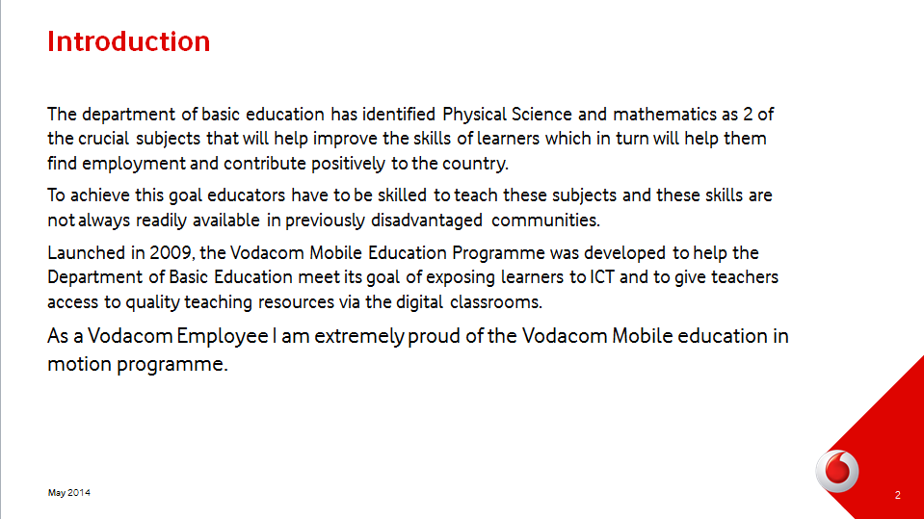

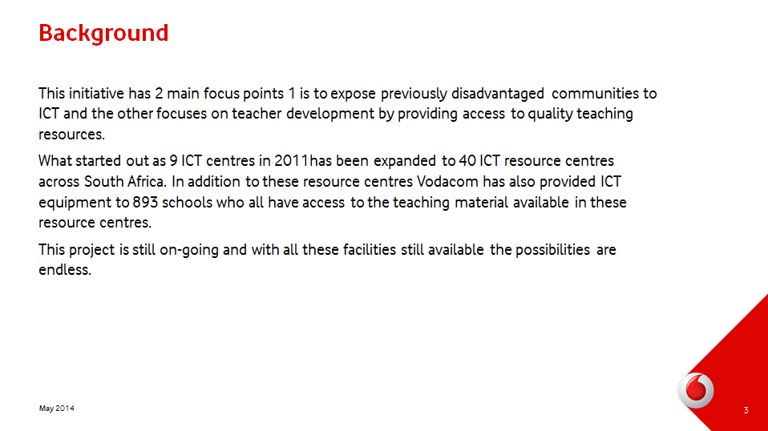

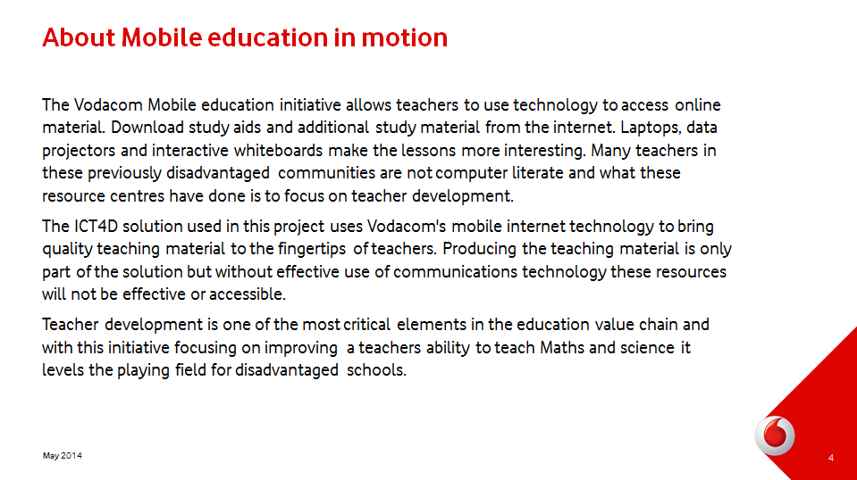

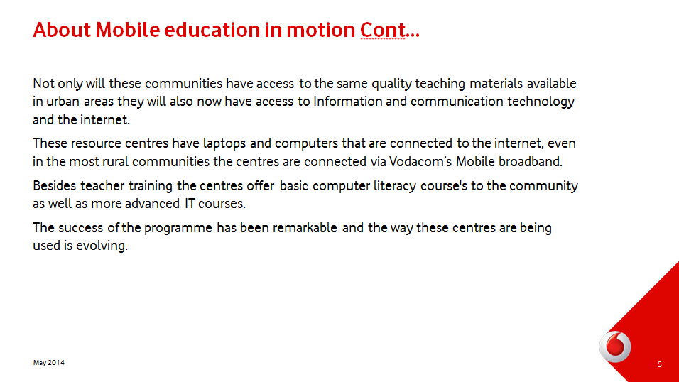

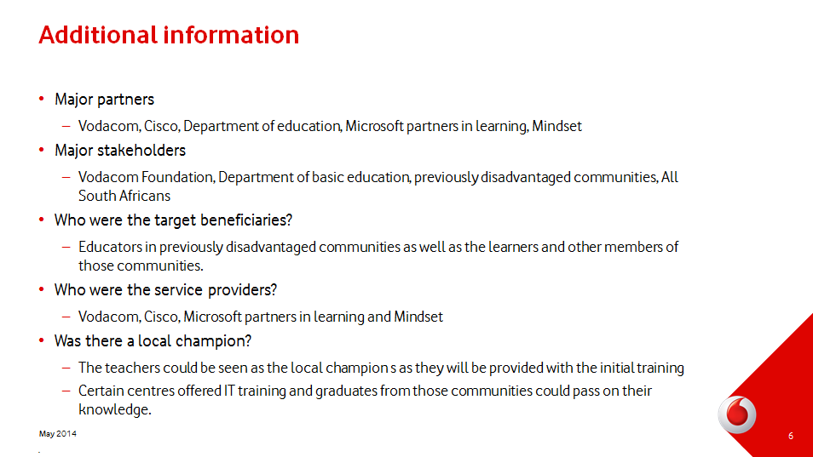

l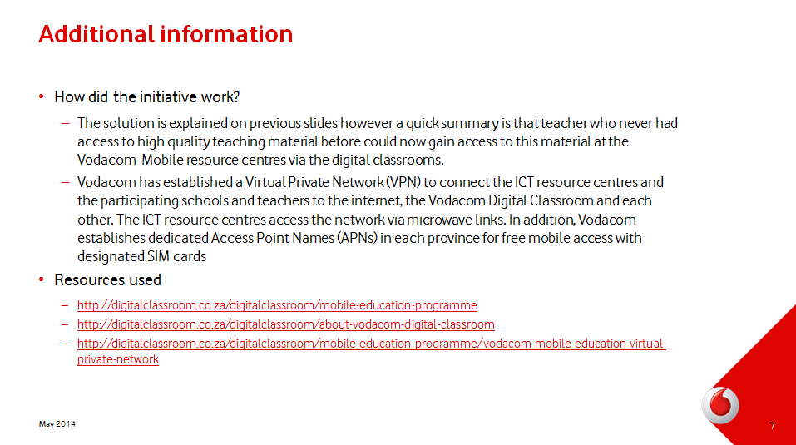

Section D
Pirated software, plagiarism and copyright infringements are all similar acts of dishonesty or unethical behaviour that is unfortunately common among people that in most cases tend not to break any other laws and generally behave in an ethical manner. University faculties are faced with students copying software needed to complete assignments, textbooks are being copied, students copy during the exams and to top it all off students pass off other people’s wok as their own when submitting assignments.
Addressing ethical and IPR issues is not easy especially in a university environment where these problems are compounded by the fact that students are working under immense stress to complete assignments and prepare for examinations. I’m not trying to make excuses for this type of behaviour; however these factors do increase the likelihood of this behaviour taking place.
Here are some steps that the university can take to try and curb this behaviour:
- Hold ethical information sessions – Yes it is common knowledge that plagiarism and other copyright infringements are not allowed, however driving the message home with regular communication and awareness sessions will help reduce the problem.
- Stop changing text books every year. Prescribed text books which are extremely expensive are being copied instead of being purchased and a contributing reason for this is that these text books change every other year. When the prescribed books change students are unable to sell the old version to make up some of the money spent on the book. No old second hand books are in circulation because students are now reluctant to buy the older version. It is understandable that books need to be changed to keep the content relevant, however from my experience these changes are so minimal that I can’t really see the point in changing them other than to earn some author a few extra bucks.
- Change assignment topics regularly – Assignment topics don’t change very often and when doing research students stumble across the assignments that they are supposed to do on the internet. If topics are changed regularly there will be less chance on students trying to pass this information off as their own.
- Put processes in place to ensure that cases of plagiarism are properly investigated and be sure that students have signed an agreement to behave in ethical manner and that they are aware of the consequences of not complying.
Dealing with students that are caught for plagiarism is complicated, the faculty needs to be 100% sure that plagiarism has taken place. There can be various reasons for work being submitted that seems to be plagiarised when it hasn’t. Plagiarism should definitely be punished, however if I was caught I would expect a fair opportunity to explain what went wrong.
The punishment for various degrees of plagiarism should vary, a student that copied an entire paper and claimed to be his own should be treated differently to a student that copied a few paragraphs without referencing the original author. Using a template as a starting point and changing most of the content is also very different to handing in someone else’s work without changing anything. Repeat offenders should also be dealt with more harshly than first time offenders. Considering what I just mentioned the consequences for plagiarism could range from expulsion, being forced to redo a course, receiving zero for the plagiarised work, to a mere warning.
Russell Hunt wrote about “Four Reasons to be Happy about Internet Plagiarism” and in that article he asked a very interesting question. Why is it that if someone wants to improve their golf score or learn to play music or create a webpage they will never consider cheating to achieve this goal. What will be the point of cheating through a music lesson because when you done you won’t be able to play any music? However university students cheat when doing assignments, maybe it’s because some of the tasks that they asked to do they will never have to repeat again? Maybe if a girl would be impressed by your music certificate and not how you actually play the guitar you might cheat to get that certificate instead of learning to play.

