Links between the diagrams
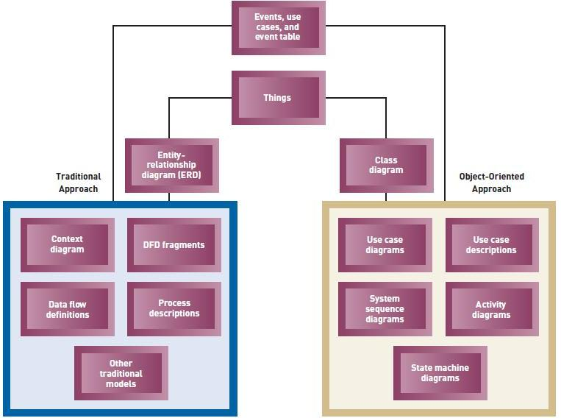

Activity Diagram
A type of workflow diagram that describes the user activities and their sequential flow. An activity diagram is simply a workflow diagram that describes the various user (or system) activities, the person who does each activity, and the sequential flow of these activities.
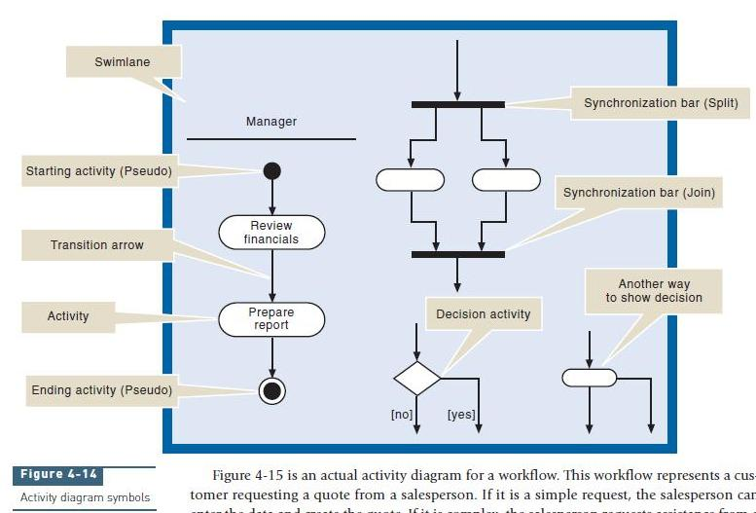

The ovals represent the individual activities in a workflow. The connecting arrows represent the sequence between the activities. The black circles are used to denote the beginning and ending of the workflow. The diamond is a decision point at which the flow of the process will either follow one path or the other path. The heavy solid line is a synchronization bar, which either splits the path into multiple concurrent paths or recombines concurrent paths. The swimlane represents an agent who performs the activities. Because in a workflow it is common to have different agents (that is, people) performing different steps of the workflow process, the swimlane symbol divides the workflow activities into groups showing which agent performs which activity.

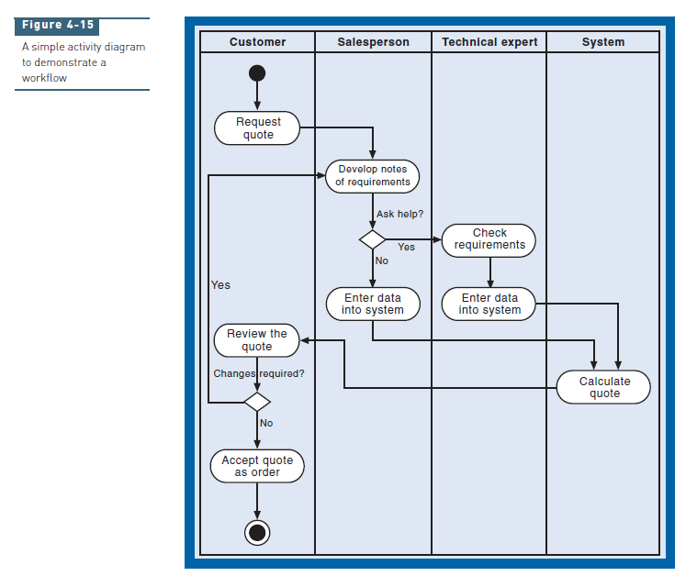
Figure 4-15 is an actual activity diagram for a workflow. This workflow represents a customer requesting a quote from a salesperson. If it is a simple request, the salesperson can enter the data and create the quote. If it is complex, the salesperson requests assistance from a technical expert to generate the quote. In both cases, the computer system calculates the details of the quote. Suppose in this case that you have interviewed the salesperson and observed the generation of a quote. Looking at Figure 4-15, you can see how the workflow progresses. The customer initiates the first step by requesting a quote. The salesperson performs the next step in the workflow. She writes down the details of the quote request and then decides whether she can do it herself or whether she needs help. If she does not need help, the salesperson enters the information into the computer system. If the salesperson needs help, the technical expert performs the next step. The expert reviews the quote request to make sure that the requested components can be integrated into a functioning computer system. The activity of checking the request is fairly complex, and you could break it down into more detailed steps if desired. For now, let’s leave the diagram at this level of detail. The expert then enters the information into the system. At this point, the computer system generates the detailed quote. Notice that no matter which path was taken, they both result in this common activity. Finally, the customer reviews the quote and decides whether it needs changes or is acceptable. In this simple case, the customer always buys something, so this workflow is obviously not completely accurate. Notice that an activity diagram focuses on the sequence of activities. This diagram is straightforward and quite easy to understand. In fact, one of the strengths of using activity diagrams to document workflows is that users also find them very easy to understand. You can use graphical representations such as this diagram to review your understanding of the particular workflow procedure with the user.

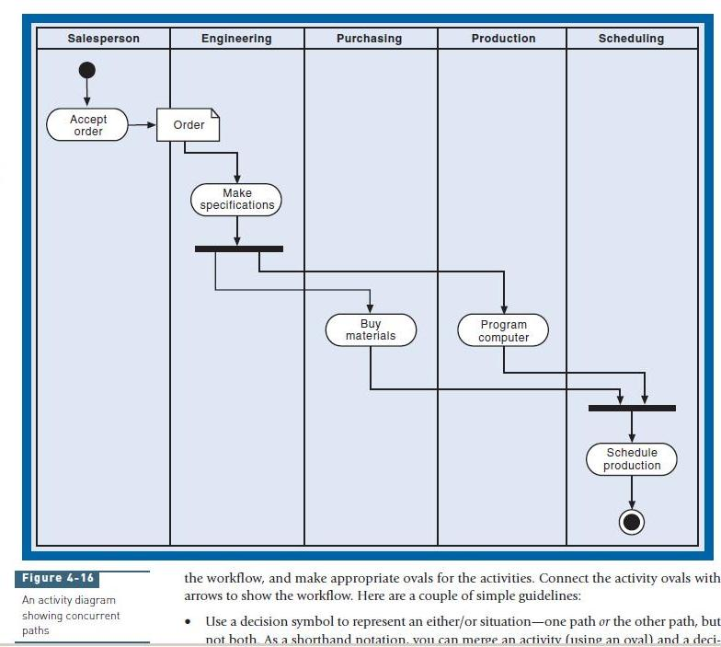
Figure 4-16 illustrates another workflow. This diagram demonstrates some new concepts. Let’s assume that the customer from the previous example did want to proceed with an order. Figure 4-16 shows the workflow that is required to get the order scheduled for production. The salesperson sends to engineering the printed quote, which has now become an order. This example emphasizes the fact that a document is being transmitted. To indicate that a document is being passed, you place the document symbol at the end of the connecting arrow, and the arrow now becomes a conduit for transmitting a document, not just a flow of activities. After engineering develops the specifications, two concurrent activities happen: purchasing orders the materials, and production writes the program for the automated milling machines. These two activities are completely independent and can occur at the same time. Notice that one synchronization bar splits the path into two concurrent paths, and another synchronization bar reconnects them. Finally, scheduling puts the order on the production schedule. Creating activity diagrams to document workflows is straightforward. The first step is to identify the agents to create the appropriate swimlanes. Next, just follow the various steps of the workflow, and make appropriate ovals for the activities. Connect the activity ovals with arrows to show the workflow. Here are a couple of simple guidelines:
• Use a decision symbol to represent an either/or situation—one path or the other path, but not both. As a shorthand notation, you can merge an activity (using an oval) and a decision (using a diamond) into a single oval with two exit arrows, as indicated on the right in Figure 4-14. This notation represents a decision (either/or) activity. Wherever you have an activity that reads “verify” or “check,” you will probably require a decision—one for the “accept” path and one for the “reject” path. You can merge either/or paths into a common activity (as in Calculate quote shown in Figure 4-15) or into other connecting arrows.
• Use synchronization bars for parallel paths—situations in which both paths are taken. Include both a beginning and ending synchronization bar. You can also use synchronization bars to represent a loop such as a “do while” programming loop. Put the bar at the beginning of the loop and describe it as “for every.” Put another synchronization bar at the end of the loop with the description “end for every.”

Fully Developed Use Case
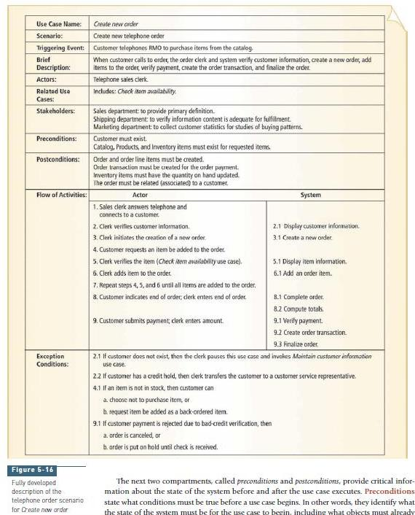
The fully developed description is the most formal method for documenting a use case. Even though it takes a little more work to define all the components at this level, it is the preferred method of describing the internal flow of activities for a use case. One of the major difficulties for software developers is that they often struggle to obtain a deep understanding of the users’ needs. But if you create a fully developed use case description, you increase the probability that you thoroughly understand the business processes and the ways the system must support them. Figure 5-16 is an example of a fully developed use case description of the telephone order scenario for the Create new order use case, and Figure 5-17 shows the Web order scenario for the same use case. Figures 5-16 and 5-17 can also serve as a standard template for documenting a fully developed description for other scenarios and use cases. The first and second compartments are used to identify the use cases and scenarios within use cases, if needed, that are being documented. In larger or more formal projects, a unique identifier can also be added for the use case, with an extension identifying the particular scenario. Sometimes the name of the system developer who produced the form is also added. The third compartment identifies the triggering event that initiates the use case from the event table. The fourth compartment is a brief description of the use case or scenario. Analysts may just duplicate the brief description they constructed earlier here. The fifth compartment identifies the actor or actors. The sixth compartment identifies other use cases and the way they are related to this use case. These cross references to other use cases help document all aspects of the users’ requirements. The stakeholders compartment identifies interested parties other than specific actors. They might be users who do not actually invoke the use case but who have an interest in results produced from the use case. For example, in Figures 5-16 and 5-17, no one in the marketing department actually creates new orders, but they do perform statistical analysis of the orders that were entered. So, marketers have an interest in the data that is captured and stored from the Create new order use case. Considering all stakeholders is an important step for system developers so that they ensure they have understood all requirements. The next two compartments, called preconditions and postconditions, provide critical information about the state of the system before and after the use case executes. Preconditions state what conditions must be true before a use case begins. In other words, they identify what the state of the system must be for the use case to begin, including what objects must already exist, what information must be available, and even the condition of the actor prior to beginning the use case. A postcondition identifies what must be true upon completion of the use case. The same items that are used to describe the precondition should be included in the statement of the postcondition. For example, during the processing of a use case that updates various financial accounts, some accounts will be out of balance. So, a postcondition for that use case would be that the updates should be complete for all accounts and that they should all be in balance. The final two compartments in the template describe the detailed flow of activities of the use case. In this instance, we have shown a two-column version, identifying the steps performed by the actor and the responses required by the system. The item numbering helps identify the sequence of the steps. Some developers prefer the one-column version, as shown at the intermediate level. Alternative activities and exception conditions are described in the final compartment. The numbering of exception conditions also helps tie the exceptions with specific steps in the use case description.
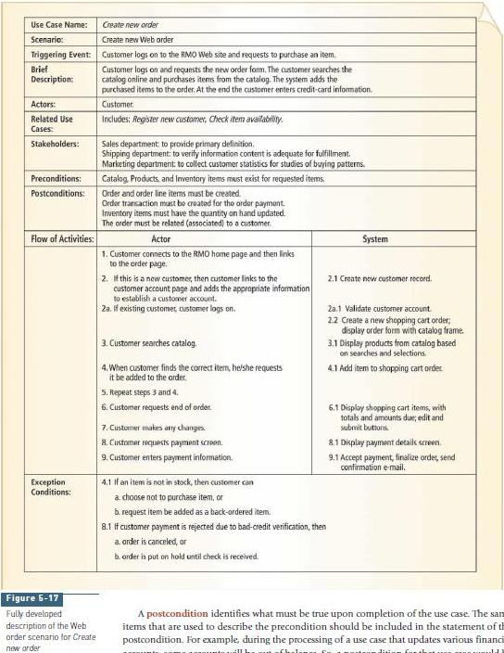

Event Tables
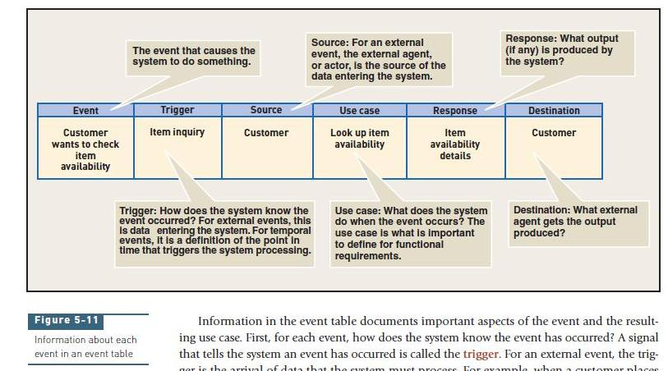
For each event, the most important information to identify is the use case to which the system needs to respond. This information can be entered in an event table. An event table includes rows and columns, representing events and their details, respectively. Each row in the event table records information about one event and its use case. Each column in the table represents a key piece of information about that event and use case. Information in the event table documents important aspects of the event and the resulting use case. First, for each event, how does the system know the event has occurred? A signal that tells the system an event has occurred is called the trigger. For an external event, the trigger is the arrival of data that the system must process. For example, when a customer places an order, the new order details are provided as input. The source of the data is also important to know. In this case, the source of the new order details is the customer—an external agent. For a temporal event, the trigger is a point in time. For example, at the end of each business day, the system knows it is time to produce transaction summary reports. Next, what does the system do when the event occurs? What the system does (the reaction to the event) is the use case. When a customer places an order, the system is used to carry out the use case Create a new order. When it is time to produce transaction summary reports, the system is used to carry out the use case Produce transaction summary reports. Finally, what response does the use case produce? A response is an output from the system. When the system produces transaction summary reports, those reports are the outputs. One use case can generate several responses. For example, when the system creates a new order, an order confirmation goes to the customer, the order details go to shipping, and a record of the transaction goes to the bank. The destination is the place where any response (output) is sent, again an external agent. Sometimes a use case generates no response at all. For example, if the customer wants to update account information, the information is recorded in the database, but no output needs to be produced. Recording information in the database is part of the use case. The list of events—together with the trigger, source, use case, response(s), and destination(s) for each event—can be placed in an event table so that the analyst can keep track of them for later use. An event table is a convenient way to record key information about the requirements for the information system. The event table for the RMO customer support system is shown in Figure 5-12. Each use case in the event table is further described with use case descriptions, as shown in the next section. Then this event table will later be used in Chapter 6 to draw data flow diagrams to define functional requirements using the traditional approach. In Chapter 7, this event table will be used to draw use case diagrams and system sequence diagrams using the object-oriented approach.
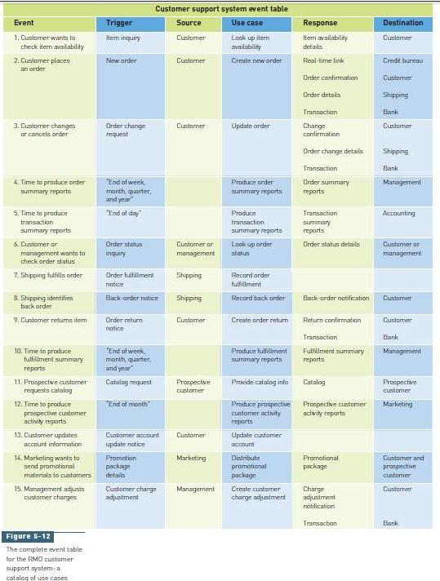
Domain Model Class Diagrams
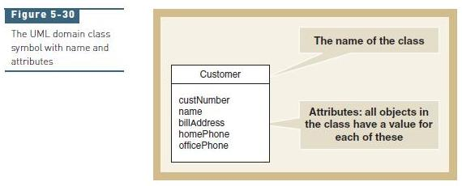
The object-oriented approach also emphasizes understanding the things involved in the user’s work. This approach models classes of objects instead of data entities. The classes of objects have attributes and associations, just like the data entities. Multiplicity (called cardinality in the traditional approach) also applies among classes. The sets of requirements models for the traditional and object-oriented approaches eventually diverge, looking quite different because of the object behavior. The design models are definitely very different. But initially, when defining requirements, the approach to modeling is similar with the object-oriented approach. The class diagram is used to show classes of objects for a system. The notation is from the Unified Modeling Language (UML), which has become the standard for models used with object oriented system development. One type of UML class diagram shows the things in the users’ work domain, referred to as the domain model class diagram. Another type of UML class diagram notation is used to create design class diagrams when designing software classes (see Chapter 11). On a class diagram, rectangles represent classes, and the lines connecting the rectangles show the associations among classes. Figure 5-30 shows a symbol for one domain class: Customer. The domain class symbol is a rectangle with two sections. The top section contains the name of the class, and the bottom section lists the attributes of the class. Class names always begin with a capital letter, and attribute names always begin with a lowercase letter. Class diagrams are drawn by showing classes and associations among classes. You will first learn about the UML notation for creating the domain model class diagram. Many of the examples used previously for the entity-relationship diagram are redrawn using UML domain class diagram notation so that you can compare them. In fact, many developers now use the UML class diagram in place of the ERD even when using the traditional approach. Later, you will learn about additional hierarchies used in domain class diagrams.

Notations:
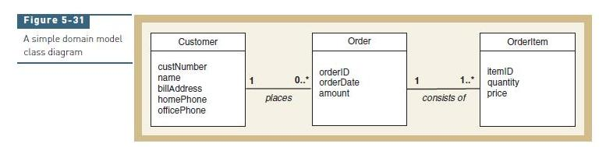
Figure 5-31 shows a simplified domain model class diagram with three classes, Customer, Order, and OrderItem. Here each class symbol includes only two sections. In the diagram notation, we see that each Customer can place many Orders, and each Order is placed by one Customer; the associations “places” and “consists of” can be included on the diagram as shown for clarity, but this detail is optional. The multiplicity is one to many in one direction and one to one in the other direction. The multiplicity notation, shown as an asterisk on the line next to the Order class, indicates “many” orders.
See Figure 5-32 below for a summary of multiplicity notation. The other association shows that an Order consists of one or more OrderItems, and each OrderItem is associated with one Order.
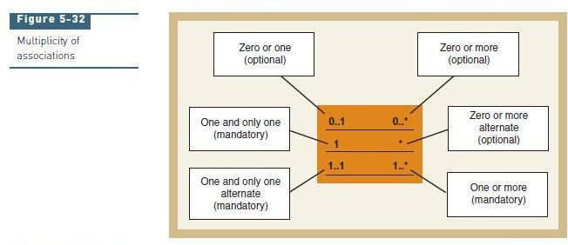
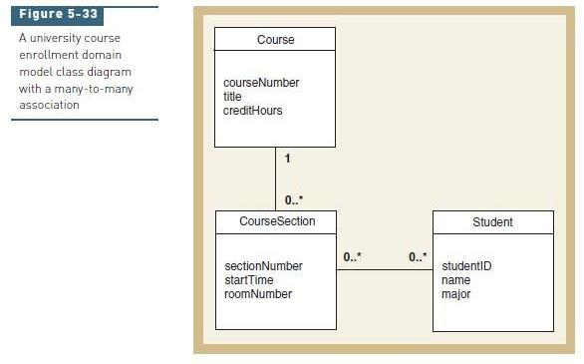
Figure 5-33 shows the initial course enrollment example as a domain model class diagram. Recall that a Course has zero or more CourseSections. Each CourseSection enrolls zero or more Students, and each Student is enrolled in zero or more CourseSections—a many-to-many association. But because each student’s grade for the section must be stored, the model must be modified, as it was in the ERD example.
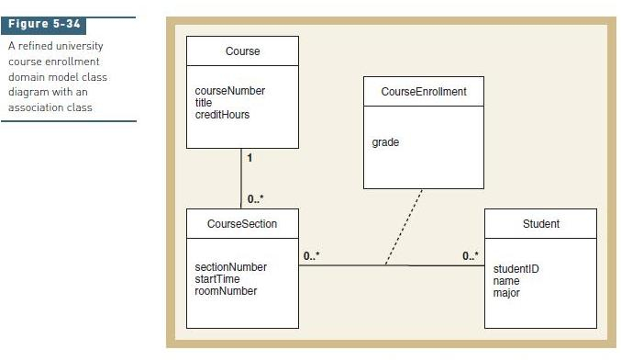
The class diagram notation adds an association class named CourseEnrollment to hold the grade attribute, as shown in Figure 5-34. A dashed line connects the association class to the association line between CourseSection and Student. Reading the associations in Figure 5-34 from left to right, the class diagram says that one course section has many course enrollments, each with its own grade, and each course enrolment applies to one specific student. Reading from right to left, it says one student has many course enrollments, each with its own grade, and each course enrollment applies to one specific course section. A system implemented on the basis of this domain model will be able to produce grade lists showing all students and their grades in each course section, as well as grade transcripts showing all grades earned by each student.

MORE COMPLEX ISSUES ABOUT CLASSES OF OBJECTS
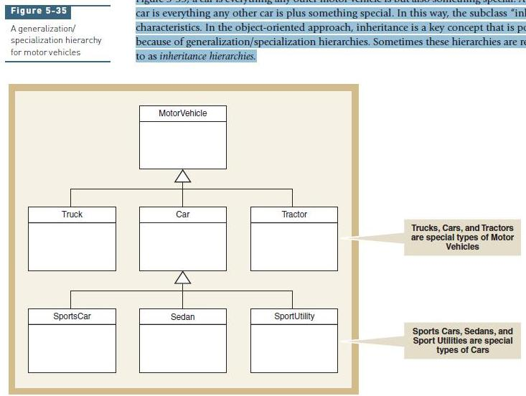
Some issues about the problem domain come up more frequently with the object-oriented approach than with the traditional approach, although the issues are not exclusively object oriented. These issues are two additional ways that people structure their understanding of things in the real world: generalization/specialization hierarchies and whole-part hierarchies. This section discusses these concepts and shows how the class diagram is used to represent them. Generalization/Specialization Generalization/specialization hierarchies are based on the idea that people classify things in terms of similarities and differences. Generalizations are judgments that group similar types of things; for example, there are many types of motor vehicles—cars, trucks, and tractors. All motor vehicles share certain general characteristics, so a motor vehicle is a more general class. Specializations are judgments that categorize different types of things—for example, special types of cars include sports cars, sedans, and sport utility vehicles. These types of cars are similar in some ways, yet different in other ways. Therefore, a sports car is a special type of car. A generalization/specialization hierarchy is used to structure or rank these things from the more general to the more special. As discussed previously, classification refers to defining classes of things. Each class of thing in the hierarchy might have a more general class above it, called a superclass. At the same time, a class might have a more specialized class below it, called a subclass. In Figure 5-35, a car has three subclasses and one superclass (MotorVehicle). UML class diagram notation uses a triangle that points to the superclass to show a generalization/specialization hierarchy. We mentioned that people structure their understanding by using generalization/specialization hierarchies. That is, people learn by refining the classifications they make about some field of knowledge. A knowledgeable banker can talk at length about special types of loans and deposit accounts. A knowledgeable merchandiser like John Blankens at Rocky Mountain Outfitters can talk at length about special types of outdoor activities and clothes. Therefore, when asking users about their work, the analyst is trying to understand the knowledge the user has about the work, which the analyst can represent by constructing generalization/specialization hierarchies. At some level, the motivation for the new customer support system at RMO started with John’s recognition that Rocky Mountain Outfitters might handle many special types of orders with a new system (Web orders, telephone orders, and mail orders). These special types of orders are shown in Figure 5-36. Inheritance allows subclasses to share characteristics of their superclasses. Returning to Figure 5-35, a car is everything any other motor vehicle is but also something special. A sports car is everything any other car is plus something special. In this way, the subclass “inherits” characteristics. In the object-oriented approach, inheritance is a key concept that is possible because of generalization/specialization hierarchies. Sometimes these hierarchies are referred to as inheritance hierarchies.
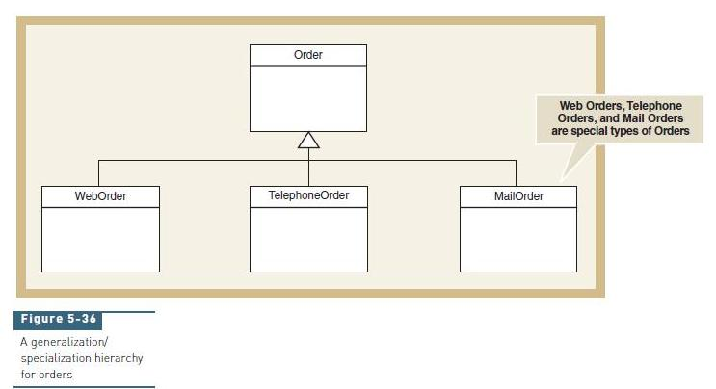
Whole-Part Hierarchies
Another way that people structure information about things is by defining them in terms of their parts. For example, learning about a computer system might involve recognizing that the computer is actually a collection of parts—processor, main memory, keyboard, disk storage, and monitor. A keyboard is not a special type of computer; it is part of a computer. Yet, it is also something entirely separate in its own right. Whole-part hierarchies capture the relationships that people make when they learn to make associations between an object and its components. There are two types of whole-part hierarchies: aggregation and composition. The term aggregation is used to describe a form of association that specifies a whole-part relationship between the aggregate (whole) and its components (parts) where the parts can exist separately. Figure 5-37 demonstrates the concept of aggregation in a computer system, showing the UML diamond symbol to represent aggregation. The term composition is used to describe whole-part relationships that are even stronger, where the parts, once associated, can no longer exist separately. The UML diamond symbol is filled in to represent composition. Whole-part hierarchies, both aggregation and composition, serve mainly to allow the analyst to express subtle distinctions about associations among classes. As with any association relationship, multiplicity can apply, such as when a computer has one or more disk storage devices. The UML class diagram examples we have seen so far are domain model class diagrams. The design class diagram is a refinement of the class diagram and is used to represent software classes in the new system.
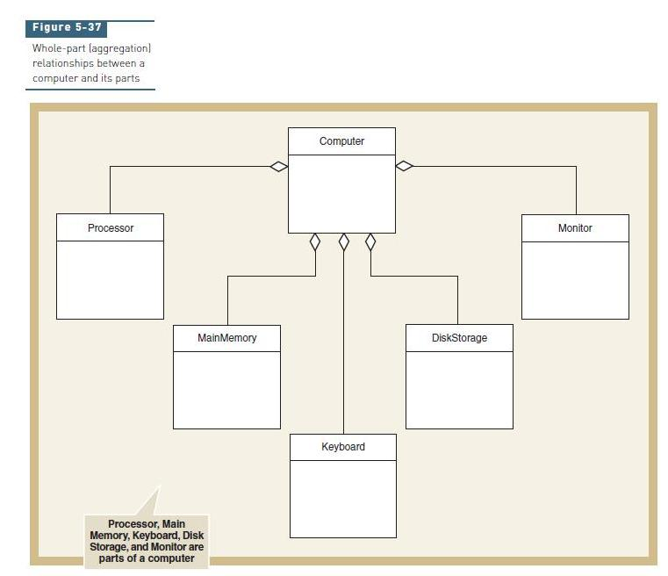

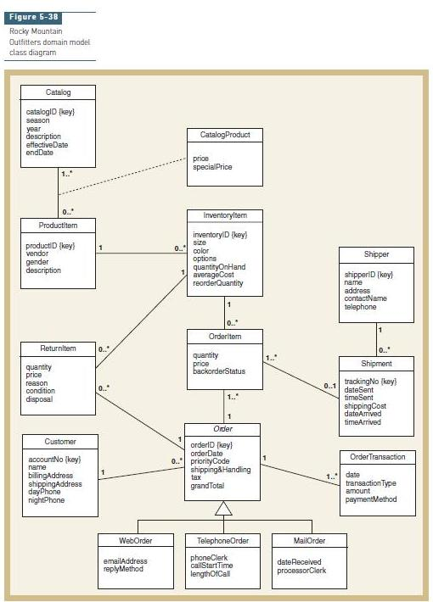
A generalization/specialization hierarchy is included to show that an order can be any one of three types—Web order, telephone order, and mail order—as discussed previously. Note that all types of orders share the attributes listed for Order, but each special type of order has some additional attributes. Order is an abstract class (the name is in italic) because any order must be one of the three special types. The other classes and associations among classes are similar to the RMO entity-relationship diagram. CatalogProduct is an association class attached to the association between Catalog and ProductItem. Multiplicity for association relationships is indicated with both minimums and maximums. No whole-part associations (aggregation or composition) are shown, although it might be argued that an OrderTransaction is part of an Order or that a ProductItem is part of a Catalog. It does not make much difference in this example because whole-part and association relationships are similar when they are implemented. Many analysts choose not to indicate aggregation or composition on class diagrams for business systems.
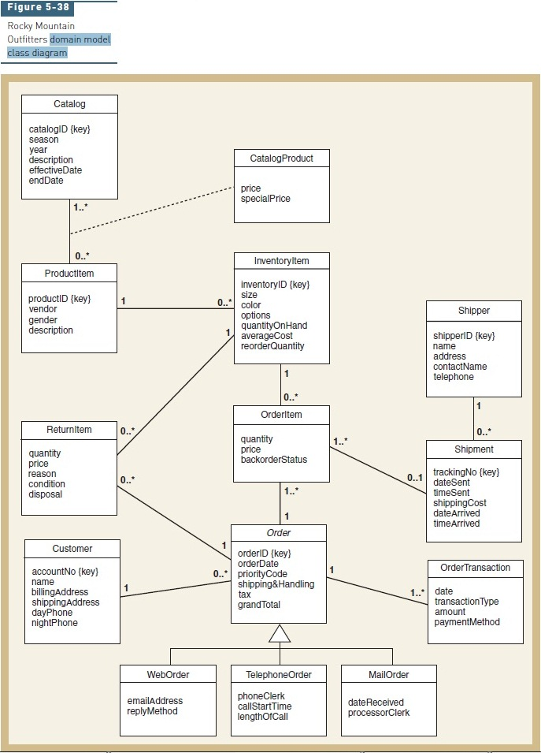
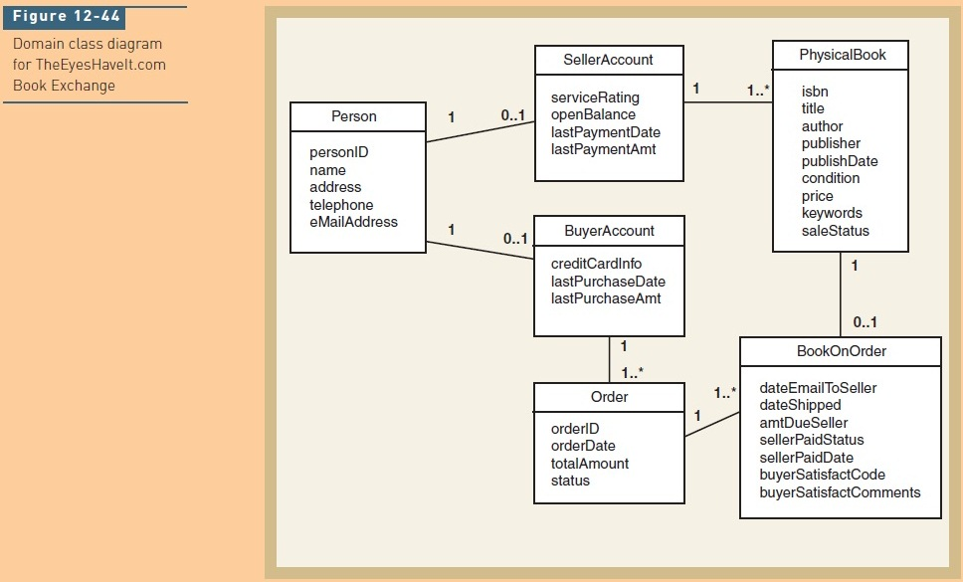
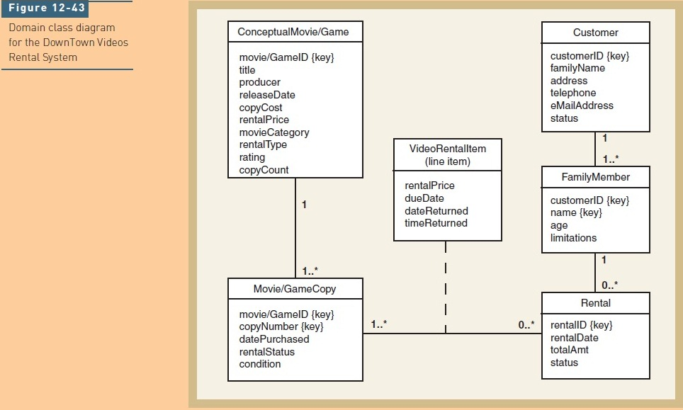

Use Case Diagrams
The purpose of a use case diagram is to identify the “uses,” or use cases, of the new system—in other words, to identify how the system will be used. The use case diagram can be derived directly from the column titled “Use case” in the event table. A use case diagram is a convenient way to document the system activities. Sometimes a single, comprehensive diagram is used to identify all use cases for an entire system. At other times, a set of smaller use case diagrams is used.
The objective of the use case model is to identify and define all of the elementary business processes that the system must support. Analysts define the use cases at two levels—an overview level and a detailed level. The event table and the use case diagrams provide an overview of all the use cases for a system. Detailed information about each use case is described with a use case description, an activity diagram, and a system sequence diagram, or a combination of these models.
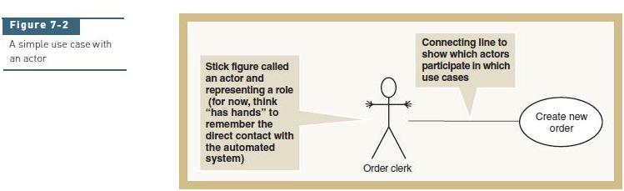
Figure 7-2 shows how a use case is documented in a use case diagram. A simple stick figure is used to represent an actor. The stick figure is given a name that characterizes the role the actor is playing. The use case itself is symbolized by an oval with the name of the use case inside. The connecting lines between actors and use cases indicate which actors invoke which use cases. Although hands are not part of the standard UML notation, the actor in this figure is drawn with hands to help you remember that this actor must have direct access to the automated system. A use case diagram is a graphical model that summarizes the information about the actors and use cases. To do use case analysis, a system developer looks at the system as a whole and tries to identify all of its major uses.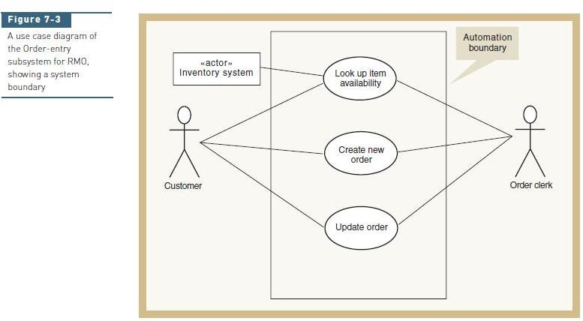
Figure 7-3 expands the use case diagram shown in Figure 7-2 to include additional use cases and additional actors. In this instance, both the order clerk and the customer are allowed to access the system directly. As indicated by the relationship lines, each person actor can use every use case. A rectangle is used to indicate an actor that is not a person. In this instance, the Inventory system actor can invoke the use case Look up item availability. A boundary line is also drawn around the entire set of use cases. This boundary is the automation boundary. It denotes the boundary between the environment, where the actors reside, and the internal components of the computer system.
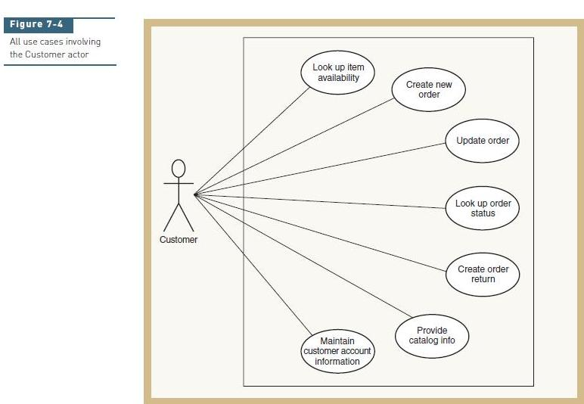
There are many ways to organize the use cases for ease of understanding and development. One way is to show all use cases that are invoked by a particular actor—that is, from the user’s viewpoint. This approach is often used during requirements definition because the systems analyst may be working with a particular user and identifying all of the functions that user performs with the system. Figure 7-4 illustrates this point of view, showing all of the use cases invoked by the Customer actor. Analysts can expand this approach to include all the use cases belonging to a particular department. During analysis, analysts focus on determining the user requirements, so organizing the use cases from the user’s viewpoint is quite beneficial. Another method of organizing use cases is from the viewpoint of a system and its subsystems. Sometimes this type of organization mirrors the user departments—focusing on accounting or warehouse operations one at a time, for example—but it does not have to do so. Instead, the system developers might want to organize the use cases by a system’s subsystems to group the development activities and team assignments. Figure 7-5 illustrates this approach, showing many of the RMO use cases organized by subsystem. In this figure, we introduce a new notation, called a package. A package groups similar components together. The package notation is a tabbed rectangle with the name of the package in the tab. In Figure 7-5, the packages indicate subsystems. This figure contains four separate subsystems, each shown as a package, and their corresponding use cases. Actors are duplicated to make the diagram easy to read; however, use cases are not duplicated because each use case belongs to only one subsystem.
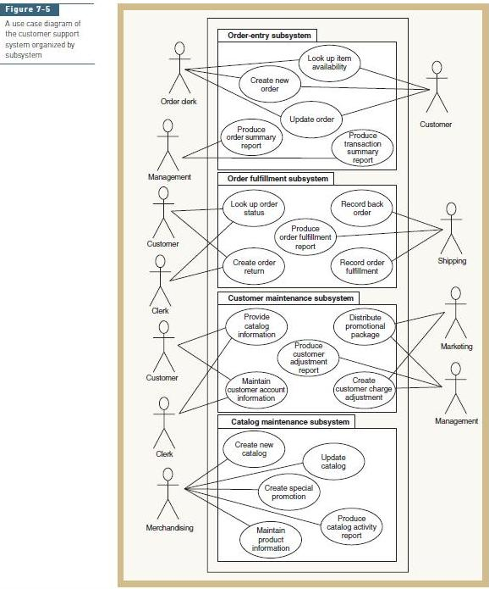

«Includes» Relationships
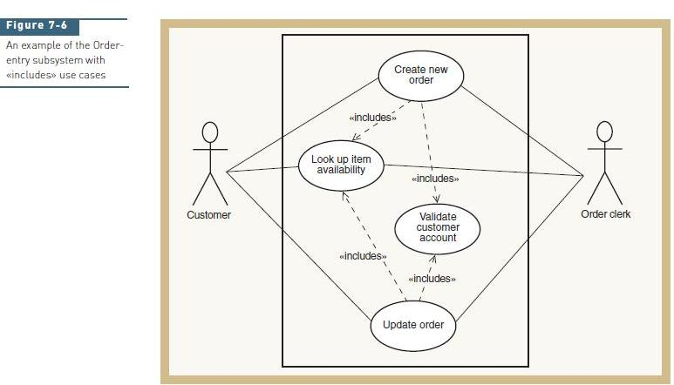
Frequently during the development of a use case diagram, it is reasonable for one use case to use the services of a common subroutine. For example, two of the Order-entry subsystem use cases are Create new order and Update order. Each of these use cases may need to validate the customer account. A common subroutine may be defined to carry out this function, and it becomes an additional use case. Figure 7-6 shows the additional use case, named Validate customer account, which is used by both the other use cases. The relationship between these use cases is denoted by the dashed connecting line with the arrow. The direction of the arrow indicates which use case is included as a part of the major use case. The relationship is read Create new order «includes» Validate customer account. Sometimes this relationship is referred to as the «includes» relationship, or sometimes as the «uses» relationship. Figure 7-6 also shows that Look up item availability can be part of an «includes» relationship. So, an analyst can define two types of «includes» use cases: one that is a common internal subroutine, such as Validate customer account, and is not directly referenced by an external actor, and one that is directly referenced by external actors. Look up item availability is an example of the latter.
DEVELOPING A USE CASE DIAGRAM
If a developer analyzed business processes and constructed an event table, he or she will use the event table to identify use cases. After additional analysis, the developer may identify a single event as a use case, combine several events to form a single use case if the processing required seems similar, or identify multiple use cases if the processing seems complex. Identification of multiple use cases usually occurs when they have the «includes» relationship and two use cases are factored out of one large use case, or when an additional use case is defined based on a common subroutine, as discussed previously. Figure 7-5, which showed the customer support subsystems, was developed using this approach. You will note that most of the use cases defined in the figure come directly from the event table shown in Figure 5-12. In fact, the names of the use cases in Figure 7-5 come from the description provided in the Use case column of the event table. There are a couple of exceptions to this pattern. Because temporal events normally also can be initiated manually, we have used the option of identifying an external actor for each temporal use case. The other exception is with event number 13, Customer updates account information. In this instance, the use case definition is expanded to include all scenarios having to do with maintaining customer information. The use case is titled Maintain customer account information to denote that it will include additions, updates, and deletions. These examples show when the use case diagram could refine the event table. If an event table has not been created, the other starting point to develop a use case diagram is to identify the actors and the elementary business processes with the user goal technique. To do so, you must remember two preconditions. First, you must make the system boundary an automated system so that the actors you identify actually contact the system—that is, have hands. Second, you must assume perfect technology. Be sure that the use cases are based on business events and not technical activities like logging on to the system or changing passwords. Given those preconditions, you can develop the use case diagram in two steps, which are done in iteration.
1. Identify the actors of the system. Note that actors are actually roles played by users. Instead of listing the actors as Bob, Mary, or Mr. Hendricks, you should identify the specific roles that these people play. Remember that the same person may play various roles as he or she uses the system. Those roles become such titles as order clerk, department manager, auditor, and so forth. It is important to be comprehensive and to identify every possible role that will use the system. Other systems can also be actors of a system, as indicated in Figure 7-3.
2. After the actor roles have been identified, the next step is to develop the list of goals those roles have in the use of the automated system. A goal is a task performed by an actor to accomplish some business function that adds value to the business. Goals are such tasks as “process a sale,” “accept a return,” or “ship an order.” Goals are units of work that can be identified and described. At the completion of the goal, the data of the system should be stable for some time.
CRUD Technique
Another important technique that you should use when developing the use case diagram directly is the CRUD technique, which compares the identified use cases with the domain model class diagram. Analysts use the CRUD technique after making an initial use case diagram to double-check their work. Recall that CRUD stands for create, read (or report), update, and delete. The CRUD technique was first introduced in Chapter 5, and it is a technique originally associated with Information Engineering (IE). The CRUD technique requires that every class in the class diagram have sufficient use cases to support creating new object instances, reading or reporting on those objects, updating those objects, and in many cases deleting object instances. The use case may not be named create or update, but the underlying process should add a new instance or update an existing instance. For example, a use case named Record payment does not explicitly indicate that a new payment object is created, but a detailed description of the use case will indicate that a new payment is created. The use case Create new order might create OrderItem objects and update InventoryItem objects. In other cases, many of the use cases are named beginning with the word maintain to cover routine additions, updates, reads, and deletions. Keep in mind, though, that with integrated systems, one system might be responsible for creating objects and another system might only update them. The CRUD technique provides a crosscheck, not a final solution, and it also provides an opportunity to confirm important system integration requirements that otherwise might not be obvious.
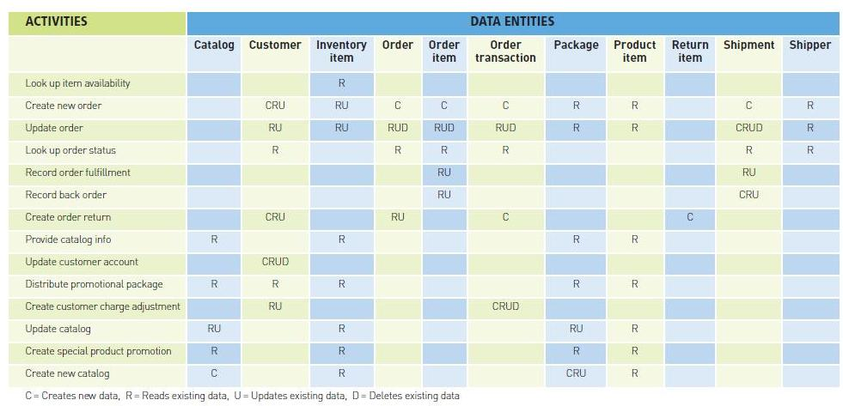

Object Oriented Databases
Object database management systems (ODBMSs) are a direct extension of the OO design and programming paradigm. ODBMSs are designed specifically to store objects and to interface with object-oriented programming languages. It is possible to store objects in files or relational databases. But there are many advantages to using an ODBMS, including direct support for method storage, inheritance, nested objects, object linking, and programmer-defined data types.
DESIGNING OBJECT DATABASES
To create an object database schema from a class diagram, follow these steps:
1. Determine which classes require persistent storage.
2. Define persistent classes.
3. Represent relationships among persistent classes.
4. Choose appropriate data types and value restrictions (if necessary) for each field.

Representing Relationships
Each object stored within an ODBMS is automatically assigned a unique object identifier. An object identifier may be a physical storage address or a reference that can be converted to a physical storage address at run time. In either case, each object has a unique identifier that can be stored within another object to represent a relationship. An ODBMS represents relationships by storing the identifier of one object within related objects. Object identifiers provide navigation visibility among objects, as first described in Chapter 11.

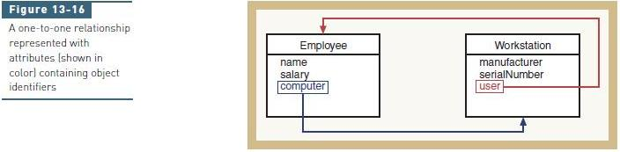

For example, consider a one-to-one relationship between the classes Employee and Workstation, as shown in Figure 13-16. Each Employee object has an attribute called computer that contains the object identifier of the Workstation object assigned to that employee. Each Workstation object has a matching attribute called user that contains the object identifier of the Employee who uses that workstation. The ODBMS uses attributes containing object identifiers to find objects that are related to other objects. The process of extracting an object identifier from one object and using it to access another object is sometimes called navigation. For example, consider the following query posed by a user:
List the manufacturer of the workstation assigned to employee Joe Smith.

An ODBMS query processor can find the requested employee object by searching all employee objects for the name attribute Joe Smith. The query processor can find Joe Smith’s workstation object by using the object identifier stored in computer. The query processor can also answer the opposite query (list the employee name assigned to a specific workstation) by using the object identifier stored in user. A matched pair of attributes enables navigation in both directions. Attributes that represent relationships are not usually specified directly by an object database schema designer. Instead, designers specify them indirectly by declaring relationships between objects. For example, consider the following class declarations for the ODL schema language:

class Employee {
attribute string name
attribute integer salary
relationship Workstation Uses
inverse Workstation::AssignedTo
}
class Workstation {
attribute string manufacturer
attribute string serialNumber
relationship Employee AssignedTo
inverse Employee::Uses
}

The keyword relationship is used to declare a relationship between one class and another. The class Employee has a relationship called Uses with the class Workstation. The class Workstation has a matching relationship called AssignedTo with the class Employee. Each relationship includes a declaration of the matching relationship in the other class using the keyword inverse, which tells the ODBMS that the two relationships are actually mirror images of one another. Declaring a relationship as shown here instead of creating an attribute containing an object identifier has two advantages:
• The ODBMS assumes responsibility for determining how to implement the connection among objects. In essence, the schema designer has declared an attribute of type relationship and left it up to the ODBMS to determine how to represent that attribute.
• The ODBMS assumes responsibility for maintaining referential integrity. For example,
deleting a workstation will cause the Uses link of the related Employee object to be set to NULL or undefined.
The ODBMS automatically creates attributes containing object identifiers to implement declared relationships. But the user and programmer are shielded from all details of how those identifiers are actually implemented and manipulated.

One-to-Many Relationships

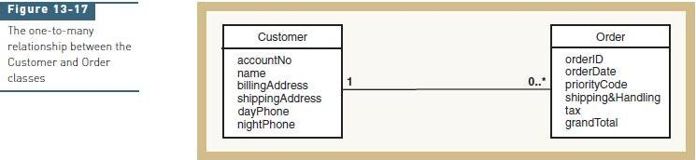

Figure 13-17 shows the one-to-many relationship between the RMO classes Customer and Order. A Customer can make many different Orders, but a single Order can be made by only one Customer. A single object identifier represents the relationship of an Order to a Customer. Multiple object identifiers represent the relationship between one Customer and many different Orders, as shown in Figure 13-18. Partial ODL class declarations for the classes Customer and Order are as follows:

class Customer {
attribute string accountNo
attribute string name
attribute string billingAddress
attribute string shippingAddress
attribute string dayPhone
attribute string nightPhone
relationship set<Order> Makes
inverse Order::MadeBy
}

class Order {
attribute string orderID
attribute string orderDate
attribute string priorityCode
attribute real shipping&Handling
attribute real tax
attribute real grandTotal
relationship Order MadeBy
inverse Customer::Makes
}

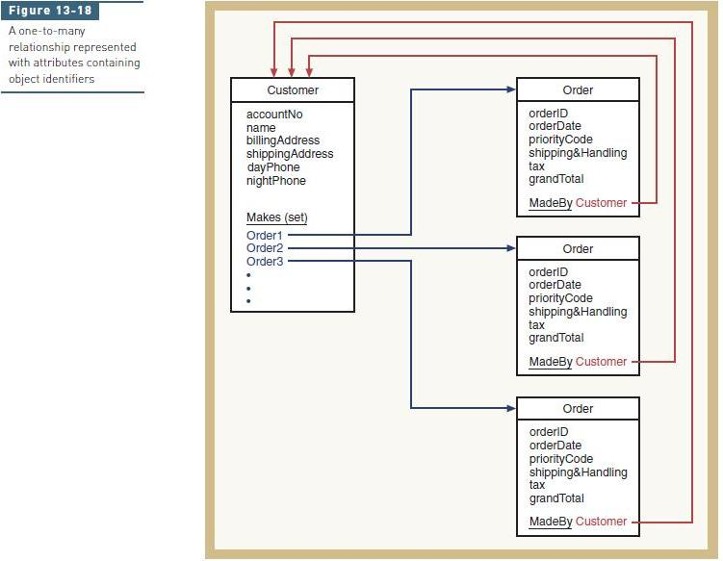

The relationship Makes is declared between a single Customer object and a set of Order objects. By declaring the relationship as a set, you instruct the ODBMS to allocate as many Order object identifier attributes to each Customer object as are needed to represent relationship instances. The ODBMS dynamically adds or deletes object identifier attributes to the set as instances of the relationship are created or deleted. The set of object identifier attributes can also be called a multivalued attribute. A multivalued attribute, also called a repeating group, is an attribute that contains zero or more instances of the same data type. Multivalued attributes are commonly supported in ODBMSs but are not supported in RDBMSs because they violate first normal form.

Many-to-Many Relationships

A many-to-many relationship is represented differently depending on whether the relationship has any attributes. Many-to-many relationships without attributes are represented as a set of object attributes in both related classes. Both classes have a multivalued attribute containing object pointers to related objects of the other class.
For example, the many-to-many relationship between Employee and Project shown in Figure 13-19 is represented as follows:

class Employee {
attribute string name
attribute string salary
relationship set<Project> WorksOn
inverse Project::Assigned
}

class Project {
attribute string projectID
attribute string description
attribute string startDate
attribute string endDate
relationship set<Employee> Assigned
inverse Employee::WorksOn
}

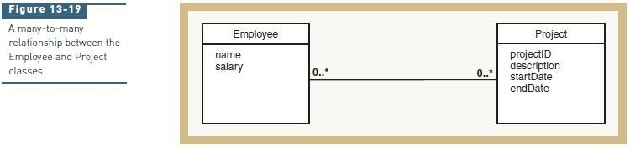

Representing a many-to-many relationship with attributes requires a more complex approach. The RMO class diagram has a many-to-many relationship between Catalog and ProductItem with an association class named CatalogProduct (see Figure 13-15). Recall from Chapter 5 that an association class is a class that stores the attributes of a many-to-many relationship.

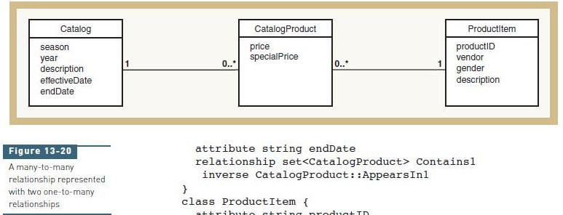

To represent a many-to-many relationship with an association class, we must reorganize the relationship as shown in Figure 13-20. The many-to-many relationship between Catalog and ProductItem has been decomposed into a pair of one-to-many relationships between the original classes and the association class. The ODL schema descriptions are as follows:

class Catalog {
attribute string season
attribute integer year
attribute string description
attribute string effectiveDate
attribute string endDate
relationship set<CatalogProduct> Contains1
inverse CatalogProduct::AppearsIn1
}
class ProductItem {
attribute string productID
attribute string vendor
attribute string gender
attribute string description
relationship set<CatalogProduct> AppearsIn2
inverse CatalogProduct::Contains2
}
class CatalogProduct {
attribute real price
attribute real specialPrice
relationship Catalog AppearsIn1
inverse Catalog::Contains1
relationship ProductItem AppearsIn2
inverse ProductItem::Contains2
}

Generalization Relationships

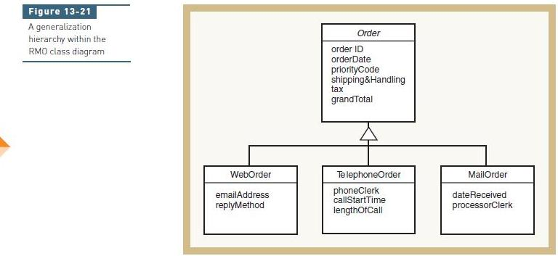

Figure 13-21 shows the order generalization hierarchy from the RMO class diagram. WebOrder, TelephoneOrder, and MailOrder are each more specific versions of the class Order. The ODL class definitions that represent these classes and their interrelationships are as follows:

class Order {
attribute string orderID
attribute string orderDate
attribute string priorityCode
attribute real shipping&Handling
attribute real tax
attribute real grandTotal
}
class WebOrder extends Order {
attribute string emailAddress
attribute string replyMethod
}
class TelephoneOrder extends Order {
attribute string phoneClerk
attribute string callStartTime
attribute integer lengthOfCall
}
class MailOrder extends Order {
attribute string dateReceived
attribute string processorClerk
}
The keyword extends indicates that WebOrder, TelephoneOrder, and MailOrder derive from Order. When stored in an object database, objects of the three derived classes will inherit all of the attributes, methods, and relationships defined for the Order class.
OBJECT DBMS DATA TYPES

ODBMSs typically provide a set of primitive and complex data types comparable to those of an RDBMS. ODBMSs also allow a schema designer to define format and value constraints. But ODBMSs provide an even more powerful way to define useful data types and constraints. A schema designer can define a new data type and its associated constraints as a new class. A class is a complex user-defined data type that combines the traditional concept of data with processes (methods) that manipulate that data. In most OO programming languages, programmers are free to design new data types (classes) that extend those already defined by the programming language. Incompatibility between system requirements and available data types is not an issue, because the designer can design classes specifically to meet the requirements. To the ODBMS, instances of the new data type are simply objects to be stored in the database. Class methods can perform many of the type- and error-checking functions previously performed by application program code and/or by the DBMS itself. In essence, the programmer constructs a “custom-designed” data type and all of the programming logic required to use it correctly. The DBMS is freed from direct responsibility for managing complex data types and the values stored therein. It indirectly performs validity checking and format conversion by extracting and executing programmer-defined methods stored in the database. The flexibility to define new data types is one reason that OO tools are so widely employed in non–business information systems. In fields such as engineering, biology, and physics, stored data is considerably more complex than simple strings, numbers, and dates. OO tools enable database designers and programmers to design custom data types that are specific to a problem domain. Another issue that must be considered during database design is the locations where data is stored and accessed. In today’s networked information systems, organizations often use distributed databases.
The System Sequence Diagram
In the object-oriented approach, the flow of information is achieved through sending messages either to and from actors or back and forth between internal objects. A system sequence diagram (SSD) is used to describe this flow of information into and out of the automated system. So, an SSD documents the inputs and the outputs and identifies the interaction between actors and the system. An SSD is a type of interaction diagram. In the following sections, and in industry practice, we often use the terms interaction and message interchangeably.

SSD NOTATION
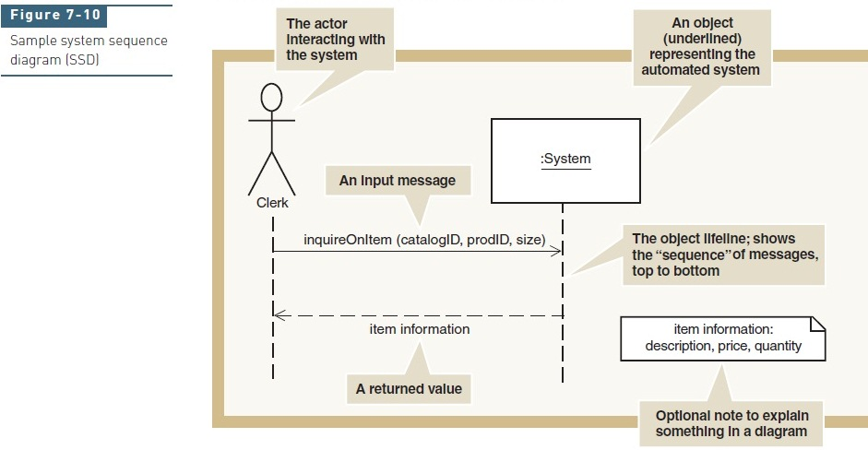

Figure 7-10 shows a generic SSD. As with a use case diagram, the stick figure represents an actor— a person (or role) that interacts with the system. In a use case diagram, the actor “uses” the system, but the emphasis in an SSD is on how the actor “interacts” with the system by entering input data and receiving output data. The idea is the same with both diagrams; the level of detail is different.
The box labeled :System is an object that represents the entire automated system. In SSDs and all interaction diagrams, analysts use object notation instead of class notation. Object notation indicates that the box refers to an individual object and not the class of all similar objects. The notation is simply a rectangle with the name of the object underlined. The colon before the underlined class name is a frequently used, but optional, part of the object notation. In an interaction diagram, the messages are sent and received by individual objects, not by a class. In an SSD, the only object included is one representing the entire system. Underneath the actor and the :System are vertical dashed lines called lifelines. A lifeline, or object lifeline, is simply the extension of that object, either actor or object, throughout the duration of the SSD. The arrows between the lifelines represent the messages that are sent or received by the actor or the system. Each arrow has an origin and a destination. The origin of the message is the actor or object that sends it, as indicated by the lifeline at the arrow’s tail. Similarly, the destination actor or object of a message is indicated by the lifeline that is touched by the arrowhead. The purpose of lifelines is to indicate the sequence of the messages sent and received by the actor and object. The sequence of messages is read from top to bottom in the diagram. A message is labeled to describe both the message’s purpose and any input data being sent. The syntax of the message label has several options; the simplest forms are shown in Figure 7-10. Remember that the arrows are used to represent both a message and input data. But what is meant by the term message here? In a sequence diagram, a message is considered
to be an action that is invoked on the destination object, much like a command. Notice in Figure 7-10 that the input message is called inquireOnItem. The clerk is sending a request, or a message to the system, to find an item. The input data that is sent with the message is contained within the parentheses, and in this case it is data to identify the particular item. The syntax is simply the name of the message followed by the input parameters in parentheses. This form of syntax is attached to a solid arrow. The returned value has a slightly different format and meaning. Notice the arrow is a dashed arrow. A dashed arrow is used to indicate a response or an answer and, as shown in the figure, it immediately follows the initiating message. The format of the label is also different. Because it is a response, only the data that is sent on the response is noted. There is no message requesting a service, only the data being returned. In this case, a valid response might be a list of all the information returned, such as description, price, and quantity of an item. However, an abbreviated version is also satisfactory. In this case, the information returned is named item information. Additional documentation is required to show the details. In Figure 7-10, this additional information is shown as a note. A note can be added to any UML diagram to add explanations. The details of item information could also be documented in supporting narratives or even simply referenced by the attributes in the Customer class.

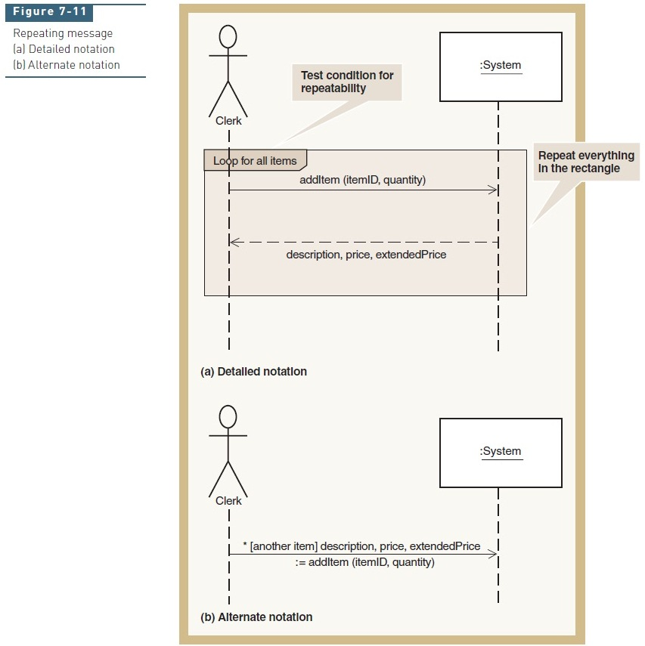

Frequently, the same message is sent multiple times. For example, when an actor enters items on an order, the message to add an item to an order may be sent multiple times. Figure 7-11(a) illustrates the notation to show this repeating operation. The message and its return are located inside a larger rectangle. In a smaller rectangle at the top of the large rectangle is the descriptive text to control the behavior of the messages within the larger rectangle. The condition loop for all items indicates that the messages in the box repeat many times or are associated with many instances. Figure 7-11(b) shows an alternate notation. The square brackets and text inside them are called a true/false condition for the messages. The asterisk (*) preceding the true/false condition indicates that the message repeats as long as the true/false condition evaluates to true. Analysts use this abbreviated notation for several reasons. First, a message and the returned data can be shown in one step. Note that the return data is identified as a return value on the left side of an assignment operator—the := sign. This alternative simply shows a value that is returned. Second, the true/false condition is placed on the message itself. Note that in this example, the true/false condition is used for the control of the loop. True/false conditions are also used to evaluate any type of test that determines whether a message is sent. For example, [credit card payment] might be used to control whether a message is sent to the system to verify a credit-card number. Finally, an asterisk is also placed on the message itself. So, for simple repeating messages, the alternate notation is shorter. However, if several messages are included within the repeat or there are multiple messages, each with its own true/false condition, the more detailed notation is more explicit and precise. The complete notation for a message is the following:
* [true/false condition] return-value := message-name (parameter-list)
Any part of the message can be omitted. In brief, the notation components are the following:

• An asterisk (*) indicates repeating or looping of the message.
• Brackets [ ] indicate a true/false condition. It is a test for that message only. If it evaluates
to true, the message is sent. If it evaluates to false, the message is not sent.
• Message-name is the description of the requested service. It is omitted on dashed-line
return messages, which only show the return data parameters.
• Parameter-list (with parentheses on initiating messages and without parentheses on
return messages) shows the data that is passed with the message.
• Return-value on the same line as the message (requires :=) is used to describe data being
returned from the destination object to the source object in response to the message.

DEVELOPING A SYSTEM SEQUENCE DIAGRAM

An SSD is normally used in conjunction with the use case descriptions to help document the details of a single use case or scenario within a use case. To develop an SSD, you will need to have a detailed description of the use case, either in the fully developed form, as shown in Figure 7-7, or as activity diagrams, as shown in Figures 7-8 and 7-9. These two models identify the series of activities within a use case, but they do not explicitly identify the inputs and outputs. An SSD will provide this explicit identification of inputs and outputs. One advantage of using activity diagrams is that it is easy to identify when an input or output occurs. Inputs and outputs occur whenever an arrow in an activity diagram goes from an external actor to the computer system. Figure 7-12 is a simplified version of Figure 7-8 for the telephone order scenario of the RMO Create new order use case. Obviously, the simplified version has many things missing, but it allows us to focus on the process without having to consider all of the complexity of the real world, and to focus on the basics of SSD development. In this simplified activity diagram, there are three swimlanes: the Customer, the Order Clerk, and the Computer System. Before beginning the SSD, you must first determine the system boundary. In this instance, the system boundary coincides with the vertical line between the Order Clerk swimlane and the Computer System swimlane. Because the purpose of the SSD is to describe the inputs to and outputs from the automated computer system, only the Order Clerk and the Computer System will be included in the SSD. It is not wrong to include both actors in the SSD, but it is more focused to show only the system and the actor who sends the inputs and receives the outputs.

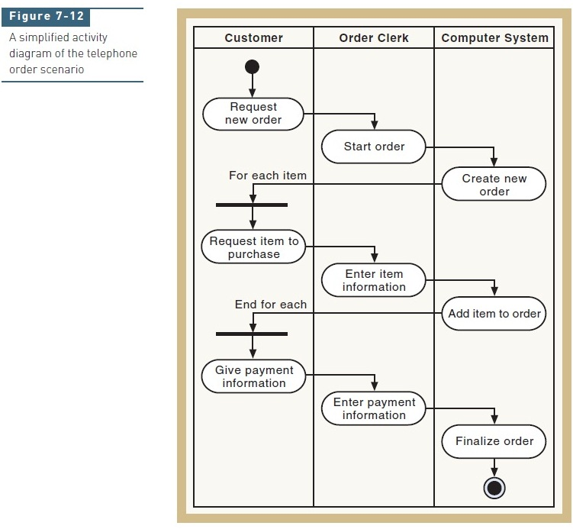

The development of an SSD based on an activity diagram can be divided into four steps:
1. Identify the input messages. In Figure 7-12, there are three locations with a workflow arrow crossing the boundary line between the clerk and the system. At each location that the workflow crosses the automation boundary, input data is required; therefore, a message is needed.
2. Describe the message from the external actor to the system using the message notation described earlier. In most cases, you will need a message name that describes the service requested from the system and the input parameters being passed. Figure 7-13, the SSD for the Create new order use case, illustrates the three messages. Notice that the names of the messages reflect the services that the actor is requesting of the system:
startOrder, addItem, and completeOrder. Other names could also have been used. For example, instead of addItem, the name could be enterItemInformation. The other information required is the parameter list for each message. Determining exactly which data items must be passed in is more difficult. In fact, developers frequently find that determining the data parameters requires several iterations before a correct, complete list is obtained. The important principle for identifying data parameters is to base it on the class diagram. In other words, the appropriate attributes from the classes are listed as parameters. Looking at the attributes, along with an understanding of what
the system needs to do, will help you find the right attributes. In the example of the first message, startOrder, the precondition for this use case states that a customer should exist. A postcondition is that the order must be connected to the customer. So, for this simplified version of the use case, the first message passes in the accountNo, which is the identifier in the customer class. Other than the accountNo, no other parameters are needed for the system to locate the existing customer details.
In the second message, addItem, parameters are needed to identify the item from the catalog and the quantity to be purchased. The parameters catalogID, prodID, and size are used to describe the inventory item that will be added to the order. The quantity field, of course, simply identifies how many. The third message, based on the activity diagram, enters the payment amount. This parameter corresponds to the amount attribute in the OrderTransaction class.
3. Identify and add any special conditions on the input messages, including iteration and true/false conditions. In this instance, the iteration box and the true/false condition associated with it are shown in square brackets.
4. Identify and add the output return messages. Remember, there are two options to show return information: either as a return value on the message itself or as a separate return message with a dashed-line arrow. The activity diagram can provide some clues about return messages, but there is no standard rule that when a transition arrow in the workflow goes from the system to an external actor, an output always occurs. In Figure 7-12, there are two arrows from the Computer System swimlane to the Customer swimlane. However, in Figure 7-13, only one output message is required. The arrow from the Create new order activity in Figure 7-12 does not require output data. In this instance, the only output identified is on the middle message showing the details of the item added to the order—the description, the price, and the extended price (the price times quantity). The other messages could possibly have shown output information such as customer name and address for the first input message, and order confirmation for the third one.

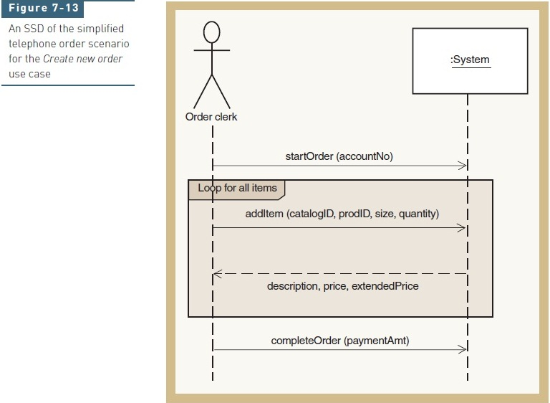

Remember that the objective is discovery and understanding, so you should be working closely with users to define exactly how the workflow proceeds and exactly what information needs to be passed in and provided as output. This is an iterative process, and you will probably need to refine these diagrams several times before they accurately reflect the needs of the users.

Example (see next page)

Let’s now develop an SSD for the Web scenario of Create new order. Not only is this example more complex, but it will highlight how to develop the requirements for deploying Webbased systems. Refer to Figure 7-9 for the activity diagram of a Web-based order. Notice that this workflow is fairly complex.
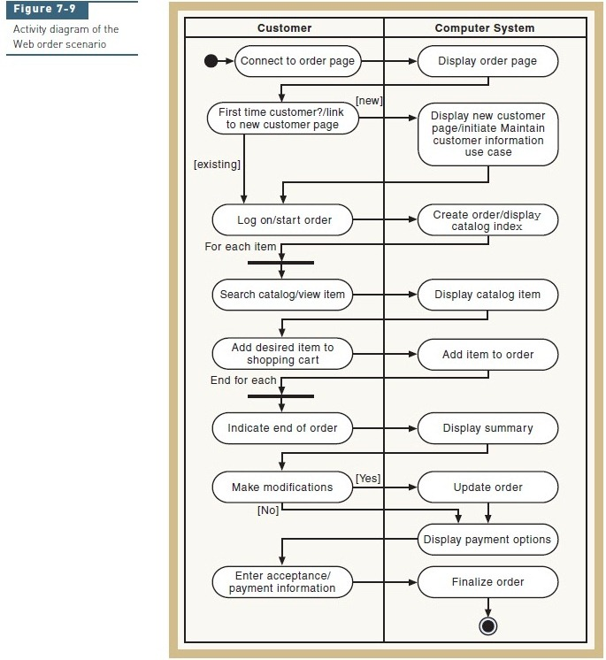
Figure 7-14 is the completed SSD for the Web-based scenario. In Figure 7-9, the workflow crosses the automated system boundary from the Customer to the Computer System eight times, some of which are optional flows. In Figure 7-14, the first message, with its response message, begins the use case by requesting the new order page (requestNewOrder). The system does not need input data to perform the processes requested by these two messages, so no input parameters are required. The next input message is a request for the new customer page (newCustomerPage). On this message, there is a true/false condition to test whether this is a new customer. Thus, the message only fires if the new customer condition evaluates to true. Because the objective of a sequence diagram is only to show the messages and not to show processing logic, there is no message to show the branching out to another use case; a simple note is added to remind the developers about that jump. The third message just allows the user to actually start an order (beginOrder). The message shows that the customer account number is an input parameter. When the user interface is actually developed, this information may already be in the system because it may be on the screen from adding a new customer. However, by showing it as an input parameter, the developers will know that it has to be available, either from the user or captured from another page. The next process is one of adding items to the order. The activity diagram in Figure 7-9 shows a loop to add items, which is captured by the iteration box. However, one of the activities in the workflow is Search catalog/view item. Even though a loop is not explicitly shown, a search normally
implies a loop of some type. So, on the input message to view a product in Figure 7-14, an asterisk has been added for iteration. The iteration box and the asterisk on the input message create a nested loop condition. Note that on these two messages, the return-value method is used to return data. The remaining messages and responses follow the activity diagram. These first sections of the chapter have explained the set of models that are used in object oriented development to specify the processing aspects of the new system. The use case diagram provides an overview of all of the events that must be supported. The scenario descriptions, as provided by written narratives or activity diagrams, give the details of the internal steps within each use case. Precondition and postcondition statements help define the context for the use case—that is, what must exist before and after processing. Finally, the system sequence diagram describes the inputs and outputs that occur within a use case. Together, these models provide a comprehensive description of the system processing requirements and give the foundation for system design.

