Discuss the purpose of a system sequence diagram (SSD) (2)

The purpose of a system sequence is used to describe the messages that flow into and out of a system. Between the user-case user and the system.

Explain the symbols that are used in a SSD (8)

A stick figure for the actor
Box with object name for the system
Vertical dashed lines for object lifelines
Horizontal arrows for messages
Horizontal dashed arrows for return messages
Comment boxes for comments
A loop : testing condition for repeatability
:= also used to indicate the return of a message when you don’t want to use return dashed horizontal arrows
Optional Frames : Optional execution
Alternative frames (if then else)

List and briefly describe the five parts of a design pattern(10)

Name | This is the name of the pattern e.g. Factory
Problem | This describes what the problem is
Solution | This describes how you can solve the problem by implementing the pattern mentioned in the name
Example | Provides a visual or code of how to implement the design pattern
Behaviour and Consequences | The resultant behaviour e.g. less coupling and more cohesion and indirection  Consequences could result it making the code incoherent or complicated or business logic is implemented here instead of the design layer.

Briefly describe the following types of classes

Controller classes (2)
This is the class that serves as the interface between the view layer and the business logic/domain layer. It serves as a switch board between the two systems

Data access classes (2)

This is the class that has the logic in the data layer to read and write to the database. It also connects to the database and disconnects from it.

What Information IS provided by use cases or a use case diagram? (2)

A use case is a way to document what users need to do with the system in order to perform a task.

What are the three key parts of an entity relationship diagram (ERD) (3)

data entities, relationships and cardinality constraints

Draw an ERD that shows

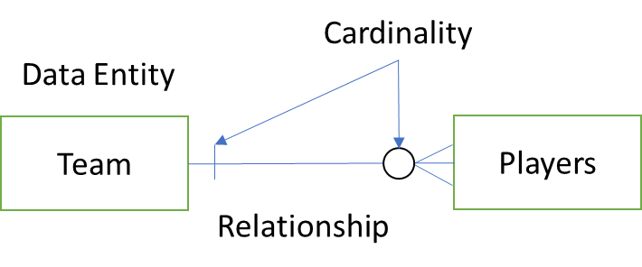

• a team has zero or more players and each player is on one and only one team (4)
• and each player IS on one and only one team
What IS the difference between an ERD and a domain model class diagram (2)

Domain model class diagrams have different notation and are used to describe classes i.e. things, relationships and cardinality/multiplicity of persistent classes that must be in the database.
An entity relationship model is very similar however it is not as detailed and good at describing real things.

Question 6
Consider the following narrative
ExchangeToday com Book Exchange is a type of e-business exchange that does business entirely on the Internet. The company acts as a clearing house for buyers and sellers of used books
To offer books for sale, a person must register with ExchangeToday com The person must provide a current physical address and telephone number as well as a current e-mail address The system then maintains an open account for this person Access to the system as a seller IS through a secure, authenticated portal
A seller can list books on the system through a special Internet form. The form asks for all the pertinent information about the book Its category, Its general condition and the asking price. A seller may list as many books as desired. The system maintains an Index of all books In the system so buyers can use the search engine to search for books. The search engine allows searches by title, author, category and keyword
People who want to buy books come to the Site and search for the books they want. When they decide to buy, they must open an account with a credit card to pay for the books. The system maintains all this information on secure servers

Complete a fully developed use case description for the Add Seller use case

Name | Add Seller
Scenario | New Seller wants to offer books for sale
Trigger | Seller wants to add books for sale on the Website
Description | Seller comes to the website. Seller wants to sell books, the system asks seller to enter information, Seller enters his information. seller account is added and seller get a confirmation email
User | Seller  Email server
Stakeholder
Precondition | Seller is not listed as a registered seller already  Seller must have details in order to register
Postcondition | An open Seller account is registered,  seller has access to system to list books
Detailed Description | - Seller comes to website and fills out a registration form. .
 | - Seller submits a registration form | - system notifies the seller that a confirmation e-mail will be sent  - System email confirmation to seller
Exceptions | Seller already exists – provide log in details via e mail  If the seller is deregistered for being having a bad reputation. A mail explaining the situation is sent and no account is created

using sing the data in the class diagram, create a database schema Please note that where It IS necessary to Indicate a primary key, underline the attribute, and where It IS necessary to indicate a foreign key, use (FK) after the attribute For Instance
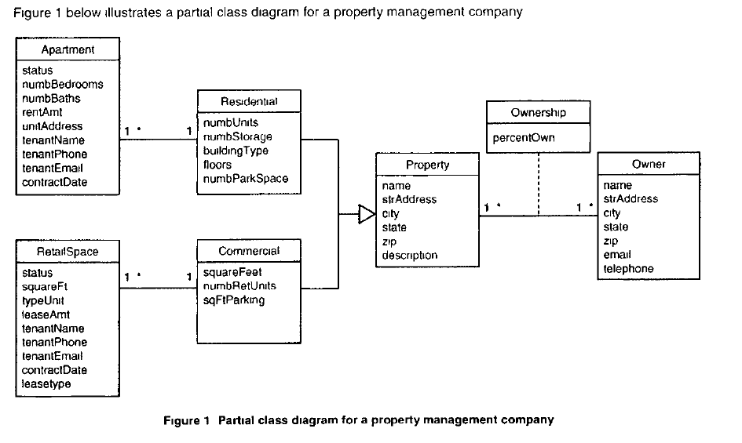
Table | Attributes
Property | PropertyID, name, strAddress, city, state, zip, description
Ownership | PropertyID, OwnerID, PropertyID(FK), OwnerID(FK), PercentOwn
Owner | OwnerID, name, strAddress, City, state, zip, email, telephone
Residential | PropertyID, numbUnits, numbstorage, buildingType,Floors, numbParkSpace
Commercial | PropertyID, squareFeet, numbRetUnits, sqFtParking
RetailSpace | RentalSpaceID, PropertyID(FK), status, squareft, typUnit, leaseAmt, tenantsName, tenantPhne, tenantEmail, contractDate, leaseType
Apartment | ApartID, PropertyID(FK), status, numbBedrooms, numbBaths, rentAmt, unitAddress, tenantName, tenantPhone, tenantEmail, contractDate

Figure 2 below shows a domain class diagram for a ticket-processing system based on four classes (Officer, Ticket, Driver and Court which Includes attributes, associations and multiplicity

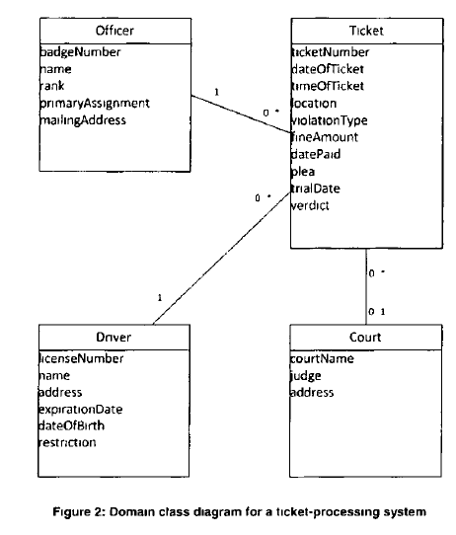

8 1 Create a set of CRC cards showing these classes, responsibilities and collaborations
8 2 Draw a design class diagram (DCD) based on your CRC cards Include method names

1st STEP |  |  | FRONT (1st Responsibility = officer) |  |  | BACK
Ticket Controller |  |  | Officer
VerifyOfficer() | Officer |  | getOfficerInfo() | TicketController
VerifyDriver() | Driver
IssueTicket() | Ticket

 |  | FRONT |  | BACK

Driver
getDriverInfo()

 |  | FRONT |  | BACK

 |  |  | Ticket
 |  |  | createTicket() | Controller

 |  | FRONT |  | BACK

 |  |  | Court
 |  |  | getCourtDate() | Ticket

