Tutorial Letter 201/2/2017

Ethics in public administration and administrative justice

PUB3707

Semester 2 module

DEPARTMENT OF PUBLIC ADMINISTRATION AND MANAGEMENT

This tutorial letter contains important
information about your module:

• COMMENTS ON ASSIGNMENTS
• EXAMINATION : OCTOBER/NOVEMBER 2017

Dear Student,

Congratulations on persevering with your studies. We trust that you have received your marked assignment(s) and have. started with your preparations for the examinations.

The purpose of this tutorial letter is to:
- provide feedback on the assignments that you submitted during the course of the semester; and
- give an indication of the format of the examination paper, the nature and extent of possible examination questions and advice on how to prepare for the examination.

1. ASSIGNMENTS

ASSIGNMENT 1: (SECTION A & B) [Multiple-choice assignment]
Assignment 1 consisted of twenty multiple choice questions on which you had to mark the correct option. The correct options are indicated below.

QUESTION | CORRECT ANSWER | QUESTION | CORRECT ANSWER
1 | 5 | 11 | 3
2 | 3 | 12 | 2
3 | 1 | 13 | 2
4 | 4 | 14 | 4
5 | 4 | 15 | 4
6 | 5 | 16 | 1
7 | 3 | 17 | 4
8 | 5 | 18 | 4
9 | 2 | 19 | 1
10 | 2 | 20 | 4

ASSIGNMENT 2: (SECTION A & B) [Multiple-choice assignment]
Assignment 2 consisted of twenty multiple choice questions on which you had to mark the correct option. The correct options are as follows:

QUESTION | CORRECT ANSWER | QUESTION | CORRECT ANSWER
1 | 3 | 11 | 4
2 | 5 | 12 | 1
3 | 4 | 13 | 3
4 | 5 | 14 | 1
5 | 1 | 15 | 4
6 | 1 | 16 | 2
7 | 4 | 17 | 2
8 | 1 | 18 | 4
9 | 2 | 19 | 4
10 | 3 | 20 | 4

ASSIGNMENT 03 (SECTION A) [Self-evaluation assignment]

Topic: Ethical guidelines for public officials.

The actions of public officials are often called unethical. What serves as a guideline for public officials to distinguish between right and wrong? Some possible guidelines are -
• the Constitution, 1996, and other laws
• policy documents
• codes of conduct.
There may be many other guidelines and you may have included them in your discussion. In an essay, you had to discuss the main aspects of this question.

You had to use Study Guide 1 (MO001) (Study unit 5), the tutorial letters and any additional sources in the compilation of this assignment. You had to use as many relevant sources as possible and not only those that appear in the lists in your tutorial matter. You had to also make use of your own examples and (motivated) opinions/insights where possible.

You should have used:
# Wessels, J.S. 2013. The Ethics of Transformation and a Representative Public Service. In: Wessels, J.S., Pauw, J.C. & Thani, X.C. (Eds.) 2014. Reflective Public Administration: Ethics. Pretoria: Unisa Press.
# Wessels, J.S. Equal employment opportunities: A conceptual puzzle. Politeia: Journal for Political Science and Public Administration. 24(2):125-141. (See article in addendum).

ASSIGNMENT 04 (SECTION B) [Self-evaluation assignment]

Question 1: Define the concept administrative justice in your own words.

You will find the answer in paragraph 1.3 of study guide 2. Administrative justice, in short, consists of those principles which the public official should comply with to be able to act in a just and fair way towards others. Make an effort to phrase this definition in your own words without losing the essential principles involved. These principles are the requirements of reasonableness, fairness, and impartiality.

Question 2: What, in your opinion, is the central problem that is evident from the newspaper clipping?

Does the treatment of Mr X by the officials concerned comply with the given definition of administrative justice? Would you agree that the central problem is that the actions of the officials are in breach of the principles of administrative justice?

Question 3: Which attitudes, on the part of the officials concerned, would be conducive to the maintenance and promotion of administrative justice?

You will find the answer in paragraph 1.6 of study guide 2. With reference to the particular situation of Mr X one should stress the importance of sensitivity on the part of the official, to the dependence and consequent vulnerability of a client (like Mr X) in obtaining a particular service. Another important attitude is a sense of reasonableness in the application of rules. The just official should also apply his or her mind to each issue. By listening with interest to each individual and seeing that he or she is treated justly, the official protects the dignity of people (like Mr X) who come into contact with the public administration.

Question 4: What is your opinion on the validity of the above response of the Department in the light of the relevant provisions of the Bill of Rights as contained in the Constitution?
The answer is in paragraphs 2.4.1 (the right to be given written reasons) and 2.5.4 (reasons for administrative action) as well as activity 2.1 of study guide 2. The Minister does have a discretion but this does not give him/her the right to withhold the reasons for the decision. It is a constitutional principle (section 33(2): 1996 Constitution) that everyone has a right to be given written reasons if such a person’s rights are adversely affected by administrative action. Section 5 of the PAJA also makes provision for a person to request written reasons from a public official where his/her rights were materially and adversely affected by administrative action. Another interesting fact is that the failure of the Minister to disclose the reasons for the decision is in breach of section 32 of the 1996 Constitution. This stipulation gives Mrs X the right of access to information held by the state where it is required for the exercise or the protection of her rights. In this case, to be informed of the reasons for the Minister’s decision to refuse her application.

Question 5: If you are of the opinion that reasons should be furnished to Mrs X by the Department, please indicate the nature of such reasons.
You will find the answer in paragraphs 2.4.1 and 2.5.4 of study guide 2. The reasons provided by the Department must be the reasons which influenced the official to take the decision in question. The reasons provided to Mrs X should therefore be both adequate and relevant to the decision in question. After all, furnishing meaningful reasons requires due consideration of and applying one's mind to a matter. Please take note also of the other criteria with which adequate reasons must comply in paragraph 2.5.4 of study guide 2.

Question 6: Would you classify the decision of the Minister as a quasi-judicial decision? Please motivate your answer.

The answer is in paragraphs 6.2 and 6.5 of study guide 2. First determine what the nature of a quasi-judicial decision is and then measure the decision of the Minister against this knowledge.

Question 7: On the basis of which measures (relevant legislation etc.) should the discretion of the Minister be evaluated to determine whether it was a valid administrative action or not? Provide a brief description of each measure.
You will find the answer in paragraph 7.7 of study guide 2. The result of the discretion of the Minister must be in accordance with the Constitution, the enabling legislation, the promotion of administrative justice act and the rules of common law.

Question 8: Could Mr X and Mrs X approach the Public Protector (Ombudsman) for assistance? Please motivate your answer.
The answer is in paragraphs 8.3(2), 9.4, and 9.5 of study guide 2. You have to determine what the jurisdiction of the Public Protector is and then provide a reasoned judgement on whether or not the behaviour of the officials and the Minister falls within the jurisdiction of the office.

2 EXAMINATION
Please take note of the format of the exam paper and the advice on how to approach the examination.

2.1 The question paper
The duration of the examination is 2 hours. The exam paper consists of two sections, each with a number of shorter and longer questions. All the questions are compulsory. Be careful with the use of time on the day: spend about 12 minutes on a 10-point question, 18 minutes on a 15-point question, et cetera. The basic principle is that you must use the mark allocation for each question to determine the length of your answer and the time you can spend on each answer.

2.2 Previous examination paper
A previous examination paper is attached for your information and to give you an idea of the kind of questions that can be expected in the examination and how an examination question is posed. Please do not assume that you will find all these questions in the next exam paper.

2.3 Preparing for the exam
To assist you in your preparation for the coming examination we are providing references to the relevant sections in the study material where answers to each of the following questions can be found. Our intention is not to provide model answers here but simply to assist you in locating the relevant sections in the study material that have direct relevance to the following examples of typical examination questions. Bear in mind that this is not intended to be an exhaustive list of possible examination questions but only examples of possible examination questions. If you use the MO001, the page numbers given in study guide 1 may differ sometimes.

STUDY GUIDE 1

- Public officials are placed in a position of trust. But what are the implications for that position of trust if an official in the service of the state receives a commission to ensure that someone who is not eligible for a state pension does receive one? [15]
See activity 1.3 in Study Guide 1 (pp 8-9).

2. Define the following concepts, distinguish them from one another and explain how they are related to public administration: ethics / Ethics [10]

See sections 3.2 and 3.3 of Study Guide 1 (pp 29-31) as well as the following parts in the book "Reflective Public Administration: Ethics, 2014": pp 4 – 7.

3. Explain the relations between a personal morality and a “public service morality” and the advantage that a clear vision of his or her personal morality has for a public official. [10]

See activity 3.2 in Study Guide 1 (pp 32-34) as well as pp 5 – 7 in the book "Reflective Public Administration: Ethics, 2014.

4. Public officials are in a position of trust with an obligation to deliver public services in an ethical manner. Discuss this statement and include the provisions of section 195 of the Constitution of the Republic of South Africa, 1996, in your discussion. ………[15]

See study unit 1, par 1.1 (pp 5-6) in Study Guide 1.

5. With reference to inter alia, the research by Hauser and Singer 2005, discuss the following statement: “People’s ethical evaluations of the same situation do not always correspond”.

See study unit 2, section 2.3 (pp 20-21) in Study Guide 1. [10]

6. Critically discuss the place of ethics in Public Administration. [20]

See section 3.3 in Study Guide 1 (pp 31-34). In the book pages 5-7, and 17-19.

7. Write an essay on the role of professionalism and professional ethics in Public Administration. [15]

See section 4.2 + 4.3 in Study Guide 1 (pp 36-40).

8. Critically discuss the role of ethical guidelines in promoting ethical conduct in the public sector. [15]
See section 5.1 in Study Guide 1 (pp 41-45).

9. Explain in a few sentences the difference between passive and active representation as explicated by Muthien. [5]
See study unit 7, section 7.4 and activity 7.3 in Study Guide 1 (pp 64-66).

10. Write an essay in which you reflect on the various ethical guidelines available for
public officials. [20]
See study unit 5, section 5.1, 5.2, 5.3, 5.4 (pp 41-43) in Study Guide 1.

STUDY GUIDE 2

1. Give a short definition of the concepts of “justice” and “administrative justice”. [10]
See section 1.2 and 1.3 on page 5 of Study Guide 2.

2. Section 33 of the 1996 Constitution reads as follows:
“33 (1) Everyone has the right to administrative action that is lawful, reasonable and procedurally fair.
(2) Everyone whose rights have been adversely affected by administrative action has the right to be given written reasons”.

(a) Give a short definition of “transparency in public administration”. [4]
(b) On what would you base an opinion that the application of section 33
does have the potential to promote transparency in public administration? [8]

(a) See section 2.6 on pages 35-36 of Study Guide 2 for a definition of “transparency”.
(b) The opinion is based on the implications of section 33(2) for public administration in general and transparency in particular. See the discussion of “The right to be given written reasons” in section 2.4.1 on pages 16-17 and of “Reasons for administrative action” in section 2.5.4 on pages 28-32 of Study Guide 2 and the implications of the right to administrative justice (section 33 of the Constitution) for public administration on pages 35-36 (section 2.6) of Study Guide 2.

3. The principle of procedural fairness of administrative action affecting members of the public (as mandated by section 4 of the Promotion of Administrative Justice Act, 3 of 2000) prescribes the following five different procedural options of which public officials must follow any one:
- Public inquiry
- Notice-and-comment procedure
- A combined procedure (public inquiry and notice and comment)
- A fair, but different, procedure
- Another appropriate procedure.

Write brief notes on each of the five procedural options. [20]
See pages 26-27 of Study Guide 2 where the five different procedural options are explained.

4. Write explanatory notes on the implications of the right to administrative justice for public administration in terms of the following:
- Accountability; and
- Public participation. [20]
See pages 36-39 of Study Guide 2 where the implications of accountability and public participation are explained in detail.

5. On what four assumptions is the trias politica based? [4]
See section 3.2 on pages 55-56 of Study Guide 2 where the four assumptions are
mentioned. Briefly explain each assumption.

6. Write an essay on the status of the Constitution of the Republic of South Africa, 1996.
See section 2.3 on pages 12-13 of Study Guide 2. [15]

7. To what extent is the theory of the trias politica followed in South Africa? [8]
See section 3.2 on pages 55-56 of Study Guide 2 where the four assumptions on which the trias politica is based, is described. Examine now the extent to which South Africa complies with each of the four basic assumptions (see section 3.4 on pages 56-58 of Study Guide 2).

8. Section 195(1) of the 1996 Constitution deals with the basic values and principles governing public administration and reads as follows:

“(d) Services must be provided impartially, fairly, equitably and without bias.
(e) People’s needs must be responded to, and the public must be encouraged to
participate in policy-making.
(f) Public administration must be accountable.
(g) Transparency must be fostered by providing the public with timely, accessible
and accurate information” [our italics].

Write brief notes on how the application of the right to administrative justice (section 33 of the 1996 Constitution) can contribute to the fulfilment of the values and principles mentioned in subsections (d) - (g) of section 195(1) of the 1996 Constitution. [10]

See section 2.4 on page 14 of Study Guide 2 where the contents of section 33 of the 1996 Constitution is mentioned to get an idea of what the scope of administrative justice is. Now use the information in the rubrics on “interpretation of section 33" (section 2.4.1 on pages 14 to 18 of Study Guide 2) and “implications of the right to administrative justice for public administration” (section 2.6 on pages 35-42 of Study Guide 2) to illustrate how the values and principles of fairness, equitability, participation, accountability, and transparency are applied in public administration to give effect to the constitutional obligation of administrative justice.

9. Write brief notes on the following:
(a) What is administrative discretion? [5]
(b) How is administrative discretion exercised? [5]

(a) See section 7.3, page 96, Study Guide 2, for the meaning of administrative discretion.
(b) See section 7.4 on pages 96 and 97 of Study Guide 2 where an explanation of how administrative discretion is exercised is provided.

10. Write brief notes on the jurisdiction of the Public Protector. [7]
See section 9.5 on page 121 of Study Guide 2 for the jurisdiction of the Public Protector.

11. Using the yardstick of the general characteristics of a classic ombudsman, assess the nature and essence of the office of Public Protector so as to evaluate the extent to which the Public Protector performs the role of an ombudsman institution. [15]

See section 8.3 on pages 108 to 110 of Study Guide 2 for a brief description of the ten general characteristics of a classic ombudsman. Use the information provided on the Public Protector in Study Unit 9 (pages 117-122 of Study Guide 2) to evaluate the extent to which the Public Protector performs the role of an ombudsman institution.

3. Concluding remarks on the examination

The Examination department of Unisa (telephone number (012 429-4122) will inform you shortly of the examination date and examination centre.

Finally, we would like to wish you all the best for the examinations!

Prof M Van Heerden 012 429 6749 vheerm@unisa.ac.za
Prof DJ Brynard 012 429 6393 brynadj@unisa.ac.za

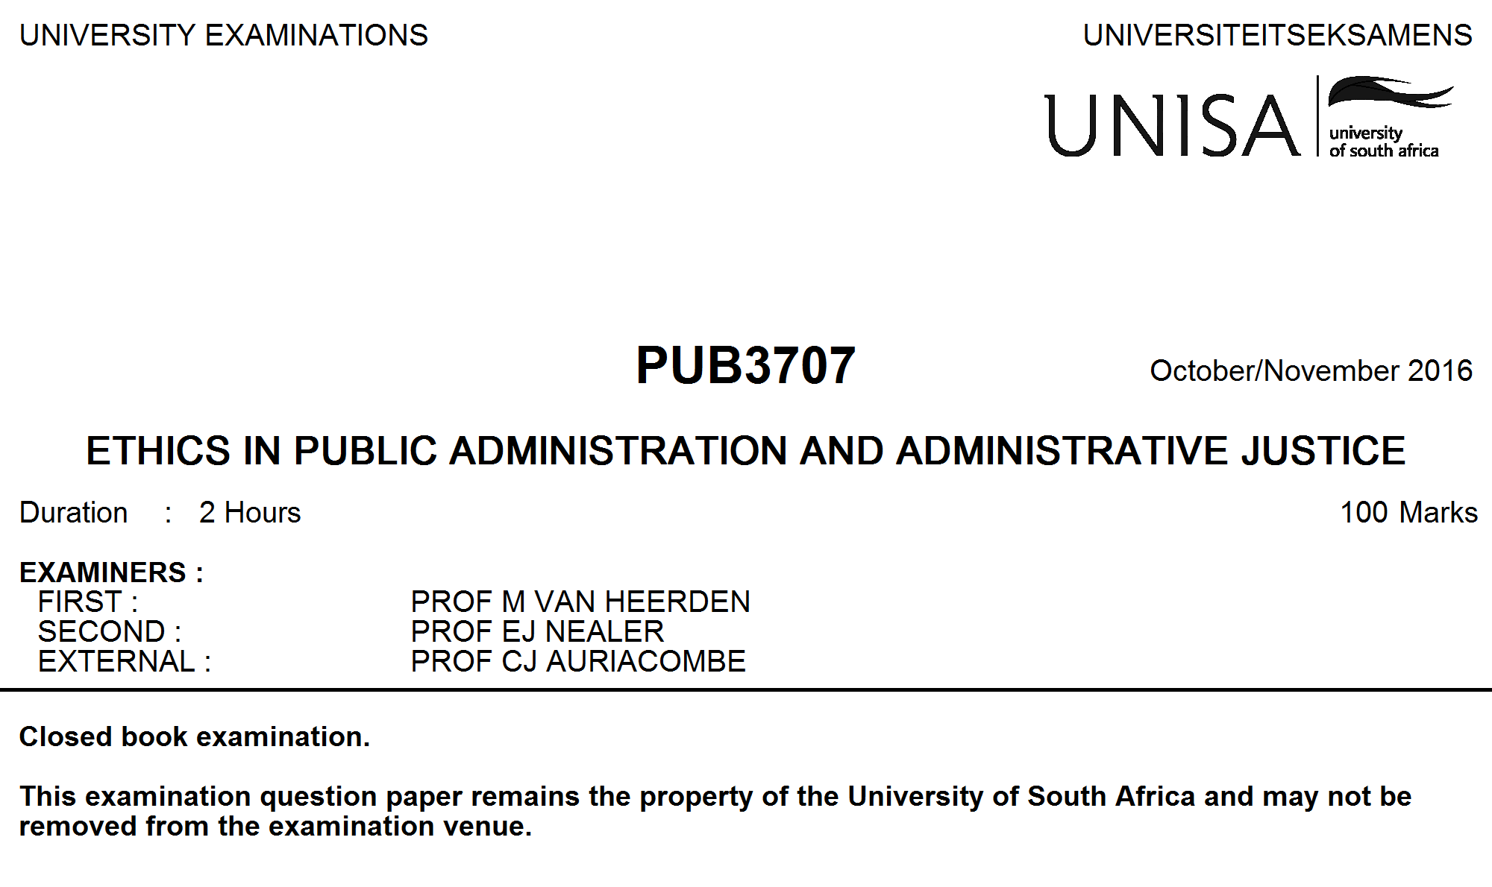

This paper consists of 3 pages.

Write the number of each question that you answer clearly at the top of your answer, and also in the space provided on the cover of the examination answer book.

ANSWER ALL THE QUESTIONS.

Note: Be very careful with the time you spend on the different questions. For each 10 mark question you have approximately 12 minutes. In determining the length of your answers, you should be guided by the marks allocated to each question.

[TURN OVER]

SECTION A: STUDY GUIDE 1: ETHICS IN PUBLIC ADMINISTRATION

QUESTION 1

When public services are rendered, questions are often posed about whether the
behaviour of public officials are right or wrong, or good or bad. With this in mind,
briefly explain the following:
- The concept of “ethics”. (6)
- The concept of “Ethics”. (6)
- The concept of “morality”. (6)
[18]

QUESTION 2

The government’s income and expenditure over a specified period of time, is estimated in a budget.
The ethical implications of a budget can be evaluated by referring to the term"distributive justice"
and the five (5) "candidate principles” of distributive justice. Explain the term"distributive justice" and
the five (5) "candidate principles” in connection with a budget. [16]

QUESTION 3

The actions of public officials are often called unethical. Discuss the following as guidelines for officials
when rendering public services, and include your own relevant examples in each case:

- The Constitution of the Republic of South Africa, 1996.
- Policy documents.
- Codes of conduct. [16]

Sub total [50]

SECTION B: STUDY GUIDE 2: ADMINISTRATIVE JUSTICE

QUESTION 4

Write brief notes on the status of the Constitution of the Republic of South Africa, 1996. [10]

QUESTION 5

The aim of administrative justice as expressed in the Constitution of the Republic of South Africa,
1996 (section 33(1) & (2)) is two-fold in nature. Write brief notes to identify the constitutional
components of administrative justice. [5]

QUESTION 6

Write an essay on the principle of procedural fairness of administrative action affecting individual
persons as mandated by section 3 of the Promotion of Administrative Justice Act, 3 of 2000. [25]

QUESTION 7

Mention the ten (10) general characteristics of an ombudsman. [10]

Sub total [50]

TOTAL:[100]

©
UNISA 2016

