MAY 2017 CHE1502
SECTION B

Question 1 [20]

- Draw the resonance forms to show the delocalization of charges in the following structure. Show the movement of electrons with curved arrows.

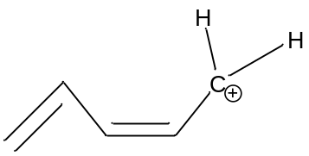
(4)

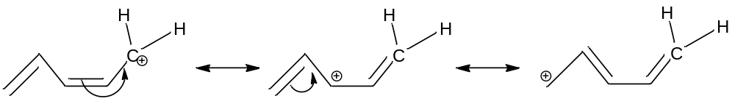

1 mark for each arrow
1 mark each for correct 2nd and 3rd structure

- Draw the Newman projection formulas of the MOST STABLE and LEAST STABLE conformations of the following compound below. Label the conformations accordingly.
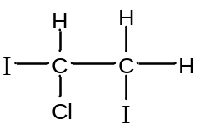
(6)

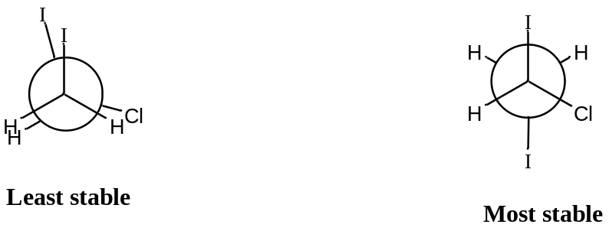

2 marks for each correct Newman projection and 1 mark for correct Least stable and 1 mark for correct most stable label.
If Newman projections are wrong but most and/or least stable identification is correct give 1 mark each.

- Draw the Lewis structure of any secondary alcohol and give the IUPAC of the chosen compound.
(4)
Any secondary alcohol √

Lewis structure : all bonds and atoms must be shown and the electrons around O √√

Correct IUPAC name √

(d) Formulate a detailed mechanism of the following nucleophilic substitution reaction:
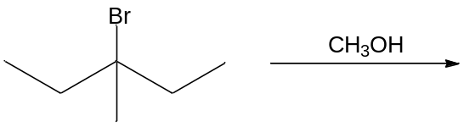

Name the product according to the IUPAC nomenclature.
(6)

Firstly, carbocation formation:
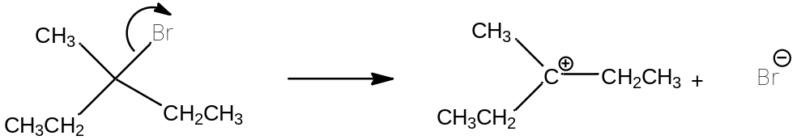
√ √

Secondly, we redraw the carbocation (in 3-D format) and show the nucleophile attacking from the bottom or top:
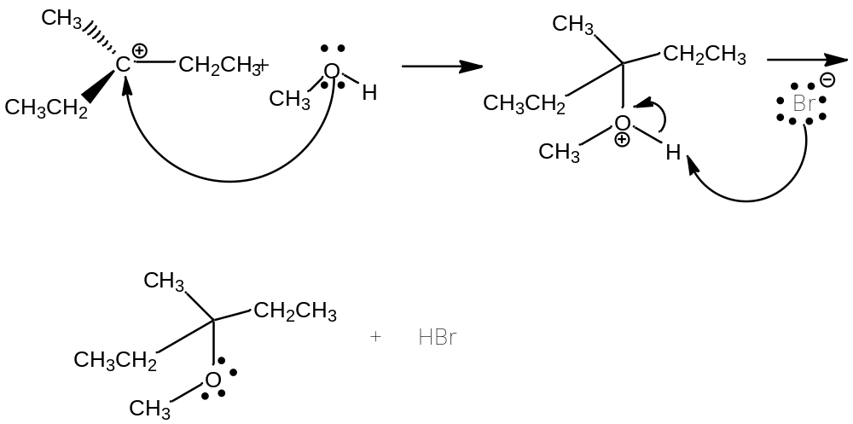
√ √ √ one of each step and the product

IUPAC name: 3-Methyl-3-methoxypentane √

Question 2 [20]

(a) Consider the following reaction:

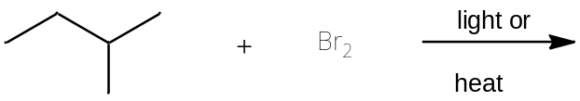

(i) Draw the structure of the MOST STABLE intermediate formed in the reaction
(2)

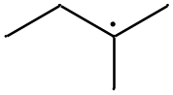

(ii) Draw the structure of the MAJOR monobrominated product formed in the reaction
(2)

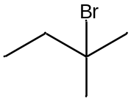

- Use curved arrows to show how bond(s) break and/or form in the process shown below:

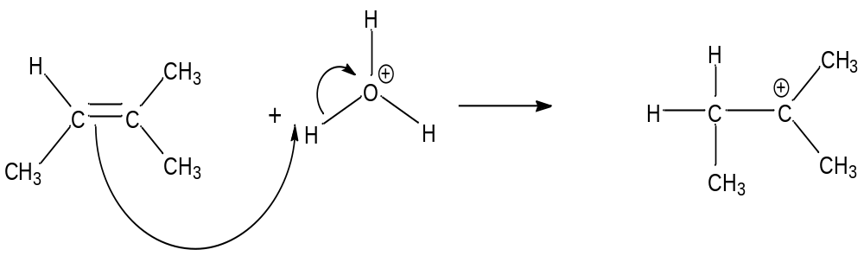
√ FOR EACH CORRECT ARROW

(2)

- Draw the geometric isomers (E- and Z-) of 2-chloro-3-methylpent-2-ene. Give the IUPAC name for each isomer
(6)

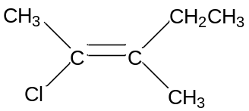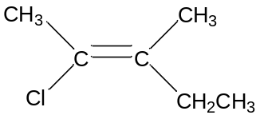

√√ √√

(E) -2-chloro-3-methylpent-2-ene (Z)-12-chloro-3-methylpent-2-ene

for E/ √ for correct name for Z / √ for correct name

- Give the MAJOR product of the following reaction. Propose a detailed mechanism for the formation of the MAJOR product.

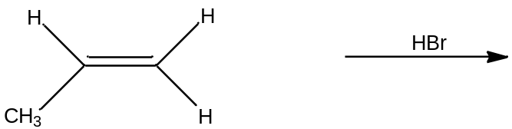
(5)

√ √
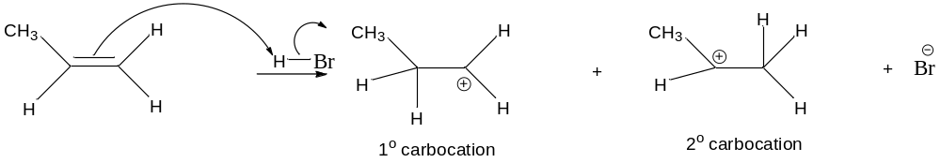

The most stable carbocation is the secondary carbocation which will give the major product √:
√ √
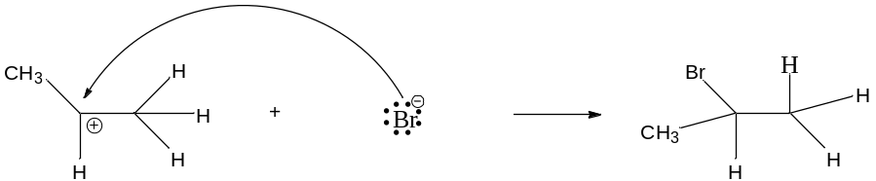

If everything is correct in the mechanism for the formation of the minor product (from sec.carbocation), then 3 marks are awarded

- Name the following compound according to the IUPAC nomenclature and identify the functional group.

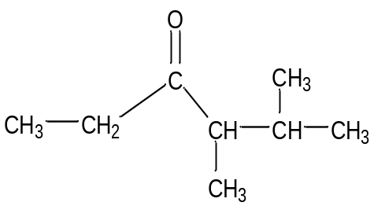

(3)

4,5-DIMETHYLHEXAN-3-ONE

√ √ √

√√ IF NUMBERING IS INCORRECT

√ IF KETONE IS CORRECT

[40]

TOTAL MARKS [100]

