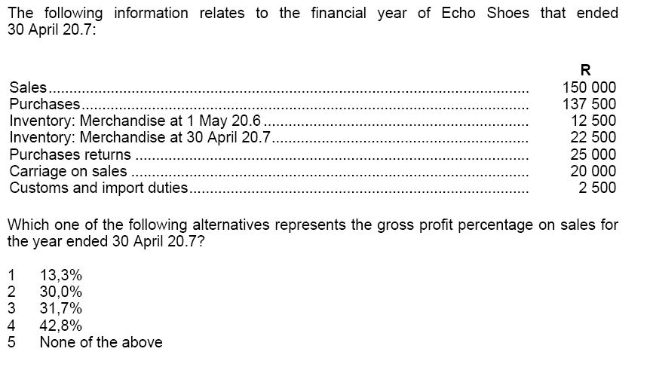
COST OF SALES AND PROFIT.

Remember that Gross Profit is the difference as a percentage between the total sales amount and the total cost of sales amount. Nowhere in any paper or anywhere else have I seen that UNISA use sales inc VAT in any question related to gross profit – which means that our life is easier because we don’t have to worry about taking VAT off.
For Unisa’s purposes – cost of sales includes everything that is used to make the goods ready for sale. Notice I said ready for sale – so it does not include the cost of getting the finished product to the customer – that cost is a separate charge to the carriage/railage expense account in the general ledger
Now where you have a question that uses inventory – the cost of sales must only include inventory that was physically used to manufacture the goods that you actually sold. Think about that for a minute.
So the first thing you must do is to take the opening inventory balance and add purchases to it. Then you take OFF the closing inventory balance. This gives you a subtotal.
Then look and see if there were any of your purchases that you returned to the suppliers – if there are you must take that figure away from your subtotal. (Makes sense because if you returned something it means you didn’t use it to manufacture goods so it must not be in your cost of sales figure).
So – if we use the figures in the question
Opening inventory 12500 PLUS
Purchases 137500 MINUS
Closing Inventory 22500
Subtotal 127500

Don’t get too excited – there is a figure of R25000 by the Purchases Returns – so we must take that off. (You could always take the returns away from the total purchases first if you find that easier – you get the same result).
So we had our subtotal R127500 which we much reduce by R25000 for the returned purchases.
So we get a new subtotal now of R102500
But we haven’t quite finished.
Cost of sales includes all charges that are incurred to get the raw materials to your factory.
Remember that charges you incurred to manufacture the goods is cost of sales – charges you incur when the goods are completed and you are shipping them to your customer are not cost of sales – those charges are expenses, railage etc.
If you imported parts in order to manufacture something then any customs charges that you incurred (and shipping charges) form part of your cost of sales.
In the question there is R2500 against Custom and Import Duties – that is also part of your cost of sales so you must add that to your subtotal
Now we have our previous subtotal of R102500 and add the R2500 to that to give us R105000.
There is nothing else in the list that forms cost of sales so the R105000 is our total cost of sales!
Remember that Gross profit is the difference between selling price and cost of sales.
Hence our next step is to take our sales figure which the question tells us is R150000 and take away our cost of sales figure which we have calculated to be R105000. Hence our gross profit is R45000 if my maths is right.
Now all you need to do is to calculate the percentage
Be careful Guys!!!!!!!!!!! Make sure you use the right calculation to work out the percentage
The question says and I quote “ The gross profit percentage on sales” What this means is that they want to know what the gross profit is as a percentage of sales
Look at pages 235 and 236 of your study guide if you are not sure about how to calculate the percentage.
Amanda

