CREDIT LOSSES
These are split into two types – an expense and a liability
To recap – if you have a bad debt it must be “written off”. You can no longer show it under debtors because it is not an asset any longer – you are not going to get paid. So you must remove it from the debtors and put the amount to your expenses.
The reason why you put it to your expenses is because the original sale was an income and the opposite of an income is an expense. (It is against GAAP - General Accepted Accounting Principals to reduce income from a prior year). What this actually means is that say you made the sale in the last month of your financial year – you would then have raised the income for that sale in that financial year (you debited debtors and credited income with the sale). Now if the debtor goes into liquidation only two or more months later it will be in your new financial year so you are not allowed to reduce that financial years income – hence you have to put it to an expense account. You don’t need to know this for your exam I’m just explaining it so you can understand the logic of why a bad debt doesn’t just reduce income.
If you have a bad debt (or a debt that you know is going to go bad) then you write it off. You credit your debtors with the amount of the bad debt and you debit your Credit Losses or Bad Debts account – they are the same account but occasionally called by different names.
That is all that you do to write off a bad debt.
Now – you are also allowed to make an allowance for debts that might just possibly go bad. (Very rare for anyone who sells on credit to always get all their money).
To do this you use a slightly different approach. You raise what is called a “provision”. A provision is literally an allowance. Provision is the term generally used in business not allowance.
The way you do this is to debit the expense account (the same one you use for writing off actual bad debts) but instead of crediting the debtors you credit a liability account called Provision for Bad Debts or Allowance for Credit Losses (same account – different names).
Usually your provision for bad debts is a straight percentage of your total debtors usually in the range of 5% - 10% depending on the nature of your business and the likelihood of incurring an actual bad debt.
When you then get a bad debt you can do either of two things in practice – you can either, credit debtors with the amount of the bad debt and then debit the provision account – or you can credit debtors and debit the expense account. Both are acceptable – but in UNISA’s case they just debit the expense account and leave the provision untouched until the end of the financial period in question – this is also a common practice in business so they are not way off base.
To increase a provision you will credit the allowance/provision account – the account is a liability account and to increase a liability you must credit it. The other side of the entry you then put to the expense account that is called Bad debts or Credit losses.
To reduce a provision you do the exact opposite – you would debit the provision/allowance account (as it is a liability account and thus a credit account you can only reduce it by debiting it). You then put the corresponding other side as a credit to the expense account (same bad debt/credit losses account as before) – makes sense because you are now decreasing the expense and to decrease an expense you must credit it.
That is all there is to it!!!!!!
Just think about it and draw up some “T” accounts and put some entries in so you make sure you get it clear.
Take the question:
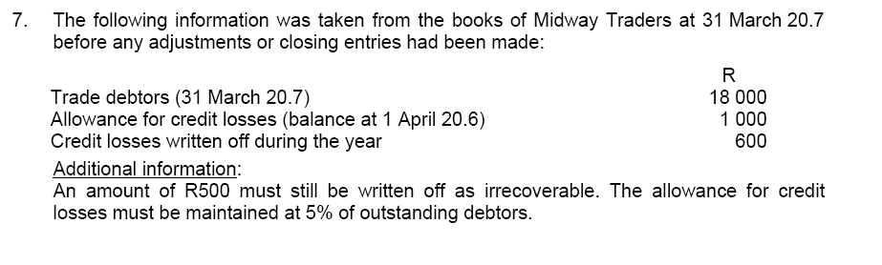

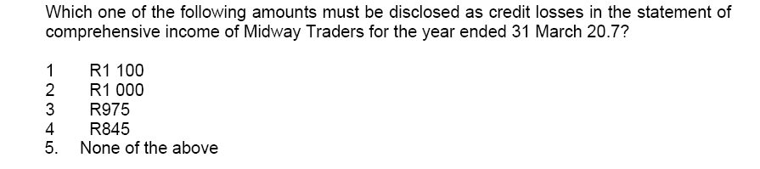

The first thing to look at is what the various accounts are. Debtors account is obvious. The allowance for credit losses is obviously the liability account and Credit Losses written off is obviously the expense account.
It tells you that R500 must still be written off – so do that first. Credit debtors with the R500 and debit the expense account with R500. (Do not touch the liability account). What are the balances now on the debtors account and the expense account?
Then it tells you that the allowance balance must be 5% of debtors. So next calculate what is 5% of the NEW debtors figure? Is it more or less than the balance in the allowance account? If it is less then you need to reduce the allowance and if it is more then you need to increase the allowance. I have told you above how to do that.
You should now have the correct balance on the allowance account and you have already calculated the debtors after you took the R500 bad debt off. You will also now have the total in your Credit Losses/Bad Debts expense account.
The question asks you what is the amount that you would disclose in your statement of comprehensive income as credit losses? Remember that the statement of comprehensive income is the Income Statement or Profit/Loss statement and contains the expenses and income accounts. Therefore what they are looking for is the balance on the expense account – not the liability account. Be careful.
Follow my steps and draw the T accounts. Do each step individually and you will have the answer.
Amanda

