Hello.
I’ve been asked about bank recons and how you would go about calculating a balance if you were only given some transactions.
Remember that reconciling a bank is simply analysing things that appear either on the bank statement and are not in your payments and receipts journals – or are in your payments and receipts journals but not on the bank statement. That is it.
Remember that if things appear on your bank statement that are not yet in your payments or receipts journals then you add the transactions to the corresponding journal (late entry).
I’ll use Q2 of the second assignment 2009 to illustrate.
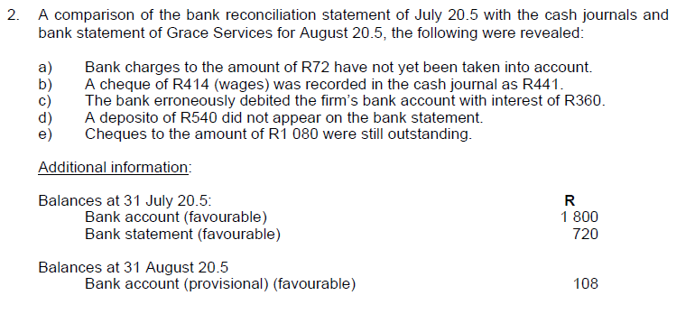
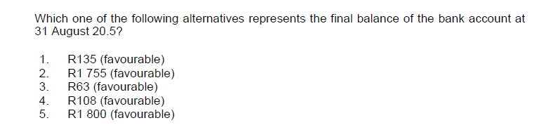

There are bank charges of R72 that are on the statement but not in your payments journal – so you add that to your payments journal.
Next one is that a cheque for R414 was recorded incorrectly in your payments journal as R441. The correct way of fixing this is that you write back the full cheque to your receipts journal and then add a new payment in your payments journal for the correct amount. So – your receipts journal would have increased by R441 to write back the cheque and then you make another entry in your payments journal for R414. (You can always just take the difference and enter that amount but it is not the right way of doing it because it makes tracing the original entry difficult from an auditing perspective – it is the type of transaction commonly used for fraud – trust me).
The next bit – there is an amount on the bank statement of R360 as a payment – but it is not for your account – the bank must correct it. The proper way of treating something like this where the bank has to correct their error is for you to carry that amount on the actual recon itself. It is not entered into your payments journal because it is not a payment that you have actually made.
Now the deposit of R540 is already in your receipts journal but somebody is being lazy at the bank and hasn’t yet credited on the bank statement. You can not enter this figure anywhere again because you already have entered in your receipts journal once. So the only thing you can do is to carry it on your recon.
The same logic applies to the outstanding cheques. You have already entered them in your payments journal it is just that they haven’t yet been presented to the bank – the money is still to come out of your actual bank account so you carry those cheques on your recon as well.
Remember that the only things usually carried on the recon are deposits that are entered in your receipts journal but are not yet showing on the bank statement and cheques that are entered in your payments journal but have not yet been presented to the bank. The only exception is where the bank has put an entry on to your statement that they must correct.
Now Q2 tells you that at 31 July your bank account in your general ledger was R1800 (remember that if a bank balance is favourable it means that you have money in the account – bank is an asset so money in the bank is a debit in your books. (Golden rule – whatever is on the bank statement is the opposite of your books – a debit in your books will be a credit on the bank statement – and if there is money in your bank statement you have a credit balance with the bank and a debit balance in your books because it is an asset).
The question also tells you that the bank statement at 31 July was R720 credit (money in bank).
It then goes on to tell you that the bank account in your general ledger at 31 Aug (called cashbook balance usually) was R108 debit. You need to calculate what the corrected cashbook balance is. Do not get confused between what UNISA calls the bank account which is actually the account in your general ledger (cashbook) and the actual account at the bank itself which they refer to as Bank Statement balance. In the question they have asked for the cashbook balance.
Here goes.
The cash payments and receipts journals have already been used to calculate the cashbook balance in your general ledger and you have been given the new balance of R108.
There are bank charges that you have not yet entered ((a) of the question) of R72. Your entry will be to debit bank charges and credit the cashbook (remember the R72 would have been a debit on the bank statement so it must be a credit to your cashbook).
So your cashbook was R108 and you now credit it with R72 so you now have a balance of R36 debit.
For (b) you must add back the cheque that was wrong and then re-enter the cheque with the correct figure. So your cashbook balance is now R36 and you add back the wrong cheque of R441 and then minus the correct cheque amount of R414 and you end up with a balance of R63
Now you stop!!!!!!!!!!!
Part (c) of the question does not affect your cashbook balance – the R360 is carried on the recon!
Part (d) is also carried on the recon – it is already in your cashbook balance because it was in your receipts journal!
Part (e) of the question also only appears on the recon itself – the cheques were entered in your payments journal; and so are already in your cashbook balance!
Be careful when you get a question like this – Remember that outstanding cheques and deposits show on your recon - they do not affect the cashbook balance because you have already accounted for them once. (unless you are writing back a cheque).
For interest if you now wanted to calculate what the actual bank statement would be you can.
You know that your cashbook balance is now R63 so to find out what the bank statement is you MINUS the outstanding deposit and ADD the outstanding cheques.
Think about it. Your cashbook balance has already been increased by the outstanding deposit because that deposit was in your receipts journal – because it is not on your bank statement you would then have to reduce your cashbook balance to make it equal the bank. The same logic applies to cheques that were in your payments journal. You have already reduced your cashbook balance by those cheques because they were in your payments journal. But the bank has not yet processed them. So for your cashbook to equal the bank statement you would increase your cashbook by the amount of outstanding cheques.

So we have the following
Cash book balance R63 (debit)
MINUS Outstanding Dep R540
PLUS Outstanding Chqs R1080
equals R603 positive money in bank.
This would usually be the result but in this question there is also the R360 that some bright spark at the bank charged to your account and should not have – so the bank statement balance will have been reduced by that R360.
Hence your calculated bank statement balance of R603 must be further reduced by R360 which means that the actual bank statement balance is R243 positive. (They haven’t asked you for that I’m just showing you for illustration purposes).
What usually happens in a recon is that they give you the bank statement balance and an amount for outstanding cheques and deposits. You then do the recon like this – I’ll use the same figures as for Q2 because it proves the calculation

Bank statement balance |  | 243
Outstanding cheques | 1080
Outstanding deposit |  | 540
Error for bank to correct |  | 360
Cashbook balance per GL | 63
Totals | 1143 | 1143

Remember that for a recon - you enter the balance on the bank statement exactly as it is – so if it is a credit on the bank statement you enter it as a credit on the recon – same logic if it is an overdrawn balance which would be a debit on the bank statement you enter it as a debit on the recon – do not turn them around!!!!!!!!!!!!!!
Always try to do a recon from the bank statement first – it is easier
Guys – slowly and baby steps. Take each step individually and think about each one logically. It is a large part of the exam
Hope this helps
Amanda

