ECS2602 TEST BANK
Question 1
Which of the following statements is/are correct?
- In this module we only study the demand side of the economy which includes the goods market and the financial market. The labour market form part of the supply side analysis and are therefore excluded from this module.
- The two most important accounts of the balance of payments are the current account and the financial account.
- If total output decreases with 2% during a specific year and the general price level increases with 4% the real GDP will decrease and the nominal GDP will increase.
  - a, b and c
  - Only a and b
  - Only a and c
  - Only b and c. (Correct option is 4.)
  - None of the options 1 t o 4

Explanation
The two important accounts of the balance of payments are the current account and the financial account. If the rise in the general price level is more that the rise in nominal production then the real production (GDP) declines while the nominal production (GDP) increases.

Question 2
Consider the consumption functions of country A and country B.
Country A: C = 2 000 + 0.7Y D
Country B: C = 1 000 + 0.9Y _{D}

Which of the follow ing state ments is/are correct?

- In country A autonomous consumption is higher than in country B.
- In country B induced consumption is definitely higher than in country A.
- In country B total consumption is definitely higher than in country A.

  - Not a, b or c
  - Only a. (Correct option is 2.)
  - Only b
  - Only c
  - None of the options 1 t o 4

Explanation
In country A autonomous consumption is 2 000 while in country B it is 1 000. It is therefore higher in country A. Induced consumption is that part of consumption that depends on income. To know what the induced consumption is we need not only to know what the marginal propensity to consume is but also what the income is. We can therefore not conclude that it is definitely higher in country B.
What total consumption is, depends on what the level of income is. Since we do not know what the level of income is, we do not know what the total consumption is.

Question 3
Which of the following statements with regards to the following consumption function? C = c₀ + cY_{D} is/are correct?

- A change in the marginal propensity to consume will result in a change in income.
- If autonomous consumption should be zero consumption will be equal to cY_{D}.
- A change in autonomous consumption will cause a change in marginal propensity to consume.

  - a, b and c
  - Only a and b
  - Only a and c
  - Only b and c
  - None of the options 1 to 4 (correct option is 5.)

Explanation
A change in the marginal propensity to consume implies that a higher proportion of income is spent and this will then result in a change in consumption spending and not in income.
If autonomous consumption is zero the part that is left is cYD.
A change in autonomous consumption does not cause a change in the marginal propensity to consume.

Question 4
In the goods market model a decrease in taxes will result in …

- an increase in autonomous consumption.
- an increase in disposable income.
- an increase in income.
- a decrease in induced consumption.

  - a, b and c
  - a, b and d
  - b, c and d
  - a, c and d
  - None of the options 1 to 4 (correct option is 5.)

Explanation
A decrease in taxes increases disposable income and consequently induced consumption spending increases. As consumption spending increases producers increase production and consequently income increases. The multiplier effect is in operation.
A decrease in taxes does not impact on autonomous consumption.
Only alternatives b and c are correct and therefore the correct option is 5.

Question 5
Which of the following are correct in terms of the goods market model?

- G↑ → Z↑ → Y↑ → YD↑ → C↑
- I↑ → Z↑ → Y↑ → YD↑ → C↑
- T↓ → Z↑ → Y↑ → YD↑ → C↑
- c0↑ → Z↑ → Y↑ → YD↑ → C↑

  - Only a, b and c
  - Only a, b and d (The correct option is therefore 2.)
  - Only b, c and d
  - Only a, c and d
  - a, b, c and d

Explanation
All the chain of events except c is correct. For c to be correct is should have been as follows:
T↓ → YD↑ → C↑ → Z↑ → Y↑

Question 6
Which of the following is/are correct in terms of the goods market model?

- Autonomous consumption is represented by c₀ + Ī + G – cT.
- Induced consumption is presented by cY_{D}.
- The demand for goods determines the amount of goods that producers produce and they will only change their production if the demand for goods changes.
- Equilibrium is presented by Y = c₀ + c(Y−T) + Ī + G.

- a, b, c and d
- Only a, b and d
- Only a, c and d
- Only a, b and c
- Only b, c and d (The correct option is therefore 5.)

Explanation
All the statements except statement a is correct. Autonomous consumption is only c0.

Questions 7 to 13 are based on the following data for the country PORTHOS for 2011.

Marginal propensity to consume = 0.5
Autonomous consumption = R600 million
Investment = R40 million
Government spending = R280 million
Taxes = R30 0 million

Question 7
Which of the following statements is/are correct?

- The value of the multiplier is equal to 2.
- The budget surplus is R20 million.
- The equilibrium level of output and income is R1 540 million.
- Total consumption is R1 220 million.

- Only a, b and c
- Only a, b and d
- Only b, c and d
- Only a, c and d

5) a, b, c and d (correct option is 5.)

Explanation
To answer this question correctly you must do the following:
Calculate the multiplier. The formula for the multiplier is 1/1-c. Given a marginal propensity to consume of 0.5 the value of the multiplier is 2.
Calculate the equilibrium level of output and income. The formula for the equilibrium level of output and income is
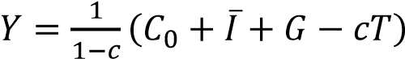

Given the information in the question the equilibrium level of income is 2 x (600 million + 40 million + 280 million – 0.5(300 million)) = 2 x R770 million = R1 540 million. Note that you must subtract cT.

Calculate the budget balance. The budget of government is the difference between tax revenue and government spending (T – G) or (G – T). In this case there is a budget surplus of R20 million since T = R300 million and G = R280 million.
Calculate consumption spending at the equilibrium level of output and income. The consumption spending in this model is C = co + cYD. Given a value of R600 million for c0 and YD
= Y – T = (R1540 million – R300 million) = R1 240 million, consumption spending at the equilibrium level of income = 600 + 0.5(1 240) = R600 million + R620 million = R1 220 million.
All the statements are correct and therefore the correct option is 5.

Question 8
An economist Dr B right Spa k calculated that the gap between the current level of output and income and the full employment level of income is R110 million.
Which of the following will en sure that full employment is re ached?

- An increase in government spending of R8 0 million which will result in a budget deficit of R10 million.
- A decrease i n taxation of R160 million which will result in a bud get deficit of R90 million.
- An increase in government spending of R4 0 million and a decrease in taxation of R80 million which will result in a budget deficit o R50 million.

- a, b and c
- Only a and b
- Only a and c
- Only b and c
- None of the options 1 t o 4 (correct option is 5.)

Explanation
The following diagram shows the economy of PORTHOS.
The vertical intercept is 770: c0 + Ī + G – cT = 600 + 40 + 280 – 0.5(300) = R920 million – R150 million = R770 million. The equilibrium level of income is R1 540 million and the level of full employment R1 650 million, that is R1540 million + R110 million (the output and income gap).

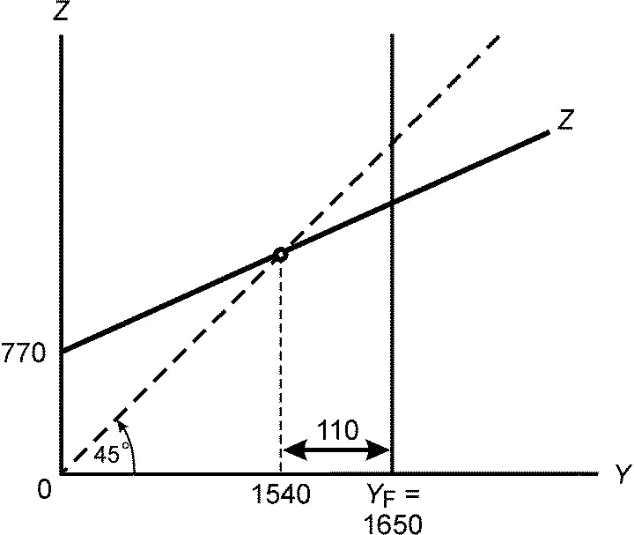
In this particular model one way of reaching full employment is to increase autonomous spending. The increase in autonomous spending that is required is equal to 110 million/2 = R55 million. Remember a multiplier of 2 indicates that for every R1 increase output and income increases with R2.
If government spending is to be used it implies that government spending must increase with R55 million. This will increase autonomous spending with R55 million. In this case the budget surplus of government changes from R20 million to a budget deficit of R35 million. Tax revenue is still R300 million but government spending is now R280 million + R55 million = R335 million. Thus T – G = R300 million – R335 million = –R35 million.

If taxation is to be used to get an increase of R55 million in autonomous spending it implies that the decrease in taxes should be R110 million. The reason why taxes should be decreased by R110 million is due to the fact that households increase their spending not by the full amount of the decrease in tax but only by c(T). In other words, c(T) must be equal to R55 million. It therefore follows that T = R55 million/0.5 = R110 million. In this case the budget surplus of R20 million changes into a deficit of R90 million. Tax revenue decreases to R300 million – R110 million = R190 million while government spending is R280 million.

An increase in government spending of R80 million will take the economy beyond full employment while the budget deficit increases to R60 million. [T – G = 300 – (280 + 80) = 300 – 360 = –R60 million].

A decrease in taxation of R160 million will take the economy beyond full employment while the budget deficit increases to R140 million. [T – G = (300 – 160) – 280 = 140 – 280 = –R140 million].

An increase in government spending of R40 million increases output and income by 2 x 40 million = R80 million while a decrease in taxes of R80 million increases output by 0.5(R80 million) x 2 = 40 x 2 = R80 million. The net change in output and income is therefore R80 million + R80 million = R160 million. The impact on the budget of government is that the budget surplus of R20 million (see question 7) changes into a deficit of 100. [T – G = (300 – 80) – (280 + 40) = 220 – 320 = –R100 million].
None of these statements are therefore correct and the correct option is 5.

Question 9
The President of the country Mr Cold Water is not interested in full employment. He is only interested to win the general elections during the current fiscal year and decide d to cut taxes with R1 50 million. By how much will the level of output and income increases if taxes are cut by R150 million?

1) R150 million. (The correct alternative is therefore 1.)
2) R300 million. 3) R75 million.
4) R50 million

Explanation
If taxes are cut by R150 million the output and income increases by c(T) x the multiplier =
0.5(150 million) x 2 = R75 x 2 =R150 million.

Question 10
Mr Cold Water then realised that the country cannot afford an increase in the budget deficit due to its inability to raise loans to finance the budget deficit. He decided to keep the tax cuts at a R150 million and a budget surplus of R20 million.
To ensure a budget surplus of R20 million the government will have to ...
- cut government spending with R80 million.
- cut government spending with R75 million.
- cut government spending with R150 million. (The correct alternative is therefore 3.)
- 4) increase government spending by R100 million.

Explanation
To ensure that the budget surplus is unchanged at R20 million government spending must decrease by R150 million to compensate for the decrease of R150 million in tax revenue. Taxes is now R300 million – R150 million = R150 million. To keep the budget surplus unchanged at R20 million (as calculated in question 7) government spending must be equal to R130 million because T – G = R150 million – R130 million = R20 million. Government spending must therefore decreased by R150 million since R280 million – R150 million = R130 million.

Question 11
The end result of the actions by Mr Cold Water is that the level of output and income will …

- increase by R150 million.
- increase by R300 million
- be unchanged.

4) decrease by R150 million. (The correct option is therefore 4.)
5) decrease by R300 million.

Explanation
To be able to answer this question you must understand the balanced budget multiplier. The balanced budget multiplier indicates that an equal change in government spending and taxes, while leaving the budget unchanged, still have an impact on the level of output and income.

In the case of an equal increase in government spending and taxes it will have a stimulatory impact on the level of output and income while for an equal decrease in government spending and taxation it will have a contractionary impact.
In this case study taxes decreased by R150 million (given in question 9) while government spending also decreased by a R150 million (calculated in question 10). The end result is that the economy contracts with R150 million. The reasoning for this as follows:

The impact of a decrease in taxation:
When dealing with taxation you have to remember that, unlike government spending, taxation influence the demand indirectly through the consumption function (which captures the behaviour of households). According to this function households will increase their consumption spending as their income increase but the increase in consumption is less than the increase in income.
This effect is captured by the marginal propensity to consume.
Therefore, in this model the decrease in taxation of R150 million causes an increase in disposable income (YD) of R150 million. This increase in disposable income causes consumption spending to increase not by R150 million but by c x YD = 0.5 x R150 million = R75 million. So, the injection in the economic system is R75 million and it is from this basis that the multiplier operates. The increase in output and income is therefore equal to the multiplier x c(T) = 2 x 0.5(150) = 2 x 75 = R150 million.

The decrease in government spending of a R150 million causes autonomous spending (this is the leakage) to decrease by R150 million. It is from this basis that the multiplier starts to operate and the decrease in output and income is equal to the multiplier times the change in government spending = multiplier x G = 2 x R150 million = R300 million.

Thus, the decrease in taxes leads to an increase of R150 million in the level of output and income while the decrease in government spending leads to a decrease of R300 million in the level of output and income. The end result is therefore: Increase in income due to the decrease in taxes – decrease in income due to decrease in government spending = R150 million – R300 million = –R150 million.

Note: In your goods market diagram the demand for goods curve shifts upwards with 75 million and then downwards with 150 million leading to a lower level of income and output.
The correct option is therefore 4.

Question 12
After these actions the gap between the equilibrium level of output and income and the full employment level of income (as calculated by Dr Bright Spark) will be …

- R280 million.
- R110 million.
- R0.

4. R260 million. (The correct option is therefore 4.)

Explanation
To answer this question you must first calculate the equilibrium level of income after the policy actions that consist of the decrease in taxation of R150 million and a decrease in government spending of R150 million.

One way of doing it is as follows:

Remember G = R130 million (calculated in question 10).
The gap between full employment and the current level of output and income is: R1 650 million – R1 390 million = R260 million.
The economy is now further away from full employment. The correct option is therefore 4.

Question 13
Mr Cold Water …
- lost the election because unemployment has increased.
- won the election because taxpayers were better off.
- won the election because the level of output and income has increased.
- winning or losing has nothing to do with the economy

Explanation
Whether Mister Cold Water wins or lose the election depends on whether the voters care about the economy when choosing their government. If they care about the economy it then depends on how well informed they are about the impact of the actions of Mr Cold Water. If they have a very short time horizon they will only consider the impact of the decrease in the tax rate. The decrease in the tax rate has an immediate impact on their disposable income while the decrease in government spending will probably only take effect after the election. A rational voter will however take this into account and will not be fooled by Mister Cold Water. There is therefore no correct answer and the question was not marked.

Question 14
If an increase in the budget deficit is unacceptable in a country where the marginal propensity to consume is 0.8, which of the following policy actions will increase the level of output and income without increasing the budget deficit?

- An increase in government spending of R10 million and an increase in taxation of R10 million.
- An increase in government spending of R20 million and an increase taxation of R20 million.
- An increase in government spending of R40 million and an increase in taxation of R40 million

1) a, b and c (The correct option is therefore 1.)
- Only a and b
- Only a and c
- Only b and c
- None of the options 1 t o 4

Explanation

This question also deals with the balanced budget multiplier. All of these actions will increase the level output and income since an equal increase in government spending and taxes will have a stimulatory impact on the level of output and income.

Questions 15 to 25 are based on the following approximate figures for the South African economy in 2010:
Investment expenditure = R358 0 00 million
Government expenditure = R383 000 million
Re al GDP = R1 835 00 0 million
Estimated population = 50 million
Labour force = 20 million
Unemployment rate = 25%
Budget deficit = R142 000 million
Government debt = R82 2 400 million
Marginal propensity to consume = 0.33
Multiplier = 1.5

Question 15
Given the structural constraints of the South African economy the South African Reserve
Bank and the World Bank estimated that the potential growth rate for South Africa is 3.5%.
Given a real GDP for South Africa of R1 835 0 00 million in 2010 by how much should real GDP have to increase to achieve an economic growth rate of 3.5%?

- R64 225 000 million.
- R1 835 000 million.
- R1 899 225 million.
- R524 285 million
- R64 225 million. (The correct option is therefore 5.)

Explanation
Given the current level of output and income as measured by the real GDP of R1 835 000 million a 3.5% economic growth rate implies the real GDP must increase by 3.5%. By how much real GDP should increase is calculated as follows:
3.5/100 x R1 835 000 million = R64 225 million.

Question 16
Assuming a multiplier of 1.5 by how much should autonomous spending in the South African economy increase to achieve a growth rate of 3. 5%?

1. R64 225 million.

2. R42 817 million. (The correct option is therefore 2.)
- R1 223 333 million.
- R524 285 million.
- R1 835 000 million.

Explanation
A multiplier of 1.5 indicates that for every R1 increase in autonomous spending the level of output and income increases with R1.50. If the increases needed in output and income is R64 225 million then the increase in autonomous spending must be R64 225 million/1.5 = R42 817 million.

Question 17
If this growth rate of 3.5% is to be achieved through an increase in government spending by how much should government spending increase?
1) R64 225 million.

2) R42 817 million. (The correct alternative is therefore 2.)
3) R1 223 333 million. 4) R524 285 million.
5) R1 835 000 million

Explanation
Remember that government spending is one of the autonomous spending components. The increase in government spending should be equal to the increase in the needed autonomous spending of R42 817 million.
Questions 18 to 21 are based on the following additional information:

Assuming that the tax revenue stays the same and government spending increases to achieve a 3.5% growth rate.

Question 18
What impact will it have on the budget deficit?
- It will increase the budget deficit by R64 225 million.
- It will increase the budget deficit by R42 817 million. (The correct alternative is therefore 2.)
- 3) It will increase the budget deficit by R524 285 million.
4) It will decrease the budget deficit by R64 225 million.
5) It will decrease the budget deficit by R42 817 million.

Explanation
The budget deficit will increase with the amount of the increase in government spending of R42 817 million.

Question 19
What is the percentage change in the budget deficit?
- It will increase the budget deficit by 45%.
- It will increase the budget deficit by 30%. (The correct alternative is therefore 2.)
- 3) It will increase the budget deficit by 36%
- It will decrease the budget deficit by 45%.
- It will decrease the budget deficit by 30%.

Explanation
The percentage change in the budget deficit is R42 817 million/R142 000 million x 100 = 30%.

Question 20
The government debt will...
- be unchanged at R822 400 million.
- increase to R865 217 million. (The correct option is therefore 2.)
- 3) decline with R42 817 million.
4) increase to R886 625 million

Explanation
The government debt will increase by R42 817 million to R865 217 million. [R822 400 million + R42 817 million = R865 217 million].

Question 21
If the 3.5% growth rate is to be achieved by a change in taxation what should happen to taxation?

- Taxes should be cut by R64 225 million.
- Taxes should be cut by R42 817 million.
- Taxes should be cut by R129 747 million. (The correct option is therefore 3.)
- Taxes should be increased by R64 225 million.
5) Taxes should be increased by R42 817 million.

Explanation
To get the necessary increase of R42 817 million spending through a decrease in taxes the c(T)part need to be R42 817 and consequently taxes must decrease by R42 817/0.33 = R129 749. The closest alternative is 3 and therefore the correct one. Note that this will have a huge impact on the budget deficit which will increase by 91%. [R129 749/R142 000 x 100% = 91%].

Question 22
If the change in the budget deficit is unacceptable which other component of expenditure might cause an increase in output and income?

- Autonomous consumption expenditure.
- Investment expenditure.
- Imports.

  - a, b and c
  - Only a and b (The correct option is therefore 2.)
  - Only a and c
  - Only b and c
  - None of the options 1 to 4

Explanation
Any increase in autonomous spending or investment spending will increase the demand for goods and the level of output and income. More spending on imports will decrease the demand for goods produced in South Africa.

Question 23
How many people were unemployed in South Africa in 2010?
  - 30 million.
  - 12 .5 million.
  - 5 million. (The correct option is therefore 3.)
  - 4) 20 million

Explanation
Given an unemployment rate of 25% and a labour force of 20 million, the number of unemployed people are 25/100 x 20 million = 0.25 x 20 million = 5 million.

Question 24
Assuming that the output per worker is R122 00 0 and for every additional worker employed output will increase with R12 2 000 (in other word s, constant returns apply). By how much will employment increase if the economy grows at 3.5%?

1) 950 555
2) 350 787
  - 250 643
  - 526 434 (The correct option is therefore 4.)

Explanation
For every R122 000 increase in output an additional job is created. If output increases by R64 225 million (as calculated in question 15) then the number of jobs created are R64 225 million/R122 000 = 526 434 jobs. This illustrated that an increase of 3.5% will not be sufficient to deal with unemployment in South Africa.

Question 25
Which of the following statements is/are correct?
  - It i s possible to solve the unemployment problem in South Africa through an increase in government spending and/or a decrease in taxation.
  - An increase in the growth rate of 3.5% is sufficient to decrease the number of employed people by 50%.
  - The only way to achieve a growth rate of 3.5% is through the fiscal policy actions.

    - a, b and c
    - Only a and b
    - Only a and c
    - Only b and c
    - Not statement a, b or c (the correct option is therefore 5.)

Explanation
As indicated in the answer to question 24, a 3.5% growth rate will not solve the unemployment problem and neither can it be solved through an increase in government spending and/or a decrease in taxation. It is also possible to achieve an increase in output and income through an increase in investment spending. None of the statements is correct and the correct option is therefore 5.

Question 26
Which of the following statements is/are correct?

  - An increase in government spending and/o r a decrease in taxes can decrease cyclical unemployment.
  - A decrease in taxes in order to decrease unemployment will be as effective in a capital- intensive economy as in a labour-intensive economy.
  - An expansionary fiscal policy is a mean to increase production, income and employment. However, high imp orts, crowding out of private investment and a too high budget deficit are all constraints to the effectiveness of this expansionary fiscal policy.

    - a, b and c
    - Only a and b
    - Only a and c (the correct option is 3.)
    - Only b and c
    - None of the options 1 t o 4

Explanation
Cyclical unemployment is also known as demand deficient unemployment and is due to a too low demand for goods. The solution to this kind of unemployment is an increase in the demand for goods that can be brought about by an increase in government spending and/or a decrease in taxation.
The more capital intensive an economy the less the number of jobs created for a given increase in production. A decrease in taxation that stimulates production will therefore be more efficient in decreasing unemployment the more labour intensive the economy.
A high import propensity, crowding out of private investment and budget deficits are all constraints on using fiscal policy to deal with unemployment.
Only statements a and c are correct and therefore the correct option is 3.

Question 27
Which of the following statements is/are correct?

- The liquidity preference theory of money refers to the demand for active and passive balances which are determined by the need to do transactions and the need to keep wealth in the form of money.
- If bonds were to pay a high interest, market participants would want to hold as little money as possible.
- If the interest rate drops from 20% to 2% market participants will tend to sell their bonds and to keep more of their wealth in the form of money.

  - a, b and c (the correct option is therefore 1.)
  - Only a and b
  - Only a and c
  - Only b and c
  - None of the options 1 to 4

Explanation
The demand for money consists of the demand for active balances – the need to do transactions – and the demand for passive balances – the need to keep wealth in the form of money. The interest rate is the opportunity cost of keeping wealth in the form of money and the lower the interest rate the lower the opportunity cost to keep money and people are therefore willing to hold more money and less bonds if the interest rate is low. All the statements are correct and the correct option is therefore 1.

Question 28
Which of the following statements is/are correct?
- On the financial market an increase in income will increase the interest rate.
- Expansionary monetary policy will increase the supply of bonds and the price of bonds will decrease.
- Exogenously determined money supply implies that as the money supply increases the interest rate will also increase.

  - Not a, b or c
  - Only a the (correct option is therefore 2.)
  - Only b
  - Only c
  - None of the options 1 to 4

Explanation
An increase in income increases the number of transactions and the demand for money increases which causes an increase in the interest rate on the financial market.
An expansionary monetary policy implies the buying of bonds in order to increase the money supply in the economy.
As more bonds are demanded the price of bonds will increase and the interest rate decline. As the money supply increases in the economy the interest rate will decrease.
Only statement a is correct and the correct option is therefore 2.

Question 29
Which of the following statements is/are correct?

- An increase in income shifts the demand for money curve to the right.
- An increase in the interest rate is represented by an upward movement along the demand for money curve.
- The money supply is determined by the central bank and is represented by a horizontal line, because it is not a function of the interest rate.

  - a, b and c
  - Only a and b (the correct option is therefore 2.)
  - Only a and c
  - Only b and c
  - None of the options 1 to 4

Explanation
An increase in income increases the number of transaction and the demand for money increases. This is represented by a rightward shift of the demand for money curve.
An increase in the interest rate is represented by an upward movement along the demand for money curve. The supply of money is determined by the central bank and is independent of the interest rate and is therefore a vertical line.
Statements a and b are correct and the correct option is therefore 2.

Question 30
Which of the following is/are correct regarding th e financial market?

- If the equilibrium interest rate is 6% then there will be an excess supply of money at 10 % and an excess demand for money at 3 %.
- An increase in income will cause an excess demand for money which will cause the interest rate to increase.
- An increase in the money supply will shift the demand for money curve to the right.

  - a, b and c
  - Only a and b (the correct option is therefore 2.)
  - Only a and c
  - Only b and c
  - None of the options 1 t o 4

Explanation
At a higher interest rate than the equilibrium interest rate there is an excess supply of money while at a lower interest rate there is an excess demand for money.
As income increase the demand for money increases which initially causes an excess demand for money on the financial market. This excess demand for money puts upward pressure on the interest rate and the increase in the interest rate continues until equilibrium is reached again.
An increase in the money supply shifts the supply of money curve to the right. Only statements a and b are correct and the correct option is therefore 2.

Question 31
Which of the following is/are correct regarding the financial market?
  - There is a negative relationship between the price of a treasury bill and the interest rate.
  - There is an inverse relationship between the price of a treasury bill and the interest rate.
  - If the price of a treasury bill is R9 700 and the rate of return is 3%, the rate of return will be lower than 3% if the price if the price of the treasury bill increases to R9 800.

    - a, b and c (the correct option is 1.)
    - Only a and b
    - Only a and
    - Only b and c
    - None of the options 1 t o 4

Explanation
A negative relationship between the price of treasury bills and the interest rate indicates that as the price of treasury bills increases the interest rate declines and vice versa. An inverse relationship indicates a negative relationship.
If the price of a treasury bill increases the rate of return on it decreases. If the rate of return on a treasury bill with a
price of R9 700 is 3% it follows that if the price increase to R9 800 the rate of return will be less than 3% All the statements are correct and therefore the correct option is 1.

Question 32
Which of the following is/are correct regarding the financial market?

- A rising interest rate can be offset by an increase in the money supply.
- A rising interest rate can be offset by contractionary monetary policy.
- A rising interest rate can be offset by an increase in the supply of treasury bills by the central bank.
- The rate of return in the market determines the price paid for treasury bills.

  - Only a (the correct option is therefore 1.)
  - Only b
  - Only c
  - Only d
  - None of the options 1 t o 4

Explanation
An increase in the money supply causes a decrease in the interest and a rising interest rate can be offset by an increase in the money supply.
A contractionary monetary policy implies a decrease in the money supply and an increase in the interest rate. A contractionary monetary policy can therefore not be used to offset an increase in the interest rate.
An increase in the supply of treasury bills implies a contractionary monetary policy. To offset a rising interest rate an expansionary monetary policy is needed which implies the buying of bonds.
In this financial market model it is the price of a treasury bill that determines the rate of return. Only statement a is correct and the correct option is therefore 1.

Question 33
Which of the following are correct in terms of the events chain: D_{B}↑ → P_{B}↑ → i↓ ?

- The events chain applies to the financial market.
- The events chain illustrates expansionary monetary policy.
- The events chain illustrates expansionary open market operations.
- The events chain shows what happens if the central bank buys treasury bills.

  - Only a, b and c
  - Only a, b and d
  - Only b, c and d
  - Only a, c and d
  - a, b, c and d (the correct option is 5.)

Explanation
The events chain indeed applies to the financial market and indicates that the central bank demand treasury bills which cause an increase in the price of treasury bills and a decrease in the interest rate. This is part of an expansionary monetary policy where open market operations are used to bring about an increase in the money supply.
All the statements are correct and therefore the correct option is 5.

Question 34
Which of the following is/are correct in terms of the events chain: Y↓ → M^{d}↓ → P_{B}↑ → i↓ ?

- The events chain applies to the financial market.
- The events chain illustrates the impact of a decrease in income on the goods market.
- The events chain illustrates what happens to the interest rate if market participants sell more bonds.

  - Not a, b or c
  - Only a (the correct option is 2.)
  - Only b
  - Only c
  - None of the options 1 to 4

Explanation
The events chain shows what happens on the financial market if there is a decrease in output and income which decreases the demand for money for transaction purposes. As the demand for money decreases the demand for bonds increases, the price of bonds increases and the interest rate decreases. Only statement a is correct and therefore the correct option is 2.

Question 35
Assuming that the face value of the treasury bill is R250 000 and the date to maturity is one year. Which of the following statements is/are correct?
(The rate of return is rounded off to one decimal point.)
- If the price paid for the treasury bill is R245 000 the rate of return is 2.0%.
- If the price paid for the treasury bill is R243 000 the rate of return is 2.9%.
- If the price paid for the treasury bill is R242 750 the rate of return is 3.0%.
- If the price paid for the treasury bill is R210 000 the rate of return is 19.0%.

  - Only a, b and c
  - Only a, b and d
  - Only b, c and d
  - Only a, c and d
  - a, b, c and d (the correct option is 5.)

Explanation
To calculate the rate of return on a treasury bill you need to do the following:
Nominal return/Price paid x 100
The nominal return is calculated as follows: Face value minus price paid.
If the price paid is R245 000 the nominal return is R5 000 and the rate of return is 2%.
If the price paid is R243 000 the nominal return is R7 000 and the rate of return is 2.9%.
If the price paid is R242 750 the nominal return is R7 250 and the rate of return is 3%.
If the price paid is R210 000 the nominal return is R40 000 and the rate of return is 19%. All the statements are correct and therefore the correct option is 5.

Question 36
Which of the following statements is/are correct?

- A decrease in income with a simultaneous increase in the money supply shifts the demand for money curve to the left and the money supply curve to the right. The equilibrium interest rate is lower.
- An increase in income with a simultaneous selling of treasury bills by the central bank shifts the demand for money curve to the right and the money supply curve to the left. The equilibrium interest rate is higher.
- An increase in income with simultaneous expansionary open market operations by the central bank shifts the demand for money curve to the right and the money supply curve to the left. The equilibrium interest rate is definitely higher.

  - a, b and c
  - Only a and b (the correct option is 2.)
  - Only a and c
  - Only b and c
  - None of the options 1 to 4

Explanation
A decrease in income shifts the money demand curve to the left and an increase in the money supply shifts the supply of money curve to the right and the interest rate is definitely lower.
An increase in income increases the demand for money and the demand curve shifts to the right. If the central bank sells treasury bills the money supply decreases and the money supply curve shift to the left and the interest rate definitely increases.
An expansionary monetary policy implies an increase in the money supply which shifts the money supply curve to the right.
Statements a and b are correct and therefore the correct option is 2.

Question 1
Which of the following statements is/are correct?
- If the unemployment rate in South Africa is 25.3% it means that 25.3% of the total population do not work.
- If the unemployment rate is 25%, and the estimated labour force is 20 million, then 5 million people are unemployed.
- The two most important accounts of the balance of payments are the current account and the capital transfer account.
- Compared with other developing countries the income distribution in South Africa is relative equal. e. A deficit on the current account indicates that more financial investment funds flow out of the country during a certain period.

  - a, b and e
  - a, c and d
  - Only b and e
  - Only a and b
  - Only b (The correct option is 5.)

Explanation
Only statement b is correct. Statement a is incorrect because the unemployment rate is measured in terms of the economically active population and not the total population. Statement b is correct: 25% x 20 million = 25/100 x 20 000 000 = 5 000 000. Statement c is incorrect. The two most important accounts of the balance of payments are the current account and the financial account. Statement d is incorrect. Compared with other developing countries the income distribution in South Africa is unequal. In fact South Africa has a highly skewed income distribution. Some studies estimated is as high as 0.68. Statement e is incorrect. A deficit on the current account indicates that the value of the country's imports exceeds the value of the exports during a certain period.

Question 2
Which of the following statements is/are correct?
- Real GDP is an official measure of the output and income (Y) during a specified time period in a country and it is measured on the horizontal axis.
- Real GDP is a measurement of GDP in which the quantities produced are valued at the prices in a base year, in other words, it excludes the impact of inflation.
- An increase in the prices of goods and services produced might increase the nominal GDP over time.
- GDP at current prices does not take the continuous and considerable rise in the prices of goods and services into consideration.
- Real per capita GDP is a measure of the economic welfare of residents of a country.

  - a, b, c, d and e
  - Only b, c and d
  - Only a, d and e
  - Only a, b, c and e (The correct option is 4.)
  - None of the options 1 to 4

Explanation
Only statement d is incorrect. GDP at constant prices takes the continuous and considerable rise in the prices of goods and services into consideration, in other words the impact of inflation is not excluded.

Question 3
Which of the following statements is/are correct? a) GDP = C + I + G + (X – IM).
- GDE = C + I + G.
- Excluded from the final consumption expenditure by government are transfer payments and interest on debt.
- Spending by households, private firms and government on residential and non-residential capital goods is termed gross capital formation.
- The biggest contributor to gross fixed capital formation in South Africa is the general government.

  - a, b, c, d and e
  - Only a, b, c and d (The correct option is 2.)
  - Only a, d and e
  - Only a, b, c and e
  - None of the options 1 to 4

Explanation
Statements c and d are also correct. Only statement e is incorrect. The biggest contributor to gross fixed capital formation in South Africa is private business enterprises.

Question 4
Which of the following statements with regards to the following consumption function C = c0 + cY are correct? a) A change in the marginal propensity to consume will result in a change in consumption.
- A change in income will change the marginal propensity to consume.
- A change in consumption will cause a change in income.
- c0 and c are the exogenous variables in the consumption function.
- Y is the endogenous variable in the consumption function.

  - Only a, d and e (The correct option is 1.)
  - Only b, d and e
  - Only a, b, d and e
  - Only a and d
  - a, b, c, d and e

Explanation
Statement a is correct. The marginal propensity to consume determines by how much consumption increases (or decreases) for a given increase (or decrease) in income. Statement b is incorrect. The marginal propensity to consume is given and exogenous in this model. Statement c is incorrect. The causality is from a change in income to a change in consumption and not the other way around. If income increases, consumption will increase.

Question 5
In our goods market model an increase in the demand for goods implies … a) an increase in output.
- an increase in income.
- an increase in the level of employment.
- a decrease in unemployment.

  - Only a, c and d
  - Only b, c and d
  - a, b, c and d (The correct option is 3.)
  - Only a
  - Only b

Explanation
Remember that what firms pay out to the factors of production as income (Y) is equal to the value of total production (TP) – hence income and output (production) are two sides of the same coin and will always be equal. If the demand for goods increases, output and income will increase. Therefore to produce more, more people will be employed and hence the unemployment decreases.

Question 6
In our goods market model an increase in taxes will result in … a) a decrease in autonomous consumption.
- a decrease in disposable income.
- an increase in income.
- a decrease in savings.

  - a, b and c
  - b, c and d
  - Only b and d (The correct option is 3.)
  - Only c and d
  - None of the options 1 to 4
Explanation
Statement a is incorrect and statement b is correct. Autonomous consumption will not be affected by taxation. Taxation impact the cYd part. An increase in taxes will result in lower income. Statement c is therefore incorrect. Statement d is correct since an increase in taxes lowers disposable income and savings is a positive function of disposable income.

Question 7
Which of the following statements are correct?
- If the income of households increases by R200 million, we can expect that consumer spending to increase but the increase will be less than R200 million. This is due to the marginal propensity to consume.
- Consumption spending has two parts: induced consumption and autonomous consumption.
- If the government decides to lower taxes, for example by R10 million, consumer spending will increase by the same amount namely R10 million.
- If c = 0.8 and the government decides to lower taxes by R20 million, consumer spending will initially increase only by cT = R16 million.

  - a, b and c
  - b, c and d
  - Only b and d
  - Only c and d
  - a, b and d (The correct option is 5.)

Explanation
Statement a is correct. Remember that households do not spend all their income on consumption. The part that is not consumed is saved: c + s = 1. Statement b is correct.

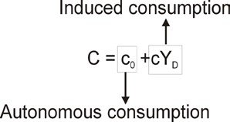

Statement c is incorrect. Lower taxes increase consumer spending but the increase is less than one to one. The formula is cT. Statement d is therefore correct. The formula is cT = (0.8)20m = R16 million.

Question 8
Which of the following are regarded as an increase in real investment? a) Buying existing shares on a stock exchange.
- The building of the Gautrain infrastructure.
- The sinking of a new shaft for a gold mine.
- An increase in savings.

  - Only a and d
  - Only b and c (The correct option is 2.)
  - a, b and c
  - Only b
  - Only d

Explanation
Make sure that you know the difference between real and financial investment. Statements a and d are examples of financial investment and statements b and c are examples of real investment.

Question 9
Which of the following statements is/are correct?
- Financial investment directly creates production capacity.
- Real investment is investment in capital goods.
- The aim of real investment is to make a profit in the future.
- In the goods market model investment is regarded as an autonomous variable, meaning that the value of investment is not determined by the level of output and income.

  - a, b, c and d
  - Only a, b and c
  - Only b, c and d
  - Only b and d (The correct option is 3.)
  - Only c and d

Explanation
Statement a is incorrect. Real investment directly creates production capacity. Statements b and c are correct. In the goods market model investment is regarded as autonomous (I = Ī) but in the IS-LM model this assumption changes. Statement d is therefore also correct.

Questions 10 to 15 are based on the following data for the country SCOREMORE for 2010.
Marginal propensity to consume = 0.8
Government spending = R360 billion
Government revenue = R241 billion

Question 10
The value of the multiplier is equal to...
- 1.25
- 8
- 0.2
- 5 (The correct option is 4.)

Explanation
The formula to calculate the multiplier is 1/1–c. Therefore 1/1-0.8 = 1/0.2 = 5.

Question 11
During 2010 the country experienced a _____of _____.
- budget surplus; R119 billion
- budget surplus; R241 billion
- budget deficit; R360 billion
- budget deficit; R119 billion (The correct option is 4.)
- 5) During 2010 the country experienced a balanced budget.

Explanation
Government spending (G = R360 billion) is more than government revenue (T = R241 billion) and therefore a budget deficit of R119 billion occurs.

Question 12
Economist calculated that the gap between the current level of output and income and the full employment level of output and income is R100 billion.
Which of the following will ensure that full employment is reached?

- An increase in government spending of R100 billion.
- An increase in taxation of R100 billion.
- An increase in government spending of R20 billion. (The correct option is 3.)
- 4) An increase in taxation of R20 billion.
5) An increase in government spending of R50 billion and a decrease in taxation of R50 billion.

Explanation
To ensure full employment you must also take the multiplier of 5 (as already calculated) into consideration: Given a gap of a R100 billion autonomous spending must increase by R100 billion/5 = R20 billion.
An increase in autonomous spending of R100 billion will increase output and income by R100 billion x 5 = R500 billion. Statement 1 is therefore incorrect. An increase in taxation will decrease the level of output and therefore statement 2 is incorrect. An increase of R20 billion in government spending increase autonomous spending by R20 billion and the level of output and income by R20 billion x 5 = R100 billion and the income gap is closed. Statement 3 is therefore correct. An increase in taxation will decrease the level of output and therefore statement 4 is incorrect. Statement 4 is incorrect since an increase in government spending of R50 billion increases income and output by R50 billion x 5 = R250 billion while a decrease in taxation increases output and income by 5 x 0.8(R50 billion) = R200 billion and thereby overshooting the level of full employment.

Question 13
If an increase in the budget deficit is unacceptable which one of the following policy actions will increase the level of output and income without increasing the budget deficit?
- A decrease in government spending of R20 billion and a decrease in taxation of R20 billion.
- An increase in government spending of R10 billion and an increase in taxation of R20 billion.
- An increase in government spending of R20 billion and an increase taxation of R20 billion. (The correct option is 3.)
- An increase in government spending of R20 billion and a decrease in taxation of R10 billion.

Explanation
To keep the budget deficit the same the increase in government spending must be matched by an increase in taxation (which is the revenue of government). This happens when the increase in government spending of R20 billion is match by an increase in taxation of R20 billion. Will this actions increase the level of output and income? Yes, because of the balanced budget multiplier. The net effect will still be positive.

Question 14
Which one of the following describes the impact of an increase in government spending of R10 billion on the goods market diagram?
- The vertical intercept increases by R10 billion and via the multiplier effect the demand for goods and the level of output and income increase by R50 billion. (The correct option is 1.)
- The vertical intercept increases by R10 billion and via the multiplier effect the demand for goods and the level of output and income increase by R10 billion.
- The vertical intercept increases by R50 billion and via the multiplier effect the demand for goods and the level of output and income increase by R50 billion.
- The vertical intercept decreases by R10 billion and via the multiplier effect the demand for goods and the level of output and income increase by R50 billion.
- The vertical intercept decreases by R10 billion and via the multiplier effect the demand for goods and the level of output and income decrease by R50 billion.

Explanation
An increase in government spending (or any other autonomous spending component) will shift the ZZ curve parallel upwards. In this case the ZZ curve will shift with R10 billion and via the multiplier effect (5 x R10 billion = R50 billion) the demand for goods and the level of output and income will increase by R50 billion.

Question 15
Which one of the following describes the impact of an increase in taxation of R10 billion on the goods market diagram?
- The vertical intercept increases by R10 billion and via the multiplier effect the increase in demand for goods and the level of output and income is R50 billion.
- The vertical intercept decreases by R8 billion and via the multiplier effect the decrease in demand for goods and the level of output and income is R40 billion. (The correct option is 2.)
- The vertical intercept increases by R8 billion and via the multiplier effect the decrease in demand for goods and the level of output and income is R40 billion.
- The vertical intercept decreases by R10 billion and via the multiplier effect the decrease in demand for goods and the level of output and income is R50 billion.
- The vertical intercept decreases by R50 billion and via the multiplier effect the decrease in demand for goods and the level of output and income is R50 billion.

Explanation
In the case of taxes, you must remember to use the formula c(T). Note that c(T) = 0.8 (given) x R10 billion = R8 billion and R8 billion x 5 (multiplier) = R40 billion.

Question 16
An increase in expenditure (e.g. G increases) implies an increase in income and employment. The implication is that government spending can be increased to a point of full employment. Which of the following factors can prevent that full employment is reached?
a) A portion of the unemployed do not have the appropriate training and skills required by the labour market. b) An unacceptable high level of inflation.
- Crowding out of private investment.
- Jobless growth.
- Structural unemployment.

  - a, b, c, d and e (The correct option is 1.)
  - Only a, c, d and e
  - Only a, b, d and e
  - Only b, c and d
  - Only b and e

Explanation
Factors such as a budget deficit, wage increases and balance of payments problems can also prevent full employment from being reached.

Question 17
Which of the following statements are correct? If the marginal propensity to save increases in the goods market model …
- it implies that households save a larger proportion of a change (or increase) in their income.
- it implies a decrease in the marginal propensity to consume. This decrease in the marginal propensity to consume leads to a decline in consumption spending. A decline in consumption spending in return causes the demand for goods to decrease and eventually output and income decline.
- investment spending will increase.
- investment spending will be unchanged since investment spending is not a function of savings. It is an exogenous variable and is determined by factors such as the interest rate, expectations, access to credit and confidence and is therefore unchanged.

  - a, b and c
  - b and d
  - Only b and c
  - a, b and d (The correct option is 4.)
  - Only a and d

Explanation
Statements a and b are correct. Remember that the marginal propensity to consume (c) + the marginal propensity to save (s) = 1. Statement c is incorrect while statement d is correct. In the goods market model investment spending is exogenous.

Question 18
Given the following information answer the question that follows:
Marginal propensity to consume = 0.8
Multiplier = 5

Which one of the following policy actions will increase the level of output and income (Y) by a R1 000. a) An increase in government spending of R200.
- A decrease in taxation of R200.
- A decrease in taxation of R250. d. A decrease in government spending of R1 000.

  - a and c (The correct option is 1.)
  - b and d
  - Only a
  - Only b
  - Only c

Explanation
We need to increase the level of output and by R1 000. This requires either an increase in government spending or a decrease in taxes. Statement d can therefore be ignored since it is incorrect.

The question is now by how much should government spending increase and taxation decline to get an increase of R1 000 in output and income? The multiplier of 5 tells us that for every R1 increase in autonomous spending income will increase by R5. In other words, we need and increase in autonomous spending of R200 (R1 000 ÷ 5 = R200 or R200 x 5 = R1 000).

Statement a is therefore correct. It is important to note that government spending directly affect the demand for goods. In other words, a R1 increase in government spending increases the demand for goods initially with R1.

Will a decrease in taxation of R200 cause an increase of R1 000 in income? When dealing with taxation you have to remember that, unlike government spending, taxation influence the demand for goods indirectly through the consumption function (which captures the behaviour of households). According to this function households will increase their consumption spending as their income increase but the increase in consumption is less than the increase in income. This effect is captured by the marginal propensity to consume. If taxes decline by R200 the disposable income of households increases with R200 and consequently their consumption spending increase by R160 (cT = 0.8 x R200). From this increase of R160 in consumption spending the multiplier effect causes output and income to increase by R160 x 5 = R900. This R900 is less than the required increase of R1 000. So by how much should taxes decline to reach the required increase in income of R1 000?

One way to calculate it is as follows: c(T) = 200
0.8(T) = 200
T = 200 ÷ 0.8
T = 250

The required decrease in taxation is therefore R250. Statement b is incorrect and statement c is correct.

Given the following information answer questions 19 and 20:
The level of full employment = 10 700
Marginal propensity to consume = 0.8
Autonomous consumption spending = 500
Investment spending = 1 000
Government spending = 800 Taxes = 400

Question 19
Which of the following statement is/are correct? a) The multiplier is 1.25.
- The equilibrium level of output and income is 9 900.
- The equilibrium level of output and income is 13 500.
- The equilibrium level of output and income is 9 500.
- The income gap is 800.
- The income gap is 1 200.

  - a, b and e
  - Only b and e (The correct option is 2.)
  - Only b
  - Only e
  - 5. None of the options 1 to 4

Explanation
Statement a is incorrect. The formula to calculate the multiplier is 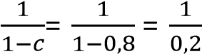= 5. Statement b is correct and statements c and d are incorrect. The equilibrium level of output and income is equal to the multiplier times autonomous spending or Y = 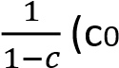+ Ī + G – cT)
The multiplier is 5 and autonomous spending = 500 + 1 000 + 800 − 0.8(400) = 1 980. The equilibrium level of output and income = 5 x 1 980 = 9 900. The income gap is therefore: 10 700 – 9 900 = 800. Therefore statement e is correct and statement f is incorrect.

Question 20
Which of the following statement is/are correct?
- To reach full employment government spending must increase by R200.
- To reach full employment government spending must increase by R160.
- To reach full employment taxes must decrease by R200.
- To reach full employment taxes must decrease by R250.

  - a and c
  - a and d
  - b and c (The correct option is 3.)
  - b and d
  - Only b

Explanation
The income gap is 800.
Government spending must therefore increase by 800÷5 = 160.
Taxation must decrease by c(T) = 160
0.8(T) = 160
T = 160/0.8
T = 200

Questions 21 and 22 are based on the following information:
The international financial crisis of 2007 had a negative impact on the goods market by undermining consumer and investment confidence. To soften this negative impact the government implemented an expansionary fiscal policy.

Question 21
What was the possible impact of the financial crisis on the goods market?
- The financial crises caused a decline in consumer and investors’ confidence.
- In the goods market model a decline in consumer and investors’ confidence will decrease autonomous spending.
- In the goods market model the demand curve for goods shift downwards (in other words the vertical intercept is lower).
- The lower autonomous spending will cause a decline in output and income.

  - a, b, c and d (The correct option is 1.)
  - Only a, c and d
  - Only a and d
  - Only a, b and d
  - Only b and d

Question 22
What was the possible impact of the expansionary fiscal policy on the goods market?
- An increase the demand for goods by increasing government spending and/or decrease taxes.
- An increase the demand for goods by decreasing government spending and/or increase taxes.
- An increase in autonomous spending and the level of output and income increases.
- A decrease in autonomous spending and the level of output and income decreases.

  - a and d
  - a and c (The correct option is 2.)
  - b and c
  - b and d
  - Only a

Explanation
Expansionary fiscal policy means that government spending must increase and/or taxes must decrease. Statement a is correct and statement b is incorrect. Government spending (autonomous spending) will increase and the level of output and income will therefore also increase. Statement c is correct and statement d is incorrect.

Questions 23 to 30 are based on the following figures for a hypothetical country:
Level of output (Y) as represented by real GDP = R200 million
Estimated population = 50 million
Estimated labour force = 20 million
Unemployment rate = 20%
Multiplier = 2
Government spending (G) = R70 million (35% of real GDP)
Government revenue (T) = R60 million (30% of real GDP)

Read the following and answer the questions that follow:
A positive relationship exists between economic growth and employment creation. The larger the employment intensity of economic growth the more jobs are created for a given economic growth rate. An employment intensity of 0.2 indicates that for a 1% economic growth rate employment increases by 0.2% while an employment intensity of 0.4 indicates that for a 1% economic growth rate employment increases by 0.4%. The following data indicates the relationship between employment intensity and the economic growth rate needed to create 500 000 new jobs in South Africa.

Employment intensity | % Change in GDP needed to create 500 000 new employment opportunities
0,2 | 18%
0,4 | 8%
0,6 | 6%
0,8 | 4%
1 | 3%

Question 23
Assuming an employment intensity of 0.4 the percentage increase in real GDP must be approximately ____ to create 500 000 new jobs.
- 4%
- 6%
- 8% (The correct option is 3.)
- 10%
- 12%

Explanation
An 8% increase in real GDP is needed to create 500 000 new employment opportunities if the employment intensity is 0.4.

Question 24
By how much should real GDP increase to create 500 000 new jobs?
- R216 million
- R8 million
- R32 million
- R16 million (The correct option is 4.)
- R70 million

Explanation
Real GDP = R200 million (given). To create 500 000 new jobs an 8% increase in GDP is necessary. Therefore R200 million x 8% =R16 million.

Question 25
If this increase in GDP is to be achieved by an increase in government spending on infrastructure by how much should government increases its spending? 1) R16 million
- R8 million (The correct option is 2.)
- R78 million
- R86 million
- R32 million

Explanation
A multiplier of 2 indicates that for every R1 increase in autonomous spending the level of output and income increases with R2. If the increases needed in real GDP (or output and income) is R16 million then the increase in government spending must be R16 million/2 = R8 million.

Question 26
Assuming that tax revenue of the government is unchanged and given the increase in government spending in question 25 government deficit as a percentage of real GDP is ____
- 12%
- 13%
- 9%
- 8.3% (The correct option is 4.)
- 39.8%

Explanation
The government deficit will increase with the amount of the increase in government spending of R8 million (see question 25). Government spending is now R78 million and taxation is R60 million. The government deficit therefore is now = R18 million. The government deficit as a percentage of real GDP is 8.3%: R18 million/ (R200 m + R16 m) x 100 = 18 million/216 million x 100 = 8.3%.

Question 27
If the creation of 500 000 new jobs is to be achieved by a decrease in taxes by how much should taxes, given a marginal propensity to consume of 0.5, decrease?
- R8 million
- R12 million
- R16 million (The correct option is 3.)
- R20 million
- R32 million

Explanation
To get the necessary increase of R8 million spending through a decrease in taxes the c(T) part need to be R8 million [c(T) = R8 million] and consequently the decrease in taxes must be as follows: Given a marginal propensity to consume of 0.5, taxes must decrease by R8 million/0.5 = R16 million.

Question 28
Given the decrease in taxes in question 27 and assuming government spending is unchanged, government deficit as a percentage of real GDP is ____
- 13%
- 12% (The correct option is 2.)
- 8.3%
- 20.4%
- 26%

Explanation
The government deficit will increase with the amount of the decrease in taxes of R16 million (see question 27). Government spending is unchanged at R70 million and taxation is now R60 million minus R16 million = R44 million. The government deficit therefore is R70 million – R44 million = R26 million. The government deficit as a percentage of real GDP is 12%: R26 million/ (R200 m + R16 m) x 100 = 26 million/216 million x 100 = 12%.

Question 29
Given the increase in government spending in question 25 and the decrease in taxes in question 27, government deficit as a percentage of real GDP is ____
- 15.7% (The correct option is 1.)
- 17%
- 12%
- 13%
- 8.3%

Explanation
Government spending is R78 million (R70m + R8m) and taxation is R44 million (R60m – R16m). The government deficit therefore is R78 million – R44 million = R34 million. The government deficit as a percentage of real GDP is 15.7%: R34 million/ (R200 m + R16 m) x 100 = 34 million/216 million x 100 = 15.7%.

Question 30
How many people will be unemployed if government spending increases as indicated in question 25 and taxes decrease as indicated in question 27?
- 4 million (The correct option is 1.)
- 4.5 million
- 5 million
- 5.5 million
- 6 million

Explanation
The unemployed people were 4 million (20% of 20 million = 4 million). If government spending increases by R8 million and taxes decreases by R16 million, there will be 500 000 + 500 000 = 1 000 000 new job opportunities. Thus
4 million – 1 000 000 = 3 million

Question 31
Given the equilibrium level of output and income is R200 million and the level of full employment is a real GDP of R300 million which the following will bring about full employment? a) An increase in government spending of R50 million.
- A decrease in taxes of R50 million.
- An increase in government spending of R30 million and decrease in taxes of R40 million.

  - a, b and c
  - Only a and c (The correct option is 2.)
  - Only a and b
  - Only b and c
  - Only a

Explanation
Statement a is correct. The income gap = R100 million (R300m – R200m). The necessary increase in government spending = 100/multiplier. The multiplier = 2, therefore 100/2 = R50 million. Statement b is incorrect. If you work with taxes, remember the formula c(T). Therefore c(T) must be equal to R50 million. The marginal propensity to consume (c) is equal to 0.5. See question 27.

Therefore: c(T) = 50 0.5(T) = 50
T = 40

Statement c is correct. The increase in autonomous spending must be equal to R50 million. If the increase in G is R30m, you can calculate the necessary decrease in T as follows: G + c(T) = 50; therefore if G = 30, c(T) must be = 20 to get the necessary R50m increase in autonomous spending: R30m + R20m = R50m

Therefore: c(T) = R20m and c = 0.5
T = 20/0.5
T = 40

Question 32
Which of the following statements are correct?
- The balance on the cheque account, cash, bonds, shares, the value of his/her house and paintings form part of the financial wealth of an individual.
- The demand for money is a function of income and the interest rate.
- The supply of money is a function of income and fiscal policy.
- There is a positive relationship between income and the demand for money.
- If the interest rate increases, the quantity of money demanded decreases.

  - a, b, c, d and e
  - Only b, d and e
  - Only a, d and e
  - Only b, c and d
  - Only a, b, d and e (The correct option is 5.)

Explanation
All the statements are correct except statement c. In this module we follow the traditional approach to the supply of money, in other words the money supply is controlled by the central bank and regarded as exogenous.

Question 33
Which one of the following describes the impact of a high economic growth rate on the financial market?
  - The supply of money increases and the interest rate declines.
  - The supply of money is unchanged while the demand for money is lower and the interest rate declines.
  - The supply of money decreases and the interest rate rises.
  - The supply of money is unchanged while the demand for money is higher and the interest rate increases. (The correct option is 4.)
  - Both the demand for and supply of money is unchanged and interest rate does not change.

Explanation
Note that a high economic growth implies an increase in the level of output and income (Y). A high economic growth will increase the demand for money since a positive relationship occurs between income and the demand for money. If the demand for money increase, the Md curve will shift to the right and the interest rate will increase. The supply of money is an exogenously determined money. The chain of events will be as follows: Y↑ → Md↑ → i↑.

Question 34
Which of the following statements are correct?
- There is a negative relationship between the price of a treasury bill and the interest rate.
- If the price of a treasury bill is R9 700 and the rate of return is 3%, the rate of return will be lower than 3% if the price of the treasury bill increases to R9 800.
- If the face value of the treasury bill is R350 000, the price paid is R280 000 with a maturity date of one year, the rate of return is 25%. d. A rising interest rate can be offset by contractionary monetary policy.
e. The events chain: DB↑ → PB↑ → i↓ shows what happens if the central bank buys treasury bills.

- a, b, c, d and e
- Only a, c, d and e
- Only b and e
- Only b, c and d
- Only a, b, c and e (The correct option is 5.)

Explanation
The correct option is 5. Statement a is correct. Statement b will therefore also be correct. 12Statement c is correct. If the face value of the Treasury bill is R350 000, the price paid for it is R280 000 and the date to maturity is one year, you can calculate your rate of return as follows:

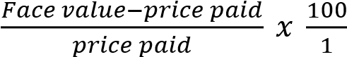

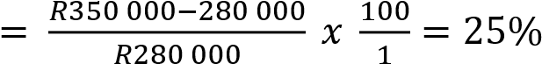

Statement d is incorrect. If the money supply increases, in other words an expansionary monetary policy, the 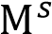 curve shifts to the right and the interest rate will decrease. Therefore a rising interest rate can be offset by an expansionary monetary policy. See also statement e. Statement e is correct. ↑: DB↑ → PB↑ → i↓.

Question 35
If there is an increase in the demand for money which one of the following actions will stop the interest rate from rising?
- The central bank should increase the interest rate to satisfy the demand for money.
- The central bank should increase the money supply to satisfy the demand for money. (The correct option is
2.)
- The central bank should decrease the money supply in order to decrease the demand for money.
- The central bank should increase the demand for money by selling bonds.

Explanation
If the money supply increases (a shift of the 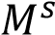 curve to the right) to satisfy the increase in the demand for money, there will be no reason for the interest rate to rise.

Question 36
Which of the following statements is/are correct?
- On the financial market an increase in income will increase the interest rate.
- Expansionary monetary policy will increase the supply of bonds and the price of bonds will increase.
- Monetary policy is measures taken by monetary authorities to influence the quantity of money and the interest rate.
- A leftward shift of the money supply curve implies a contractionary monetary policy.

  - a, b, c and d
  - Only a, c and d (The correct option is 2.)
  - Only a, b and c
  - Only c and d
  - None of the options 1 to 4

Explanation
Statement a is correct. An increase in income will shift the 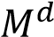 curve to the right and the result is a higher interest rate. Statement b is incorrect. The central bank will buy (not sell) bonds, the 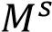 curve will shift to the right and the interest rate decreases. Statements c and d are correct.

Question 37 is based on the following diagram:
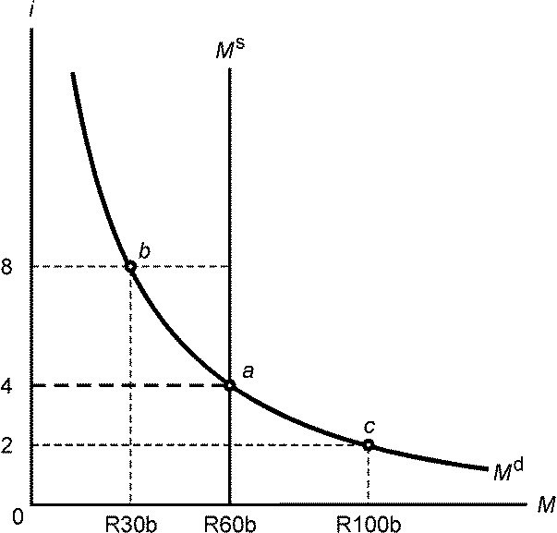

Question 37
Which one of the following statements is incorrect?
  - An increase in income will cause a movement from point a to point c. (Only statement 1 is incorrect.)
  - At an interest rate of 2% the quantity for money demanded is higher than the quantity of money supplied, in other words an excess demand for money exists.
  - At an interest rate of 8%, R30b of money is demanded while R60b of money is supplied. An excess money supplied occurs in the financial market.
  -  is an exogenously determined money supply. It implies that the money supply is determined by the central bank and is independent of the interest rate.
  - Financial market equilibrium is at point a.

Explanation
An increase in income will shift the 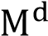 curve to the right. It is not a movement along the Md curve. Statement 2 is correct. At an interest rate of 2% the quantity of money demanded (R100b) is higher than the quantity of money supplied (R60b). A surplus demand for money of R40b exists. Statement 3 is correct. At an interest rate of 8%, R30b is demanded while R60b of money is supplied. A surplus of money supplied of R30b occurs in the financial market. Statement 4 is correct.  is an exogenously determined money supply. It implies that the money supply is determined by the central bank and is independent of the interest rate. Statement 5 is correct. At point a the quantity of money demanded is equal to the quantity of money supplied and financial market equilibrium occurs.

Question 38
Which one of the following chain of events represents the impact of a decrease in income on the financial market?
1) Y↓ → I↑ 2) Y↓ → i↑
- Y↓ → Md↓ → PB↓ → i↓ → Y↓
- Y↓ → Md↑ → PB↓ → i↑ → Y↑
- Y↓ → Md↓ → PB↑ → i↓ (The correct option is 5.)

Explanation
The chain of events that represents the impact of a decrease in income on the financial market is as follows:
Y↓ → 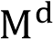↓ → PB↑ → i↓. If income decreases, the demand for money for transaction purposes will decrease. On the bonds market the demand for bonds increase causing the price of bonds to increase and consequently the interest rate will decrease.

Question 39
A decrease in income with simultaneous expansionary open market operations by the central bank shifts the …

- demand for money curve to the left and the money supply curve to the right. The equilibrium interest rate is higher.
- demand for money curve to the right and the money supply curve to the left. The equilibrium interest rate is higher.
- demand for money curve to the left and the money supply curve to the right. The equilibrium interest rate is lower. (The correct option is 3.)
- demand for money curve to the right and the money supply curve to the left. The equilibrium interest rate is lower.

Explanation
A decrease in income will shift in the demand for money curve to the left and expansionary open market operations by the central bank will shift the money supply curve to the right. The interest rate will decline. See the diagram below.

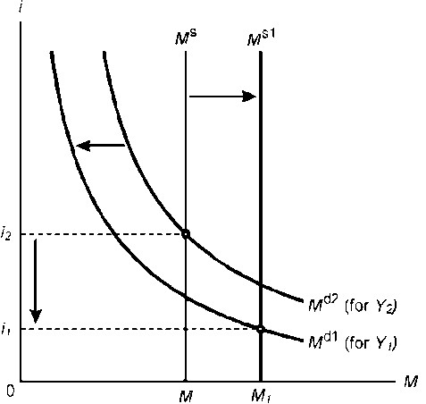

Question 40
Contractionary monetary policy involves the …
- selling of bonds by the central bank on the open market to increase the supply of money and the interest rate will decrease.
- buying of bonds by the central bank on the open market to decrease the supply of money and the interest rate will increase.
- selling of bonds by the central bank on the open market to decrease the supply of money and the interest rate will increase. (The correct option is 3.)
- buying of bonds by the central bank on the open market to increase the supply of money and the interest rate will decrease.

Explanation
Contractionary monetary policy involves the selling of bonds by the central bank on the open market to decrease the supply of money and the interest rate will increase. See the diagram below.

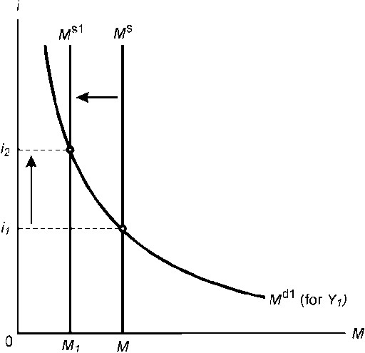

Question 1
Which one of the following statements is not a macroeconomic issue?
- The unemployment rate in South Africa, according to the strict definition, was 25,5% in 2006.
- The unexpected rainfalls in the Lowveld reduced the total banana crop and caused the price of bananas to rise. (The correct option is number 2.)
- The annual inflation in South Africa roses from 2005 to 2006.
- Because of high inflation, it is expected that the interest rate will increase.
- Annual percentage change in real GDP decreases from 5,1% in 2005 to 5,0% in 2006.

Question 2
The main focus of this macroeconomics module is the study of ….
- The determinants of the short, medium and long-term growth potential of the economy.
- Only the interaction between the goods market and the financial market.
- Different theories on the determination of output in a closed economy in the short term only.
- Only the determination of output and the impact of fiscal and monetary policy on the financial, labour and foreign exchange markets.
- The determination of output and the impact of fiscal and monetary policy on the level of output. (The correct option is number 5.)

Question 3
Adding up the total value of production (or output) of all firms in the economy … 1) Yields gross domestic product (GDP) at market prices.
2) Yields gross domestic product (GDP) at constant prices. 3) Yields real per capita gross domestic product (GDP).
- May overestimate the value of production in the economy. (The correct option is number 4.)
- May underestimate the value of production in the economy.

Question 4
Which of the following would be included in the calculation of gross domestic product (GDP) of South Africa? a) A citizen from Zimbabwe (foreign country) earns a wage at a gold mine in South Africa.
- A farmer from Gauteng (South Africa) buys his neighbour's tractor.
- Ford Motor Company of America builds an assembly plant in the Eastern Cape (South Africa). d) Exports of agricultural products to Britain.
e) Imports of motorcars from Japan to South Africa.

- All the statements are correct.
- Only statements a, c and d are correct. (The correct option is number 2.)
- Only statements b, c and e are correct.
- Only statements a and c are correct.
- Only statements b and e are correct.

Question 5
Expenditure on the gross domestic product (GDP) in South Africa is spending on goods and services produced inside the borders of South Africa …
- Excluding exports and including imports.
- Excluding imports and including exports. (The correct option is number 2.)
- Including exports and imports.
4) Excluding exports and imports.

Question 6
If a positive relationship exists between income (Y) and consumption (C), it means that … 1) An increase in consumption spending will increase income.
- An increase in consumption spending will decrease income.
- An increase in income will increase consumption spending. (The correct option is number 3.)
- An increase in income will decrease consumption spending.

Question 7
The difference between induced consumption and autonomous consumption is that …
- Induced consumption is influenced by the level of disposable income while autonomous consumption changes with a change in income.
- Induced consumption is influenced by the level of disposable income while autonomous consumption is not influenced by the level of income. (The correct option is number 2.)
- Induced consumption reflects the influence of non-income determinants of consumer spending while autonomous consumption can be regarded as consumption that is financed from sources other than income.
- Induced consumption is not influenced by the level of disposable income while autonomous consumption is influenced by the level of income.

Question 8
An autonomous (or exogenous) variable in our model means that the variable …
a) Is not determined by the level of income or production in the economy.
- Is determined by exogenous factors such as business confidence, regulations and political influences.
- Is determined by the level of income or production in the economy.
- Increases or decreases if income in the economy increases or decreases.

  - Only statement a is correct.
  - Only statement b is correct.
  - Only statement c is correct.
  - Only statement d is correct.
  - Only statements a and b are correct. (The correct option is number 5.)

Question 9
Expansionary fiscal policy means that …
  - Government spending has to be increased and/or taxes have to be decreased in order to increase aggregate demand in the economy. (The correct option is number 1.)
  - Government spending has to be decreased and/or taxes have to be increased in order to increase aggregate demand in the economy.
  - Government spending has to be decreased and/or taxes have to be increased in order to stimulate economic activity by increasing the aggregate demand in the economy.
  - Government spending has to be increased and/or taxes have to be decreased in order to "cool down" economic activity by decreasing aggregate demand in the economy.

Given the following information, answer questions 10 and 11.

Autonomous consumption = R100 million
Investment spending = R300 million
Government spending = R200 million
Taxes = R60 million
Marginal propensity to consume = ¾

Question 10
Which of the following statements is/are correct? a) Autonomous spending = R660.
- The multiplier = 4.
- Consumer spending will decrease by R7.5 million if the government increases taxes from R60 to R80 million.
- The marginal propensity to consume of ¾ means that if Y = 100, C = 75.

  - Only statements a, b and c are correct.
  - Only statements b, c and d are correct.
  - Only statements a and b are correct.
  - Only statements b and d are correct. (The correct option is number 4.)
  - 5) All the statements are correct.

Explanation
Autonomous spending will be R555 (100 + 300 + 200 - ¾(60) = 555). Consumer spending will decrease by R15 million if the government increase taxes from R60 to R80 million (cT = ¾(20) = 15).

Question 11
The equilibrium level of income is … 1) R138.75 million.
  - R2 640 million.
  - R2 220 million. (The correct option is number 3.)
  - 4) R416.25 million.
  - R2 580 million.

Explanation
The equilibrium level of income is 4 x R555 = R2 220 million.

Question 12
If total production is R500 million and aggregate demand is R550 million …
  - Excess demand occurs and producers will cut back on production until equilibrium is attained.
  - Excess supply occurs and producers will cut back on production until equilibrium is attained.
  - Excess demand occurs and producers will increase production until equilibrium is attained. (The correct option is number 3.)
  - Excess supply occurs and producers will increase production until equilibrium is attained.

Question 13
If the current level of income () is less than the full-employment level of income (Yf) in a Keynsian model of a closed economy …,
- Investment can be increased to move the economy to full employment.
- The marginal propensity to consume can be increased to move the economy to full employment.
- Government spending can be increased to move the economy to full employment.
- Taxes can be decreased to move the economy to full employment.

  - Only statements a, b and c are correct.
  - Only statements b, c and d are correct.
  - Only statements a and c are correct.
  - Only statements b and d are correct.
  - All the statements are correct. (The correct option is number 5.)

QUESTION 14
To calculate an individual's financial wealth, the following different kinds of assets will form part of it … 1) Salary, bonds, interest received from bonds and the value of his/her house.
  - Salary, balance on cheque account, bonds and interest received from bonds.
  - Money, bonds, residential land, gold coins, cash and the outstanding loan on his/her house.
  - Balance on cheque account, cash, bonds, shares, the value of his/her house and paintings. (The correct option is number 4.)

Question 15
If income increases, the demand for money …
  - Decreases and the money demand curve will shift to the left.
  - Increases and the money demand curve will shift to the right. (The correct option is number 2.)
  - Increases and there will be an upward movement along the money demand curve.
  - Increases and there will be downward movement along the money demand curve.

Question 16 is based on the following diagram below:

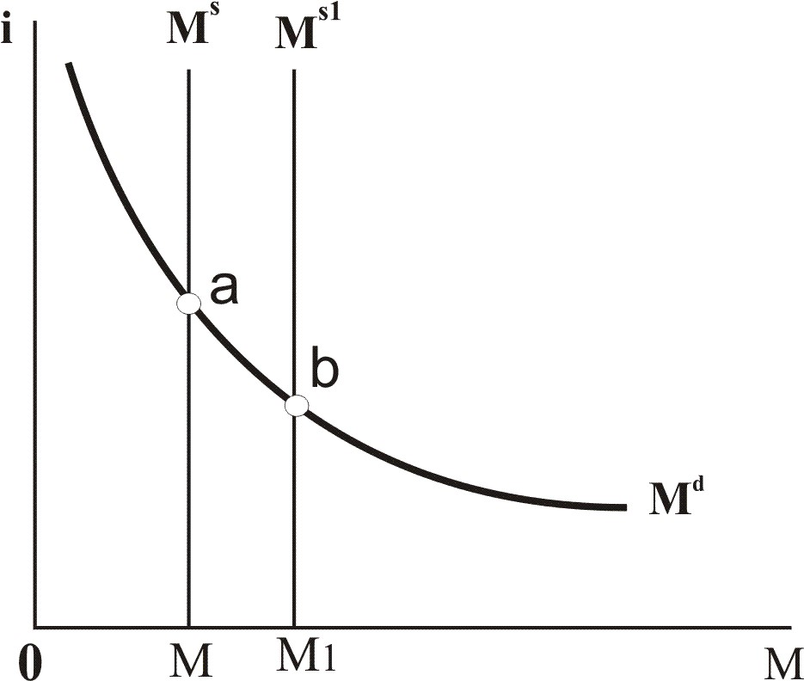

Question 16
Which of the following statements are correct?
- The money supply is a demand-determined money supply that implies that the supply of money depends on the demand for money and the interest rate.
- The initial equilibrium position in the financial market is at point a where the quantity of money demanded is equal to the quantity of money supplied.
- If money supply increases, a movement from point a to point b implies that the central bank sells treasury bills on the open market in order to decease the interest rate.
- In terms of a chain of events the diagram presented the following:
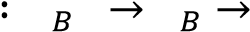

1) Only statements b and d are correct. (The correct option is number 1.)
2) Only statements b, c and d are correct.
  - Only statements a, b and d are correct.
  - Only statements a, c and d are correct.
  - 5) All the statements are correct.

Question 17
Assuming that the face value of the treasury bill is R150 000, the price paid for the bill is R140 000 and the date to maturity is one year, the rate of return is …
- 7.14% and it will decrease if the price paid for it decreases to R135 000.
- 7.14% and it will increase if the price paid for it decreases to R135 000. (The correct option is number 2.)
- 6.67% and it will decrease if the price paid for it increases to R145 000.
4) 6.67% and it will increase if the price paid for it increases to R145 000.

Questions 18 and 19 are based on the following diagram below which represents changes in the supply of money:
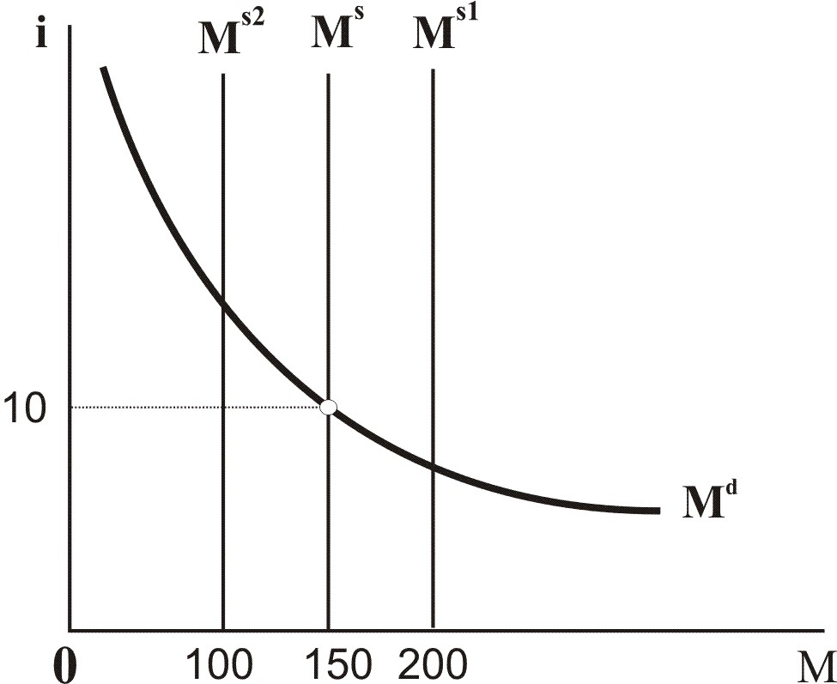

Question 18
Which of the following statements are correct?
At the initial interest rate of 10% …
- An increase in the supply of money from MS to MS1 results in a surplus of money of R50.
- An increase in the supply of money from MS to MS1 results in a shortage of money of R50.
- A decrease in the supply of money from MS to MS2 results in a surplus of money of R50.
- A decrease in the supply of money from MS to MS2 results in a shortage of money of R50.

1) Only statements a and d are correct. (The correct option is number 1.)
2) Only statements b and d are correct.
  - Only statements a and c are correct.
  - Only statements b and c are correct.

Question 19
A shift from  to 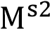 represents the impact of an …
- Expansionary monetary policy where the central bank buys treasury bills on the open market and consequently the interest rate increases.
- Expansionary monetary policy where the central bank sells treasury bills on the open market and consequently the interest rate increases.
- Contractionary monetary policy where the central bank sells treasury bills on the open market and consequently the interest rate increases. (The correct option is number 3.)
- Contractionary monetary policy where the central bank buys treasury bills on the open market and consequently the interest rate increases.

Question 20
A decrease in income with simultaneous expansionary open market operations by the central bank shifts the …
- Demand for money curve to the left and the money supply curve to the right. The equilibrium interest rate is higher.
- Demand for money curve to the right and the money supply curve to the left. The equilibrium interest rate is higher.
- Demand for money curve to the left and the money supply curve to the right. The equilibrium interest rate is lower. (The correct option is number 3.)
- Demand for money curve to the right and the money supply curve to the left. The equilibrium interest rate is lower.

Question 1
Which of the following statements is/are correct?
- An exogenous factor is a variable that we take as given, and is not determined within the model.
- Investment spending is positively related to the interest rate.
- The higher the interest rate, the fewer the potential profitable investment projects.

  - All the statements are correct.
  - Only statements a and b are correct.
  - Only statements a and c are correct (The correct alternative is 3.)
  - l4) Only statements b and c are correct.
5) None of the options 1 to 4 is correct.

Explanation
Investment spending is negatively related to the interest rate. An increase in the interest rate increases the cost of borrowing money and firms will find that there are fewer profitable investment opportunities.

Question 2
According to our analysis in this module investment will increase if there is … a) an increase in the interest rate.
- an increase in government expenditure.
- an increase in income or output.
- a decrease in taxes.

  - Only statements a, c and d are correct.
  - Only statements a, b and d are correct.
  - Only statements a, b and c are correct.
  - Only statements b, c and d are correct. (The correct alternative is 4.)
  - None of the options 1 to 4 is correct.

Explanation
There is a positive relationship between the level of output and the level of investment. Any factor which causes an increase in output will therefore cause an increase in investment.

Question 3
Which of the following statements is/are correct?
- There is a positive relationship between the level of output and the level of investment.
- A decrease in the level of output decreases the level of sales and investment spending decreases.
- The higher the interest rate, the fewer funds are available for current spending as well as for capital spending by the government.

  - All the statements are correct. (The correct alternative is 1.)
  - Only statements a and b are correct. 3) Only statements a and c are correct.
  - Only statements b and c are correct.
  - None of the options 1 to 4 is correct.

Explanation
The first two statements refer to the positive relationship between production and investment.
The third statement refers to the negative relationship between the interest rate and investment.

Question 4
Investment takes place when … 1) Households save more.
  - Firms buy existing shares on the stock exchange.
  - Government borrows money to finance current expenditure.
  - Firms increase their spending on capital goods. (The correct alternative is 4.)
  - Government employs more people.

Explanation
Investment is spending on capital goods such as factories, equipment, tools and buildings and should be distinguished from financial investment which is investment in existing shares and bonds.

Question 5
The interest rate is the cost of borrowing money, expressed as a percentage, usually over a period of one year. An increase in the interest rate …
- Increases the interest payments on loans.
- Increases the cost of borrowing money causing households and firms to borrow less money.
- Decreases the cost of borrowing money causing households and firms to borrow more money.

  - All the statements are correct.
  - Only statements a and b are correct. (The correct alternative is 2.)
  - Only statements a and c are correct.
  - Only statements b and c are correct.
  - None of the options 1 to 4 is correct.

Explanation
An increase in the interest rate increases the cost of borrowing money causing households and firms to borrow less money.

Question 6 is based on the following table which indicates potential investment projects, expected rate of returns for each project and the funding required for each project.

Project | Expected rate of return | Funding required
A | 5% | R1 million
B | 10% | R2 million
C | 15% | R3 million
D | 20% | R4 million

Question 6
Which of the following statements is/are correct?
- At a market interest rate of 19% planned investment spending is R4,0 million.
- At a market interest rate of 14% planned investment spending is R7,0 million.
- At a market interest rate of 4% planned investment spending is R9 million.
- An increase in the interest rate decreases planned investment spending in the economy.
  - All the statements are correct.
  - Only statements a, b and d are correct. (The correct alternative is 2.)
  - Only statements a, b and c are correct.
4) Only statements b, c and d are correct. 5) Only statement d is correct.

Explanation
An increase in the interest rate increases the cost of borrowing money and firms will find that there are fewer profitable investment opportunities.

Question 7
Which one of the following scenarios explains the positive relationship between the level of output and investment spending?
  - Due to the introduction of investment subsidies for the manufacturing sector in South Africa investment, spending in this sector will increase.
  - Due to high volumes of sales which are the result of higher economic growth in South Africa, investment spending in the manufacturing sector will increase. (The correct alternative is 2.)
  - In South Africa manufacturing firms decide to increase their investment spending due to lower interest rates.
  - Due to increased business confidence, firms in the manufacturing sector in South Africa increase their investment spending.

Explanation
A positive relationship exists between the level of output Y and investment since an increase in output increases the level of sales and consequently investment spending increases.

Question 8
The higher the interest rate …..
- The higher the cost of borrowing.
- The higher the opportunity cost of own funds is.
- The fewer the profitable investment opportunities in the economy.
- The lower the profitable investment spending in the economy is.

- All the statements are correct. (The correct alternative is 1)
- Only statements a, b and d are correct.
- Only statements a, b and c are correct.
- Only statements b, c and d are correct.
- Only statements a, c and d are correct.

Explanation
The correct alternative is 1 which shows that as output increases (Y ↑) investment increases (I↑).

Question 9
When we introduce investment as an endogenous variable to our previous model our equilibrium equation changes to:
- Y = Z = c₀ + c(Y – T) + + G
- Y = Z = c₀ + c(Y – T) + I(Y,i) + G
- Y = Z = c₀ + C(Y – T) + + G
- Y = Z = c₀ + C(Y – T) + I(Y,i) + G

- All the equations apply.
- Only equations a and b.
- Only equations c and d.
  - Only equations a and d.
  - Only equations b and d (The correct alternative is 5.)

Question 10
Which one of the following chain of events represents the positive relationship between the level of output and investment spending?
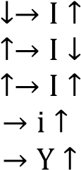
  - Y
  - Y

3) Y (The correct alternative is 3)
- I
- I

Explanation
The correct alternative is 3 which shows that as output increases (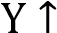) investment increases (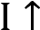 ).

Question 11
Which one of the following explains what happens on the goods market if the interest rate increases?
- An increase in the interest rate increases government spending, the demand for goods increases and the equilibrium level of income rises.
- An increase in the interest rate increases investment spending which increases the demand for goods and the equilibrium level of income rises.
- An increase in the interest rate decreases taxation, disposable income of households and the demand for goods increases, and the equilibrium level of income rises.
- An increase in the interest rate decreases investment which decreases the demand for goods and the equilibrium level of income falls. (The correct alternative is 4.)

Explanation
On the goods market an increase in the interest rate decreases investment spending which decreases the demand for goods and the equilibrium level of income falls.

Question 12
Which one of the following chain of events describes what happens on the goods market if the interest rate decreases?
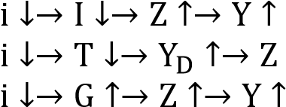
1)
2) 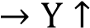
3)

4) (The correct alternative is 4.)

Explanation
The chain of events that describes the impact of a decrease in the interest rate on the goods market is:
i↓ → I↑ → Z↑ → Y↑. This chain of events shows that a decrease in the interest rate increases investment spending which increases the demand for goods and the equilibrium level of income increases.

Question 13
Which one of the following is the correct definition of the IS curve?
- The IS curve represents the combinations of output and the interest rate where the goods and financial markets are in equilibrium.
- The IS curve represents the combinations of output and the interest rate where the financial market is in equilibrium.
- The IS curve represents the combinations of output and the interest rate where the goods market is in equilibrium. (The correct alternative is 3.)
- The IS curve represents the single level of output where the goods market is in equilibrium.
Explanation
The IS curve represents the combinations of output and the interest rate where the goods market is in equilibrium.

Question 14
Which of the following statements is/are correct?
- To derive the IS curve we change the interest rate to determine the effect on income.
- To derive the IS curve we change the level of income to determine the effect on the interest rate.
- To derive the IS curve we change government spending to determine the effect on income.

  - None of the statements are correct.
  - Only statement a is correct. (The correct alternative is 2.)
  - Only statement b is correct.
  - Only statement c is correct.
  - Only statements a and b are correct.

Question 15
Which of the following factors will cause a shift of the IS curve? a) A change in the tax rate.
- A change in government spending.
- A change in consumer confidence.
- A change in any of the autonomous factors that change the demand for goods.

- All the factors are correct. (The correct alternative is 1.)
- Only factors a, b and d are correct.
- Only factors a, b and c are correct.
  - Only factors b, c and d are correct.
  - Only factors a, c and d are correct.

Explanation
A shift of the IS curve occurs when any of the autonomous variables such as government spending, taxation, autonomous consumption or autonomous investment changes.

Question 16
Which of the following will shift the IS curve to the right? a) An increase in government expenditure.
- A decrease in taxes.
- An increase in the money supply.
- An increase in autonomous consumption.
- An increase in autonomous investment.

  - Only statements b, c, d and e are correct.
  - Only statements a, c, d and e are correct.
  - Only statements a, b, d and e are correct. (The correct alternative is 3.)
  - Only statements a, b, c and e are correct.
  - Only statements a, b, c and d are correct.

Explanation
A shift of the IS curve to the right occurs when any of the autonomous variables such as government spending, autonomous consumption or autonomous investment increases or when taxation decreases.

Question 17
A change in investment spending does not always shift the IS curve …
- Because a shift of the IS curve only occurs when the interest rate changes.
- Because a change in investment spending due to a change in autonomous investment is represented by a movement along the IS curve.
- Because a change in investment spending due to a change in the interest rate is represented by a movement along the IS curve. (The correct alternative is 3.)

Explanation
An increase in income and spending causes firms to increase their investment which is represented by a shift of the IS curve to the right. However, an increase in investment because of a decrease in the interest rate is represented by a shift along the IS curve.

Question 18
Which of the following statement(s) is/are correct?
- An increase in the interest rate causes a rightward shift of the IS curve.
- A leftward shift of the IS curve indicates that at each and every interest rate the demand for goods and the equilibrium level of income are higher.
- An increase in autonomous investment is represented by a downward movement along an IS curve.

- None of the statements is correct. (The correct alternative is 1.)
- Only statement a is correct.
  - Only statement b is correct.
  - Only statement c is correct.
  - Only statements a and b are correct.

Explanation
An increase in the interest rate causes an upward movement along the IS curve. A leftward shift of the IS curve indicates that at each and every interest rate the demand for goods and the equilibrium level of income are lower. An increase in autonomous investment is represented by a rightward shift of the IS curve.

Question 19
An decrease in the level of output (Y) implies …
  - There is more money in the economy and the money supply increases.
  - There is less money in the economy and the money supply decreases.
  - That people wish to carry out more transactions and the demand for money increases.
  - That people wish to carry out less transactions and the demand for money decreases. (The correct alternative is 4.)

Explanation
A decrease in the level of output Y implies that people wish to do less transactions (since they can only afford to do less transactions) and the demand for money decreases.

Question 20
Which one of the following chain of events describes the impact of a decrease in output on the financial market?
1)
2)
3)

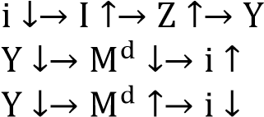
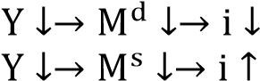
4) (The correct alternative is 4.)
5)

Explanation
The chain of events describing the LM curve is Y↑ → 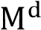↑ → i↑. It can also be in the opposite direction: Y↓ → 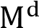 ↓ → i↓.

Question 21
Which of the following statements is/are correct?
- To derive the LM-curve we change the interest rate to determine the effect on income.
- To derive the LM-curve we change the level of income to determine the effect on the interest rate.
- To derive the LM-curve we change government spending to determine the effect on income.

  - None of the statements are correct.
  - Only statement a is correct.
  - Only statement b is correct. (The correct alternative is 3.)
  - Only statement c is correct.
5) Only statements a and c are correct.

Question 22
Which of the following chain of events describe the derivation of the LM curve?
- 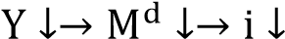
- 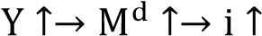
- 

  - Only a.
  - Only b. 3) Only c.
4) Only d.

5) Only a and b. (The correct alternative is 5.)

Explanation
The chain of events describing the LM curve is Y↑ → ↑ → i↑. It can also be in the opposite direction: Y↓ → ↓ → i↓.

Question 23
When we derive the LM curve an increase in income will cause …
a) The demand for money curve to shift to the right.
- An increase in the demand for money.
- An increase in the equilibrium interest rate.

  - All the statements are correct. (The correct alternative is 1.)
  - Only statements a and b are correct.
  - Only statements a and c are correct.
  - Only statements b and c are correct.
  - None of the options 1 to 4 is correct.

Question 24
Within the IS-LM model, which one of the following policy actions will bring about an increase in the level of output and a decrease in the interest rate?

- A decrease in government spending.
- A decrease in the budget deficit.
- An increase in the money supply. (The correct alternative is 3.)
- An increase in government spending.
- A decrease in the money supply.

Explanation
An increase in the money supply causes a decrease in the interest rate and an increase in the level of output.

Question 25
Within the IS-LM model, which one of the following policy actions will bring about an increase in the level of output and an increase in the interest rate?
  - A decrease in government spending.
  - A decrease in the budget deficit.
  - An increase in the money supply.
  - An increase in government spending. (The correct alternative is 4.)
  - A decrease in the money supply.

Explanation
An increase in government spending causes an increase in the level of output and an increase in the interest rate.

Question 26
Within the IS-LM model, which one of the following policy actions will bring about a decrease in the level of output and an increase in the interest rate?
  - A contractionary fiscal policy.
  - A contractionary monetary policy. (The correct alternative is 2.)
  - A decrease in the budget deficit.
  - An expansionary fiscal policy.
  - An expansionary monetary policy.

Explanation
A contractionary monetary policy shifts the LM curve to the left and the interest rises and the level of output falls.

Question 27
Within the IS-LM model, which one of the following policy actions is appropriate if the objective is to decrease the budget deficit without decreasing the level of output?
1) An expansionary fiscal policy coupled with a contractionary monetary policy.
2) An expansionary fiscal policy coupled with an expansionary monetary policy.
3) A contractionary fiscal policy coupled with an expansionary monetary policy. (The correct alternative is 3.)
4) A contractionary fiscal policy coupled with a contractionary monetary policy.

Explanation
Using a contractionary fiscal policy coupled with an expansionary monetary policy it is possible to decrease the budget deficit and keep the level of output unchanged.

A contractionary fiscal policy, for instance a decrease in government spending, causes a lower deficit. In the IS-LM model the IS curve shifts to the left and the level of output falls.

By implementing an expansionary monetary policy through increasing the money supply, the LM curve shifts to the right and the level of output returns to its original level.

Question 28
In our analysis of the labour market we assume the following: a) Labour productivity is constant.
- The price of oil and other raw material stays constant.
- The price of products set by firms is based on cost plus mark-up.

- All the statements are correct. (The correct alternative is 1.)
- Only statements a and b are correct.
- Only statements a and c are correct.
  - Only statements b and c are correct.
  - None of the options 1 to 4 is correct.

Question 29
Which of the following statements is/are correct?
- About 50% of all separations in the United States are layoffs.
- Year-to-year movements in the unemployment rate are closely associated with recessions and expansions.
- Higher unemployment is associated with both a lower chance of finding a job and a higher chance of losing your job.

  - All the statements are correct.
  - Only statements a and b are correct.
  - Only statements a and c are correct.
  - Only statements b and c are correct. (The correct alternative is 4.)
  - None of the options 1 to 4 is correct.

Question 30
Institutional differences influence wage determination between countries. Which of the following are forces that are common in all countries?
- Most workers are paid a high enough wage that they prefer being employed to being unemployed.
- The lower the unemployment rate, the higher the wages.
- Wages typically depend on labour market conditions.

- All the statements are correct. (The correct alternative is 1.)
- Only statements a and b are correct.
- Only statements a and c are correct.
  - Only statements b and c are correct.
  - None of the options 1 to 4 is correct.

Question 31
Which of the following statements is/are correct?
- Workers do not care about nominal wages but only about real wages.
- Firms do not care about real wages but only about nominal wages.
- If workers expect the price level to double, they will not be satisfied with a 25% increase in their nominal wage.

  - All the statements are correct.
  - Only statements a and b are correct.
  - Only statements a and c are correct. (The correct alternative is 3.)
  - Only statements b and c are correct.
5) None of the options 1 to 4 is correct.

Explanation
Both workers and firms care about real wages and not about nominal wages. Workers will therefore not be satisfied with a 25% increase in their nominal wage if the expected price level will increase with 50%.

Question 32
Which of the following statement(s) is/are correct?
- Workers are able to determine the real wage through nominal wage bargaining.
- Through an increase in their nominal wages workers are able to increase their real wages.
- An increase in the markup by firms causes a decrease in real wages.

  - None of the statements is correct.
  - Only statement a is correct.
  - Only statement b is correct.
  - Only statement c is correct. (The correct alternative is 4.)
  - Only statements a and b are correct

Explanation
Statement a is correct in terms of the WS curve, which indicates that at lower unemployment rates workers can bargain, through higher nominal wages, for a higher real wage. This, however, is only valid as long as the price level stays the same. The price level, however, is set by firms and when wage costs increase, the price level increase leaving the real wage the same. It then turns out that while labour can bargain for higher real wages though an increase in nominal wages, they cannot eventually ensure that they receive this higher real wage.

An increase in the mark-up by firms causes a decline in real wages since firms now claim a larger part of the product for themselves.

Question 33
Which of the following factor(s) will increase the bargaining position of workers? a) A lower level of output and a higher unemployment rate.
- A higher level of output and a lower unemployment rate.
- An increase in unemployment benefits.
- Labour laws that protect workers from being dismissed.

- Only factors b, c and d. (The correct alternative is 1.)
- Only factors b and d.
  - Only factors a, c and d.
  - Only factors b and c.
  - Only factor b.

Explanation
A lower level of unemployment, an increase in unemployment benefits, and labour laws that protect workers from being dismissed are all factors which increase the bargaining position of workers.

Question 34
An increase in the level of output will cause the following events on the labour market …
- The natural level of unemployment decreases causing an increase in the bargained real wage.
- The level of unemployment decreases causing an increase in the bargaining position of workers which enables them to bargain for a nominal wage increase. (The correct alternative is 2.)
- The level of unemployment increases which causes a decline in the bargaining position of workers resulting in a lower bargained nominal wage.
- The natural level of unemployment increases causing a decrease in the bargained real wage.

Explanation
An increase in the level of output cause the unemployment rate to decrease causing an increase in the bargaining position of workers which enables them to bargain for a nominal wage increase.

Question 35
Which one of the following chain of events describes the impact of an increase in output on the labour market?
1) 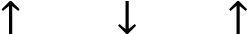
2)
3)

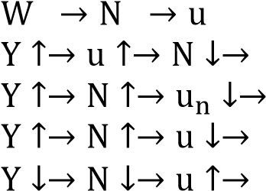
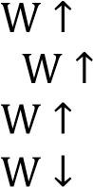
4) (The correct alternative is 4.)
5)

Explanation
The chain of events describing the events on the labour market is: Y↑ → N↑ → u↓ → W↑.

Question 36
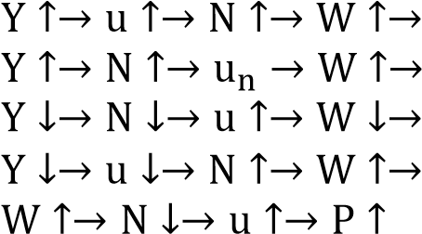
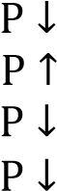
Which of the following events is/are represented by the AS curve?
1)
2)

3) (The correct alternative is 3.)
4)
5)

Explanation
The downward movement along the AS curve shows that a decrease in output decrease employment which increases unemployment. The increase in unemployment decreases the bargaining position of workers and consequently the nominal wage declines causing a decrease in the price level. The chain of events is therefore
Y↓ → N↓ → u↑ → W↓ → P↓.

Question 37
Which of the following events is represented by the AD curve?

- Only a.
- Only b. 3) Only c.
- Only d.
- Only a and d. (The correct alternative is 5.)

Explanation
Behind the AD curve are the following events: P↑ → M/P↓ → i↑ → I↓ → Z↓ → Y↓ or P↓ → M/P↑ → i↑ → I↑ → Z↑ → Y↑.

Question 38
Which one of the following events applies in the medium term in the case of an expansionary monetary policy in the labour market?
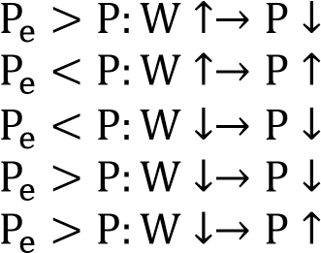
1)

2) (The correct alternative is 2.)
3)
4)
5)
Explanation
In the medium run the expected price level is lower than the actual price level. This causes workers to bargain for an increase in the nominal wage which leads to an increase in the price level.

Question 39
Which one of the following events applies in the medium term in the case of an expansionary monetary policy in the financial market?
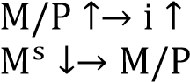
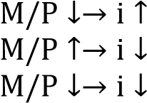
1)
2) 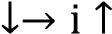

3) (The correct alternative is 3.)
4)
5)

Explanation
The increase in the price level causes a decrease in the real money supply. Due to the lower real money supply the interest rate rises.

Question 40
Which one of the following events applies in the medium term in the case of an expansionary monetary policy in the goods market?

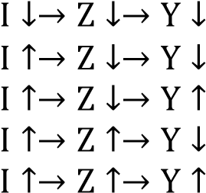
1) (The correct alternative is 1.)
2)
3)
4)
5)

Explanation
Due to the higher interest rate investment, the demand for goods and output decline.

Question 1
The difference between microeconomics and macroeconomics is that ….
- Microeconomics studies businesses while macroeconomics studies people.
- Microeconomics studies what is happening in the economy now while macroeconomics studies what happened in the past.
- Microeconomics studies the performance of the private sector while macroeconomics studies the performance of the government.
- Microeconomics studies the overall price level while macroeconomics studies price determination in a single industry.
- Microeconomics studies individual decision makers while macroeconomics studies the economy's overall performance. (The correct option is number 5.)

Question 2
Gross domestic product (GDP) …
- Is the total value of all goods and services produced within the boundaries of a country in a particular period.
- Is the broadest, best-known and most used measure of economic activity.
- Includes imports of goods and services.
- Can be expressed in real or nominal prices.

  - Only statements a, b and d are correct.
  - Only statements b and d are correct. (The correct option is number 2.)
  - Only statements b, c and d are correct.
  - Only statements a, c and d are correct.
  - Only statement d is correct.

Question 3
The overall balance of payments position in the balance of payments is reflected by the …
1) Balance on the current account.
  - Balance on the financial account.
  - Balance on the capital transfer account.
  - Balance of unrecorded transactions.
  - Change in foreign reserves. (The correct option is number 5.)

Question 4
Gross domestic expenditure, which is the total value of spending on final goods and services within the borders of a country …
- Includes imports but excludes exports. (The correct option is number 1.)
- Excludes exports but includes imports.
- Includes both imports and exports.
- Excludes both imports and exports.

Question 5
Which one of the following options is incorrect?
  - The four major spenders in the economy are households, government, private firms and the foreign sector.
  - Final consumption expenditure by households (C) is classified in terms of durable, semi-durable, and nondurable goods and services.
  - Transfers payments and interest on debt are included from final consumption expenditure by government
(G) since they are part of the purchase of final goods and services. (The correct option is 3)
4) Gross capital formation is the spending by households, private firms and government on residential and nonresidential capital goods.

Question 6
When an economist refers to investment, he or she usually means …
  - Financial investment, in other words, investment in shares and other financial instruments.
  - Financial investment, in other words, spending on additions to the capital stock, such as machinery and structures.
  - Real investment, in other words, investment in shares and other financial instruments.
  - Real investment, in other words, spending on additions to the capital stock, such as machinery and structures. (The correct option is number 4.)

Question 7 is based on the following diagram.
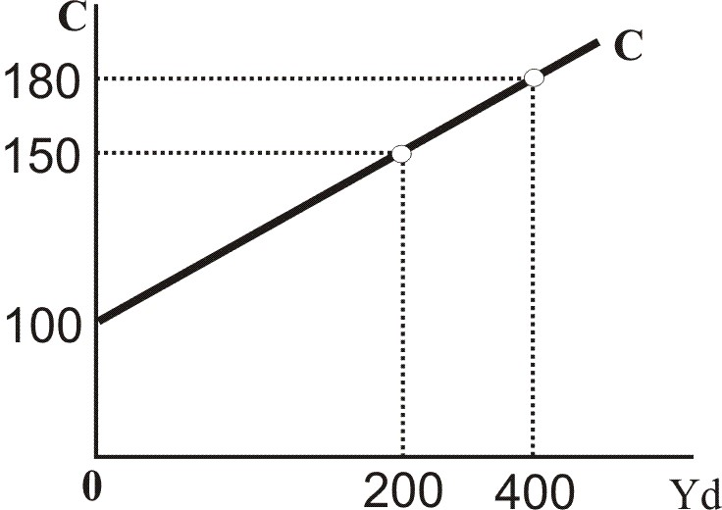
Question 7
Which of the following statements is/are correct? a) Induced consumption is equal to R100.
- The marginal propensity to consume is equal to 0.15. It means that if the income of households increases by R100 million, the increase in consumer spending will be R15 million.
- An increase in autonomous consumption will influence the slope of the consumption curve.
- If the marginal propensity to save by households increases, the marginal propensity to consume will be lower. In other words, the slope of the C curve will be flatter.

  - Only statements a, b and c are correct.
  - Only statements a, b and d are correct.
  - Only statements b and d are correct. (The correct option is number 3.)
  - Only statements a and d are correct.
5) Only statements b and c are correct.

Explanation
Statement a refers to autonomous consumption.
Statement b is correct since 0.15 x R100 million = R15 million.
Statement c is incorrect because any change in autonomous consumption will affect the position of the consumption curve and not the slope of the curve. Statement d is correct.

Question 8
Given that co = 800, = 600, G = 700, c = 0.8 and T = 400 the equilibrium level of income is ...
- R12 500
- R12 100

3) R8 900 (The correct option is number 3.)
- R2 100
- R1 424

Explanation

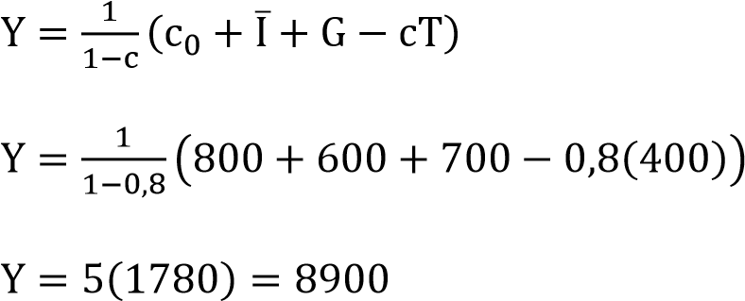

Question 9 is based on the following diagram below.

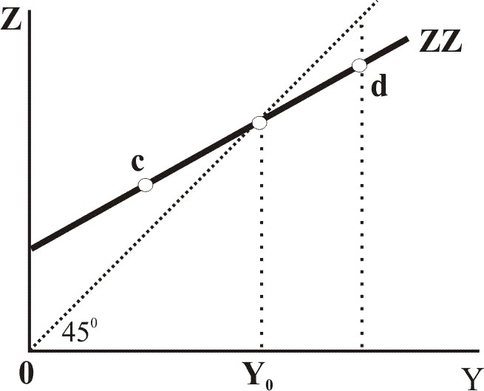

Question 9
Given a demand for goods curve ZZ …
- At point d the demand for goods exceeds the level of output; therefore excess supply occurs and producers will cut back on production to move back to Y0.
- At point d the level of output exceeds the demand for goods; therefore excess supply occurs and producers will cut back on production to move back to Y0.
- At point c the demand for goods exceeds the level of output; therefore excess demand occurs and producers will increase production to move back to Y0.
- At point c the level of output exceeds the demand for goods; therefore excess demand occurs and producers will increase production to move back to Y0.

  - Only statements a and c are correct.
  - Only statements a and d are correct.
  - Only statements b and c are correct. (The correct option is number 3.)
  - Only statements b and d are correct.

Question 10
If the multiplier is 3 and income increased by R72 million, the increase in autonomous spending must have been …
1) R72 million.
2) R24 million. (The correct option is number 2.)
3) R0.04 million.
  - R216 million.

Explanation
The increase in autonomous spending will be R24 since 72/3 = 24.

Question 11
Given that co = R50, =̅ R230, G = R300, c = ¾, T = R100 and Yf = R3 000 the equilibrium level of income is ... and in order to reach the full-employment level of income, government spending must increase by …
1) R2320 million and G must increase by R170 million.
- R2020 million and G must increase by R980 million.
- R2020 million and G must increase by R245 million. (The correct option is number 3.)
- R2720 million and G must increase by R70 million.

Explanation
The equilibrium level of income (Ye) is 4 x R505 = R2 020 million and G must increase by R245 million. The difference between Yf and Ye is equal to R3 000m – R2020 = R980m and 4 x 245 = 980. This refers to the multiplier effect.

Question 12
Given that an economy is at equilibrium at an income level less than full employment, an increase in the marginal propensity to consume will cause …..
- An upward shift of the demand for goods curve.
- A downward shift of the demand for goods curve.
- A flatter slope of the demand for goods curve.
- A steeper slope of the demand for goods curve. (The correct option is number 4.)
- A higher vertical intercept of the demand for goods curve.

Question 13
Money, which can be used for transactions, includes …
- Income, interest received from bonds, shares and currency.
- Income, bonds, shares, checkable deposits, coins and notes.
- Currency, checkable deposits, income and the interest rate.
- Investment, shares, coins and notes and checkable deposits.
- Coins and notes and checkable deposits. (The correct option is number 5.)

Question 14
The demand for money in an economy depends on the …
1) Supply of money and the interest rate.
- Marginal propensity to consume.
- Multiplier.
- Interest rate and the level of income. (The correct option is number 4.)

Question 15
Exogenously determined money supply implies that …
- As the interest rate increases the money supply will also increase.
- The supply of money is determined by the demand for money and the interest rate. 3) Money supply is determined by the central bank. (The correct option is number 3.)
- Money demand is determined by the central bank.
5) The money supply curve is perfectly elastic.

Question 16 is based on the figure below:

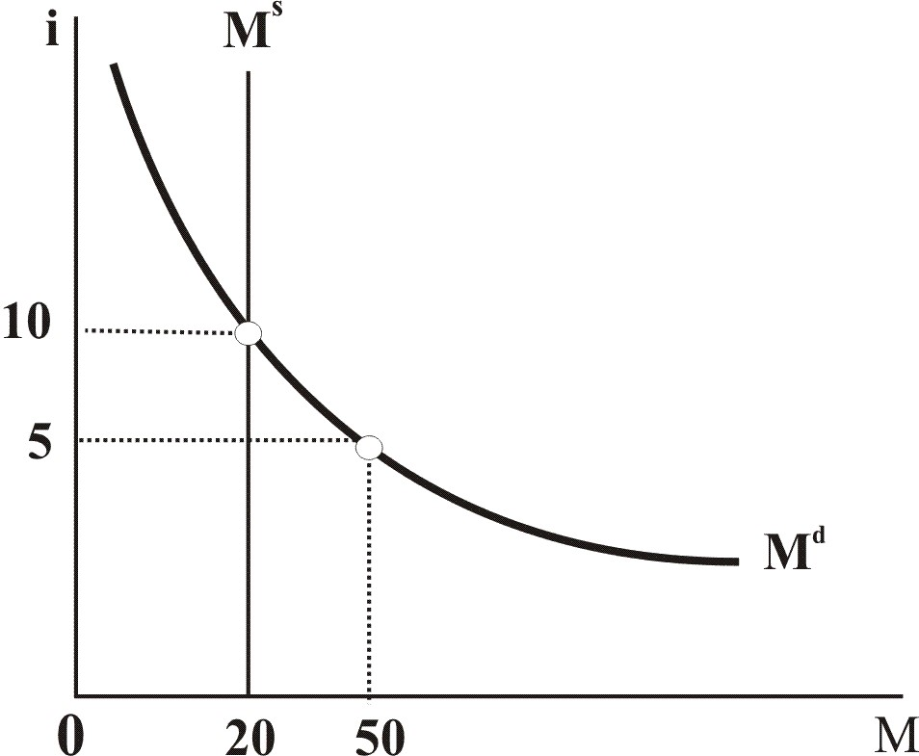

Question 16
Which of the following statements are correct?
- At an interest rate of 5% the quantity of money supplied is 20 if the money supply is regarded as exogenous.
- At an interest rate of 10% equilibrium occurs in the financial market; the quantity of money supplied (=20) is equal to the quantity of money demanded (=20).
- If the level of income increases, an excess supply of money exists at an interest rate of 10%.
- An increase in the demand for money shifts the curve to the right.

1) Only statements a, b and c are correct. 2) Only statements a and d are correct.
  - Only statements b, c and d are correct.
  - Only statements b and d are correct.
  - Only statements a and b are correct. (The correct option is number 5.)

Question 17
An expansionary monetary policy involves …
  - The selling of bonds by the central bank on the open market to increase the supply of money and the interest rate will decrease.
  - The buying of bonds on the open market by the central bank to decrease the supply of money and the interest rate will increase.
  - The selling of bonds on the open market by the central bank to decrease the supply of money and the interest rate will increase.
  - The buying of bonds on the open market by the central bank to increase the supply of money and the interest rate will decrease. (The correct option is number 4.)

Question 18
If the face value of the Treasury bill is R300 000, the price paid is R280 000 with the maturity date of one year, the rate of return is ...
  - R20 000
  - 7.14% (The correct option is number 2.)
  - 6.67%
  - R280 000
  - 2.07%

Question 19
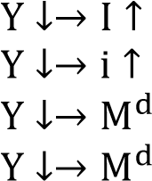
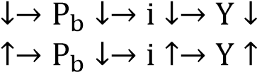
Which one of the following chain of events represents the impact of a decrease in income on the financial market?
1)
2)
3)
4)
  - 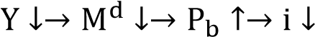 (The correct option is number 5.)

Question 20
A decrease in income with simultaneous contractionary open market operations by the central bank …
- Is represented by a shift of the demand for money curve to the left and the money supply curve to the right.
- Is represented by a shift of the demand for money curve to the right and the money supply curve to the left. c) Will result in an increase in the interest rate.
- Will result in a decrease in the interest rate.
- Will result in an indeterminate impact on the interest rate.

- Only statement e is correct. (The correct option is number 1.)
- Only statements a and e are correct.
  - Only statements b and c are correct.
  - Only statements b and d are correct.
  - Only statements b and e are correct.

Question 1
In the IS-LM model investment spending is determined by …..
a) The interest rate.
- The level of output.
- Government spending.

  - All the statements are correct.
  - Only statements a and b are correct. (The correct alternative is 2.)
  - Only statements a and c are correct.
  - Only statements b and c are correct.
  - None of the options 1 to 4 is correct.

Question 2
When we introduce investment as an endogenous variable to our previous model our equilibrium equation changes to …
a) Y = Z = c0 + c(Y – T) + ̅ + G
- Y = Z = c0 + c(Y – T) + I(Y,i) + G
- Y = Z = c0 + C(Y – T) + ̅ + G
- Y = Z = c0 + C(Y – T) + I(Y,i) + G

1) All the equations apply.
2) Only equations a and b.
3) Only equations c and d.
4) Only equations a and d.

Explanation
There is no correct alternative. Only equation b is correct ie. Y = Z = c0 + c(Y – T) + I(Y,i) + G. All answers were taken as correct.

Question 3
Which of the following statements is/are correct? a) Consumption is a positive function of output.
- Investment is a positive function of output.
- Investment is a positive function of the interest rate

  - All the statements are correct.
  - Only a and b are correct. (The correct alternative is 2.)
  - Only a and c are correct.
  - Only b and c are correct.
  - None of the options 1 to 4 is correct.

Explanation
Consumption and investment are positive functions of output. Investment is a negative function of the interest rate.

Question 4
When firms increase their spending on capital goods …
a) Financial investment takes place.
- Real investment takes place.
- It means that the expected rate of return on an investment project exceeds the market interest rate.

  - All the statements are correct.
  - Only statements a and b are correct.
  - Only statements a and c are correct.
  - Only statements b and c are correct. (The correct alternative is 4.)
  - None of the options 1 to 4 is correct.

Explanation
Investment is spending on capital goods such as factories, equipment, tools and buildings and should be distinguished from financial investment which is investment in existing shares and bonds.

Question 5
The interest rate is the cost of borrowing money, expressed as a percentage, usually over a period of one year. A decrease in the interest rate …
  - Decreases the cost of borrowing money and households and firms will borrow more money. (The correct alternative is 1.)
  - Increases the cost of borrowing money and households and firms will borrow less money.
  - Increases the interest payments on loans.
  - Causes banks to decrease their lending to households and firms.

Explanation
A decrease in the interest rate decreases the cost of borrowing money and households and firms will borrow more money. Since the cost of money has decreased, lending by banks increase. Interest payments on loans decrease.

Question 6
Between the interest rate and investment spending …
- A negative relationship exists and the chain of events that describes the relationship between the interest rate and investment spending is 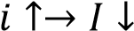.
- A negative relationship exists and the chain of events that describes the relationship between the interest rate and investment spending is 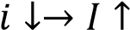.
- A positive relationship exists and the chain of events that describes the relationship between the interest rate and investment spending is 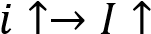.
- A positive relationship exists and the chain of events that describes the relationship between the interest rate and investment spending is 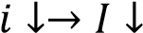.

  - Only statement a is correct.
  - Only statement c is correct.
  - Only statements a and b are correct. (The correct alternative is 3.)
  - Only statements c and d are correct.
5) None of the options 1 to 4 is correct.

Explanation
Between the interest rate and investment spending a negative relationship exists and the chain of events that describes the relationship between the interest rate and investment spending is i↓ → I↑ or i↑ → I↓.

Question 7
A negative relationship exists between the interest rate and investment spending since …
- An increase in the interest rate increases the return on savings and it is worthwhile for households to increase their savings.
- A decrease in the interest rate decreases the cost of borrowing and households are able to borrow more money from banks.
- An increase in the interest rate increases the cost of borrowing money and firms will find that there are fewer profitable investment opportunities. (The correct alternative is 3.)
- An increase in autonomous investment increases the interest rate.
5) A decrease in investment spending causes a decrease in the level of output.

Explanation
An increase in the interest rate increases the cost of borrowing money and firms will find that there are fewer profitable investment opportunities.

Question 8
Which of the following events cause a shift of the investment curve?
- In South Africa manufacturing firms decide to increase their investment spending due to a lower interest rate.
- Due to increased business confidence firms in the manufacturing sector in South Africa increase their investment spending.
- Due to the introduction of investment subsidies for the manufacturing sector in South Africa, investment spending in this sector increases.

  - All the events.
  - Only events a and b.
  - Only events b and c. (The correct alternative is 3.)
  - Only events a and c.
5) None of the events.

Explanation
Business confidence and investment subsidies will shift the investment schedule and the IS curve.

Question 9
The following chain of events  indicates that …
  - A positive relationship exists between investment spending and the level of output.
  - A positive relationship exists between the level of output and investment spending. (The correct alternative
is 2)
  - A negative relationship exists between investment spending and the level of output. 4) A negative relationship exists between the level of output and investment spending.

Explanation
The correct alternative is 2 which shows that as output increases (Y ↑) investment increases (I↑).

Question 10
Which one of the following explains what happens on the goods market if the interest rate increases?
  - Investment spending increases which causes an increase in the demand for goods and the equilibrium level of income rises.
  - Disposable income of households increases which increases the demand for goods and the equilibrium level of income rises.
  - Investment spending decreases which causes a decrease in the demand for goods and the equilibrium level of income declines. (The correct alternative is 3.)
  - Government spending declines and the demand for goods decreases and the equilibrium level of income declines.

Explanation
On the goods market an increase in the interest rate decreases investment spending which decreases the demand for goods and the equilibrium level of income falls.

Question 11
Which one of the following chain of events describes what happens on the goods market if the interest rate decreases?
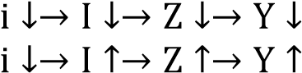
1)

2) (The correct alternative is 2.)
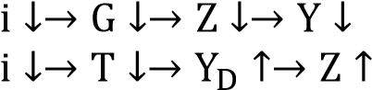
3)
4) 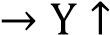

Explanation
The chain of events that describes the impact of a decrease in the interest rate on the goods market is: i↓→I↑→ Z↑→Y↑. This chain of events shows that a decrease in the interest rate increases investment spending which increases the demand for goods and the equilibrium level of income increases.

Question 12
The statement “a decrease in the interest rate causes an increase investment spending and the IS curve shifts rightwards” is incorrect since …
- A decrease in the interest rate causes a decrease in investment spending.
- It causes a leftward shift of the IS curve.
- It causes a downward movement along the IS curve. (The correct alternative is 3.)
- 4) It causes an upward movement along the IS curve.

Explanation
A shift in the IS curve occurs when any of the autonomous variables such as government spending, taxation, autonomous consumption or autonomous investment changes while a movement along the IS curve occurs when a change in the interest rate changes investment spending.

Question 13
If there is an increase in income ceteris paribus the …
a) Demand for money will increase.
- Interest rate will increase.
- Supply of money will decrease.

  - All the statements are correct.
  - Only statements a and b are correct. (The correct alternative is 2.)
  - Only statements a and c are correct.
  - Only statements b and c are correct.
  - None of the statements is correct.

Explanation
The supply of money is an autonomous variable in our model.

Question 14
On the financial market the demand for money …
- Increases as the level of output increases since people wish to do more transactions and therefore need more money.
- Decreases as the level of output decreases since people wish to do fewer transactions and therefore need less money.
- Decreases as the interest rate decreases since the opportunity cost of holding money is higher.

  - All the statements are correct.
  - Only statements a and b are correct. (The correct alternative is 2.)
  - Only statements a and c are correct.
  - Only statements b and c are correct.
  - None of the statements is correct.

Explanation
An increase in the level of output Y implies that people wish to do more transactions (since they can now afford to do more transactions) and the demand for money increases.

Question 15
In the financial market an increase in the demand for money due to an increase in the level of output is represented by …
  - A leftward shift of the demand for money curve and the equilibrium interest rate increases.
  - An upward movement along the demand for money curve and the equilibrium interest rate increases.
  - A rightward shift of the demand for money curve and the equilibrium interest rate increases. (The correct alternative is 3.)
  - A downward movement along the demand for money curve and the equilibrium interest rate decreases.

Explanation
In the financial market an increase in the demand for money is represented by a rightward shift of the demand for money curve and the equilibrium interest rate increases.

Question 16
Which one of the following chain of events describes the impact of a decrease in output on the financial market?
1)
2)
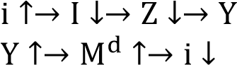
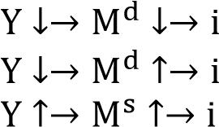
  - (The correct alternative is 3.)
4)
5)

Explanation
The chain of events that describes the impact of a decrease in output on the financial market is
Y↓ → Md↓ → i↓. This chain of events shows that a decrease in output and income decreases the demand for money and on the financial market the interest rate falls.

Question 17 The LM curve ….
- Consists of combinations of interest rates and income levels where the financial market is in equilibrium.
- Consists of combination of interest rates and income levels where the goods market is in equilibrium.
- Consists of combination of interest rates and income levels where both the goods and the money markets are in equilibrium.
- Represents a positive relation between the interest rate and the level of income.

- Only statements a and d are correct. (The correct alternative is 1.)
- Only statement b and d are correct.
  - Only statement c and d are correct.
  - Only statement c is correct.
  - None of the options 1 to 4 is correct.

Explanation
The LM curve consists of combinations of interest rates and income levels where the financial market is in equilibrium and represents a positive relation between the interest rate and the level of income. The IS curve consists of combination of interest rates and income levels where the goods market is in equilibrium.

Question18
Which one of the following chain of events describes the derivation of the LM curve?
1) 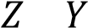
2)
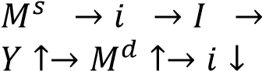
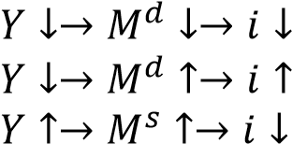
  - (The correct alternative is 3.)
  - 5)

Questions 19 and 20 are based on the following LM curve:

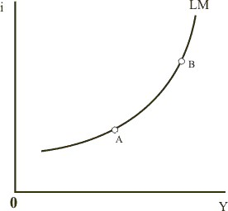

Question 19
At point A compared to point B .. a) The level of output is lower.
- The demand for money is lower.
- The equilibrium interest rate is lower.

- All the statements are correct. (The correct alternative is 1.)
- Only statements a and b are correct.
- Only statements a and c are correct.
  - Only statements b and c are correct.
  - None of the statements is correct.

Explanation
At point A compared to point B the level of income is lower, the demand for money is lower and the interest rate is lower.

Question 20
Which of the following will cause a shift of the LM curve? a) A change in the demand for money.
- A change in the level of output.
- An increase in the money supply.
- A decrease in the money supply.

  - Only statements a, c and d are correct.
  - Only statements a, b and c are correct.
  - Only statements a, b and d are correct.
  - Only statements b, c and d are correct.
  - None of the options 1 to 4 is correct. (The correct alternative is 5.)

Explanation
An increase in the money supply shifts the LM curve to the right and a decrease in the money supply shifts the LM curve to the left.

Question 21
An increase in the nominal money supply causes …
  - The LM curve to shift to the right and the interest rate decreases. As the interest rate decreases investment spending increases and the IS curve shifts to the right.
  - The LM curve to shift to the left and the interest rate increases. As the interest increases investment spending decreases and the IS curve shifts to the left.
  - The LM curve to shift to the right and the interest rate decreases. As the interest decreases investment spending increases and a movement along the IS curve takes place. (The correct alternative is 3.)

Explanation
An increase in the money supply shifts the LM curve to the right. On the financial market the interest rates falls and on the goods market the decrease in the interest rate increases investment spending, the demand for goods and the level of output. An increase in the money supply causes an increase in the level of output and a decrease in the interest rate.

Question 22
An increase in government spending …
  - Increases the demand for goods and the IS curve shifts to the right. As government spending increases, the supply of money increases and the LM curve shifts to the right.
  - Increases the demand for goods and the IS curve shifts to the right. The demand for money increases and the interest rises and a movement along the LM curve takes place. (The correct alternative is 2.)
  - Increases the demand for goods and the IS curve shifts to the left. The demand for money increases and the interest rises causing the LM curve to shift to the left.

Explanation
An increase in government spending shifts the IS curve to the right and the interest rate rises and the level of output increases.

Question 23
Which one of the following policy actions will bring about a decrease in the level of output and an increase in the interest rate?
  - An increase in the money supply.
  - An increase in government spending.
  - A decrease in the money supply. (The correct alternative is 3.)
  - A decrease in government spending. 5) An increase in the budget deficit.

Explanation
A decrease in the money supply shifts the LM curve to the left and the interest rises and the level of output falls.

Question 24
Which one of the following policy actions will bring about an increase in the level of output and an increase in the interest rate?
- An increase in the money supply.
- An increase in government spending. (The correct alternative is 2.)
- A decrease in the money supply.
- A decrease in government spending.
- A decrease in the budget deficit.

Explanation
An increase in government spending shifts the IS curve to the right and the interest rate rises and the level of output increases.

Question 25
Which one of the following policy actions will bring about a decrease in the level of output and an increase in the interest rate?
- An expansionary fiscal policy.
- An expansionary monetary policy.
- A contractionary fiscal policy.
- A contractionary monetary policy. (The correct alternative is 4.)
- A decrease in the budget deficit.

Explanation
Contractionary monetary policy shifts the LM curve to the left and the interest rises and the level of output falls.

Question 26
Which one of the following policy actions is appropriate if the objective is to decrease the budget deficit without decreasing the level of output?
- An expansionary fiscal policy coupled with an expansionary monetary policy.
- A contractionary fiscal policy coupled with a contractionary monetary policy.
- An expansionary fiscal policy coupled with a contractionary monetary policy.
4) A contractionary fiscal policy coupled with an expansionary monetary policy. (The correct alternative is 4.)

Explanation
Using a contractionary fiscal policy coupled with an expansionary monetary policy it is possible to decrease the budget deficit and keep the level of output unchanged.
A contractionary fiscal policy, for instance a decrease in government spending, causes a lower deficit. In the IS-LM model the IS curve shifts to the left and the level of output falls. By implementing an expansionary monetary policy through increasing the money supply, the LM curve shifts to the right and the level of output returns to its original level.

Question 27
Our analysis of the labour market implies the following …
- There is a negative relation between the real wage and the unemployment rate.
- The higher the unemployment rate, the weaker the workers' position in bargaining.
- The higher the unemployment rate, the lower the real wage.

- All the statements are correct. (The correct alternative is 1.)
- Only statements a and b are correct.
- Only statements a and c are correct.
  - Only statements b and c are correct.
  - None of the options 1 to 4 is correct.

Explanation
There is a negative relation between the real wage and the unemployment rate. The higher the unemployment rate, the weaker the workers' position in bargaining. The higher the unemployment rate, the lower the real wage.

Question 28
On which of the following do the prices set by firms depend? a) The nature of the production function.
b) The relation between the inputs used in production and the quantity of output produced. c) The prices of the inputs.

- All the statements are correct.( The correct alternative is 1.)
- Only statements a and b are correct.
- Only statements a and c are correct.
- Only statements b and c are correct.
- None of the options 1 to 4 is correct.

Explanation
Prices set by firms depend on the nature of the production function, the relation between the inputs used in production and the quantity of output produced, and the prices of the inputs.

Question 29
Which of the following factor(s) will increase the bargaining position of workers? a) The more expensive it is to dismiss workers.
- A higher level of output and a lower unemployment rate.
- An increase in unemployment benefits.
- Labour laws that protect workers from being dismissed.

- All the factors. (The correct alternative is 1.)
- None of the factors.
  - Only factors a, b and c.
  - Only factors b, c and d.
  - Only factor b.

Explanation
A lower level of unemployment, an increase in unemployment benefits, and labour laws that protect workers from being dismissed are all factors which increase the bargaining position of workers.

Question 30
Which of the following statement(s) is/are correct?
- The price level in the economy is partly the outcome of nominal wage bargaining and the price setting behaviour of firms in the economy.
- An increase in the nominal wage is enough to ensure an increase in the real wage.
- A decrease in the mark-up by firms causes an increase in real wages.

  - All the statements are correct.
  - None of the statements is correct.
  - Only statements a and b are correct.
  - Only statements b and c are correct.
  - Only statements a and c are correct. (The correct alternative is 5.)

Explanation
A decrease in the mark-up by firms causes an increase in real wages since firms now claim a smaller part of the product for themselves.

Question 31
A decrease in the level of output will cause the following events on the labour market …
- The level of unemployment decreases causing an increase in the bargaining position of workers which enables them to bargain for a nominal wage increase.
- The level of unemployment increases which causes a decline in the bargaining position of workers resulting in a lower bargained nominal wage.
- The natural level of unemployment decreases causing an increase in the bargained real wage. (The correct alternative is 2.)
- The natural level of unemployment increases causing a decrease in the bargained real wage.

Explanation
The unemployment rate is higher which decreases the bargaining position of workers and the nominal wage they bargain for decreases.

Question 32
Which one of the following chain of events describes the impact of an increase in output on the labour market?
1)
2)
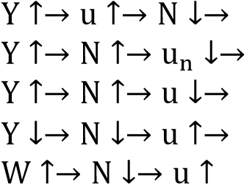
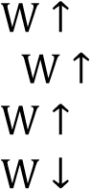
3) (The correct alternative is 3.)
4)
5)

Explanation
The chain of events describing the events on the labour market is: Y↑ → N↑ → u↓ → W↑.

Question 33
Which of the following events is/are represented by the AS curve?

- Only a.
- Only b.
- Only c. (The correct alternative is 3.)
- Only d.
5) Only b and c.

Explanation
The upward movement along the AS curve shows that an increase in output, an increase in employment which decreases unemployment. The decrease in unemployment increases the bargaining position of workers and consequently the nominal wage increases causing an increase in the price level. The chain of events is therefore
Y↑ → N↑ → u↓ → W↑ → P↑.

Question 34
Which of the following events is represented by the AD curve?

- Only a.
- Only b. 3) Only c.
- Only d.
- None of the options 1 to 4 is correct. (The correct alternative is 5.)

Explanation
Equations a and b represents the derivation of the AD curve. Behind the AD curve are the following events: P↑ → M/P↓ → i↑ → I↓ → Z↓ → Y↓ or P↓ → M/P↑ → i↑ → I↑ → Z↑ → Y↑.

Questions 35 and 36 are based on the following AS curve:

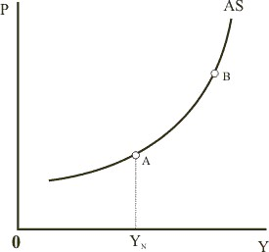

Question 35
At point B compared to point A the …
- Expected price level is lower than the actual price level.
- Expected price level is higher than the actual price level.
- Expected price level is the same as the actual price level. (The correct alternative is 3.)

Explanation
The level of output and the actual price level are higher. The expected price level is the same since this is the short run. It is only in the medium and long run that the expected price level changes. Since the level of output is higher the level of employment is higher and unemployment lower. Lower unemployment increases the bargaining position of workers and the nominal wage rises. The real wage is unchanged since both the nominal wage and price level increased.

Question 36
Which one of the following events describes the adjustment from the short to the medium term if the economy is at point B?
- The expected price level is lower than the actual price level. Workers respond to this by increasing their nominal wage demands and the AS curve shifts to the right.
- The expected price level is higher than the actual price level. Workers respond to this by increasing their nominal wage demands and the AS curve shifts to the left.
- The expected price level is lower than the actual price level. Workers respond to this by increasing their nominal wage demands and the AS curve shifts to the left. (The correct alternative is 3.)
- The expected price level is higher than the actual price level. Workers respond to this by increasing their nominal wage demands and the AS curve shifts to the right.

Explanation
At point B the expected price level which is lower than the actual price level. Workers respond to this by increasing their nominal wage demands and the AS curve shifts to the left showing that at each output level the price level is higher.

Question 37
Which one of the following applies when the aggregate demand curve (AD-curve) is derived?
- A decrease in the nominal money supply causes an increase in the interest rate which in return causes a decrease in investment spending, the demand for goods and the level of output.
- A decrease in the price level decreases the real money supply which causes an increase in the interest rate which in return causes a decrease in investment spending, the demand for goods and the level of output.
- An increase in the price level decreases the real money supply which causes an increase in the interest rate which in return causes a decrease in investment spending, the demand for goods and the level of output. (The correct alternative is 3.)
- An increase in government spending causes an increase in the interest rate which in return causes a decrease in investment spending, the demand for goods and the level of output.

Explanation
Behind the AD curve is the following events: P↑ → M/P↓ → i↑ → I↓ → Z↓ → Y↓.

Question 38
Which of the following factors cause a shift in the AD curve? a) A change in wages.
- A change in the price level.
- A change in the nominal money supply.
- A change in government spending.

  - Only factors a, b and c.
  - Only factors b and d.
  - Only factors a and c.
  - Only factors b, c and d.
  - Only factors c and d. (The correct alternative is 5.)

Explanation
A change in the price level is represented by a movement along the AD curve while a change in the nominal wage influences the AS curve.

Question 39
When the shift of the AD curve to the right in the short run is due to an increase in government spending then the following takes place in the goods, financial and labour markets.

 | Goods market | Financial market | Labour market
1 | 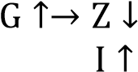  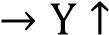 |  | 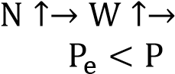  
2 |  | 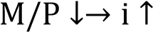 | 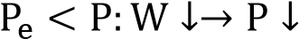
3 | 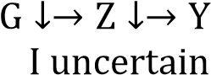 | 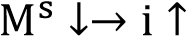 | 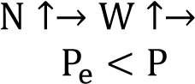
4 | 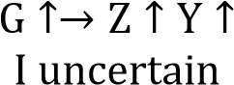 | 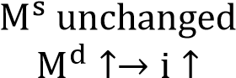 | 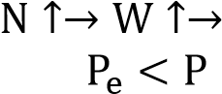  
5 |  | 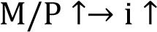 | 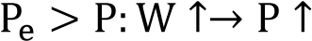

The correct alternative is 4 which is the events chain of expansionary fiscal policy in the short run.

Question 40
Which one of the following events describes the adjustment from the short to the medium term in the case of an expansionary monetary policy?
 | Labour market | Financial market | Goods market
1 | 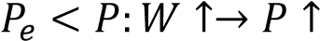 | 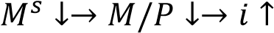 | 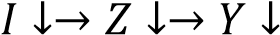
2 | 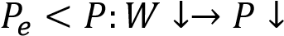 | 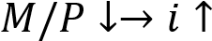 | 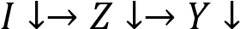
3 | 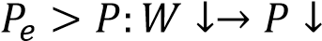 | 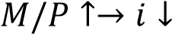 | 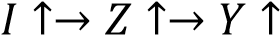
4 | 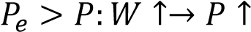 | 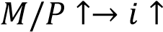
5 | 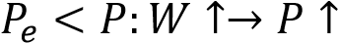

The correct alternative is 5. In the short run the expected price level is lower than the actual price level. This causes workers to bargain for an increase in the nominal wage which leads to an increase in the price level.

Question 1
Which of the following factors are regarded as exogenous variables in the IS-LM model? a) Government spending.
- Level of output and income.
- Interest rate.
- Investment spending.
- Money supply.

  - a, b and d
  - b, c and e
  - Only b and c
  - a and e (The correct option is 4.)
  - None of the options 1 to 4

Explanation
Government spending and money supply are the factors that are regarded as exogenous variables in the IS-LM model. The level of output and income, the interest rate and investment spending are endogenous variables in the IS-LM model.

Question 2
When firms increase their spending on capital goods …
a) financial investment takes place.
- real investment takes place.
- it means that the expected rate of return on investment projects exceed the market interest rate.

  - a, b and c
  - Only a and b
  - Only a and c
  - Only b and c (The correct option is 4.)
  - None of the statements is correct

Explanation
Real investment is spending on additions to the capital stock (machinery, structures, inventories, etc). Such investment is undertaken in order to make profits in the future. Financial investment is investment in shares and other financial instruments. When people put money on deposit with a bank or buy bonds or shares, they are making a financial investment, on which they will earn a return. When an economist refers to investment, he or she usually means real investment. Statement c is correct since real investment is usually financed through borrowing and only projects that give a return higher than the market interest rate will be undertaken. Therefore only statements b and c are correct.

Question 3
You are the owner of a business and are given the given the following information with regards to different investment projects you wish to undertake:

Project | Expected rate of return | Funding required
A | 15% | R1,5 million
B | 12% | R1 million
C | 8% | R2,5 million
D | 4% | R3 million

If the market interest rate is 9%, which of these project will you consider undertaking?
- All the projects
- None of the projects
- Only projects A, B and C
- Only projects A and B (The correct option is 4.)
- Only project D

Explanation
One way to determine whether an investment project is worth undertaking, is to compare the internal rate of return of the project (i.e. the rate of return earned from the investment) with the market interest rate (which is the interest cost of borrowed funds or the opportunity cost of own funds). If the internal rate of return is higher than the market interest rate, it would profitable to undertake the investment. If, however, the internal rate of return is lower than the market interest rate, it would not be worthwhile undertaking the project. The cost of financing the project is more than its return.
Therefore if the market interest rate is 9%, only projects A and B will be considered. At a market interest rate of 8%, project C is not profitable since the internal expected rate of return is less than the market interest rate of 9%. At a market interest rate of 4%, project D is also not profitable since the internal expected rate of return is less than the market interest rate of 9%.

Question 4
A negative relationship exists between the interest rate and investment spending since a(n) …
- increase in the interest rate increases the return on savings and it is worthwhile for households to increase their savings.
- decrease in the interest rate decreases the cost of borrowing and households are able to borrow more money from banks.
- increase in the interest rate increases the cost of borrowing money and firms will find that there are fewer profitable investment opportunities. (The correct option is 3.)
- increase in autonomous investment increases the interest rate.
- decrease in investment spending causes a decrease in the level of output.

Explanation
A negative relationship exists between the interest rate and investment spending since an increase in the interest rate increases the cost of borrowing money and firms will find that there are fewer profitable investment opportunities.

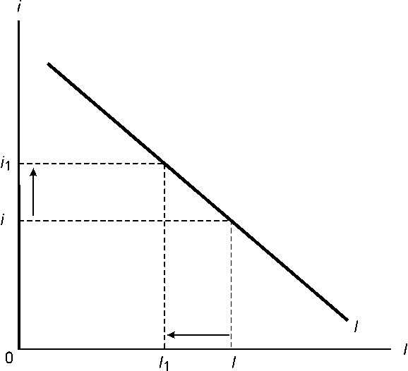

Question 5
Which one of the following refers to the possible impact of the current level of output and income on the investment decision of firms?
- One politician to another: “In the interest of achieving equality in our society we should only consider awarding projects to those companies in which we, as the representatives of the people, have shares in”.
- The Minister of Finance: “Capital expenditure by the public sector is to be increased over the next five years”.
- A manager during a business meeting: “Sales are up, it is time to increase our capacity”. (The correct option
is 3.)
- One stockbroker to another stockbroker: “Oil prices are down. It is time to sell shares in oil companies”.

Explanation
The statement of a manager during a business meeting “Sales are up, it is time to increase our capacity” refers to the possible impact of the current level of output and income on the investment decision of firms. Options 1 and 2 refer to autonomous investment and statement 4 to financial investment.

Question 6
In the event of a rise in the interest rate a(n) _________ an investment curve takes place while an increase in output will cause a(n) ________ an investment curve.
- rightward shift of; downward movement of
- downward movement along; rightward shift of
- upward movement along; leftward shift of
- upward movement along; rightward shift of (The correct option is 4.)
- downward movement along; upward movement along

Explanation
In the event of a rise in the interest rate an upward movement along an investment curve takes place while an increase in output will cause a rightward shift of an investment curve.

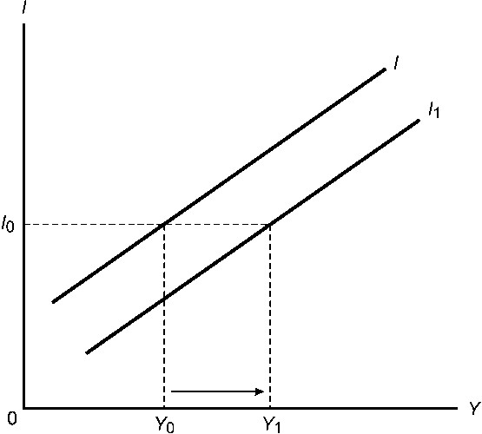

Question 7
In the goods market an increase in investment due to a decrease in the interest rate is represented by an upward shift of the demand for goods curve while an increase in investment due to an increase in output is represented by a
downward movement along the demand for goods curve. The above statement is incorrect since an …
- increase in investment due to a decrease in the interest rate is represented by a downward shift of the demand for goods curve.
- increase in investment due to a decrease in the interest rate is represented by a downward movement along the demand for goods curve.
- increase in investment due to an increase in output is represented by an upward shift of the demand for goods curve.
- increase in investment due to an increase in output is represented by an upward movement along the demand for goods curve. (The correct option is 4.)

Explanation
The correct statement will read as follows: In the goods market an increase in investment due to a decrease in the interest rate is represented by an upward shift of the demand for goods curve (see diagram a below) while an increase in investment due to an increase in output is represented by a upward (and not downward) movement along the demand for goods curve (see diagram b below).

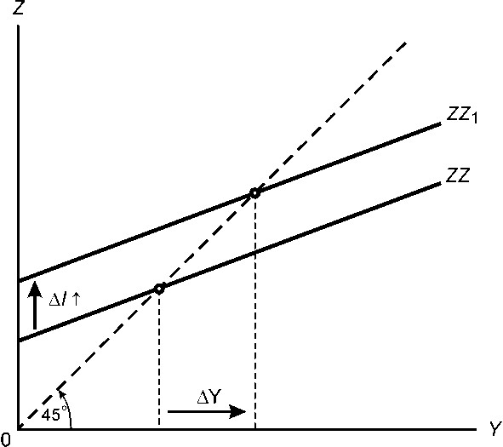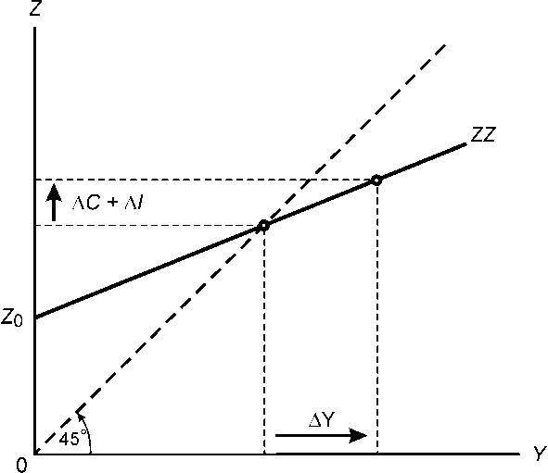

Question 8
Which one of the following explains what happens on the goods market if the interest rate increases?
- Investment spending increases which causes an increase in the demand for goods and the equilibrium level of income rises.
- Disposable income of households increases which increases the demand for goods and the equilibrium level of income rises.
- Investment spending decreases which causes a decrease in the demand for goods and the equilibrium level of income declines. (The correct option is 3.)
- Government spending declines and the demand for goods decreases and the equilibrium level of income declines.

Explanation
There is a negative relationship between the interest rate and investment. Therefore if the interest rate increases on the goods market investment spending decreases which causes a decrease in the demand for goods and the equilibrium level of income declines. This relationship is represented by the following chain of events:
i↑ → I↓ → Z↓ → Y↓.

Question 9
Which one of the following chain of events describes what happens on the goods market if the interest rate decreases?
- i↑ → I↓ → Z↓ → Y↓
- i↓ → I↑ → Z↑ → Y↑ (The correct option is 2.)
- i↓ → G↓ → Z↓ → Y↓
- i↓ → T↓ → YD↑ → Z↑ → Y↑

Explanation
This question is the opposite of question 8. Therefore the chain of events that describes what happens on the goods market if the interest rate decreases is as follows: i↓ → I↑ → Z↑ → Y↑.

Questions 10 to 14 deals with the derivation of the IS curve and are based on the following information and diagram:

The autonomous spending at an interest rate of 8% is 3 000. A decrease in the interest rate from 10% to 8% increases investment spending by 1 000.

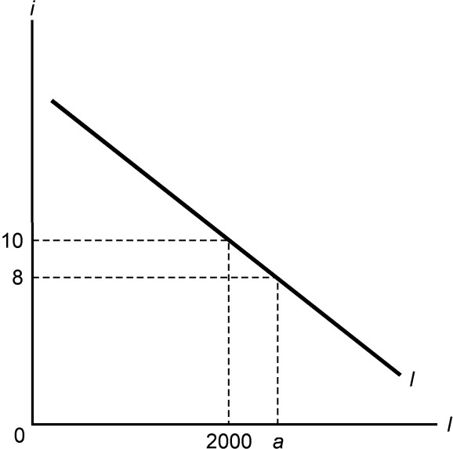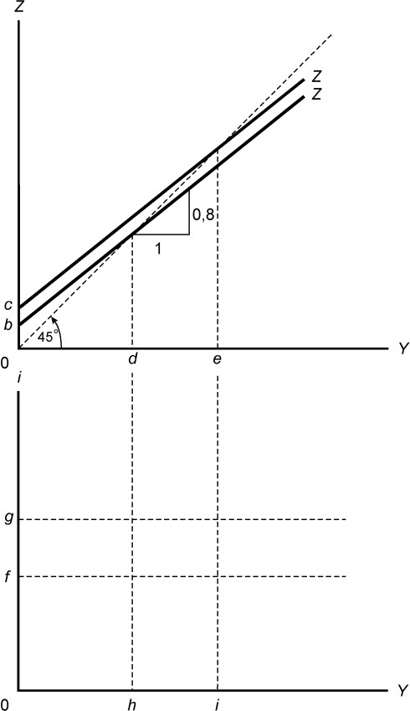

Question 10
The value for a is: 1) 1 000
- 2 000
- 3 000 (The correct option is 3.)
- 4 000

Explanation
The value for a is 3 000. See the information given in the beginning of the question. The autonomous spending at an interest rate of 8% is 3 000.

Question 11
The values for b and c are:
- b = 1 000 c = 2 000
- b = 4 000 c = 3 000
- b = 2 000 c = 3 000
- b = 3 000 c = 4 000 (The correct option is 4.)
- b = 3 000 c = 6 000

Explanation
The values for b = 3 000. At an interest rate of 8% autonomous spending = 3 000. The value for c = 4 000. A decrease in the interest rate from 10% to 8% increases investment spending by 1 000. Therefore the Z curve will shift upwards and the new intercept is now 4 000 (3 000 + 1 000).

Question 12
The values for d and e are:
- d = 12 000 e = 16 000
- d = 10 000 e = 20 000
- d = 15 000 e = 20 000 (The correct option is 3.)
- d = 15 000 e = 16 000
- d = 5 000 e = 10 000

Explanation
The values for d = 15 000. The formula to calculate the multiplier is 1/1-c. The value of c = 0.8 (given on the diagram). The value of the multiplier is therefore 5. To calculate point d you must multiply autonomous spending with the multiplier: 3 000 x 5 = 15 000. The value for point e = 20 000. To calculate point e you must multiply autonomous spending with the multiplier: 4 000 x 5 = 20 000.

Question 13
The values for f and g are:
- f = 3 000 g = 4 000
- f = 1 000 g = 5 000
- f = 2000 g = 3 000
- f = 10% g = 8%
- f = 8% g = 10% (The correct option is 5.)

Explanation
The values for f = 8% and for g = 10%. The values are given. Remember that the IS curve gives us a picture of what happens in the goods market when the interest rate changes. Therefore, the starting point for the derivation of the IS curve is a change in the interest rate.

Question 14
The values for h and i are:
- h = 12 000 i = 16 000
- h = 10 000 i = 20 000
- h = 15 000 i = 20 000 (The correct option is 3.)
- h = 15 000 i = 16 000
- h = 5 000 i = 10 000

Explanation
The values for h and i are 15 000 and 20 000 respectively. It will be the same as the equilibrium levels of output and income as calculated in the goods market at different interest rates. To plot the first and second point of the IS curve the equilibrium levels of income and output in the goods market will be extended from the goods market model to the derivation of the IS curve. Therefore the values will be the same as calculated in question 12 above.

Question 15 is based on the following diagram:

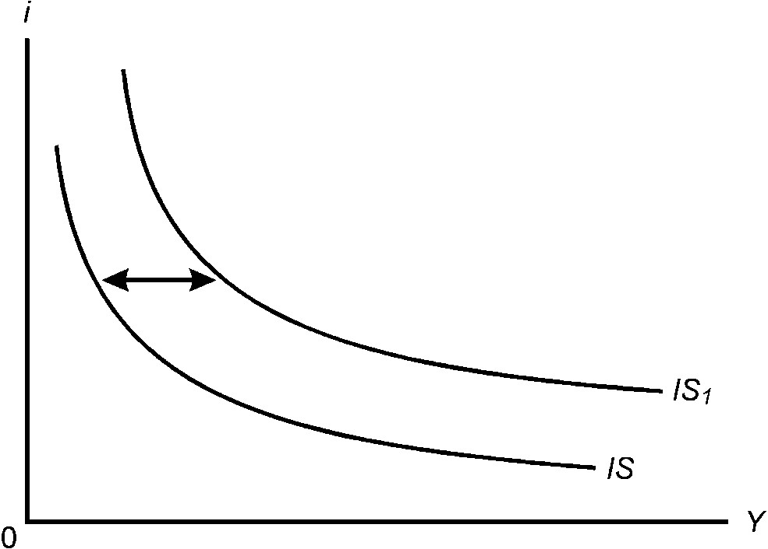

Question 15
Which of the following statements is/are correct?
- The IS curve may shift from IS to IS1 because of an increase in the tax rate.
- The IS curve may shift from IS to IS1 because of an increase in consumer confidence.
- The IS curve may shift from IS1 to IS because of a decrease in any of the autonomous factors that change the demand for goods.
- The IS curve may shift from IS1 to IS because of an increase in any of the autonomous factors that change the demand for goods.
- The IS curve may shift from IS1 to IS because of an increase in the interest rate.

  - a, b and d
  - b, c and e
  - Only b and c (The correct option is 3.)
  - Only c
  - None of the options 1 to 4

Explanation
Statement a is incorrect. An increase in the tax rate will shift the IS curve leftwards (from IS₁ to IS). Statement b is correct. The IS curve may shift from IS to IS₁ because of an increase in consumer confidence.
Statement c is also correct. The IS curve may shift from IS₁ to IS because of a decrease in any of the autonomous factors that change the demand for goods.

Statement d is incorrect. An increase in any of the autonomous factors that change the demand for goods may shift the IS curve rightwards from IS to IS1. Statement e is incorrect. An increase in the interest rate will cause an upward movement along the IS curve (and not a shift of the curve).

Question 16
The statement that the LM curve is upward sloping since an increase in the interest rate increases the demand for money is incorrect because it is …
- upward sloping since an increase in the interest rate decreases the demand for money.
- upward sloping since an increase in the interest rate increases the money supply.
- upward sloping since an increase in income increases the demand for money and the interest rate. (The correct option is 3.)
- upward sloping since an increase in the interest rate increases the income level.
- upward sloping since an increase in income increases the money supply.

Explanation
The statement that the LM curve is upward sloping since an increase in the interest rate increases the demand for money is incorrect because it is upward sloping since an increase in income increases the demand for money and the interest rate. Remember that the key to the derivation of the LM curve is the events that take place in the financial market when the level of output and income changes.

Question 17
To derive the LM curve we change …
- the interest rate to determine its effect on the level of income.
- government spending to determine its effect on the level of income.
- the income level to determine its effect on the demand for goods.
- the interest rate to determine its effect on the demand for goods.
- the level of income to determine its effect on the interest rate. (The correct option is 5.)

Explanation
To derive the LM curve we change the level of income to determine its effect on the interest rate.

Question 18
The derivation of the IS curve is described by the following chain of events ___________ while the derivation of the LM curve is described by __________ chain of events.
- IS: i↑ → I↑ → Z↑ → Y↑ LM: Y↓ → Md↓ → i↓
- IS: i↑ → G↑ → Z↑ → Y↑ LM: Y↑ → Ms↑ → i↓
- IS: i↓ → I↑ → Z↑ → Y↑ LM: Y↑ → Md↑ → i↑ (The correct option is 3.)
- IS: i↑ → T↓ → YD↑ → Z↑ → Y↑ LM: Ms↓ → i↑ → I↓ → Z↓ → Y↓
- IS: i↓ → I↓ → Z↑ → Y↑ LM: Y↑ → Ms↑ → i↓

Explanation
The derivation of the IS curve is described by the following chain of events: IS: i↓ → I↑ → Z↑ → Y↑ while the derivation of the LM curve is described by the following chain of events: LM: Y↑ → Md↑ → i↑.

Question 19
Which one of the following will cause a rightward shift in the LM curve?
- An increase in the demand for money.
- An increase in the level of output and income.
- An increase in the money supply. (The correct option is 3.)
- A decrease in the money supply.
- An increase in the interest rate.

Explanation
An increase in the money supply will cause a rightward shift in the LM curve. Statements 1 and 2 are incorrect since an increase in the demand for money and an increase in the level of output and income are factors that will not have an influence on the LM curve. Statement 4 is incorrect. A decrease in the money supply will cause a leftward shift of the LM curve. Statement 5 is incorrect. An increase in the interest rate will cause an upward movement along the LM curve.

Question 20
In the IS-LM model an increase in the nominal money supply causes the LM curve to shift to the …
- right and the interest rate decreases. As the interest rate decreases investment spending increases and the IS curve shifts to the right.
- left and the interest rate increases. As the interest increases investment spending decreases and the IS curve shifts to the left.
- right and the interest rate decreases. As the interest decreases the investment spending increases and a movement along the IS curve takes place. (The correct option is 3.)

Explanation
In the IS-LM model an increase in the nominal money supply causes the LM curve to shift to the right and the interest rate decreases. As the interest decreases the investment spending increases and a movement along the IS curve takes place (from a to a1).

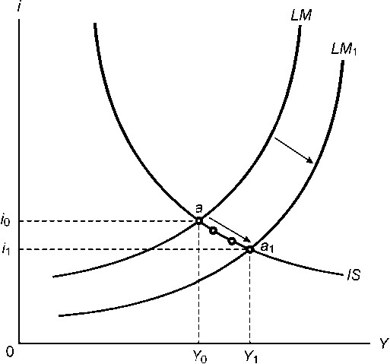

Question 21
In the IS-LM model an increase in government spending increases the demand for goods and the …
- IS curve shifts to the right. As government spending increases the supply of money increases and the LM curve shifts to the right.
- IS curve shifts to the right. The demand for money increases and the interest rises and a movement along the LM curve takes place. (The correct option is 2.)
- IS curve shifts to the left. The demand for money increases and the interest rises causing the LM curve to shift to the left.

Explanation
In the IS-LM model an increase in government spending increases the demand for goods and the IS curve shifts to the right. The demand for money increases and the interest rises and a movement along the LM curve takes place from point a to point a1. Note: the movement from point b to point a1 represents the decrease in investment spending because of the increase in the interest rate.

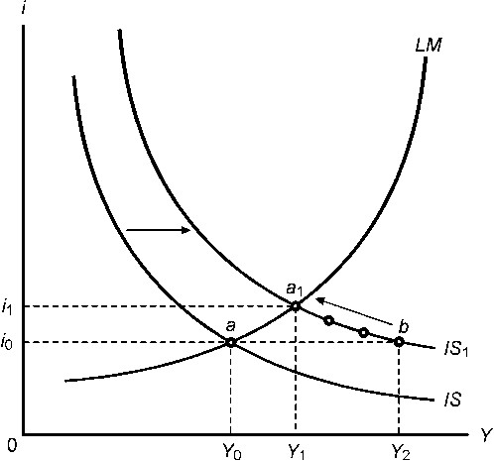

Question 22
Which of the following policy actions will bring about an increase in the level of output and an increase in the interest rate?
- An increase in the money supply.
- An increase in government spending.
- A decrease in the money supply.
- A decrease in government spending.
- An increase in the budget deficit.

  - a, b and d
  - b, c and e
  - Only b and c
  - Only b and e (The correct option is 4.)
  - a, b and e

Explanation
The IS curve must shift to the right to bring about an increase in the level of output and an increase in the interest rate, in other words an expansionary fiscal policy that means an increase in government spending and/or a decrease in taxes. Therefore only statements b and e are correct. An increase in the budget deficit implies an increase in government spending and/or a decrease in taxation.

Read through the following and answer the questions 23 to 28.

In 1999, the South African economy embarked on its longest expansion phase. It lasted for 99 months and come to an end in November 2007 and in the fourth quarter of 2008 the South African economy experienced an economic recession. (See figure 2).

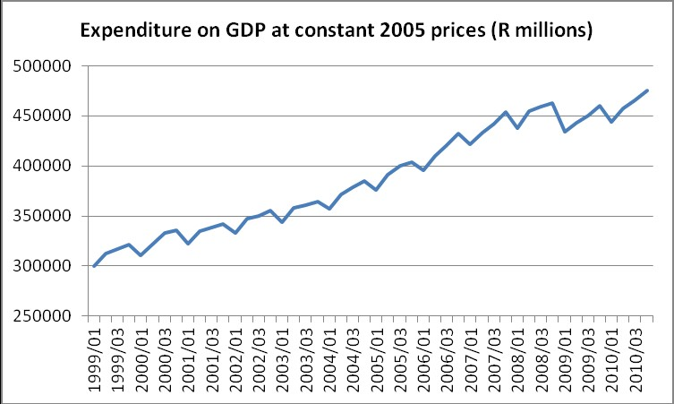

Figure 1

What triggered the end of the expansion phase and the economic recession in South Africa was falling house prices in the United States of America which led to the so-called “subprime mortgage” crisis. Preceding the crisis there was a rapid increase in mortgages to less creditworthy borrowers in America. A combination of falling house prices and default mortgage payments led to the failure and near failure of major financial institutions in America. This sent shockwaves across the financial markets of the world and resulted in a loss of confidence in financial markets and institutions, with the result that share prices fell sharply, investor confidence plunged and the availability of credit to firms and households were severely curtailed. This had the result that consumption spending by households and investment spending by firms declined worldwide which had a major impact on the level of output and income in the major economies of the world. Today this is referred to as the Great Recession.

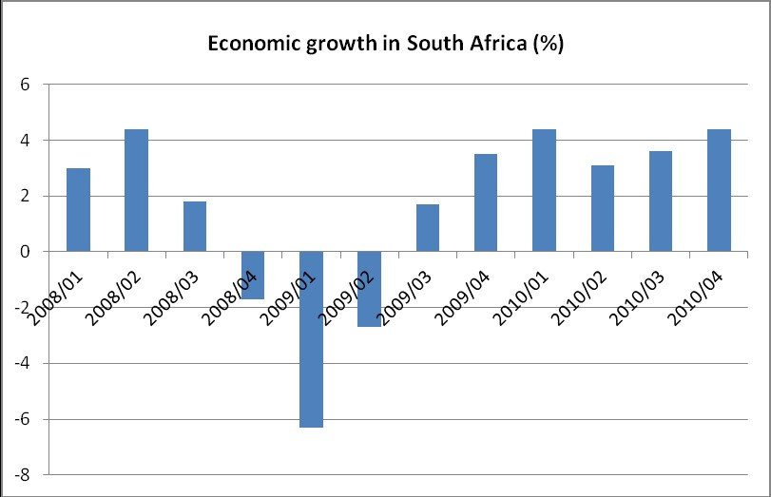

Figure 2

Due to the recession experienced by the major trading partners of South Africa there was a dramatic drop in our exports. In 2009 exports declined by 20% as shown in figure 3. The impact on the economy was worsened by a decline of both consumption spending and investment spending.
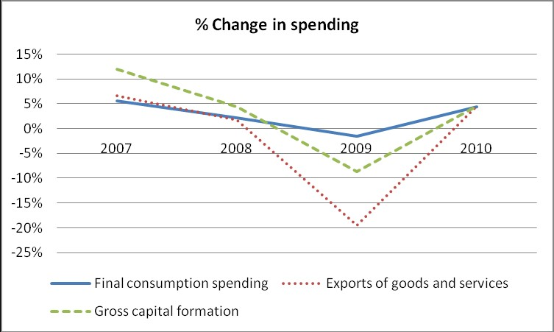

Figure 3

The recession could have been much worse. But it was met by a strong macroeconomic response, which certainly limited the dept and the length of the recession.

Take monetary policy first. In response to the economic slowdown the South African Reserve Bank started to decrease the repurchase rate. (Figure 4 shows the decline in the repurchase rate for the period 2008 to 2009.) In April 2008 the repurchase rate was 11.5% while at the end of 2009 it was 7%.

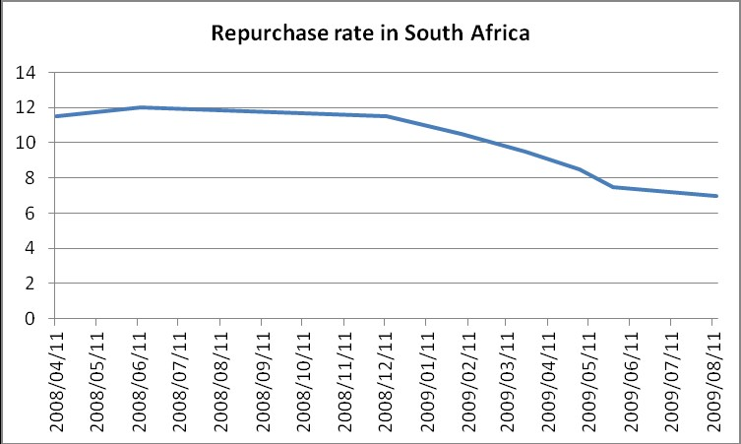

Figure 4

Turning to fiscal policy. Figure 5 shows the evolution of government spending and revenue during 2008 and 2009, both as expressed as a ratio of GDP.

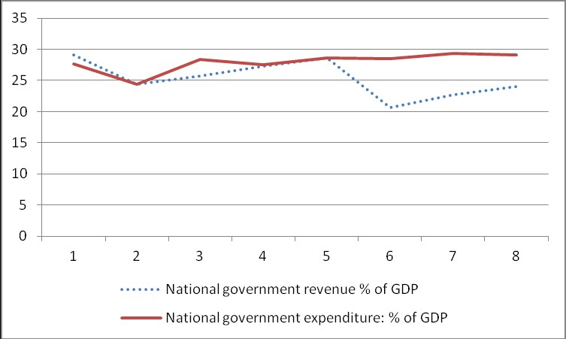

Figure 5

Note the very sharp decline in government revenue in 2009. This was due to the two things namely the decline in output and income which decreases the tax revenue of government and a decline in income tax rates (as part of the expansionary fiscal policy measures). Due to the decline in income tax rates the decrease in tax revenue was much larger than can be explained by the recession. Also note the steady increase in government spending since the fourth quarter of 2008 which continued during the 2009 period. As a result, the budget surplus that was experienced before the start of the recession then turned negative.

Question 23
In the goods market model the impact of the decline in the demand for goods due to the decline in consumption spending and investment spending can be represented by a(n)… 1) steeper demand for goods curve.
- flatter demand for goods curve.
- upward shift of the demand for goods curve.
- downward shift to the demand for goods curve. (The correct option is 4.)

Explanation
In the goods market model the impact of the decline in the demand for goods due to the decline in consumption spending and investment spending can be represented by a downward shift to the demand for goods curve. A change in the marginal propensity to consume will cause a steeper or flatter demand for goods curve.

Question 24
In the IS-LM model the impact of the decline in the demand for goods due to the decline in consumption spending and investment spending can be represented by a …
1) leftward shift of the LM curve.
- rightward shift of the LM curve.
- leftward shift of the IS curve. (The correct option is 3.)
- rightward shift of the IS curve.

Explanation
In the IS-LM model the impact of the decline in the demand for goods due to the decline in consumption spending and investment spending can be represented by a leftward shift of the IS curve. Take note that statements 1 and 2 are incorrect since consumption and investment spending are not factors that will have an influence on the LM curve.

Question 25
The policy mix that was used to limit the impact of the recession consists of:
- An expansionary monetary policy and a contractionary fiscal policy.
- A contractionary monetary and fiscal policy.
- An expansionary fiscal and monetary policy. (The correct option is 3.)
- A contractionary monetary policy and an expansionary fiscal policy.

Explanation
To limit the impact of the economic recession there must be an increase in the equilibrium level of output and income (Y). Therefore the policy mix that was used to limit the impact consists of an expansionary fiscal and expansionary monetary policy.

Question 26
In the IS-LM model the impact of the policy mix that was used can be represented as follows:
- The IS curve and LM curve shift to the right. (The correct option is 1.)
- The IS curve and the LM curve shift to the left.
- The IS cure shifts to the right and the LM curve shifts to the left.
- The IS curve shifts to the left and the LM curve shifts to the right.

Explanation
In the IS-LM model the impact of the policy mix that was used can be represented by a shift to the right of the IS curve and LM curves.

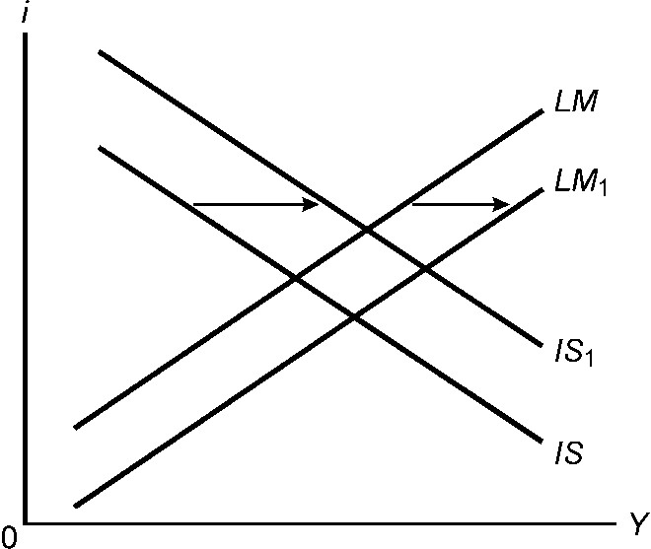

Question 27
The impact of the policy mix on the equilibrium level of income in the IS-LM model was as follows:
- It increased the level of output in the third quarter of 2009 to a higher level than before the recession.
- It ensured that the level of output decreased less than it would have decreased in the absence of the policy mix. (The correct option is 2.)
- It worsened the economic recession by causing the level of output to decrease more.

Explanation
The impact of the policy mix on the equilibrium level of income in the IS-LM model was that it ensured that the level of output decreased less than it would have decreased in the absence of the policy mix. Statement 1 is incorrect. Statement 3 is incorrect. See the diagram above under question 26 (Y↑).

Question 28
The impact of the policy mix on the budget deficit was that it …
- increased the budget deficit since exports decline more that imports.
- increased the budget deficit since government revenue decreased and government spending increased. ( The correct option is 2.)
- decreased the budget deficit since government revenue increased and government spending declined.
- decreased the budget deficit since imports decline more than exports.

Explanation
In the IS-LM model the IS curve shift to the right as a result of expansionary fiscal policy (in other words, government spending increases and/or taxes decrease). Therefore the impact of the policy mix on the budget deficit was that it increased the budget deficit since government revenue (taxes) decreased and government spending increased.

Question 29
Comparing a contractionary fiscal policy with an expansionary monetary policy in the IS-LM model the results are best described by the following?

1 | FISCAL POLICY | MONETARY POLICY
The demands for goods | Lower | Higher
The level of output | Lower | Higher
The interest rate | Higher | Lower
Investment spending | Lower | Higher
Budget deficit | Lower | Unchanged

2 | FISCAL POLICY | MONETARY POLICY
The demands for goods | Lower | Higher
The level of output | lower | Higher
The interest rate | Lower | Lower
Investment spending | Higher | Higher
Budget deficit | Unchanged | Unchanged

3 | FISCAL POLICY | MONETARY POLICY
The demands for goods | Lower | Higher
The level of income | Lower | Higher
The interest rate | Lower | Lower
Investment spending | Indeterminate | Higher
Budget deficit | lower | Unchanged

4 | FISCAL POLICY | MONETARY POLICY
The demands for goods | Higher | Lower
The level of income | Higher | Lower
The interest rate | Higher | Higher
Investment spending | indeterminate | Lower
Budget deficit | Higher | Unchanged

5 | FISCAL POLICY | MONETARY POLICY
The demands for goods | Lower | Higher
The level of income | Lower | Lower
The interest rate | Lower | Lower
Investment spending | Indeterminate | Indeterminate
Budget deficit | Lower | Unchanged

The correct option is 3. To answer this type of question you must make use of chain of events. A contractionary fiscal policy means that government spending has to be decreased and/or taxes have to be increased. We use the example of a decrease in government spending:

The impact is on the goods market first:
G↓ Z↓ Y↓

Impact on the financial market:
Y↓ Md↓ i↓

i↓ I↑ Y↓ I↓

Then back to the goods market:
i↓ I↑ Z↑ Y↑

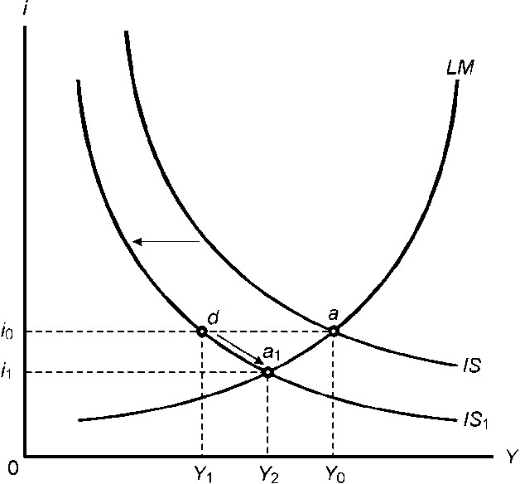

An expansionary monetary policy is an increase in the nominal money supply in order to stimulate economic activity by increasing the demand for goods.

The impact is on the financial market first:
M↑ M/P↑ i↓

Impact on the goods market:
i↓ I↑ Z↑ Y↑

Y↑ I↑
Y↑ C↑

Therefore comparing a contractionary fiscal policy with an expansionary monetary policy in the IS-LM model the results are best described by the following option:
3 | FISCAL POLICY | MONETARY POLICY
The demands for goods | Lower | Higher
The level of income | Lower | Higher
The interest rate | Lower | Lower
Investment spending | Indeterminate | Higher
Budget deficit | lower | Unchanged

Question 30
Which one of the following policy actions is appropriate if the objective is to decrease the budget deficit without decreasing the level of output?
- An expansionary fiscal policy coupled with an expansionary monetary policy.
- A contractionary fiscal policy coupled with a contractionary monetary policy.
- An expansionary fiscal policy coupled with a contractionary monetary policy.
- A contractionary fiscal policy coupled with an expansionary monetary policy. (The correct option is 4.)

Explanation
If the objective is to decrease the budget deficit (G must decrease) without decreasing the level of output a contractionary fiscal policy coupled with an expansionary monetary policy must be applied. Graphically it can be presented as follows:

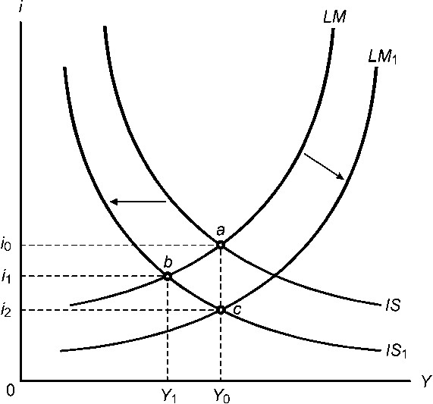

Question 1
Which one of the following is an example of stabilisation policy?
- Labour market policies aimed to increase the productivity of labour.
- Inflation targeting.
- Expansionary monetary policy during a recession. (Option 3)
- Industrialisation.
5) Tariffs on imports.

Question 2
Given the following consumption function C = 100 + 0.8Y_{D} calculate by how much induced consumption spending will decrease if government increase taxes with R100.
- R100
- R200
- R180

4) R80 (Option 4)
5) R20

Question 3 is based on the following diagram:
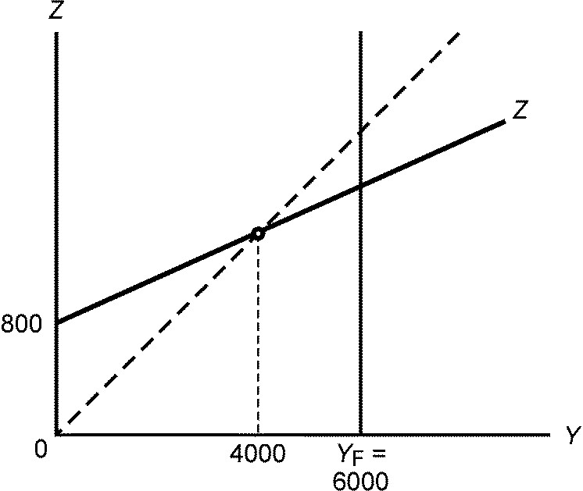
Marginal propensity to consume = 0.8 (4/5)
Multiplier = 5

Question 3
Which of the following policy actions will increase the level of output and income to achieve full employment?
- An increase in government spending of R400.
- A decrease in taxation of R500.
- A decrease in taxation of R400.

  - a, b and c
  - a and b (Option 2)
  - a and c
  - b and c
  - Not a, b or c

Questions 4 and 5 are based on the following diagram:
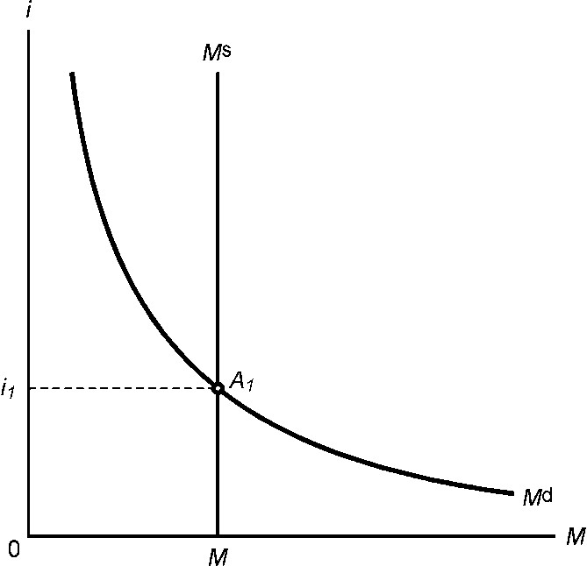

Question 4
If the interest rate is higher than i1 then ...
- an excess supply of money exists and financial market participants will buy bonds. (Option 1)
- an excess demand for money exists and financial market participants will sell bonds.
- an excess supply of money exists and financial market participants will sell bonds.
- an excess demand for money exists and financial market participants will buy bonds.
- an excess supply of money exists and financial market participants will neither buy nor sell bonds.

Question 5
If the central bank wishes to increase the interest rate in the economy it should …
1) sell bonds on the open market and the curve shifts to the left. (Option 1)
2) buy bonds on the open market and the  curve shifts to the left.
- sell bonds on the open market and the  curve shifts to the right.
- buy bonds on the open market and the  curve shifts to the right.

Question 6
If uncertain economic conditions lead to an increase in the demand for money then the ...
- price of bonds will increase and the interest rate will increase.
- price of bonds will increase and the interest rate will decrease.
- price of bonds will decrease and the interest rate will decrease.
- price of bonds will decrease and the interest rate will increase. (Option 4)
- price of bonds and the interest rate will be unchanged.

Question 7
Which of the following can be regarded as exogenous variables in the IS-LM model?
a) Nominal money supply.
- Interest rate.
- Government spending.

  - a, b and c
  - a and b
  - a and c (Option 3)
  - b and c
  - Not a, b or c

Question 8
Which of the following statements regarding investment spending in the IS-LM model is/are correct?
a) An increase in the level of output increases investment spending in the economy.
- A decrease in the interest rate increases investment spending.
- An increase in investors’ confidence increases investment spending.

  - a, b and c (Option 1)
  - a and b
  - a and c
  - b and c
  - Not a, b or c

Question 9
Which one of the following factors will cause a rightward shift of the IS curve?
- An increase in investment spending due to a decrease in the interest rate.
- An increase in consumption spending due to an increase in the level of output and income.
- An increase in investment spending due to an increase in the level of output and income.
- An increase in the money supply.
- An increase in government spending. (Option 5)

Question 10 is based on the following diagram:

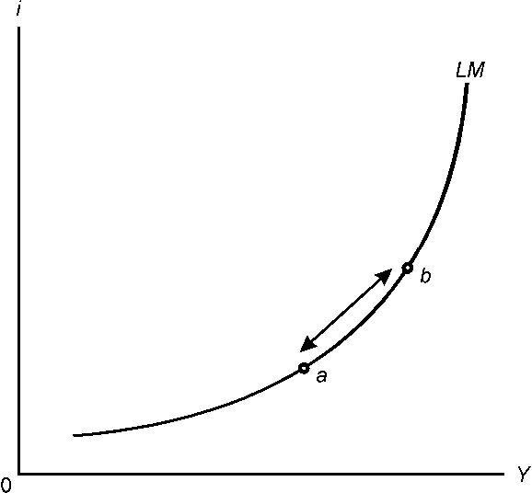

A movement from point a to point b implies that ...
- the money supply in the economy decreases causing the interest rate to increase.
- an increase in the level of output and income increases the money supply and the interest rate decreases.
- an increase in the level of output and income increases the demand for money and the interest rate increases. (Option 3)
- an increase in the interest rate decreases investment spending in the economy.
- the money supply in the economy increases causing the level of output and income to increase.

Question 11
Which one of the following policy actions in the IS-LM model is effective if the objectives are to decrease the budget deficit and increase the level of output and income?
- An expansionary fiscal and an expansionary monetary policy.
- A contractionary fiscal and a contractionary monetary policy.
- A contractionary fiscal policy and an expansionary monetary policy. (Option 3)
- It is not possible to achieve the policy objectives.

Question 12
An expansionary fiscal policy will have a greater impact on the level of output and income the ...
- more sensitive investment spending is for a change in the interest rate.
- less sensitive investment spending is for a change in the level of output and income.
- less sensitive investment spending is for a change in the interest rate. (Option 3)
- smaller the multiplier.
5) smaller the increase in government spending.

Question 13
Which one of the following factors will cause an increase in real exchange rate for South Africa?
- An increase in the price level of South African goods compared to goods in the rest of the world. (Option 1)
- A decrease in the price level of South African goods compared to goods in the rest of the world.
- An appreciation of the rand.
4) A depreciation of the dollar.

Question 14 is based on the following diagram:
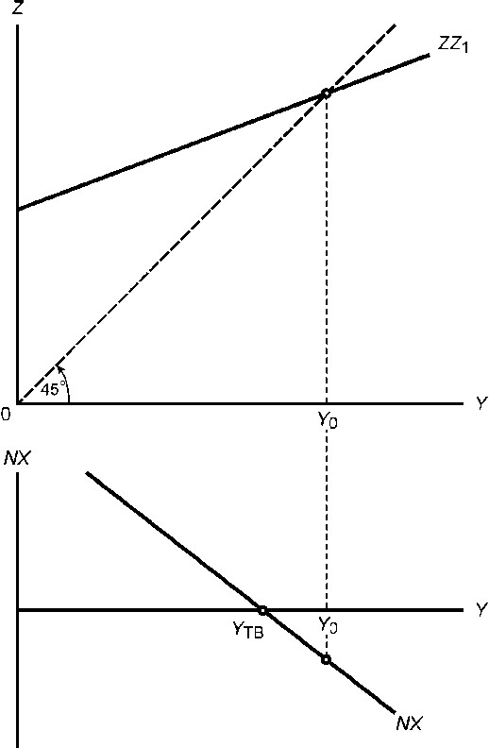

Question 14
Given a goods market equilibrium and a budget deficit in the diagram above, what happens to the level of output, budget deficit and the trade balance if government spending increases?
- The level of output decreases, the budget deficit increases and the trade deficit increases.
- The level of output decreases, the budget deficit decreases and the trade deficit decreases.
- The level of output increases, the budget deficit decreases and the trade deficit increases.
- The level of output increases, the budget deficit increases and the trade deficit increases. (Option 4)

Question 15 is based on the following information:

The country of Mambala is facing a recession and an unaffordable budget deficit. To deal with the budget deficit taxes are raised and to deal with the recession the money supply is increased.

Question 15
Which of the following statements are correct?
- Both the IS curve and LM curve will shift to the right.
- The IS curve will shift to the left and the LM curve will shift to the right.
- The results of these policy actions are that the interest rate increases, a capital outflow occurs, the domestic currency appreciates and the trade balance worsens.
- The results of these policy actions are that the interest rate declines, a capital outflow occurs, the domestic currency depreciates and the trade balance improves.

  - a and d
  - b and d (Option 2)
  - a and c
  - c and d
  - a and b

Question 16
Which one of the following factors will cause a rightward shift of the wage setting curve?
- An increase in the bargaining position of workers resulting from a decrease in the unemployment rate.
- An increase in the mark-up by firms.
- An increase in the bargaining position of workers due to labour legislation. (Option 3)
- A decrease in the expected price level.
5) An increase in the level of output and income.

Question 17
Which one of the following will increase the real wage implied by price setting (price determined real wage)?
- An increase in the level of output and income which leads to a decrease in unemployment.
- A lower mark-up by firms. (Option 2)
- Improved bargaining position of workers due to labour legislation.
- A higher mark-up by firms.
- An increase in consumption spending by households.

Question 18 is based on the following diagram:

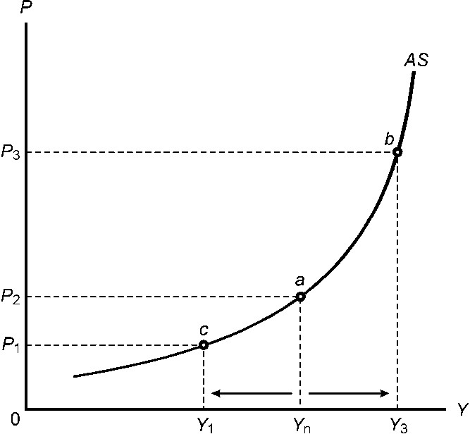

Question 18
A movement from point a to point b indicates that the ...
a) real wage increases.
- expected price level increases.
- natural rate of output increases.

  - a, b and c
  - a and b
  - a and c
  - b and c
  - Not a, b or c (Option 5)

Question 19 and 20 are based on the following diagram:

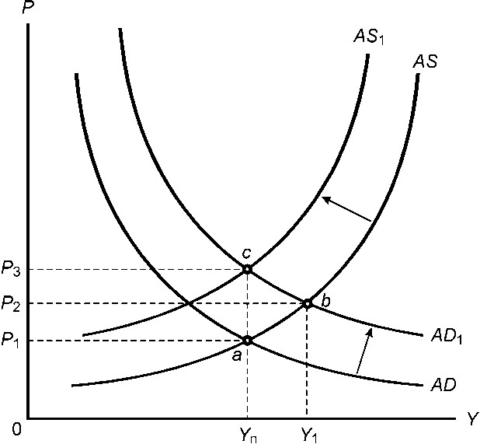

Which one of the following chain of events represents the adjustment from point b to point c?
1) P_{e}↓ W↓ P↓ M/P↑ i↓ I↑ Z↑ Y↑
  - Pe↑ W↑ P↑ M/P↓ i↑ I↓ Z↓ Y↓ (Option 2)
  - P↑ M/P↓ i↑ I↓ Z↓ Y↓
  - Y↑ N↑ u↓ W↑ P↑
  - M↑ M/P↑ i↓ I↑ Z↑ Y↑

Question 20
If the rightward shift of the AD curve is caused by an increase in the money supply then at point b compared to point a the …
- interest rate is higher and investment lower.
- interest is lower and investment is higher. (Option 2)
- actual price level and the expected price level are higher.
- output is higher and unemployment is higher.
- nominal money supply is higher and the real money supply lower.

Question 1 (5 marks)
The IS-LM model is a simplification of the interrelationship between selected economic variables. The model consists of a number of endogenous variables (those variables whose values are determined inside the model) and a number of exogenous variables (those variables whose values are determined outside the model). List the various endogenous and exogenous variables in the IS-LM model.

Answer
Endogenous variables | Exogenous variables
C = co + cYD  The Y_{D} part of the consumption function is the endogenous component. | C = co + cYD  The autonomous or exogenous variables in the consumption function are c_{o} and c (the marginal propensity to consume). The c_{o} part is known as autonomous or exogenous consumption.
The part of investment (I) that is dependent on income and the interest rate are the endogenous components. | The part of investment that is influenced by expectations, business confidence, and political and social factors is the exogenous component of investment. This is known as autonomous or exogenous investment (Ī).
Government spending (G) does not contain any endogenous component. | Government spending (G) is an exogenous variable  because its value is not determined by the endogenous variables in the model.
In this specific version of the IS-LM model taxation (T) does not contain any endogenous component. If it is assumed that taxation is a function of the level of output and income, then it would be an endogenous variable. | Taxation (T) is an exogenous component because its value is not determined by the endogenous variables.
The supply of money ( ) does not contain any endogenous component. | The supply of money ( ) is entirely exogenous and the quantity of money is determined by the central bank.
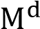  The endogenous component of the demand for money ( ) is the part of the demand for money that is determined by the interest rate and the level of production and income. | The exogenous component of the demand for money ( ) is the part that is influenced by expectations, business confidence, and political and social factors.

Question 2 (6 marks)
Explain why investment spending is a negative function of the interest rate and a positive function of the level of output and income and name two determinants of autonomous investment in South Africa.

Answer
Question 2 Investment is usually funded through borrowing. The higher the interest rate, the higher the cost of borrowing and the fewer the profitable investment opportunities will be. In terms of a chain of events: i↓ I↑ i↑ I↓

As the level of output (production) increases, the level of sales rises and firms tend to invest more – hence a positive relationship exists between the level of output and the level of investment. In terms of a chain of events:
Y↑ I↑ Y↓ I↓
Autonomous investment is determined by factors other than the level of output and income and the interest rate.
These are factors such as investor confidence, expectations, uncertainty, political and social stability and regulations. Any of these factors apply to South Africa. To explain the relatively low investment in the mining and agricultural sector popular explanations in the financial press are the uncertainties regarding nationalisation of mines and the redistribution of land as well as strikes in the mining industries.

Question 3 (6 marks)
Use the following information to derive an IS curve:
- A decrease in the interest rate from 6% to 4% increases investment spending by 200.
- Autonomous spending before the decrease in the interest rate is 800.
- The multiplier is 5.

Answer
Given the information the first point of the IS curve can be derived as follows:
Autonomous spending is 800 and the multiplier is 5. The equilibrium level of output and income is therefore 800x5=4 000. The first point of the IS curve therefore indicates that at an interest rate of 6% the equilibrium level of output and income is 4 000.

The second point is derived as follows:
The vertical intercept in the goods market increases by 200 – that is the increase in investment spending due to the decrease in the interest rate – and the vertical intercept is equal to 800+200=1 000. The equilibrium level of output and income is therefore 1000x5=5 000. At an interest rate of 4% the equilibrium level of output and income is 5 000. This is then the second point on the IS curve. The IS curve is then drawn by combining these points. Graphically the derivation is done as follows:

