- When macro economists study an economy, which of the following variables do they consider?
  - The level of production.
  - The unemployment rate.
  - The inflation rate.
  - The balance of payments.
  - The distribution of income.
- Which of the following statements is/are correct with regards to an IS curve?
  - The first equilibrium point is determined for a specific interest rate which relates to a corresponding total spending curve which relates to a specific output level.
  - To plot the second point of the IS curve the interest rate can be decreased to see what the effect is on output.
  - When the IS curve is derived we assume that government spending, taxation and consumer confidence are unchanged.
  - The IS curve has a negative slope because an increase in the interest rate will cause a decrease in savings.
- Which of the following statements is/are correct with regards to the IS curve?
  - An increase in the interest rate causes a decrease in investment which causes total spending and income to decrease.
  - An increase in the interest rate also causes consumption spending to decrease.
- Any point on an IS curve corresponds to an equilibrium point in the goods market
- A decrease in the interest rate is represented by a downward movement along an IS curve.
- Which one of the following factors will cause an upward movement along the IS curve?
  - ? An increase in the money supply.
  - ? An increase in the interest rate.
  - ? An increase in government spending.
  - ? A decrease in taxation.
  - ? A decrease in the interest rate.
- Which of the following are correct in terms of the demand for money?
  - An increase in the interest rate decreases the amount of money demanded.
  - An increase in income increases the demand for money for transaction purposes.
  - An increase in the demand for money shifts the demand for money curve (Md) to the right.
- Which of the following statements is/are correct according to the LM relation?
  - An increase in output and income leads to an increase in the demand for money.
  - An increase in the demand for money leads to an increase in the interest rate.
  - An increase in the demand for money also leads to an increase in the supply of money.
- Which of the following factors will increase the demand for money?
  - An increase in the level of output.
  - An increase in the interest rate.
  - An increase in government spending.
  - An increase in investment spending.
- Which one of the following factors will cause a shift of the LM curve to the right?
An increase in the money supply.

- Which of the following factors cause structural unemployment?
  - A mismatch between workers' qualifications and job requirements.
  - A lack of education, training and skills.
  - Changes in production methods and techniques.
  - Foreign competition.
- Which one of the following statements is correct in terms of a monetary-fiscal policy mix in the IS-LM model?
The right mix can mean using the two policies in opposite directions.

- Which of the following factors cause an increase in the nominal wage demands of labour?
  - A higher expected price level
  - A lower level of unemployment
  - A decrease in the demand for labour.
- Which of the following factors will cause an increase in the natural rate of unemployment?
  - An increase in the level of output.
  - An increase in the markup by firms.
- Study the following AS curve and answer the question that follows:
Which of the following statements is/are correct? None of the statements
  - At point b the expected price level, the natural level of employment and the nominal wage are higher than at point a.
  - At point c the level of output and the expected price level are higher than at point b.
  - At point c the natural level of output and the expected price level are lower than at point a.
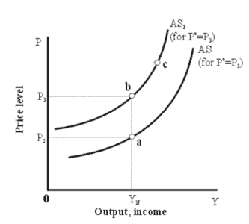
- Study the following AS-AD model and answer the question that follows:
Given that the economy is at point a, in the medium term the AS curve ...
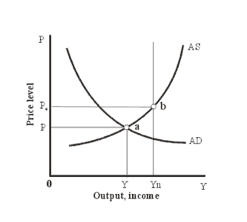 | - ? will shift to the right since the expected price level is higher than the actual price level.  - ? will shift to the left since the expected price level is higher than the actual price level.  - ? will not shift since the expected price level is equal to the actual price level.  - ? will shift to the left since the expected price level is lower than the actual price level.  - ? will shift to the right since the expected price level is lower than the actual price level.
- If investors, based on the following information:
  - Domestic interest rate in South Africa: 12%
  - Domestic interest rate in the USA: 6%
prefer to buy USA bonds it indicates that they expect the R/$ exchange rate to ...
depreciate with more than 6%.

- A depreciation of the nominal exchange rate causes ...
imports to be more expensive and exports to be cheaper

- According to the interest-parity relation ...
a higher domestic interest rate leads to an appreciation of the nominal exchange rate.

- Given a trade surplus an increase in income taxation ...
increases the trade surplus.

- In the IS-LM model for an open economy the IS curve is downward sloping because ...
a decline in the interest rate causes an increase in investment spending as well as a depreciation of the nominal exchange rate which causes an increase in exports.

- In the IS-LM model for an open economy an increase in the money supply causes ... a decrease in the interest rate, an increase in investment spending and a depreciation of the nominal exchange rate.

