HISTORY
  - Which ONE of the following is NOT an authoritative source
    - SA case law (is)
    - Corpus Luris Civilis (is)
    - The Constitution of RSA 1996 (is)
    - Judgements of the Dutch courts before 1652 (is)
    - English case law (this is foreign law)

SOURCES

AUTHORITATIVE
i Statue Law
ii Constitution
iii legislation
iv Customary Law
v Judgement of the courts

PERSUASIVE
i Foreign law
ii Textbooks & Law journals

  - Who is responsible for the issue of process, maintenance of records and issuing of orders of the high court
    - The Clerk
    - The Registrar
    - The litigating parties themselves
    - The Sheriff
  - Which ONE of the following sources will a SA lawyer consult on Roman-Dutch law
    - The law of the Twelve Tables
    - The Institutions
    - The corpus luris Civilis
    - Commentarius ad Pandectas
  - Which ONE of the following legal systems is the basis of SA legal system
    - Dutch law
    - Roman law
    - English law
    - Roman-Dutch law
  - Which ONE of the following statements regarding the application of the stare decisis doctrine is INCORRECT
    - A high Court, irrespective of whether it is full bench or not, is bound by the decisions of the Supreme Court of Appeal
    - One High Court is not bound to follow the decisions of a High Court in another area of jurisdiction
    - Within the area of jurisdiction of one High Court a full bench is bound by an earlier decision of the full bench of the same Court
    - If there are conflicting judgments of different high Courts a magistrate’s court can follow any decision it deems to be correct
  - VARIGORS V Fidelit Bank ltd 1989 (4) SA 384 (SCA)
    - VARIGORS – applicant, claimant or appellant
    - v - versus or against
    - FIDELITY BANK LTD – defendant or respondent
    - 1989 (4) – case is reported in the 4th part of the 1989 law reports
    - SA – Reported in SA
    - 384 - denotes the page number on which the case is reported
    - (SCA) – case was heard in the SUPREME COURT OF APPEAL
  - Meaning
    - STARE DECISIS – decision stands
    - RATIO DECIDENDI – the reason for the decision
    - OBITER DICTUM – incidental remark

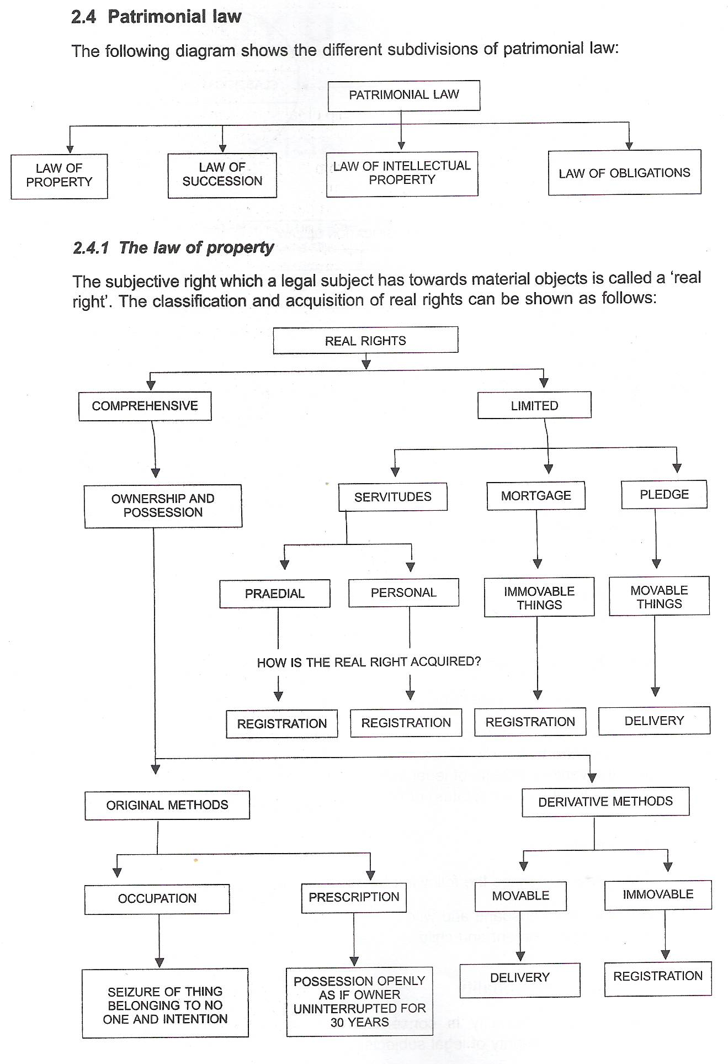

INTRODUCTION TO THE SCIENCE OF LAW
  - The right to claim performance from someone is a/an….

    - real right
    - intellectual property right
    - personality right
    - personal right

Solomon works on a Welkom goldmine. Before leaving is home in Limpopo he asked his nephew Bheki, to look after his cattle during his absence and gave permission to use the cattle. Everyone in their village now considers the animals to be Bheki’s as Solomon has been gone for so long. Bheki uses the dung of the cattle to fertilize his fields and sell and consumes their milk.
  - Under these circumstances, which ONE of the following statements Is CORRECT
    - Bheki is the usufructuary of the cattle
    - Bheki is the holder of a praedial servitude in the cattle
    - Bheki is the pledge of the cattle
    - Bheki is the mortgagee of the cattle
    - Bheki is the owner of the cattle through prescription
  - Nkosi wishes to grant Ntola a usufruct to live in Nkosi’s house. Which ONE of the following statements is INCORRECT
    - Ntola would have the right to let the house if he had to move to another province
    - Ntola is not allowed to sell Cheslin the right to occupy the house
    - Nkosi can grant Ntola a usufruct to last until Ntola graduates from university in four years time
    - Ntola is entitled to demolish one wing of the house and install a swimming pool in that area
  - Jerry sinks a borehole on his property. As a result of this, the water supply to his neighbour, Bob unfortunately dries up. Is Jerry delictually liable to Bob?
    - Yes, because Jerry infringed Bob’s rights of ownership
    - no because Jerry did not act unlawfully
    - No, because there is no causation
    - Yes because Bob suffered damages

Consider the following statements”
- The legal personality of a person is terminated for all purposes by his death
- The legal personality of a person is terminated by his death, except for purposes of the finalization of his estate
- The legal personality of a person comes into existence at conception, provided that his born alive
- The legal personality of a person comes into existence at birth
  - Which of the above statements are correct?

    - A AND C
    - A AND D
    - B AND C
    - B AND D

  - Which ONE of the following rights is infringed where a person makes defamatory statements about another person

    - personality right
    - personal right
    - real right
    - intellectual property right

John’s isolated shop is plundered periodically and the only reasonable way of protecting his property is by setting up a gun inside the shop with a conspicuous sign warning that the gun has been set. If a thief is injured or killed by the gun, Jon will NOT be liable because his actions will have been justified.
  - This is an example of

    - Voluntary assumption of risk
    - necessity
    - self-defence
    - consent by the injured party

  - Which ONE of the following actions should someone who has paid a sum of money to another I the mistaken belief that it was due, institute to recover the money from the other person?

    - condictio indebtiti (transferor of property given in error)
    - action inuriarum (sentimental damages)
    - action legis Aquiliae (economic loss assessed i.t.o. money)
    - rei vindication (owner reclaim property from another possessing wrongfully)

LAW OF A CONTRACT
  - Which one of the following is NOT a requirement for the conclusion of valid contract?
    - Each party to the contract must have a capacity to act
    - There must be consensus between the parties
    - It must by physically possible to perform i.t.o. the contract
    - the Contract must be permitted by law
    - The contract must be in writing, signed and dated.

Shaun studies at Unisa and envied Sandy to go to the movies with him and they agree to meet the next Friday at 6 o clock but Sandy didn’t pitch. Her car broke down on her way to the movies.
  - Which one of the options complete the sentence correctly
Shaun’s appointment with sandy was NOT a contract because…
    - their appointment was not in writing and signed by them
    - they did not have the intention to create legally enforceable obligations
    - it was not physically possible for Sandy to honor their appointment
    - it was not juridical possible for sandy to honor their appointment.

Robert wants to rent a house belonging to Johnny. Johnny tells Robert about the terms of is offer. Robert is not sure whether he should accept Johnny’s offer or not and he asks for more time to consider it. They agree that the offer will remain open for a period of one week. The following day Johnny is approached by Masedi who also want to rent the house.
  - Which one is correct
    - Johnny may let the house to Masedi because there is no contract that forbids him from doing so
    - Johnny may let the house to Masedi while his offer to Robert is still open
    - Johnny must keep the offer open for a period of one week until Robert has rejected or accepted it.
    - Johanny may not let the house to Masedi even after the period of one week has lapsed, but must wail until Roberts has given him an answer.

CONSENSUS
Richard makes an offer to buy Tumelo’s motor car for R1000. He gives Tumelo 10 days to accept his offer. On the ninth day Tumelo informs that he accepts the offer, but that he wants the amount of R1200
  - Which ONE of is CORRECT
    - A contract came into existence between R & T with a purchase price of R1200
    - A contract came into existence between R & T with a purchase price of R1000
    - No contract came into existence between R & T as T made a counter offer, which has not yet been accepted
    - Richards offer still stands

Muzi and Sipho arrange telephonically to meet at Jack’s Restaurant. At the restaurant Muzi offers to buy sipho’s car for R35000 which siphon accepts without hesitation. A week later Sipho calls Muzi to tell him how pleasant it is doing business with him. The delivery of the car and the payment of the purchase price takes place two days after the call at the Menlyn shopping mall. (MSM)
  - When & where did the contract come into being?
    - The moment Sipho accepted the offer at Jacks Restaurant.
    - The moment Sipho telephoned Muzi to tell him how pleasant it was doing business with him
    - The moment M & S arranged telephonically to meet at Jacks restaurant
    - the moment the delivery of the car and payment of the purchase price too place at MSM

At an auction of vintage motor cars the conditions of sale expressly provide that the auction is held subject to reservation. Deon makes a bid of R3k on a m/v of which the reserve price is R50k
  - Which ONE of is CORRECT
    - D made a valid offer which the auctioneer is obliged to accept because it was the highest bid
    - D’s bid or R30k constitutes acceptance of the offer which the auctioneer made to accept the highest bid
    - A valid contract came into existence when D accepted the auctioneer’s offer
    - D made a valid offer which the auctioneer can accept/reject regardless of whether it is the highest bid

F holds a pistol to T’s head and threatens to kill him should he not sell his house to him. T agrees and the contract of sale is singed by both parties.
  - Which ONE of is CORRECT
    - There is no consensus between F & T
    - A valid contract was not concluded because of the absence of consensus
    - The contract is void as a result of duress
    - The contract is voidable because T signed it under duress
  - Which ONE of the following situations does consensus NOT exist?
    - A the seller tells the purchases that he is buying a 1992 model car while it is in fact a 1990 model
    - A the seller doesn’t know whether the purchases is Jonathan Lee or his brother John Lee
    - Surgeon convinces his patient a very sick Leabe shortly before a Leabe is to undergo an operation to sell his car cheaply to him
    - A persuades V at gun point to sell him his 1994 model car for R500 although it is worth R50000

  - LEGAL CAPACTY TO ACT

