COMMERCIAL LAW CLA1501
(Chapter 2: Introduction to the Science of Law)

Law- system of rules which apply in a community
overlap
÷International/ constitutional/ administrative/ criminal laws & law of procedure
÷ law of persons/ family/ personality/ patrimonal
Control relationship between citizens & the state
Legal rules govern relationship between citizens & their dealings with each other
Person’s assets/ liabilities etc = monetary measurable

Law is divided in 2: Public Law
Private Law

Public Law – legal rules between state & citizens
Pvt Law – legal rules between citizens

Legal Subjects/persons: (has rights) - ***not human beings***
Natural persons – human beings (legal capacity: start @ birth ***completed & alive*** end at death)
Juristic person – e.g companies, universities, municipality etc

Right - any right a legal subject has regarding specific legal object and which is protected by law = subjective right.

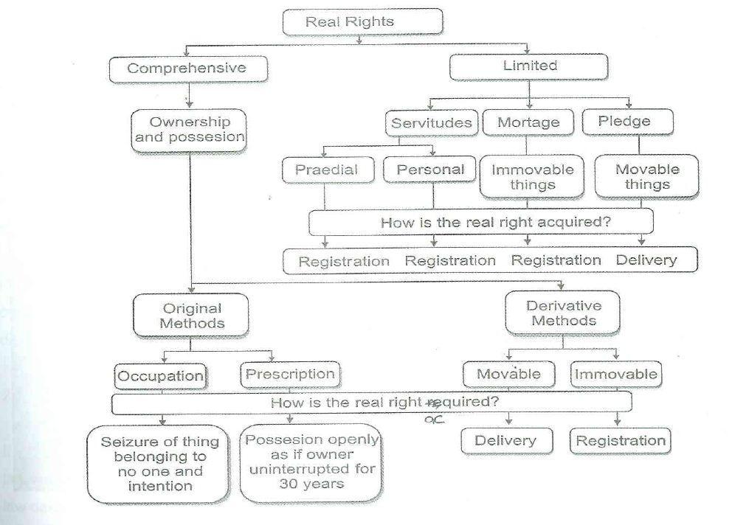

SUBJECTIVE RIGHTS: x4
Right of Legal Object (legally claim to right) – CAN BE COMPREHENSIVE OF LTD
Right to performance arises from – contract, delict, unjustified enrichment
Real Right | Intellectual Property Right | Personality Rights | Personal Rights
- Ownership  - Servitudes (Property rights)  * Praedial servitude –  nl use of rd, sea view  * Personal servitude –  nl. usufruct  - Mortgage and Pledge (Right of security – to secure debt) | - Artist, writer inventor  - Right to a patent | - Physical integrity or reputation of person | - performance (doing or giving something, not doing something)

PRIVATE LAW
Law of Persons | Family Law | Law of Personality | Patrimonial Law
- Who are legal subjects  - Becomes legal at birth only if born alive, ceases at death (but body & assets still protected for sake of creditors & heirs)  - Classes of legal subjects (minors don’t have same rights as adults)  - Status (affected by age/ sex/ marriage/ sanity/ decent etc.) | - Marriage: Husband & Wife  - Parents & Children  - Excluding relatives (cousins & in-laws) | (right to privacy/ non defamation etc)  - Physical being, dignity and reputation.  - Protected by Criminal Law and Civil Law  - psychical integrity  - subject to limitations  (politician not complain  about cartoon) | - Sum of assets & liabilities (anything with $ value)  - Law of Succession  - Will of deceased estate  - Law of Intellectual Property  - Products of human intellect that may be of economic value. Patents, copyrights, trademarks, goodwill etc  - Law of Obligations  - Contract (1 obligated to deliver, 1 obligated to pay)  - Delict (crime/offense) – damage is caused by delicit then offender must pay damages to owner  - Unjustified Enrichment  (If A erroneously deposits $ into B’s account, B must return it to A)  - Law of Property  *(see below table for further details)
*Law of Property:
“Granting and recognition of rights over property”
- The Right of Ownership & Possession (COMPREHENSIVE)
- Most complete Power over property
- May not use as you like: dependant on public law ****always restricted****
- Ownership: Person who has the right of ownership (belongs to) over property is not necessarily the possessor (person who has it).
- Possession: has physical control and at same time intents to possess it (Mpho holds John’s jacket – no possession), to have physical control over property does not require direct/immediate control over it (park car – has keys )
- Acquisition of Ownership

Original methods of acquiring ownership
nl. First time owner
- Occupation
Seizure of property that belongs to no one, with intention to keep (think catching wild bird)
Original method of acquiring ownership, coz not getting someone else
****can not become owner of property belonging to someone else****
- Prescription
Take ownership after 30 years as if you were the owner (but only if you’ve been using/ in possession openly uninterrupted for 30 years)
NB consideration – legal certainty
Original method of acquiring ownership, coz not getting someone else, previous owner lost ownership
- Movable Property
MUST Deliver property(e.g. delivery of bought vehicle), only agreement not sufficient
Derivative methods of acquiring ownership
nl. Trf ownership

MUST be intention of both parties to trf right of ownership
Derivative method of acquiring ownership – ownership trf not first time owner
- Immovable Property
MUST do registration at Deeds office (even if money paid its not yours till it is registered)
- *** PROTECTION BY REMEDY “REI VINDICATIO” Owner may reclaim their property from any person who wrongfully possesses it (think: D stole B’s pen & gave it to C). But owner can not forcefully take it from person but should claim item in court action of rightful ownership. Also if A damages/destroys B’s property, B can claim damages against A. ****
Note: You can’t deprive someone of possession against their will even if its your stuff

- Servitudes (LTD)
- “Limited Real Right over the property”
- Praedial servitude – the “dominant tenement” have the right to use the “servient tenement” land for whatever the servitude right is
- MUST be registered at deeds office
- - Prescription Possible
Take ownership after 30 years as if you were the owner (but only if you’ve been using/ in possession openly uninterrupted for 30 years)
NB consideration – legal certainty
- Personal Servitudes – Usufruct/life-interest: wife may live on property if husband dies, and children receive ownership upon her death.
- MUST be registered – usually in terms of will/testament
- Mortgage and Pledge (LTD)
- Limited real rights over property
- Way in which debt is secured
- MUST register against title deed – mortgage – immovable property
- MUST have agreement & delivery – pledge – movable property

LAW OF SUCCESSION:
* Executorships (legal representative) granted by Master of High Court
* Executor of estate become legal owner of assets – only naked ownership
* debt binding estate not executor,
* only executor can sue & be sued re the estate

LAW OF DELICT:
Grounds of justification trf unlawfull act to lawfull
Necessity – nl break window to safe a life
Self-defence –against human act
Consent
Consent to injury
Consent to risk of injury
Statutory authority
* must auth the infringement
* must not exceed bounds
of auth
Provocation
* reaction to provocation
must be reasonable
* reaction must be
immediate, not revenge
Must have al 5x Elements to be a delict:
- Wilful Voluntary human act
- Unlawfulness

- Fault (either intent or negligence)
- must have capacity to act – age, mentally ect
- Test - if in wrongdoer shoes – would a reasonable person act differently/same
- Causation
- can only be liable for consequences he/she legally causes
- 2x elements/parts:
*** factual causation – link exist between act & damage
*** legal causation – which one of followed harmful events should give rise to liability
- Damage or injury of personality (harm)
- Patrimonial loss (estate)
*** calc diff between estate prior & after damages
*** guilty person can not claim damages extinguished by medical aid ect
*** claimant - not allowed to let damages increase due to own fault
- Impairment personality (good name)
*** difficult to proof extend
*** calc according fair & just - after looking facts

Remedies: x 2
Interdict & payments/compensation of damages –
3 types of proven loss:
- Patrimonial loss – “actio legis Aquillae”
- Sentimental damage – “action iniuriarumis”
- Pain & suffering(personality)

Law of Unjustified Enrichment

- no one s/be enriched at expense of another
- claim is ltd to amount of actual enrichment
- Obligation upon enriched person – 2 forms:
** Restitution (recover what was done) is due when:
- pmt /del was done in error provided that:
* was mistake
* mistake reasonable
* was not make on condition not to be returned
* not made by way of compromise
2. Compensation
* Partial performance- one party performed only partially, which is indivisible (half build of house) – can claim part build
* Improvements to Property – person does improvements for own
benefit, but property not his, improvement become property real owner.
Can however claim compensation, if changes accepted by owner
- Negotiorum gestio
* when a person voluntary, without permission runs anothers affairs.
They are entitled to pmt if the other accepts negotiorum gestio

