COMMERCIAL LAW CLA1501
(Chapter 2: Introduction to the Science of Law)

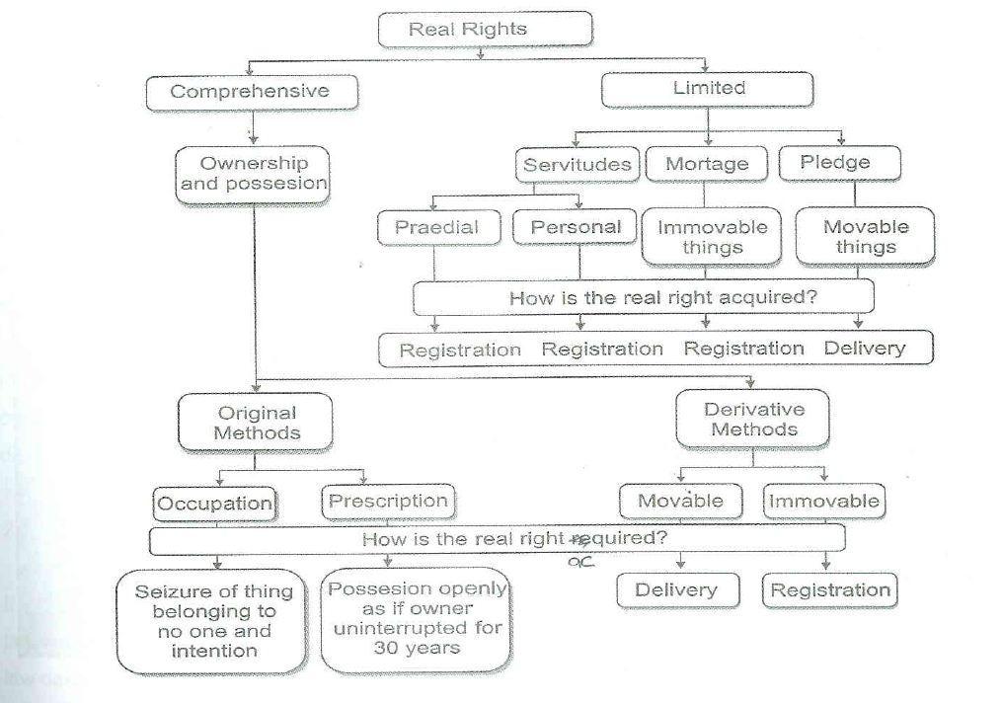

Law- system of rules which apply in a community
Right - any right a legal subject has regarding specific legal object and which is protected by law = subjective right.
overlap
÷International/ constitutional/ administrative/ criminal laws & law of procedure
÷ law of persons/ family/ personality/ patrimonal
Control relationship between citizens & the state
Legal rules govern relationship between citizens & their dealings with each other
Person’s assets/ liabilities etc = monetary measurable

Law is divided in 2: Public Law
Private Law

Legal Subjects:
Natural persons – human beings
Juristic person – e.g companies, universities, municipality etc

SUBJECTIVE RIGHTS:
Right of Legal Object (legally claim to right)
Real Right | Intellectual Property Right | Personality Rights | Personal Rights
- Ownership  - Servitudes (Property rights)  - Mortgage and Pledge (Right of security – fail to settle debt then mortgagee can sell property) | - Artist, writer inventor  - Right to a patent | - Physical integrity or reputation of person | - Rights in terms of conduct, performance (doing or giving something)  - One person owes another money

PRIVATE LAW
Law of Persons | Family Law | Law of Personality | Patrimonial Law
- Who are legal subjects  - Becomes legal at birth only if born alive, ceases at death (but body & assets still protected for sake of creditors & heirs)  - Classes of legal subjects (minors don’t have same rights as adults)  - Status (affected by age/ sex/ marriage/ sanity/ decent etc.) | - Marriage: Husband & Wife  - Parents & Children  - Excluding cousins & in-laws | (right to privacy/ non defamation etc)  - Physical being, dignity and reputation.  - Protected by Criminal Law and Civil Law  - Relation between people concerning their physical & psychical integrity | - Sum of assets & liabilities (anything with $ value)  - Law of Succession  - Will of deceased estate – consist of assets & liabilities.  - Executor not bound to deceased debts but can be and can sue  - Law of Intellectual Property  - Products of human spirit that may be of economic value to discoverer/ inventor. Patents, copyrights, trademarks, goodwill etc  - Law of Obligations  - Contract (1 obligated to deliver, 1 obligated to pay)  - Delict (crime/offense) – damage is caused by declit then offender must pay damages to owner  - Unjustified Enrichment  (If A erroneously deposits $ into B’s account, B must return it to A)  - Law of Property  *(see below table for further details)
*Law of Property:
“Granting and recognition of rights over property”
- The Right of Ownership
- Power over property
- May not use as you like: dependant on public law
- Ownership: Person who has the right of ownership over property is not necessarily the possessor.
- Possession direct or indirect control over property – physical control and at same time intents to possess it
- Acquisition of Ownership
- Occupation
Original methods of acquiring ownership
Seizure of property that belongs to no one (think catching wild bird)
Original method of acquiring ownership
- Prescription
Take ownership after 30 years as if you were the owner (but only if you’ve been using it uninterrupted for 30 years)
- Movable Property
Derivative methods of acquiring ownership
Delivery of property (e.g. delivery of bought vehicle)
- Immovable Property
Property only after registration at Deeds office (even if $ paid its not yours till it is registered)
- Servitudes
- “Limited Real Right over the property”
- Ownership protected by the remedy “reivindicatio”. Owner may reclaim their property from any person who wrongfully possesses it (think: D stole B’s pen & gave it to C). But owner can not forcefully take it from person but should claim item in court action of rightful ownership. Also if A damages/destroys B’s property, B can claim damages against A.
Note: You can’t deprive someone of possession against their will even if its your stuff
Protection of ownership & possession
- Praedial – have the right to drive or walk over the plot of another
- Personal Servitudes – Usufruct: wife may live on property if husband dies, and children receive ownership upon her death.
- Mortgage and Pledge
- Limited real rights over property

LAW OF DELICT:
Elements of delict:
Grounds of justification
Necessity
Self-defence
Consent
Consent to injury
Consent to risk of injury
Statutory authority
Provocation
- Voluntary human act
- Unlawfulness

- Fault (either intent or negligence
- Causation
- Damage or impairment of personality

Remedies:
Interdict & payments of damages – 3 types of proven loss:
- Patrimonial loss
- Recovering sentimental damage
- Pain & suffering

