DYNAMICS OF THE PERSONALITY
Motivation : Freud’s Drive Theory
He believes that the human is psyche functions with the help of energy which is converted from a physical-biological form to a psychic energy according to the principle of energy transformation
Internalisation- process by which people make things such as attitudes, values and beliefs of others as part of their personality so that they can cope with things better in the future
The energy can either urge the individual to act (satisfy sexual desires) or torture the individual with guilt feelings

Characteristics of drives
Source
Has its source in the body- but from different parts of the body (example- source of hunger is at the stomach)
Energy
Every drive has impetus or energy which is affected by the condition of the energy source
Goal
Goal of satisfaction-desires to accomplish something specific, and the pressure remains until the drive is satisfied
Object
Something or someone suitable for its satisfaction- the object of the hunger drive is eating. This object is chosen by the ego and is invested with psychic energy-
The process of object choice is known as cathexis
Object can be substituted when the original object is no longer available- known as displacement
The moral prohibition that the superego places on an object is known as anticathexis.

Types of Drives
Life Drives(Eros) | Death Drive(Thanatos)
Ego Drive
Sexual Drive

Ego Drive
Individual survival-includes all drives aimed at satisfying basic life needs or primary needs (eating, breathing, and eating) except the sexual need
Different from sexual drives in that
- They are related to the survival of the individual-sexual needs are related to the survival of the species
- They are not associated with moral prescriptions and guilt feelings- as compared to the sexual drives
- They provide energy for the functioning of the ego
Sexual Drives
Primary function is erotic - satisfaction of sexual drives provides erotic pleasure and the satisfaction of the drives causes discomfort.
Present at birth-but start functioning in service of reproduction and survival of the species only after puberty
Freud says that even small babies have sexual drives- seeking erotic pleasure
Baby’s body source for sexual drives is the mouth area-especially the lips and inside of the mouth
The original object of the “oral sexual drives” is the mother’s breast- Freud says that the inclination to suckle even after the hunger is satisfied indicates purely erotic pleasure and is an expression of the sexual drive
Other sexual drives develop as they emerge as the child develops- they are either controlled or prohibited by society-meaning that the drives create ongoing psychological problems for people and play an important role right through people’s lives- play a significant role in development of mental disturbance

Death Drive
Intrapsychic explanation for phenomena like war, aggression and murder- hence the death drive
Basic function is to break down living cells and change them into dead matter
The death drive is brought into conflict with the life drives and is projected outward in the form of aggression and destructive behaviour towards other people and things
Examples- baby bites the mother (first form of aggression)

Anxiety

Freud identified three types of anxiety:
- Neurotic anxiety is the unconscious worry that we will lose control of the id's urges, resulting in punishment for inappropriate behaviour.
- Reality anxiety is fear of real-world events. The cause of this anxiety is usually easily identified. For example, a person might fear receiving a dog bite when they are near a menacing dog. The most common way of reducing this anxiety is to avoid the threatening object.
- Moral anxiety involves a fear of violating our own moral principles.
In order to deal with this anxiety, Freud believed that defence mechanisms helped shield the ego from the conflicts created by the id, superego, and reality.

From <http://psychology.about.com/od/theoriesofpersonality/ss/defensemech.htm>

DEFENCE MECHANISM
Defence Mechanisms: Strategies that the ego uses to defend itself against the conflict between forbidden drives and moral codes which cause neurotic and moral anxiety. Individuals are not aware of the deep-seated reasons for their defensive behaviour

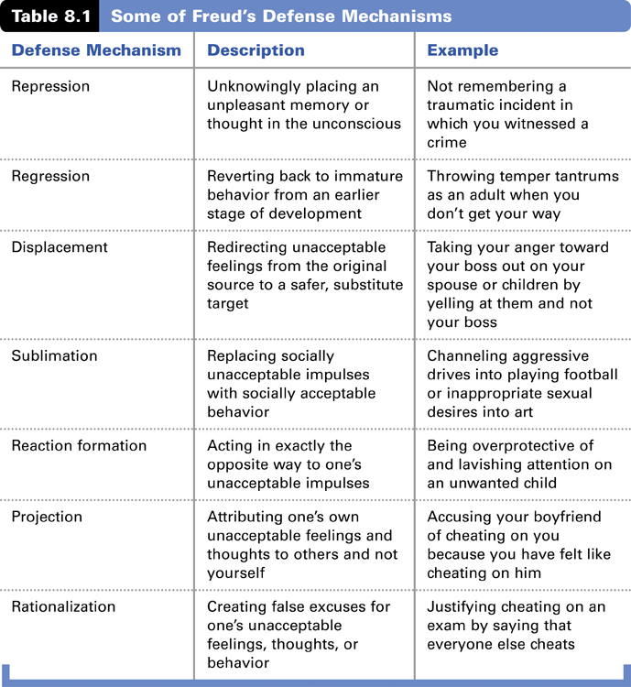

http://blog.lib.umn.edu/chamb169/myblog/2011/11/anxiety.html

DREAMS
According to Freud, dreams always have a manifest and latent content. The manifest content is what the dream seems to be saying. It is often bizarre and nonsensical. The latent content is what the dream is really trying to say. Dreams give us a look into our unconscious. Freud believes that we can chip through the dream's manifest content to reveal the underlying significance and its latent by utilizing the technique of "free association". Using this technique, you start with one dream symbol and then follow with what automatically comes to your mind first. You continue in this manner and see where it leads.

Parapraxes
parapraxis, is an error in speech, memory, or physical action that is interpreted as occurring due to the interference of an unconscious ("dynamically repressed") subdued wish, conflict, or train of thought guided by the ego and the rules of correct behaviour. They reveal a "source outside the speech". The concept is thus part of classical psychoanalysis.
Slips of the tongue and of the pen are the classical parapraxes, but psychoanalytic theory also embraces misreadings, mishearings, temporary forgettings, and the mislaying and losing of objects
http://en.wikipedia.org/wiki/Freudian_slip

