RSK2601 [s2-2014]
(Sources & References Used: Discussion Slides, Study Guide, Text Book isbn 9781118742426)
"Risk is the effect of uncertainty on objectives"
The effect may be positive, negative or a deviation from the expected. Risk is often described by an event, a change in circumstances or a consequence. ^{(ISO 31000)}
Topic 1: ERM (Enterprise Risk Management) in Context [Su 1] Intro
- Risk Diversity rapid changes in globalisation/markets/technology, communication speed
- Expansion strategies investing in emerging markets; develop significant new products; acquisition; major org. restructuring; outsourcing key processes; major capital investment increases risk exposure.
- Risk management is no longer silo-based as it affects multiple business areas
- Risk-taking tendency to engage behaviours that have harmful/dangerous potential, yet could also provide a positive opportunity
- Risk & opportunity competitive differentiator, heart of growth & wealth creation
  - Benefits improved cost certainty; higher economic returns, sustainable shareholder value, increased stakeholder confidence, reduction of costly disputes & claims
  - Controlling certain risks to maximise business opportunities
  - Board should ensure comprehensive & consistent management
- Board's role ^{SG p8, TB p7}
- ERM (strategic business risk management) aims to provide a coherent framework to holistically deal with all risks that result from operating in the ever-changing economic environment thereby improving business performance & creating value for shareholders.
- Benefits of ERM improved business performance, increased organisational effectiveness & better risk reporting
  - Increased likelihood of realising business objectives techniques to identify, record, assess opportunity
  - Build confidence in stakeholders & investment community
  - Comply with relevant legal & regulatory requirements
  - Align risk appetite & strategy
  - Improve organisational resilience degree/flexibility to recover from & respond to change
  - Enhance corporate governance challenge potential excessive risk taking, improve risk appetite decision-making
  - Embed risk process throughout organisation creation of framework, policy, process, plans & training
  - Minimise operational surprises & losses capability to identify, assess & establish responses
  - Enhance risk response decisions risk removal, reductions, transfer, retention
  - Optimise resources allocation
  - Identify & manage cross-enterprise risks Integrate risk transfer strategies & management, centralised risk reporting,
  - Link growth, risk & return acceptable levels of risk relative to potential growth
  - Rationalise capital assess overall capital needs & allocation
  - Seize opportunities
  - Improve organisational learning
ERM Elements/Structure: ^{TB Fig. 1.2}

- Corporate Governance rules & practices ensuring board's accountability, fairness & transparency with stakeholders
  - Explicit & implicit contracts for distribution of responsibilities, rights & rewards between org. & stakeholders
  - Reconciling procedures in accordance with stakeholders duties, privileges & roles
  - Procedures for proper supervision, control & info flow.
- Internal Control ^{process, effected by board &} ^{all} personnel, designed to provide reasonable assurance of objective achievement
  - Operation effectiveness & efficiency
  - Reliability of financial reporting
  - Compliance with applicable law & regulations
- Implementation mapping, communicating & agreeing on action parameters. Resourced internally or externally
- Risk management framework basic conceptual structure assisting in integrating RM into a routine activity
  - Composition Mandate & commitment; Design framework; Implement framework; Monitor framework; Improve framework
- Risk management policy How(control); Who(responsibility, accountability), boundaries & reporting; What(intention)
- Risk management process establish context, communicate & consult, identify, analyse, evaluate, treat, monitor & review
- Sources of risk
Topic 1: ERM in Context [Su 2] Corporate Governance
Definition: The relationships among the management of an organisation, its board, its shareholders and other relevant stakeholders. It also refers to the specific responsibilities of boards of directors and management to maintain established relationships.
- Good corporate governance contributes to shareholders’ wealth and a key factor in the investor decision-making process. higher future share prices, reducing risk (avoid/cope), trend
- Impact Employ assets efficiently; Attract lower-cost capital; Comply with social obligations & laws; Overall performance
- History of corporate governance in South Africa:
- King I Report (1994) integrated approach, guides on financial reporting & good social, ethical, environmental practices
- King II Report (2002) triple bottom-line principle, emphasis on non-financial indicators (social, economy, environment)
- King III Report (2009) annual reporting; Apply to JSE listings, banks, financial & insurance institutes, some public agents
  - Leadership, sustainability & corporate citizenship
  - Integration of social, environmental & economic issues
  - Inclusive stakeholder approach
  - Integrated reporting
  - Emerging governance trends incorporated in the report
- Companies Act 61 of 1973 directors ' role & liability; loaning; share capital allocation; shareholding & transactions
- Companies Act 71 of 2008
Governance of risk King III: 10 Principles: Study this & section on “King III at a glance” (Appendix A) in TL501
- Risk governance is the board’s responsibility.
- The board should determine the risk tolerance & risk threshold for the company.
- Risk committee/audit committee should assist the board.
- Management's responsibility to implement & control the risk management process.
- There has to be an ongoing risk assessment process.
- There has to be an early warning & monitoring system to detect & anticipate unpredictable risks.
- Management must control the response systems.
- Management must control the risk monitoring systems.
- Management is to advise the board on the effectiveness of the risk management process & systems.
- The board is to ensure that the company’s disclosure framework includes reporting on the effectiveness of the risk management process.
Topic 2: ERM Process
Definition: The risk management process entails the planning, arranging and controlling of activities and resources to minimise the negative impacts of all risks to levels that can be tolerated by stakeholders whom the board has identified as relevant to the business of the company, as well as to optimise the opportunities or positive impacts of all risks.
Exam tips
- ERM Process and understand concepts under each stage
- No ratio calculations will be asked
- Understand figures & able to explain – not do.

Topic 2: ERM Process [Su 3] Stage 1: Establishing Context
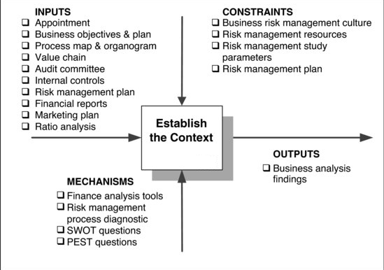
Read TB
Read TB
Study SG & TB
Study SG & TB
- Foundation for all the other stages.
- To acquire accurate data & information about the whole business.
- Assists in determining sources of risks & the participants in the risk identification process.
- A risk breakdown structure must be constructed. These process activities include: ^{TB p149}
  - Clarifying & recording business objectives (Objectives are criteria for measuring success; should be SMART)
  - Understanding the business plan
  - Examining the industry wherein business operates
  - Establishing business processes (B.P Def.: Series of steps designed to produce a product or service)
  - Evaluate financial statements (Portray the predicted financial outcomes of pursuing a particular course pf action)
  - Identify resources available (Efficiently used to competitive advantage)
  - Change management
  - Marketing plan (Need for competitor analysis and R&D)
  - Compliance system (Regulatory framework embedded in business operations)
  - May also include: internal controls, role of audit committee, examination of existing risk management processes.
Topic 2: ERM Process [Su 4] Stage 2: Risk Identification
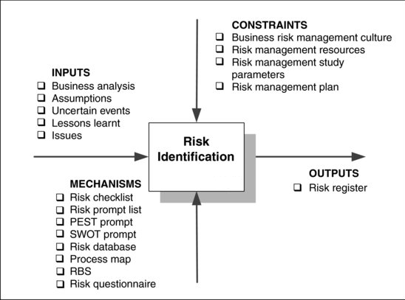
Read TB
Read TB
SG: "Tool used by a business to compile a list of all the risks identified, then categorised according to impact, probability, risk owner and counter measures"
Study SG & TB
Refer TB 8.6
- Identification of the risks/risk events & opportunities (upside & downside)
- Understanding how they fit into the overall business.
- As a business grows, expands or improves, the exposure to risk/opportunities will also change.
- Assists in formulating a business strategy.
- Process Mechanisms / Enablers: ^{TB p163}
  - Risk Checklist in-house list of risks identified on previous projects
  - Risk Prompt List Categorise risks into types or areas identifying main categories of risk; may be too exhaustive
  - Gap Analysis used to draw out main risks to a certain activity/project, commonly by questionnaire
  - Risk Taxonomy BRT is a structured checklist breaking down risks in to general classes subdivided into elements & attributes; manageable components that can be aggregated for exposure measurement, management & reporting purposes
  - PEST Analysis gain greater insight & understanding into competitors, market position environmental analysis; PESTELI
  - SWOT Analysis quick to implement & easily understood, analysing both internal & external environments
  - Database capturing all info in consistent way, providing audit trail & effective monitoring system of actions & risks
  - Business Risk Breakdown Structure (RBS) decomposition of business environment illustrating sources of risk
  - Risk Questionnaire elicit as much info on issues as possible without deterring recipients from responding
  - Risk Register capture info in a consistent manner/constant basis & simplify communication, reflecting sequence of capture
- Activities to capture & record the risks: ^{TB p171}
  - Clarify business objectives
  - Reviewing the business analysis of Stage 1 for sources of risk & opportunities
  - Need for risk & opportunity identification predicted on assumptions of: exposed activities; poor communication; consistency; ad hoc = blind spots; non-judgemental environment;1; opportunity identification
  - Risk & opportunity identification group-oriented approach, exposing relationships between risks
  - Facilitation (interactive workshops) non-employee involved in controlling and leading a team
    - Facilitator responsibilities Timing; Physical enviro; arranging attendees; agenda; briefing pack; manage process
    - 7 Techniques Brainstorming, (semi)Structured interviews. Nominal Group (NGT), Scenario Analysis, Delphi, Cross Impact Method, Systems Dynamics, Risk Meta-language, Implementation
  - Consensus on risks, opportunities & interdependencies to be able to assign risks to risk owners
  - Risk Register populated with above findings becoming proactive tool for management
Topic 2: ERM Process [Su 4] Stage 3: Risk Analysis
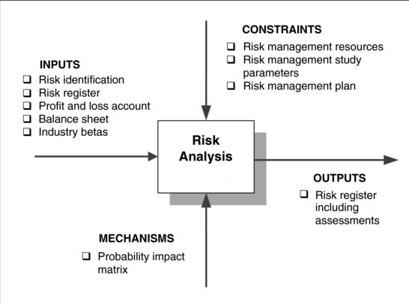
Read TB
Read TB
Refer TB 8.6
Study SG & TB

- Provides info on the likelihood of risks & opportunities occurring & their impact.
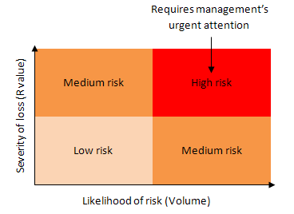
- Assess all the risks identified in the risk register.
- To separate the minor, acceptable risks from the major risks.
- Process Mechanisms / Enablers: ^{TB p188}
  - Probability Distributions, Probability impact matrix
- Tasks necessary to capture the likelihood of risk occurring and impact: ^{TB p189}
  - Casual analysis relation between effect and possible causes, determining problem's root cause, learning from past events
  - Decision analysis structures decisions, uncertain events & values of outcome & influence diagrams graphical representation assisting model design, development, serving as framework for expressing exact nature of variable relationships
  - Pareto analysis or 80/20 rule focus on risk with potential for greatest detrimental impact; ranking / ordering risks
  - C^{apital} A^{sset} P^{ricing} M^{odel} analysis determines return on asset in relation to risk / risk profile. Required rate of return
  - Defining risk evaluation categories & values qualitative & quantitative assessments
Topic 2: ERM Process [Su 4] Stage 4: Risk Evaluation
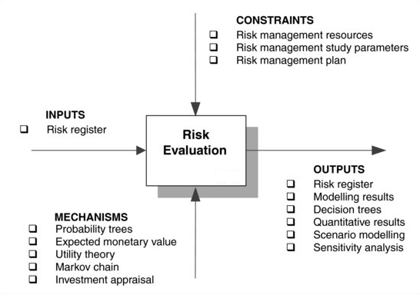
Read TB
Read TB
Dictated by eval. process objectives, mechanisms used and data collected
Refer TB 8.6
Study SG & Refer TB
- Evaluate the financial impact (loss or gain) of a risk in numerical terms.
- Assessment & measurement of the risk exposures with the aim to manage & control the risks that can negatively influence the business strategy/objectives.
- Understand the combined effect of a group of risks & opportunities.
- Process Mechanisms / Enablers: ^{TB p200}
  - Probability Trees way of ensuring all possible outcomes has been taken into account. Dependant / independent events
  - Expected monetary value (EMV) assign probability of each uncertain outcome being achieved then calculate combination of weighted outcomes; many similar situations of similar character; select decision with largest monetary value
  - Utility Theory & Functions alternative decision does not necessary reflect relative attractiveness to decision maker; measure personal attitudes towards risk
    - Risk Attitudes: 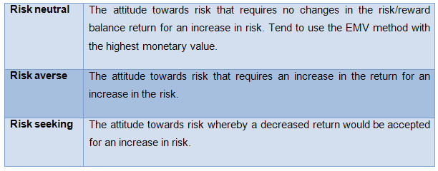
  - Decision Trees illustrate decision problems graphically, consisting of nodes with interconnected branches/alternatives
  - Markov Chain combine probability with matrix algebra, assumes probabilities remain fixed but system changes
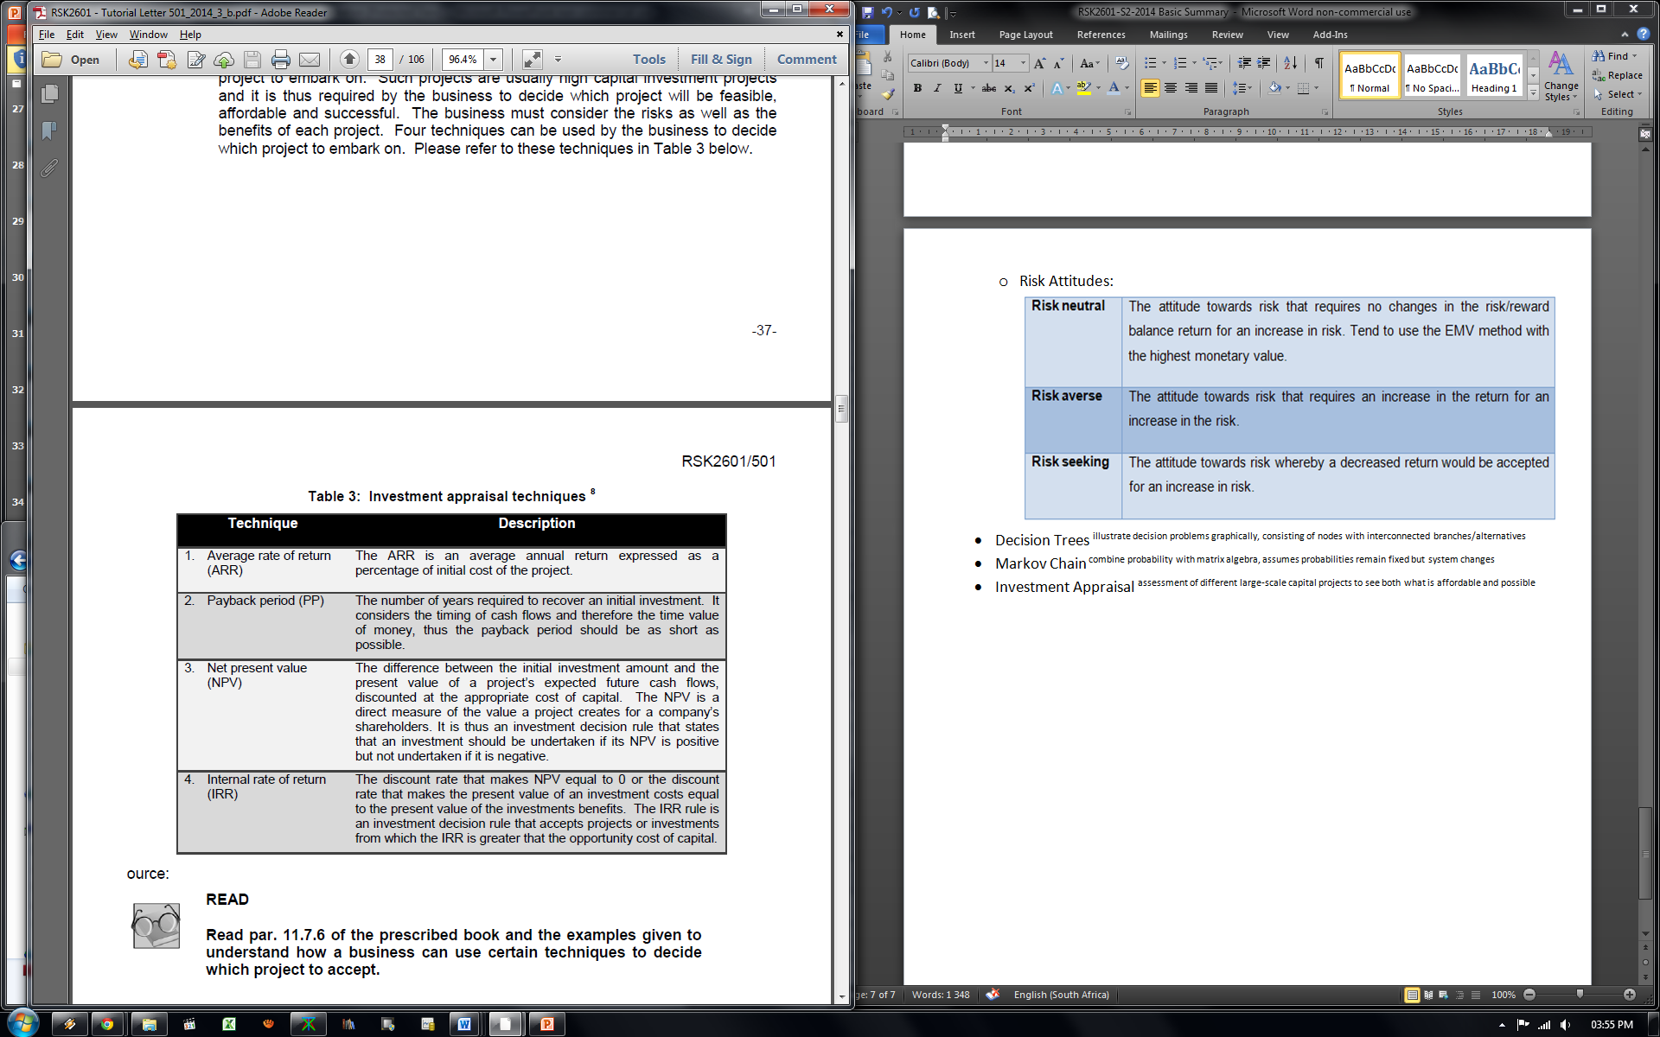
  - Investment Appraisal assessment of different large-scale capital projects to see both what is affordable and possible
- Process Activities in risk evaluation: ^{TB p215}
  - Basic concepts of probability assess chance of particular outcome in given situation (non-/mutually exclusive)
  - Sensitivity analysis assess how sensitive project outcomes are to changes in business using one specific variable
  - Scenario analysis consequences of combinations of events regarded as very unlikely to happen, changing various variables
  - Simulation analyse uncertain variables in financial/time models, using statistical software/ commercial available spreadsheet
  - Monte Carlo simulation evaluate effect of uncertainty on planned activity in range of situations using random numbers to sample from a probability distribution
  - Latin hypercube sampling More recent Monte Carlo; accurately re-creates probability distributions specified by distribution functions in fewer iterations
  - Probability distributions defended from expert opinion subjective estimates, non-existent data
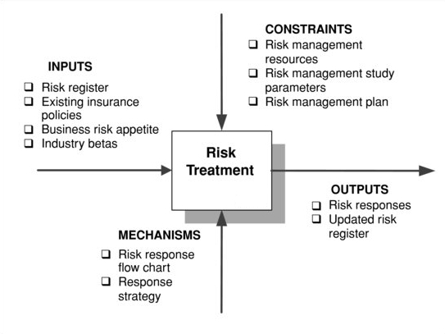
Topic 2: ERM Process [Su 4] Stage 5: Risk Treatment
Refer TB 8.6
Read TB
Read TB
Study SG & Refer TB

- Designing a specific action plan to address the risks and opportunities.
- Response strategies must be implemented effectively in the business.
- Commonly it is not possible to remove a risk in its entirety.
- Process Mechanisms / Enablers: ^{TB p225}
  - Resolution Strategy pre-defined plan designed to respond to a particular reoccurring risk
  - Risk Response flow chart illustrates decision options made to arrive at desired risk response category
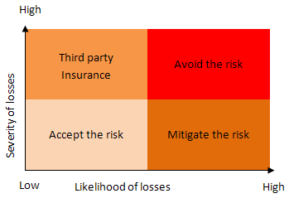
- Activities to construct the priority list of risks into a concrete action plan is: ^{TB p226}
  - Conduct research
  - Develop appropriate alternative responses
  - Risk response(s) for each risk/opportunity
  - Assess cost of response against risk impact
  - Identify risk owner, manager and actionee
  - When to implement
  - Consider emergence of secondary risks
  - Establish early warning indicators
  - Defining & understanding risk appetite amount of risk business prepared to tolerate at any point in time
  - Risk response strategies: ^{TB p228}
    - Risk reduction (mitigate/treat) seen as risk diversification (reduction by distribution)
General approaches: Reduce likelihood of occurring; limit loss if materialise
Methods: protection, controls, maintenance and risk spreading
    - Risk removal (avoid/exclude) eliminate altogether when anticipating negative outcome/impact
When abandoning, Consider: Opportunity, Business Objective and Costs.
    - Risk transfer (deflect/third party) move risk onto another entity using contracts/financial agreements
Consider: Parties' objectives, managing ability, risk context, cost effectiveness.
    - Risk retention (accept/absorb) more economic or there are no alternatives
Consider: Options, Timing and Ability to absorb.
Topic 2: ERM Process [Su 4] Stage 6: Monitoring & Review
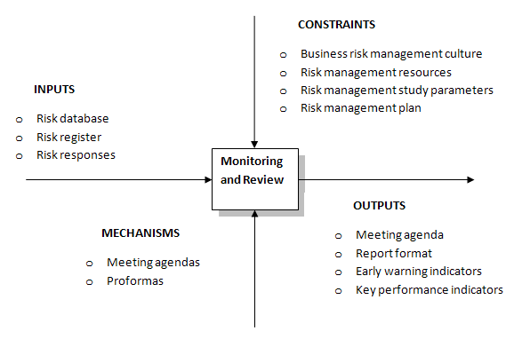
Read TB
Read TB
Refer TB 13.6
- Ever changing environment / availability of new info.
- Review all the previous stages (continuous process), increasing success of ERM process.
- Early warning system in order to identify areas which could potentially lead to risk exposures & financial losses.
- Business is constantly reacting, registering, reviewing & reporting.
- Reacting ^{to warning indicators,} Registering ^{changes,} Recording, reviewing ^{implementation,} Reporting.
- Activities necessary to ensure this stage is managed proactively to execute responses:
  - Executing risk response actions planned in risk treatment stage.
  - Monitoring progress, early warning indicators, discerning movement in risk exposure/changes in environment.
  - Controlling (intervening) Satisfy 7 specs: economical, meaningful, appropriate, congruent, timely, simple, operational
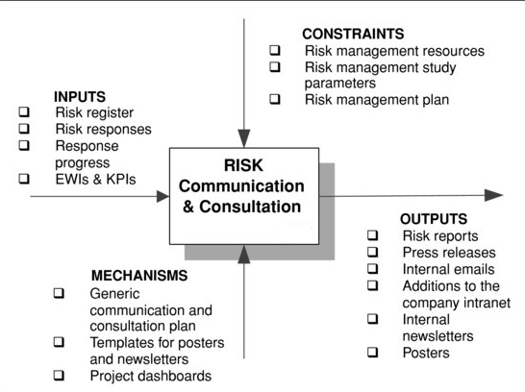
Topic 2: ERM Process [Su 4] Stage 7: Communication & Consultation
Read TB
Read TB
Refer TB 14.6
- Used across all the other ERM stages.
- Efficacy each stage is communicated & understood by decision makers/employees.
- Support the implementation of a risk management culture in a business.
- Activities to ensure the overall risk management process is effective: Study TB 244-5
  - Internal communication to support & encourage accountability and ownership
  - External communication to deliver open & honest information on risks facing & how business responds to them
(KRI vs. KPI: SG & ex myUnisa " Additional+information+to+Study+Unit+3")
  - Key risk indicators captured info providing useful view of underlying risk profiles at various levels for ^{decision making}
  - Key performance indicators high level snapshots of business health on specific predefined measures, 7 types.
Topic 3: Internal Influences – Micro Factors
To a large degree generated internally, within the sphere of influence of any one business
F_{inancial}
O_{perational}
T_{echnology}
P_{roject}
E_{thics}
H_{ealth & safety}
=
Sounds Like "Thought Pê"
=
Thoughts are internal

Topic 3: Internal Influences – Micro Factors [Su 5] Financial Risk Management
Definition: Financial risk is the exposure of an enterprise to adverse events, eroding profitability and in extreme situation brings about business collapse.
- Managed to maintain business continuity
- Benefits of FRM:
  - Improves financial planning & management; heart of corporate governance
  - Facilitates more robust investment decisions
  - Informs hedging decisions
  - Encourages constant monitoring of markets & economy for decision making
  - Encourages due diligence when outsourcing / engaging counterparties
- Implementation depends on:
  - Robust financial systems & internal control
  - Concise, lucid reporting tools
  - Preparation of cash budget plan diminishing likelihood of threat of liquidity risk
  - Securing credit insurance to cover non-payment of goods/services/bad debts
  - Carry out due diligence on counterparties whose default could seriously harm org.
  - Monitoring predicted changes in interest rates
  - Robust assessment of planned investments with tried & tested techniques
- Scope of Financial Risk: ^{TB p250}
  - Liquidity Risk short-term inability to meet financial obligations. Higher ration = better liquid current position
    - Current Ratio ⁼ relationship between current assets ÷ current liabilities
    - Quick Ratio further refines/more conservative = current assets – stocks/inventory ÷ current liabilities
    - Mitigation of Liquidity Risk payment of debts when they fall due. Achieved by preparing cash budget
  - Credit Risk lack of payment on goods supplied/default (quantity & quality) of borrower/counterparty under contract
    - Default risk probability of default event. Payment, breaking covenant, economic
    - Exposure risk uncertainty surrounding payment of future amounts (scheduling of outflows & repayments)
    - Recovery risk uncertainty over likely recovery of outstanding amounts due. Use of corrective/legal actions
    - Credit insurance mitigation action for credit risk. Covers payment for sale of goods/services
    - Counterparty risk ^{the} risk to each party of a contract that counterparty will not honour contractual obligations
    - Due Diligence care reasonable person should take before entering into agreement/transaction with another party
  - Interest Rate(IR) risk ^{when borrowing} know: IR determination, IR at commencing of borrowing, IR nature (fixed/variable), payment duration. Rate of interest paid depends on: amount, term, forecasts, inflation, risk, opportunity cost, and market. Affects consumer's disposable income, resulting in deterioration of trade.
  - Currency (foreign exchange) risk fluctuations in exchange rates adversely affecting expected overseas cash flows
  - Funding risk borrowers, unable to meet capital repayment requirements & interest, paying fixed charges on company asset
  - Foreign investment risk when pursuing opportunity abroad e.g. restrictions/taxation/freezing accounts/expropriation
    - Country Risk geographical distance of market increasing cost & time, discouraging policies (see e.g. above)
    - Environment Risk different laws, practices, cultural & ethical norms profoundly effecting proposition's viability
  - Derivatives financial product derived from existing product; market speculation; hedge; redistribution/cover of risk/exposure
    - Exchange Traded bought & sold on recognised world exchanges. Restricted by "ticks" min. movement amount
    - Over the Counter(OTC) to meet specific needs of individual clients. Banks/fin. institutes not on any exchange
  - Systems
  - Outsourcing risks default of counterparty gone into liquidation / failed to deliver by due date / breached contract
Topic 3: Internal Influences – Micro Factors [Su 6] Operational Risk Management
Definition: exposure to losses resulting from inadequate/failed processes & systems, technology, people, external events or strategies.
- Can affect firm's solvency, fair treatment of clients, incidence of financial crime
- Establish series of systems & controls to manage people risk
- Risk sources: Business, crime, disaster, information, technology, legal, regulatory, reputational, systems and outsourcing.
- Benefits of ORM: ^{TB p270}
  - Improves ability to do business objectives
  - Management can focus on revenue generating activities rather than fighting crisis's
  - Minimise day-to-day loses
  - Provide more robust ERM system
  - Contributes to a system enabling the correlation of different risk classes to be understood and modelled
- Implementation of ORM:
  - Shouldn't constrain risk taking / slow down decision-making / limit business volume
  - Implementers must be separate from individual business units' managers
  - Risk must be managed at appropriate organisational level
  - Culture rewarding disclosure of risk rather than encouraging to hide them
- Strategy description of what business will do & rationale behind it.
  - Strategic risk initial strategy selection, execution or modification over time, resulting in lack of achieving overall objectives
  - Objectives align to strategy; cover key business areas; SMART; experience lacking; superficial initial assessment
- People combination of detrimental impact of employee & employer behaviour e.g. absenteeism, labour turnover, accidents, quality
- Processes & Systems poor design, complexity / non-performance result in operational loss. Leads to inability to meet orders, poor quality control, fraud, information security failure (transaction risk, IT & info security)
- External Events occurrences outside business. May require change management / establishing contingency / business continuity
- Outsourcing to independent 3rd parties because of cost, efficiency or risk transfer
  - Benefits reduced cost, reorganizing staff structure, increase working capital, improve quality, reduce business risk level
  - Potential risks ^{TB p305}
- Measurement use historical data & high-powered analytical tools to prioritise & manage issues of greatest detrimental effect
- Mitigation ^{depend on number of things}

Topic 3: Internal Influences – Micro Factors [Su 7] Technological Risk Management
- Technology can transform enterprises & contribute to enhanced, sustainable stakeholder value
- Rapid tech changes constantly redefining "industrial boundaries"
- Tech risk events that lead to inefficient, inappropriate or mismanagement of investment in technology i.t.o. manufacturing processes, product design or information management
- Changes can be opportunity and a threat in terms of market share and development
- Technologies can raise productivity, lower costs and drive growth of organisations.
- Benefits ^{TB p311}
- Implementation issues ^{TB p311}
- Not to be outwitted by competition – ideal goal is to set the pace
- Responding/mitigate tech risk using IT governance, investment & projects

Topic 3: Internal Influences – Micro Factors [Su 8] Project Risk Management
- Project unique activity with defined objectives, undertaken in pursuit of achieving beneficial change, constrained by lim. resources
- Definite start & finish dates
- Can damage reputation, erode stakeholder relationships, diminish share price, undermine financial performance if mismanaged
- Project risk likelihood of negative/positive event impacting on a project's objectives
- PRM Primary Functions ^{TB p334}
  - Management function (what) drive down risk exposure & exploit opportunities
  - Goal-seeking function (why) support the satisfaction of a project's aims / objectives
- PRM management process designed to exploit opportunity & treat risks to secure projects' agreed, defined & disseminated objectives
- Sources Extensive, emanate from external business environment, industry wherein sits, sponsor's organisation, project itself
- Benefits ^{TB p335-6}
- Common challenges of PRM implementation ^{TB p336}
- PRM Process should provide methodical, efficient & effective way of managing risks to delivery of a project
  - Steps similar to ERM but focus differs & potential risk sources relates to project life cycle, sponsor's organisation and the wider context:
- Project director's role overall responsibility for delivering successful project that satisfies stated objectives TB347
- Project Team composition and performance has fundamental impact on realisation of project's objectives – Major source of risk
  - Issues Lack of team structure / role definition / responsibility assignment matrix, poor leadership / team communication
- Supporting Techniques enhancing implementation Table 18.4 e.g. taxonomy, PESTLE, SWOT, flow charts

Topic 3: Internal Influences – Micro Factors [Su 9] Business Ethics Management
Definition: Ethical risk is the exposure to events, which may result in criminal prosecution, civil law suits or erosion of reputation.
- Ethics branch of philosophy addressing questions about morality
- Morality sense of behavioural conduct differentiating intentions, decisions & actions between those that are right & wrong
- Business ethics moral rules and regulations governing the business world
- Linked to reputation breach leads to reduced share price/profitability/lost opportunities, unfavourable media, fines, additional administrations, extreme cases, imprisonment.
- Risk management strategy is to design & implement business ethics programme that meets emerging global standards.
- Scope Bribery, Tax Evasion, False accounting, Money laundering, Child labour, Invasion of Privacy, Misleading advertising etc. TB p356
- Benefits ^{read TB p357}
- Ethical codes governing business honesty, objectivity, integrity, carefulness, openness, responsibility, confidentiality
- Implement organisational ethics system as preventive action composed of 7 sequential components
  - Primary orientations Compliance-based / protecting senior management / satisfying external stakeholders / value-based approaches
  - Application based on orientation levels compliance, risk management, reputation enhancement, benefit
  - Never complete after evaluate component, re-examine vision in light of accumulated knowledge & evaluation findings

Topic 3: Internal Influences – Micro Factors [Su 10] Health & Safety Management
Definition: Health & Safety risk is the risk of injury, ill health or fatality of employee(s)
- Legally enforceable by minimum standards on health and safety practice
- Losses may result from non-compliance to rules & regulations relating to health and safety.
- Scope ^{read TB p376}
- H & S risk management is good business & improves bottom-line profitability
- Benefits Increased productivity/reliability/staff morale etc.; Avoids civil claims/incidents & impact/adverse media/loss of time
- HSRM system implementation
  - Management Arrangements essentially the management of the system
    - Five-step approach Setting policy; Organise staff; Define & set standards; Measuring performance; Audit & review
  - Risk Control Systems (RCS) ensure workplace precautions are implemented & kept in place
    - Ensuring Measures Input controls (purchasing); Process controls (maintenance); Output controls (product labels)
  - Workplace precautions prevent harm at the point of risk
    - Very considerable, covering both multiple industries & activities
  - Positive indicators of system implementation ^{TB p382}
- Improving human reliability in the work place:
  - Reward schemes for both safety performance and productivity
  - Job satisfaction employee consultation & concerns assists uncovering causes behind absenteeism, incidents, illness
  - Appraisal schemes mechanism for setting goals, assessing performance & instigating corrective action
  - Selection assessing necessary mental, physical, medical requirements
  - Training ensures that staff has skills, knowledge & attitude making them competent in H & S aspects of their work. Refresh
  - Human reliability analysis
- Risk management best practice & crisis management plan ^{TB p389}
Topic 4: External Influences – Macro Factors ^{Ref SG}
Outside the control of individual businesses, occurring at national & international levels

Topic 4: External Influences – Macro Factors: Economic Risk ^{Ref SG}
Definition: Influence of national macroeconomics on the performance of individual business
- Benefits & Implementation
- Affecting Factors:
  - Micro-economics driven by households/consumers' need for goods & services & resources chose to satisfy them
  - Macro-economics whole economy's output, income & expenditure measured by GDP over period
  - Government policy Fiscal (government revenue/taxation) & Monetary (money/credit supply by government/bank)
  - Aggregate demand spending on goods & services. Determinants: consumer, government, investment, import/exports
  - Aggregate supply total output of the economy at given price level at point in time
  - Inflation a sustained general rise in prices. Creeping: rise few % on avg. per year. Hyperinflation: very high levels
  - Interest rate changes affects business & consumer behaviour (exchange rate, discretionary expenditure, savings, borrowing)
  - House prices small changes in interest rate cause relatively large change in annual mortgage payments, effecting demand
  - International trade & protection Protection methods: Tariff, Import quota, domestic policies. Trade Policy
  - Currency risk expected cash flow from overseas investments are adversely affected by fluctuations in exchange rates
- Economic risk deals with basic macro-economic theory together with fiscal and monetary policies aimed at modifying aggregate demand and supply in order to achieve a government’s objectives of full employment, low inflation, stable balance of payments and economic growth

Topic 4: External Influences – Macro Factors: Environmental Risk ^{Ref SG}
- Threat of adverse effects on the environment by wastes, emissions, resource depletion etc. arising out of business activities.
- Scope ^{SG p81}
- Benefits & implementation
- Energy sources Problems: cost, quality, reliability, longevity of supply & control of emissions. Search for renewable energy
- Pollution risk prosecution for pollution / breaching environmental legislation
- Global warming rise in avg. temp. of earth's atmosphere & oceans. Cause: greenhouse gases produced by burning fossil fuels
- Response to global warming policies & frameworks e.g. earth summit, Kyoto Protocol, US Climate Pact etc.
- Environmental sustainability maintenance of factors contributing to quality of environment on a long-term basis "green"
Topic 4: External Influences – Macro Factors: Legal Risk ^{Ref SG}
- Risk arising from violations of non-compliance with laws, rules, regulations, prescribed policies and ethical standards.
- Expose fines, financial penalties, payment of damages, voiding of contracts, reduced reputation / franchise value / opportunities
- Scope ^{SG p83-84}
- Benefits & implementation ^{TB p436}
- Business Law Public: relationship between state & citizens (Constitutional, administrative, criminal law). Private: Rights & duties of individuals towards each other
- Companies rules & regulations abide by when forming a company
- Intellectual property product/process marketable & profitable because of uniqueness (copyright, patent, trademark laws)
  - Patents issues of application, items that can be patented, exclusions, registrations and infringement TBp442
  - Copyright issues of ownership, durations and infringement TB p445
  - Designs colouring, shape, texture and/or material associated with product TB p446
- Employment law hire staff on law of contract, terms of remuneration, leave, dismissal procedures. Failure leads to prosecution
- Contracts Speciality / Simple. Include: legality, agreement, consideration, intention, capacity, genuineness of consent, formalities
- Criminal liability Affects supplier in misleading descriptions / price indications, safety & quality of consumer goods & food
- Computer misuse Hacking / Virus infection. Includes: unauthorised access/modification of computer material / internet
Topic 4: External Influences – Macro Factors: Political Risk ^{Ref SG}
Definition: uncertainty that stems from exercise of power by government actors and actions of non-government groups
- Impact domestic & international markets, overseas exposure & developing countries
- Macro political risks can affect all business in a country, potential threats of adverse economical magnitude
  - Terrorism, labour disputes, high inflation, civil war, crime, economic recession
- Micro political risks only affects specific businesses or industries
  - New regulations, taxations, tariffs & quotas, politically motivated violence
- Benefits & implementation ^{TB p455}
- Political risk factors Contract risk events; SA Government fiscal policy; Pressure groups; Terrorism & blackmail
- Mitigations strategies & tools ^{SG p87}
Topic 4: External Influences – Macro Factors: Market Risk ^{Ref SG}
Definition: Exposure to a potential loss arising from diminishing sales/margins due to changes in market conditions, outside the control of the business.
- Understand opportunities and threats from existing and potential competitors.
- Proactive risk management vital to adapt to changes in market environment.
- Scope/Macro marketing environment
  - Political, Cultural, Demographic, Physical & Natural, Legal & Regulatory, Economic, Technological, Competitive
- Benefits & implementation ^{TB p470}
- Market Structure characteristics of a market that can determine business behaviour
  - Number of firms in market & their relative sizes
  - Barriers to entry ease/difficulty with which new entrants might enter the market
  - Product Homogeneity, diversity & branding extent to which goods are similar
  - Knowledge extent to which all businesses share the same knowledge
  - Interrelationships how actions of one business affects another business (Bargaining power of suppliers and buyers)
- Product Life Cycle Stages grows in S-shaped manner then decline to be replaced by new product

- Alternative strategic directions grow the business, do nothing / withdraw. Business plans to expand:
  - Market penetration Sell more of the same to the same market
  - Product development Sell new products to existing customers
  - Market development seek out new markets for existing products
  - Diversification sell new products to new groups of customers
- Acquisition
- Competition oligopolistic market characterised by price stability, non-price competition, branding & certain market strategies
- Price elasticity sensitivity of demand to changes in price. Measure = change in demand ÷ % change in price
- Market risk measurement: Value at risk calculations of worst possible loss to be expected at a given confidence level over a given time period under normal market conditions
  - Methods Historical simulations; Variance-Covariance / Analytical; Monte Carlo
- Risk response planning how evaluate; distinguish responsibilities, roles & authority levels; broad strategies, insurance policy
  - Mitigation risk identification, measurement & reporting

Topic 4: External Influences – Macro Factors: Social Risk ^{Ref SG}
Definition: The society's impact on business and not vice versa
- Seen as social aspects impacting business' performance were business has no ability to control / minimal opportunity to influence.
- Workforce assumes behaviours, habits, social cultures wherein they work, function, live
- Scope ^{TB p 500}
- Benefits & implementation ^{TB p500-501}
- Influencing Factors:
  - Crime business vulnerability; staff relocation
  - Education ^{general level; language skills}
  - Population movements location; age mix; pensions; "grey market"
  - Social-cultural patterns & trends
  - Lifestyles & social attitudes stress levels, smoking & drinking, long working hours & home situations, health

