Steven

MNK203R ESSAY ANSWERS

QUESTION 1

1.1
- The number of successes cannot be more that the number of possible outcome. Therefore the maximum value of P is
- The number of successes cannot be negative value. Therefore the minimum value of P is O

1.2
FUNDAMENTAL RISK are losses that arise from impersonal in orgin and consequence and originate in the economic, political, and social interdependency of the society eg. Drought
PARTICULAR RISK are losses that have their origin indiscrete events which have an essentially personal cause
- It is necessary to distinguish between the two types of risk so to establish whether commercial insurance may be appropriate or available as a means of financing the consequences of such a risk.

QUESTION 2

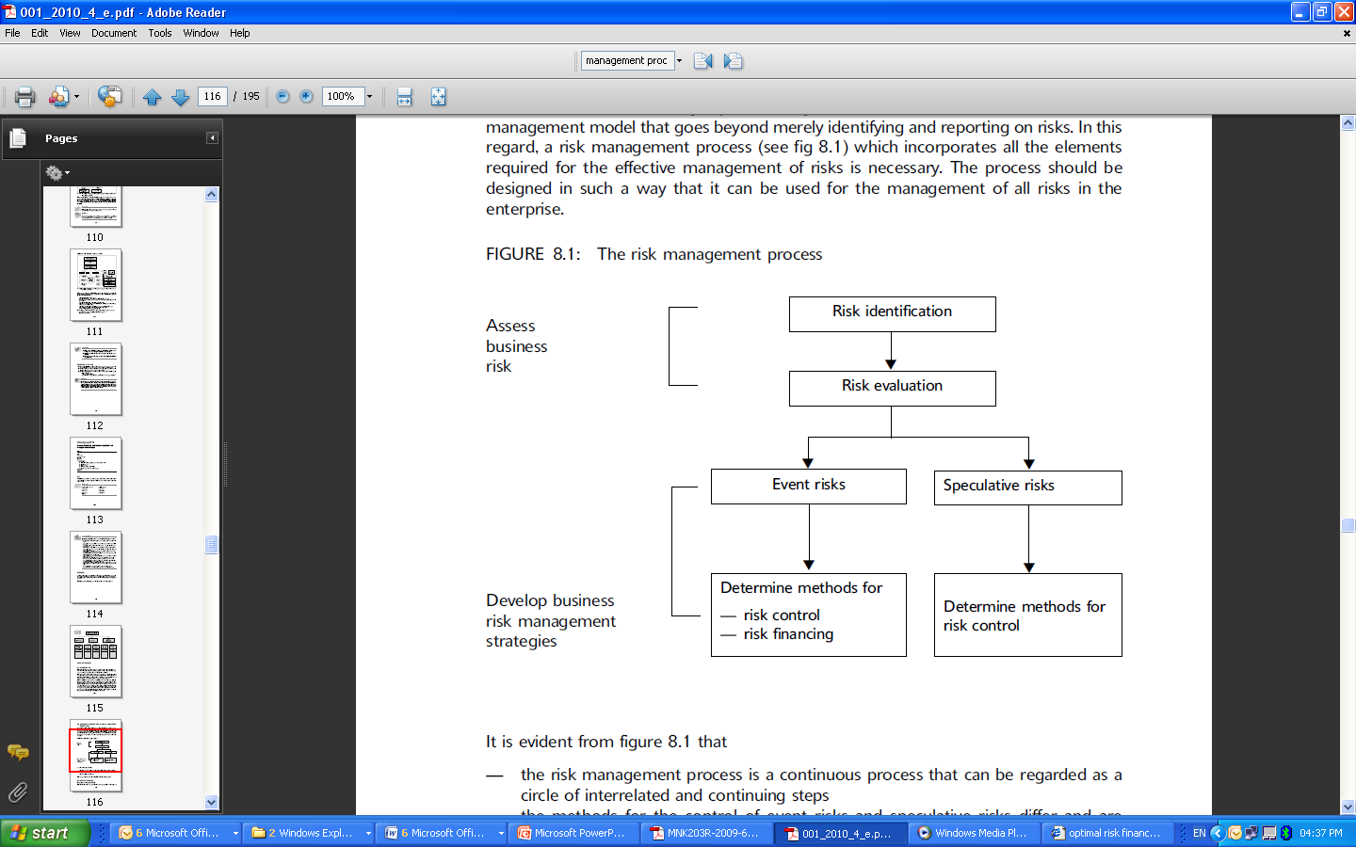
The risk management process is a continuous process that can be regarded as a circle of interrelated and continuing steps
The methods for the control of event risks and speculative risks differ and are therefore considered separately

QUESTION 3
Not sure myself but I think it is to do with section 8.4.1.loss size; therefore

Maximum possible loss (MPL)
Maximum cost of a loss that could result from a single event under unfavourable conditions. Unfavorable conditions imply that risk control measures did not operate as planned and that the loss was therefore not controlled. - Total replacement cost

Normal loss expectancy (NLE)
NLE is the maximum loss that could result from a single event given that all risk control measures operate as expected

``As if'' analysis
Past claims history of an organization

Accumulation
Accumulation is the term used to describe the extent to which various risks could accumulate into a large loss as the result of the operation of a single event.

Asset value
The question to be answered is whether the value of the asset is equal to
- the depreciated value as reflected in the company's books
- the cost of replacing the asset with a similar or new asset if it is destroyed (This second argument may be more correct if one considers that the asset may be vital to production operations and that the depreciated book value has no significance relative to production.)
- the value to production and its contribution to revenue
- the amount for which the asset can be sold

Business interruption
Loss of revenue while plant was closed etc

