MNG302B – Exam Prep
Section A Questions – Compulsory
**Explain why corporate governance is important in strategy implementation (5)
- It is the responsibility of the board of directors of an organisation to define the purpose of the organisation and identify the stakeholders relevant to the business of the organisation.
- The board has to formulate a strategy based on these factors.
- The King Report states that it is the board of director’s responsibility to ensure that managers implement the formulated strategy and monitor the implementation.
- Top management must ensure that strategy implementation activities support the drive towards social and environmental responsibility.
- Stakeholder engagement should be encouraged.
- Strategy implementation should take issues as social responsibility, environmental responsibility, stakeholder engagement and sustainability into consideration at all times.

**Describe the major types of executive bonus compensation plans (5)
- Share options
- It link individual rewards to organisational performance.
- Top managers will be motivated to pursue long-term goals in line with stakeholder expectations.
- Executives only receive a bonus if the organisations share price appreciated.
- Restricted share plan
- Uses company’s shares as an incentive for executives.
- Executives are given a certain number of shares but may not sell it for a specified period.
- The rational is to promote longer executive tenure.
- Golden Handcuffs
- Cash bonuses are deferred in a series of annual instalments.
- Should the executive leave the company before a certain time, compensations is forfeited.
- Golden Parachutes
- An executive retains a substantial cash bonus regardless of whether he or she quits, resigns or is fired.
- Executive is rewarded regardless of success or failure.
- Cash bonuses
- Cash bonuses are more widespread in organisations (not only executives)
- Bonuses are calculated using accounting measures such as ROE, EPS and growth rates.

**Discuss the ‘warm square’ in the modified McKinsey 7-S framework (5)/
Discuss the component of the McKinsey 7S framework

- This model links the organisations strategy to the various factors that need to be addressed to ensure successful implementation and consequently strategic success. The 7 –s are:

- The framework distinguishes between a cold triangle and a warm square.
- The warm square are style, skills, staff and shared values
  - It refers to the people in the organisation.
  - Strategy
    - The organisations chosen strategy and the way it intends to achieve its strategic goals and vision.
  - Structure
    - The way in which an organisation is structured.
  - Systems
    - Including systems such as reward systems, strategic control systems and operational control systems.
  - Style
    - the leader and management style of the organisation
  - Staff
    - the people in the organisation
  - Skills
    - the organisations core competencies and source of competitive advantage
  - Shared values
    - the values the organisation believes in
- The cold triangle refers to structure, strategy and systems of the organisation.
- These issues cannot be isolated from one another.

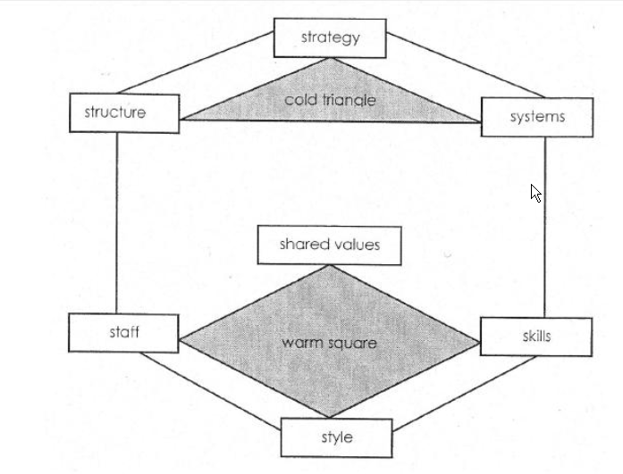

*Explain any five of the strategic change issues (5)

- Time
  - how quickly is change needed
- Scope
  - is dramatic revolutionary change needed or only a moderate change
- Diversity
  - the level of homogeneity in the organisation
- Capacity
  - does have the resources to change
- Readiness
  - employees ready for change
- Capability
  - does employees and managers have the capabilities to implement change

*Provide guidelines for overcoming resistance to change (5)

- Education and communication
  - Help people to understand the need for change.
  - Must be communicated so that it is clearly understood by all.
- Participation and Involvement
  - If people are part of the strategy formulation process, they will be more supportive of changes necessary to implement new strategy.
- Facilitation and support
  - Building support networks helps to overcome resistance to change.
- Negotiation and agreement
  - Linked to incentives and rewards.
- Manipulation and co-optation
  - Influencing people to accept change and "buying-off" people to accept and promote change.
- Giving clear direction
  - May use authority to set direction and impose means to implement change.
- Explicit and implicit coercion
  - this may work in the short-term - unlikely that this will result in long term commitment from employees

*Discuss the five basic parts of the organisation (5)

- Strategic apex
  - The home for top management and strategic leadership in an organisation.
- Middle line
  - Includes all the managers in direct line relationships between strategic apex and the operating core.
- Operating core
  - Occurs where the actual operating tasks for an organisation are performed to produce the product/service.
- Techno-structure
  - Includes all staff analyses who design the systems by which work processes are formally designed.
- Support staff
  - Includes the support for the organisation outside its operating workflow, corporate communications, legal, etc.

**Discuss the instruments in strategy implementation (5)

- Short term objectives
- Short term objectives must be suitable, achievable, acceptable, motivating, flexible and understandable.
- Each goal must indicate clearly who is responsible and the focus area, action require, how it will be measured and the time frame.
- It should be consistent across functional areas.
- Functional tactics
- Are the key activities that have to be performed in each functional are to provide the organisations products and services.
- It translates the organisations grand strategy into action to ensure that the short term goals are attained.
- It typically includes marketing, finance, operations and human resource management.
- Policies
- It entails specific guidelines, methods, procedures, rules and administrative practices that direct thinking, decisions and actions of managers and employees in strategy implementation.
- Policies create empowerment.
- It provides a basis for control and promotes coordination and consistency across organisational units.

Comment on the importance of strategic implementation as a component of the strategic management process (5)

- Strategy implementation is an essential part (the most important part) of strategic management process.
- Is the process that turns strategic plans into a series of actions tasks and ensures that these tasks are executed in such a way that the objectives of the strategic plan are achieved?
- It entails the communication, interpretation, adoption and enactment of strategic plans.
- It is the phase in which management aligns strategic leadership, organisational culture, organisational structures, reward systems, policies and resource allocation with the chosen strategy.
- It involves taking management form thinking to actually doing.
- It is also an important source of competitive advantage.

*Discuss the barriers to successful strategic implementation (5)

- Vision Barrier
  - Failure to communicate the vision and strategy may confuse the work force.
  - If lower levels of management and the work force do not know or understand the organisations vision and strategy, they won’t understand their role in the implementation process.
- Management Barrier
  - Too often executives are focused on solving short term problems and not enough time is spent on strategic management.
  - Some executives that were promoted from the functional areas and tent to remain involved in functional issues.
- Resource Barrier
  - Resource allocation plans or budgets are not linked to the chosen strategies.
  - Resources are not allocated in support of the strategy.
- People Barrier
  - About 75% of managers do not have rewards and incentives inked to strategies.
  - Key responsibilities of employees are not clearly defined.

***Discuss the different types of strategic control and indicate how strategic control can alter an organisations chosen strategy (5)
- Premise control
- Check whether the assumptions on which the choice of a strategy was based are still valid.
- Usually deals with the macro environment as well as the industry.
- Strategic surveillance
- The organisation identified both external and internal events that may affect the course of it strategy. The sources could include conferences and conversations.
- Special alert control
- The rapid reconsideration of an organisations strategy in the light of a sudden event.
- Like the terrorist attack on the world trade centre on 11 September 2001.
- It support s strategic surveillance and premise control.
- Implementation control
- Assesses whether the overall strategy could be changed in the light of the results of the incremental actions taken to implement it.
- It provides management with information regarding the success of the implementation.

Diagrammatically depict the operational control process (5)
Set standards of performance
Initiate corrective action
Identify deviations from the standards set.
Measure actual performance

*Explain what strategic implementation entails (5)
- Strategic implementation can be defined as the process that turns strategic plans into a series of action tasks, and ensures that these tasks are executed so that objectives of the strategic plan are achieved.
- It entails:
  - The communication, interpretation, adoption and enactment of strategic plans.
  - Management aligning or matching strategic leadership, organizational culture, organizational structures, reward systems, policies and resource allocation with the chosen strategy or strategies.
  - involves taking management from thinking to actually doing and;
  - Involves management developing short term objectives and policies.

Indicate the difference between management and leadership (5)

LEADERSHIP | MANAGEMENT
Coping with change | Coping with complexity
Concerned with guiding, encouraging and facilitating others in pursuit of ends by the use of means, both of which they have either selected or approved. | Concerned with directing others in the pursuit of ends and by the use of means, both of which have been selected by the manager
Tend to be more visionary, experimental, flexible and creative | Tend to be more analytical, structured and controlled
Value the intuitive side of their work | Value the quantitative science part of their work
Focus on the bigger picture | Focus on the details
Inspire and apply influence | Instruct and apply authority

Briefly explain Hofstede’s five value dimensions (5)
- Power distance
- The extent to which people accept that power is distributed unequally.
- Uncertainty avoidance
- The extent to which people feel uncomfortable with uncertainty and ambiguity.
- Masculinity / femininity
- The extent to which gender roles are clearly distinct
- Individualism / collectivism
- The extent to which there is a preference for belonging to a tightly knit collective rather than a more loosely knit society.
- Confusion dynamism
- The extent to which long-termism or short-termism tends to predominate.

*Discuss the drivers of strategic implementation (5)
- Leadership
  - This is vital in strategy implementation as it is only through effective leadership that organisations are able to use strategic management successfully.
- Organisational culture
  - Is a set of important beliefs, behavioural norms and values that the members of an organisation share. It refers to the way we do things around here.
- Reward system
  - Required to motivate managers and employees to ensure commitment to the implementation of new strategies.
- Organisational structure
  - Refers to the framework within which the strategic process must operate to achieve the organisations goals. Identify the tasks necessary for strategy implementation and how is responsible for the tasks.
- Resource Allocation
  - is essential that resources be allocated in such a way that they supports the organisations long-term goals, chosen strategy, structure and short term goals.

Explain how functional tactics differ from corporate and business strategies (5)

Differences | Functional tactics | Business strategy
Time horizon | Identify tasks and activities that must be done in the near future | Grand strategies focus on the organisations position in the next few years
Specificity | Identify the specific activities that needs to be performed | Provides general direction
Developers | Developed within the operational areas of the organisation | Developed at top management level

Expound on the importance of having sound policies in place in strategic implementation (5)/
Defend the use of policies in the strategy implementation process

- Policies guide the thinking, decisions and actions of managers and employees in the strategy implementation process.
- Policies inform employees about what is expected of them
- Clarify what can and cannot be done in the pursuit of the short term goals
- Standardise routine decisions, thus reducing the time to make decisions
- Provide a basis for control and promote coordination and consistency across organisational units.

Section B – Answer any two questions

Discuss the drivers of strategic implementation by referring to the following criteria
*B1.1 – Differentiate between visionary and managerial leaders by identifying four key characteristics of each (HINT use table) (8)

VISIONARY LEADERS | MANAGERIAL LEADERS
· Are proactive, shape ideas, change the way people think about what is desirable, possible and necessary | · Are reactive, adopt passive attitudes towards goals. Their goals arise out of necessity and not out of desires and dreams, and are often are based on the past
· Work to develop choice and fresh approaches to long-standing problems and work from high-risk positions | · View work as an enabling process involving some combination of ideas and people interacting to establish strategies.
· Are concerned with ideas, relate to people in intuitive and empathetic ways | · Relate to people according to their roles in the decision-making process
· Feel separate from their environment; they work in, but do not belong to, organizations; in other words their sense of who they are does not depend on their work | · See themselves as conservators and regulators of the existing order. Their sense of who they are depends on their role in the organization.
· Influence the attitudes and opinions of others in the organization | · Influence the actions and decisions of those with whom they work
· Are concerned with ensuring the future of the organization, especially through development and management of people | · Are involved in situations and contexts characteristic of day-to-day activities

*B1.2 – Explain the different aspects and levels of organisational culture (as identified by Thompson & Martin 2005) (12)
The aspects and levels of culture can be grouped into manifestations, people and power.

MANIFESTATION | PEOPLE | POWER
Artefacts and symbols | Stories from the past | Ownership and structure
Values | Leadership and management styles | Personal power
Underlying assumptions | Communication | Politics
Behaviours

**B1.3 – Provide guidelines for structuring effective reward systems (5) /Name guidelines to aligning the reward system with the chosen strategy (7) or Match an organisations compensation plan to its chosen strategy (4)

- Start-up phase
- Organisations that pursue growth strategies should incorporate large salaries and equity into their reward systems.
- Rapid growth phase
- Reward systems should include a salary plus large bonuses for growth targets, plus equity for key people.
- Maturity phase
- Link reward systems to efficiency and profit-margin performance.
- Decline phase
- Reward systems should be linked to cost savings.

B2.1 – Comment on the statement that “structure follows strategy” (5)
- There should be a tight fit between strategy and structure to ensure successful strategy implementation.
- Before implementing the chosen strategy, it is important to determine whether the organisations current structure facilitates the implementation of its strategy.
- Structure should not be a determinant of strategy, thus structure follows strategy.

B2.2 – Explain how organisational structures evolve over time (3)
- Organisational growth tends to follow predictable patterns.
- These patterns are related to volume, geography, integration (vertical/horizontal) and diversification (product/business).
- Change from simple to complex.

B2.3 – Discuss the five basic parts of an organisation (5)

- Strategic apex
  - The home for top management and strategic leadership in an organisation.
- Middle line
  - Includes all the managers in direct line relationships between strategic apex and the operating core.
- Operating core
  - Occurs where the actual operating tasks for an organisation are performed to produce the product/service.
- Techno-structure
  - Includes all staff analyses who design the systems by which work processes are formally designed.
- Support staff
  - Includes the support for the organisation outside its operating workflow, corporate communications, legal, etc.

*B2.4 – Discuss the six basic coordination mechanisms used by organisations to coordinate activities (12)

- Mutual adjustment
  - The informal communication used to coordinate mechanisms.
- Direct supervision
  - This is where one person is responsible for coordinating the work of others and gives orders and instructions.
- Standardisation of work processes
  - Refer to the specifications how the work should be carried out.
- Standardisation of skills and knowledge
  - This is also a co-ordination but less formal. Employees know each other responsibilities.
- Standardisation of outputs
  - This focus on the results that must be achieved.
- Standardisation of norms
  - refer to the organisations culture, shared beliefs and values of the employees

B3.1 – Explain how functional tactics differ from corporate or business strategy (6)

Differences | Functional tactics | Business strategy
Time horizon | Identify tasks and activities that must be done in the near future | Grand strategies focus on the organisations position in the next few years
Specificity | Identify the specific activities that needs to be performed | Provides general direction
Developers | Developed within the operational areas of the organisation | Developed at top management level

**B3.2 – Explain the role of policies in strategy implementation (4)
- The strategy implementation instruments are Short term objectives, functional tactics and policies.
- Short term objectives
- Short term objectives must be suitable, achievable, acceptable, motivating, flexible and understandable.
- Each goal must indicate clearly who is responsible and the focus area, action require, how it will be measured and the time frame.
- It should be consistent across functional areas.
- Functional tactics
- Are the key activities that have to be performed in each functional are to provide the organisations products and services.
- It translates the organisations grand strategy into action to ensure that the short term goals are attained.
- It typically includes marketing, finance, operations and human resource management.
- Policies
- It entails specific guidelines, methods, procedures, rules and administrative practices that direct thinking, decisions and actions of managers and employees in strategy implementation.
- Policies create empowerment.
- It provides a basis for control and promote coordination and consistency across organisational units.

B3.3 – Discuss the four “levers” that are considered when designing strategic control systems (8)
- The 4 levers of control that should be taken into consideration in designing strategic control systems are

- Diagnostic control systems
- These systems are used to track the performance of departments, managers and employees, to monitor goals and to measure progress towards profitability and revenue growth targets.
- Belief systems
- These systems relate to the organisations values and organisational culture and provide guidelines for implementing decisions.
- Boundary systems
- These systems supplement diagnostic control systems and belief systems.
- Diagnostic and Belief systems tell the managers and employees what should be done and what behaviour is accepted, boundary system provide information on what should not be done and what falls outside the scope.
- Interactive control systems
- Provides the managers with a sense of what is happening in different areas of the organisation.

**B3.4 – Discuss the balance scorecard as a strategy implementation and control system (7)
- The balanced scorecard sets objectives, measures, targets and initiatives for four organisational areas based on the vision or strategy.
- The 4 processes of the balance scorecard that forms a framework for strategic control are:
- Translating the vision
- Ensures that the vision is translated into goals and measures linked to the strategy.
- Communicating and linking
- Ensures that the long term strategy is clearly understood by the entire organisation through communicating and linking.
- Business Planning
- Forces organisations to link their business plans to the strategy through the setting of targets or milestones.
- Through this process organisations integrate their strategic planning and budgeting processes.
- Feedback an learning
- Provides organisations with the capacity of strategic learning.
- Strategic learning consists of gathering feedback, testing the assumptions on which the strategy is based and making the necessary adjustments.

*B1.1 – Differentiate between strategic planning and strategic implementation (8)
 | Strategic Planning | Strategy implementation
1 | Is the intellectual or thinking phase | The thinking phase in which these thoughts are operationalised and turned into action.
2 | Is mostly a market driven activity with an external focus | Is an internal, operational driven activity.
3 | Requires good intuitive and analytical skills | Requires strong motivation and leadership skills.
4 | Well structured, rational and controlled | Not so well structured, rational and controlled.
5 | Takes place at top management and senior management | The responsibility of all levels of management and the entire work force is involved.
6 | Focus on effectiveness | Focus on efficiency
7 | Positioning forces before the action | Managing forces during the action
8 | Requires co-ordination among a few individuals | Requires co-ordination among many individuals

B2.1 – Explain why different strategies require different leadership styles (5)
- Strategic implementation is essential about creating a tight fit between strategy and leadership, strategy with culture, strategy with reward systems, strategy with organisational structure and strategy with short-term objectives.
- A change in strategy will therefore require a change in any of these drivers and instruments of strategy implementation to ensure that the strategy remains aligned with the tasks that need to be performed to ensure sound implementation.
- Below are the matching leadership styles with the chosen strategy.
- Growth strategy, leaders pay attention to managing relationships, inspiring people and communicate the goals and strategies to the people.
- Corporate Combination strategy, require leaders who can integrate different cultures and values systems.
- Decline strategy, leaders who are tasks orientated and who can focus on reducing assets and costs.
- Start-up phase, needs a risk taker
- Rapid growth phase, needs a caretaker
- Mature phase, needs a surgeon
- Death or decline phase, requires an undertaker
B2.2 – Differentiate between adaptive, weak, strong and unhealthy cultures (8)
- Strong culture
- Values, norms and beliefs are deeply ingrained and difficult to eliminate.
- It is a valuable asset if a tight fit exits between the chosen strategy and strong culture.
- Weak culture
- Is a fragmented and there are very few traditions, values and beliefs that are shared.
- Adaptive culture
- Members share a feeling of confidence that the organisation can neutralized the threats and exploit opportunities that cross its path.
- Unhealthy culture
- It has a politicised internal environmental where influential managers operate in autonomous kingdoms.

B3.3 – Comment on the criteria used to evaluate strategies during the strategic control phase
- Criteria for effective strategies include appropriateness, feasibility and desirability. Including the questions for strategy evaluation.
- Appropriateness strategic criterion questions
- Is the strategy in line with the mission?
- Is the strategy still appropriate taking the changes in external environment is consideration?
- Is strategy still acceptable for all stakeholders?
- Feasibility
- Can it be carried out?
- Still feasible in terms of resources?
- Desirability
- Have stakeholders preferences changed?
- Has the strategy produces adequate results in the short term?

B1.1 – Explain the different types of strategic change (4)
- Adaptation
  - Change that must happen in order to achieve desired goals.
  - Only adapt to new situation, organisation can handle it.
- Reconstruction
  - Organisation can handle a sudden alteration in the market conditions.
  - It may be that only reconstruct processes and policies are needed to implement the new strategy.
- Evolution
  - Fundamental changes over time.
  - Organisation must become a learning organisation to manage this change.
- Revolution
  - Fundamental changes as a result of sudden and fast-changing conditions.
  - May be a treat for takeover, in which case the organisation has to implement a new strategy very fast.

B1.2 – Briefly comment on the strategic change process
- Identify the areas of change
- Manage resistance to change
- Using Power and influence to persuade member of the organisation to support the changes.
- How to become a learning organisation.
Strategic Change

Analysing the causes of change

Strategic Change Process

Become a Learning organisation
Use organisational persuasion
Identify barriers to change
Identify areas of change
*B2.1 – Expound on the role that structures play in the implementing the chosen strategy (4)

- To provide a formal allocation of work rules
- Serves as channels for collaborative working
- Set boundaries of authority and lines of communication
- It’s a means of allocating power and responsibility
- Prescriptive levels of formality and complexity.
- Organisational design can be a source of competitive advantage if it ensures that organisational structures are
- Aligned with the chosen strategy
- Functional
- Difficult to copy
- Make it easy for customers to do business with the organisation.

*B2.4 – Describe any five types of organisational structures (10)
- Entrepreneurial structures
- A simple structure typically consisting of the owner-manager and the employees
- Functional structures
- Consist of a CEO supported by a limited number of corporate staff such as legal advisors, accountants and functional managers.
- Divisional structures
- Activities and responsibilities are organized into a series of divisions, each with its general manager and functional areas.
- Strategic business units (SBU)
- It is similar to the divisional structure.
- Matrix structures
- Dual lines of authority.
- Network structure
- Are loosely grouped business teams that come together or a single project.
- Structures of the future
- Are based on networks of temporary external and internal relationships, linked primarily by information technology in order to share skills, costs and access to markets.

*B3.1 – Explain the role of resource allocation in the strategic implementation with specific to human resources (8)

- To achieve successful strategy implementation, the scare resources must be allocated in such a way that they support the organisations
- Long term goals
- Chosen strategy
- Structure and
- Short term objectives.
- The role of Human resources in organisations and strategy implementation is becoming increasingly important as the world moves from the information technology era to a knowledge-based society and economy.
- Human resources are the heart of strategy and it is important that people are allocated to the most important task in implementing the strategy.
- Organisations can no longer generate profits without the ideas, skills and talent of knowledge workers.
- Technologies, natural resources and capital are no longer difficult to obtain and are less important in developing and sustaining competitive advantage.
- The opposite may be said to talent and skills of people and that may be one of the reasons for the rise in CEO and executive compensation.

B3.2 – Identify the different types of resources in an organisation (3)

- Tangible resources are often described as the resources that can be touch, feel or see.
- Examples include property, land, buildings, equipment and shares (balance sheet items).
- Intangible resources cannot be seen or touched.
- It forms the core of an organisations competitive advantage. It’s classified into
- human capital, (employees skills, talent and knowledge)
- information capital (technology infrastructure, databases)
- Organisation capital. (culture, leadership, teamwork)

B3.3 – Discuss the role of the master budget and strategic funds in the strategy implementation (6)

- The master budget of an organisation includes the monitoring of activities that is important for the survival of the organisation.
- Activities such as sales, manufacturing, administrative activities investment and cash management.
- Projected sale are the foundation of budgeting.
- Forecasting sales is critical because all other budgeted activities depend on these forecasts.
- Strategic funds are expense items required for implementation of strategic actions, expected to benefit the organisation in the long term.
- The 3 main components of strategic funds are investment in tangible assets, development expenses such as advertising increase or decrease in working capital.

B1.1 – Discuss the key responsibilities of a strategic leader (6)

- Develop appropriate strategic direction
- Communication of vision and strategic direction
- Motivate employees to achieve strategic objectives
- Design appropriate reward systems and organisation structure
- The development of strategic and operational control systems
- Develop and maintain effective organisational culture
- Ensure good corporate governance and management

B1.4 – Discuss the different types of organisational culture as identified by Charles Handy (6)

- Power culture
- It can be compared to a spider (power and influence source) and a web (functional area).
- It depends on trust and empathy for effectiveness and personal communication
- It is strong and has the ability to move quickly.
- Role culture
- Is often stereotyped as bureaucracy where logic, rules and procedures dominate.
- The role or job description is considered more important than the person who fills it.
- It offers individual security.
- Task culture
- Is project-oriented and this type of culture is often found in organisations with matrix structures.
- It seeks to bring together the right people, functional expertise and resources.
- Person culture
- Have the individual as the central point and the organisation only exists to serve the individual within it.
- This type of culture is formed when a group of people band together, like sharing space, services and equipment.

B1.5 – Explain how the strategy culture relationship can be managed (6)

B3.1 – Distinguish between the different levels of objectives (3)
- The three levels of objectives are:
  - Strategic
  - Operational
  - Functional
- You will have to discuss each of these in terms of the parties involved, time-frame, level of detail etc

***B1.3 - Discuss the strategy implementation challenges and problems (barriers) that organizations face in the contemporary business environment (15)

- The challenges are as follows: (7)
- Lack of resources
- Poor leadership
- The strategy is poorly communicated
- As the strategy is cascaded down the organisation, critical issues become lost in translation
- Actions required for implementation are not clearly defined
- Organisational culture is not aligned to the strategy
- Reward and incentive systems are not aligned to strategic goals.
- Too much emphasis is place on strategic planning and too little time is allocated for strategic implementation.

- The problems (barriers) of successful strategic implementation are: (8)
- Vision Barrier
  - Failure to communicate the vision and strategy may confuse the work force.
  - If lower levels of management and the work force do not know or understand the organisations vision and strategy, they won’t understand their role in the implementation process.
- Management Barrier
  - Too often executives are focused on solving short term problems and not enough time is spent on strategic management.
  - Some executives that were promoted from the functional areas and tent to remain involved in functional issues.
- Resource Barrier
  - Resource allocation plans or budgets are not linked to the chosen strategies.
  - Resources are not allocated in support of the strategy.
- People Barrier
  - About 75% of managers do not have rewards and incentives inked to strategies.
  - Key responsibilities of employees are not clearly defined.

B2.5 - Describe any four monetary reward systems that can be used as drivers in the strategic implementation process (8)
 | Monetary | Non-monetary
1 | Salary increases  Profit sharing  Share options  Cash bonuses  Retirement packages | Status  Recognition awards  Job security  Promotion  Perks

B3.1 – Use a diagram to indicate the position of strategic control in the strategic management process (12)

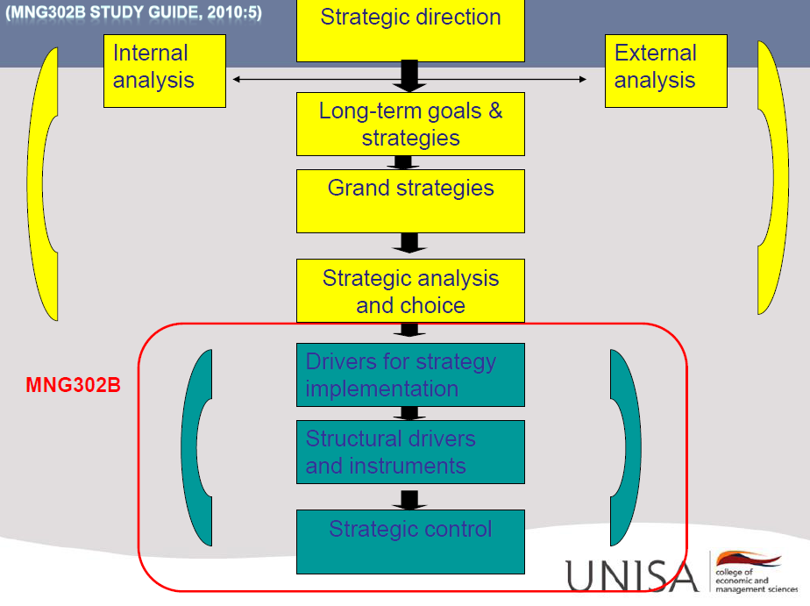

B3.3 – Explain how continuous improvement builds customer value and comment on the approaches to sustain competitive advantage through continuous improvement (5)

- Benchmarking
- The comparison of selected performance measures or operational processes that serve as challenging, yet comparable, yardsticks.
- These include the organisations own history, major competitors or best in class/world performance.
- Total quality management
- A Culture, inherent in which is a total commitment to quality and attitude expressed by everybody’s involvement in the process of continuous improvement of products and services by using innovative scientific methods.
- Re-engineering
- An organisation is reorganized in a way that creates value for customers by eliminating barriers that create distance between employees and customers.
- As such cost are lowered and service to customers improved.
- Six sigma approach
- A methodology linking improvement to profitability.
- Highly rigorous and analytic approach to quality and continuous improvement with the objective of improving profits through defect reduction, yield improvement, improved customer satisfaction and best in class performance.

B3.1 – Provide guidelines for matching structures with strategies (4)
- There is no one size fit all structure that all organisations can use, but below is several guidelines for matching strategy with structure.
- Functional structure :Single-product or dominant product organisations
- Divisional structure: Organisations with several business lines
- Strategic business units: Large, diverse organisations with unrelated business divisions
- Matrix structure: Product development and innovation oriented organisations.

*** Chandler found that a particular structure sequence is often repeated as organisations grow and change their strategy over time.
