Topic 1:

- Explain what strategic implementation entails (5)

- Strategic implementation is the process that turns strategic plans into a series of actions tasks and ensures that these tasks are executed in such a way that the objectives of the strategic plan are achieved.
- It entails the communication, interpretation, adoption and enactment of strategic plans.
- It is the phase in which management aligns strategic leadership, organisational culture, organisational structures, reward systems, policies and resource allocation with the chosen strategy.
- It involves taking management form thinking to actually doing.
- It involves management developing short term objective and policies.
- It is the most important phase in the strategic management process.

- Differentiate between strategic planning and strategy implementation (8)
 | Strategic Planning | Strategy implementation
1 | Is the intellectual or thinking phase | The thinking phase in which these thoughts are operationalised and turned into action.
2 | Is mostly a market driven activity with an external focus | Is an internal, operational driven activity.
3 | Requires good intuitive and analytical skills | Requires strong motivation and leadership skills.
4 | Well structured, rational and controlled | Not so well structured, rational and controlled.
5 | Takes place at top management and senior management | The responsibility of all levels of management and the entire work force is involved.
6 | Focus on effectiveness | Focus on efficiency
7 | Positioning forces before the action | Managing forces during the action
8 | Requires co-ordination among a few individuals | Requires co-ordination among many individuals

- Discuss the strategy implementation challenges and problems (barriers) that organizations face in the contemporary business environment (15)
- The challenges are as follows: (7)
- Lack of resources
- Poor leadership
- The strategy is poorly communicated
- As the strategy is cascaded down the organisation, critical issues become lost in translation
- Actions required for implementation are not clearly defined
- Organisational culture is not aligned to the strategy
- Reward and incentive systems are not aligned to strategic goals.
- Too much emphasis is place on strategic planning and too little time is allocated for strategic implementation.
- The problems (barriers) of successful strategic implementation are: (8)
- Vision Barrier
  - Failure to communicate the vision and strategy may confuse the work force.
  - If lower levels of management and the work force do not know or understand the organisations vision and strategy, they won’t understand their role in the implementation process.
- Management Barrier
  - Too often executives are focused on solving short term problems and not enough time is spent on strategic management.
  - Some executives that were promoted from the functional areas and tent to remain involved in functional issues.
- Resource Barrier
  - Resource allocation plans or budgets are not linked to the chosen strategies.
  - Resources are not allocated in support of the strategy.
- People Barrier
  - About 75% of managers do not have rewards and incentives inked to strategies.
  - Key responsibilities of employees are not clearly defined.

- Explain the different types of strategic change and the issues involved (10)
- Strategic change are:
- All the efforts and actions that are taking place to move an organisation from it present state toward the desired future state to increase its competitive position and its profitability.
- It is the implementation of a new strategy
- It is the proactive change that must happen in organisations to achieve the strategic objectives.
- The 4 different types of strategic change are:
- Adaptation
  - Change that must happen in order to achieve desired goals.
  - Only adapt to new situation, organisation can handle it.
- Reconstruction
  - Organisation can handle a sudden alteration in the market conditions.
  - It may be that only reconstruct processes and policies are needed to implement the new strategy.
- Evolution
  - Fundamental changes over time.
  - Organisation must become a learning organisation to manage this change.
- Revolution
  - Fundamental changes as a result of sudden and fast-changing conditions.
  - May be a treat for takeover, in which case the organisation has to implement a new strategy very fast.

- The strategic issues to consider during change are:
- Time, how quickly is change needed
- Scope, is dramatic revolutionary change needed or moderate change?
- Diversity, what is the level of homogeneity in the organisation?
- Capacity, does the organisation have the capacity in terms often resources needed to change?
- Readiness, are employees ready to change? Refer to the level of resistance to change
- Capability; does the organisations employees and managers have the capabilities to implement the change?

- Name the main causes/triggers/forces of strategic change?
- Environment changes, like macro and market environment changes. Also main reason for strategic changes.
- Regulation events, it’s outside the control of organisations but they have to respond.
- Business relationship changes may require change in organisational structure.
- Technology improvement can have a big impact on the survival of the organisation.
- Strategic awareness and skills of managers and employees, promotion expectations requires strategic development and growth in the organisation.

- Explain the Strategic Change process?
- Identify the areas of change
- Manage resistance to change
- Using Power and influence to persuade member of the organisation to support the changes.
- How to become a learning organisation.
Strategic Change

Analysing the causes of change

Strategic Change Process

Become a Learning organisation
Use organisational persuasion
Identify barriers to change
Identify areas of change

- Name the broad areas (4) of change needed as a result of a new strategy?
- New Technology and Operational, may be needed in a new product/service delivery
- Administrative changes , like new structures, policies, budgets and reward system
- People must match individual and corporate value.

- Name ways how to overcome/manage resistance of change? (7) (Key obstacle to successful strategic implementation)
- Participation and involvement _If people are part of strategy formulation they will be supportive of the strategic changes.
- Education and communication _Helps people to understand why change is necessary
- Facilitation and support _Involves giving support for change.
- Manipulation and cooptation _manipulating people to accept the necessity for change
- Explicit and implicit coercion _Coercion is not a positive way to mange resistance of change. Might work short term but not long term.
- Negotiation and agreement _ normally linked to incentives and rewards.
- Giving clear direction _Authority may be use to set the direction to implement change

- Name important elements of Power and influence?
- Managers must have power to implement the decisions that will bring about change
- Influence people to change

- Name 2 ways management can exercise control over behavior of people? **
- They can structure the situation in such a way that the employees will comply with their wishes.
- The can communicate with the employees to that they can see things differently and decide to do what their managers suggest.

- Name the important characteristics of a Learning organisation? **
- Learning must be seen as a continues process
- The employees word and learn as a team
- Management development and personal growth are important
- Visions of the future must be shared
- Employees skills must be the most important asset of the organisation
- A system approach must be applied when analyzing and viewing the business environment

- Comment on the strategic change process? (12)
- It involves clarity on what changes are necessary.
- Involves the understanding and managing of the resistance to change
- The process needs to identify the areas that need to change (Question 7 answer)
- It needs to identify how to manage resistance for change (Question 8 answer)
- Need to identify how to use power and influence to persuade people to support change. (Question 10 answer to explain)
- Need to identify how to become a learning organisation (Question 11 answer)

- Comment on the importance of strategy implementation as a component of the strategic management process (5) (the same as entails).
- Strategy implementation is an essential part (the most important part) of strategic management process.
- Is the process that turns strategic plans into a series of actions tasks and ensures that these tasks are executed in such a way that the objectives of the strategic plan are achieved.
- It entails the communication, interpretation, adoption and enactment of strategic plans.
- It is the phase in which management aligns strategic leadership, organisational culture, organisational structures, reward systems, policies and resource allocation with the chosen strategy.
- It involves taking management form thinking to actually doing.
- It is also an important source of competitive advantage.

- Draw a diagram depicting the strategic management process. Show which of these components forms part of the strategic implementation and control process (12)?

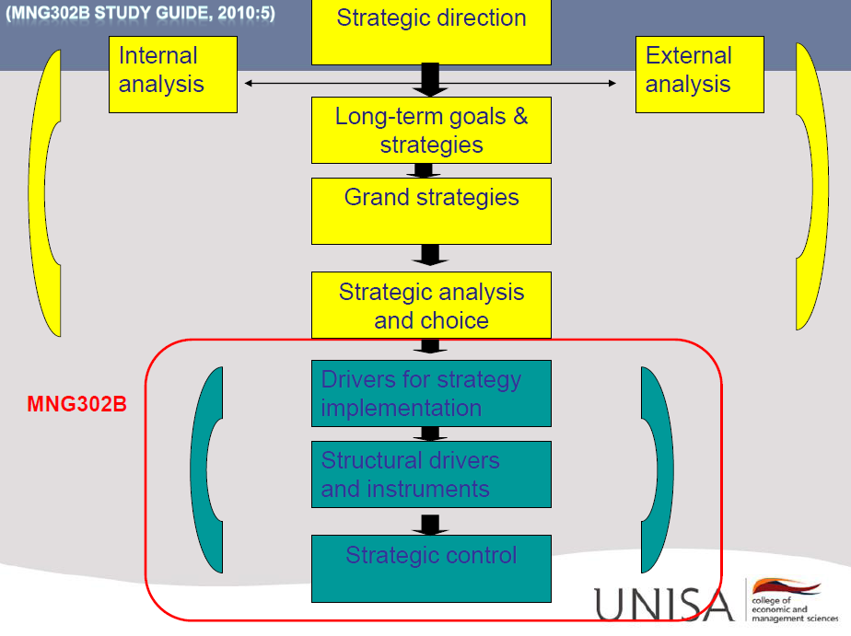

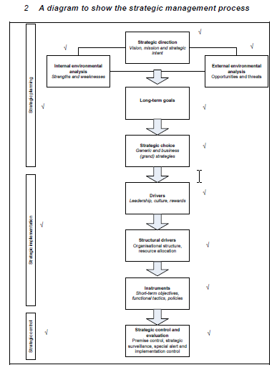

- Explain the Strategy Management Process? (12)
- The strategic management process is divided into 3 stages, namely 1st Strategic planning, 2nd strategic implementation and 3rd strategic control.
- Strategic planning is also refers to as strategy formulation.
- Strategic direction can be set with the Vision statement, mission statement or strategic intent.
- It is the thinking phase and requires good analytical skills.
- It is a market-driven activity with an external focus.
- Takes place at top management.
- Strategy implementation is an internal, operations-driven activity.
- Requires strong motivation and leadership skills.
- The responsibility of all levels of management and the entire workforce.
- Strategies are implemented through different drivers.
- The last stage of Strategic Management process is Strategic control.
- This is the checking stage.
- It provides feedback on the planning and implementation stages of the strategic management process.
- This stage management would evaluate the success or failure of the chosen strategies.
- The 2 main objectives of strategic control is to evaluate the content of the strategy and to monitor the strategy implementation activities.

- Comment on the importance of corporate governance in strategy implementation (5)
- It is the responsibility of the board of directors of an organisation to define the purpose of the organisation and identify the stakeholders relevant to the business of the organisation.
- The board has to formulate a strategy based on these factors.
- The King Report states that it is the board of directors responsibility to ensure that managers implements the formulated strategy and monitor the implementation.
- Top management must ensure that strategy implementation activities support the drive towards social and environmental responsibility.
- Stakeholder engagement should be encouraged.
- Strategy implementation should take issues as social responsibility, environmental responsibility, stakeholder engagement and sustainability into consideration at all times.

- Name 2 approaches organisations can follow to ensure strategy implementation is successful?
- The Mckinsey 7-s framework
- The drivers and instruments of strategy implementation.

- Discuss the components of the modified McKinsey 7-S framework (10)
- This model links the organisations strategy to the various factors that need to be addressed to ensure successful implementation and consequently strategic success. The 7 –s are:
- Strategy - The organisations chosen strategy and the way it intends to achieve its strategic goals and vision.
- Structure – The way in which an organisation is structured.
- Systems – including systems such as reward systems, strategic control systems and operational control systems.
- Style – the leader and management style of the oerganisation
- Staff – the people in the organisation
- Skills – the organisations core competencies and source of competitive advantage
- Shared values – the values the organisation believes in
- The framework distinguishes between a cold triangle and a warm square.
- The warm square are style, skills, staff and shared values. It refers to the people in the organisation.
- The cold triangle refers to structure, strategy and systems of the organisation.
- These issues cannot be isolated from one another.

- Diagrammatically depict the components of the modified McKinsey 7-Ss framework?

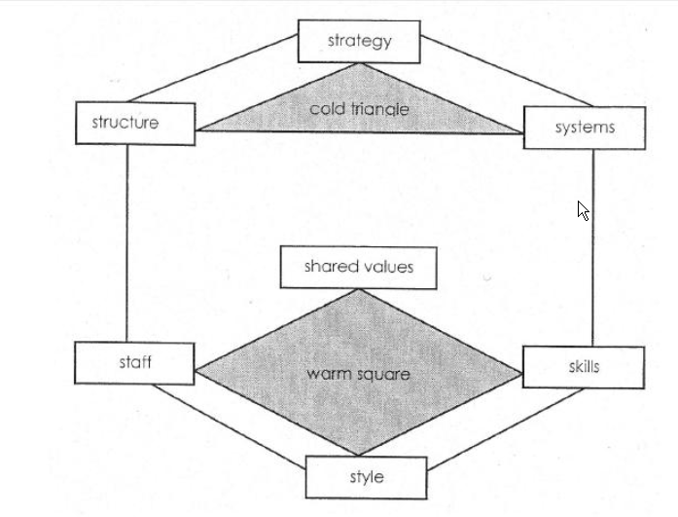

- Name the strategic implementation DRIVERS? **
- Leadership
- Organisational culture
- Reward system
- Organisational structure (design)
- Resource allocation
- The 1st 3 drivers are contemporary organisational as it concern the people of the organisation
- The last 2 drivers are structural drivers off strategy implementation.

- Name the strategic implementation INSTRUMENTS? **
- Short-term objectives
- Functional tactics
- Policies

Important: For successful strategy implementation, these drivers and instruments must be aligned with the chosen strategy to ensure a tight fit between the strategy that are formulated and those that are implemented.

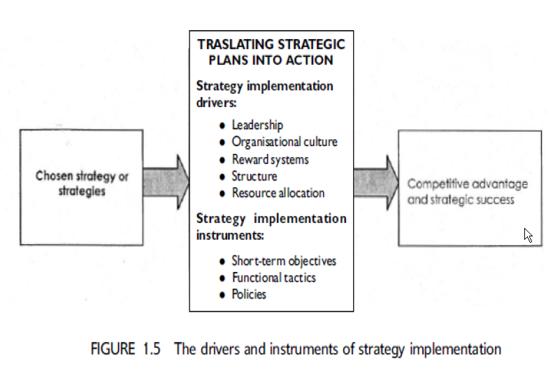

_____________________________________________________________________________

Topic 2:

- Who are the strategic leaders in an organisation? **
- In a company the leaders are top management, namely the CEO, chief financial officer, chief human resources as well as the board of directors.

- What is strategic leadership? **
- The ability to anticipate, envision, maintain flexibility and empower others to create strategic change as necessary.
- To create a vision for the organisation and to motivate others to buy into the vision.
- It involves managing through others and influencing human behaviour in order to achieve goals.
- Name the key components/attributes of EMOTIONAL INTELLIGENCE (10)?
- Self awareness refers to the extent to which an individual is aware of his/her emotions, strengths, weaknesses, needs and drivers.
- Self-regulation refers to the extent that people are in control of their emotions, feelings and impulse.
- Motivation, leaders have a deep desire to achieve for the sake of achievement and not for large salaries or status.
- Empathy, the extent that a leader can thoughtfully consider employees feelings in the process of making decisions.
- Social skills, leading people in a desired direction and being able to build relationships throughout the organisation.
- 1st 3 are self management skills and the last 2 are ability to manage relationships.

- Give reasons why leadership is an important driver for strategic implementation (5)
- Leaders are important because strategies cannot be implemented by itself, someone needs to lead and coordinate this process.
- It is vital in strategy implementation as it is only through effective leadership that organisations are able to use strategic management successfully.
- Develop appropriate strategic direction
- Communication of vision and strategic direction
- Motivate employees to achieve strategic objectives
- Design appropriate reward systems and organisation structure
- The development of strategic and operational control systems
- Develop and maintain effective organisational culture
- Ensure good corporate governance and management
- Distinguish between Leadership and Management (12)

 | Leadership | Management
1 | Is concerned with guiding, encouraging and facilitating others in the pursuit of ends by the use of means, both of which they have either selected or approved. | Is concerned with directing others in the pursuit of ends by the use of means, both of which had been selected by the manager.
2 | Focus on change | Focus on complexity
3 | Experimental, visionary, flexible and creative | Structured, analytical, controlled
4 | Value the intuitive side of their work | Value the quantitative science part of their work
5 | Focus on the bigger picture | Focus on the details
6 | Inspire and apply influence | Instruct and apply authority

- Distinguish between visionary leaders and managerial leaders (10)

 | Visionary Leaders | Managerial Leaders
1 | Are proactive, shape ideas, change the way people think, positive and necessary | Are reactive, adopt passive attitudes towards goals, goals are based on the past
2 | Work to develop choice and fresh approaches to long standing problems | View work as an enabling process involving some combination of ideas and people interacting to establish strategies
3 | Are concerned with ideas, relate of people intuitive and empathetic ways | Relate to people according to their roles in the decision making process
4 | Influence attitudes and opinions of others in organisations | Influence actions and decisions of those with whom they work
5 | Are concerned with ensuring the future of the organisation, especially through developing and management of people | Are involved in situations and contexts characteristic of day-to-day activities
6 | Are more likely to make decisions based on values | Are less likely to make value-based decisions
7 | Know less than their functional experts about functional areas | Are experts in their functional area

- What are the role/responsibilities/tasks of leadership in Strategic implementation?
- Develop appropriate strategic direction
- Communication of vision and strategic direction
- Motivate employees to achieve strategic objectives
- Design appropriate reward systems and organisation structure
- The development of strategic and operational control systems
- Develop and maintain effective organisational culture
- Ensure good corporate governance and management

- Explain why different strategies require different leadership styles (10)
- Strategic implementation is essential about creating a tight fit between strategy and leadership, strategy with culture, strategy with reward systems, strategy with organisational structure and strategy with short-term objectives.
- A change in strategy will therefore require a change in any of these drivers and instruments of strategy implementation to ensure that the strategy remains aligned with the tasks that need to be performed to ensure sound implementation.
- Below are the matching leadership styles with the chosen strategy.
- Growth strategy, leaders pay attention to managing relationships, inspiring people and communicate the goals and strategies to the people.
- Corporate Combination strategy, require leaders who can integrate different cultures and values systems.
- Decline strategy, leaders who are tasks orientated and who can focus on reducing assets and costs.
- Start-up phase, needs a risk taker
- Rapid growth phase, needs a caretaker
- Mature phase, needs a surgeon
- Death or decline phase, requires an undertaker

- What are the 4 dimensions of leadership according to King Report (corporate governance)? **
- Responsibility
- Efficiency
- Probity (honesty)
- Transparency and accountability

- Name the 5 moral duties of strategic leaders according to King Report (corporate governance)? **
- Care about the affairs of the organisation
- Courage, to take risk
- Commitment, to directors duties and responsibilities
- Competence, director should have the knowledge and skills
- Conscience, act with honesty in the best interest of the organisation

- What is organisational culture?
- It refers to an organisations values, beliefs, behavioural norms and personality.
- It is “the way we do things around here”.
- Discuss the levels/aspects/dimensions of Culture/Organisational Culture? (12)
- The aspects/levels of culture can be grouped into manifestations, people and power.
- Manifestation
- The most visible level of culture is artefacts and symbols.
- Artefacts include the physical and social environment, written communication, advertisements, etc.
- Symbols include the organisations logo, etc.
- Values are the 2nd level and represent a sense of “what ought to be”/
- Underlying assumptions are the 3rd level and they represent the taken-for-granted way of doing things.
- Example of behaviours that become accepted on the basis of the values and underlying assumptions, include working long hours, innovation, etc.
- People
- Is also an important part of an organisations culture.
- The way people do things, their values and underlying assumptions are based on stories of the past, the leadership and management style of the organisation and by communications.
- Power
- Is reflected in the ownership of the organisation.
- Structural issues include the extent to which the organisation is centralized or decentralized and will impact on control and reward systems.
- Personal power is the power of key managers
- Politics refers to the way in which managers use power to affect decisions and actions.

- Why is organisational culture important/ Explain what Organisational culture encompasses? (3)
- Organisational culture affects the way people in an organisation make decisions, think, feel and act in response to opportunities and threats.
- The culture of an organisation is therefore related to the people, their behaviour and the operation of the structure.
- When culture is strong, people know what is expected from them.
- It’s also its policies, stakeholder relationships and its approach to corporate governance and ethics.
- It can be a source of competitive advantage.

- What is the origin of culture/ Comment on the link between leadership and organisational culture? (2)
- Strategic leadership affects organisational culture through the way managers design organisation structure and reward systems.
- The way an organisation designs its structure affects the cultural norms and values that develop within the organisation.
- It is also said that leaders shape organisational culture through their passion for the organisation and the selection of talented managers to be future leaders.

- Differentiate between adaptive, weak, strong and unhealthy cultures / describe the different types/categories of culture? (4)
- The different types of culture are strong, weak, adaptive and unhealthy cultures.
- Strong culture
- Values, norms and beliefs are deeply ingrained and difficult to eliminate.
- It is a valuable asset if a tight fit exits between the chosen strategy and strong culture.
- Weak culture
- Is a fragmented and there are very few traditions, values and beliefs that are shared.
- Adaptive culture
- Members share a feeling of confidence that the organisation can neutralized the threats and exploit opportunities that cross its path.
- Unhealthy culture
- It has a politicised internal environmental where influential managers operate in autonomous kingdoms.

- Differentiate between the different types of culture, as classified by Charles Handy (8)
- The different types of culture as classified by Charles Handy are power, role, task and person cultures.
- Power culture
- It can be compared to a spider (power and influence source) and a web (functional area).
- It depends on trust and empathy for effectiveness and personal communication
- It is strong and has the ability to move quickly.
- Role culture
- Is often stereotyped as bureaucracy where logic, rules and procedures dominate.
- The role or job description is considered more important than the person who fills it.
- It offers individual security.
- Task culture
- Is project-oriented and this type of culture is often found in organisations with matrix structures.
- It seeks to bring together the right people, functional expertise and resources.
- Person culture
- Have the individual as the central point and the organisation only exists to serve the individual within it.
- This type of culture is formed when a group of people band together, like sharing space, services and equipment.

- Explain Hofstede’s five value/culture dimensions (10)
- Power distance
- The extent to which people accept that power is distributed unequally.
- Uncertainty avoidance
- The extent to which people feel uncomfortable with uncertainty and ambiguity.
- Masculinity / femininity
- The extent to which gender roles are clearly distinct
- Individualism / collectivism
- The extent to which there is a preference for belonging to a tightly knit collective rather than a more loosely knit society.
- Confusion dynamism
- The extent to which long-termism or short-termism tends to predominate.

- Define Reward system?
- The umbrella term for the different components considered in performance evaluation and the assignment of monetary and non-monetary rewards to them.

- Your description of the major executive bonus compensation plans/ Types of reward systems (7)
- The 5 major types of executive bonus compensation plans are share options, restricted share plan, golden handcuffs, golden parachutes and cash bonuses.
- Share options
- It link individual rewards to organisational performance.
- Top managers will be motivated to pursue long-term goals in line with stakeholder expectations.
- Executives only receive a bonus if the organisations share price appreciated.
- Restricted share plan
- Uses company’s shares as an incentive for executives.
- Executives are given a certain number of shares but may not sell it for a specified period.
- The rational is to promote longer executive tenure.
- Golden Handcuffs
- Cash bonuses are deferred in a series of annual instalments.
- Should the executive leave the company before a certain time, compensations is forfeited.
- Golden Parachutes
- An executive retains a substantial cash bonus regardless of whether he or she quits, resigns or is fired.
- Executive is rewarded regardless of success or failure.
- Cash bonuses
- Cash bonuses are more widespread in organisations (not only executives)
- Bonuses are calculated using accounting measures such as ROE, EPS and growth rates.

- Explain the importance/role of reward systems in strategic implementation (3)
- The reward system motivates managers and employees to give their commitment to the implementation of the chosen strategy.
- Failure to use reward system as a driver of strategy implementation can weaken the entire strategy implementation process.
- It should be tightly linked to the strategy, encourage a change in behaviour to support strategy implementation and reward managers to performance over the long term.
- The system influence e organisational culture and leadership styles.

- Name the 4 employee recognition practices?
- Existential recognition (person)
- Recognition of the way work is performed (work in progress)
- Recognition of job dedication (work in progress)
- Recognition of results (product/service)
***Recognition is not only a very important component of employee motivation but also an important source of organisational engagement during strategic change.

- Name some monetary and non-monetary compensations/rewards systems?

 | Monetary | Non-monetary
1 | Salary increases  Profit sharing  Share options  Cash bonuses  Retirement packages | Status  Recognition awards  Job security  Promotion  Perks

- Describe any four types of monetary reward systems that can be used as drivers in the strategy implementation process (8)
- Share options
- It link individual rewards to organisational performance.
- Top managers will be motivated to pursue long-term goals in line with stakeholder expectations.
- Executives only receive a bonus if the organisations share price appreciated.
- Cash bonuses
- Cash bonuses are more widespread in organisations (not only executives)
- Bonuses are calculated using accounting measures such as ROE, EPS and growth rates.
- Restricted share plan
- Uses company’s shares as an incentive for executives.
- Executives are given a certain number of shares but may not sell it for a specified period.
- The rational is to promote longer executive tenure.
- Golden Handcuffs
- Cash bonuses are deferred in a series of annual instalments.
- Should the executive leave the company before a certain time, compensations is forfeited.
- Golden Parachutes
- An executive retains a substantial cash bonus regardless of whether he or she quits, resigns or is fired.
- Executive is rewarded regardless of success or failure.

- Provide guidelines for structuring effective reward systems/ Name guidelines to aligning the reward system with the chosen strategy (7) or Match an organisations compensation plan to its chosen strategy (4)
- Start-up phase
- Organisations that pursue growth strategies should incorporate large salaries and equity into their reward systems.
- Rapid growth phase
- Reward systems should include a salary plus large bonuses for growth targets, plus equity for key people.
- Maturity phase
- Link reward systems to efficiency and profit-margin performance.
- Decline phase
- Reward systems should be linked to cost savings.

- Name the recommendations of King II Report for organisation regarding Reward systems?
- One of the responsibilities of a board of directors is to monitor remuneration.
- Organisations should provide full disclosure of director remuneration and give detail of earnings, share options and all other benefits.
- The report also provides guidelines for allocation of share options.
- The performance-related elements of remuneration should constitute a substantial portion of the total remuneration package of executives in order to align their interest with that of the shareholders.
- Organisations should establish a formal and transparent procedure for developing a policy on executive and directive remuneration.
- It should be supported by a statement of remuneration philosophy in the annual report.

_____________________________________________________________________________

Topic 3:

- Explain what organisational structure encompasses? (4)
- It is the framework within which the strategic process must operate to achieve the organisations goals.
- It aids in identifying the tasks necessary for strategy implementation, groups them together and ensured coordination of these tasks across the organisation so that the strategic goals can be reached.
- It also specifies who is responsible for specific tasks.
- Are found in the organisations internal environment.

- Expound on the role that organisational structure plays in implementing the chosen strategy (5)
- To provide a formal allocation of work rules
- Serves as channels for collaborative working
- Set boundaries of authority and lines of communication
- It’s a means of allocating power and responsibility
- Prescriptive levels of formality and complexity.
- Organisational design can be a source of competitive advantage if it ensures that organisational structures are
- Aligned with the chosen strategy
- Functional
- Difficult to copy
- Make it easy for customers to do business with the organisation.

- Explain how structures evolve over time / Evolution of organisational structure (4)
- Organisational growth tends to follow predictable patterns.
- These patterns are related to volume, geography, integration (vertical/horizontal) and diversification (product/business).
- Change from simple to complex.

- Comment on the statement “structure follows strategy”
- There should be a tight fit between strategy and structure to ensure successful strategy implementation.
- Before implementing the chosen strategy, it is important to determine whether the organisations current structure facilitates the implementation of its strategy.
- Structure should not be a determinant of strategy, thus structure follows strategy.

- Discuss the building blocks of organisational design/ the 3 components of organisational design of Mitzberg (20)
- The 3 components of organisational design are:
- The 5 basic parts of an organisation
- Six basic coordinating mechanisms
- The essential parameters of design.
- The 5 basic parts of an organisation
- Strategic apex – the home for top management and strategic leadership in an organisation.
- Middle line – includes all the managers in direct line relationships between strategic apex and the operating core.
- Operating core – occurs where the actual operating tasks for an organisation are performed to produce the product/service.
- Techno-structure – includes all staff analyses who design the systems by which work processes are formally designed.
- Support staff – includes the support for the organisation outside its operating workflow, corporate communications, legal, etc.
Draw picture to make sense:

- Six basic coordinating mechanisms
- Mutual adjustment – the informal communication used to coordinate mechanisms.
- Direct supervision – this is where one person is responsible for coordinating the work of others and give orders and instructions.
- Standardisation of work processes – refer to the specifications how the work should be carried out.
- Standardisation of skills and knowledge – this is also a co-ordination but less formal. Employees know each other responsibilities.
- Standardisation of outputs – this focus on the results that must be achieved.
- Standardisation of norms – refer to the organisations culture, shared beliefs and values of the employees
- The essential parameters of design
- Job specilisation – focus on what each person should do and how many tasks the job should contain.
- Behaviour formalization – refers to the extent to which tasks are specified and how it should be carried out.
- Training – decide what formal training is required for different positions
- Socialisation – refers to the process by which a new employee learns and become part of the value systems.
- Unit size – refers to the size of each unit which is determined by the extent to which standardization is used.
- Unit grouping – refer to grouping different positions into units, each under its own manager.
- Planning and control systems – used to create linkages
- Liaison devices – include jobs that are created to coordinate the work of 2 units, like project teams.
- Centralisation / Decentralisation – the extent to which decisions and power is shared in an organisation.

- What are the probable characteristics of the organisational structures of the future?
- Decentralised, flat structure
- Focused on teams
- Informal, virtual organisations
- Network relationships linked by information technology.

- Discuss the different types of organisational structure? (14)
- Entrepreneurial structures
- A simple structure typically consisting of the owner-manager and the employees
- Owner makes all the major decisions and monitors the employees
- High level of mutual adjustment and informal communication
- Functional structures
- Consist of a CEO supported by a limited number of corporate staff such as legal advisors, accountants and functional managers.
- Units and the tasks within units are grouped according to specialized functional areas.
- Divisional structures
- Activities and responsibilities are organized into a series of divisions, each with its general manager and functional areas.
- Divisional clusters represent clusters of similar businesses.
- Strategic business units (SBU)
- It is similar to the divisional structure.
- It groups similar divisions into strategic business units and delegate responsibility for each unit to senior executives who reports to the CEO.
- Matrix structures
- Dual lines of authority.
- The matrix structure has both vertical and horizontal lines of authority.
- Combines functional expertise with product-project spesicialisation.
- Network structure
- Are loosely grouped business teams that come together or a single project.
- Characterised by informal coordination, a learning approach and regular change of information.
- Structures of the future
- Are based on networks of temporary external and internal relationships, linked primarily by information technology in order to share skills, costs and access to markets.

- Provide guidelines for matching structures with strategies (4)
- There is no one size fit all structure that all organisations can use, but below is several guidelines for matching strategy with structure.
- Functional structure :Single-product or dominant product organisations
- Divisional structure: Organisations with several business lines
- Strategic business units: Large, diverse organisations with unrelated business divisions
- Matrix structure: Product development and innovation oriented organisations.

*** Chandler found that a particular structure sequence is often repeated as organisations grow and change their strategy over time.
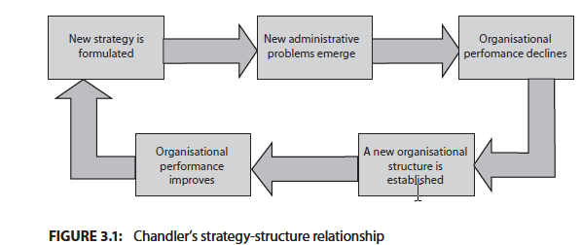

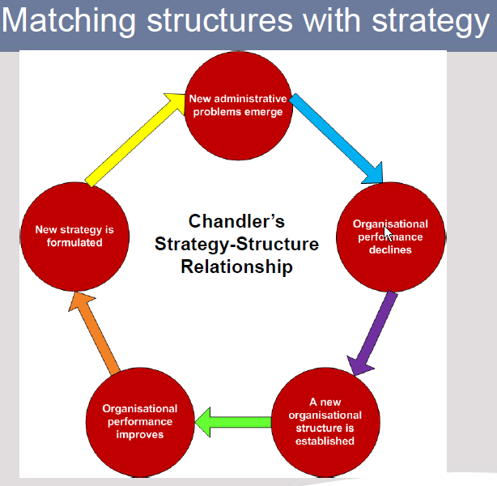

- Explain what organisational architecture entails (4)
- Is an integrated strategic response that draws together key dimensions of the organisation (such as organisational structure, leadership, organisational culture, policies and strategies) to guide strategic planning and implementation.
- It provides a blueprint of the internal and largely invisible workings of the organisation.
- It is a formal document that clarifies the key strategic drivers.
- It is unique to a specific organisation.

- Describe the components of organisational architecture?
- Capabilities are distributed to the various stakeholders through the different organisational processes.
- The structure/system, KSA’s (knowledge, skills and abilities) and technology specific to each organisation shape these processes, which are all in turn underscored by the organisational culture.
****Diagram of organisation architecture must be read from right to left.

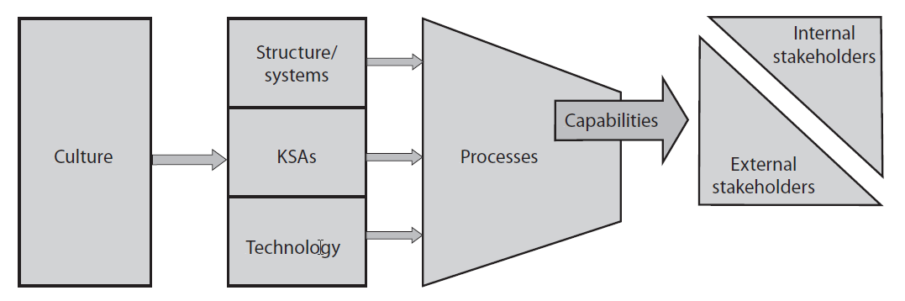

- What is a resource?
- Something that an organisation owns, or has access to, even if that access is temporary.
- Resources can be categorized into tangible and intangible resources.

- Identify the different resource of an organisation (6)
- Financial resources
- Physical resources
- Human resources
- Technological resources
- Information resources.
- Resources can be categorized in tangible resources and intangible resources.
- Tangible resources are often described as the resources that can be touch, feel or see.
- Examples include property, land, buildings, equipment and shares (balance sheet items).
- Intangible resources cannot be seen or touched.
- It forms the core of an organisations competitive advantage. It’s classified into
- human capital, (employees skills, talent and knowledge)
- information capital (technology infrastructure, databases)
- organisation capital. (culture, leadership, teamwork)

- Describe the role of resource allocation?
- Organisational resources are scared and it can be a strength or a weakness.
- This depends on how the strategic manager allocates the resources; it can either enhance the successful implementation of the strategy or hinder it.
- To achieve successful strategy implementation, the scare resources must be allocated in such a way that they support the organisations
- Long term goals
- Chosen strategy
- Structure and
- Short term objectives.

- Define budget and the role of budgets (how budget is used in the strategy implementation process)?
- A budget is a resource plan, a guideline; a summary of what is available, planned expenditure or a list of priorities.
- Budgets support strategy implementation and should be based on the organisations short-term objectives and operating results.

- What is meant by resource allocation and what impact this has on strategy implementation?
- Resource allocation is important to enable the employees to carry out the necessary tasks to achieve the chosen strategy.
- The right people with the right skills must be allocated.
- It deals with the inputs that are required to implement the strategy process successfully.
- A change in strategy requires a change in the resource allocation process.

- Discuss the role of the master budget and strategic funds in the strategy implementation process (6)
- The master budget of an organisation includes the monitoring of activities that is important for the survival of the organisation.
- Activities such as sales, manufacturing, administrative activities investment and cash management.
- Projected sale are the foundation of budgeting.
- Forecasting sales is critical because all other budgeted activities depend on these forecasts.
- Strategic funds are expense items required for implementation of strategic actions, expected to benefit the organisation in the long term.
- The 3 main components of strategic funds are investment in tangible assets, development expenses such as advertising increase or decrease in working capital.
- Differentiate between strategic funds and operational funds (4)
- Strategic funds are expense items required for implementation of strategic actions, expected to benefit the organisation in the long term.
- The 3 main components of strategic funds are investment in tangible assets, development expenses such as advertising and increase or decrease in working capital.
- Operational funds are those expense items required to maintain the business in its present position.
- Examples of operational funds are petty cash, stationary and team building events.
- Explain the role of resource allocation in strategy implementation with specific reference to the importance of human resources (8)
- To achieve successful strategy implementation, the scare resources must be allocated in such a way that they support the organisations
- Long term goals
- Chosen strategy
- Structure and
- Short term objectives.
- The role of Human resources in organisations and strategy implementation is becoming increasingly important as the world moves from the information technology era to a knowledge-based society and economy.
- Human resources are the heart of strategy and it is important that people are allocated to the most important task in implementing the strategy.
- Organisations can no longer generate profits without the ideas, skills and talent of knowledge workers.
- Technologies, natural resources and capital are no longer difficult to obtain and are less important in developing and sustaining competitive advantage.
- The opposite may be said to talent and skills of people and that may be one of the reasons for the rise in CEO and executive compensation.
- Aligning an organisations resource allocation plan to it chosen strategy? **
- The value of a resource allocation plan lies in its alignment with the organisations strategic goals.
- If too few resources are allocated, this slows down and hinders strategy implementation efforts.
- The allocation of too many resources wasted costly resources and reduces financial performance.
- A change in strategy requires a change in the resource allocation process.

- Explain how the chosen strategy could be implemented through resource allocation (4) (aligning facts can also be used)
- To achieve successful strategy implementation, the scare resources must be allocated in such a way that they support the organisations
- Long term goals
- Chosen strategy
- Structure and
- Short term objectives

- Describe the drivers of strategy implementation (5)
- Leadership, this is vital in strategy implementation as it is only through effective leadership that organisations are able to use strategic management successfully.

- Organisational culture is a set of important beliefs, behavioral norms and values that the members of an organisation share. It refers to the way we do things around here.

- Reward system required to motivate managers and employees to ensure commitment to the implementation of new strategies.

- Organisational structure refers to the framework within which the strategic process must operate to achieve the organisations goals. Identify the tasks necessary for strategy implementation and how is responsible for the tasks.

- Resource Allocation is essential that resources be allocated in such a way that they supports the organisations long-term goals, chosen strategy, structure and short term goals.

_____________________________________________________________________________

Topic 4:

- Define short term goals? (3)
- Measurable outcomes that are achievable or intended to be achieved in one year or less.
- It guides action and direct the activities of organisational members.
- It is derived from long-term goals.

- Name reasons why short term goals is a valuable Strategy implementation instrument. **
- It helps to establish departmental and organisational priorities.
- It assist in monitoring the process made towards achievement of long-term goals
- It can be used as checkpoints for operational and strategic control.
- Can be linked to reward systems and serve as a primary method for evaluating performance.

- Explain what constitutes a well-formulated short-term objective (5) (criteria for short term goals)
- Short term goals must be
- Suitable Unsuitable
- Achievable unachievable
- Acceptable unacceptable
- Motivating de-motivated
- Flexible not flexible
- Understandable not understandable
- Each goal must indicate clearly who is responsible and the focus area, the action require, how it will be measured and the time frame.
- It should be consistent across functional areas.

- Differentiate between long-term and short term goals? (3)

 | Long term goals | Short term goals
1 | Strategic important is high | Strategic importance is low
2 | Strategic nature | Operational nature
3 | Time frame is 3 – 5 years | Time frame is 12 months or less
4 | High level management involvement | Low level management involvement
5 | Specific level is low | Specific level is high
6 | Few high level objectives | Low level objectives

- Explain how long-term goals are translated into short term goals? (3)
- Short term goals are derived from the long-term goals to ensure that the mission and strategic intent become a reality.
- The focus areas of the mission statement and long term goals must be incorporated into the short term goals
- With the organisations mission and strategy confirms that the strategy management process is interrelated and that a change in one component will trigger a change in others.

- Comment on the different management levels and their involvement in strategy implementation?

 | Management level | Involvement
1 | Top management | Known as strategic management  Responsible for the whole organisation.  Responsible for strategy formulation
2 | Middle management | Represent the functional management  Responsible for strategy formulation.
3 | Lower management | Supervisors, have more technical skills and are involved in the day-to-day operations. Responsible for strategic implementation.

- Explain what a functional tactic is and why it is important?
- The key activities that have to be performed in each functional area to provide the organisations products and services.
- It translates the organisations grand strategy into action to ensure that the short term goals are attained.
- It typically includes marketing, finance, operations and human resource management.

- Explain how functional tactics differ from corporate and business strategies (5) or differentiate

Differences | Functional tactics | Business strategy
Time horizon | Identify tasks and activities that must be done in the near future | Grand strategies focus on the organisations position in the next few years
Specificity | Identify the specific activities that needs to be performed | Provides general direction
Developers | Developed within the operational areas of the organisation | Developed at top management level

- Describe the relationship between functional tactics, short-term goals, long-term goals and the mission of the organisation? (4)
- The mission serves as the foundation for the development of long term objectives and the selection of strategies.
- The long-term goals have high level management involvement and a time frame of 3 – 5 years.
- The focus areas of the mission statement and long term goals must be incorporated into the short term goals which have a time frame of 12 months or less.
- Functional tactics translate the organisations grand strategy into action to ensure that the short term goals are attained.
- With the organisations mission and strategy confirms that the strategy management process is interrelated and that a change in one component will trigger a change in others.

- Name key concerns that functional tactics in human resources, finance, research and development, operations management and marketing have to deal with?
- The role of the marketing function is to ensure that profitable sale of an organisations products and services in its target markets so the organisation achieve its overall long term goals.
- The finance function focuses on four key tasks, namely financing, investment, the administration of financial matters and report of financial matters.
- The operations function of the organisation is responsible for converting inputs into outputs.
- Human resources management focuses on recruiting, developing and retaining the human resources of an organisation.

- Explain what the concept policy entails? (3)
- The functional managers play an active role in the formulation of policies.
- Specific guidelines, methods, procedures, rules and administrative practices that direct thinking, decisions and actions of managers and employees in strategy implementation.
- “Red tape” Standard operating procedures that organisations have in place to direct the thinking, decisions and actions of managers and employees in implementing an organisations strategy.
- Policies create empowerment.

- Expound on the importance of having sound policies in place in strategy implementation (5) / Defend the use of policies in the strategy implementation process?
- Policies guide the thinking, decisions and actions of managers and employees in the strategy implementation process.
- Policies inform employees about what is expected of them
- Clarify what can and cannot be done in the pursuit of the short term goals
- Standardise routine decisions, thus reducing the time to make decisions
- Provide a basis for control and promote coordination and consistency across organisational units.

- Comment on the role and importance of the various instruments in strategy implementation(9)
- The strategy implementation instruments are Short term objectives, functional tactics and policies.
- Short term objectives
- Short term objectives must be suitable, achievable, acceptable, motivating, flexible and understandable.
- Each goal must indicate clearly who is responsible and the focus area, action require, how it will be measured and the time frame.
- It should be consistent across functional areas.
- Functional tactics
- Are the key activities that have to be performed in each functional are to provide the organisations products and services.
- It translates the organisations grand strategy into action to ensure that the short term goals are attained.
- It typically includes marketing, finance, operations and human resource management.
- Policies
- It entails specific guidelines, methods, procedures, rules and administrative practices that direct thinking, decisions and actions of managers and employees in strategy implementation.
- Policies create empowerment.
- It provides a basis for control and promote coordination and consistency across organisational units.

____________________________________________________________________________
Topic 5:

- Explain what strategic control entails (5)
- It the phase of the strategic management process that concentrates on evaluating the chosen strategy in order to verify whether the results produced by strategy are those intended.
- It provides feedback of the formulation and implementation phase.
- It has two focus points, namely to review the content of the strategy and to evaluate and control the implementation phase.
- It is concerned in guiding the actions as the strategy takes place.
- It must be performed on a continuous basis.

- Differentiate between the different types of strategic control (8)
- Premise control
- Check whether the assumptions on which the choice of a strategy was based are still valid.
- Usually deals with the macro environment as well as the industry.
- Strategic surveillance
- The organisation identified, both external and internal events that may effect the course of it strategy. The sources could include conferences and conversations.
- Special alert control
- The rapid reconsideration of an organisations strategy in the light of a sudden event.
- Like the terrorist attack on the world trade centre on 11 September 2001.
- It support s strategic surveillance and premise control.
- Implementation control
- Assesses whether the overall strategy could be changed in the light of the results of the incremental actions taken to implement it.
- It provides management with information regarding the success of the implementation.

- Difference between strategic control and operational control and traditional management control?
- Traditional management control focuses on the implementation process, strategic control focuses on key success factors of the strategy.
- Operational control focuses on the short term and strategic control focuses on the long term.
- Traditional management control and Operational control action is taken only after deviations from performance measures have occurred, whereas strategic control is concerned with guiding the action as the strategy takes place.
- Why is Strategic control an important component of the strategic management process?
- It provides feedback on the formulation and implementation phases of the strategic management process.
- Evaluates the chosen strategy in order to verify whether the results produced by the strategy are those intended.

- What are the 4 steps commonly found in operational control systems?
- Set standards of performance
- Measure actual performance
- Identify deviations from standards set
- Initiate corrective action.

- Explain how operational control systems can be used to monitor performance and evaluate decisions?
- Implementation control is enabled through operational control.
- Strategic control systems evaluate the organisation over an extended period.
- Operational control provides feedback over shorter time periods, such as months, quarters and so forth.
- It usually takes four steps to all post-action controls:
- The steps are Set standards of performance, measure actual performance, identify deviations from standards set and initiate corrective actions.
- Operational systems evaluate the progress of strategy implementation by monitoring the achievement of short term goals.
- An example of operational control is the budget.

- Diagrammatically depict the components of an operational control system?

Set standards of performance
Initiate corrective action
Identify deviations from the standards set.
Measure actual performance

- What are the limitations of traditional strategic control system?
- It makes provision for single-loop learning only and not for double-loop learning.
- Balance scorecard makes provision for both.

- Comment on the criteria used to evaluate strategies during the strategic control phase? (6)
- Criteria for effective strategies include appropriateness, feasibility and desirability. Including the questions for strategy evaluation.
- Appropriateness strategic criterion questions
- Is the strategy in line with the mission?
- Is the strategy still appropriate taking the changes in external environment is consideration?
- Is strategy still acceptable for all stakeholders?
- Feasibility
- Can it be carried out?
- Still feasible in terms of resources?
- Desirability
- Have stakeholders preferences changed?
- Has the strategy produces adequate results in the short term?

- Explain how continuous improvement builds customer value and comment on the approaches to sustain a competitive advantage through continuous improvement (5) (the 4 approaches for continuous improvement)
- Benchmarking
- The comparison of selected performance measures or operational processes that serve as challenging, yet comparable, yardsticks.
- These include the organisations own history, major competitors or best in class/world performance.
- Total quality management
- A Culture, inherent in which is a total commitment to quality and attitude expressed by everybody’s involvement in the process of continuous improvement of products and services by using innovative scientific methods.
- Re-engineering
- An organisation is reorganized in a way that creates value for customers by eliminating barriers that create distance between employees and customers.
- As such cost are lowered and service to customers improved.
- Six sigma approach
- A methodology linking improvement to profitability.
- Highly rigorous and analytic approach to quality and continuous improvement with the objective of improving profits through defect reduction, yield improvement, improved customer satisfaction and best in class performance.

- Discuss the levers of control? (4)
- The 4 levers of control that should be taken into consideration in designing strategic control systems are
- Diagnostic control systems
- These systems are used to track the performance of departments, managers and employees, to monitor goals and to measure progress towards profitability and revenue growth targets.
- Belief systems
- These systems relate to the organisations values and organisational culture and provide guidelines for implementing decisions.
- Boundary systems
- These systems supplement diagnostic control systems and belief systems.
- Diagnostic and Belief systems tell the managers and employees what should be done and what behaviour is accepted, boundary system provide information on what should not be done and what falls outside the scope.
- Interactive control systems
- Provides the managers with a sense of what is happening in different areas of the organisation.

Any organisation needs a balance between these levers when designing a strategic control system.

- Name the difference between interactive control systems and diagnostic control systems?
- Interactive control systems focus on constantly changing information that top management has identified as strategic
- This information is significant enough to demand frequent and regular attention from operating managers on all levels of the organisation
- The data generated by these systems is best discussed face-to-face in meetings
- The interactive control system forms the foundation for ongoing debate regarding assumptions and action plans.

- Comment on the recommendations of the King III Report on strategic control?
- The King III report states that the board must retain full and effective control over the company and must monitor management’s implementation of board plan and strategies.
- The board must also ensure that adequate internal controls exist and that the organisations information systems can cope with the strategic direction in which the organisation is headed.

- Describe how the balanced scorecard can be used to set short – term goals?
- A framework according to which strategic or long-term goals could be set.
- Provides a guideline for setting short-term goals for each of the long-term goals.
- Provides for the translation of these long-term goals into short-term goals.
- Insures that long-term goals are tightly linked to the vision and that short term goals are directly related to long-term goals.
- Tightly links the functional tactics to the short term goals.
- The balanced scorecard comprises 4 perspectives, namely Financial perspective, Customer Perspective, Internal business perspective and Learning and growth perspectives.
- Each of the perspectives comprises clear objectives, measures, targets and initiatives.

- Diagrammatically depict the components of the Balanced Scorecard? (pg104)

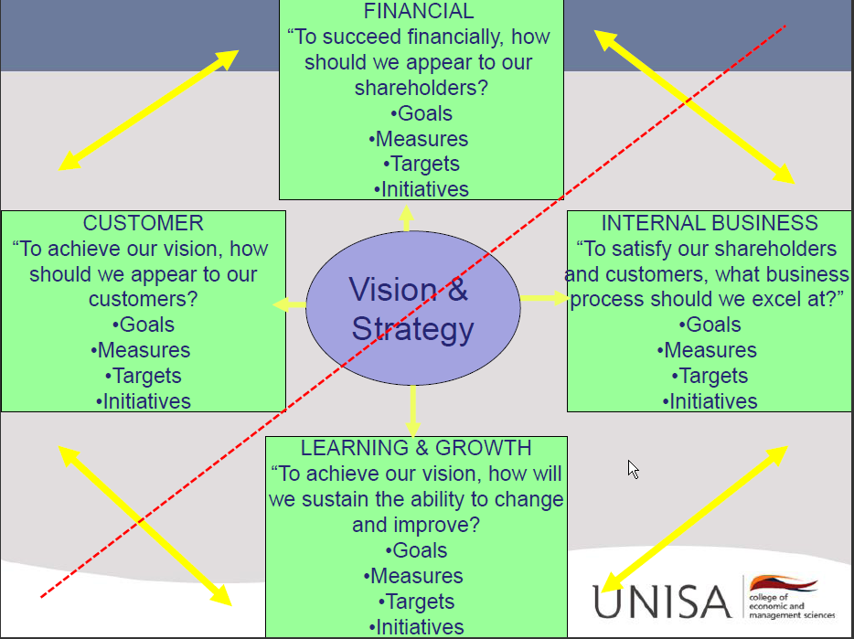

- Diagrammatically depict and explain the 4 dimensions of the balanced scorecard? (8)
- The balanced scorecard sets objectives, measures, targets and initiatives for four organisational areas based on the vision or strategy.
- The 4 processes of the balance scorecard that forms a framework for strategic control are translating the vision, communication and linking, business planning and feedback and learning.
- Translating the vision
- It is the first of the processes that form a framework for strategic control.
- It ensures that the strategy is the reference point an d it forces top management to gain consensus on the organisations vision and strategy.
- Ensures that the vision is translated into goals and measures linked to the strategy.
- Communicating and linking
- This 2nd process ensures that the long term strategy is clearly understood by the entire organisation through communicating and linking.
- It promotes commitment and accountability to the organisations strategy.
- Business Planning
- The 3rd process forces organisations to link their business plans to the strategy through the setting of targets or milestones.
- Through this process organisations integrate their strategic planning and budgeting processes.
- Feedback an learning
- The 4th process provides organisations with the capacity of strategic learning.
- Strategic learning consists of gathering feedback, testing the assumptions on which the strategy is based and making the necessary adjustments.
- The 1st three processes provide a framework for implementation control.
- This vision is translated and communicated, goals are set and initiatives are taken.
- The 4th process reviews the content of the strategy.
- The strategic goals within the 4 dimensions are interlinked in terms of cause and effect.

The balanced scorecard as a framework of strategic control:

- Explain the use of the balanced scorecard in the strategic implementation stage?
- The balanced scorecard was developed to overcome the limitations of focusing only on the financial aspects.
- It provides for the use of both financial and non-financial performance measures.
- It incorporates financial performance measures, customer knowledge, internal business process measures and criteria for assessing learning van growth prospects.
- These measures are combined to measure the implementation of strategies in a balanced way.

