Nortje V Pool 1966
Majority judgment
The majority judgment in the Appellate Division, delivered by Botha JA (Williamson and Wessels JJA concurring) upheld the exception.
It was held that the action which a bona fide possessor has always had to claim compensation for improvements, which had been
extended to occupiers, lay only for visible or tangible improvements such as a building or a well. If A were to have an action because
he had enriched B by disclosing qualities in B’s land which had always existed, but which were unknown, it would have to be a general
enrichment action. Botha JA then examined our law in this respect and concluded that it had not yet reached the stage where a
general enrichment action was recognised, although such a development might still take place.
The effect of this decision can be summarised as follows (De Vos 327):
. The classical Roman-Dutch actions, as set out by the old writers, still apply.
. Our courts have developed ad hoc extensions of enrichment liability, and, where appropriate, can recognise further extensions.
These ad hoc extensions are available only in specific circumstances.
. These ad hoc extensions of enrichment liability are developed enrichment actions (whereas the old actions are not) in so far as
detrimental side effects of the enrichment (and presumably also favourable side effects of the impoverishment) are taken into
account in determining the extent of the enrichment liability.
. The ad hoc extensions are available only in instances where the old actions are not applicable. If a specific instance falls within the
ambit of one of the old actions, the old actions must be used. If the rules of an old action exclude a right to comp nsation, the
impoverished party cannot succeed with one of the ad hoc actions.
. The rules for a general enrichment action set out by De Vos in his first edition and repeated in his second and third editions, are
applicable to the ad hoc extensions of enrichment liability, with the addition in each instance of a further vague requirement that
specific circumstances must be present.
. A general enrichment action is not recognised as forming part of our law.
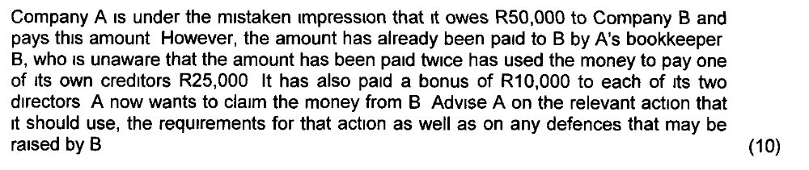
CONDICTIO INDEBITI
• Most familiar / common action
• When person performed under mistaken belief that such performance was due
MONEY EXCHANGED FOR SOMETHING ELSE
• If receiver bought something he would have bought in any case, then he is enriched by the full amount originally
received (saved expenses)
• If receiver bought something he would otherwise not have bought, he is enriched only to the extent of the value
of performance obtained i.e. luxury holiday – not enriched.
• If he bought something which is worth more than he paid for it, he is liable for full amount of undue payment. If
worth less – liable only for lesser amount representing value of thing (or released from liability by delivering the
thing to impoverished party)
• Where worth more than amount paid – and chooses to return thing – plaintiff must pay excess value.
Principle: Impoverished party can NEVER receive more than quantum of his impoverishment.
Note:
Where a party receives money which is not due to him, but is unaware of the fact that the money was not owing, he may
spend the money on some or other luxurious item. So at the end of the month you find that there is more money left in
your account than you thought (because someone had by mistake paid money into it) and you spend the money on a
weekend trip which you would not otherwise have done. When the payer of the money seeks to reclaim the undue
payment you will suddenly find yourself in a difficult position, because you have in fact spent the money on something
which you would not normally have doen and you now further have to pay it back. However, if you were reasonable in
believing that the undue money was yours, your defence of non-enrichment could succeed.
Receiver of undue payment liable for full value (although no longer in possession):
• Knows that money is not due
• Later becomes aware of fact payment was not due.
• Should have realised there is a possibility that performance could later prove to be undue.
Defence (lessening liability / falling away): Only if he can show it was not his fault.
Mora re repayment of un-owed performance: Defence can only succeed if enriched party can show that he performed
in time – same fate would have befallen thing in hands of plaintiff.
INTEREST DUE TO MORA
• Liable if falls into mora with performance to repay.
• When impoverished party demands payment
• Not because of enrichment principle, but to compensate for damage caused by mora.
10
ERROR OF LAW / ERROR OF FACT
Error of fact: Party who deliver un-owed performance must NOT have been aware that performance was NOT owing. Act
under mistake as to true position.
Error of law (errorem iuris): see; Willis Faber Enthoven (Pty) Ltd v Receiver of Revenue.
Further requirement: iustus error - Mistake must be reasonable, but there has to be gross negligence on part of plaintiff
for his mistake to be deemed unreasonable.
PRESUMPTION OF ANIMUS DONANDI
Irrebuttable presumption that delivery in the knowledge that performance is not due constitutes donation is totally
unacceptable. It is possible to perform knowingly that which is not due without the intention to donate.
Law allows relief when undue payment is made under protest. Not the protest which founds the claim but fact that
protest is incompatible with intention to donate.
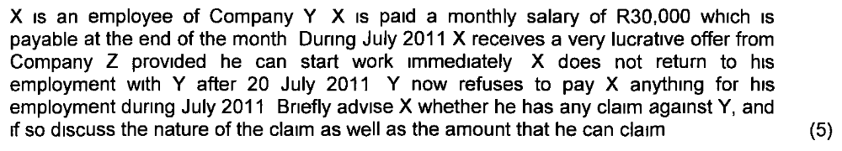
- Contract of service or employment (locatio conductio operarum) – employee only entitled to compensation when completed term of employment (2).
- No claim in contract because of exceptio non adimpleti contractus, but claim based in enrichment (2)
- Requirements (2-3).
- Discussion Spencer v Gostelow 1920 AD 617 (3-4)
- Pro rata payment (3)
- Case of deserter and criticism (3)

Must be a causal link between the enrichment and the impoverishment. The enrichment must be at the expense of the plaintiff.
Indirect Enrichment
A and B enter into a contract. A renders performance to B, but benefit of the performance accrues to C.
Example:
A contracts with B to build swimming pool for B.
A builds pool on C’s property believing it to be that of B’s.
De Vos:
B renders performance to A and B pays A for work. C is enriched at B’s expense (not A).
If B has not yet paid A (and he is in a position to pay) – A can enforce contractual action.
If B is insolvent or disappears - A cannot bring enrichment action against C because C is enriched at B’s expense – NOT A.
This view was endorsed in Gouws v Jester Pools
Problem addressed in:
Buzzard Electrical v 158 Jan Smuts Avenue Investments
Cannot be used to confirm or reject Gouws decision – deals with subcontractor cases.
Enrichment lien – right of retention – operates against anyone, including the owner. Retain possession until compensated. Same requirements satisfied as for enrichment action.
See; Brooklyn House Furnishers v Knoetze
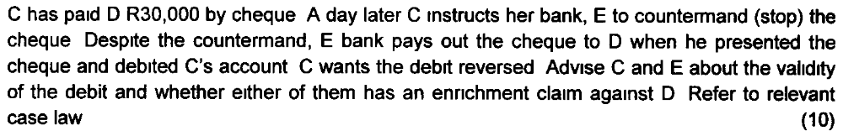
The condictio indebiti could be used to claim moneys that had been paid without authority or beyond the powers of the person
making the payment in a representative capacity (ultra vires payments).
Condictio indebiti
• Something given or transferred in ownership to another (1). Can consist of corporeal things or incorporeal things, such as
rights (1);
• Transfer must have taken place as a result of mistake on the part of the transferor – he or she must have believed that
performance was due; and (1)
• The mistake may be one of law or fact (1), but must have been reasonable (iustus error) in the circumstances. (1)
Since A had cancelled the payment instruction, the bank which acts in a representative capacity was not entitled to debit A’s account.
Therefore the bank is the impoverished party and not A. The bank may then use the condictio indebiti to reclaim the undue amount.
In Bowman, De Wet and Du Plessis v Fidelity Bank the court held that there is sufficient authority to the effect that an ultra vires
payment can be reclaimed with the condictio indebiti. The court stated that such payments are, by their very nature, payments of
something not owing by the payee.
The person relying on estoppel must prove that through the misrepresentation the person misled has changed his or her position to his or her prejudice, whether by failing to act or by acting.
For example, the person may have made a payment when buying something from a non-owner, or he or she may have failed to gain an advantage or to terminate a contract (eg Nzimande v Smuts 1960 (3) SA 264 (0)), or he or she may have contracted with a third party or incurred an expense which he or she would not otherwise have done (eg Autolec Ltd v Du Plessis 1965 (2) SA 243 (0); South British Insurance Co Ltd v Glisson 1963 (1) SA 289 (D)).
De Wet avers that the prejudice which the estoppel-asserter stands to suffer if his or her reliance on estoppel fails, must be patrimonial prejudice. Prejudice in this sense equals the concept of ``patrimonial loss'' and is determined by comparing the actual patrimonial position of the aggrieved person (if his or her plea of estoppel fails) with a hypothetical position, namely the position he or she would have been in had he or she never been misled, that is if the misrepresentation were true.
If the patrimonial position which he or she would have been in, is better than his or her actual position at the moment, that is should the plea of estoppel fail, prejudice exists. In other words, the patrimonial position in which the estoppel-asserter finds himself or herself at the moment of litis contestatio must be compared with the hypothetical patrimonial position in which he or she would have been (at the moment of litis contestatio) had no false belief been created.
There is prejudice if the former is at all less advantageous than the latter. Recently in Jonker v Boland Bank Pks Bpk 2000 (1) SA 542 (O) the court held that the type of prejudice which underlies a successful invocation of estoppel is patrimonial in nature. Unfortunately our courts have not always approached the question of prejudice correctly, for example, the Appellate Division in Baumann v Thomas 1920.
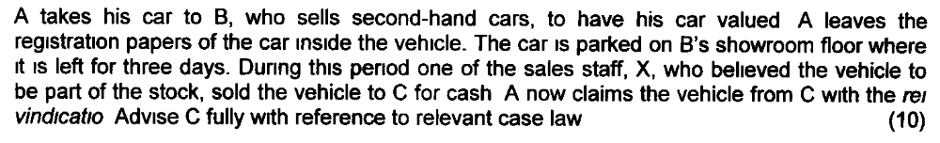
The question whether there could reasonably be misrepresentation often arises where an owner entrusts his or her property to the possession of another.
Since the separation of ownership from possession occurs so frequently, it would be unreasonable and contrary to the legal views of the community, as interpreted by the courts, to accept without further investigation that the possessor of a car is its owner.
The representation is a misrepresentation if the message it gives a reasonable person is false. However, if the owner goes further and not only tolerates the possession of his or her property by another, but also gives him or her the title documents or a blank transfer form or something similar, his or her representation may in fact amount to a misrepresentation, since his or her conduct may be reasonably conducive to the false conclusion that the possessor is the owner.
In Electrolux (Pty) Ltd v Khota 1961 (4) SA 244 (W) this matter is explained as follows:
The first enquiry should be into what was the specific conduct of the owner that the respondent relies upon for the estoppel. If that conduct is not such as would in the eyes of a reasonable person, in the same position as the respondent, constitute a representation that the swindler was the owner of, or entitled to dispose of, the articles, then cadit quaestio - no estoppel could then arise. But if such conduct does beget that representation, then the next enquiry would logically be whether the respondent relied upon, or was misled by, that representation in buying the articles.
The owner's mere entrusting a person with the possession of its articles is not sufficient to produce the representation that the dominium or ius disponendi was vested in the possessor. The respondent would not be entitled to assume from such mere possession that the possessor was authorised to dispose of the articles. If he made such an assumption he would only have himself to blame for his gullibility. To give rise to the representation of dominium or ius disponendi, the owner's conduct must be not only the entrusting of possession to the possessor but also the entrusting of it with the indicia of the dominium or ius disponendi.
It could be argued that A’s conduct was a misrepresentation as the leaving of the registration papers in the vehicle can be seen as giving the impression that B is the owner of the car.
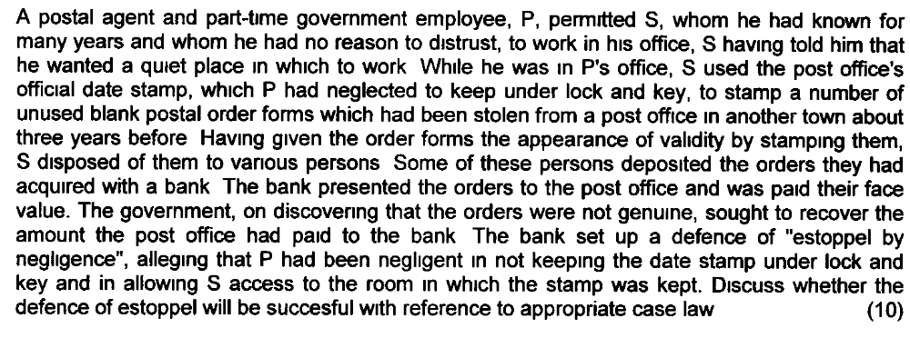
The Appellate Division in Union Government v National Bank of SA Ltd held that the government was not estopped from claiming the money the post office had paid to the bank.

Innes CJ decided the case on the basis that there had been no negligence on the part of P vis-aÁ-vis the bank and that the government was accordingly not estopped from asserting the invalidity of the postal orders. Solomon JA held that, even if P had been negligent (a question on which the learned judge expressed no opinion), his negligence was not the proximate cause of the bank's having been misled into believing in the genuineness of the postal orders.

The learned judge held, furthermore, that even if there had been negligence on the part of P in his custody of the date stamp, such negligence was only ``very remotely'' connected with the payment by the bank to the depositors of the false postal orders, and that such payment was ``not the necessary or ordinary or likely result'' of that negligence. Payment would never have been made by the bank, the learned judge said, but for the occurrence of ``the very extraordinary event'' that S should have obtained possession of a number of postal order forms which had been stolen three years earlier.

The ``direct cause'' of the bank's loss, the learned judge held, was ``the intervention of an act of wickedness'' on the part of S which P could not have been expected to anticipate. The third member of the court, Juta JA, decided the case on two grounds: first, that P had not been negligent vis-aÁ-vis the bank, and second, that even if there had been negligence on his part, that negligence was not the proximate cause of the bank's loss.

As to the question of causation, he posed the question whether P's negligence, if any, was the proximate cause of damnum to the bank, or whether it was not ``too remote'', and then proceeded to hold that events which intervened between the negligence and the cashing of the orders by the bank prevented that negligence from being the proximate cause of the loss of the bank.

The judgments of Solomon JA and Juta JA indicate clearly that factual and legal causation are implicit in the proximate cause test. They expressly require that the prejudice must not be too remote a consequence of the misrepresentation.

However, the proximate cause test does not require that the misrepresentation must be the sole cause of the prejudice. In Autolec Ltd v Du Plessis 1965 (2) SA 243 (0) it is put as follows: ``It is sufficient for the representee to prove that the representation was an inducing cause. He need not establish that it was the (sole) inducing cause'' (our emphasis).

Applied literally, the proximate cause test means that estoppel cannot be invoked in cases where the estoppel-denier makes use of an intermediary, for example where the owner entrusts his property to a person whose conduct, together with his possession of the thing, misleads a third party to act to his own prejudice.

However, our courts do not seem to be so ``consistent''. Only where the intermediate party's fraudulent acts are quite independent of the conduct of the owner, will the necessary causal link between the owner's conduct and the prejudice be deemed to be absent. In such cases the conduct of the intermediary can be regarded as a novus actus interveniens (new intervening cause) which interrupts the (legal) causal chain of events.

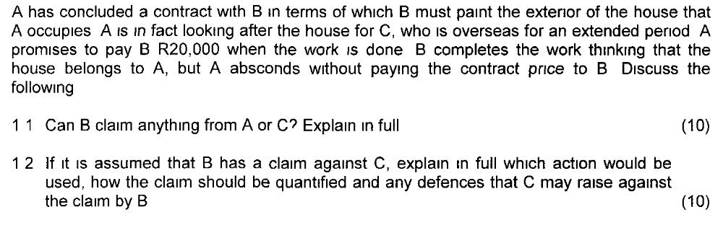
The facts here are similar to that of Gouws v Jester Pools (Pty) Ltd 1968 (3) SA 653 (T). The facts in this case were that A had built a swimming pool for B in terms of a contract between himself and B and on land which he believed belonged to B but which was in fact the property of C.

After B disappeared without paying A for the pool, A brought an enrichment action against C. The action failed, Jansen J holding that C had been enriched at B’s expense and not at A’s.

The views expressed by De Vos (and endorsed by the Gouws judgment) are not shared by everybody, however. Van der Walt, Scholtens and Van Zyl are all of the view that in the circumstances of the Gouws case, C was indeed enriched at the expense of A and that A’s action should have succeeded. Van der Walt’s view is that the at-the-expense-of requirement is satisfied once there has been a direct transfer of assets from A’s estate to that of C. What Van der Walt means by a ‘‘direct transfer’’ is that the assets pass directly from A to C and not from A to B and then from B to C, that is not via the estate of an intermediary person. This can be illustrated by means of the following two examples:

- Assume that B and C enter into a contract in terms of which B undertakes to build a swimming pool for C. Assume further that B now engages A to do the work and that A uses his own materials in doing it. The moment that A has built the pool C becomes owner thereof by accessio — the ownership of the materials therefore passes directly from A to C and the at-the-expense-of requirement, in Van der Walt’s view, is satisfied. In his view, should A now be unable to obtain payment from B, A should succeed in an enrichment action against C. (If B does pay A, A will, of course, not be impoverished and for that reason will not have an action against C.)

- Assume once again that B and C enter into a contract in terms of which B undertakes to build a swimming pool for C. Assume further that B now orders the materials for the pool from A, who supplies the materials to B. Thereafter B uses the materials to build the pool. C once again becomes owner of the materials by accessio, but in this case the materials did not pass directly from A to C; they passed, in fact, from A to B and then from B to C so that the at-the-expense-of requirement is not satisfied.

This problem was addressed by the Appellate Division in Buzzard Electrical v 158 Jan Smuts Avenue Investments 1996 (4) SA 19 (A). Even though the case was decided with reference to the third requirement, that is the sine causa requirement, the court made a very important distinction between the following two situations: (1) where A effects improvements to the property of an owner, not pursuant to a contract with the owner but pursuant to a contract with B and A then sues the owner for enrichment (as was the case in the Gouws case); and (2) where the owner contracts with B for improvements to his or her property, B subcontracts the job to A and once he has completed the work A sues the owner (with whom he never entered into a contract) on the basis of enrichment liability.

According to the Appellate Division, the answer to the above-mentioned problem will depend on a further question, namely whether the owner has been unjustifiably enriched. In other words, the third requirement for enrichment liability is then applicable.

The court in the Buzzard case makes it clear that that case deals with the second situation, ie with the subcontractor situation. In the case of the subcontractor, there is no enrichment claim because the various relationships between the owner, the main contractor and the subcontractor are all regulated by contract. The owner is not enriched because it owes a contractual debt to the main contractor for the improvements. The subcontractor is not unjustifiably impoverished because it has a contractual claim against the main contractor. The court did not make a decision on the first type of situation described above. Buzzard’s decision cannot, therefore, be used to confirm or reject the Gouws decision.

• Only applied where no other condictiones can find application
• Roman law distinguished between condictio sine causa specialis and condictio sine causa generalis.
• The general condictio is an alternative to any of the three previous condictiones and could be used in the place of any of the three as long as one of them could have been instituted. The formula was less complicated.

In SA Law it is used under the following circumstances

Where party performs – performance was due – but causa for performance has fallen away (condictio ob causam finitam)

Plaintiff’s property consumed/alienated by someone else

Bank made payment under countermanded/forged cheque

Ownership transferred sine causa – where none of the other condictiones would lie.

Where possessor receives thing ex causa onerosa (for value) their enrichment is constituted by the profit of the thing

Estoppel can be raised successfully only if the deceived party himself or herself has not been negligent.

For example, anyone who, without making inquiries, assumes that the possessor is also the owner, is usually himself or herself negligent (Adams v Mocke; also LMS Electrical Engineers v Tassburg Screw Industries 1980).

Often the negligence of the deceived (estoppel-asserter) amounts to the negation of fault on the part of the deceiver (estoppel-denier) after all, the negligent act of another person will not always be reasonably foreseeable. However, if the misrepresentation is intentional it will be of no avail to assert that the other party was negligent. In that event the act was specifically aimed at deceiving the other party, regardless of whether the other was negligent or not (Strydom v Scheepers 1942 GWL 73).

Come back to this

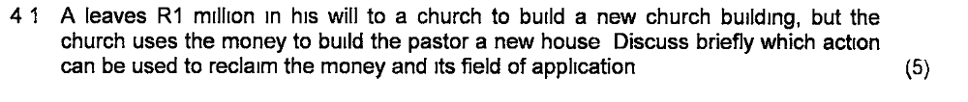
This is a modus. A modus is an obligation which is usually created either in contracts of donation or in testamentary dispositions. In Roman and Roman-Dutch law modi gave rise to a claim with the condictio causa data causa non secuta where the modus remained unfulfilled. In modern South African law its application is restricted to testamentary dispositions as contractual modi are now dealt with as a form of breach of contract — see Benoni Town Council v Minister of Agricultural Credit and Land Tenure 1978.

Where a testamentary disposition is made subject to a modus there is an obligation on the legatee or heir to comply with the provisions of the modus. However, it is not quite certain who would be able to enforce compliance with the modus, although it is assumed that the executor or heirs would be entitled to do so. Where the disposition is revoked owing to noncompliance, the disposition can be reclaimed with the condictio indebiti.

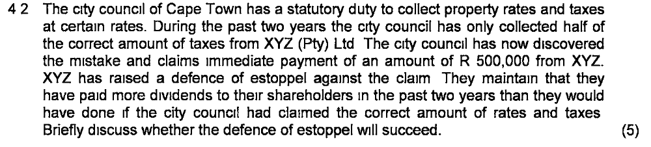

A statutory body has such powers and duties as are conferred by statute and it cannot be bound by estoppel to do something beyond its powers or be prevented from something which it has the duty do. Therefore, XYZ will not be successful with its reliance on estoppel because estoppel is not allowed by law in instances where the city council must carry out a statutory duty.

It is not only an express statement or positive act creating a false impression which can give rise to estoppel; a silence or omission (omissio) can also constitute a misrepresentation. An omission constitutes a misrepresentation only if a legal duty rests on the estoppel-denier to act positively; an omission in the form of the nonfulfilment of a legal duty to act (or to speak) is therefore a misrepresentation which can give rise to a successful plea of estoppel.

In English law the duty to act positively is referred to as the ``duty to act or speak''. There is no unanimity in our law about the question whether the existence of such a duty is a requirement for the existence of a misrepresentation by omissio and therefore for a plea of estoppel. De Wet holds the view that (except in the form of a ``duty to take care'', which is a criterion for fault in the form of negligence) it plays no part in the creation of or failure to rectify a misconception.

De Wet says that the existence or non-existence of a duty has no effect on the ``factual course of events''. One can in fact create or fail to rectify a mistaken impression without the existence of such a duty. However, the question remains whether the impression has been created by a misrepresentation contrary to a legal duty, that is which is objectively unreasonable and thus wrongful.

To establish this (and not to determine the factual course of events) it is necessary to make use of the concept of the duty to speak. If the impression is created by a representation in the form of an omission, the omission will be wrongful if there is a legal duty to act positively, in other words, if the impression was created contrary to a legal duty. Only when it has been established that the existing impression which has been created was brought about by means of a misrepresentation (per omissionem), can estoppel possibly enter into the picture. In broad outline this is also Van der Merwe's viewpoint.

When is there a duty to speak? It is clear that a person does not have a general duty to rectify existing misconceptions. A person may have a legal duty in specific circumstances. This will happen when the boni mores, the legal views of the community as a whole, require that such a duty to act positively should exist. In accordance with the abovementioned criterion, such a duty will exist in certain circumstances where the estoppel-denier can reasonably be expected to act positively.

For example, in Maling v Hargreaves, the owner of a cow which had disappeared five years before, recognised the cow at an auction, but allowed it to be sold (an omissio, therefore). The defendant successfully raised a plea of estoppel against his rei vindication.
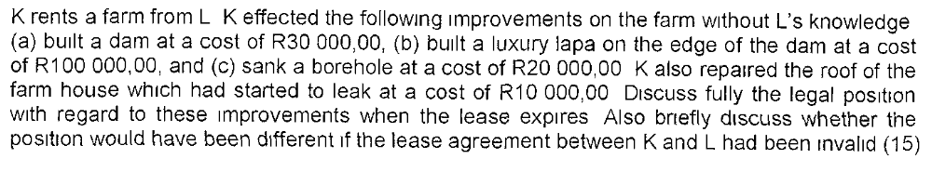
It appears from the old decision of Lord de Villiers in Bellingham v Bloommetje 1874 Buchanan 36 that the judge was prepared to grant the mala fide possessor compensation for improvements which had added to the value of the land: ‘‘It would follow that, ... as a mala fide possessor, he would still, according to very eminent authority, be entitled to an allowance of all expenses which have enhanced the value of the farm, dolphus Kraal, so far as such increased value exists.’’

The ‘‘eminent authority’’ referred to by the judge was Groenewegen (Ad Inst 2 1 30), Voet (6 1 36) and Van Leeuwen (cf 1 2 11 7 and 8). In De Beers Consolidated Mines v London and SA Exploration Co (1893) 10 SC 372 the same Lord de Villiers restricted the mala fide possessor’s claim for compensation for improvements to necessary improvements, except where the true owner was aware of the mala fide possessor’s activities and remained silent, in which case the mala fide possessor had the same rights as a bona fide possessor.

In Lechoana v Cloete and Others 1925 AD 536 it was said in an obiter dictum that a mala fide possessor can also claim for useful expenses, but not in the case of a mala fide possessor of a movable thing (a thief) (Eiselen & Pienaar 243–245; De Vos 102– 103). The view held by Lord de Villiers in the Bellingham case is to be preferred, since it tends to steer the liability of the true owner towards the mala fide possessor on an enrichment basis; if the mala fide possessor can claim compensation only for necessary improvements, it means that the owner remains unduly enriched as a result of the useful improvements which the mala fide possessor has brought about.

You may perhaps argue that the bad faith of the mala fide possessor is sufficient to deny him a right to compensation for useful improvements, but you must remember that it is not private law’s function to punish bad faith, but rather to ensure a fair balance between the interests of the parties. Therefore, the mala fide possessor should, in our opinion, be in exactly the same position as the bona fide possessor, and the right to compensation of both should be based purely on enrichment (Nortje´ v Pool 1966 (3) SA 96 (A) 129–130).

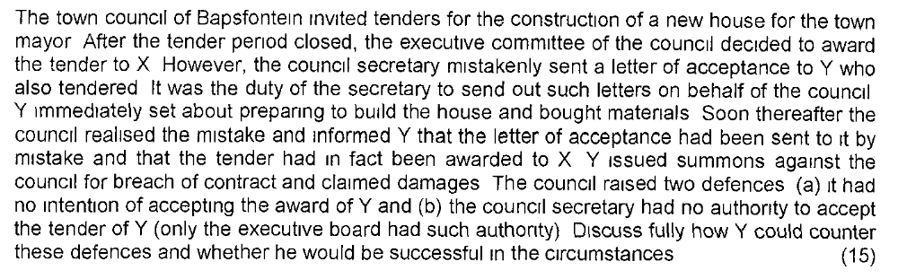
COME BACK TO

