Study Unit 9
Domicile

  - Domicile is:
  - The place where, for the purpose of the exercise of his or her rights
  - and the fulfilment of his or her obligations
  - a person is deemed to be constantly present,
  - even in the event of his or her factual absence.

  - Importance of Domicile

Domicile affects many aspects of private law like:

- A fathers Lex loci domicilii determines whether his child is legitimate or illegitimate at the time of his/her birth.
- A persons Lex loci domicilii determined whether he/she is capable of entering into a contract and is also important in the law of succession. (It is the law of intestate succession of the country in which the deceased was domiciled at the time of his/her death which determines how his/her estate should be devolved in the event of dying intestate.
- In the law of procedure, domicile determined the jurisdiction of a division or the high court (Generally the plaintiff must sue the defendant in the court having jurisdiction in the area where the defendant is domiciled.

  - Basic principles of Domicile:

  - No one can be without a domicile at any time
  - No one can have a domicile in more than one place at the same time
  - The changing of a person’s domicile is never accepted without proof

  - Kinds of Domicle

a) Domicile of origin (domicilium originis)

The domicile the law assigns to a person at birth. (In the past the importance of the domicile of origin lay in the fact that if a person abandoned her domicile of choice without assuming a new domicile, her domicile of origin revived)

The above position has now been changed by the Domicile Act 3 of 1992, which provides that no one loses his/her domicile until he/she has acquired another domicile, whether by choice or by operation of law.

- Domicile of Choice

The domicile which a person who has capacity to act has chosen for himself by exercise of his own free will (the most important domicile)

In terms of section 1 (1) of the Domicile Act 3 of 1992, every person who is over the age of 18 as well as every person under 18 who by law has the status of a major, is competent to acquire a domicile of choice, regardless of such a person’s sex or marital status. Before the act came into operation, a wife acquired and followed her husband’s domicile

Requirements for domicile of choice:

    - The person must actually settle at the particular place, (that is the fuctum requirement); and
    - He/she must have the intention of residing permanently at that place (that is the animus requirement)

c) Domicile by operation of law

Every person who has capacity to act can acquire domicile of choice. However, children and mentally ill persons cannot acquire a domicile of choice, but are granted a domicile by operation of law for as long as their minority or insanity continues.

Child:

Section 2 (1) of the Domicile Act 3 of 1992, provides that a person who is incapable of acquiring a domicile of choice in terms of section 1 of the act will be domiciled at the place to which he/she is most closely connected (parental home)

Mentally ill person.

Formally the courts held the view that mentally ill persons retained the domicile they had before they became mentally ill. The Domicile Act, now provides that mentally ill persons are domiciled at the place with which they are most closely connected.

Comparrision:

Domicile of  Origin | Domicile of  choice | Domicile by operation of law
Domicile which the law assigns to every person at his/her birth | Domicile which a person with capacity to act, has chosen for himself or herself by the exercise of his or her own free will | Children below 18 and mentally ill persons cannot acquire a domicile of choice, but are granted a domicile by operation of law as for as long as their minority or mental illness continues.

  - Persons who are not free to choose where to reside.

Development of law dealing with domicile of soldiers:

- Before 1945: in McMillan v McMillan 1943 TPD 345 the court held that a soldier could not acquire a domicile of choice as the place where he was stationed, as the continuation of his residence there depended on the decisions of his superiors, and not on him self.
- In 1945: in Baker v Baker 1945 AD 708 the court held that a soldier serving another country could in fact acquire a domicile of choice in the country where he was stationed. The question in each case was whether the person had the “final and deliberate intention” of abandoning his previous domicile.
- After the Baker-case: In Moore v Moor 1945 TPD 407 and Nicol v Nicol in 1948 (2) SA613 (C) the courts decided that a soldier or sailor could acquire a domicile of choice in the country where he was stationed.

Domicile of a Prisoner

It was generally accepted that prisoners retained their last domicile before imprisonment and could not acquire domicile of choice in prison

In Nefler v Nefler it was held that a prisoner who had been imprisoned for life acquired a domicile of choice in prison by operation of law

Domicile of a prohibited immigrant

The residence relied on for the acquisition of a domicile of choice must be lawful illegal immigrants can therefore not acquire a domicile of choice in South Africa even if they have the animus to settle permanently because their animus is unlawful

Where prohibited immigrants are, however, openly permitted by the authorities to reside in this country, they may acquire a domicile of choice in South Africa.

The Domicile Act is not retrospective.

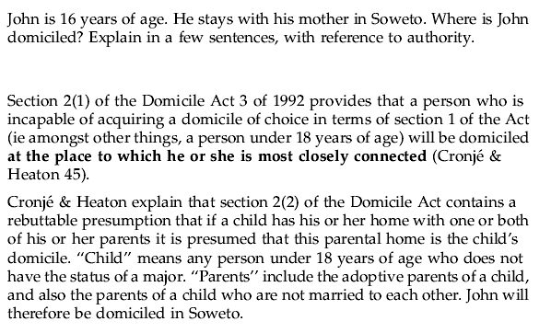

Study Unit 10
Extra-marital children

Legitimate child: Is born of parents who were legally married to each other at the time of the child’s conception or birth or any time between these dates.
Extra-marital child: where the parents of the child were not legally married to each other at any of the above stages.

Proof of paternity

1. Presumption of paternity

a) Married Persons

South Africa law recognises the rebuttable presumption that a child born of marriage is that the husband, in other words it is presumed that the child is legitimate. However, unlike the case in English law, either spouse could bring proof that they did not have sexual intercourse during the period in which the period in which the child could have been conceived.

Today, the position, therefore, is that the presumption pate rest quem nuptiae demonstrant is rebuttable. The fact that the husband was absent at the time of conception, or that he is impotent or sterile is sufficient proof to rebut the presumption.

b) Unmarried Persons

Previously, where the parties are unmarried, the position used to be that if the mother named a particular man as the child’s father, and he admitted, or it was proofed that he had sexual relations with her at any time, he was presumed to be the father. However, now legislature intervened and provided in section 1 of the Children’s Status Act 82 of 1987 that it should be proved that the man had sexual intercourse with the child’s mother at any time when the child could have been conceived, he is presumed to be the child’s father, unless the contrary is proved. The onus then is on him to prove on a balance of probabilities that he can not possibly be the father.

2. Rebuttal of the presumption of paternity

Factors taken into account when proof is sought that a particular man is not the father of a particular child ( applies to legitimate and extramarital children)

a) Absence of sexual intercourse

If a man can proof that he did not have sexual intercourse with the woman at the time the child could have been conceived, i.e. out of country at the time, the allegation (or presumption) of paternity will be refuted (disproved)

b) Sterility

An allegation or presumption of paternity is also refuted if the man can prove that he is sterile.

c) The Exception plurium concubentium

The above defence applies when the man as pointed out by the woman, admits that he had sex with the woman during the time conception could possibly have taken place, but alleges and proves that at the same time another man or other men also had sex with the woman.

Vallidness of the Exception plurium concubentuim defence

Unless blood tests can provide the necessary proof, it will remain uncertain who the father of the is. The question that arises on who will be held liable for the maintenance. Solutions: 1) all the men concerned could be absolved from liability 2) all the men could be held liable 3) only the man named by the mother could be held liable.

d) Physical Features

The fact that the physical features of the child do or do not resemble those of the alleged father will not carry much weight in proving that he/she is or is not the child’s father.

e) Contraceptives

The presumption of paternity will also not be rebutted if the man proves that he used contraceptives when he had sex with the mother.

f) Blood Tests

The courts have accepted blood tests as sufficient proof that the spouse could not have been the father of the child. This has been the case where blood tests were submitted voluntarily. However, the legal position regarding the question whether the court may compel a person to undergo blood tests, is still uncertain. This question was raised in a number of cases two cases are relevant: M v R and S v L.

It is indicated from the above cases that the courts may in future be hesitant to order blood tests in paternity suits on the ground that such orders violate not only the right to privacy (Constitution of South Africa 108 of 1996 s 14) but also the tight to bodily and psychological integrity (Constitution of South Africa 108 of 1996 s 12 (2)). However, if infringement of the said rights were in the best interest of the child to do determine paternity, it will be considered justifiable as sec 28 (2) of the constitution of South Africa 108 of 1996 provides that the child’s best interests shall be paramount in all matters concerning the child.

g) The gestation period.

The courts today decide on an ad hoc basis (no fixed period), with reference to medical evidence, when conception could possibly have taken place. However, the courts are disinclined to declare a child illegitimate, resulting in rather lengthy periods of gestation.

READ RELEVANT CASES!!!

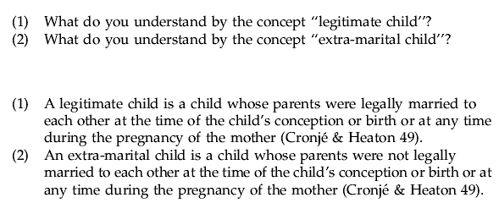

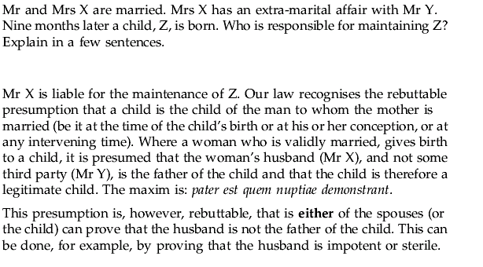
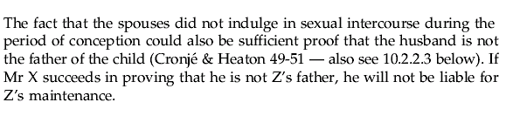

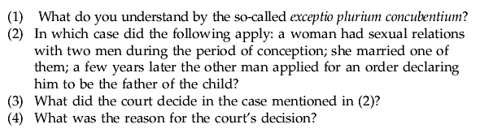

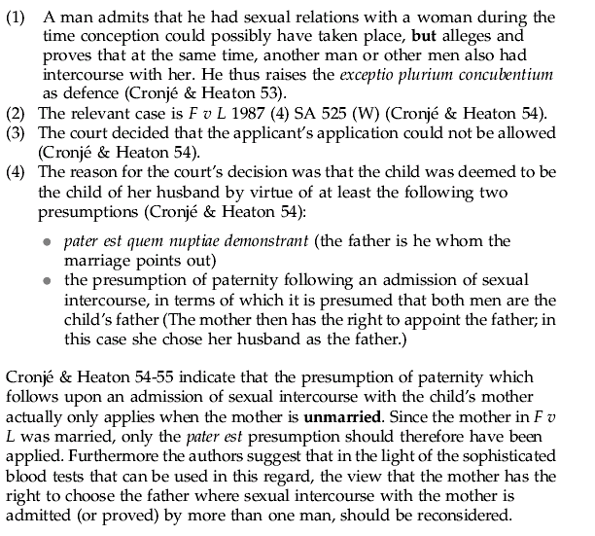

Study Unit 11
Extramarital Children (continued)

1) Classes of extramarital children.

a) Natural Children (spurii or liberi naturals)

Children who’s parents were not married to each other at the time of conception, birth of at any time between these events but who could validly have been married at the time of conception.

b) Adulterine children (adulterine)

One or both of the child’s parents were married to someone else at the time of conception

c) Incestuous children (incestuosi)

Children who are born of parents who were incapable of marrying at the time of conception because they were too closely related.

2) The status of the extramarital child

In the past extramarital children were subject to a number of legal restrictions. Their legal position has been improved in a number of respects i.e. the Children’s status Act 82 of 1987, but their status still differs from that of legitimate children in the following respects:

2.1 Parental power

a) Extramarital children’s relationship with their mother.

In the case of a legitimate child, both parents are vested with guardianship and custody but, it is the mother who has the right of guardianship and custody over an extramarital child. (Not if the mother is still a minor herself, guardian ship then vests in the mother’s guardian, mother however still has custody of the child unless a court directs otherwise)

If an extramarital child’s mother, who is over the age of majority marries a man who is not the child’s father, she remains the child’s only guardian.

Formally illegitimate children acquired their mother’s domicile, but now the Domicile Act 3 of 1992 provides that children are domiciled at the place which they are most closely related. In the normal course of events this will be their mother’s home so that illegitimate children will in most instances still have their mother’s domicile.

b) Extramarital children’s relationship with their father.

i) General

“The allegation has often been made that there is no relationship between a father and extramarital child except that he is obliged to maintain such children and the children have a right to claim maintenance from him”

This view was criticised by J van Zyl in Van Erk v Holmer. According to him, the fathers obligation to maintain his extramarital child Is clearly based on the blood relationship. It can therefore not be said that the father of an illegitimate child is not related to the child. If he is not related to the child, he should have neither rights nor duties in respect of the child.

In S v S J Flemming disagreed with J v Zyl and was of the opinion that to say that an extramarital child was not related to his father was just the law’s approach in that “the legal consequences of the natural relationship between the child and his father…are reduced to a minimum.

          - Guardianship and custody

If the mother of an extramarital child is deprived of her guardianship or custody, these rights may be awarded to the father. Formally it was decided that the father does not have a stronger claim than any other suitable person, but from recent case law it seems that the father is in a stronger position than strangers due to genetic factors and his biological ties with the child. In Bethell v Bland Casebook the custody of an extramarital child was removed from the child’s mother and awarded to the father because he was, with the support of his parents, in a better position to care for the child.

iii) Access

Relevant cases: B v P; Van Erk v Holmer and B v S

In most of the above-mentioned cases, it was declared that the father of an illegitimate child, like any other third party, has right to apply for access and will be granted this right if he can satisfy the court that it is in the interests of the child. However, in some cases it was indicated that the right would not lightly be granted to him.

When considering the fathers application, the court must take the following circumstances into account:

- The relationship between the applicant ant the child’s mother, in particular whether either party has a history of violence against or abuse of each other or the child
- The Childs relationship with the applicant and the mother, or with the proposed adoptive parents (if any) or any other person.
- The effect that separating the child from the applicant or the mother or proposed adoptive parents (if any) or any other person is likely to have on the child.
- The child’s attitude in relation to granting of the application.
- The degree of commitment the applicant has shown towards the child

iv) Adoption

The Constitutional Court in Fraser v Children’s Court Pretoria North, decided that sec 18(4)(d) of the Child Care Act 74 of 1983, was unconstitutional on the grounds that it discriminated unfairly against fathers in some matrimonial unions and also infringed the right of equality. The act was amended to require the consent of both the parents of a child born out of wedlock if the child’s father acknowledged paternity in writing and made his identity and whereabouts known as contemplated in section 19A of the Child Care Act.

Section 19A provides that if only 1 parent consents to the child’s adoption and the other parent is unavailable to give consent or his or her consent is not required, a notice must within 14 days, be served on the other parent informing him that consent has been given, giving the parent the opportunity to:

  - Also give or withhold consent
  - Advance reasons why his consent should not be dispensed with;
  - in the case of an illegitimate child, apply for the adoption of the child.

The above notice need not be served if the other parent’s whereabouts are unknown and need only be served on the father of a child born our of wedlock if:

- He has acknowledged paternity in writing and has entered his particulars in the child’s birth registration; or
- The child’s mother, at the time of consenting to the adoption, confirms in writing that the child’s father has acknowledged paternity and furnishes particulars regarding his identify and whereabouts; or
- A social worker within 60 days of the mother’s having consented or at any stage before the adoption order is granted, submits a report confirming the fathers identity and whereabouts. The report must be made to the commissioner who attested the mother’s consent or to the children’s court in which the adoption application has been made.

Sec 19 of the Child Care Act lays down the circumstances under which consent to adoption may be dispensed with:

- The father has failed to acknowledge paternity
- The child was conceived as a result of incest
- The father was convicted of the rape or assault of the child’s mother
- The father was found on a balance of probabilities to have raped or assaulted the child’s mother
- The father failed to respond to a notice in terms of section 19A of the Child Care Act.

In addition, the consent of either parent of an extramarital child can be dispensed with if he or she, without good cause, failed to discharge his or her parental duties.

  - Maintenance

Both parents or their estates are obliged to support their extra-marital child provided they are in a financial position to do so and the child is in need of support.

  - The right to inherit

a) Intestate succession

The rule “een moeder maakt geen bastaard” has always been applied in South African law, at common law the rule meant that natural extramarital children (spurii) inherited intestate from their mothers and maternal relations in the same way as legitimate children. At common law, extramarital children could not inherit from their father and paternal blood relatives and the father and his relatives could also not inherit intestate form extramarital children.

Extramarital children’s capacity to inherit intestate from both parents and vice versa is now regulated by the Intestate Succession Act 81 of 1987 which provides that as far as intestate succession is concerned, no distinction is drawn between legitimate, adoptive and extramarital children

b) Testate succession

South Africa’s common law accepted that a mother could benefit her extramarital children as if they were legitimate.

In modern South African law, both parents may benefit their natural and adulterine children in a will, even to the exclusion of their legitimate children

3. The Legitimation of extramarital children

The legitimation of extramarital children may be effected in the following ways:

- By the subsequent marriage of the parents of the child to each other (legitimation per subsequens matrimonium)

Sec 4 if the Children’s Status Act 82 provides that any child born of parents who marry each other at any time after his birth shall, even though his parents could not have legally married each other at the time of his conception or birth, as from the date of marriage be in all respects the legitimate child of his parents.

It is evident from the above provision that not only natural children but also adulterine children are legitimated by their parent’s subsequent marriage.

- By an order of the authorities (legitimaio per rescriptum principis)

- By Adoption

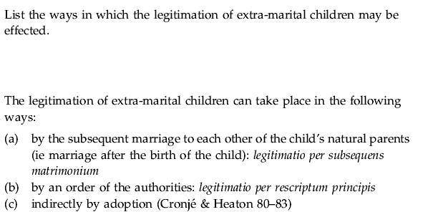

Study Unit 12
Age – Introduction.

[See module map]

1. Introduction

A person’s status (capacity to act, legal capacity to litigate, and capacity to be held accountable for delicts and crimes) is affected by age.

      - Children’s rights

Although children can evoke the rights which the Constitution of South Africa 108 of 1996 confers on everyone, they are also afforded special protection by Sec 28 of the constitution:

Sec 28 (1) gives every child the right:

- To a name and nationality from birth
- To family or parental care or appropriate alternative care when removed from the family environment
- To basic nutrition, shelter, basic health care and social services;
- To be protected from maltreatment, neglect, abuse and degradation
- To be protected from exploitive labour practices
- Not to be required or permitted to perform work or provide services that:
  - Are inappropriate for a person of that child’s age; or
  - Place at risk the child’s well-being, education, physical or mental health or spiritual, moral or social development.
- Not to be detained except as a measure or last resort. In addition the child may only be detained for the shortest period and has the right to be:
  - Kept separately from detained persons over the age of 18
  - Treated in a manner and kept in conditions that take account of the child’s age
- To have a legal practitioner assigned to the child in civil proceedings by the state, at state expense
- Not to be used directly in armed conflict, and to be protected in times of armed conflict.

The restrictions on minors’ capacity do not amount to unfair discrimination on the ground of age, owing that the object of the restrictions is to protect minors.

3. Fundamental Concepts with regard to contractual capacity of a minor

There is an agreement if there consensus between two or more people, and all are aware of having reached consensus (conscious consent)

A contract (or obligatory agreement) is an agreement undertaken with the intention of creating an obligation/s

Contractual Liability means that the party or parties to the contract can be held legally liable for the fulfilment of the provisions of the contract.

An obligation is a juristic bond in terms of which the party or parties on the other side have a right to performance and the party or parties on the other side have a duty to render performance. Contracts, delicts and various other causes (i.e. undue enrichment) give rise to obligations)

Performance is human conduct which may consist of a commission or omission.

A civil obligation is a legally enforceable obligation, while a natural obligation is unenforceable

A unilateral contract is a contract in terms of which only one of the parties undertake to render some performance. An example of such a contract would be a contract of donation. Only the donor undertakes to render some performance.

A multilateral contract is a contract in terms of which more than one party undertakes to render a performance. An example will be a contract of loan. The lender undertakes to lend the borrower a certain amount and the borrower undertakes to repay the amount.

A reciprocal contract is a special type of multilateral contract. It is a multilateral contract in terms of which performance is promised on the one side in exchange for performance on the other side.

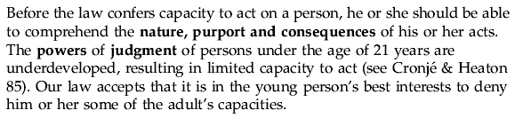

Study unit 13
The legal status of an infans

[See module map]

1. Definitions – infans & Minor

- An infans is a person below the age of 7 years
- An Minor is a person below the age of 21 years. In South African law 21 is the age of majority (s 1 of the Age of Majority Act 57 of 1972

2. The capacity to act of the infans

Infans has absolutely no capacity to act and cannot conclude any juristic act not even with the assistance of a guardian, his/her guardian has to act on her behalf

3. The delictual and criminal liability of the infans.

An infans is completely unaccountable he/she can never be criminally or delictually liable where liability is based on fault. However, he/she may be liable for delicts not based on fault.

Delict = Is a wrongful (i.e. in conflict with legal norms), culpable act causing damage to another.
Crime = is an act prohibited by the law (whether by statute or common law)

- It is a requirement for both that the perpetrator must be at fault, that is that he/she must have acted intentionally or negligently. The capacity to be at fault is known as accountability.
  - A person can be accountable only if her or she can differentiate between right and wrong and act accordingly, since an infans does not have this ability he/she is not accountable.

4. The capacity to litigate of the infants

Capacity to litigate = capacity to be a litigation party in a civil case

An infinas has no lucus standi in iudicio and cannot be party to a law suit even if he/she is assisted by his/her guardian. The guardian must act for his/her behalf on his/her behalf.

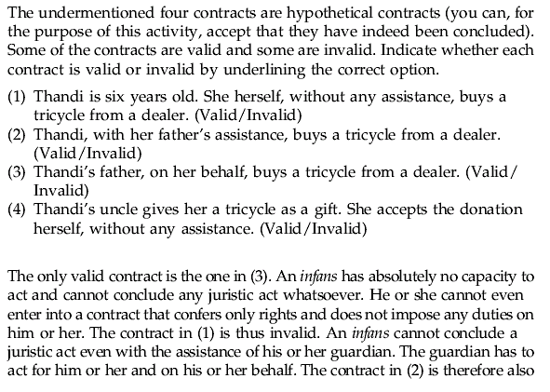
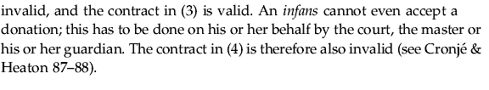

Study Unit 14
The legal status of a minor ~ General principles

“Minors between the ages of 7 and 21 have limited capacity to act”

1. The minors contractual capacity – General Principles

Generally a minor cannot incur contractual liability if not assisted by his guardian when the contract is made. The minor can, however, enter into a contract without assistance if such contract will improve his position without imposing any duties on him i.e. a minor may except donations without assistance.

Statuary exceptions to the rule that a minor cannot incur contractual liability unless he has been assisted by his guardian.

- A minor above the age of 18 may, without his guardian’s assistance deal with a life insurance policy and pay the premiums due under the policy.
- A minor over the age of 16 may be a depositor with any mutual bank.
- Once minor who has attained the age of 7, deposits in his name may be repaid to him “ in every respect as if he were of full age”

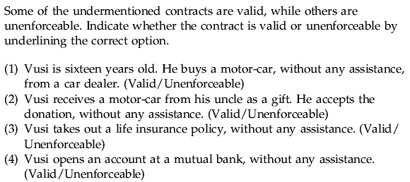
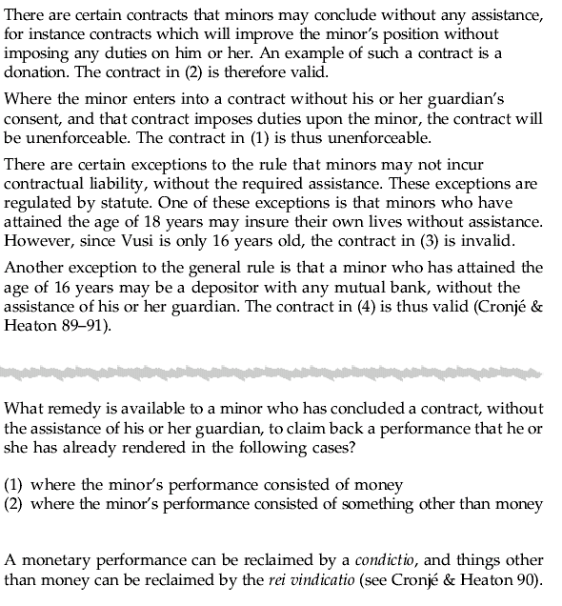

Study Unit 15
The minor’s contractual capacity – the exceptio non adimpleti contactus and misrepresentation.

1. The exceptio non adimpleti contractus (Important)

The exceptio non adimpleti contractus is a legal remedy which can be used by a party to a reciprocal contract. The remedy applies where parties must perform simultaneously, or the one must perform before the other.

A party to a reciprocal contract my use this remedy if he/she is sued for performance by the other party without the other party having yet performed or tendered performance, if in terms of the contract the parties must perform at the same time, or the party who is claiming performance has to perform before the other party. If the parties to a reciprocal contract have not agreed on when they must perform, they must perform at the same time.

Remedy can also be used in specific cases by an adult who has contracted with a minor who has acted without assistance. If the minor claims performance without himself performing or tendering performance, the adult can refuse to perform, if, in terms of the contract, the minor had to perform before or at the same time as the adult.

2. Misrepresentation by a minor

“General view: fraudulent minor must be held liable”

But, there is no consensus on what the basis for this liability should be. There are two possibilities:

  - The minor can be held liable on the basis that the contract he/she concluded is enforceable (i.e. the minor can be held contractually liable)
  - The minor can be held liable on the basis of the delict / wrongful act he/she committed namely misrepresentation (i.e. the minor can be held delictually liable)

Contract as possible basis for liability:

1^{S t} Point of view supporting this approach:

The Roman-Dutch writers denied the fraudulent minor the remedy of restitution in integrum (return of the previous condition) this means that the minor could not claim back the performance he/she had already rendered in terms of the contract. Restitutio in integrum is solely applicable to contracts which the minor has concluded with assistance (and which are therefore valid and enforceable), but are prejudicial (damaging) to the minor. Some legal writers argue that the mere fact that the restitutio is at all at issue, implies that in cases of misrepresentation there is an underlying binding contract.

This viewpoint can not be accepted for the following two reasons:

  - In Roman-Dutch law it was a practice to apply for resitutio also where a minor had contracted without the necessary consent. It is clear therefore, that there need not have always been a binding contract in cases where restitutio in integrum was claimed.
  - A contract concluded by a minor without the necessary assistance is unenforceable. Therefore it is unnecessary for the minor to reclaim the performance by means of restitutio. He/she can simply reclaim it by means of the rei vidicatio, or by means of a condictio in the case of monetary performance.

Therefore, the fact that the minor is denied restitutio, does not mean that the contract is valid and enforceable. It simply means that he/she id denied the possibility of a remedy that he or she does not in any case require.

2nd Point of vies supporting this approach.

Some legal writers argue that the fraudulent minor is bound to the contract by the rules of so-called “estoppel” in terms of estoppel, the minor is bound by the pretence he/she created. The minor is therefore not permitted to rely on the true state of affairs, namely that he/she is not contractually liable. The minor can not avoid contractual liability by raising his or her minority as a defence and must fulfil the provisions of the contract

Importance of Louw v MJ & H Trust 1975 (4) SA 268 (T)

In this case the court decided that a minor, who had bought a motorcycle from an adult without the assistance of his guardian, could not reclaim the purchase price. The reason for this was that he fraudulently represented himself as an adult

The reasons as set out by the Judge:

- He held that the fact the minor could not rely on the restitutio in integrum, does not mean that the contract was valid and enforceable. The misrepresentation therefore did not make the contract valid and enforceable. A contract concluded by a minor without assistance is unenforceable.
- The court decided that a minor could not reclaim, by means of the restitutio in integrum, the purchase price paid as he has no need for this remedy.

Conclusion – contractual liability as basis of the minor’s liability is unacceptable.

It is accordingly incorrect to hold a fraudulent minor liable on the ground of a contract Such liability would mean that a minor who contracts without the assistance of a guardian, will be permitted to supplement his/her limited capacity to act.

Delict as possible basis for liability:

A fraudulent minor must be held delictually liable. A minor who makes a misrepresentation, commits a delict and can therefore be held dilictually liable. This means that the prejudiced party has a claim for damages against the person committing the delict on the grounds of undue enrichment. Delictual liability of minors exists completely independently of contractual liability. Its application does not allow the minor to extend his or her capacity to act by means of misrepresentation.

Requirements for delictual liability in terms of misrepresentation:

- What is the position of the adult who is not mislead by the misrepresentation, i.e. where the adult knows the minor and knows that he/she is a minor
- What is the position where the minor is so young that he or she cannot reasonably be mistaken for an adult i.e. the minor is 10 yrs old
- Can the adult accept the minor’s stated age, or must the adult investigate the minors true age.

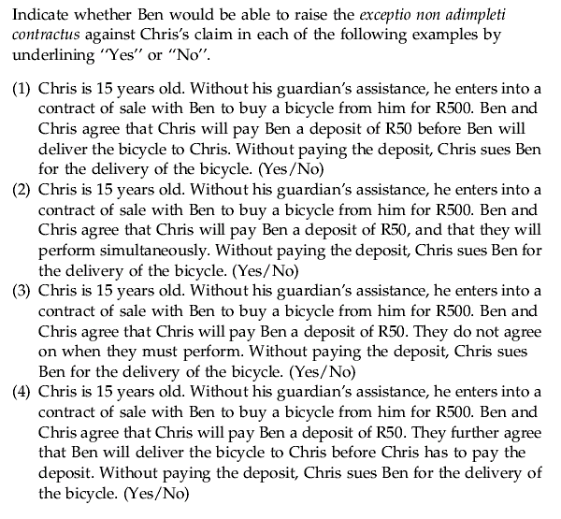
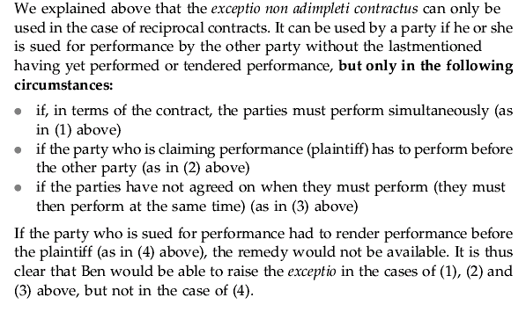

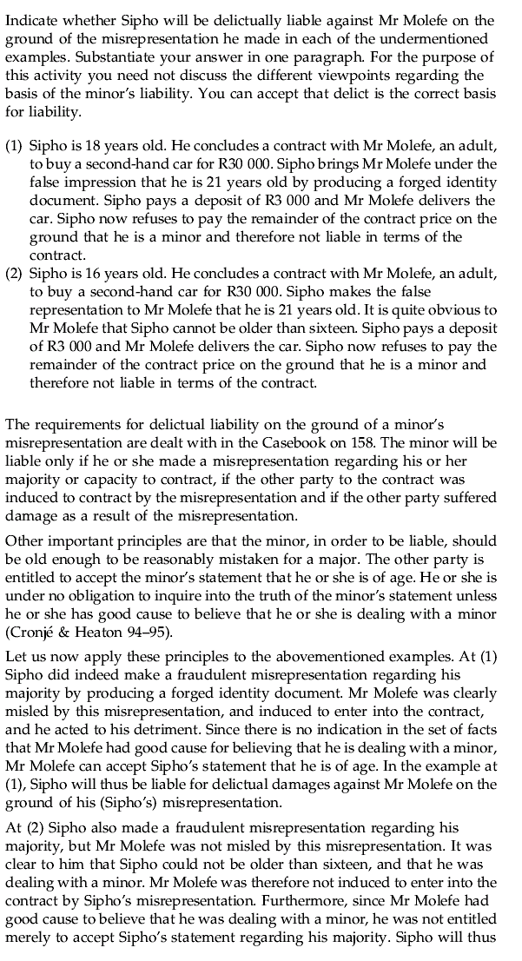
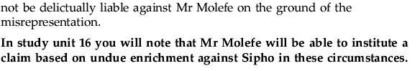

Study Unit 16
The minor’s contractual capacity – undue enrichment and negotiorum gestio

1. Undue Enrichment

“General rule that a person’s estate may not be enlarged without legal ground at the cost of another person”

Undue enrichment = When a person is unduly enriched at the cost of another person if he/she gains a patrimonial benefit (i.e. increases the value of his/her estate) at the cost of another person without there being a recognised legal ground justifying the transfer of the benefit.

In such a case the law obliges the recipient to return the prejudiced party the amount by which his/her estate has been enlarged. The prejudiced party thus has a claim against the recipient based on undue enrichment. The general rule can also be applied where a minor contracts with an adults without the necessary permission..

If the adult has already performed in terms of the contract, and the minor in his turn refuses to perform, the minor is enriched at the cost of the adult who already delivered performance. The adult can hold the minor liable on the ground of undue enrichment for the repayment of the amount by which he/she was enriched.

Benefit theory:

The Benefit theory was introduced in our law in the case of Nel v Divine Hall & Co in which the court decided that once the contract, taken in its entirety, is to the minor’s benefit, the minor is contractually liable.

The Supreme Court of Appeal authoritively rejected the benefit theory in Edelstein v Edelstein 1952 and decided that the contract of a minor who acted without assistance can never be valid because it is to his/her benefit. However, the minor is liable for the extent to which he/she as been unduly enriched.

How is the extent of the minor’s enrichment calculated:

Five principles are applicable when calculating the extend of the minor’s enrichment

    - The moment on which the calculation must be based, is the moment when the other party institutes his/her claim, that is at litis contestation.
    - Actual value is calculated not purchase price
    - The amount by which the estate of the other party is decreased as a result of the performance (actual value and not contract price)
    - Determine the above two amount, the minor is liable for the lesser of the two
    - If the minor has lost the performance he/she received or its value has decreased, or if he/she has sold it, the following rules apply:
- Lost/stolen = The other party is not entitled to anything
- Value decreased = The minor is liable only for the decreased value.
- Sold before litis contestatio he/she remains liable for the purchase price received, depending on how he/she applied the proceeds thereof
- If the proceeds is still in the possession of the minor at the time of litis contestatio, he/she is liable for as much of it as is still remaining during litis contestatio.
- If the minor used the proceeds for necessaries, he or she is still liable for the purchase price of these necessaries. Reason being, that he/she would have had to purchase the items out of his/her own estate in any case
- If the minor purchased luxury items with the proceeds he/she is till liable for what ever remains.

2. Negotiorum Gestio

Parents have a duty to maintain their children. Therefore, if a child in the absence of its parents incurs expenses by purchasing necessaries like food, the parents may be held liable by the other party on the basis of negotiorum

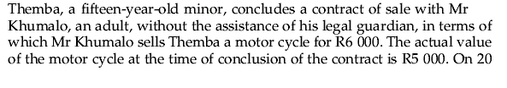
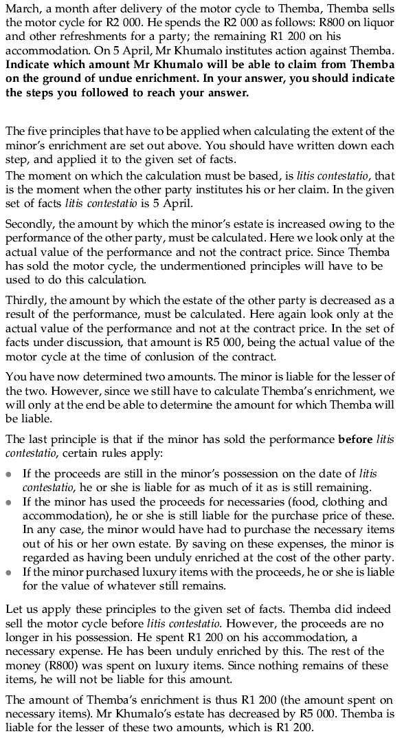

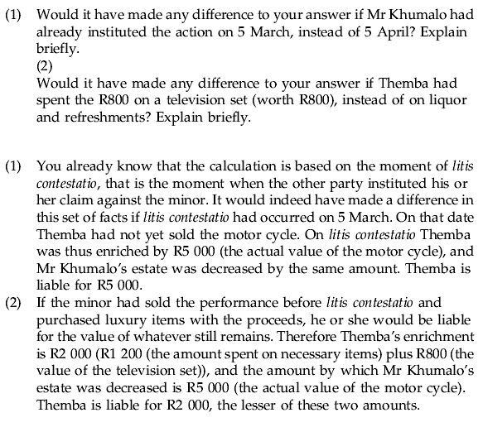

Study Unit 17
The minors contractual capacity ~ assistance by the parent or guardian, ratification and liability of the guardian.

      - Assistance by the parent or guardian in contracting and the effect of such assistance

Forms of assistance:

        - The guardian can contract on behalf of the minor
In some contracts the guardian cannot enter into on behalf of the minor, such as agreements of personal nature i.e. antenuptial contracts also the guardian can not contract on behalf of the minor where the contract will only come into operation after the minor has attained majority.
        - The minor can enter into the contract himself with the consent of his guardian, or the guardian can ratify the agreement after it has been concluded.
- Consent may be given expressly or tacitly i.e. if the guardian is aware of an agreement the minor has concluded and raises no objection, it can be accepted that he tacitly consents to it.
- The guardian must be aware of the its nature and essential terms, consent obtained trough fraud is valueless

Ratification

- A minor may, when he/she comes of age, ratify a contract initially concluded without his/her guardian’s assistance, with the result that the contract becomes completely valid with retrospective effect. Ratification may take place expressly or tacitly.
- A Guardian may ratify a contract initially concluded by the minor without the guardian’s consent.
- Ratification validates the contract with retrospective effect.
- A contract which a guardian could not have entered into initially cannot subsequently be ratified by that guardian.

Liability of the Guardian

“A guardian acting in his capacity as guardian does not incur personal liability towards the other party, even if he/she assisted the minor or acted on his behalf” However…

- The Guardian will be liable if the minor has acted as his/her agent, or if the guardian has ratified a contract that the minor has concluded as his/her agent.
- The guardian will be personally liable if he/she has guaranteed performance by the minor or if the guardian has bound himself as surety.

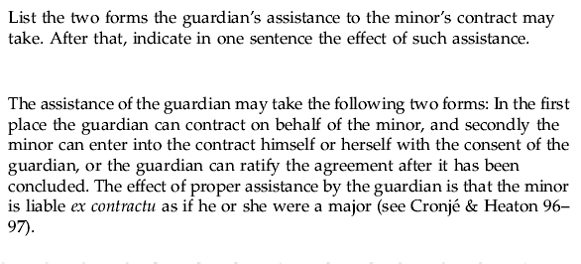

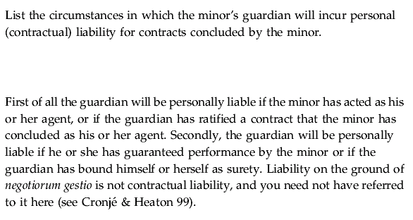

Study Unit 18
The minor’s contractual capacity ~ restitutio in integrum

1. Restitutio in integrum

A legal remedy whereby a minor can escape liability if he/she contracted with the assistance of her guardian (or the guardian has contracted on his/her behalf) and the contract was prejudicial to the minor at the moment it was made.
- A minor seeking restitutio must prove that all the requirements of this remedy have been met.
- The remedy is not available to a minor who misrepresented himself as a major or who, in a fraudulent manner, persuaded the other party to enter into the contract
  - It can also not be relied upon to escape the bonds of marriage or criminal/civil liability

Requirements for the application of restitutio:

- The minor should have concluded the contract with the assistance of a guardian or the guardian should have contracted on his/her behalf
- The contract should have been prejudicial to the minor at the moment it was made

Purpose of the remedy:

To place both parties in the position they would have been as if they never entered into the contract.
- Each party must return everything received under the contract as well as the proceeds or any advantage derived from the contract.
- He/she must also compensate the other party for any loss he/she has suffered as a result of the contract.

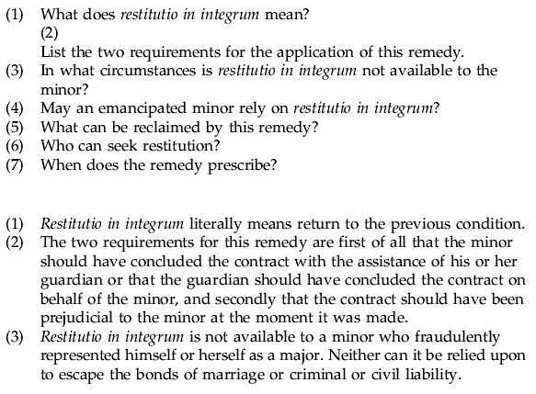
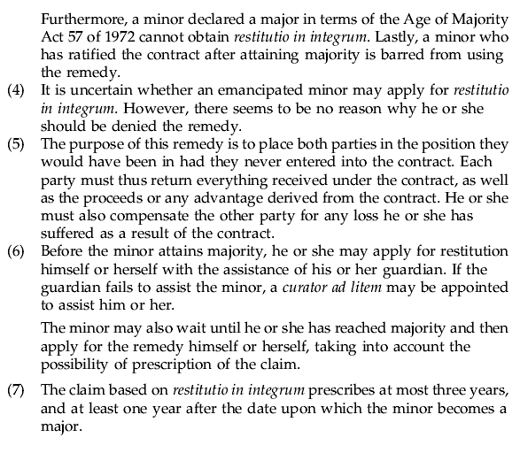

Study Unit 19
The minor’s capacity in respect of other types of juristic acts, and litigation.

“The principle that a minor may improve his position but not encumber it without his guardians consent also applies to other agreements”
1. The minor’s capacity to make agreements other than contracts.

Requirements for validness of agreements between adults and minors!

A minor can enter into a valid agreement with someone else by which the minor’s debt is extinguished, but the minor cannot without assistance enter into a valid agreement with another by which the later debt to the minor is extinguished.

A minor cannot render performance without his guardian’s assistance and if he has done so he can recover whatever he has performed. However where a minor enters into a contract with the assistance of his guardian but performs under that contract without assistance, he is not entitled to recover his performance.

The other party is not released from his obligation to perform but the minor may be liable on the basis of undue enrichment.

A real agreement (an agreement by which a right i.e. right of ownership is transferred) by which a right is transferred to minor is valid, even although the minor acts without the assistance of his guardian, but a real agreement by which a minor attempts to transfer a right to another without his guardian’s assistance, is completely invalid.

In Edelstein v Edelstein it was held that an antenuptial contract entered into by a minor without the required consent is void. This is still the position.

2. Capacity to make a will

A person who is 16 yrs or older may make his/her own will. A witness to will must be at least 14yrs old

2. Capacity to marry

Minors require their parents consent in order to get married. Minors must sometimes also obtain the consent of the minister of home affairs.

      - The Minors capacity to hold certain offices and perform certain functions

A minor or an emancipated minor can not hold the following offices: Director of a company or a mutual bank; the trustee of an insolvent estate. However, the minor who has been granted major under the Age of Majority Act 57 of 1972 or who attained majority status through marriage are not disqualified.

3. The Minor’s delictual and criminal liability

“Fault can be attributed to a miner over 7 yrs. The capacity to be held accountable for one’s unlawful acts is the basis and essential element of fault.”

- A person can be held accountable only if he has the mental faculties to:
- Distinguish right from wrong
- Act accordingly
  - It is rebuttably presumed that minors between the ages of 7 and 14 cannot be held accountable.
  - Minors between the ages of 14 and 21 are rebuttably presumed to be accountable

“It is important to distinguish between a minor’s capacity to act and his accountability as a minor may be accountable even though he/she does not have the capacity to act.

4. The minor’s capacity to litigate

“It is often said that a minor has no locus standi (cpacity to litigate in a civil case) in iudicio (minor does not have the capacity to be a party (plaintiff, defendant, applicant or respondent) in a civil (private law) lawsuit. However…

- A minor has limited capacity to litigate in most private-law lawsuits with the assistance of his/her guardian.

!READ 103 – 106 TEXTBOOK!

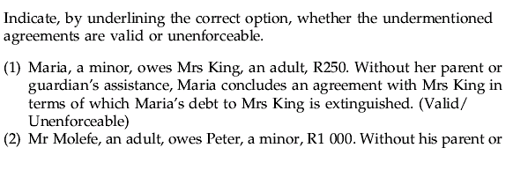
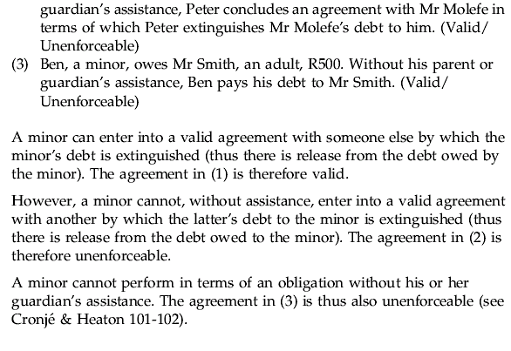

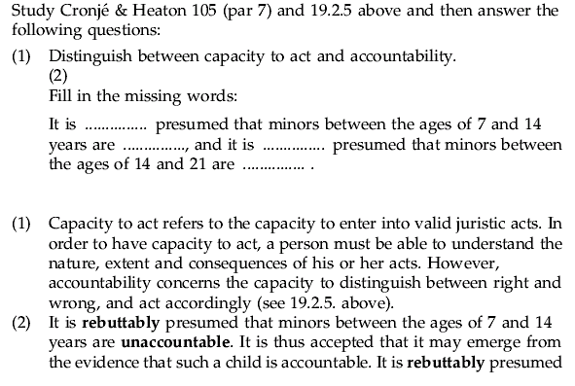
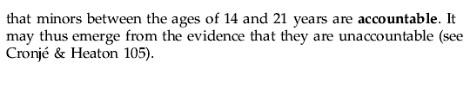

Study unit 20
The termination of minority

- Attainment of the prescribed age: The attainment of majority has been fixed by statue at the age of 21 yrs for both sexes.

- Marriage: Someone who enters into a valid marriage before the age of 21 becomes a major for all purposes

- Venia aetatis and release from tutelage
In common law the sovereign could grant a minor concession to act as a major = venia aetatis. The effect was to make the minor a major in the eyes of the law with the exception that he/she could not alienate his/her immovable property or burden it with a mortgage unless this capacity was expressly conferred. (granted by the sovereign / Limited capacity)

Release from tutelage refers to the authority the courts had to confer full capacity to act on a minor (granted by the courts / Full capacity)

Read Study Guide 106-107

4. The Age of Majority Act 57 of 1972

Any person who has attained the age of 18 may apply to the high court to be declared a major in the form of a notice of motion supported by an affidavit stating the following:

- Full names of the applicant, ordinary place of residence and date of birth.
- Full details of the application for judgement by the court i.e. behaviour, mental development and business acumen
- Whether the applicant lives with his parents and if so whether he intends continue living with them
- Whether the application is supported by the applicant’s parents/guardian
- Full particulars of any immovable property which the applicant is the owner or probably will become the owner
- Full particulars of any movable/immovable property of which the applicant is the owner and which is subject to a fideicommissim, usufruct or similar right
- Any other relevant material that will place the court in a position to judge whether it is necessary or desirable in the interests of the applicant to grant the application.

After consideration of the application and any report on it or objections to it, the court may grant, refuse or postpone the application.

Effect of declaration as a major is stated in section 7. It provides that any person to whom an order is granted, shall for all purposes be deemed to have attained the age of majority.

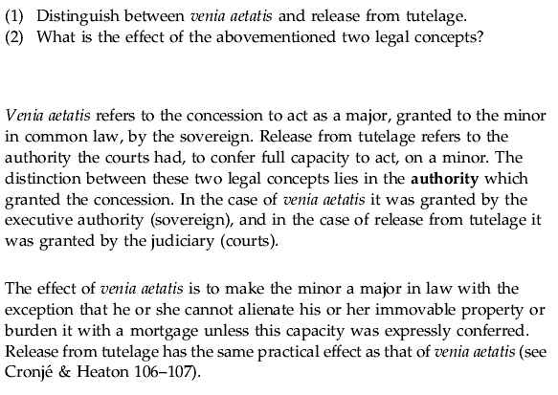

Study Unit 21
The termination of minority (Emancipation)

1. Emancipation

- A minor is emancipated if his/her guardian grants him/her freedom to contract independently when the minor participates in commercial as an economically independent person.
- With emancipation the guardian consents to a specific class of juristic act.
- With this consent, the minor incurs liability like a major
- Where a minor has no parents, he/she can be emancipated by her legal guardian
- Emancipation can only be effected by the express or implied consent of the parents. Mere carelessness on the part of the parent does not result in the minor’s emancipation.
- The question of the effect of emancipation on the minor’s capacity to act has not been authoritatively decided.
  - The issue is whether emancipation applies to only certain transactions or whether the minor can act beyond the scope of such trade.
    - Some authoritative views suggests that tacit emancipation gives the minor capacity to act in respect of all contracts except that he/she can not alienate or encumber immovable property and cannot enter into a marriage without his/her guardian’s consent. In other cases it has been held that the minor is only tacitly emancipated in respect of contracts in connection with his/her particular business.
    - Express emancipation refers to the declaration before the court by the parent or guardian that he/she had emancipated his or her child from parental authority (Venia aetatis)
    - Tacit emancipation occurs where a minor lives apart from his/her parents and manages his/her own undertaking

READ PG 109-112 Textbook!

